Food Demand Analysis
Client Report | Findings and Recommendations
Prepared for business decision-makers

Executive Summary
Across 145 observed weeks, average weekly demand was 824,534 orders. The highest weekly total was 1,303,457 in week 48; the lowest was 380,065 in week 62. The three largest meal categories represented 66.07% of orders. A linear-regression validation on weeks 136–145 produced an RMSE of 191.66 orders per center-meal-week record. The evidence can inform demand review, but the observed promotion and price relationships are not causal findings.
Objective and Data
This analysis describes weekly demand, meal and center patterns, observed relationships with promotion and discount, and the validation performance of a linear-regression model. The prepared analysis dataset contains 456,548 rows, 145 weeks, 77 centers, and 51 meals, with no missing cells or duplicate rows reported in the saved notebook output. The regression used 456,548 training records from weeks 1–145 and predicted 32,573 unlabeled test records for weeks 146–155.
In the read-only training CSV, num_orders ranges from 13 to 24,299 orders per center-meal-week record; the mean is 261.87 and the median is 136. This record-level target must not be confused with the total number of orders across a company in a week.
Key Findings
1. Weekly demand varies substantially
Average demand was 824,534 orders per week. The observed weekly total ranged from 380,065 in week 62 to 1,303,457 in week 48. These are weekly aggregates, not individual meal-record counts. Week numbers have no calendar dates, so the pattern cannot be assigned to a season or holiday from these data.
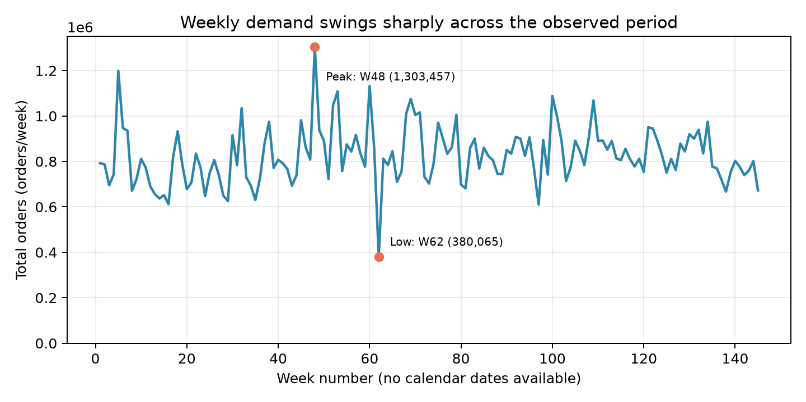
Figure: Weekly order demand. Total meal orders vary substantially across observed weeks. Week numbers are not calendar dates.
2. A small number of categories account for much of demand
The three largest categories account for 66.07% of orders. Beverages lead, with 40480525 orders (33.86%); the largest individual meal in the notebook summary is meal 2290, an Indian Rice Bowl, with 9,770,303 orders (8.17%). Italian cuisine has the largest cuisine share at 36.95%. These are cumulative historical counts, not a guarantee of future demand.
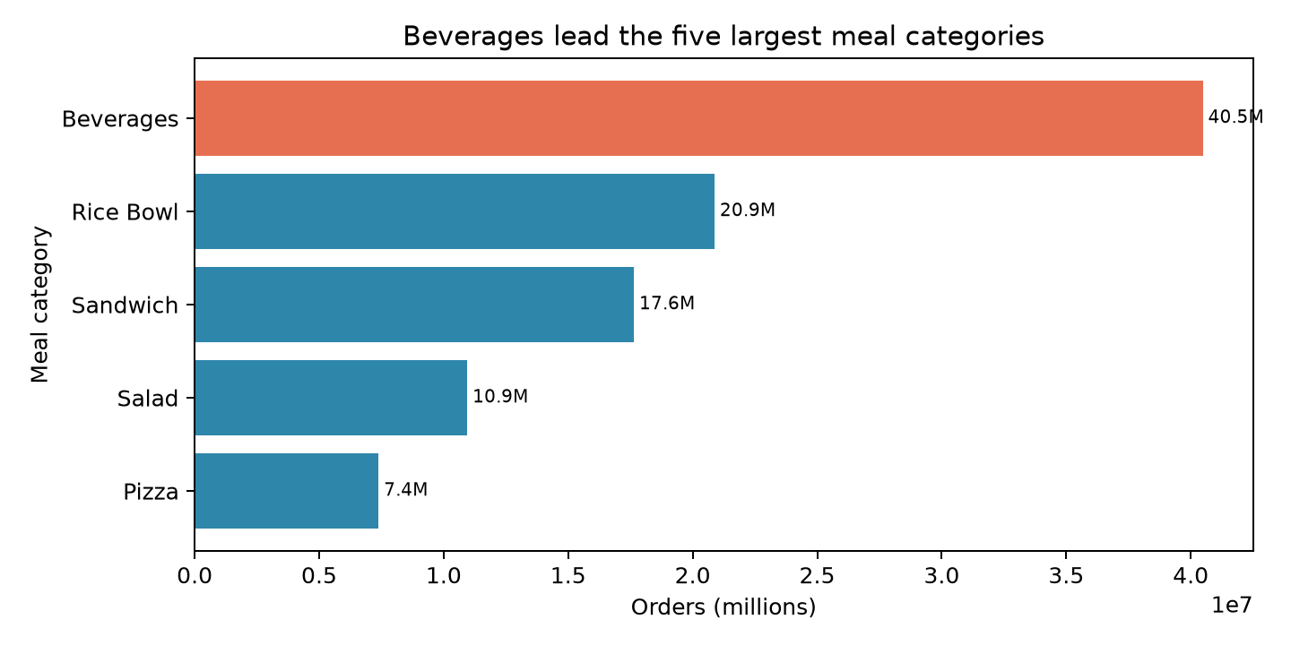
Figure: Most-ordered meal categories. The top three categories represent a large share of total orders, led by Beverages.
3. Center totals and center-type averages differ
Center 13 recorded the highest cumulative total, 4,296,545 orders. TYPE_B had the highest average total per center: 1,999,738 across 15 centers. The total by center type is affected by the different number of centers in each group; observed differences do not identify their cause.
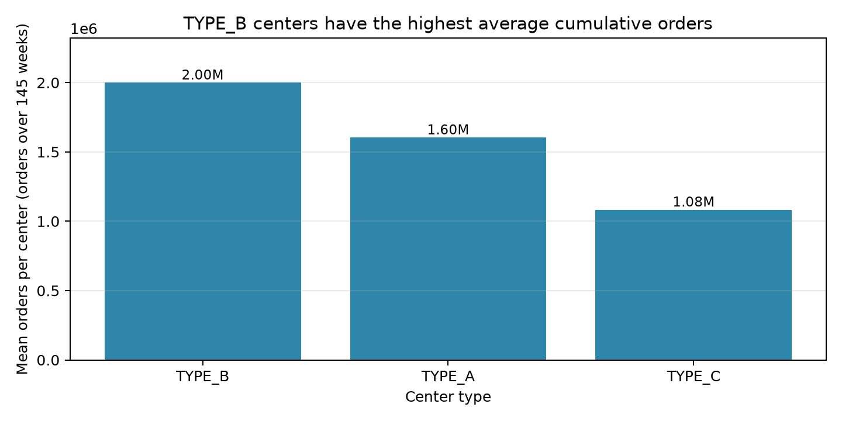
Figure: Average orders by center type. TYPE_B has the highest average per-center total among the displayed center types; the comparison does not establish why groups differ.
4. Higher observed orders coincide with promotion exposure
Mean orders were 631.10 for email-promoted records versus 229.26 without email promotion; homepage-featured records averaged 594.88 versus 221.05 without featuring. These are unadjusted associations: promotions may be assigned to different meals or circumstances, so the comparisons do not show that promotion caused the difference. The matched center-meal statistical comparisons are exploratory because weeks repeat within pairs.
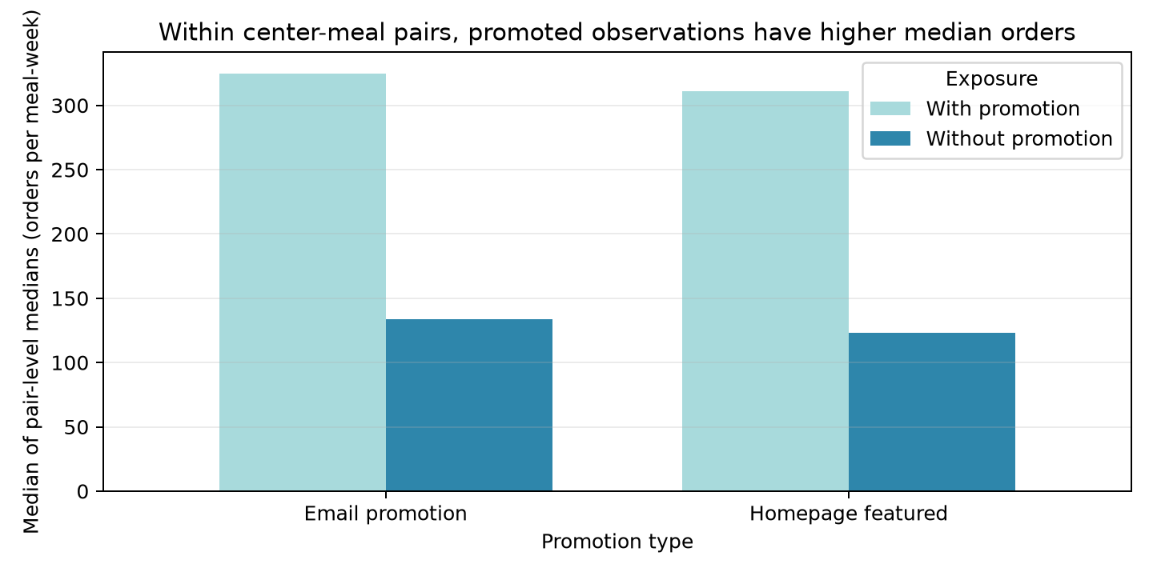
Figure: Observed orders with and without promotion. Promotion exposure is associated with higher observed orders, but matched comparisons are observational and do not prove a causal effect.
5. Discount has a weak positive rank association with orders
The Spearman rank correlation between discount percentage and orders is 0.122, calculated over 456548 records. This is a weak positive association, not evidence that larger discounts cause more orders. Differences in meal, center, and week may also relate to the observed counts.
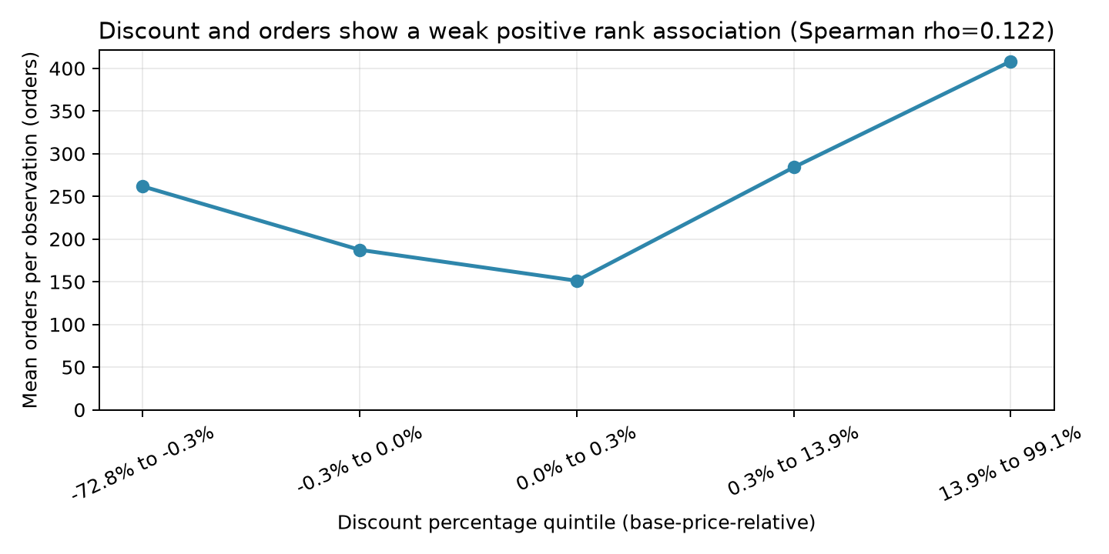
Figure: Discount and order association. The measured rank correlation is positive but weak; the association does not demonstrate causation.
Predictive Model Results
The linear-regression model was evaluated chronologically on the final 10 labeled weeks, weeks 136–145, covering 32,821 records. Validation RMSE was 191.66 orders per center-meal-week record, and MAE was 136.38 orders. The model was then refit on all labeled weeks before generating predictions for test weeks 146–155; actual labels for those test rows are not available for calculating their prediction error.
Measure | Result
Training records | 456,548 (weeks 1–145)
Test records | 32,573 (weeks 146–155)
Validation records | 32,821 (weeks 136–145)
Mean absolute error (MAE) | 136.38 orders per center-meal-week record
Root mean squared error (RMSE) | 191.66 orders per center-meal-week record
How to Interpret RMSE
RMSE expresses prediction error in the target's units: orders per center-meal-week record. The RMSE of 191.66 is about 73.2% of the training-data mean of 261.87 orders per record. RMSE squares errors before averaging and taking the square root, so large errors receive more weight; it is not a simple arithmetic average of the errors. The training target ranges from 13 to 24,299 orders per record. There is no universal commercial acceptance threshold: the business must define a tolerable error for each operational decision and compare this model with a suitable baseline.
Hypothetical illustration, not an observed prediction: if one center-meal-week record had an actual count of 500 orders, an error with a magnitude of roughly the RMSE (192 orders) would correspond to a prediction around 308 or 692 orders. This example explains the scale of the metric; it does not describe a specific model prediction. It is a per-record illustration, not an estimate of total weekly company orders.
Practical Recommendations
- Pilot forecasts at the center-meal level and compare each forecast with actual orders before using it to adjust supply.
- Prioritize availability reviews for the largest-demand categories and meals, while checking inventory and waste records separately.
- Define acceptable forecast error by operational use, then compare the model with a simple baseline on the same chronological validation window.
- Evaluate promotions and price changes with a controlled experiment or stronger causal design before treating observed associations as expected lift.
Notes and Limitations
- The order data do not directly measure inventory, food waste, or stockouts; separate operational records are required.
- Week numbers are not calendar dates, so these results cannot identify seasonality, holidays, or specific calendar events.
- Promotion and discount results are observational associations and do not prove causal effects.
- RMSE and MAE are from labeled training-period validation, not from future test weeks 146–155.
- The report summarizes aggregated demand patterns and does not attempt to identify the company, customers, or individuals.

