VariYO!
Motivation for this project started when I found out how much decent varios actually cost, that they are mostly more expensive then outdoor watches which are basically the same hardware-wise any also as kind of personal challenge.

What i wanted to do is make some decent sized hardware platform with all the necessary hardware (which proved not so hard) and then find some good friends who like coding to help me out with the software (which proved harder :-)) and send it out in the world to make it a better place.

The final foal was vario roughly of a size of skydrop skybean with nicely working vario (duh...), GPS tracklogging capability and nicely readable display.

Some key decisions

Microcontroller
I did something with arduino before, but atmega328 is way too slow, not enough ROM and RAM for anything decent, so that was out of question. However arduino also works with 32bit ARM based uC SAMD21G18, a microcontroller with plenty of ROM, 32kB RAM, enough IO pins and all the nice things that could make it work. Nice thing is that there is bootloader enabling it to be programmed via native USB port, so no programmer is needed and no extra circuitry on PCB is needed either. And there are libraries for all the basic things which is nice.

Display
objective number one: perfectly sunlight readable
objective number two: decent resolution
If i wanted something sunlight readable, all the color TFTs were out of the question, as well as OLEDs. I was searching for some monochromatic LDCs, remembering times of nokia 3310, where even outdoors everything was nice. But im either really bad at googling, or there are non (with a price tag under $200).
So, lets try some e-paper! 1.54inch, 200x200, partial update capable so it doesnt have to blink like crazy every time it is updated, that could work.

Button
I really like 5way joysticks, so this was actually really easy decision which proved a bit harder later. Not sure yet how its gonna work with thick gloves, but will manage something (hope)

So this was kind of what i outlined for myself, now it was a lot of iteration, debugging and (so far) 2 years of... fun?

Hardware
How i did it was that i ordered some proto board from the internet, tried how it works and as soon as it was too much of a wire mess, i made a PCB to fit it all on an continued with testing mire peripherials. Then later on found out that something allready on the board cant work for whatever reason so changed it for a defferent one and so on. Tough life of people who are never satisfied. Obviously it ended up with some iterations...

Sensors

Barometer
is the core of every vario, so there was some fun with that. My fist choice was MS5611, everybody around the world is using it as a best sensor so it has to be the best, right? Well... it is. In a way.
My problem with this one is that it is not very autonomous device. When you want to get a pressure out of it, it goes something like this

you: "hey sensor, measure the pressure"
sensor: "okay, in a sec.... im ready, here is some funny number, now do some magic with it and it will give you the atmospheric pressure"
you: "i need temperature to do that magic, measure temperature"
sensor: "okay, in a sec.... here is the temperature"

So there is no FIFO from which you could just read these data, no mode where it just keeps on measuring and you just get the last result when you want. So it ends up with more complicated software, because you just have to poll it if it has result ready for you, there is an extra communication, plenty of computation on uC side to get the pressure. So this is where i dropped it.

So i did some more research and came across BME280. Nice small device, has also humidity sensor within, has some of those features i was missing with MS5611 (but still you have to do some funky things with the number it gives you, its not directly the pressure), but at least the communication is way more simple.
Waiting for a catch? Okay, here it is: self-heating. If you want to use it as a temperature sensor as well (which you do), its just gonna give you like +2degC. But also maybe +1 if theres a lot of wind around. Or +3 when there is no wind around. Okay, next!

LPS33HW. Love at first sight. it has all the features i like in it. You just get a number from it which is directly proportional to pressure, so no need to do any math whatsoever in you uC. Datasheet says beautifully low noise. It is waterproof so with a bit of box engineering, there could be a waterproof vario (comes handy when flying in a thunderstorm, right?).
Waiting for a catch? Okay, here it is: the noise is not as good as datasheet says.

So at this point, I took all three sensors, put them on one PCB and tried their noise performance. well, it went like this:

winner is MS5611
second place LPS33
bronze medal BME280

Would really love to provide you with some figure, but I guess I've lost it. difference between MS5611 and LPS33 was not that big, so i decided to do with the latter one for the sake of software simplicity.

GNSS (aka GPS)
What i found out is that GNSS is actually gonna be responsible for over half of the total vario consumption, ouch. So i started looking for the most energy efficient one. Then found out the best ones are pretty often in BGA package which i cannot solder by myself.
Then i found SAM-M8Q by uBlox. All the nice stuff is already soldered on a module, antenna included and you just follow some PCB layout guidelines. And this was one of two things where i stopped liking it. The module actually uses the PCB copper as a part of the antenna (or like impedance matching or whatnot), so it requires pretty big area around it, otherwise the performance suffers. The other thing i did not like was that the antenna is pretty directional in a direction perpendicular to PCB, so when put vertically on the riser (which is how I like my vario), the best reception is towards horizon.

So back to research: CAM-M8Q. Also a module that you just have to solder, but this time with omnidirectional antenna, recommended placement is at the edge of PCB (which was for me more convenient) and the copper area around it can be smaller. Supports SPI communication (i personally don't like the UART, since it requires some interrupt and stuff on uC side) and should support some pretty energy efficient modes. GPS, GLONASS, Galileo and BeiDou are supported with 3 concurrent systems, so it could get pretty nice accuracy)

IMU
Inertial measurement unit, meaning accelerometer and gyroscope was chosen BMI160. Basically for its low power consumption (which proved totally irrelevant, since the consumption of that one device is like... 1% of total consumption? But I didn't know it back then) and by the time i was choosing it, pin compatible BMX160 was being released, which also integrated magnetometer in one device.

Temperature, humidity
Since I didn't go with BME280 barometer, which also integrates humidity measurement, i needed another device. Sillicon labs Si7021 offers recent accuracy and version with waterproof PTFE cover to prevent liquid water from entering in the sensor, so it went on with my wet dream of making it waterproof.

Other circuitry

SD card
There is an SD card slot for tracklogging, which is pretty straightforward and simple. Tricky part was moving the data to computer. Naturally I am too lazy to remove the card from the device, look for a card reader, then put it back. What would be nice is to have a mass storage capability. Went back to the internet, looking for some library to do it via the microcontroller, but couldn't find any. So there is an extra USB2244 card reader controller, sharing the SD card bus with the microcontroller, which can via USB interface connect to PC and show the SD card as mass storage, with USB2.0 speed.

LDO
whole device runs on 3.3V. Even in off state, the regulator is still running, just almost everything is turned off and uC is in sleep state, consuming around 20uA. In order to keep the battery life in off state as long as possible, some low quiescent current regulator was necessary. STLQ020 was used, later replaced with pin compatible NCP718, having 4uA quiescent current. This should ensure a few years of battery life in off state.

Power management
Everybody loves to see how many percent of battery is remaining. Easy way to do it: measure battery voltage and then somehow approximate it and give plus minus 20 percent approximate guess. Better way is to do a coulomb counter and measure how much charge went in or out. Or just get MAX17055 battery fuel gauge circuit, which measures voltage, temperature, has coulomb counter and some crazy fusing algorithm in it. you just read some registers via I2C with remaining capacity, voltage, current, whatever you find interesting.

Thing with lipo batteries is that under certain conditions, they like to turn into a fireball, so there is also a protection circuit LC05111CMT, disconnecting the battery when it being overcharged, undercharged or too much current goes in any direction. Later on when i bought a battery, i found out that most of them have a protection circuit already installed, so there is a solder bridge on PCB and this circuit doesn't have to be installed

For charging the battery, there is small linear charging circuit. I know, some switch mode controller has better efficiency, but my intention was to charge from USB so the losses are not that big and this solution saves some board space. My first choice was LTC4057, later was replaced with cheaper MCP73831, which is (almost) pin compatible, only one solder bridge was added to support both of them still.

Power to all the components except for uC and a battery monitoring circuits can be switched off with a PMOS transistor, further reducing consumption in off-state.

Currently I am using 1200mAh battery, giving over 20h battery life.

EEPROM
Unfortunately, the microcontroller doesn't have an integrated eeprom to save some data that you don't want to lose, so there is 4kbit microchip 25AA040A to store some essential stuff.

SRAM
Not sure if necessary, so far not used, but in case one run out of RAM in microcontroller, there is 256kbit microchip 23K256 on the PCB.

Buzzer
Originally, I wanted to use piezo buzzer, but at the voltage of one battery was way too low to produce loud enough noise. So I switched to magnetodynamic transducer, which can make more noise with given voltage and is also much smaller. But then I checked how much current it consumes and quickly went back to piezo buzzer. To make it louder, there is sort of a charge pump, roughly tripling the battery voltage to make it loud enough. The charge pump is supplied from R-R opamp which buffers the uC DAC voltage, so the volume can be adjusted by simply changing the DAC voltage of uC. The piezo buzzer is driven in a full bridge configuration. Schematic diagram for simple understanding below:

DAC
Internal uC

Epaper
Waveshare 1.54inch 200x200 display is used. It needs some supplementary circuitry (simple SMPS) to generate high driving voltage. That is also integrated on the PCB.

Bluetooth
RN4871 Bluetooth low energy module is present and connected on uC UART bus. If someone makes it work, he/she will be my personal hero.

Heater
Since e-paper displays don't work at low temperatures, there is a heater, that can warm up the screen. It's a thick film ceramic resistor glued to the display from the back side. Its connected via NMOS directly to the battery voltage. 14.4R resistance gives heating capability of 1W at nominal voltage 3.7V. This dramatically reduces the battery life (but who flies for 5 hours in winter, right?).

Architecture
most devices communicate with uC over SPI bus, with exception of MAX17055 and Si7021, which are on I2C and Bluetooth on UART.
There are two separate SPI buses, one called SPI, the other SPI_IRQ. As name suggests, SPI_IRQ is used in interrupt routine and will be explained later in software.
on SPI bus are connected:
- display
- SD card
- GPS module
- EEPROM
- SRAM
on SPI_IRQ are connected:
- Barometer
- IMU

USB2244 shares same SD card pins as SPI bus, so when it is used, all the devices on this bus must be disabled to have Hi-Z pins and cannot be used.

There are two USB ports. Native USB port of uC used for programming and USB2244 USB port for mass storage and charging.

Lipo battery voltage is linearly regulated to 3.3V. This voltage is used to power the uC. Another linear regulator is connected to all the other circuitry and is inabled/disabled by uC. Motivation for this is to limit the standby current to absolute minimum when the device is off. PMOS is used to connect this voltage to the SD card. This has to be done to allow USB2244 circuit to control power independently of the uC.
GPS module has a backup power pin. Backup power enables it to remember some data (time, last location, satellite orbital data,...) to obtain faster fix. This pin is connected to GPIO of uC.
Stupid simple regulator is made to charge battery with solar panels. NMOS has its gate connected to 3.3V and when solar cellk voltage is above 3.3V+Vth, its wasted in the transistor, otherwise it goes via a diode to the battery. (haven't tested yet, works only theoretically and even in theory its not very efficient:-)).

Buzzer is connected to uC GPIO pin that can be multiplexed to internal counter output, allowing simple waveform generation without wasting program time.

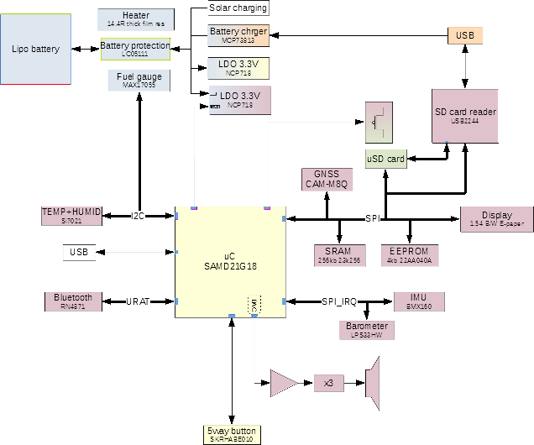
Mechanical

PCB
PCB is 2 layer board, 70x50mm. Design rules to comply with JLCPCB.
There is milling for thermal isolation of Si7021, milling for display cable, piezo buzzer housing, under the bluetooth antenna and mechanical relief of LPS33.
There is an attempt to make a good copper area to manage extra heat from lipo charging circuit (worst case wasting around 1watt). In this area, silkscreen keepout was used to allow applying extra solder to help with heat transfer.
There are total 6 holes for mechanical purpose
- 4 holes for closing the platic enclosure
- one hole for attaching the board to the top piece of the enclosure to hold the board in place when enclosure is not closed
- one hole for cord strap lanyard thingie (don't know how its called in english).

There is an additional tiny pcb connecting main board to the piezobuzzer since i don't like wires when i can avoid them.

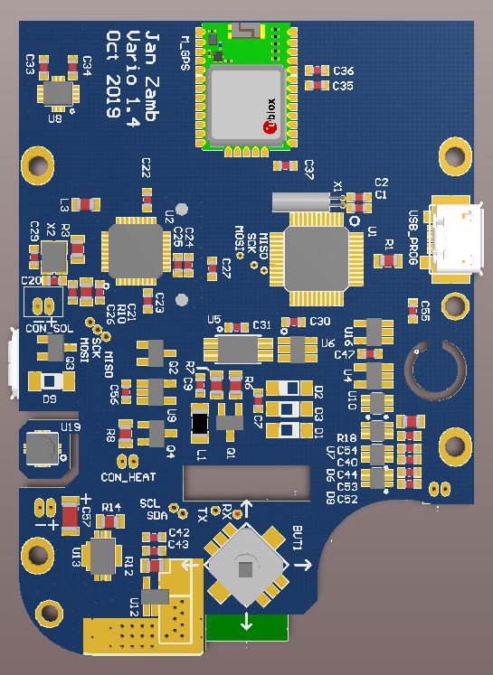
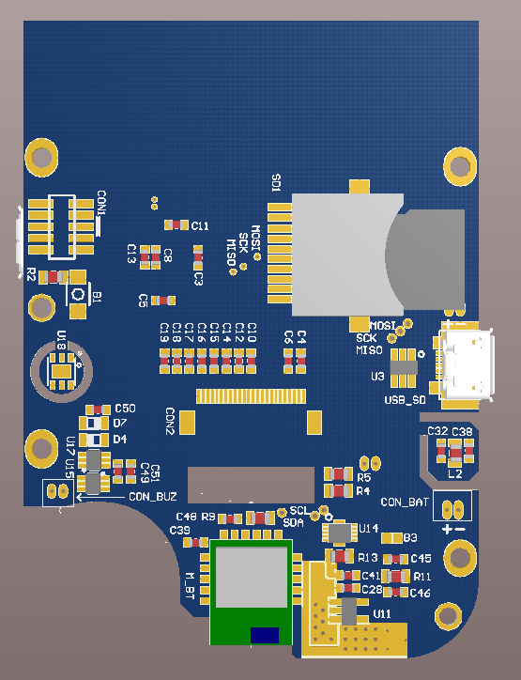

Enclosure
Current enclosure, which looks like it was designed in 80's, is 5mm larger then the PCB and 18mm thick. It consists of two parts, 3D printable and there is silicone rubber cap tight fit in a hole and over the joystick.

Temperature and humidity sensor is in a front-rear oriented tunnel, sealed around PCB with an O-ring to isolate the area from the rest of the enclosure, limiting the heat from within interfering with the measurement.

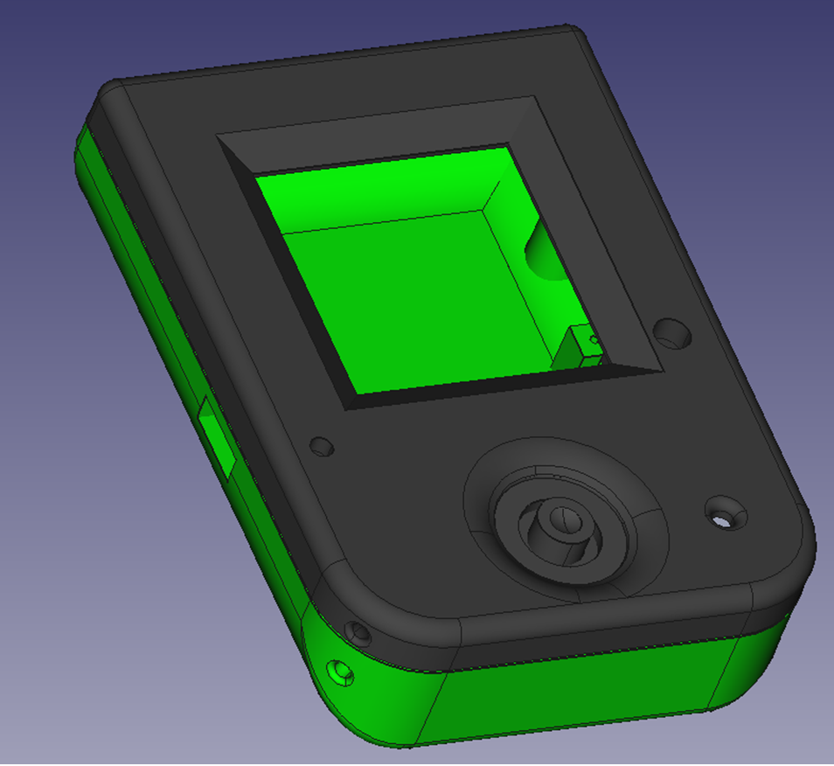
Silicone rubber cap on the joystick was cast to a metal mold, made on lathe. Consists of three parts (though only two are possible. Drawing with dimensions in joystick_mold.pdf. Doing this without lathe or mill might be tricky, but probably possible through some 3d printing trial and error.

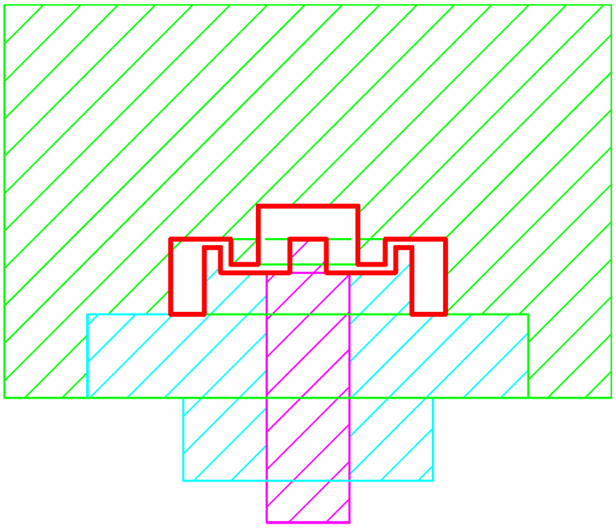

Software

Initialization
Key procedures happening in setup() function after power up are:
- EEPROM is read and data stored in statVar struct (containing all the stuff that are supposed to be remembered, such as display layout, calibration values and so on)
- GNSS is initialized in state corresponding to state saved in statVar struct
- IMU is set to FIFO mode forced 100hz, accelerometer, gyroscope and magnetometer data stored
- barometer is set in bypass mode, output data rate 75hz
- counter is initialized with attached interrupt routine, calling it cca 60 times a second
- some other shit
During setup(), sensors are checked whether present and this info is stored in present_devices variable. Idea is to 1) later on perform only those task that have a corresponding device present and not freeze the whole program or return nonsenscial values. 2) check functionality of all the connected devices, making HW debugging easier.

Interrupt service routine
This serves mostly for the device's main functionality, meaning calculating vario. Vario is calculated by fusing barometer and IMU data in Kalman filter. Filter is updated with 60Hz frequency, using IMU data sampled at 100Hz.
Buttons are also updated in ISR, which ensures button debouncing but fast enough response and some supplementary counters are incremented and flags set.
Piezo buzzer is updated.

Read barometric pressure
calculate pressure altitude
Read FIFO frame
(acceleration, gyro, magnetometer)
Frame to read
Get number of IMU measurements frames in FIFO
Update AHRS
Madgwick
Update vario
Kalman filter
yes
Update piezo buzzer
no
Update buttons state
Increment 500ms counter
Used in main() loop timing
Timer interrupt
500ms counter > 30
Set redraw flag
return
yes
no

Main function
main loop() function repeats the routine tasks which are not so time sensitive and shows something on the display. Routine tasks are in routine() function and include:
- check for new GPS data (if enabled) / check if 1s passed based on RTC timer
- set display redraw flag if new GPS data available or 1s passed
- update position fix
- calculate AGL
- calculate wind
- save data to tracklog
- read temperature and humidity
- read battery status (turn off if discharged)
- yaw/pitch/roll calculation from quaternions
- ...

Routine function should be looped in every possible device state to avoid gaps in tracklog or discharging battery too much!

Rest of the main loop depends on the state of the device.

Default screen

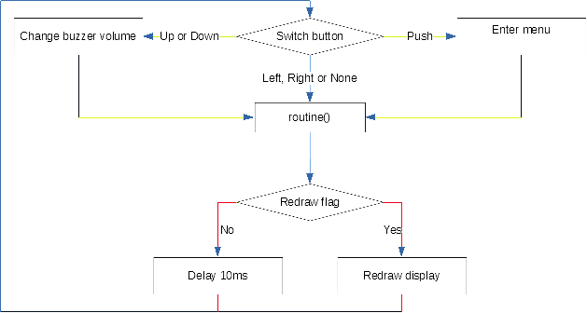
This is the screen that is seen most of the time. It shows all the flight data that are enabled and some device status (battery, GNSS,...).
Screen in updated twice a second when redraw flag is set. Every full-second update is synchronized by either GNSS module or RTC timer, the half-second update is synchronized by the ISR, happening ~30 ISR entires after the full-second display update.

Every data is displayed using Gauge struct. These are structures within statVar (meaning stored in EEPROM), that contain:

- X/Y position on screen
- X/Y size
- displayed name (max 9 chars)
- displayed units (max 3 chars)
- value to be displayed (float)
- averaging period
- 16bit settings containg:
  - show either fixed number of decimal places or fixed number of digits
  - number of valid digits/decimal places (0 to 7)
  - draw frame around gauge
  - font size (4 options)
  - show/hide "+" sign with positive numbers
  - if gauge is enabled (will be printed)
  - some bits are still empty to be assigned later

All these options are user changable from device interface. So far, there are following gauges implemented:
- vario 1
- vario 2 (can be set to different averaging period)
- altitude
- altitude above ground level
- altitude above take off
- ground speed
- heading
- temperature
- humidity
- wind speed
- wind direction
- Lift to drag
- flight time in minutes

Whenever new valid value is obtained, gauge value is updated using updateGauge() function. This function does with the gauge value following:

This means the gauge averaging set in gauge is not a time period, but "number-of-times-the-gauge-is-updated" period. This period is different for different gauges:
- Vario 1, Vario 2, Lift to drag: 6 times a second
- Speed, Heading: every time there is a valid fix (mostly 1x/s)
For other gauges the averaging is not used and value is written directly to the gauge->value variable (less computation workload).

When the value is not valid, a NAN can be written to the gauge and "--" is then printed instead of a number. This is useful when values dont make any sense (heading when not moving, speed with GPS off and so on).

Gauges are printed to the display using Gauge_print() function with hidden argument to print inverse value. This is useful for Lift/drag, because the stored value is actually drag/lift to make averaging possible (L/D is not continuous function).

Menu
Menus are structures consisting of array of string containing each item (eg "vario", "settings", "power off",....), neme of the menu ("top menu",...) , number of items, unique menu id, index of selected item and variable telling if the menu is detailed (meaning there is some value shown for each item, like threshold value for rise and sink).

There is structure for each menu (topmenu, settings, ...)

Parameter for entering the menu via menuEnty() function is pointer to the structure. Then, it goes like this:
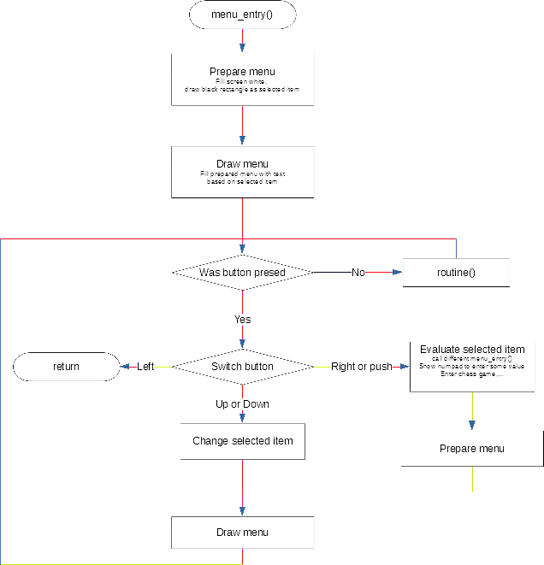

Evaluation of selected item is like this:

if(menupointer->menu_id = xxxx)
if (selected = yyy) perform something;
if (selected = zzz) perform something else;
if(menupointer->menu_id = aaa)
...

Walking through submenus is done recursively by calling another menu_entry() with different menu pointer.

To provide as fast response as possible, there is a small tweak making the code a bit less straightforward. To perform as little display pixel operation as possible after pressing the button, drawMenu() writes text to the display framebuffer, updates the display and then writes the same text of inverse color, effectively erasing the text from the display, but this time without updating the display. This way, all that needs to happen after pressing the up/down button is writing new text on the display (which is much less pixel operation).

Calibration
Both magnetometer and accelerometer can (and sometimes need to) be calibrated. Ellipsoid fitting algorythm is used on set of points. Center of ellipsoid (measurement bias) and axes (gain error) are then stored to statVar and every reading is then corrected.

Wind speed
Works on principle very well described here: http://blueflyvario.blogspot.com/2012/09/calculating-wind-speed-from-gps-track.html .
Last 60 heading and speed points are stored and then fitter by taubin method. Number of point can be changed via WIND_RBUFF_SIZE definition.

Ground level
uses 90m mesh of topographical data from SRTM (or compatible) in .hgt format. Data are expected in /HGT/ folder with the i believe standard naming (e.g. N41E003.HGT). Data are bilinearly interpolated from 4 closest points. Not verified on souther and western hemisphere, might be some bug there.

Acknowledgments

Obviously there are plenty of third party libraries used, for which i'm deeply grateful. Thank you guys!

Arduino libraries
Probably no need to write more, but for those who dont know: https://www.arduino.cc/

GxEPD2
Library for controlling the e-paper display. Developed by ZiggyJM, who can be found on arduino forum in a crazy long thread and his GitHub page is here.

Adafruit
GxEPD2 library uses some features of AdafruitGFX library. Ther from that, i used some info found on ther website about configuring SERCOM's in uC and higly likely somthing else I dont remember.

NeoGPS
Minimalistic GPS library by SlashDevin, also found on github, with arduino forum thread as well.

x-io technologies
From those guys, i used Madgwick AHRS library

Circle fit by Taubin
Algorythm to fit circle on bunch of points. However much I'm looking i can't find the webpaged I downloaded it from and there is no header in the source code, so can't give you guys credit, sorry :-(

Ellipsoid fit
C port of this MATLAB library

Kalman filter
The core of it all. This guy did kalman filter IMU/barometer vario, with source codes also on GitHub and some really good documentation on this page. So naturally i used his Kalman filter code.

MAX17055
For the fuel gauge, there is a library from Awot Ghirmai and Ole Dreessen.

