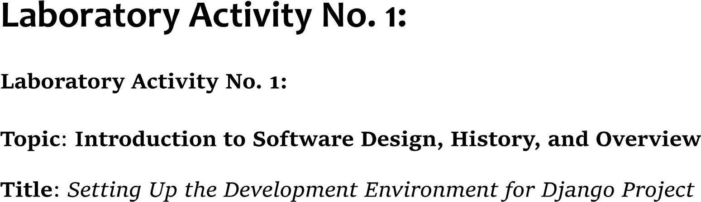

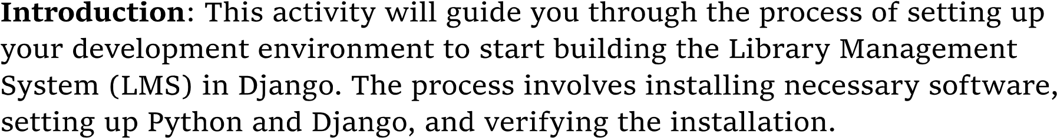

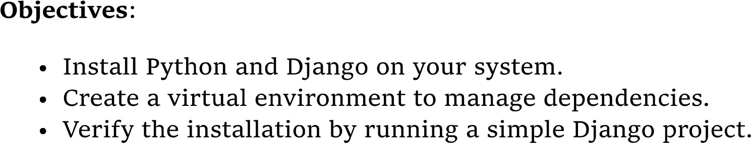

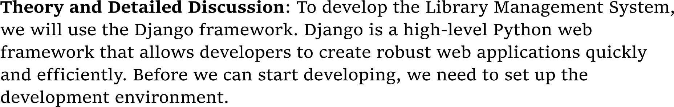

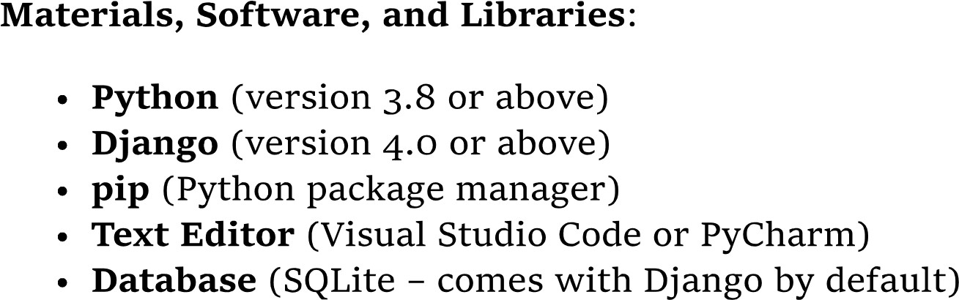

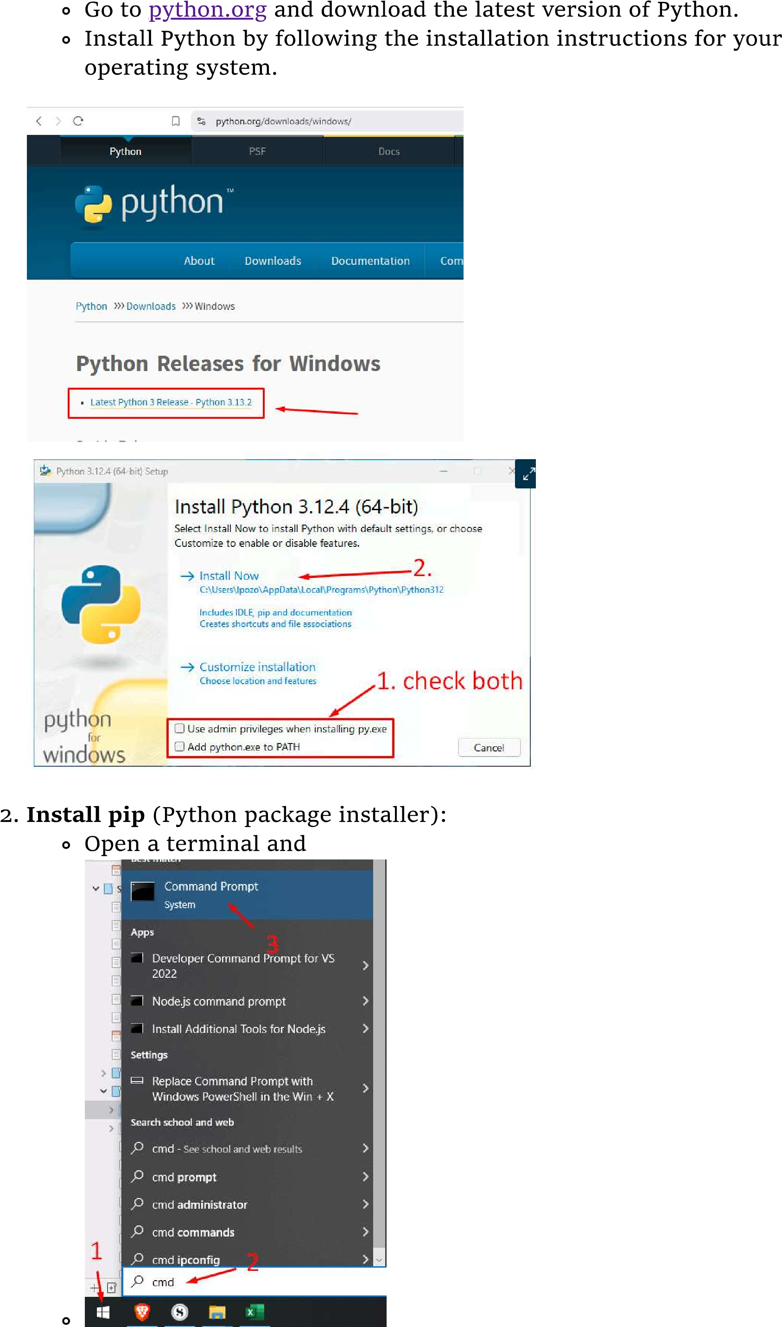

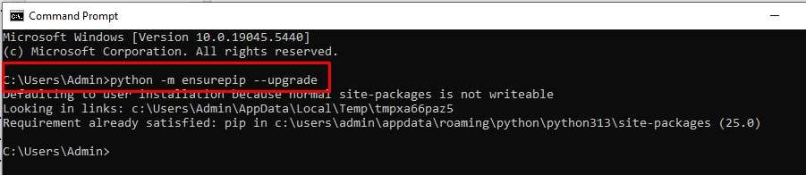



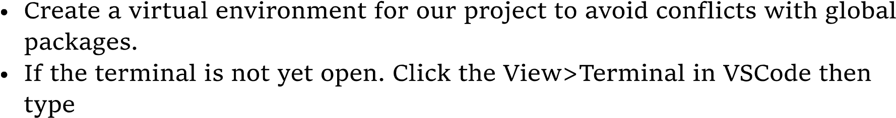

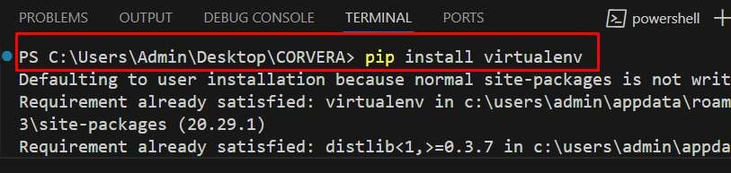

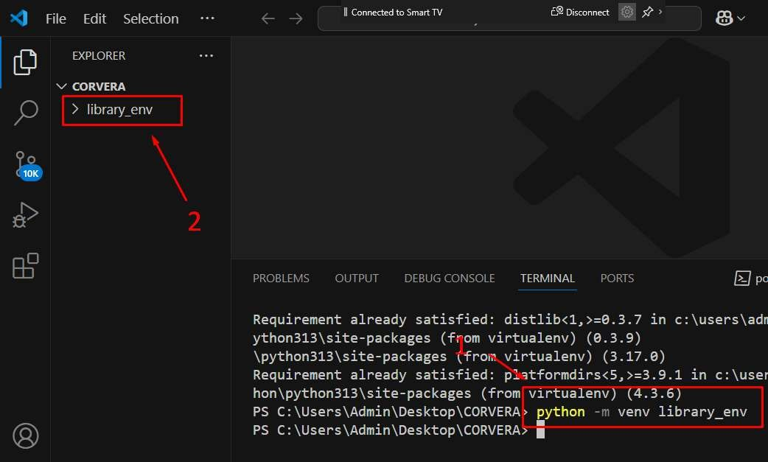

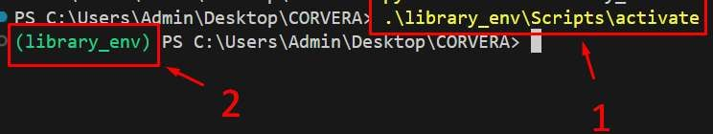

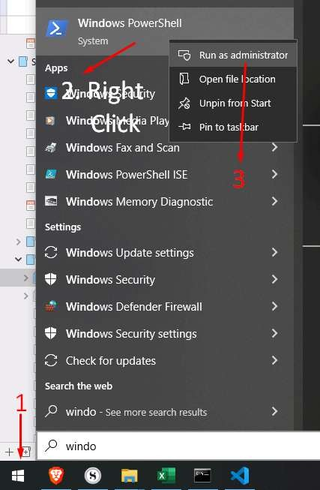

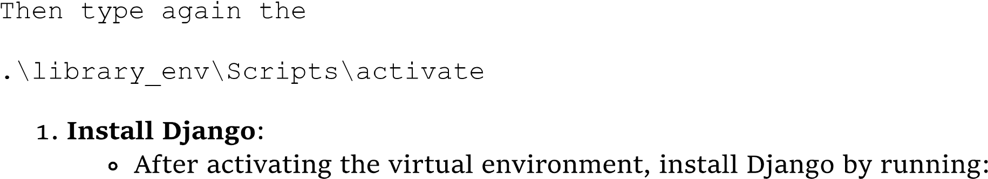

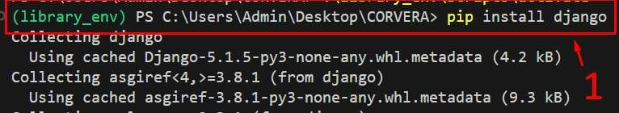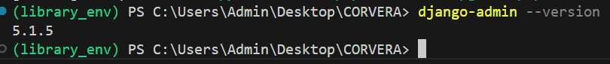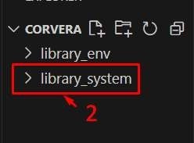

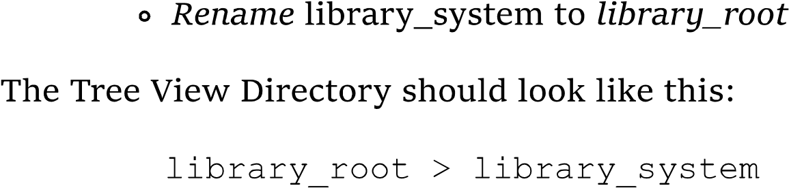

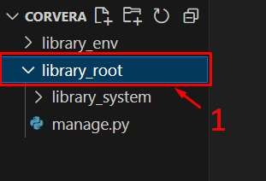

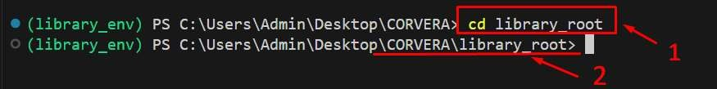



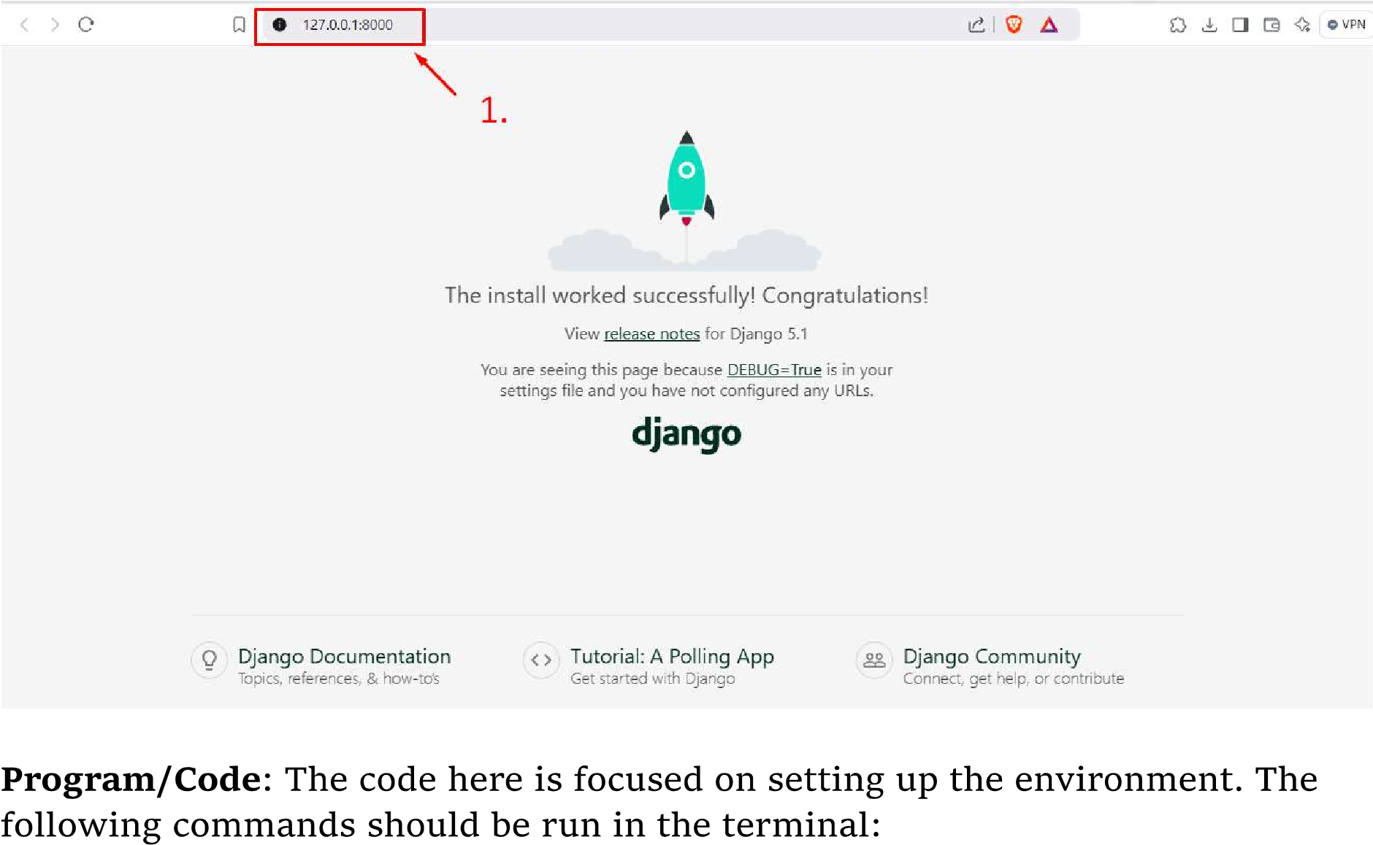

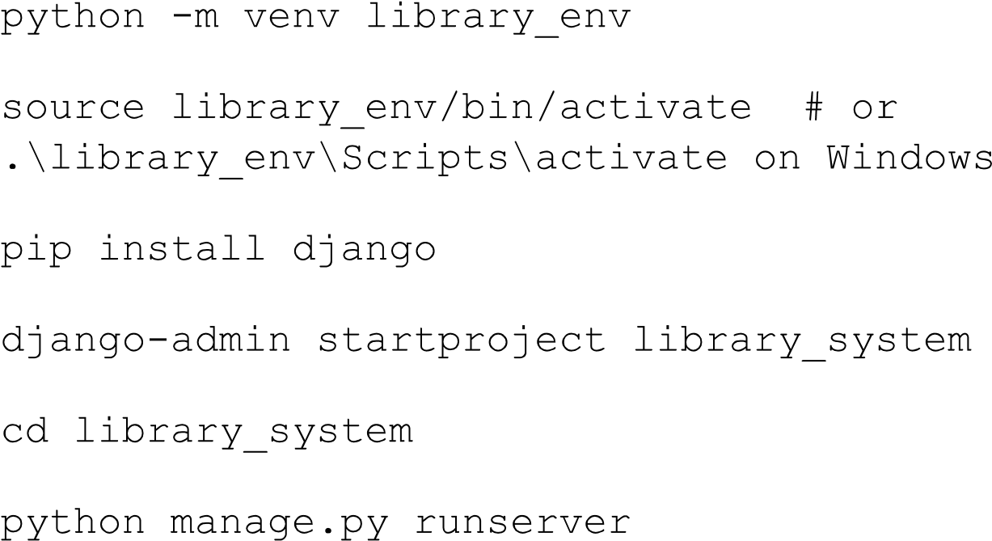

**Results:**

It is important because a virtual environment essentially makes an isolated workspace when doing your coding stuff. So when you have pre-requisites like libraries and so on when working with Python and Django code development. You can lessen the risk of inter conflicts between other installed versions of Python. It also helps in ensuring you use only the libraries you need with necessity in project to reduce the risk of bloat in the code from unnecessary libraries and so on being used

The main advantage of using Django is that it is more intuitive and easier to use from my own experience. Having built in tools and a pre-established framework allows for faster and easier development due to a strong foundation to rely on when creating web development coding projects.