**Task _no _1 Payment Getaway**

# 1 Payment Gateway

Create Donation Form (Name, Donation Amount). After Click on Submit Button Redirect on Payment Gateway (Any). If Payment Successfully Then Redirect on Success Screen Otherwise Failure Screen.

# 2 Payment Gateway Output

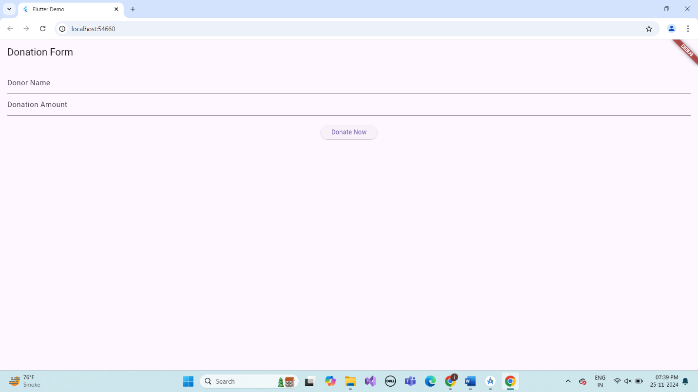

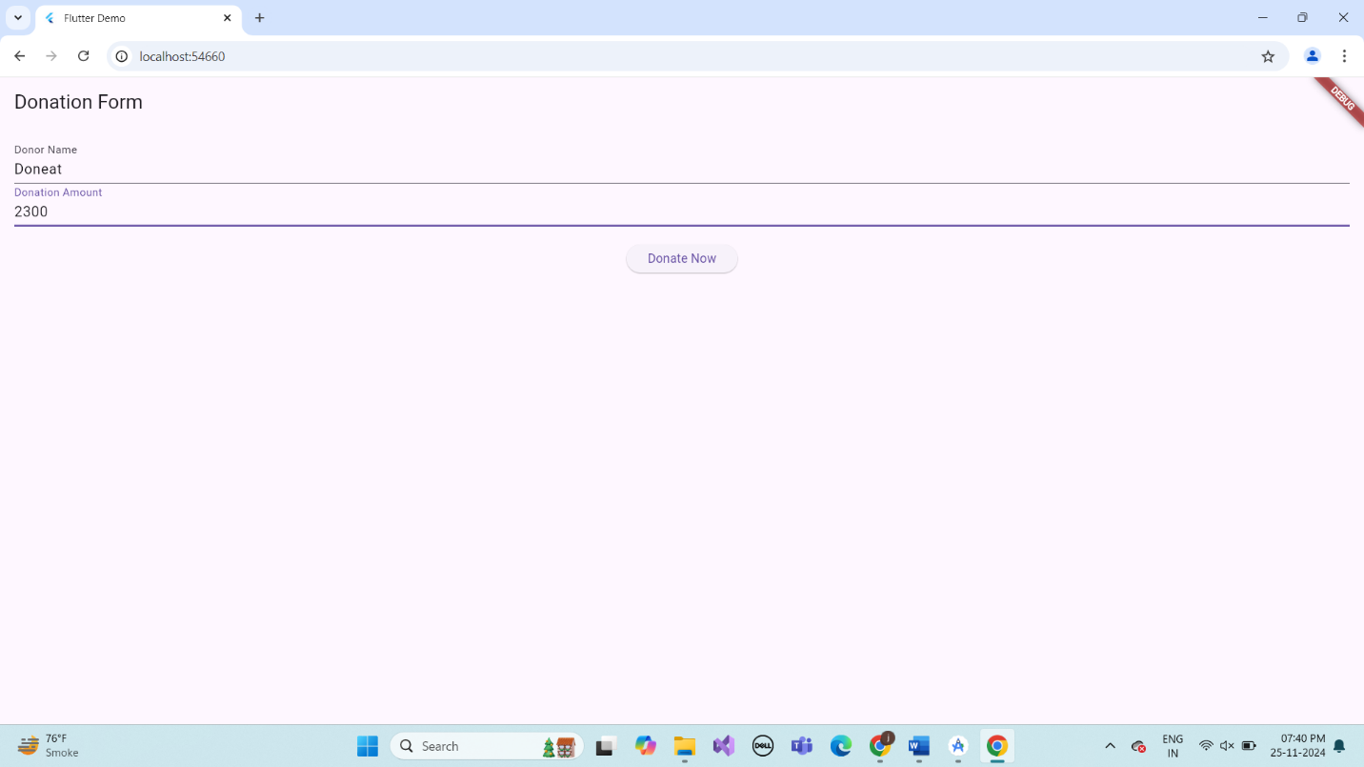

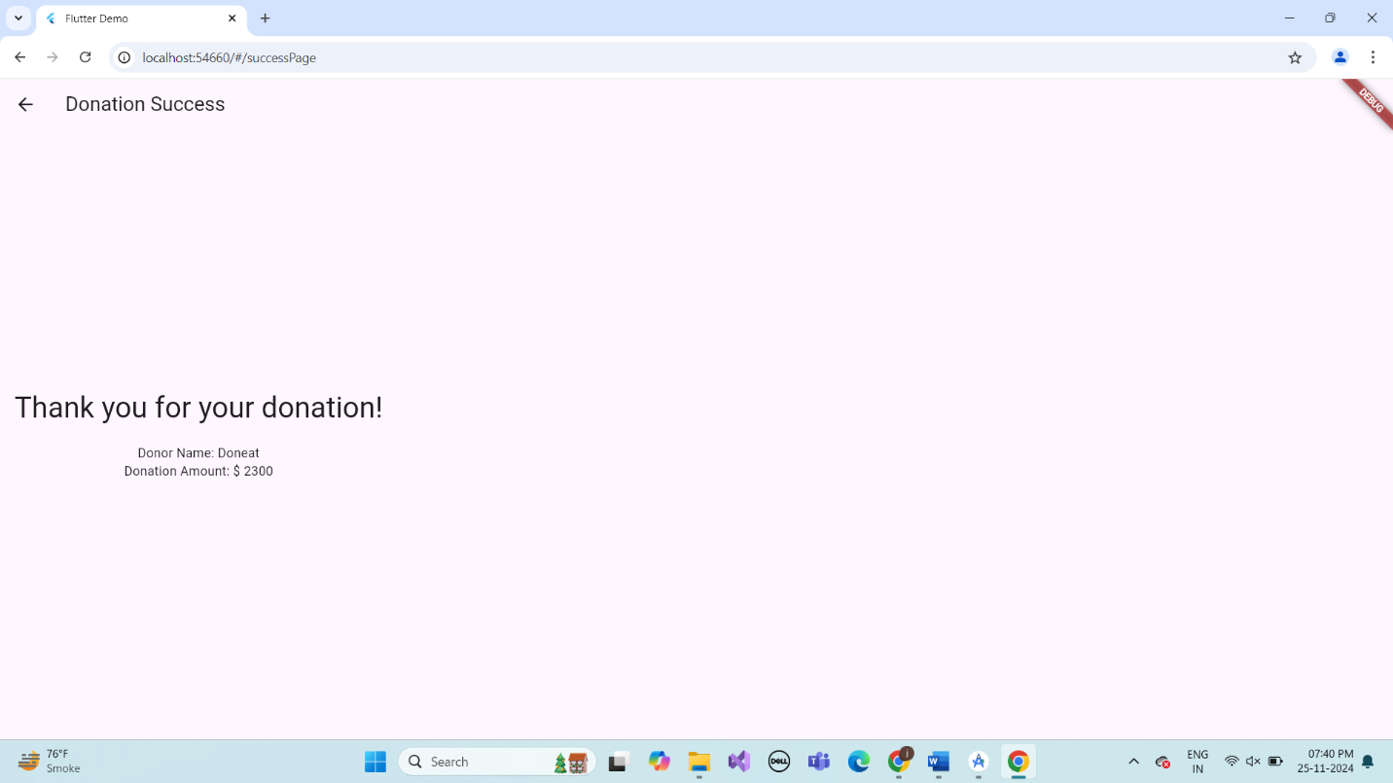



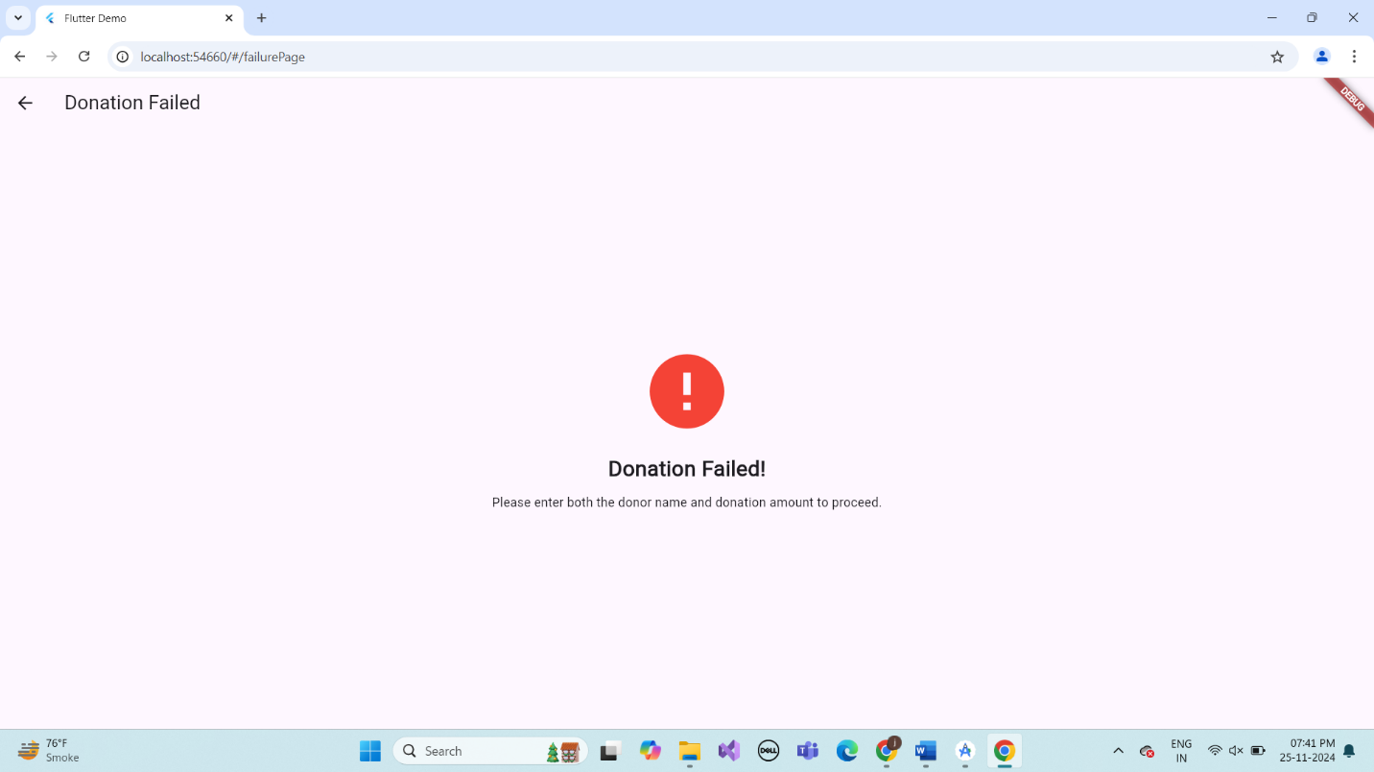

# 3.Describe Widget/Algorithm Used In Payment Getaway

In this donation app project, several key Flutter widgets and algorithms are used to handle user input, validate data, and navigate between pages. The Text Field widget collects the donor's name and donation amount, while the Elevated Button triggers navigation based on validation. The input fields are validated using a simple check to ensure they are not empty; if any field is empty, the app navigates to a failure page, otherwise, it passes the data to a success page using Navigator.pushNamed() with arguments. On the success page, ModalRoute.of(context).settings. Arguments is used to retrieve the donor's details and display them. The Scaffold, Column, and Padding widgets help manage the layout and structure of the app's pages, ensuring a clean and responsive user interface. The use of these widgets and algorithms provides a seamless flow from user input to dynamic page rendering based on the validation results.