**Task_n0_2_YouTube Media Player**

# 1 YouTube Media Player

# Implement YouTube Media Player and Play Video

# 2 YouTube Media Player Output

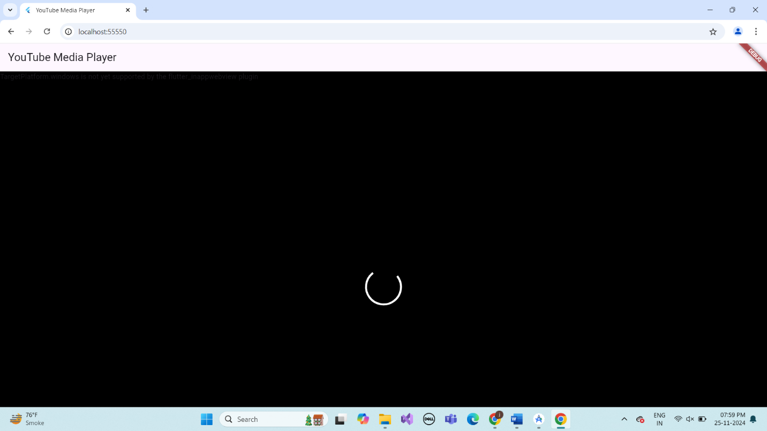

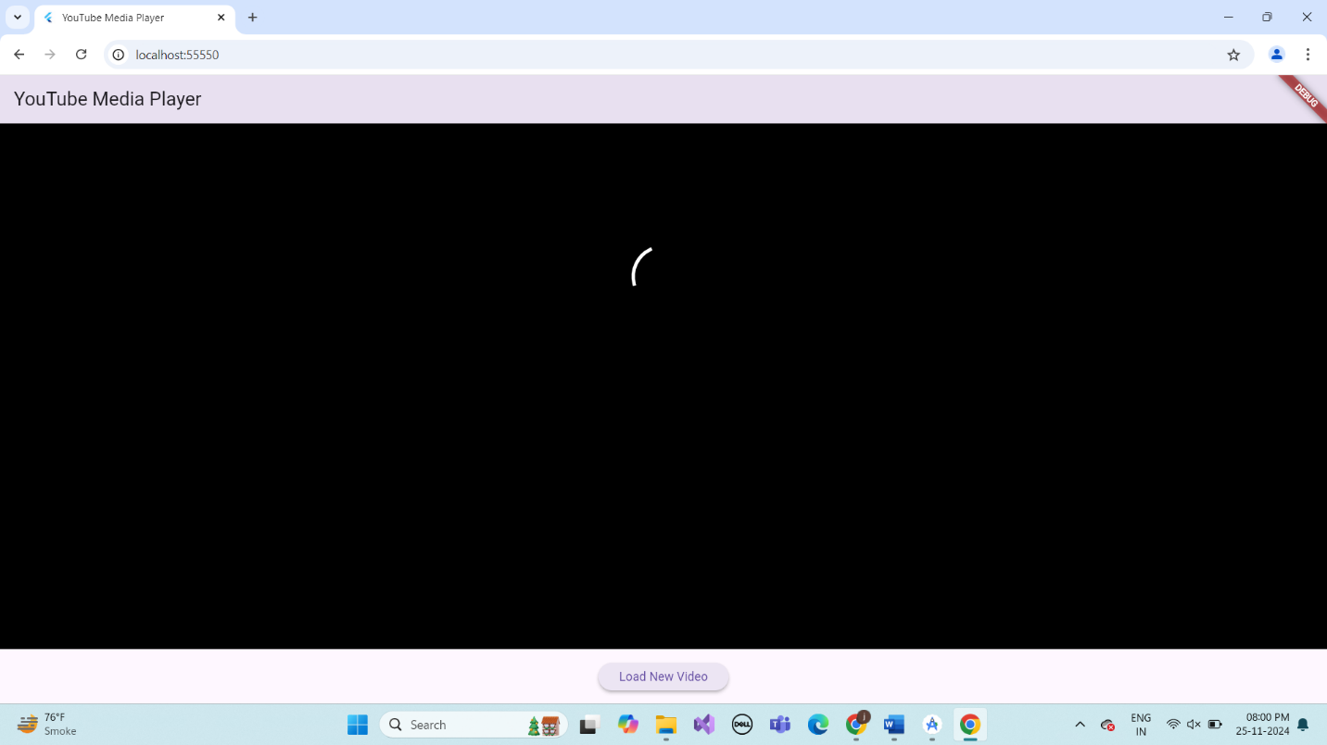

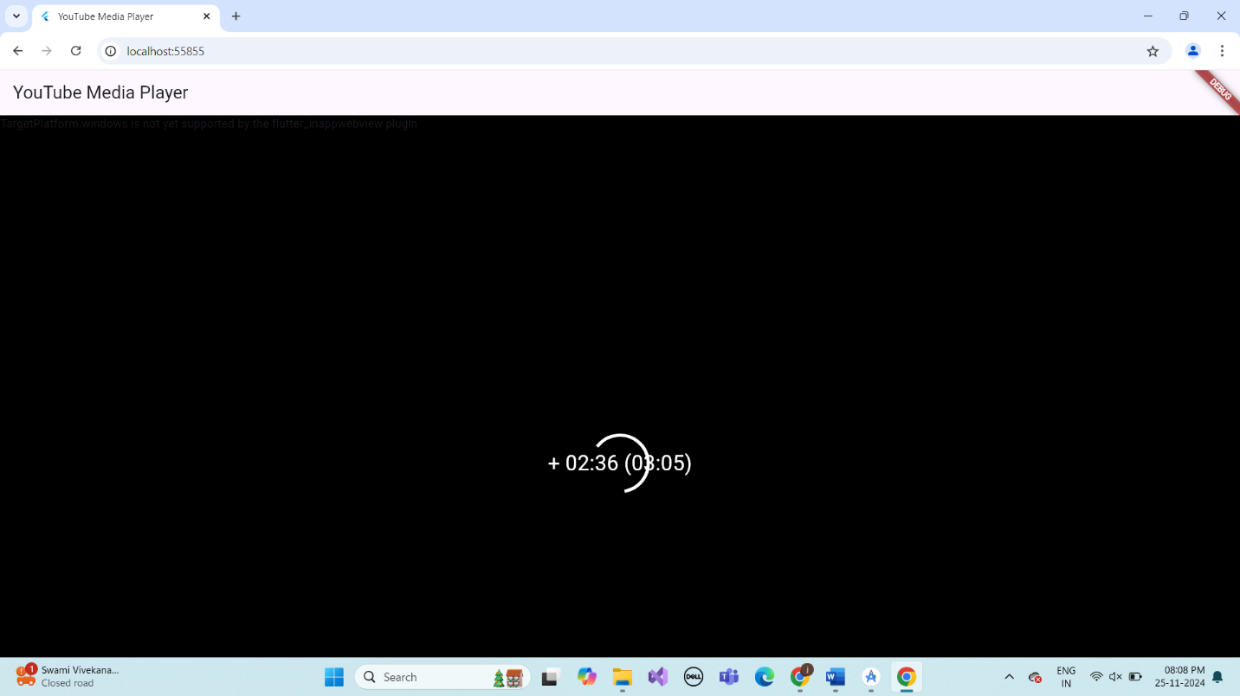

# 3.Describe Widget/Algorithm Used YouTube Media Player

The YouTube Media Player in Flutter is implemented using the youtube_player_flutter package, which provides a YouTube Player widget to embed and control YouTube videos. The YoutubePlayerController is used to manage the video, including the video ID, autoplay settings, and whether the video is muted. The widget allows for a seamless video playback experience, with options such as auto-playing the video, showing the video progress indicator, and enabling or disabling sound. The YoutubePlayerFlags are used to customize these playback settings. The player is integrated within a Scaffold widget, with controls like play, pause, and stop. The app supports multiple video loading, dynamically changing the video ID, and responding to user interactions through UI elements such as buttons. The UI design is kept minimal and responsive, ensuring that the video adjusts to different screen sizes without causing overflow. This approach ensures an interactive, user-friendly media player experience in Flutter.