**Task_n0_3_Implementation Category List**

# 1 Implementation Category List

Display Category List Using Custom List View and Design it with the help of Material Design. (Ex. Category GIF, Name). When Click on Category, GIF/Name Redirect on Next Screen and Display Selected/Clicked Category GIF And Name.

# 2 Implementation Category List Output

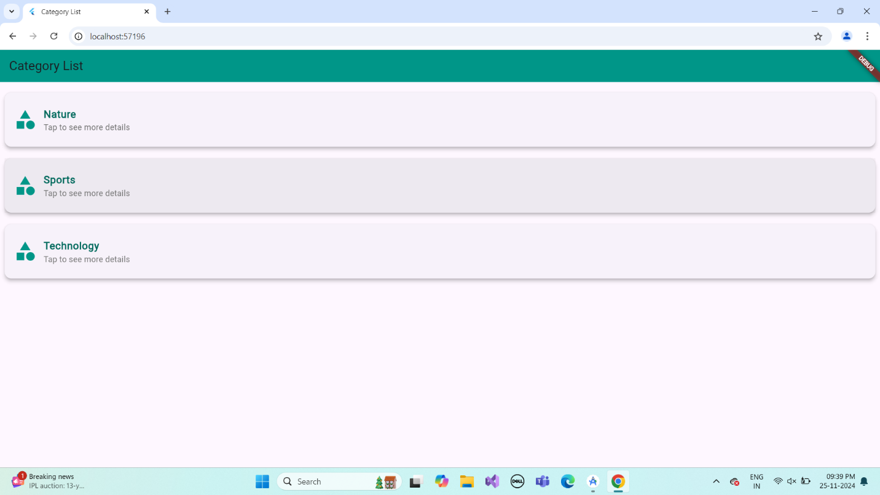

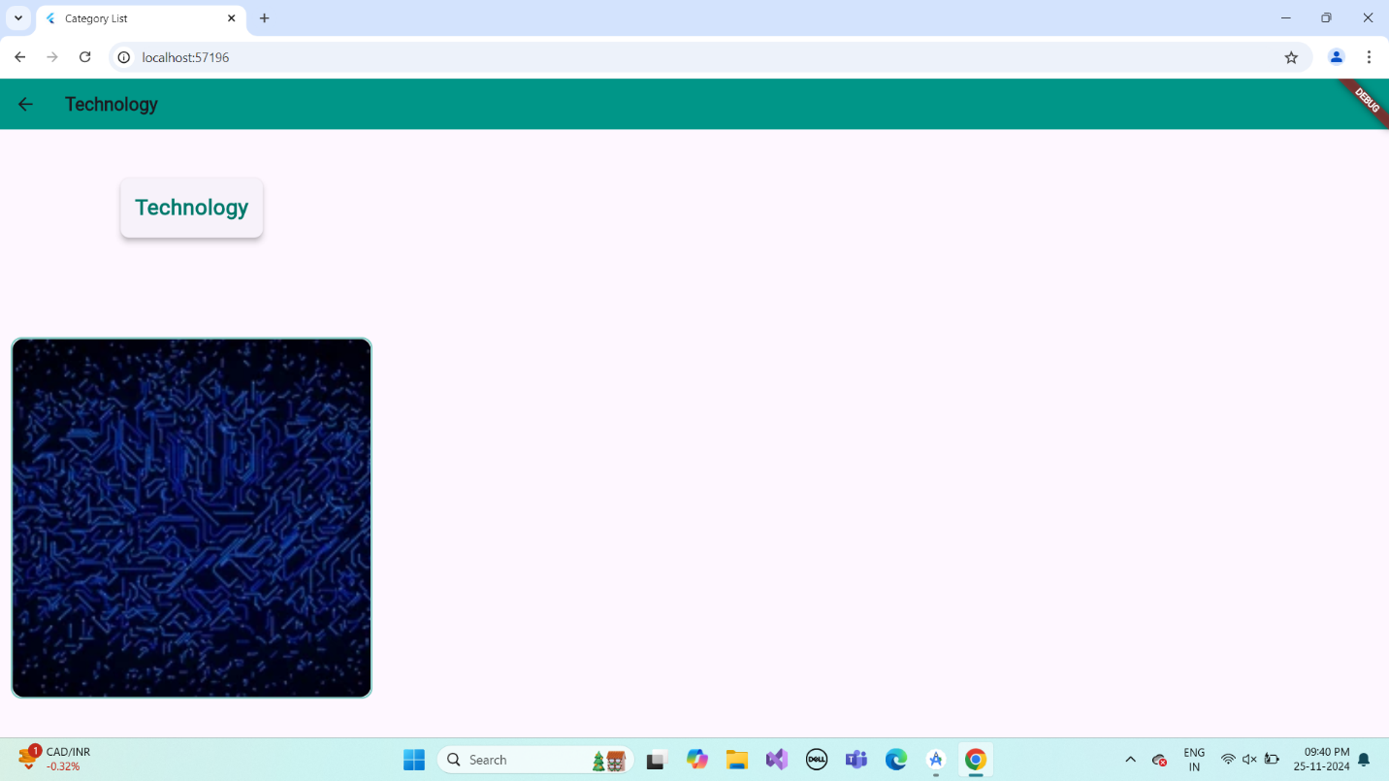

# 3.Describe Widget/Algorithm Used Implementation Category List

The **Category List** implementation in Flutter uses a ListView.builder widget to dynamically create a scrollable list of categories from a predefined list of maps. Each category is displayed using a List Tile, which includes the category's name and an on-Tap event that navigates to a detailed page using Navigator. Push. The navigation passes the category's name and associated GIF path as arguments to the CategoryDetailPage. This approach ensures efficient rendering and allows for dynamic updates, making it scalable for lists of any size.