**Task_n0_2_Crop Image**

# 1 Crop Image

# Select Image from Gallery and Crop Image Using External Library and Store Cropped Image in Internal Storage.

# 2 Crop Image Output

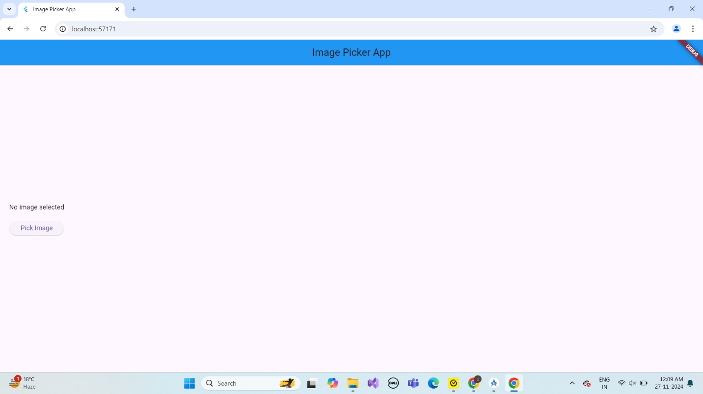

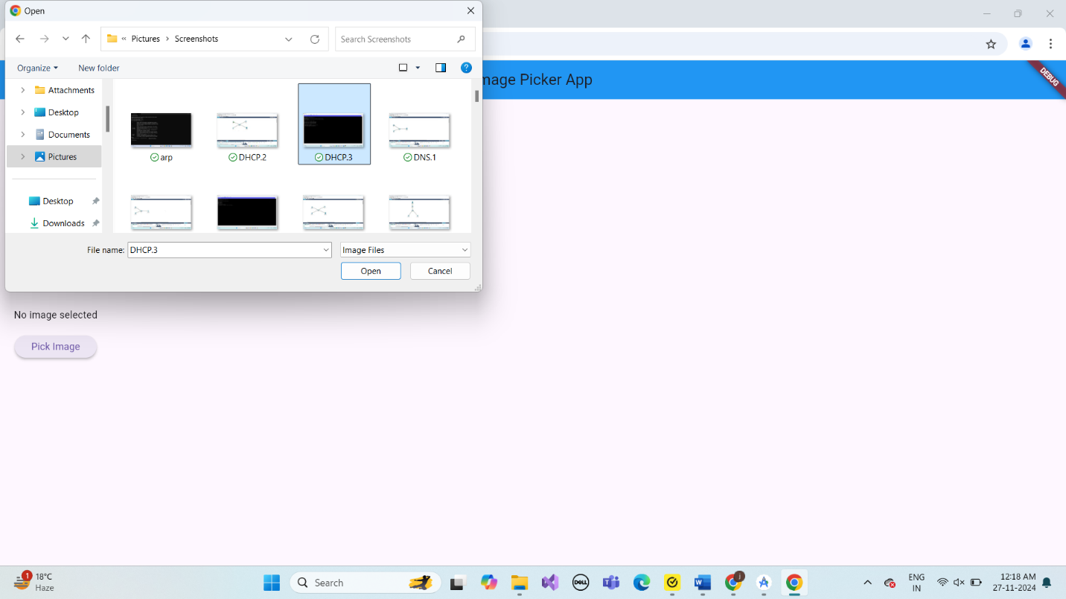

# 3.Describe Widget/Algorithm Used YouTube Media Player

The **Image Cropper** in Flutter leverages a combination of widgets and platform-specific APIs to enable users to crop images efficiently. It utilizes the **Image Cropper** widget, which integrates native iOS and Android UI frameworks to provide a seamless and intuitive cropping experience. The library allows developers to configure settings like aspect ratio presets (e.g., square, 16:9), lock aspect ratio options, and customize UI elements such as toolbar colors and titles. On Android, it uses **AndroidUiSettings**, while on iOS, it relies on **IOSUiSettings** to control the appearance and behavior of the cropping tool. This ensures cross-platform compatibility and a native-like user experience for cropping operations.