**Task_n0_5_Movie Booking**

# 1 Movie Booking

# Display Movie Booking Screen UI And Selection Functionality.

# 2 Movie Booking Output

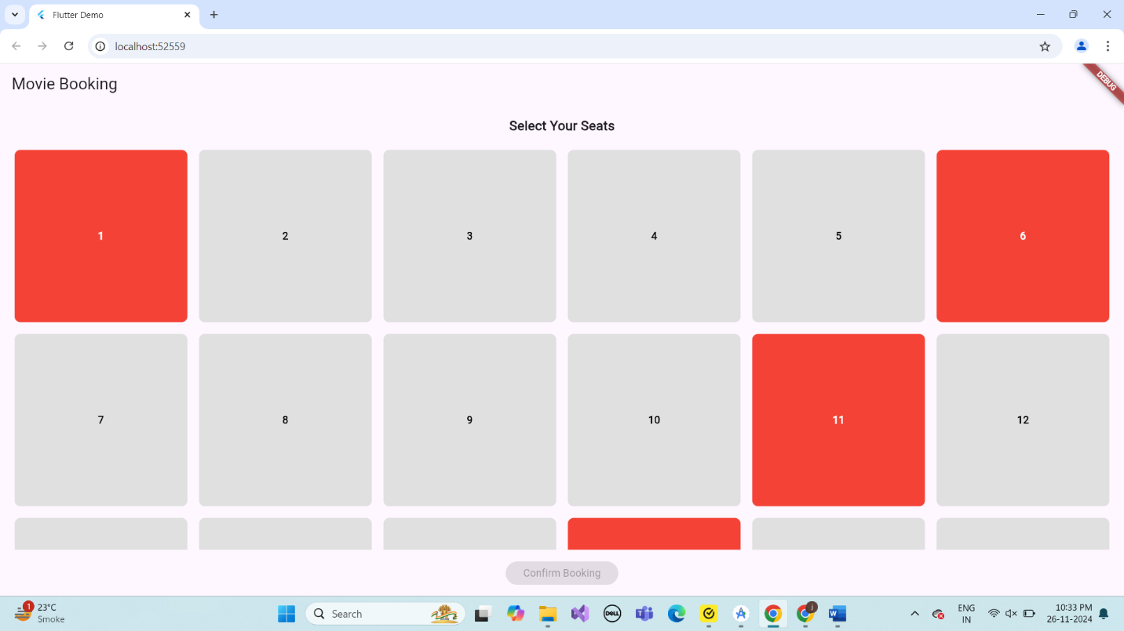

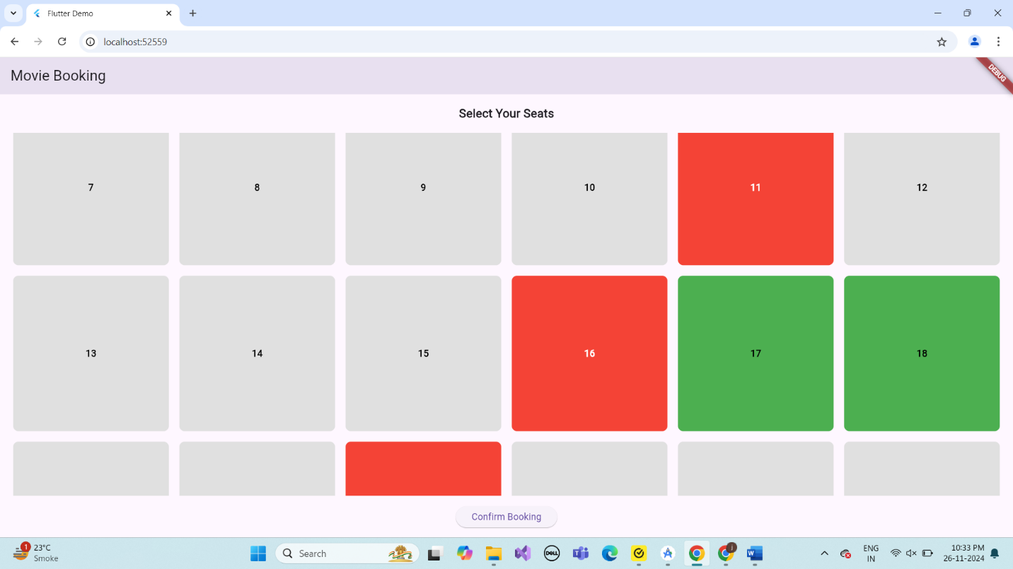

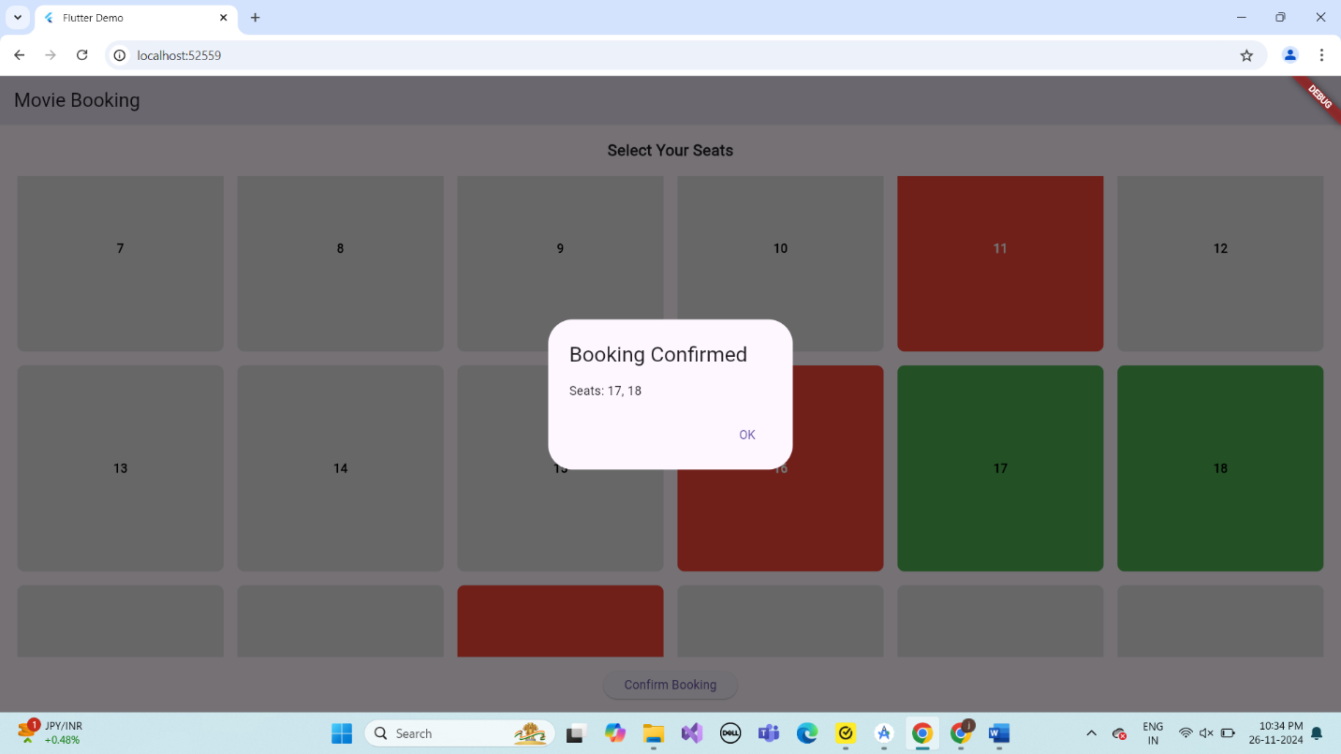

# 3.Describe Widget/Algorithm Used Movie Booking

the movie booking system in Flutter uses a combination of widgets and state management to provide an interactive and visually appealing user interface. A grid layout (GridView.builder) is utilized to display seats, which are represented by a custom Seat Widget. Each seat's state (available, selected, or booked) is dynamically managed using a model class, with properties like is Booked and is Selected. User interactions, such as seat selection, are handled using Gesture Detector within the widget, toggling seat states and updating a selected seats list. Premium and standard seats are differentiated with distinct styling and pricing logic, which is calculated in real-time. The overall functionality is wrapped in a responsive and user-friendly layout that includes a legend for seat statuses, a theater screen indicator, and a booking summary displaying total selected seats and the total cost, ensuring an intuitive booking experience.