Student Name

Student ID Number

Course

College

Personal Information

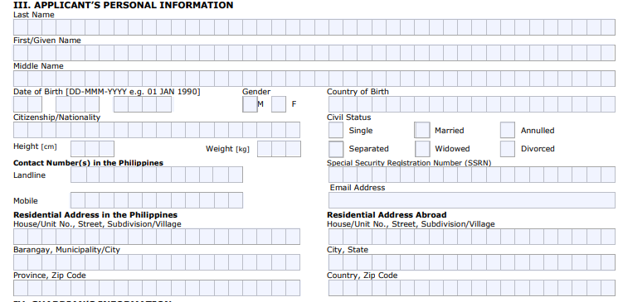

Travel Information



ACR I-Card



Gurdians’s Information

