2025

IT114126
2025/11/20

TAN Xiuhao – 240253372
TAN James Anthroi – 240350922
ZHOU Zekai – 240154228
Music with our life
Table of Content
Introduction 2
Data 3
Findings 4
General View 4
Explanatory Analysis 5
Exploratory Analysis 6
Suggestions 6

Introduction
The goal of this project is to extract meaningful insights from a large amount of Spotify music data, and to present corresponding trends in the form of charts using data visualization methods, studying global music popularity, regional style preferences, and various categories of popular music.

1. Music style preferences in different regions around the world
2. The contributions of different artists to the global popularity of music
3. Which type of music is more easily accepted and loved by people in different regions?
4. Which kind of song will become the next trend?

Data
The only one dataset is from open data organization Kaggle, the Kaggle source is an open dataset from the British government. The dataset includes artists, country, popularity and some music data, which is recorded from 2024 to 2025. The following is the metadata table.

Field | Type | Range | Description | Example
Spotify_id | String |  | The unique identifier for the song in the Spotify database | 2RkZ5LkEzeHGRsmDqKwmaJ
Name | String |  | The title of the song | Ordinary
Daily_rank | Number | 1~50 | The daily rank of the song in the top 50 list | 1
Artists | String |  | The name(s) of the artist(s) associated with the song | Alex Warren
Country | String |  | The ISO code of the country of the Top 50 Playlist | ZA
Popularity | Number | 1~100 | A measure of the song's current popularity on Spotify | 95
Speechiness | Number | 0~1 | A measure of the presence of spoken words in the song | 0.06
Valence | Number | 0~1 | A measure of the musical positiveness conveyed by the song | 0.391
… | … | … | … | …

Furthermore, the dataset is cleaned and transformed properly by R script. For example:1. Add columns for "Full Country Name" and "Region" base on https://help.adjust.com/en/article/countries-by-region. 2. Convert the numeric values ​​of speechiness and value into text tags using a four-part classification method.
3. Clear all null data and replace blank "country" with "Global".

Findings
This part will be divided into three subparts. The General View will introduce the basic circumstance of this dataset. Then, The Explanatory Analysis will answer the stated questions that mentioned before. Furthermore, The Exploratory Analysis is innovative findings apart from the questions

General View
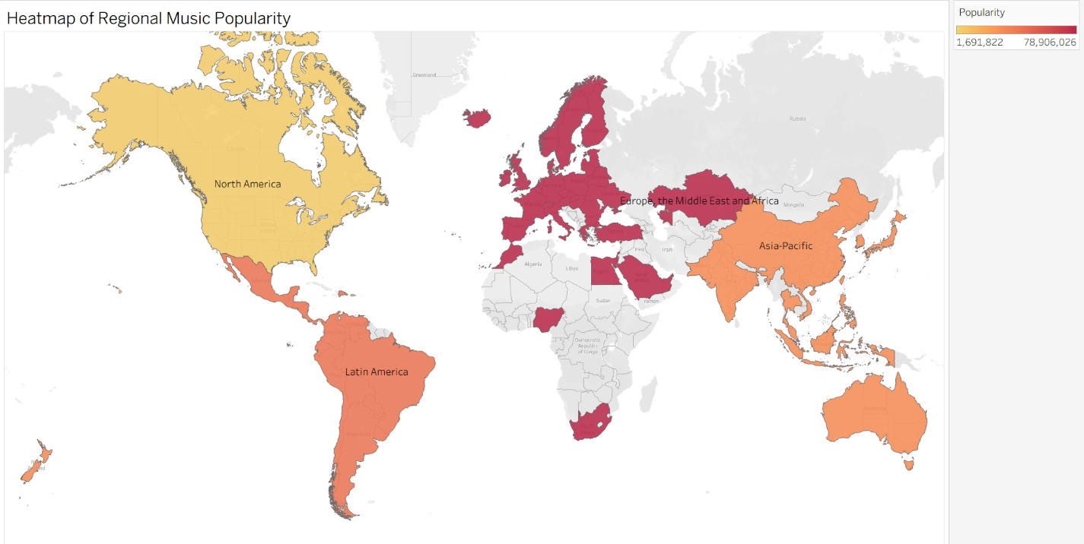
Figure 1

Figure 1 shows the global distribution of music popularity by region. Europe, the Middle East, and Africa dominate with nearly 79M listeners, followed by Latin America with 42M and Asia-Pacific with 31M. North America, though lighter at 5M, still contributes to shaping global music trends. The heatmap illustrates that darker shades represent stronger regional influence, while lighter tones highlight smaller but culturally distinct contributions — confirming that global music is shaped by diverse cultural fingerprints

Explanatory Analysis
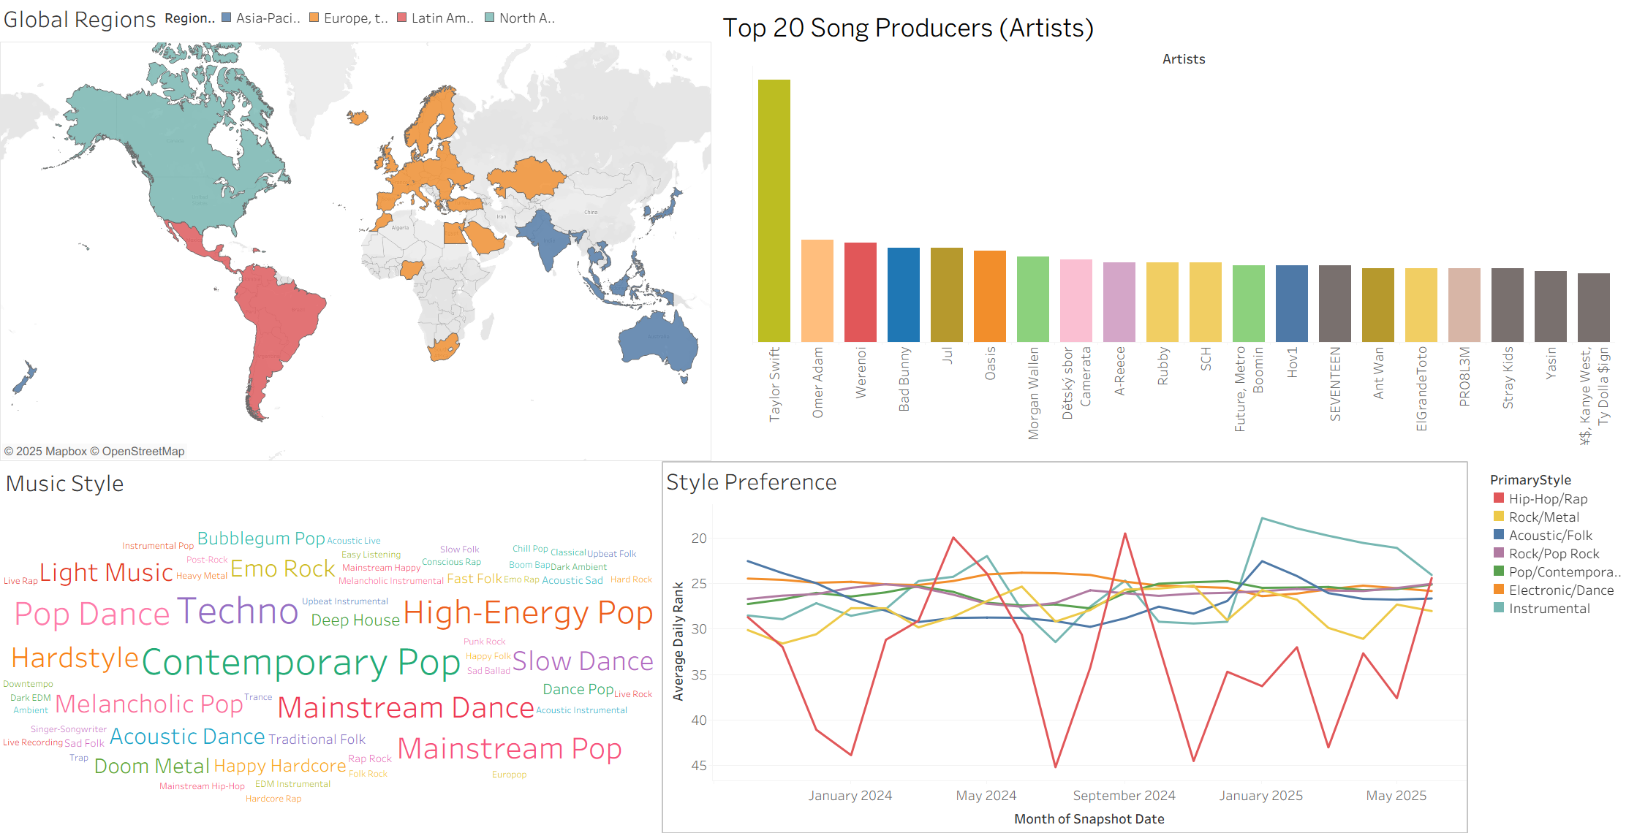
Figure 2: Global Region

Top Artists in Context: Culture, Energy, and Reach
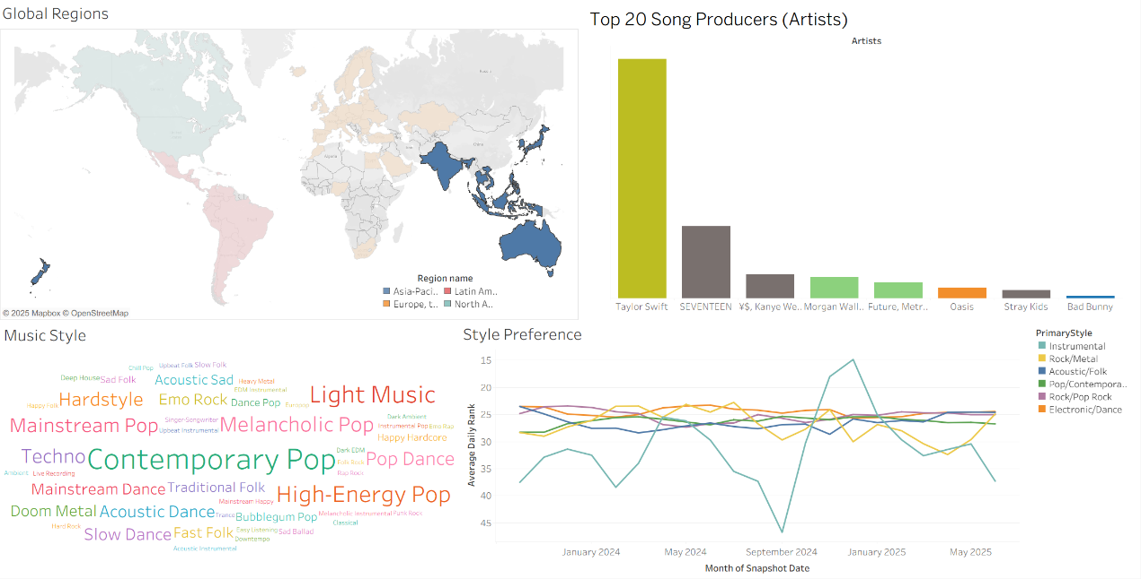
Overall, people across the world love pop and electronic music the most, especially contemporary pop and techno. Taylor Swift and Jul have made significant contributions in these two areas, respectively.
Figure 3: APAC

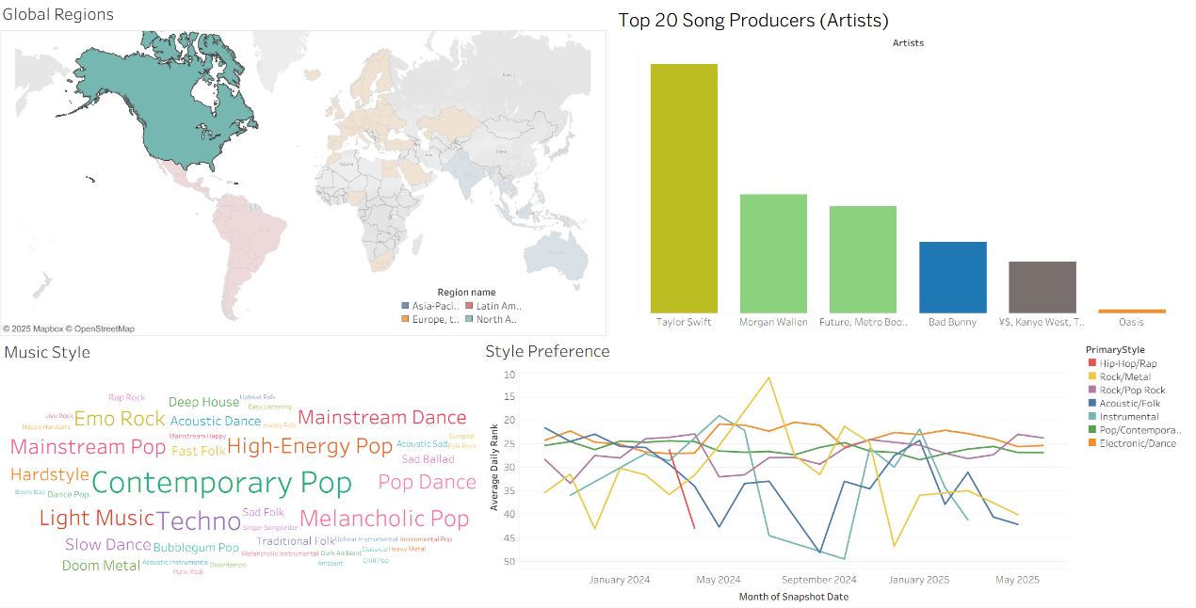
In addition, APAC is very similar to North America. APAC is the most popular region for pop music, followed closely by North America. Both regions also have a strong preference for light music and emo rock.If you're from North America, you're probably familiar with Future and MetroBoom. If you're from Asia, you've likely heard Taylor Swift's songs.
Figure 4: North America

EMEA is similar to the regions mentioned above, but they also love dance music, such as pop dance and slow dance.Europeans are likely familiar with Jul's Techno music and Werenoi's mainstream dance.
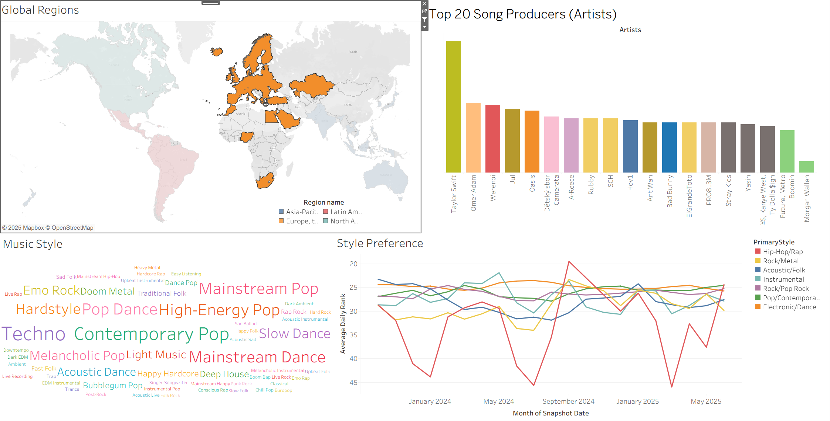
Figure 5: EMEA

Latin America is a unique region where people's love for dance music surpasses that of mainstream pop. They adore pop dance, but also enjoy slow dance, mainstream dance, and acoustic dance. Bad Bunny is likely a well-known artist among South Americans.
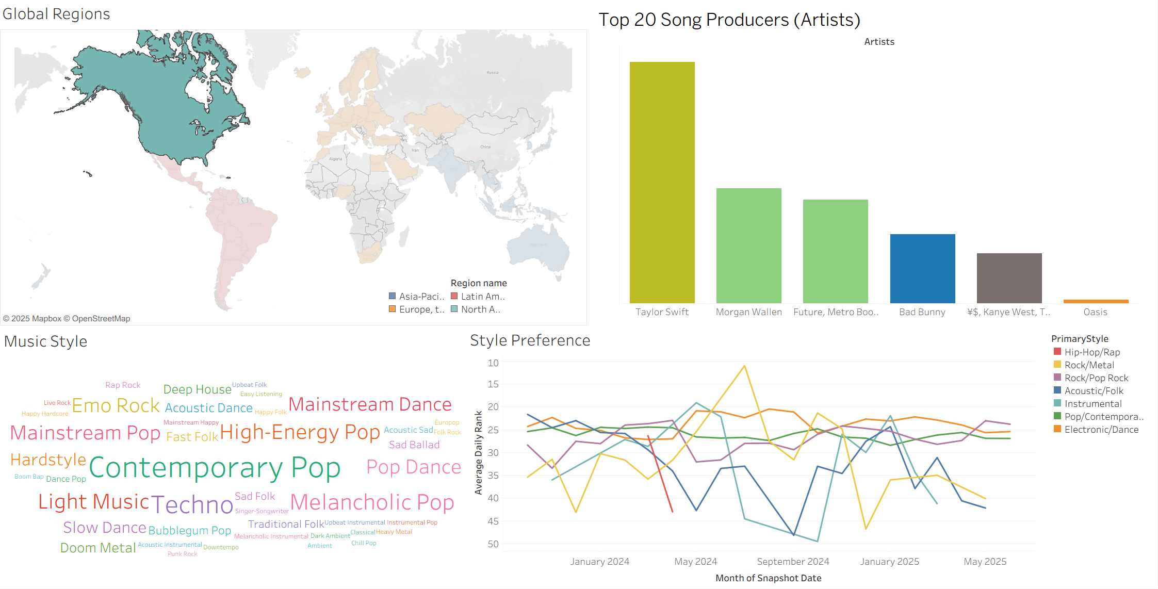
Figure 6: Latin America

Trends indicate a growing interest in instrumental music, while electronic and pop continue to anchor global popularity. Folk and rock show minor fluctuations but maintain loyal audiences across regions. Hip-hop, though currently in decline, has a cyclical history that suggests the possibility of future resurgence.

Exploratory Analysis
Figure 7 shows the relationship between energy and valence in the works of the top ten contributing artists. The data indicates that users are less interested in songs with both high energy and high valence. Instead, popularity clusters around two clear patterns: songs with both high energy and high valence, and songs with low energy and low valence. This distribution suggests a positive correlation between energy and valence in shaping global music preferences, highlighting that alignment of these two metrics is a key driver of success.

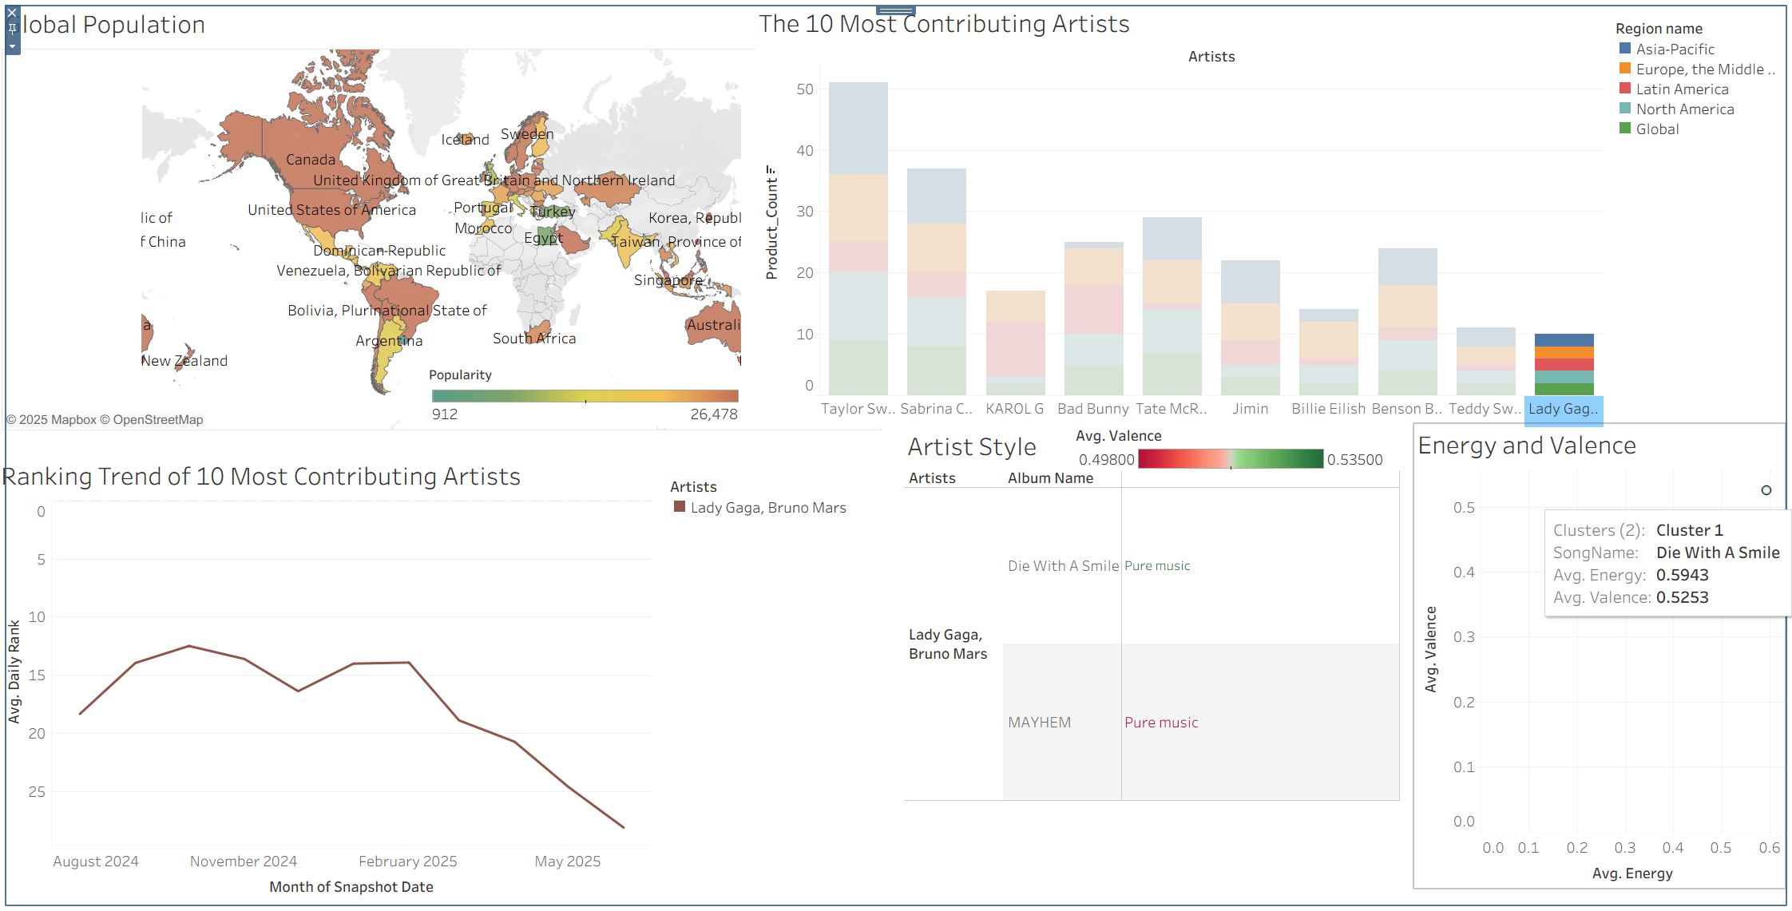
Figure 7: Energy–Valence Correlation in Global Music Preferences

Figure 8 illustrates how sustained output influences global chart presence. Lady Gaga’s example shows that globally influential artists may reach the top 50 with only one album, reflecting the strength of established fan bases. In contrast, Taylor Swift demonstrates that even international superstars gradually fade from the top 50 without consistent new releases. Her absence is partly explained by external circumstances, such as her 2024 world tour, which limited time for new production. This comparison highlights the importance of release timing and sustained engagement in maintaining global visibility.

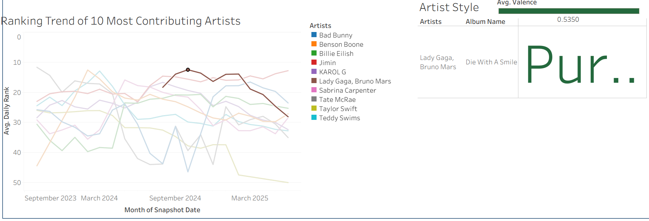
Figure 8: Artist Output and Global Visibility

The exploratory findings highlight that global music preferences are shaped by deeper structural patterns beyond the stated questions. Popular songs tend to align energy and valence, confirming that emotional intensity is a key driver of success. Artist visibility depends not only on fan base strength but also on sustained output, as shown by the contrast between Lady Gaga and Taylor Swift. Moreover, global recognition remains fragmented: even the top ten contributing artists rarely dominate worldwide charts, and their audiences are concentrated mainly in Europe and Asia, with limited representation from Latin America. Together, these insights suggest that while global music is diverse and culturally rich, worldwide dominance is difficult to achieve, and the market continues to be centered in developed regions.

Suggestions
- Align Style with Listener Preferences
Artists should focus on energy–valence combinations that resonate globally (high‑high or low‑low), since these patterns consistently drive popularity.
- Sustain Output for Visibility
Even established stars must maintain regular releases — through albums, singles, or collaborations — to avoid fading from global charts. Strategic timing of releases is critical to sustaining engagement.
- Diversify Regional Appeal
The global market remains concentrated in Europe and Asia. To reduce reliance on developed regions, artists should expand into underrepresented markets such as Latin America and Africa, where cultural diversity offers untapped potential.
- Leverage Fan Base Strength
Established artists with large fan bases can achieve global impact with fewer albums, but they should reinforce visibility through innovative formats (e.g., live collaborations, digital releases).
- Monitor Emerging Trends
Instrumental and dance genres are rising, while hip‑hop shows signs of cyclical resurgence. Artists and producers should track these shifts to anticipate future demand and adapt their creative strategies.
Global dominance in music requires sustained output, regional diversification, and alignment with emerging listener trends. Established fan bases can secure short-term visibility, but long-term success depends on consistent releases, tapping into underrepresented regions, and adapting to rising genres such as instrumental and dance.

