Admin
1. in this frontend the hod is assigned by the admin , however there will different hods for different department and there credentials will be different for each hod , so there should be a section where the creadentials of each hod is added by the admin, and also for the enrollment of the faculty as well as student there should be a field to enter the password which will be used by user to login into the system once they are registered
I have created an implementation plan to add:
- Department-Specific HOD Management & Credentials in Admin Console:
  - A dedicated section to manage and assign HODs for each department.
  - Admin can add, assign, view, update, and reset login credentials (login email & password) for every department's HOD.
  - Clean UI with password reveal toggles and HOD assignment directory.
- Password Field in Faculty and Student Enrollment:
  - Added Password input field with show/hide toggle in the user enrollment form in Admin Console.
  - User credentials (email & password) are saved to persistent storage (localStorage) upon enrollment.
  - Password management in user editing modal.
- Dynamic Authentication System (login.js):
  - Department HODs can log in with their unique department-specific credentials and be directed to the HOD Console with their department context.
  - Newly enrolled faculty and students can immediately log in with their registered emails and passwords.

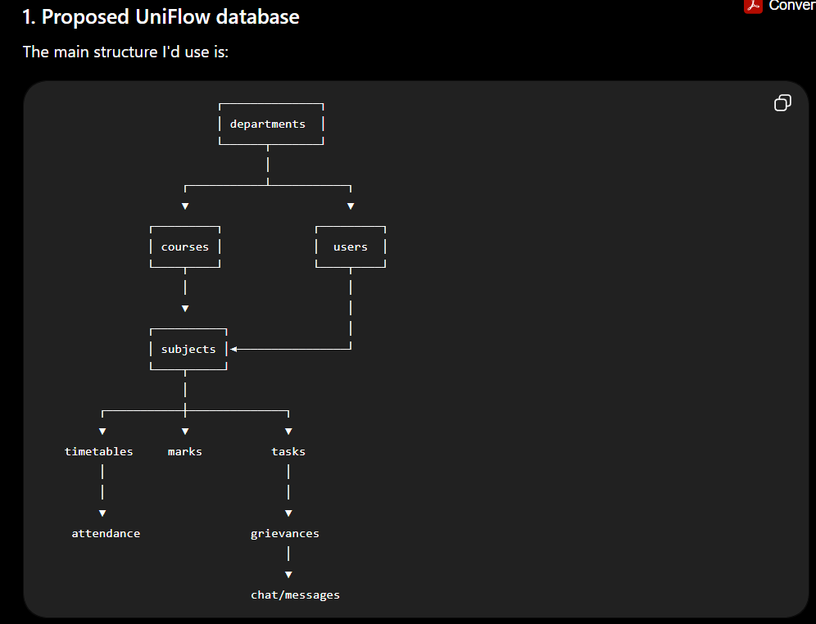

Databases

-- ==========================================
-- UNIFLOW DATABASE SCHEMA
-- ==========================================

-- 1. USERS
CREATE TABLE users (
id SERIAL PRIMARY KEY,
custom_id VARCHAR(50) UNIQUE NOT NULL,
name VARCHAR(100) NOT NULL,
email VARCHAR(150) UNIQUE NOT NULL,
password_hash TEXT NOT NULL,
role VARCHAR(20) NOT NULL
CHECK (role IN ('admin', 'faculty', 'student')),
is_hod BOOLEAN DEFAULT FALSE,
created_at TIMESTAMP DEFAULT CURRENT_TIMESTAMP,
updated_at TIMESTAMP DEFAULT CURRENT_TIMESTAMP
);

-- 2. DEPARTMENTS
CREATE TABLE departments (
id SERIAL PRIMARY KEY,
code VARCHAR(20) UNIQUE NOT NULL,
name VARCHAR(100) NOT NULL,
hod_user_id INTEGER,

created_at TIMESTAMP DEFAULT CURRENT_TIMESTAMP,

FOREIGN KEY (hod_user_id)
REFERENCES users(id)
ON DELETE SET NULL
);

-- 3. USER DEPARTMENTS
CREATE TABLE user_departments (
user_id INTEGER NOT NULL,
department_id INTEGER NOT NULL,

PRIMARY KEY (user_id, department_id),

FOREIGN KEY (user_id)
REFERENCES users(id)
ON DELETE CASCADE,

FOREIGN KEY (department_id)
REFERENCES departments(id)
ON DELETE CASCADE
);

-- 4. COURSES
CREATE TABLE courses (
id SERIAL PRIMARY KEY,
department_id INTEGER NOT NULL,
name VARCHAR(150) NOT NULL,
code VARCHAR(50) UNIQUE,
total_semesters INTEGER NOT NULL DEFAULT 8,

FOREIGN KEY (department_id)
REFERENCES departments(id)
ON DELETE CASCADE
);

-- 5. STUDENT ENROLLMENTS
CREATE TABLE student_enrollments (
id SERIAL PRIMARY KEY,
student_id INTEGER NOT NULL,
course_id INTEGER NOT NULL,
semester INTEGER NOT NULL,
academic_year VARCHAR(20),

created_at TIMESTAMP DEFAULT CURRENT_TIMESTAMP,

FOREIGN KEY (student_id)
REFERENCES users(id)
ON DELETE CASCADE,

FOREIGN KEY (course_id)
REFERENCES courses(id)
ON DELETE CASCADE,

UNIQUE(student_id, academic_year)
);

-- 6. SUBJECTS
CREATE TABLE subjects (
id SERIAL PRIMARY KEY,
course_id INTEGER NOT NULL,
name VARCHAR(150) NOT NULL,
code VARCHAR(50),
semester INTEGER NOT NULL,
credits INTEGER DEFAULT 0,

FOREIGN KEY (course_id)
REFERENCES courses(id)
ON DELETE CASCADE,

UNIQUE(course_id, code)
);

-- 7. SUBJECT FACULTY
CREATE TABLE subject_faculty (
subject_id INTEGER NOT NULL,
faculty_id INTEGER NOT NULL,

PRIMARY KEY (subject_id, faculty_id),

FOREIGN KEY (subject_id)
REFERENCES subjects(id)
ON DELETE CASCADE,

FOREIGN KEY (faculty_id)
REFERENCES users(id)
ON DELETE CASCADE
);

-- 8. TIMETABLE
CREATE TABLE timetable (
id SERIAL PRIMARY KEY,
course_id INTEGER NOT NULL,
semester INTEGER NOT NULL,
subject_id INTEGER NOT NULL,
day VARCHAR(15) NOT NULL,
period INTEGER NOT NULL,

FOREIGN KEY (course_id)
REFERENCES courses(id)
ON DELETE CASCADE,

FOREIGN KEY (subject_id)
REFERENCES subjects(id)
ON DELETE CASCADE,

UNIQUE(course_id, semester, day, period)
);

-- 9. TIMETABLE FACULTY
CREATE TABLE timetable_faculty (
timetable_id INTEGER NOT NULL,
faculty_id INTEGER NOT NULL,

PRIMARY KEY (timetable_id, faculty_id),

FOREIGN KEY (timetable_id)
REFERENCES timetable(id)
ON DELETE CASCADE,

FOREIGN KEY (faculty_id)
REFERENCES users(id)
ON DELETE CASCADE
);

-- 10. TASKS
CREATE TABLE tasks (
id SERIAL PRIMARY KEY,
created_by INTEGER NOT NULL,
assigned_to INTEGER NOT NULL,
subject_id INTEGER,

description TEXT NOT NULL,
difficulty INTEGER,
deadline DATE,
status VARCHAR(30) DEFAULT 'Active',

created_at TIMESTAMP DEFAULT CURRENT_TIMESTAMP,

FOREIGN KEY (created_by)
REFERENCES users(id)
ON DELETE CASCADE,

FOREIGN KEY (assigned_to)
REFERENCES users(id)
ON DELETE CASCADE,

FOREIGN KEY (subject_id)
REFERENCES subjects(id)
ON DELETE SET NULL
);

-- 11. MARKS
CREATE TABLE marks (
id SERIAL PRIMARY KEY,
student_id INTEGER NOT NULL,
subject_id INTEGER NOT NULL,

assignment_score NUMERIC(5,2),
exam_score NUMERIC(5,2),

updated_by INTEGER,

created_at TIMESTAMP DEFAULT CURRENT_TIMESTAMP,
updated_at TIMESTAMP DEFAULT CURRENT_TIMESTAMP,

FOREIGN KEY (student_id)
REFERENCES users(id)
ON DELETE CASCADE,

FOREIGN KEY (subject_id)
REFERENCES subjects(id)
ON DELETE CASCADE,

FOREIGN KEY (updated_by)
REFERENCES users(id)
ON DELETE SET NULL,

UNIQUE(student_id, subject_id)
);

-- 12. GRIEVANCES
CREATE TABLE grievances (
id SERIAL PRIMARY KEY,
submitted_by INTEGER NOT NULL,
department_id INTEGER,

subject VARCHAR(200) NOT NULL,
details TEXT NOT NULL,
status VARCHAR(30) DEFAULT 'Pending',
resolution TEXT,

resolved_by INTEGER,

created_at TIMESTAMP DEFAULT CURRENT_TIMESTAMP,
resolved_at TIMESTAMP,

FOREIGN KEY (submitted_by)
REFERENCES users(id)
ON DELETE CASCADE,

FOREIGN KEY (department_id)
REFERENCES departments(id)
ON DELETE SET NULL,

FOREIGN KEY (resolved_by)
REFERENCES users(id)
ON DELETE SET NULL
);

-- 13. CHAT THREADS
CREATE TABLE chat_threads (
id SERIAL PRIMARY KEY,

type VARCHAR(20) NOT NULL
CHECK (type IN ('individual', 'group')),

name VARCHAR(150),

created_by INTEGER,

created_at TIMESTAMP DEFAULT CURRENT_TIMESTAMP,

FOREIGN KEY (created_by)
REFERENCES users(id)
ON DELETE SET NULL
);

-- 14. CHAT PARTICIPANTS
CREATE TABLE chat_participants (
thread_id INTEGER NOT NULL,
user_id INTEGER NOT NULL,

joined_at TIMESTAMP DEFAULT CURRENT_TIMESTAMP,

PRIMARY KEY(thread_id, user_id),

FOREIGN KEY (thread_id)
REFERENCES chat_threads(id)
ON DELETE CASCADE,

FOREIGN KEY (user_id)
REFERENCES users(id)
ON DELETE CASCADE
);

-- 15. MESSAGES
CREATE TABLE messages (
id SERIAL PRIMARY KEY,

thread_id INTEGER NOT NULL,
sender_id INTEGER NOT NULL,

message TEXT NOT NULL,

created_at TIMESTAMP DEFAULT CURRENT_TIMESTAMP,

FOREIGN KEY (thread_id)
REFERENCES chat_threads(id)
ON DELETE CASCADE,

FOREIGN KEY (sender_id)
REFERENCES users(id)
ON DELETE CASCADE
);

-- 16. ATTENDANCE
CREATE TABLE attendance (
id SERIAL PRIMARY KEY,

student_id INTEGER NOT NULL,
subject_id INTEGER NOT NULL,

date DATE NOT NULL,

status VARCHAR(20) NOT NULL
CHECK (status IN ('present', 'absent', 'late')),

marked_by INTEGER,

FOREIGN KEY (student_id)
REFERENCES users(id)
ON DELETE CASCADE,

FOREIGN KEY (subject_id)
REFERENCES subjects(id)
ON DELETE CASCADE,

FOREIGN KEY (marked_by)
REFERENCES users(id)
ON DELETE SET NULL,

UNIQUE(student_id, subject_id, date)
);

Change in database
ALTER TABLE tasks
ADD COLUMN scheduled_date DATE;

