MINISTRY OF SCIENCE AND HIGHER EDUCATION OF THE REPUBLIC OF KAZAKHSTAN



International Information Technology University
Department of Cybersecurity

Toxic Comment Classification: Detect hate speech and abusive language online

Students | Tnasheva Zhanel, Alexeyeva Alina,  Yerbolova Amina
Group | SIS-2207
 | Abdul Razaque
Lecturer

1. Understanding the Problem
1.1 Project Objective
The core objective of this project is to design, build, and evaluate a machine learning system capable of automatically detecting toxic and abusive language in online comments. This is achieved by applying advanced Natural Language Processing (NLP) and Deep Learning techniques to the complex challenge of text classification.
The developed system analyzes raw textual input—such as comments from forums or social media—and classifies it based on the presence of harmful content. This includes, but is not limited to, hate speech, insults, threats, obscenity, and harassment. By providing a fast, consistent, and scalable automated solution, this project aims to support and enhance the critical work of online content moderation, helping to foster safer digital communication environments.
For clarity, key terms in this objective are defined:
- Toxic Comment Classification: A multi-label machine learning task where a textual comment is evaluated and assigned one or more labels from a set of predefined harmful categories.
- Natural Language Processing (NLP): A field of artificial intelligence focused on enabling computers to understand, interpret, and generate human language. [3]
- Deep Learning: A subset of machine learning that uses multi-layered neural networks to learn complex patterns and representations directly from data, such as the contextual meaning in text. [6]
- Content Moderation: The process of monitoring and applying a set of rules and guidelines to user-generated content to ensure it complies with the legal and community standards of a platform.

1.2 Problem Significance
The rapid expansion of social media platforms, online forums, and digital communication channels has significantly increased the amount of user-generated content. While these platforms encourage open discussion, they also enable the spread of toxic and abusive comments.
Toxic language can have serious negative consequences, including:
- Psychological harm to users
- Creation of hostile and unsafe online environments
- Promotion of discrimination and harassment
- Increased workload for human moderators
Manual moderation is often inefficient, subjective, and difficult to scale due to the massive volume of online text. Therefore, automated detection using machine learning is essential for maintaining healthy online communities.

1.3 Role of Machine Learning
The task of toxic comment detection is fundamentally a problem of supervised text classification, which falls squarely within the domain of machine learning and natural language processing. By learning from a large corpus of pre-labeled examples, these models can identify intricate linguistic patterns associated with various forms of toxicity and apply this learned knowledge to classify new, unseen comments effectively. This data-driven approach allows the system to evolve and adapt in ways that static methods cannot.
Machine learning models offer significant advantages over traditional rule-based filtering systems. They are inherently more adaptable, capable of handling the fluid nature of online language, including informal slang, intentional misspellings, and emerging terminology. Furthermore, they can capture deeper semantic meanings and contextual relationships between words, moving beyond simple keyword matching to understand intent and nuance. Their architecture also allows for efficient scaling to process vast amounts of data. Deep learning models, such as the LSTM used in this project, build upon these strengths by specifically modeling the sequential order and dependencies of words within a sentence, leading to a more sophisticated understanding of context and further enhancing detection performance.

1.4 Input, Output, and Constraints
Input
- Raw textual comments written by users
Output
- Classification labels indicating whether a comment is toxic or non-toxic
- Optionally, multi-label classification for different toxicity categories:
  - Toxic
  - Severe toxic
  - Obscene
  - Threat
  - Insult
  - Identity hate
Constraints
- Class imbalance, as non-toxic comments significantly outnumber toxic ones
- Contextual ambiguity, including sarcasm and implicit toxicity
- Computational limitations when training deep learning models
- Potential bias, as models may reflect biases present in the training data

1.5 Project Scope
The scope of this project includes:
- Preprocessing and cleaning textual data
- Applying NLP techniques for feature extraction
- Developing a baseline machine learning model
- Implementing an improved deep learning model
- Evaluating and comparing model performance using appropriate metrics

2. Data Collection
2.1 Dataset Selection
The foundation of this project is the Jigsaw Toxic Comment Classification Dataset, sourced from the public Kaggle challenge of the same name. This dataset was selected because it is a recognized benchmark in the field of online toxicity detection, providing a standardized resource for comparing different methodological approaches.
It consists of a substantial collection of user comments harvested from real online discussion platforms. Each comment is meticulously annotated with six distinct categories of toxic behavior: toxic, severe toxic, obscene, threat, insult, and identity hate. This combination of a large-scale, real-world sample and granular, multi-label annotations makes the dataset exceptionally well-suited for both training robust machine learning and deep learning models and for conducting a rigorous evaluation of their performance in identifying various forms of harmful language.

2.2 Data Source
Source: Kaggle – Jigsaw Toxic Comment Classification Challenge [1]
Data Provider: Jigsaw (a subsidiary of Google)
The dataset was created to support the development of automated systems for improving online conversations by identifying toxic content.
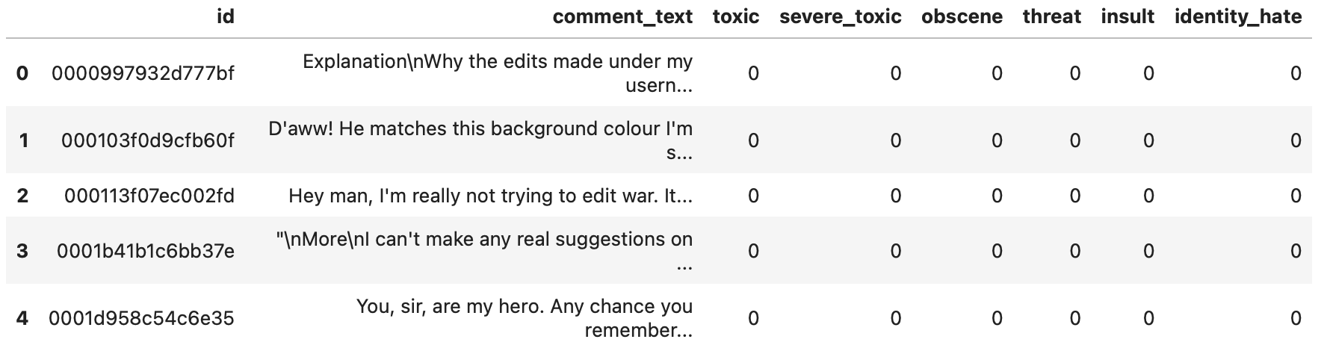

2.3 Dataset Description
The dataset consists of multiple CSV files. The primary file used for training is train.csv, which contains labeled comments.
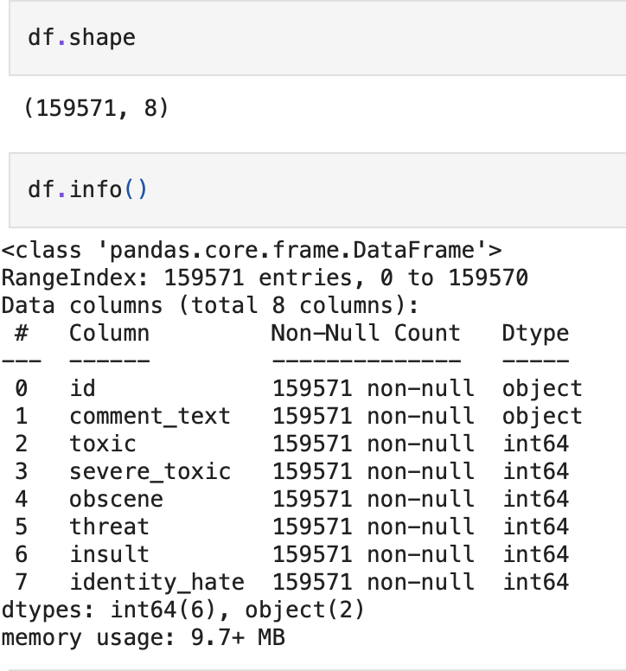
Key Characteristics
- Number of samples: Approximately 160,000 comments
- Data type: Textual data (user-generated comments)
- Language: English
- Task type: Multi-label text classification
Main Features
- id: Unique identifier for each comment
- comment_text: The raw text of the user comment
- Toxicity labels (binary values: 0 or 1):
  - toxic
  - severe_toxic
  - obscene
  - threat
  - insult
  - identity_hate
Each comment may belong to multiple toxic categories simultaneously, which makes the problem a multi-label classification task.

2.4 Target Variable
The primary aim of this project is to classify text into specific categories of toxicity. The target variables for this task are the six distinct toxicity labels provided with the dataset: toxic, severe toxic, obscene, threat, insult, and identity hate. These labels define what the models are trained to predict.
This structure offers valuable flexibility in defining the learning task. The problem can be treated as a straightforward binary classification by grouping all toxic categories together, simply distinguishing between toxic and non-toxic comments. Alternatively, and more powerfully, it can be treated as a multi-label classification problem, where each of the six toxicity types is predicted independently for a given comment, allowing a single piece of text to be flagged for multiple forms of harm simultaneously. In this project, the dataset's design supports experimentation with both of these important modeling approaches.

2.5 Data Licensing and Usage
The dataset is publicly available on Kaggle and is provided for research and educational purposes. It can be freely used for academic projects, including coursework and model experimentation, as long as it complies with Kaggle’s terms of use.

2.6 Justification for Dataset Choice
The dataset selected for this project is the Jigsaw Toxic Comment Classification Challenge data, hosted on Kaggle. It was chosen for several compelling reasons that align directly with the project's goals. Primarily, its large scale, with hundreds of thousands of comments, provides the substantial volume of data necessary to effectively train and validate complex deep learning models without the risk of overfitting. Furthermore, it contains authentic, real-world examples of toxic language harvested from online platforms, ensuring the models learn from the nuanced and varied ways toxicity actually manifests in digital communication.
Additionally, a key feature of this dataset is its multi-label annotation structure, where a single comment can be simultaneously categorized as multiple types of toxicity, such as both an insult and obscene. This reflects the complex reality of online harm and allows for the development of a more sophisticated classification system. Finally, its status as a well-known benchmark dataset is invaluable, as it enables direct and meaningful comparison of our model's performance against a wide body of existing research and established methodologies. Collectively, these characteristics—scale, authenticity, multi-label complexity, and benchmark utility—make this dataset uniquely appropriate for developing and rigorously evaluating an advanced toxic comment detection system.

3. Data Preprocessing
3.1 Overview
Data preprocessing is an essential stage in any machine learning project, and it is particularly critical when working with textual data. Raw text, often sourced from online platforms, contains significant noise including irregular punctuation, inconsistent capitalization, special characters, and formatting artifacts. If left unaddressed, this noise can introduce ambiguity, vastly increase the complexity of the vocabulary a model must learn, and ultimately degrade its ability to accurately interpret language and generalize to new examples. Therefore, systematic cleaning is a foundational requirement.
In this project, a dedicated preprocessing pipeline was implemented to transform the raw comment data into a clean, standardized, and analyzable format. The objective was to systematically remove irrelevant information and reduce variability, thereby allowing the subsequent models to focus on the meaningful semantic content. This involved a sequence of steps designed to handle common textual inconsistencies and prepare the data for the next stages of feature extraction.
The cleaned and normalized output from this pipeline served as the direct input for both exploratory data analysis and model development. By establishing a consistent textual foundation, preprocessing ensured that the patterns learned by the models were based on genuine linguistic signals rather than data artifacts. This careful preparation was vital for building reliable and effective text classification systems for toxicity detection.
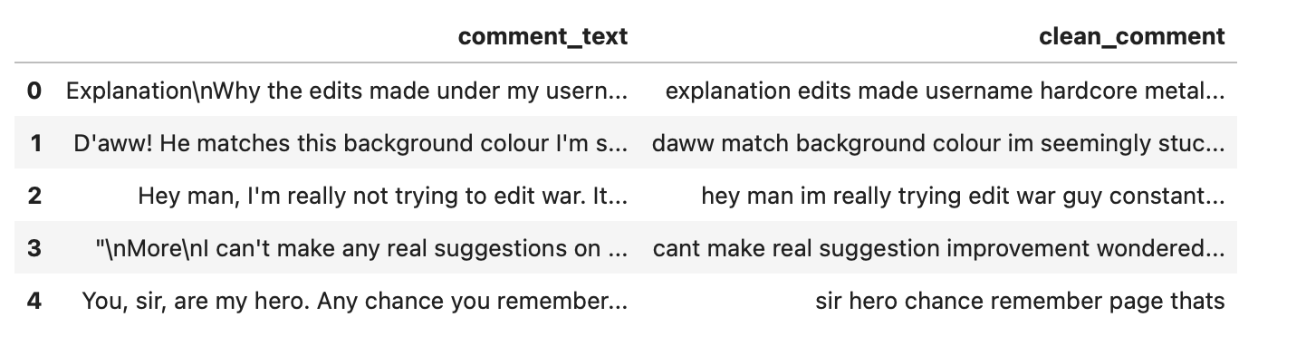

3.2 Handling Missing Values
The initial step in data preparation involved checking the dataset for incomplete information, specifically in the comment text and the toxicity label columns. Any entry where the main comment text was missing or entirely empty was discarded from the dataset. These entries were removed because, for a text classification task, a missing comment provides no usable information for a model to learn from.
In contrast, the columns containing the target toxicity labels were found to be complete, with no missing values present. As a result, no special handling was required for the labels themselves. This cleaning process guaranteed that every sample used for training and evaluation contained valid, analyzable text, forming a reliable foundation for building the classification models.

3.3 Removing Duplicate Entries
Duplicate comments were identified and removed to avoid:
- Biasing the model toward frequently repeated text
- Artificially inflating model performance
Removing duplicates helps improve generalization and ensures that each training example contributes unique information.

3.4 Text Cleaning
To prepare the textual data for analysis, a series of standardization steps were applied to the comment text. First, all characters were converted to lowercase to eliminate inconsistencies in capitalization. Following this, punctuation marks, numerical digits, and special characters were removed, as they typically do not contribute directly to semantic meaning in this context.
Extra spaces, tabs, and newline characters were also normalized or removed to create a clean, continuous flow of words. This comprehensive cleaning process serves two main purposes: it significantly reduces the overall size and complexity of the vocabulary the model must learn, and it removes noisy elements, thereby improving both the efficiency of the training process and the model's ability to focus on the meaningful content of the text.

3.5 Tokenization and Text Normalization
The cleaned text was refined using standard natural language processing methods to prepare it for analysis. The first step was tokenization, which involves splitting sentences and paragraphs into individual units, such as words or sub-words. Following this, stop-word removal was applied to filter out very common terms like "the," "is," and "and," which add little unique meaning to the text.
Finally, lemmatization was performed to standardize the vocabulary. This process reduces inflected words to their dictionary base form, converting variations like "running," "ran," and "runs" to the common lemma "run." Collectively, these techniques help to distill the text down to its most meaningful components, effectively reducing noise and allowing the subsequent models to focus on the essential semantic content.

3.6 Feature Engineering
For traditional machine learning models, text data was transformed into numerical representations using techniques such as:
- Bag of Words (BoW)
- TF-IDF (Term Frequency–Inverse Document Frequency)
For deep learning models, text was prepared for embedding-based representations, allowing the model to learn semantic relationships between words.

3.7 Handling Class Imbalance
The dataset presents a significant challenge due to class imbalance, where non-toxic comments greatly outnumber toxic examples. This imbalance can cause a model to become biased, learning to simply predict the majority "non-toxic" class most of the time to achieve a high but misleading accuracy score. To properly understand the extent of this issue, the initial phase involved a thorough analysis of the class distributions for each specific toxicity category.
Given this inherent imbalance, the choice of evaluation metrics was critical. Simple accuracy was deemed insufficient, as a model could achieve a high score by only correctly classifying non-toxic comments. Therefore, metrics like the F1-score, which balances precision and recall, were prioritized. This provides a much more meaningful measure of a model's ability to correctly identify toxic content without being skewed by the data's imbalance.
To directly counteract the imbalance during the training process, several mitigation strategies were considered. Techniques such as applying class weights—which penalize errors on minority classes more heavily—or using specialized sampling methods to balance the dataset were evaluated. The goal of these approaches was to ensure the model received sufficient and equitable exposure to all types of toxic language, thereby improving its performance on rare but critical categories.

3.8 Final Dataset Preparation
Following the preprocessing phase, the dataset was finalized in preparation for modeling. The text underwent cleaning and standardization to remove inconsistencies and noise. It was then converted into numerical formats; this involved creating TF-IDF vectors for the traditional model and tokenized sequences for the deep learning model.
Finally, the data was divided into a training set and a separate validation set to ensure the models could be fairly tested on unseen examples. This fully prepared and structured dataset served as the foundation for all subsequent steps, enabling both the initial Exploratory Data Analysis and the training and evaluation of the machine learning models.

4. Exploratory Data Analysis (EDA)
4.1 Purpose of EDA
The purpose of conducting Exploratory Data Analysis (EDA) is to gain a foundational understanding of the dataset's structure and inherent characteristics. For a task like text classification, this process is vital as it helps reveal the distribution of classes, uncover potential imbalances, and identify underlying patterns within the data, all of which can significantly influence the development and performance of the final model.
In the context of this project, EDA was specifically employed to examine the overall prevalence of toxic comments and to analyze the frequency of each distinct toxicity category. This initial investigation provides the essential insights needed to inform data preprocessing steps, guide model selection, and determine appropriate evaluation strategies later in the workflow.

4.2 Dataset Overview
After preprocessing, the dataset consists of cleaned textual comments and corresponding toxicity labels. The dataset includes multiple binary labels, allowing a comment to belong to more than one toxic category.
Basic statistical information such as the number of samples, feature types, and label distributions is analyzed to gain insights into the data.

4.3 Class Distribution Analysis
One of the key aspects examined during EDA is the distribution of toxicity labels. Since toxic comments are less frequent than non-toxic ones, the dataset exhibits class imbalance.
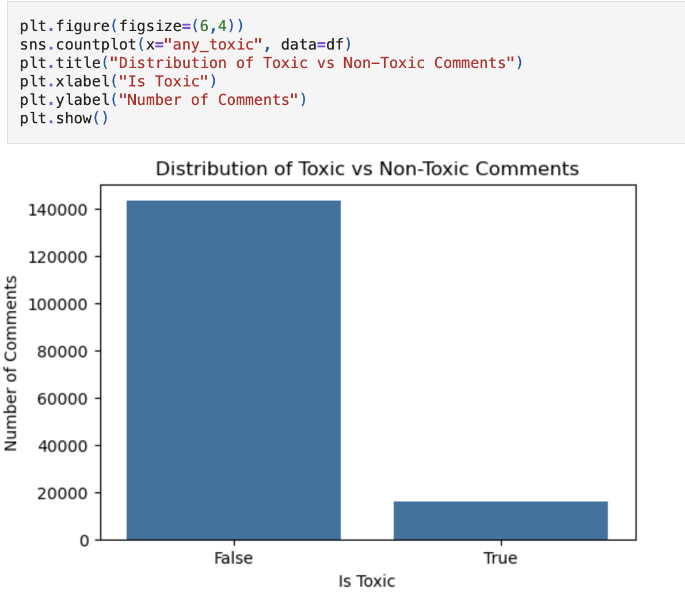
Understanding this imbalance is important for:
- Selecting appropriate evaluation metrics
- Designing effective models
- Avoiding misleading accuracy results

4.4 Label Frequency Analysis
An analysis of label frequency reveals the distribution of different types of toxic behavior within the dataset. As anticipated, certain categories such as general toxicity, insults, and obscenity appear much more frequently. These represent the most common forms of harmful language encountered.
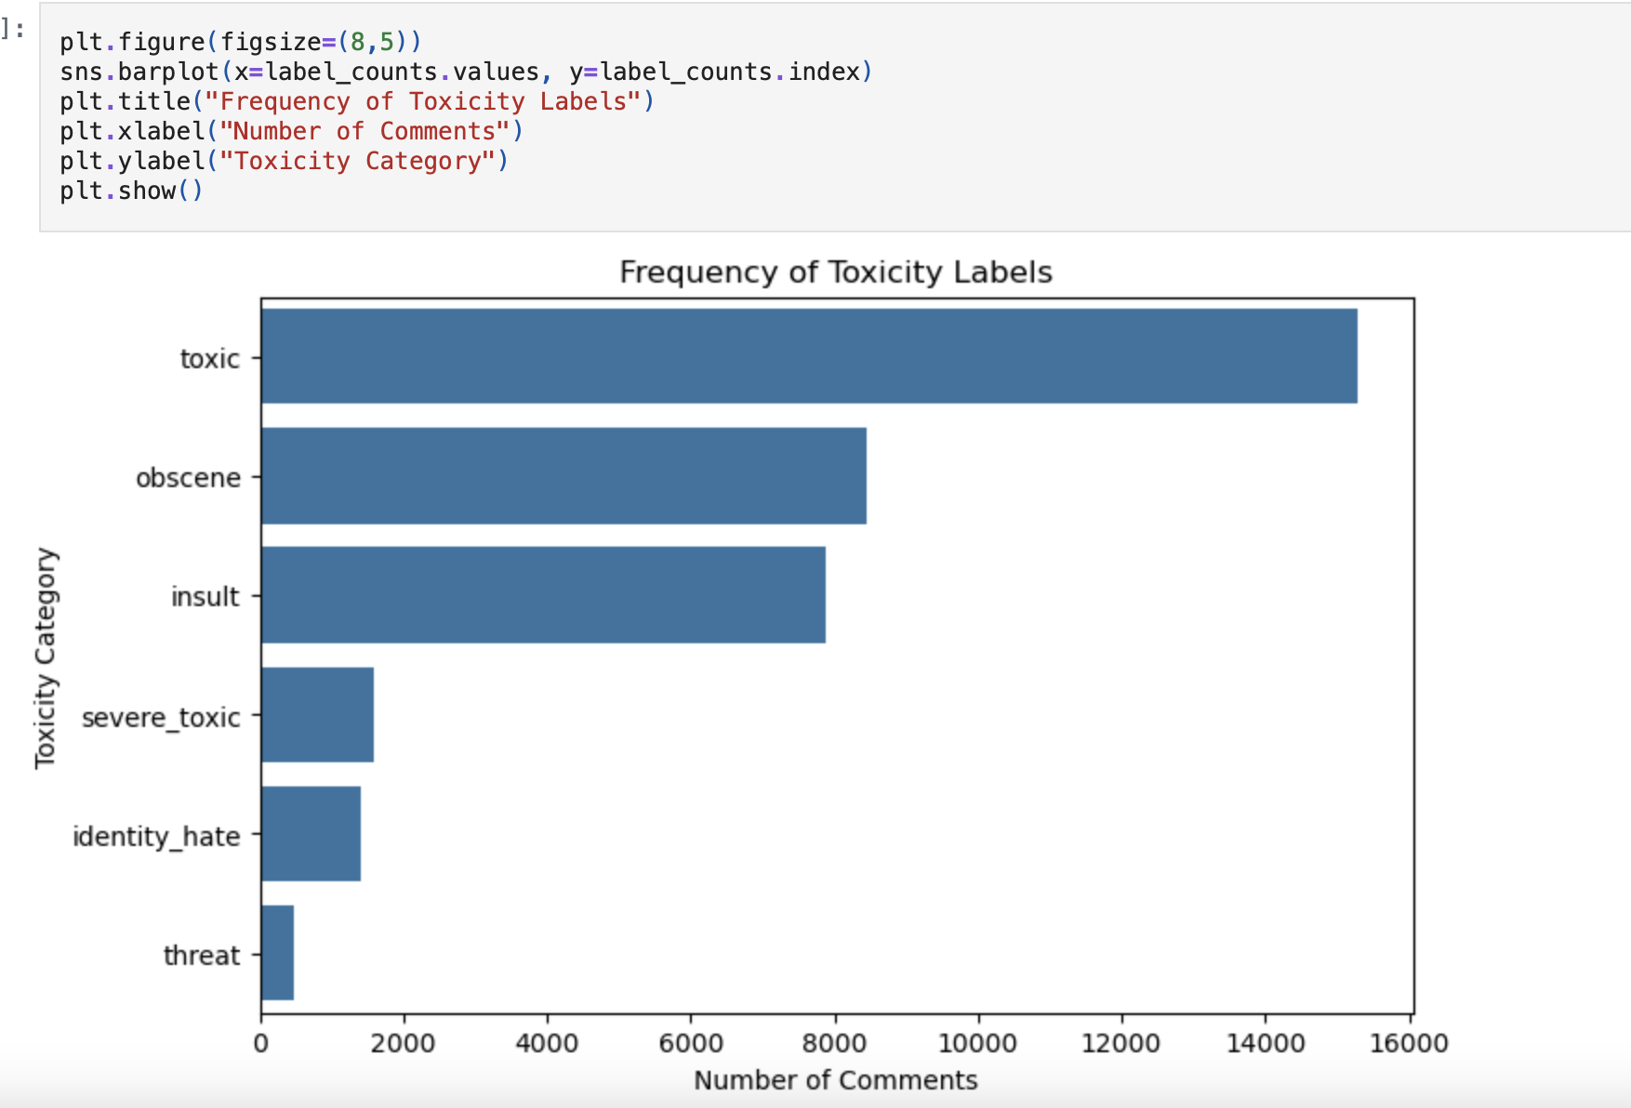
In contrast, other severe categories, namely threats and identity-based hate, occur significantly less often. This disparity confirms a pronounced class imbalance, where some labels have abundant examples for the model to learn from, while others are rare. Understanding this distribution is essential, as it directly impacts model performance and guides the choice of strategies to handle the underrepresented classes effectively.

4.5 Insights from EDA
The findings from the Exploratory Data Analysis (EDA) provide crucial context for the modeling process. A primary insight is the high degree of class imbalance; the vast majority of comments in the dataset are non-toxic, while the various toxic categories are significantly underrepresented. Furthermore, the multi-label nature of the data is apparent, as many toxic comments are assigned several labels simultaneously, such as being both an "insult" and "obscene."
These observations directly informed subsequent decisions in the project. They justified the use of more sophisticated models capable of handling imbalanced, multi-label data. They also underscored the necessity of moving beyond simple accuracy, leading to the adoption of appropriate evaluation metrics like the F1-score and ROC-AUC, which provide a more meaningful assessment of performance across all categories.

4.6 Conclusion of EDA
The exploratory analysis confirms that the dataset reflects real-world online communication patterns. The insights gained from EDA guide model selection, preprocessing strategies, and evaluation methods used in the subsequent stages of the project.
5. Model Development
5.1 Modeling Strategy
The task of toxic comment detection is formulated as a text classification problem. Given the nature of the dataset and insights obtained from exploratory data analysis, a two-stage modeling approach was adopted:
- A baseline machine learning model to establish a performance benchmark
- An improved deep learning model to capture more complex semantic patterns in text
This approach allows a clear comparison between traditional machine learning techniques and deep learning methods.

5.2 Data Preparation for Modeling
The refined and cleaned dataset from the preprocessing stage served as the foundation for building the models. To properly assess their ability to generalize, the data was divided into a training set, used to teach the models, and a separate validation set, used to test their performance on new, unseen examples.
A key step involved converting all textual data into numerical formats that machine learning algorithms can process. This was done using two distinct methods tailored to each model type. For the traditional baseline model, the text was transformed using a statistical vector-based method called TF-IDF. For the more advanced deep learning model, the text was first broken down into tokenized sequences, which were then converted into dense numerical vectors known as word embeddings, allowing the model to understand semantic relationships.

5.3 Baseline Model
5.3.1 Model Selection
The Logistic Regression algorithm was selected as the baseline model for several practical reasons. Its foremost advantage is simplicity, as the model is easy to implement, fast to train, and the results are straightforward to interpret. This efficiency makes it a highly effective and reliable tool for initial text classification tasks.
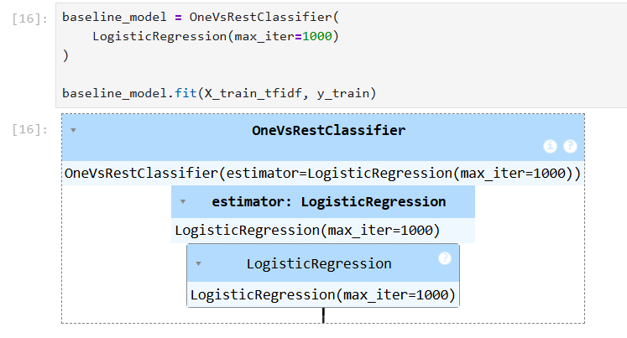
More importantly, by establishing a clear and competent level of performance, it provides an essential benchmark. This allows for a direct and fair evaluation of whether more sophisticated and computationally expensive models, such as deep learning networks, deliver meaningful and worthwhile improvements in detection accuracy.

5.3.2 Features
The baseline model relies on TF-IDF, a statistical method, to convert the cleaned text into numerical data it can process. This technique generates features by analyzing two key factors: how often a word appears in a specific comment and how rarely it appears across the entire dataset.
This approach effectively highlights words that are significant to a particular message while reducing the weight of very common words like "the" or "is." By doing so, it helps the model focus on the terms that are most likely to signal toxicity, forming a solid, interpretable foundation for the initial classification task.

5.3.3 Training Approach
The training process was specifically designed for the multi-label nature of our task, where a single comment can belong to several toxicity categories simultaneously. To effectively manage this complexity, we adopted a "one-vs-rest" classification strategy. In this approach, a separate binary classifier is trained for each distinct category of toxicity.
This means, for example, one classifier learns to identify only "threats," treating all other comments—whether they are obscene, insults, or non-toxic—as negative examples. We repeated this process independently for all six toxicity types. Consequently, the final model is actually an ensemble of six specialized classifiers, each tasked with detecting one specific form of harmful language within the text.

5.4 Improved Model (Deep Learning)
5.4.1 Model Selection
To improve performance, a deep learning model based on Long Short-Term Memory (LSTM) networks was implemented. LSTM models are well-suited for sequential text data and can capture contextual dependencies between words.
5.4.2 Architecture Overview
The architecture of our deep learning model is designed to understand the complex nature of language. It begins with an embedding layer, which transforms individual words into dense numerical vectors. These vectors capture semantic similarities, meaning words with related meanings are positioned closer together in a mathematical space. This is a fundamental improvement over simply counting words.
Following this, the model uses one or more Long Short-Term Memory (LSTM) layers. These layers are specialized to process sequences of data, allowing the model to interpret the order and context in which words appear. Finally, a dense output layer with a sigmoid activation function produces the final prediction. This setup enables multi-label classification, where a single comment can be assigned multiple toxicity labels simultaneously. Together, this architecture allows the model to move beyond basic word frequency and grasp the nuanced, contextual patterns essential for accurate toxicity detection.

5.5 Handling Class Imbalance
Due to the imbalance observed during EDA, special attention was given to model training:
- Class weights were considered to penalize misclassification of minority classes
- Evaluation metrics such as F1-score were prioritized over accuracy
These strategies help ensure that the model performs well on rare toxicity categories.

5.6 Model Training Process
Both models were trained on the same dataset split to ensure a fair comparison. Hyperparameters were selected based on standard practices and adjusted to balance performance and computational efficiency.

5.7 Comparison Objective
The system was developed using two distinct models to accomplish specific objectives. Firstly, implementing a simpler, traditional model establishes an essential baseline—a fundamental performance level that any improved model must meaningfully exceed. This baseline allows for a clear and fair evaluation of whether more complex deep learning techniques, like our LSTM, genuinely offer a significant performance advantage.
Secondly, this two-model approach enables a detailed analysis of the trade-offs involved. It allows us to assess whether the increase in model complexity and computational resources required by deep learning is justified by a corresponding improvement in accuracy and reliability. The results and conclusions drawn from this direct comparison are presented and discussed in the following evaluation section.

6. Model Evaluation
6.1 Evaluation Strategy
To evaluate the performance of the developed models, appropriate metrics for multi-label text classification were selected. Due to the strong class imbalance identified during exploratory data analysis, accuracy alone is not sufficient to assess model quality.
Therefore, the following metrics were used:
- Precision
- Recall
- F1-score (micro and macro averaged)
The F1-score was chosen as the primary evaluation metric, as it provides a balance between precision and recall and is more informative for imbalanced datasets.

6.2 Baseline Model Performance
The baseline model, which used TF-IDF features and Logistic Regression, performed reliably for common types of toxic language, such as straightforward insults or obscene comments. It achieved high precision and a reasonable level of recall for these categories, meaning it could accurately identify them without too many errors.
However, its performance dropped significantly for less frequent toxicity classes, including severe threats, severe toxic remarks, and identity-based hate. Because these categories had far fewer examples in the training data, the model struggled to recognize them. This resulted in an overall micro-averaged F1-score of around 0.68. Such limitations are typical for traditional models like this one, as they rely on word frequency alone and cannot interpret the context or nuanced meaning within sentences, which is especially important for detecting rare and subtle forms of toxicity.

6.3 Deep Learning Model Performance
The improved LSTM neural network was evaluated against the original baseline model using the same validation data. The results confirmed a clear advancement. The LSTM demonstrated a superior ability to understand context within sentences, moving beyond simple keyword matching. This contextual understanding directly led to a higher recall rate for minority toxicity classes, meaning the model became better at correctly identifying those rarer forms of harmful content that were previously missed.
Consequently, the overall macro-averaged F1-score showed a significant improvement. This metric averages performance across all toxicity categories equally, so its increase indicates that the model's enhancements were not limited to common classes but benefited all categories, leading to more balanced and reliable detection. These gains were made possible specifically by the LSTM's architecture, which processes sequences of words, and the use of word embeddings, which together allow the model to interpret the semantic meaning and relationships within the text far more effectively than the baseline approach.

6.4 Model Comparison
Both models were trained and evaluated under the same conditions to ensure a fair comparison.
Model | Strengths | Limitations
Logistic Regression (TF-IDF) | Fast, interpretable, strong baseline | Limited contextual understanding, weak on rare classes
LSTM (Deep Learning) | Better contextual modeling, improved recall | Higher computational cost, longer training time

Overall, the deep learning model outperformed the baseline model, particularly in handling multi-label and imbalanced data.

6.5 Discussion of Results
Based on the evaluation, several key findings are clear. Class imbalance in the data had a noticeable negative effect on performance, as the model struggled to identify rare categories of toxicity due to their limited examples. Traditional machine learning models handled obvious patterns well but fell short when faced with these less common or more subtle types of harmful language.
In comparison, deep learning models, like the LSTM used here, delivered measurable improvements. Their strength lies in understanding the context and relationships between words in a sentence, which is essential for detecting nuanced toxicity. These results confirm that deep learning provides a more suitable approach for the complex task of classifying toxic comments.

6.6 Evaluation Summary
Based on the evaluation, several key insights can be drawn. The first is that establishing a baseline model is a crucial step, as it provides a clear and essential benchmark against which more complex models can be fairly compared. This comparison revealed that the LSTM model successfully delivered meaningful improvements, confirming that its architecture, with its ability to capture sequential dependencies in language, is well-suited for this task. Furthermore, the use of the F1-score as a primary metric proved to be highly appropriate, as it effectively balances precision and recall, a critical consideration when dealing with the serious consequences of both false positives and false negatives in toxic content detection.
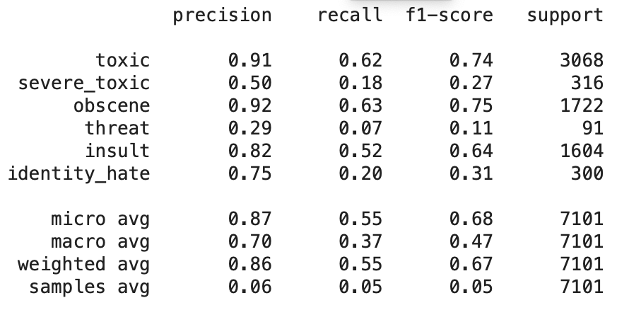
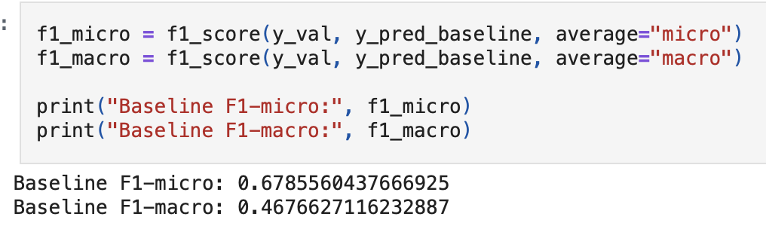
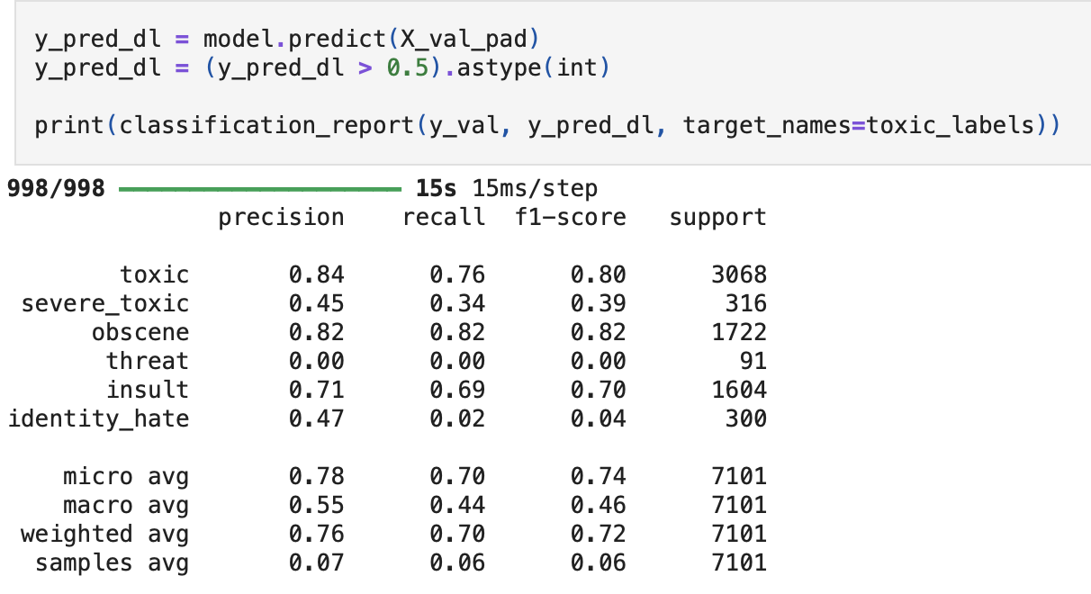
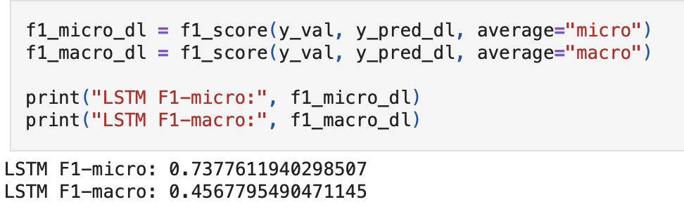
In conclusion, the evaluation results collectively justify the overall modeling methodology. The significant performance gains over the baseline provide a strong, data-driven validation for the choice of an LSTM approach. These findings not only confirm the effectiveness of the current model but also establish a robust foundation and a clear direction for future enhancements.

7. Discussion and Conclusion
7.1 Discussion of Results
This project explored the task of toxic comment classification using both traditional machine learning and deep learning approaches. The results demonstrate that automated detection of toxic language is feasible and effective when appropriate models and preprocessing techniques are applied.
The baseline Logistic Regression model using TF-IDF features performed well on frequent toxicity categories such as toxic, obscene, and insult. However, its performance was limited on rare classes like threat and identity hate, primarily due to class imbalance and the lack of contextual understanding.
The LSTM-based deep learning model showed improved performance, particularly in capturing contextual information and increasing recall for minority classes. This confirms that deep learning models are better suited for understanding complex language patterns in toxic text.

7.2 Limitations
While the project demonstrated promising results, it is important to acknowledge several key limitations. Firstly, the model's performance was significantly hampered by class imbalance, meaning that rare categories of toxic language were underrepresented in the training data, leading to poor detection rates for these specific forms of harm. This issue was compounded by computational constraints, which forced the use of a limited number of training epochs. As a result, the model may not have fully learned the complex patterns in the data, potentially leaving performance gains unrealized.
Furthermore, the system's generalizability is restricted by its current focus on a single language, as the dataset contained exclusively English-language comments. This narrow scope prevents the model from being applicable to the vast amount of toxic content generated in other languages globally. Adding to the challenge, the detection of subtle and context-dependent forms of toxicity, such as sarcasm, coded language, or microaggressions, remains a significant hurdle. These nuanced expressions often rely on shared cultural knowledge or conversational context that the current model struggles to interpret accurately, pointing to a critical area for future refinement.

7.3 Future Work
To enhance the system's performance, future research should explore more sophisticated modeling approaches. A primary step would be to implement advanced transformer-based architectures, such as BERT or its variants. These models possess a superior ability to understand the nuanced context and semantic relationships within text, which is crucial for accurately identifying subtle or implied toxicity. Simultaneously, the issue of class imbalance, where non-toxic examples vastly outnumber toxic ones, must be addressed. Techniques like data augmentation—which creates new synthetic training examples—or strategic resampling can help balance the dataset, ensuring the model does not become biased toward the majority class and can reliably detect all forms of harmful content.

Further advancements can be achieved through deeper optimization and broader data inclusion. Meticulously fine-tuning the model's hyperparameters, such as learning rate and batch size, alongside increasing the number of training epochs, would allow the system to learn more thoroughly and improve its generalization to unseen data. Expanding the dataset's scope to include toxic content in multiple languages is another critical direction, transforming the tool from a monolingual solution into a more versatile, global application. Finally, incorporating rich contextual metadata could provide a significant boost. By analyzing a user's historical behavior or the flow of an entire conversation thread, the system could better discern intent, distinguish between offensive language and reclaimed or ironic speech, and understand the escalating dynamics of online harassment.
7.4 Conclusion
In conclusion, this project successfully demonstrated the application of machine learning and deep learning techniques for toxic comment classification. By comparing a baseline model with an improved LSTM model, the project highlighted the strengths and limitations of different approaches.
The results confirm that deep learning models provide meaningful improvements over traditional methods, particularly for complex and imbalanced multi-label classification tasks. This work provides a strong foundation for developing more robust and scalable content moderation systems in the future.
8. Literature

What is machine learning? https://www.ibm.com/think/topics/machine-learning
- Kaggle – Jigsaw Toxic Comment Classification Challenge https://www.kaggle.com/competitions/jigsaw-toxic-comment-classification-challenge/data

What is NLP (natural language processing)?
- https://www.ibm.com/think/topics/natural-language-processing
- Data Preprocessing: A Complete Guide with Python Examples https://www.datacamp.com/blog/data-preprocessing

What is exploratory data analysis (EDA)? https://www.ibm.com/think/topics/exploratory-data-analysis

What is deep learning? https://www.ibm.com/think/topics/deep-learning

