Jenel Ricafrente

BSI/T-3E

Individual Performance Test #1

Backend Course Data API Test Documentation

Test Procedure

Step 1: Setting Up the Environment

1. Install MongoDB Database Tool:

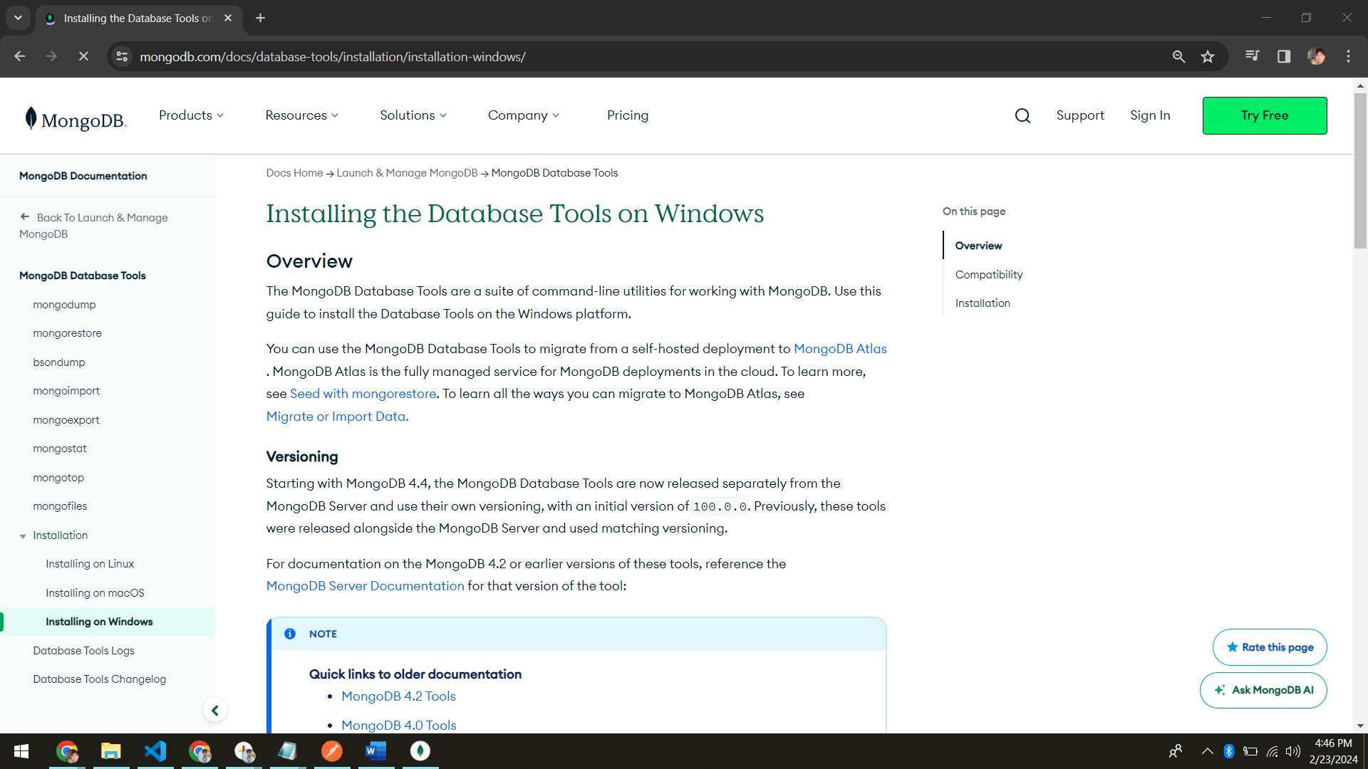 - Downloaded and installed the MongoDB Database Tool from [this link](<https://fastdl.mongodb.org/tools/db/mongodb-database-tools-windows-x86_64-100.9.4.zip>).

2. Installed Node.js:

- Ensured Node.js is installed on the local machine by downloading it from [https://nodejs.org/](https://nodejs.org/).

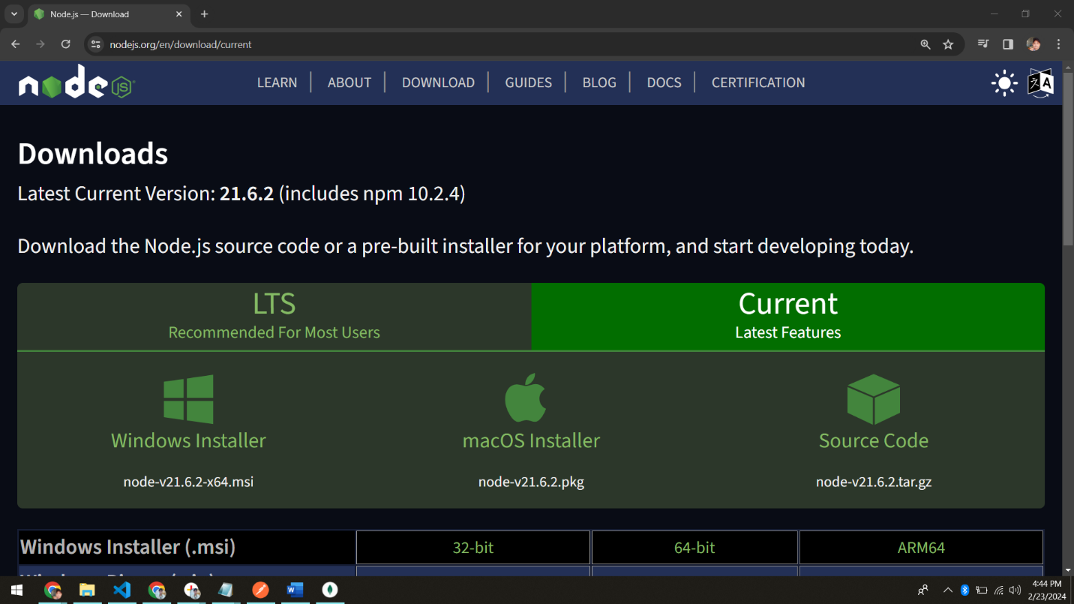

3. MongoDB Server:

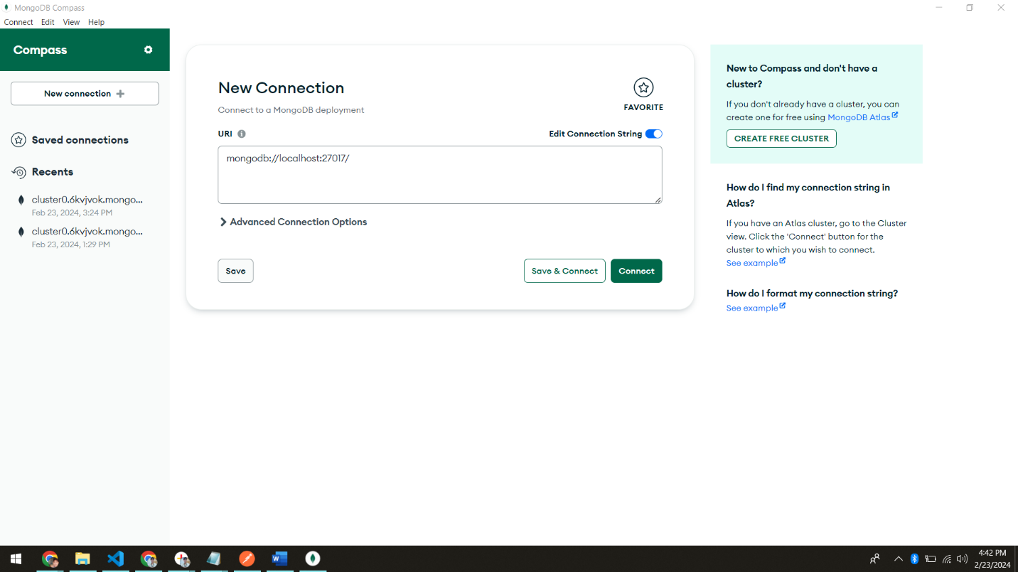 - Confirmed that the MongoDB server is installed and running locally.

Step 2: Import Course Data

- Used the `mongoimport` command to import the provided course data into MongoDB:

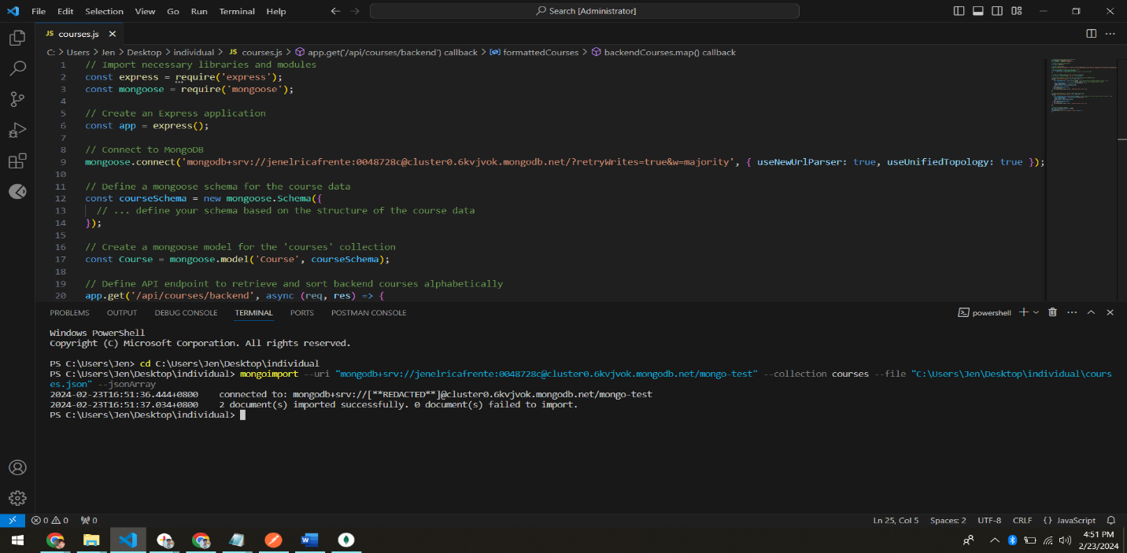 mongoimport --db mongo-test --collection courses --file courses.json --jsonArray

Step 3: Backend API Implementation

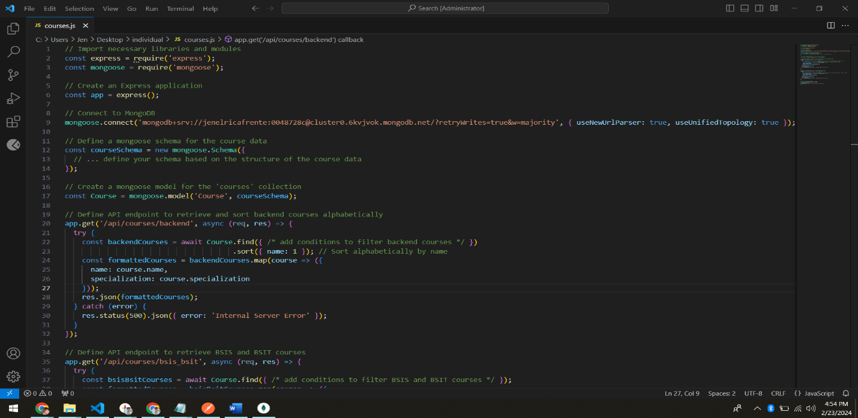- Created a Node.js application using Express to implement backend API endpoints.

Step 4: API Endpoint Testing

1. Retrieve and Sort Backend Courses:

- Sent a GET request to `/api/courses/backend`.

- Verified that the response contains an alphabetically sorted list of published backend courses.

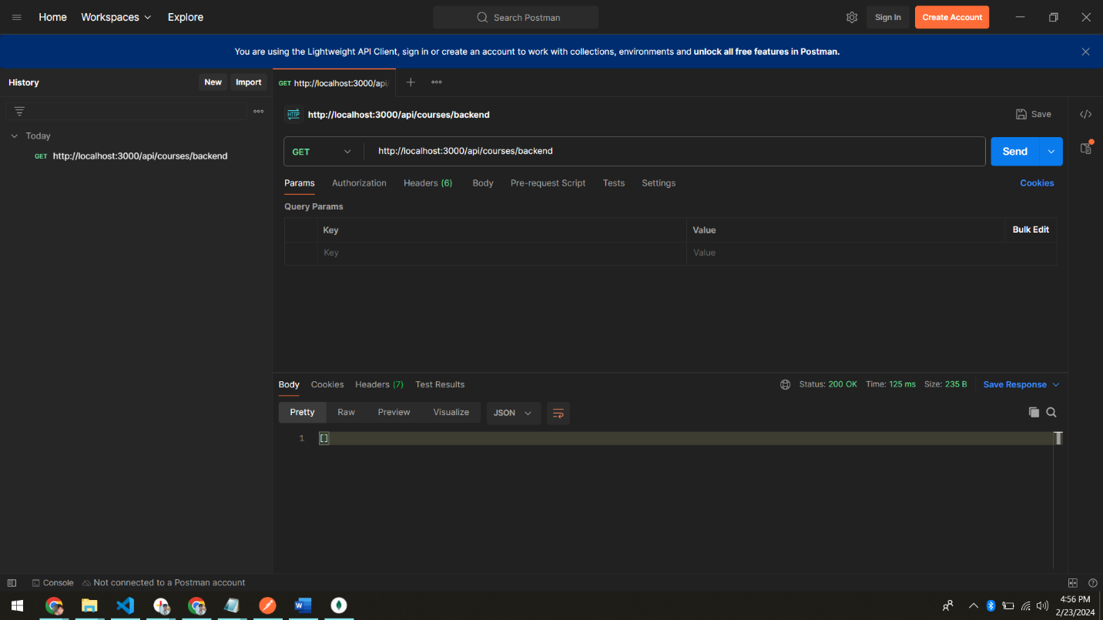

2. Retrieve BSIS and BSIT Courses:

- Sent a GET request to `/api/courses/bsis_bsit`.

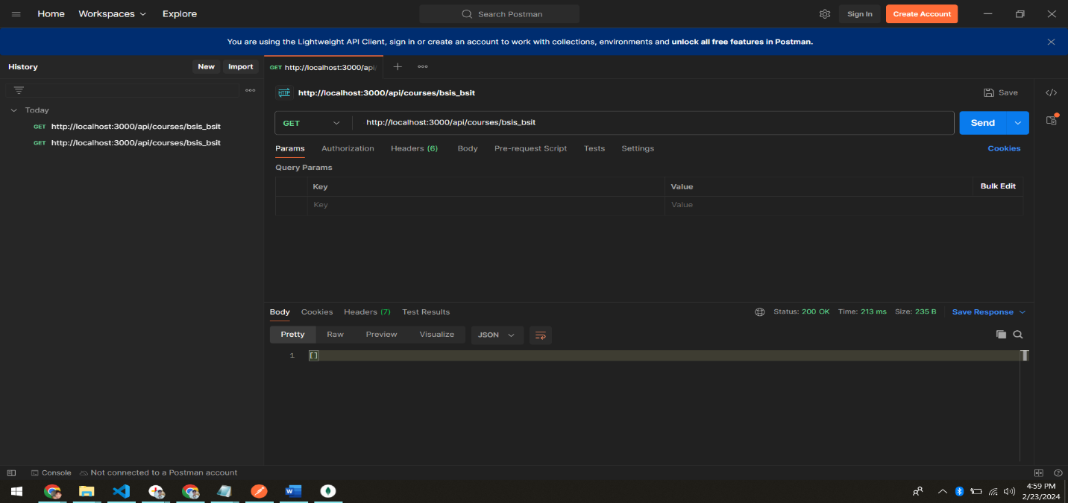 - Verified that the response contains a list of published BSIS and BSIT courses.

Step 5: Data Validation

- Ensured data validation at each step:

- Validated the structure of the course data during import.

- Implemented Mongoose schema validation to ensure correctness.

Step 6: Documentation

- Documented the entire test procedure in this document.

Challenges Faced and Solutions Implemented

1. Challenge: MongoDB Connection Issues

- Encountered issues connecting to the MongoDB server.

Solution:

- Verified the MongoDB server status and ensured the correct connection string in the application code.

2. Challenge: Incorrect Data Format in Imported JSON

- The provided JSON file format was not directly compatible with the Mongoose schema.

Solution:

- Modified the Mongoose schema to match the structure of the imported JSON data.

3. Challenge: Data Not Sorting Correctly

- Initial implementation did not sort backend courses alphabetically.

Solution:

- Modified the MongoDB query to include sorting by the course name.

4. Challenge: Error Handling

- Implemented proper error handling to return meaningful responses in case of failures.