**CSE 220 Homework Assignment 2 (Due 2/24/23)**

**1) (30 pts)** The following problems deal with analysis of critical programming characteristics and terminology in Java. Your response to each should be 1-2 paragraphs.

a. Explain what bytecode is, and how it distinguishes Java from most other programming languages. Make sure to include details regarding how programs in bytecode form are ultimately executed.

b. i. Explain the difference between private and public visibility in Java.  
 ii. Explain why programmers don’t choose to always make every attribute and   
 method public in practice.

**Problems 2 and 3 below deal with JavaFX GUI components and controls.**

**2) (40 pts)** The second problem requires you to construct a basic GUI to permit a user to convert from kilometers to miles and vice versa – this file must be called **MilesKMConverter.java**. Recall that 1 mile is approximately equal to 1.609 kilometers. The interface of the GUI is largely up to you, but at the minimum it should have two text field controls (one for inputting km to convert to miles, the other for inputting miles to convert to km), and labels to indicate which field is km and which is miles. Remember that you will have to include event handling functions to perform the conversion.

If you are unsure where to begin, it is highly recommended that you start with the FahrenheitConverter.java code from Chapter 4. Just remember that your code for this problem will need to convert in both directions (both from km to miles and vice versa).

*Note: you must build a JavaFX GUI for this problem -- building a program that uses the Scanner class with System.in and System.out.print(ln) will not be accepted for credit.*

**3) (30 pts)** Your third task deals with creating a non-interactive JavaFX art program using shapes, subject to the following:

- You must include a background for your setting.  
- You must include a minimum of three unique shape types (ex: the screenshot below uses Circles, Rectangles, and Lines).  
- You must include at least seven individual shapes (ex: the one below uses 15).  
- You must use at least three distinct colors

Beyond that, feel free to construct whatever design you like, and call the program whatever you feel would make for a good description.

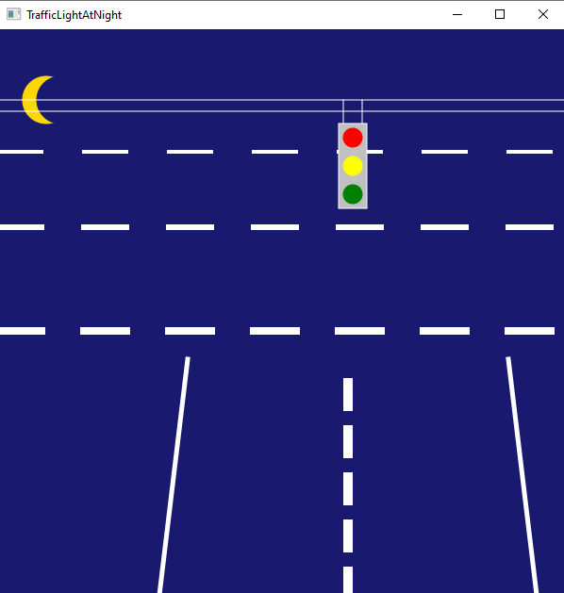

**Responses to Problem #1 should be in .doc(x) or .pdf format. Upload a .zip file containing this and your .java files for problems 2 and 3 to Blackboard with the filename “LN_FN_2.zip” where LN is your last name and FN is your first name.**

1. Bytecode is an intermediate code generated by the compiler after the compilation of source. The compiler converts the source code or Java program into byte code (binary code). The interpreter can also be called JVM (Java virtual machine), this process makes Java being running in multiples platform and you do not have to reinstall interpreter or compiler from different source because Java include this tool.

Programs in bytecode form are executed by a VM, which verify, interpret and JIT compile the bytecode into machine code. This approach allows programs to be written in a portable way that can be run on any platform, it is why we hear this famous phase for Java (“Code once, Run everywhere”).

1. Public visibility reference to classes, methods, and variables that any programmer or person can get access. This means that any class member is accessible from any other class in the program. Public data can also be access outside the package in which the class is defined.

Private visibility reference to classes, methods, and variables that any programmer or person cannot get access. This means that any class member is not accessible to other class or subclass. This allows for better encapsulation and information hiding. Private visibilities are not exposed to the rest of the program.