**Program Structure**

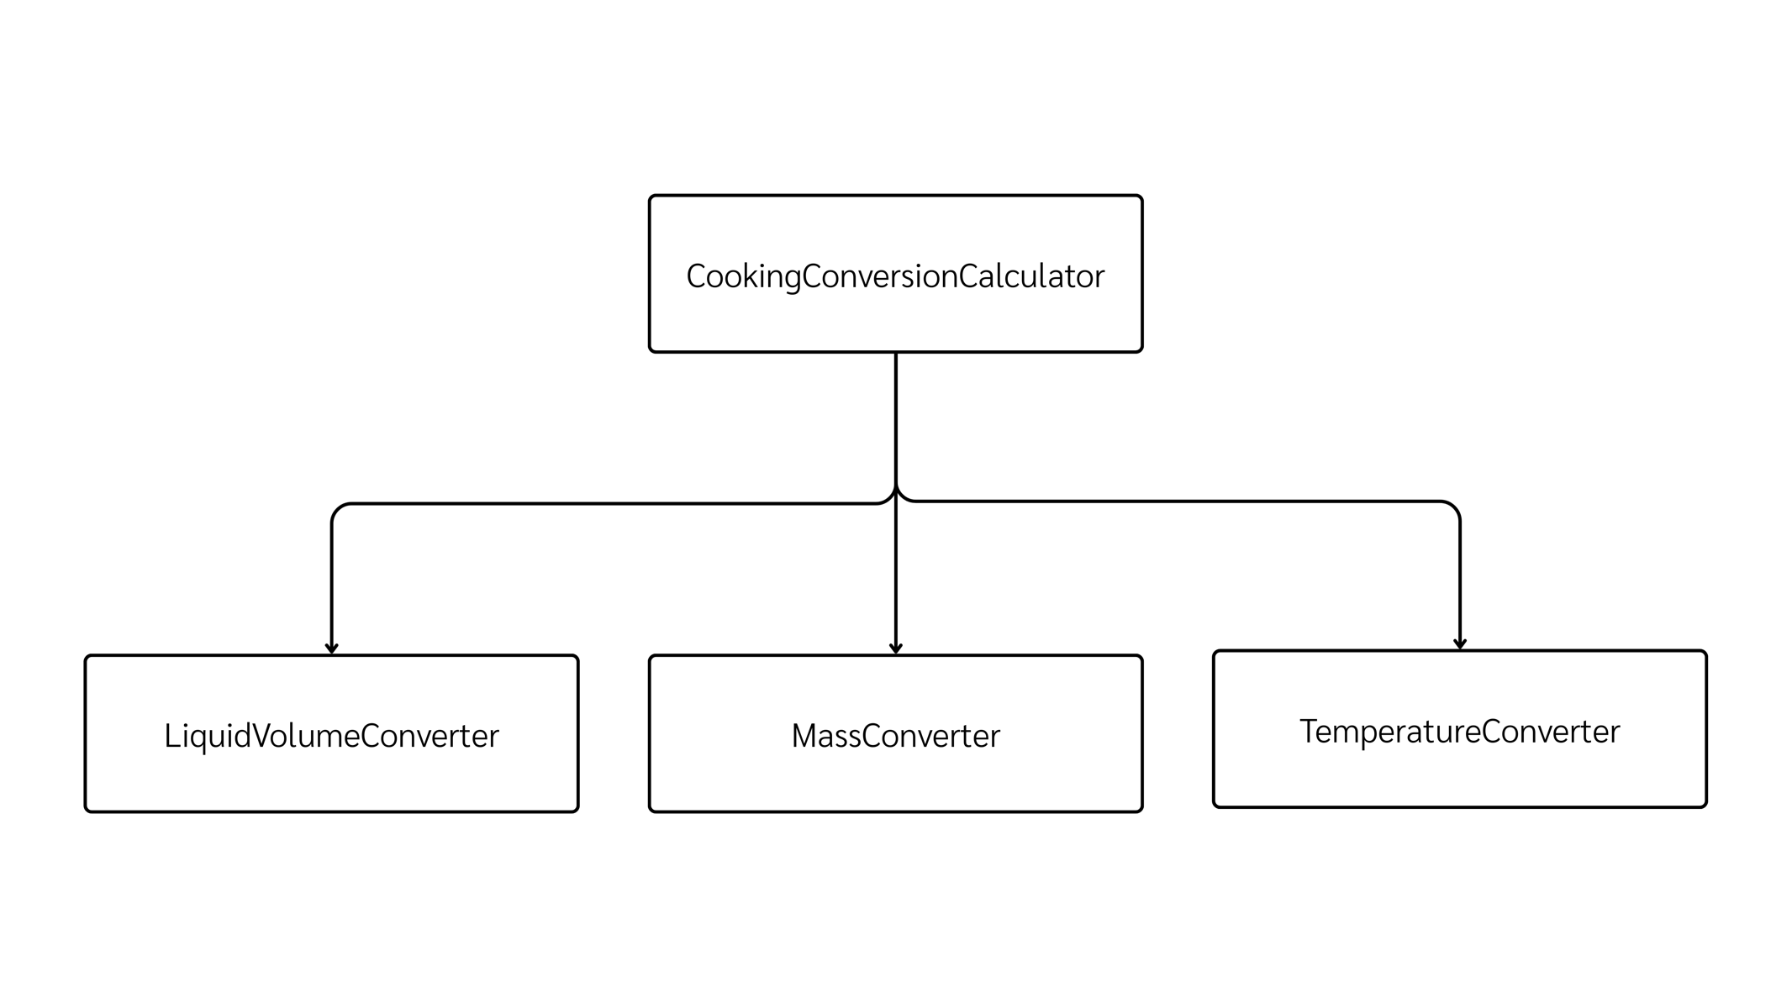

**Top-down Integration**

|  |  |  |  |  |  |  |
| --- | --- | --- | --- | --- | --- | --- |
| Unit under test | List of Stubs/Drivers | result | Stub’s return value | Expected results | Actual results | Pass/Fail/No run |
| CookingConversionCalculator.convert() | (TemperatureConverterStub) | 100 | 100.0 | 100.0 | 100.0 | psss |
| CookingConversionCalculator.convert() | MassConverterStub | 100 |  | 200.0 | 200.0 | pass |
| CookingConversionCalculator.convert() | LiquidVolumeConverterStub | 300 | 300.0 | 300.0 | 300.0 | pass |
| CookingConversionCalculator.convert()  ->  TemperatureConverter.convert() | Module จริง | 100 | - | 100.0 | 0 | fail |
| CookingConversionCalculator.convert()  ->  MassConverter.convert | Module จริง | 125 | - | 125.0 | 125.0 | pass |
| CookingConversionCalculator.convert()  ->  LiquidVolumeConverter.convert() | Module จริง | 250 | - | 250.0 | 250.0 | pass |
| CookingConversionCalculator.convert()  ->  Integration All (mass) | Module จริง | 16 | - | 16.0 | 16.0 | pass |
| CookingConversionCalculator.convert()  ->  Integration All (liquid) | Module จริง | 15 | - | 15.0 | 15.0 | pass |

**Bottom-up Integration**

|  |  |  |  |  |  |  |
| --- | --- | --- | --- | --- | --- | --- |
| Unit under test | List of Stubs/Drivers | result | Stub’s return value | Expected results | Actual results | Pass/Fail/No run |
| TemperatureConverter.convert() | - | 100.0 | - | 100.0 | 0 | fail |
| TemperatureConverter.convert() | - | 32.0 | - | 32.0 | 0 | fail |
| MassConverter.convert() | - | 125.0 | - | 125.0 | 125.0 | pass |
| MassConverter.convert() | - | 16.0 | - | 16.0 | 16.0 | pass |
| LiquidVolumeConverter.convert() | - | 250.0 | - | 250.0 | 250.0 | pass |
| LiquidVolumeConverter.convert() | - | 15.0 | - | 15.0 | 15.0 | pass |
| CookingConversionCalculator.convert() ->Temperature | - | 100.0 | - | 100.0 | 0 | fail |
| CookingConversionCalculator.convert() -> Mass | - | 125.0 | - | 125.0 | 125.0 | pass |
| CookingConversionCalculator.convert() ->Liquid | - | 250.0 | - | 250.0 | 250.0 | pass |