SQL PROJECT REPORT
IMDB Movies

Submitted by: Jenihelan M
Project id: PTID-CDA-MAR-26-1371
Project Code: PRSQL-01
Date: 02.04.2026

CHAPTER – 1: INTRODUCTION

1.1 Introduction
This project focuses on analyzing an IMDB Movies dataset using SQL. The dataset contains information about movies and their directors, including attributes such as movie titles, revenue, popularity, ratings, and director details.
The objective of this project is to perform data analysis using SQL queries to extract meaningful insights and understand trends in the movie industry.
1.2 Objectives of the Study
- To analyze the IMDB movies dataset using SQL
- To understand relationships between movies and directors
- To perform data cleaning and validation
- To extract meaningful insights using SQL queries
- To identify trends in movie popularity, revenue, and ratings
1.3 Scope of the Study
- The project focuses on analyzing movie and director data
- It includes querying structured data using SQL
- The analysis is limited to the given dataset
- Visualization can be extended using tools like Power BI
1.4 Limitations of the Study
- The database provided had restricted access (read-only)
- Operations such as CREATE, UPDATE, and ALTER were not permitted
- Therefore, table modification steps like:
    - Dropping columns
    - Renaming columns
    - Updating NULL values (e.g., tagline)
could not be performed
- Some data fields (like tagline) contained NULL values which could not be updated
- Certain queries returned no results due to missing relationships in the dataset.

CHAPTER – 2: METHODOLOGY

2.1 Data Source
The dataset used in this project was sourced from a structured IMDB Movies database provided for SQL-based analysis.
Database Name: project_movie_database
Host: 18.136.157.135
Source: Datamites
The data was accessed using MySQL Workbench through a remote database connection. The dataset contains information related to movies and their respective directors.

2.2 Dataset Description
The project dataset consists of two tables:
Table: Directors
This table contains information about movie directors.
Name: Name of the director
ID: Unique identifier for each director (Primary Key)
Gender: Gender of the director (0/2 = Male, 1 = Female)
Department: Department of the director

Table: Movies
This table contains details about movies.
ID: Unique identifier for each movie
Original_title: Name of the movie
Budget: Budget of the movie
Popularity: Popularity score of the movie
Release_date: Release date of the movie
Revenue: Revenue generated by the movie
Title: Display title of the movie
Vote_count: Number of votes received
Vote_average: Average IMDB rating
Overview: Description of the movie
Tagline: Tagline of the movie
UID: Another unique identifier for the movie
Director_ID: References the director (Foreign Key)

2.3 Data Preparation and Cleaning
The following steps were performed:
- Checked for NULL values in both tables
- Verified duplicate records
- Validated numeric columns (budget, revenue)
- Understood table structure using DESCRIBE

2.3.1 Database Overview
SQL Query:
USE project_movie_database;
SHOW TABLES;
DESCRIBE movies;
DESCRIBE directors;
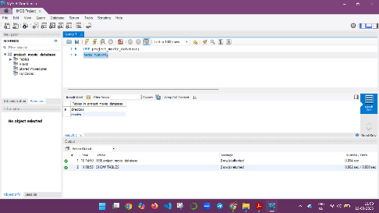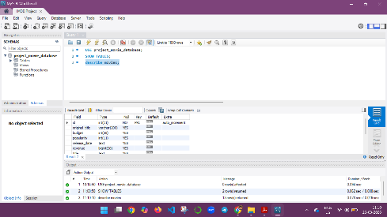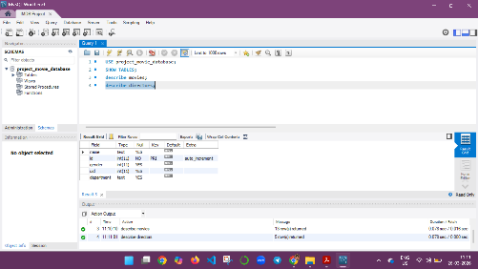

Interpretation:
The database structure was explored using commands like SHOW TABLES and DESCRIBE to understand table schema.

2.3.2 Data Exploration
SQL Query:
SELECT * FROM movies LIMIT 10;
SELECT * FROM directors LIMIT 10;
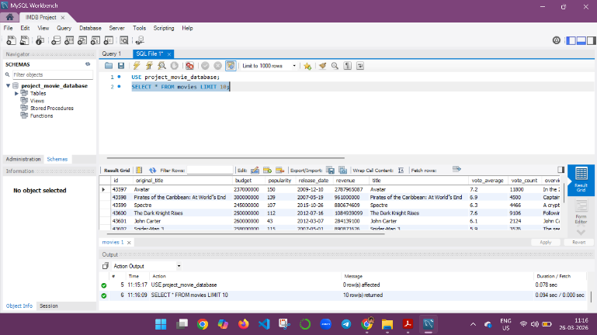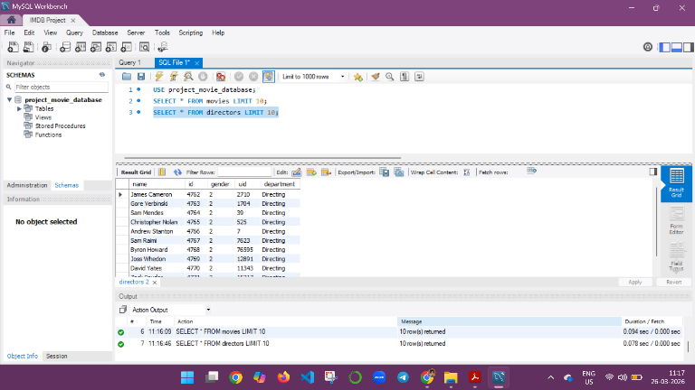
Interpretation:
Sample records were retrieved to understand the structure and content of the dataset.

2.3.3 Data Cleaning
NULL Check
SQL Query:

Null check for movies table
SELECT * FROM movies
WHERE id IS NULL
OR original_title IS NULL
OR budget IS NULL
OR popularity IS NULL
OR release_date IS NULL
OR revenue IS NULL
OR title IS NULL
OR vote_average IS NULL
OR vote_count IS NULL
OR overview IS NULL
OR tagline IS NULL
OR uid IS NULL
OR director_id IS NULL;

Null check for directors table
SELECT * FROM directors
WHERE id IS NULL
OR name IS NULL
OR gender IS NULL
OR department IS NULL;
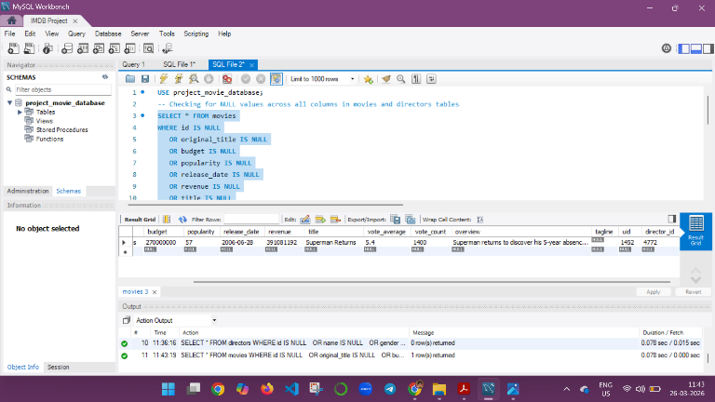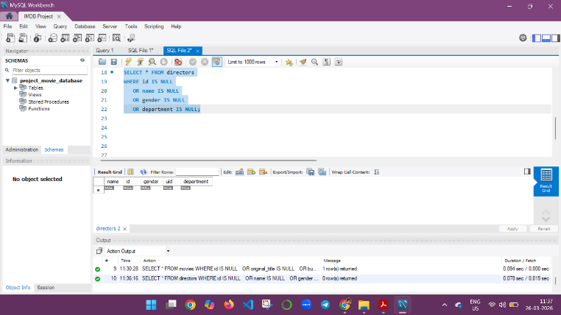

Interpretation:

Checked for missing values across all columns in movies and directors tables in the dataset.

Duplicate Check
SQL Query:
Checking duplicate movies based on original_title

SELECT original_title, COUNT(*) AS count

FROM movies

GROUP BY original_title

HAVING COUNT(*) > 1;

Checking duplicate directors based on name

SELECT name, COUNT(*) AS count

FROM directors

GROUP BY name

HAVING COUNT(*) > 1;

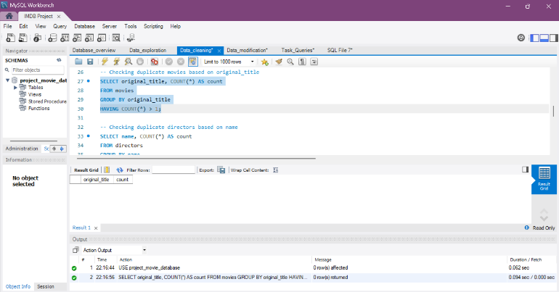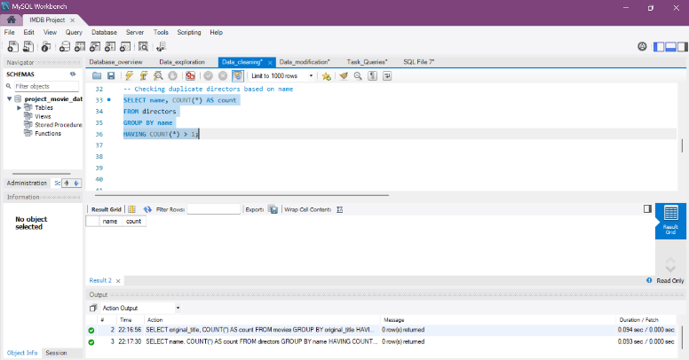

Interpretation:

Verified duplicate records in movies and directors tables.

Invalid Values

SQL Query:

Checking for invalid values like negative revenue or budget

SELECT * FROM movies WHERE revenue < 0 OR budget < 0;

Checking if gender has only valid values as (0,1,2)

SELECT * FROM directors WHERE gender NOT IN (0,1,2);

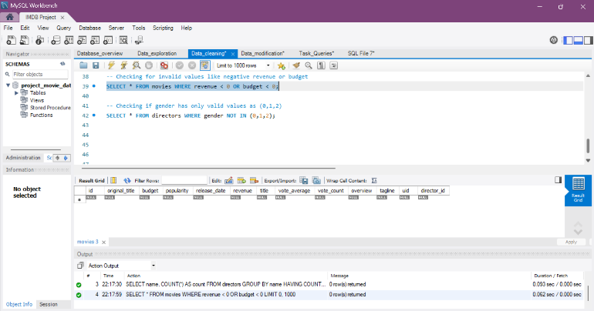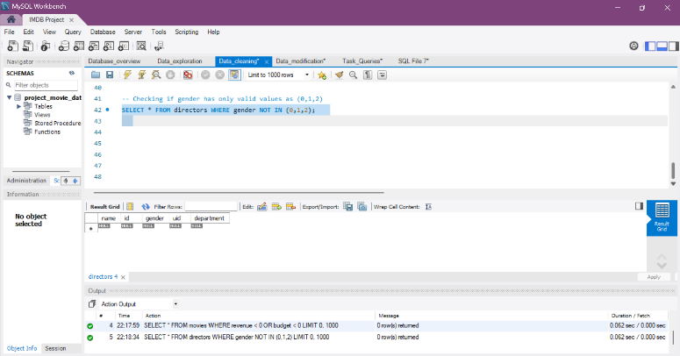

Interpretation:

Checked for invalid or inconsistent data values.

2.3.4 Data Modification
Data Modification Attempt
SQL Query:
USE project_movie_database;

-- updating the empty values in tagline with not available
UPDATE movies SET tagline = 'Not Available' WHERE tagline IS NULL;

-- Creating backup for table movies before modification
CREATE TABLE movies_backup AS SELECT * FROM movies;
ALTER TABLE movies DROP COLUMN id;
ALTER TABLE movies CHANGE COLUMN director_id id INT;
DESCRIBE movies;
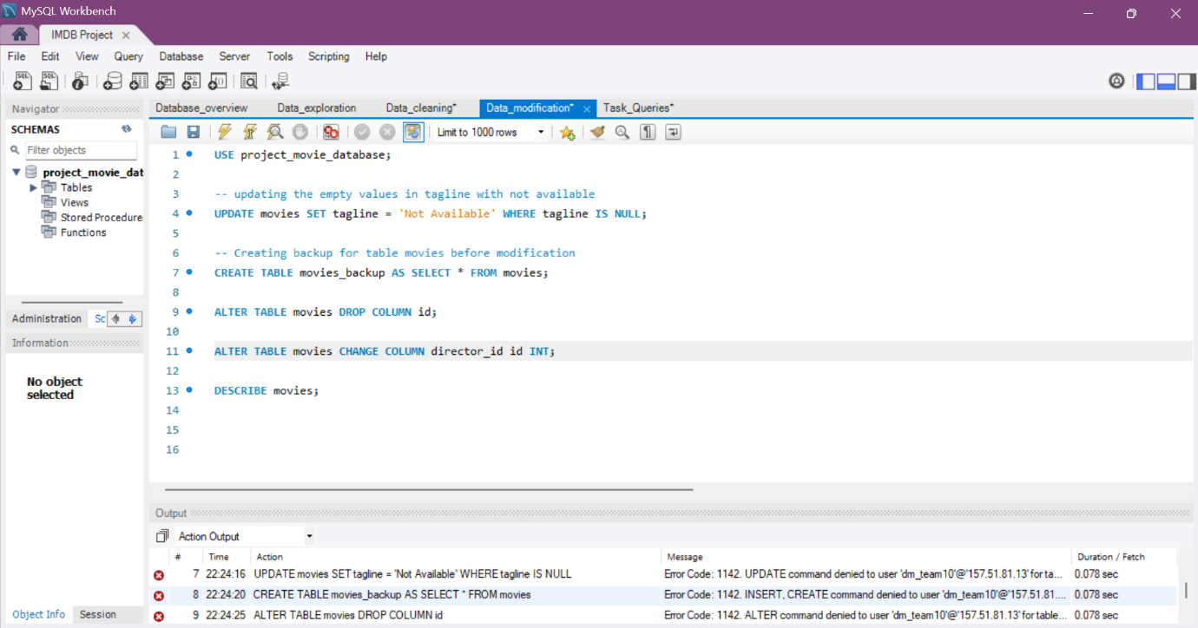

- The above modification queries were attempted as per project instructions. However, due to restricted database access, operations such as UPDATE and ALTER could not be executed.
- Therefore, data transformation and table merging were handled logically using SQL JOIN operations without modifying the original dataset.

Table Merging Approach
- As per the project instructions, it was suggested to drop the ID column from the Movies table and rename Director_ID to ID for merging both tables.
- However, due to access limitations in the provided database environment, modification operations such as ALTER, UPDATE, and CREATE were not permitted.
- Hence, the tables were merged logically using SQL JOIN operations based on the relationship:
movies.director_id = directors.id
- This approach ensured accurate analysis while preserving the original structure of the dataset.

2.4 Tools and Technologies Used
- MySQL Workbench
- SQL (Structured Query Language)
- Power BI (for visualization)

CHAPTER – 3: ANALYSIS
3.1 SQL Queries & Analysis
The following queries were performed:
- Can you get all data about movies?

SQL Query :
SELECT * FROM movies;

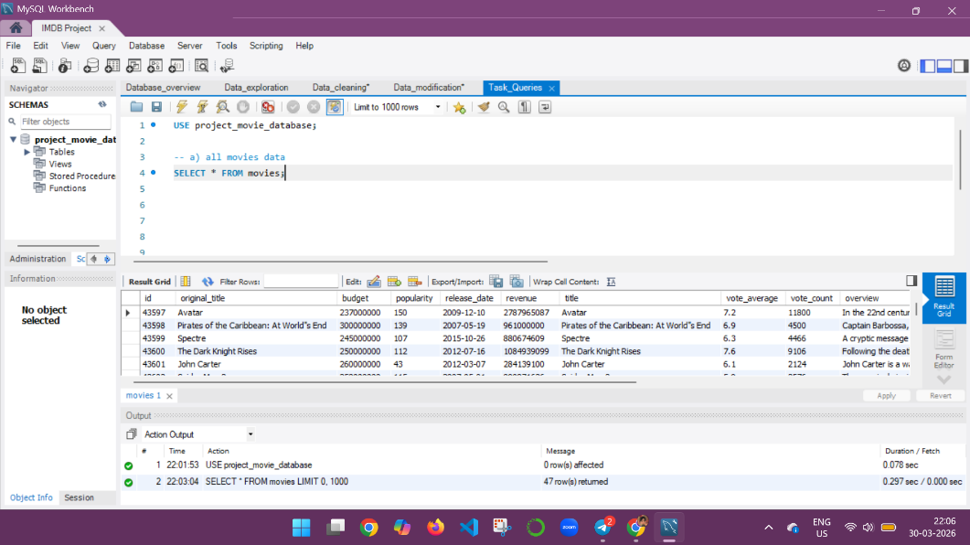

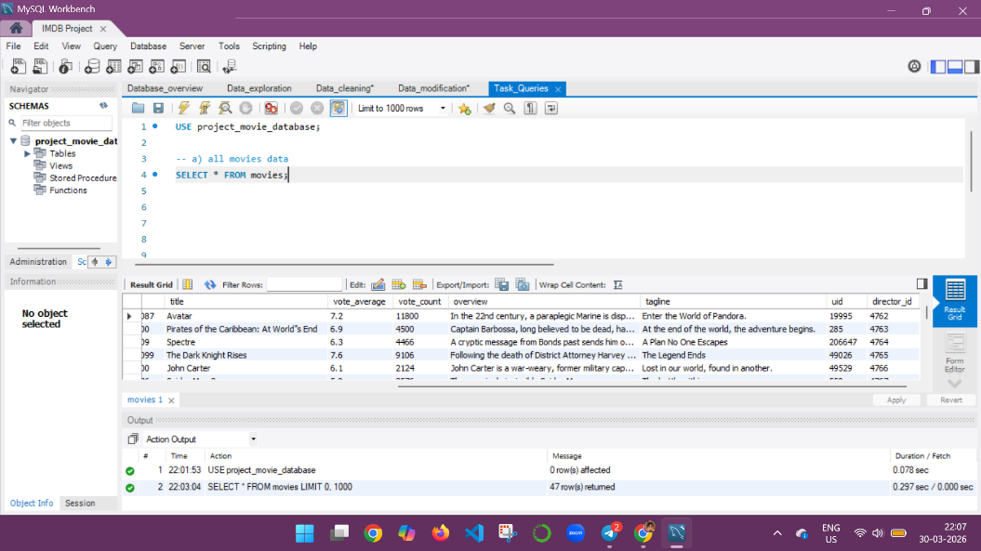

Interpretation:
Retrieves all records and columns from the movies table.

- How do you get all data about directors?

SQL Query :
SELECT * FROM directors;

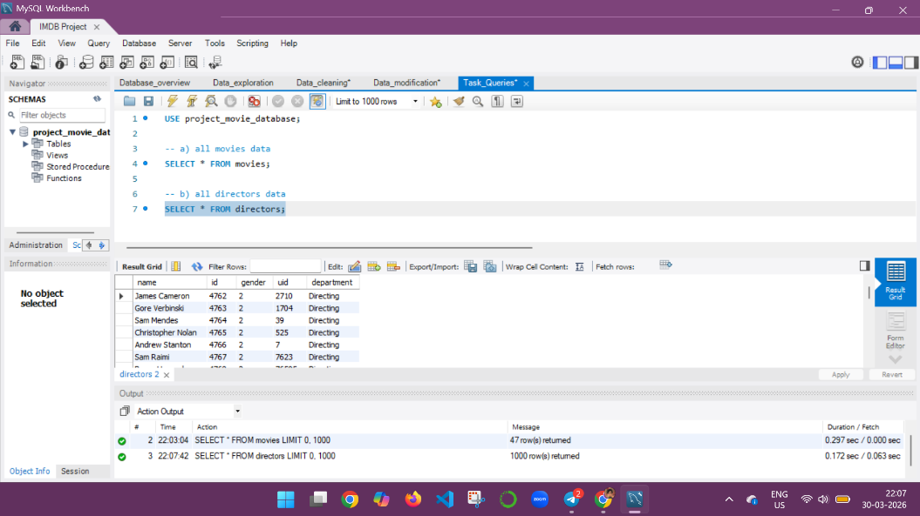

Interpretation:
Retrieves all records and columns from the directors table.

- Check how many movies are present in IMDB.

SQL Query :
SELECT COUNT(*) AS total_movies FROM movies;

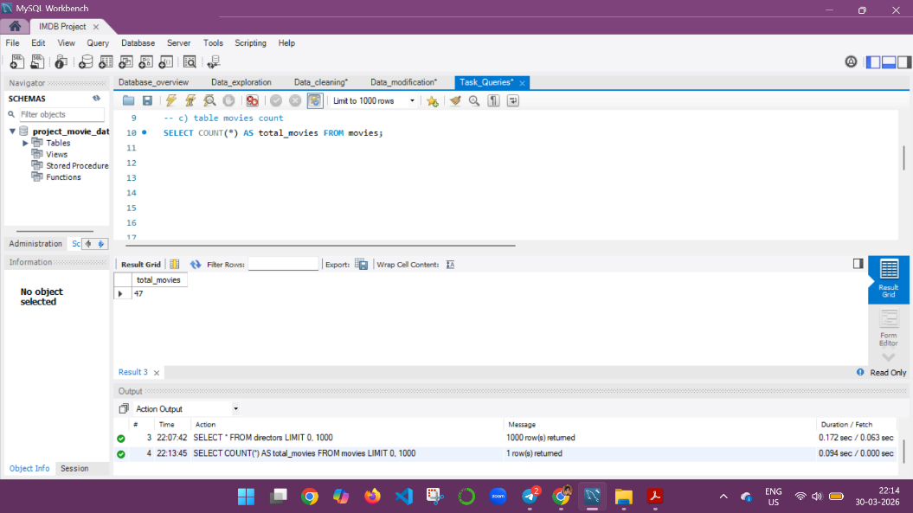

Interpretation:
Calculates the total number of movies present in the movies table.

- Find these 3 directors: James Cameron ; Luc Besson ; John Woo

SQL Query:
SELECT * FROM directors WHERE name IN ('James Cameron', 'Luc Besson', 'John Woo');

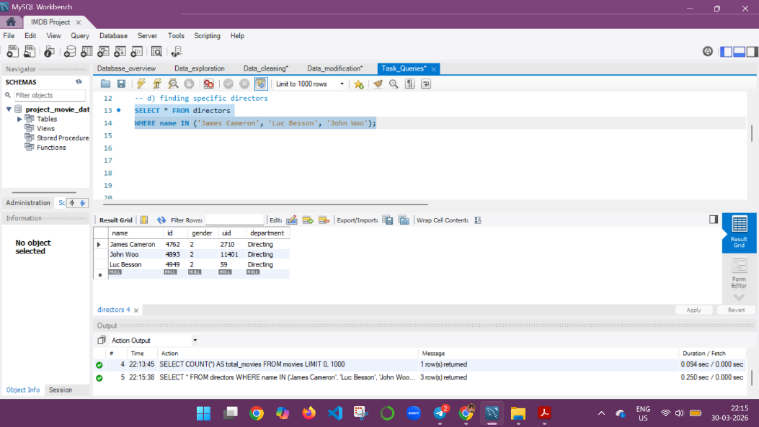

Interpretation:
Filters and retrieves details of the specified directors (James Cameron, Luc Besson, John Woo)

- Find all directors with name starting with S.

SQL Query:
SELECT * FROM directors WHERE name LIKE 'S%';

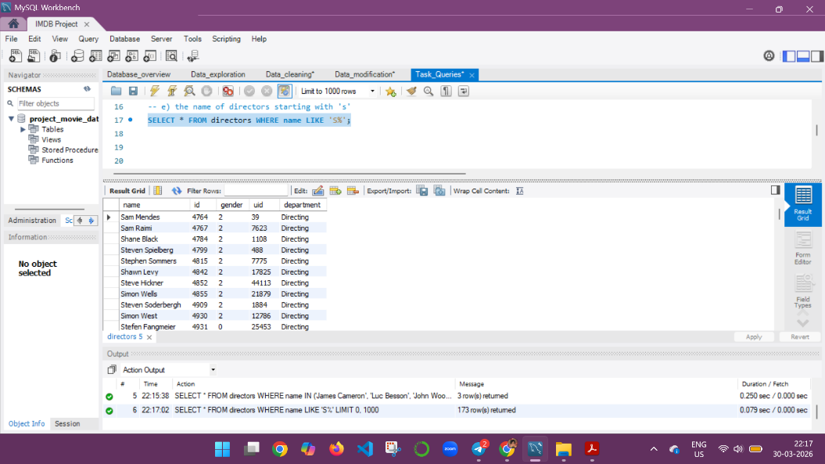

Interpretation:
Finds directors whose names start with the letter 'S'.

- Count female directors

SQL Query:
SELECT COUNT (*) AS total_female_directors FROM directors WHERE gender = 1;

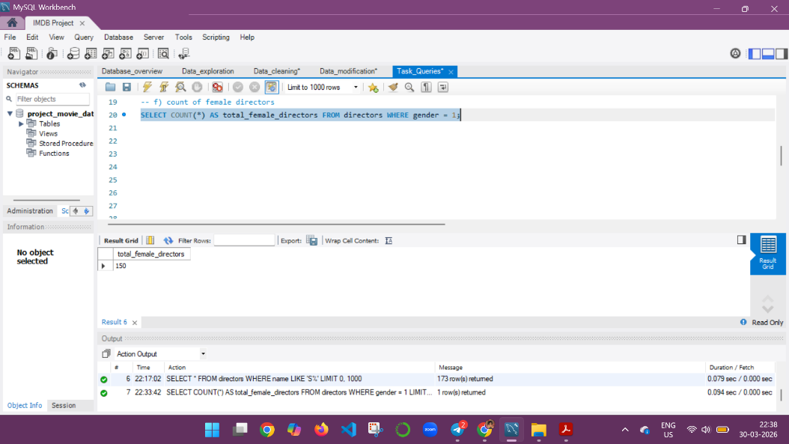

Interpretation:
Counts the number of female directors from the directors table in the dataset.

- Find the name of the 10th first women directors?

SQL Query:
SELECT name FROM directors WHERE gender = 1 LIMIT 1 OFFSET 9;

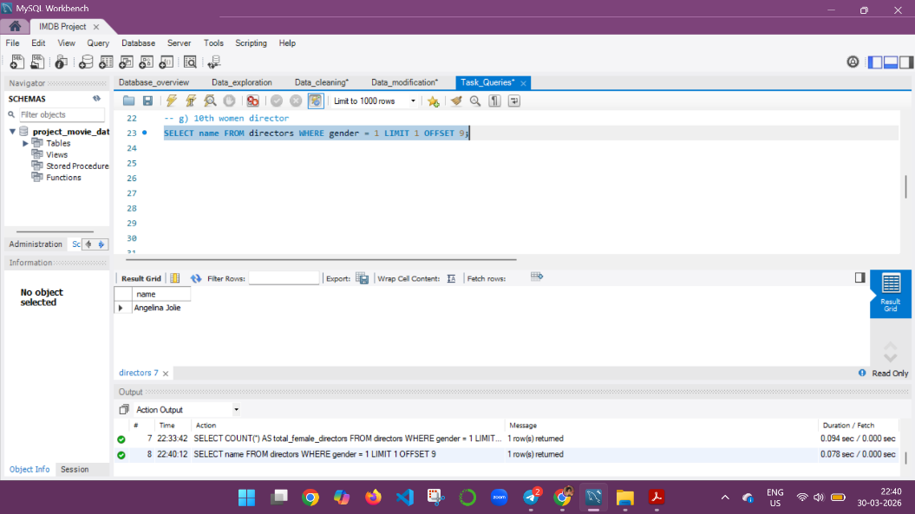

Interpretation:
Retrieves the 10th female director using row offset.

- What are the 3 most popular movies?

SQL Query:
SELECT original_title, popularity FROM movies ORDER BY popularity DESC LIMIT 3;

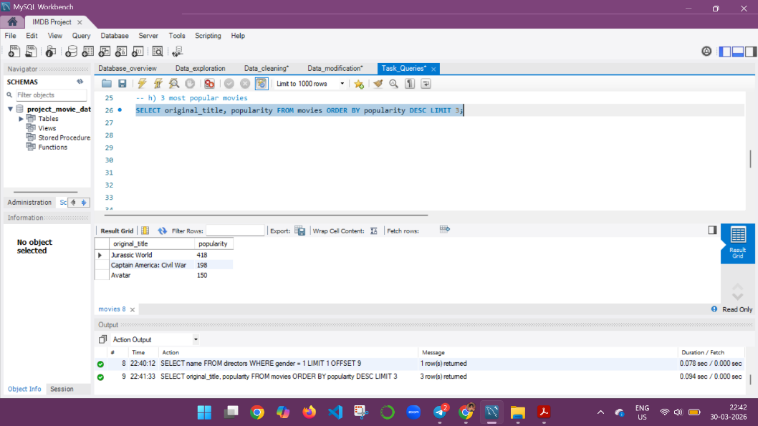

Interpretation:
Finds the top 3 movies based on popularity.

- What are the 3 most bankable movies?

SQL Query:
SELECT original_title, revenue FROM movies ORDER BY revenue DESC LIMIT 3;

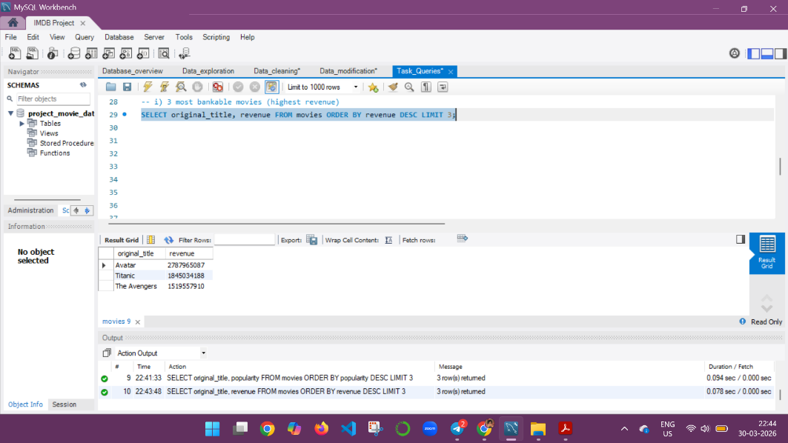

Interpretation:
Identifies movies with the highest revenue.

- What is the most awarded average vote since the January 1st, 2000?

SQL Query:
SELECT original_title, vote_average
FROM movies
WHERE release_date >= '2000-01-01'
ORDER BY vote_average DESC
LIMIT 1;

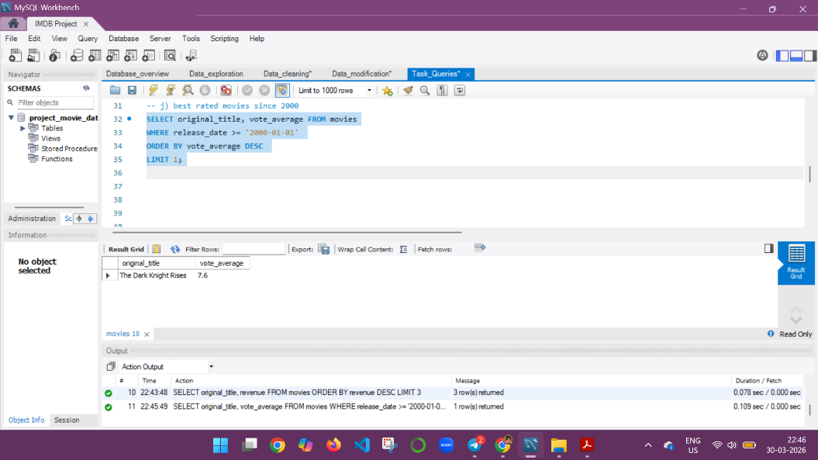

Interpretation:
Calculates the average rating of all movies released after January 1, 2000.

- Which movie(s) were directed by Brenda Chapman?

SQL Query:
SELECT m.original_title
FROM movies m
JOIN directors d ON m.director_id = d.id
WHERE d.name = 'Brenda Chapman';

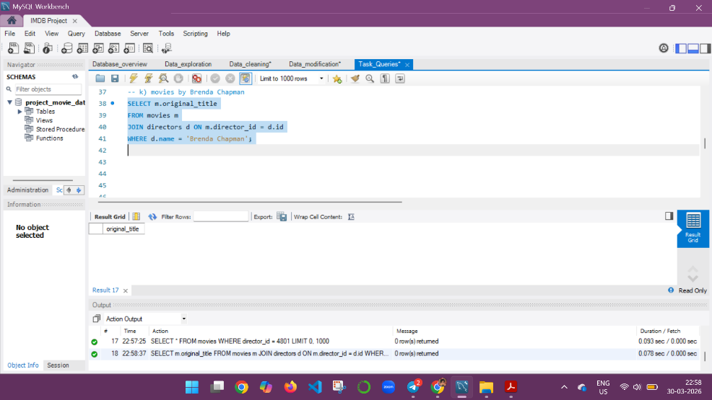

Interpretation:
Finds movies directed by Brenda Chapman (no results found in dataset).

- Which director made the most movies?

SQL Query:
SELECT d.name, COUNT(*) AS total_movies
FROM movies m
JOIN directors d ON m.director_id = d.id
GROUP BY d.name
ORDER BY total_movies DESC
LIMIT 1;

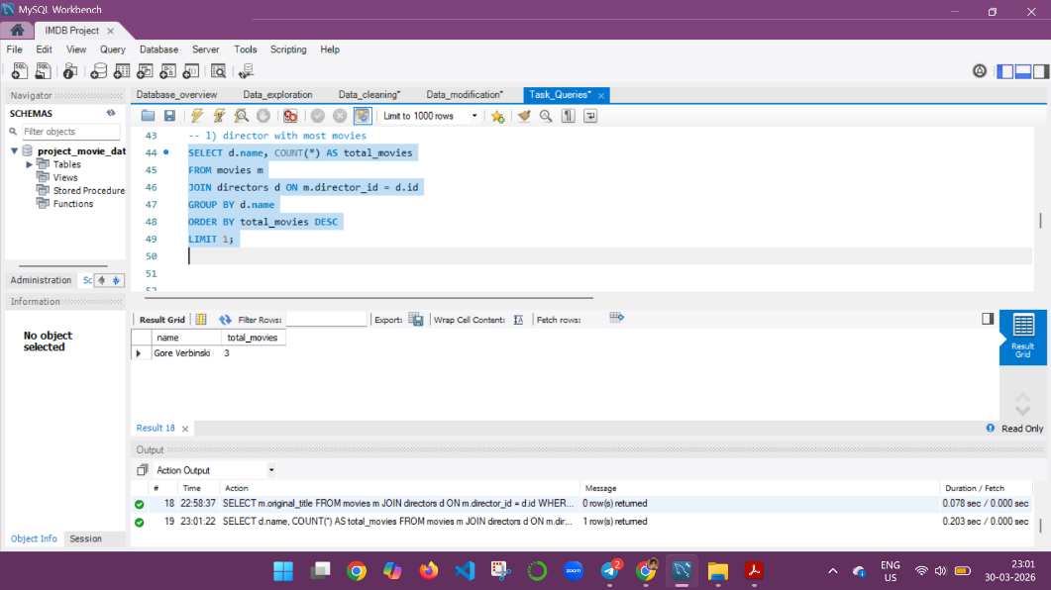

Interpretation:
Identifies the director who directed the highest number of movies.

- Which director is the most bankable?

SQL Query:
SELECT d.name, SUM(m.revenue) AS total_revenue
FROM movies m
JOIN directors d ON m.director_id = d.id
GROUP BY d.name
ORDER BY total_revenue DESC
LIMIT 1;

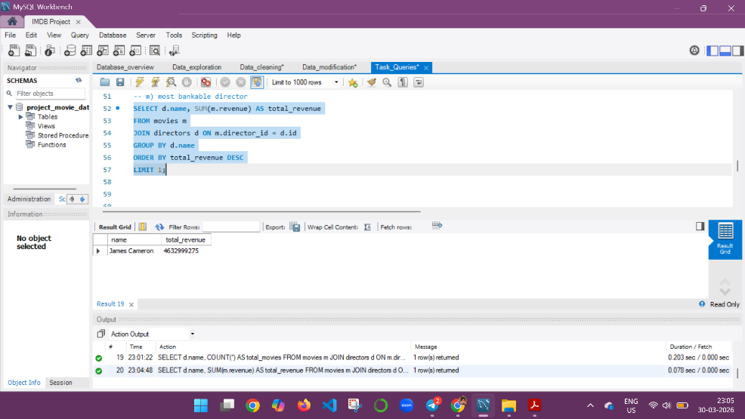

Interpretation:
Finds the director whose movies generated the highest total revenue.

3.2 Dashboard Design
The Power BI dashboard was designed to provide an interactive and visual analysis of the IMDB Movies dataset. The dashboard includes KPI cards, charts, and slicers to allow dynamic exploration of the data.

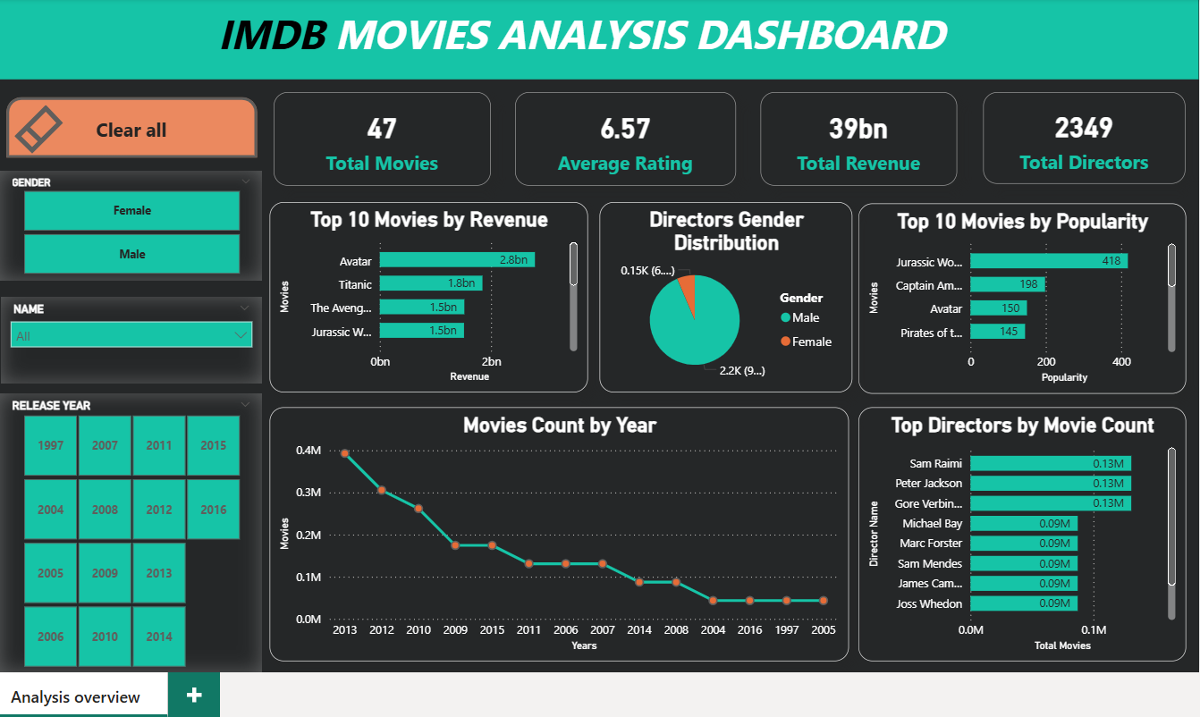

Key components of the dashboard:
1. KPIs (Cards):
- Total Movies: Count of movies in the dataset
- Average Rating: Average IMDB rating (vote_average)
- Total Revenue: Sum of revenue of all movies
- Total Directors: Count of directors in the dataset
Measures formulas (DAX):
Total Movies = COUNT(movies[ID])
Average Rating = AVERAGE(movies[vote_average])
Total Revenue = SUM(movies[revenue])
Total Directors = COUNT(directors[ID])

2. Charts:

- Top 10 Movies by Revenue: Shows highest revenue movies (Bar Chart)
- Top 10 Movies by Popularity: Shows trending/popular movies (Bar Chart)
- Movies Count by Year: Displays the number of movies released each year (Line Chart)
- Gender Distribution of Directors: Pie Chart showing male/female directors
- Top Directors by Movie Count: Bar Chart showing number of movies per director
3. Slicers:
- Year: Filter movies by release year (based on the Year column created in Power Query)
- Director Name: Filter data by director
- Gender: Filter data by gender using Gender_Name column (Male/Female)
4. Data Preparation:
- A separate Year column was created from the release_date to enable year-based filtering.
- Gender column was transformed into Gender_Name (Male/Female) for user-friendly slicers.
- Measures were created in DAX to calculate KPIs dynamically.
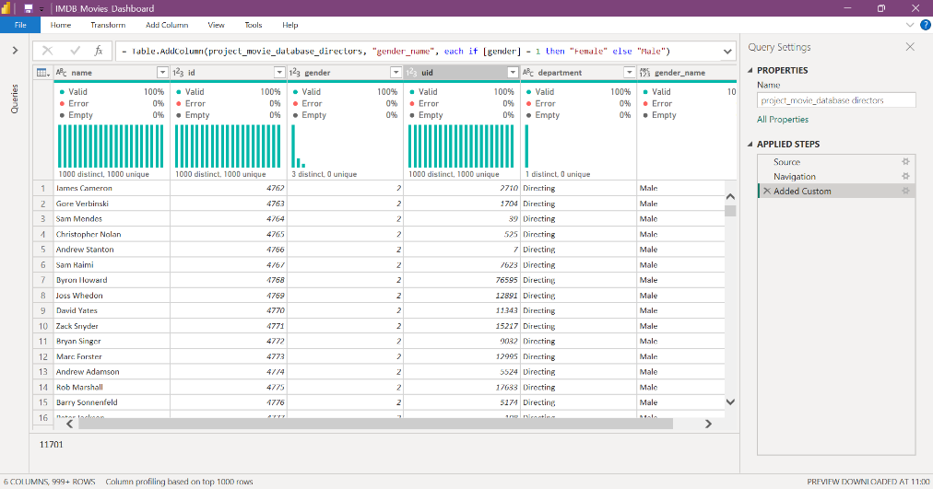
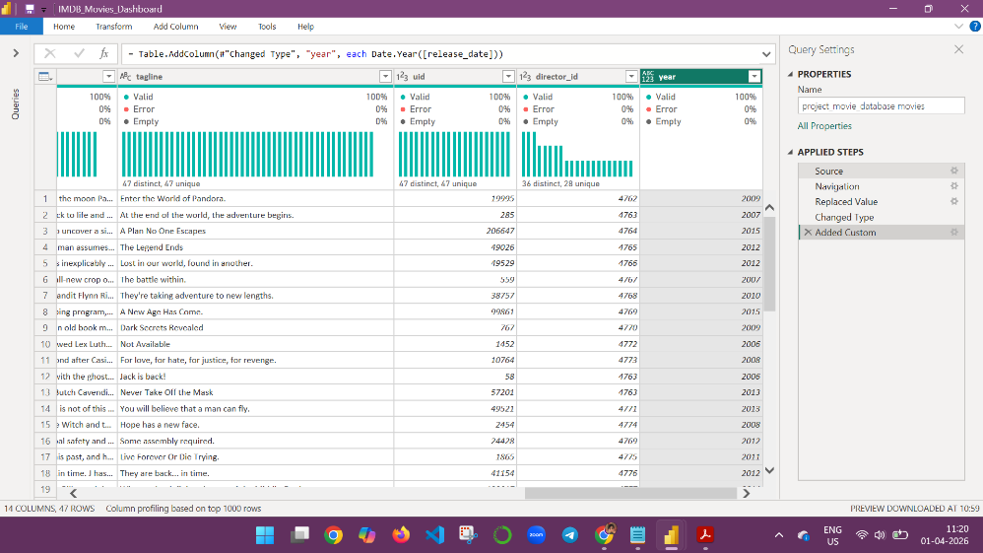

3.3 Results and Insights
- Movies in the dataset have varying levels of popularity and revenue, indicating differences in performance.
- The distribution of movies across directors shows slight variation, with a few directors having up to 3 movies, while the majority have directed only one movie.
- It was observed that higher revenue does not necessarily correspond to higher ratings in some cases.
- Female directors are comparatively fewer in the dataset.
- Movies released before 2000 have higher average ratings compared to movies released after 2000.
- A few directors in the dataset do not have associated movies, which resulted in empty query outputs during analysis.
- The analysis highlights trends in movie performance, director contribution, and data limitations within the dataset.

CHAPTER – 4: CONCLUSION

4.1 Conclusion
This project helped in understanding how SQL can be used to analyze real-world datasets. It provided hands-on experience in data cleaning, querying, and extracting insights. The integration of SQL with visualization tools like Power BI enhances data interpretation and decision-making.

