Project Title :PUBLIC TRANSPORT OPTIMIZATION – IOT

Phase 5: PROJECT DOCUMENTATION AND SUBMISSION

Project Definition:

This project provides a combination of process of sensing several gas levels in the air and also the ambient temperature and humidity, thus sensing the quality of the air. The levels of the gases and the temperature is displayed in a LCD display panel. The current air quality monitoring methods, including those used by regulatory agencies and research institutes, have been providing useful information on the trend and status of air pollutants worldwide, supporting ongoing assessment of air quality at different locations. Those measurements at fixed stations, however, are rather discrete spatially, thus cannot provide full coverage of the air quality status in a larger area. Such full coverage is essential in some studies of the effects of air pollution, for instance, in epidemiological studies for the health effects of different air pollutants.

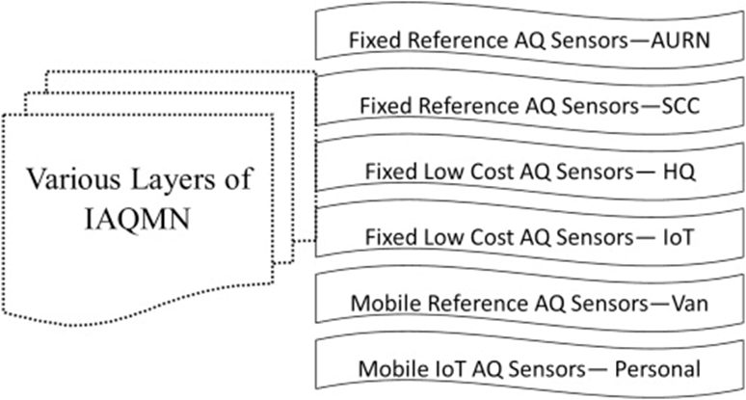

This work dissects the application of big data and artificial intelligence (AI) technology in environmental protection monitoring. The application principle of big data in environmental data collection is analysed based on atmospheric science and AI technology. In addition, a combined model of air quality forecasting based on machine learning is proposed to resolve real air quality monitoring challenges in environmental protection, namely, the improved complete ensemble empirical mode decomposition with adaptive noise-whale optimization algorithm-extreme learning machine (ICEEMDAN-WOA-ELM). On this basis, deep learning is introduced to establish a deep learning-based time-space-type-meteorology (TSTM) model to predict air quality. Finally, the model is verified by experiments. The results demonstrate that the ICEEMDAN-WOA-ELM model significantly outperforms a single AI model in air quality forecasting. The five evaluation index values of ICEEMDAN-WOA-ELM are 14.187, 17.235, 0.140, 0.067, and 0.946, which are higher than those of the other models. The single-step accuracy and average of the TSTM model in the heavily polluted weather forecast results almost reached full marks, with a maximum of 1.00. The performance also decreases with the growth of the step size but remains above 0.86. It can be seen that a single AI model can no longer meet the requirements of air quality forecasting. The ICEEMDAN-WOA-ELM model combined with big data has advantages in air quality monitoring and is effective for environmental protection.

Big data have gradually entered all walks of life. Data resources will be a critical wealth in the future. Applying big data thinking and artificial intelligence (AI) diagnosis technology in environmental governance can provide data and technical support for environmental public governance. In addition, environmental governance can provide scientific and accurate ideas for government decision-making in public environmental monitoring and early warning through data collection, real-time monitoring, and citizen participation management. In recent years, global air quality monitoring has developed rapidly. These infrastructure improvements related to air quality monitoring can be attributed to governments’ new or expanded monitoring networks and essential contributions from global citizens and nongovernment agencies. Despite progress, many countries and regions still lack air quality monitoring, leaving large sized populations without access to the information necessary to address pollution and make informed health decisions. Globally, Africa, Latin America, and West Asia have the sparsest monitoring networks. After 2020, the world has taken significant epidemic prevention measures and improved air quality. However, the air pollution caused by human activities such as climate deterioration and burning fossil fuels is still severe. Pollution levels are very high in California, South America, Siberia, and Australia due to wildfires and dust storms triggered by a warming climate. An IoT-based air and sound pollution monitoring system is implemented using a network of sensors, connectivity technologies, and data analytics platforms. Air quality sensors are deployed in strategic locations to measure pollutant levels such as particulate matter, gases, and volatile organic compounds (VOCs). IoT (Internet of Things) has become an integral part of our lives and it has already made an impact in various sectors, including the environment. Air pollution is a severe problem that has been affecting our planet for years. Therefore, there is a need for a reliable and efficient air pollution monitoring system to protect ourselves from its hazardous effects. An IoT-based air pollution monitoring system is an ideal solution that can provide real-time data and insights about the air quality in a particular area.

An IoT based air pollution monitoring system consists of several hardware and software components that work together to collect and process data. The hardware components include sensors, microcontrollers, and communication modules. The software components consist of a cloud platform, a mobile application, and a web-based dashboard.

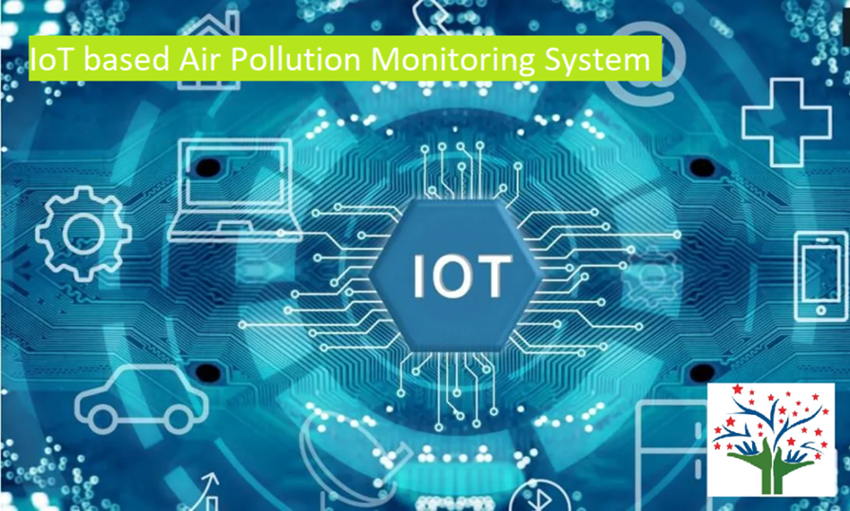

Air quality is getting worse worldwide, especially in cities with high population density and many industrial parks. Raising community awareness and applying science and technology are effective ways to mitigate the negative impacts of industrialization and pollution on the natural environment as well as public health. This work presents the design and deployment of an IoT-based air quality monitoring system, named the Environmental Monitoring System (EnMoS). LoRa (Long-Range) wireless communication technology and innovation sensors being used aim to facilitate the development of data communication network over a large area, improving sensing reliability, extending battery life as well as reducing total system costs. The air quality factors such as particulate matter (PM2.5 and PM10), carbon dioxide (CO 2 ), air temperature and humidity, after being read from the sensors were uploaded to a real-time database server for Air Quality Index (AQI) calculation. In addition, for indicating conveniently obtained AQI values a web page is also developed to provide an interactive map along with corresponding charts. A case study on an actual LoRa network consisting of three sensing nodes and a gateway were conducted for validating the feasibility of the system.