FPGA-Based Elevator Controller Using Verilog HDL

Abstract
This project focuses on the design and simulation of a four-floor elevator controller using Verilog HDL. The controller is modeled as a Finite State Machine (FSM) that manages floor requests, elevator movement, and door operations. Simulation results and waveform analysis demonstrate the correctness of the design. The project provides practical exposure to FPGA-based digital system design, sequential logic, and hardware verification.

Introduction
FPGA technology is widely used for implementing digital systems because of its flexibility, speed, and reconfigurability. An elevator controller is a common example of a real-time control system where decisions must be taken based on user requests. In this project, Verilog HDL is used to design a controller capable of moving between floors while maintaining correct state transitions.

Objectives
• Design a functional elevator controller using Verilog HDL.
• Implement Finite State Machine (FSM) based control.
• Simulate floor requests and elevator movement.
• Verify operation using waveform analysis.
• Understand FPGA design and hardware verification concepts.

System Architecture
The system consists of clock and reset inputs, a floor request input, FSM control logic, and outputs representing the current floor and operating state. The FSM continuously compares the requested floor with the current floor and decides whether the elevator should move upward, move downward, remain idle, or open its door.

FSM Design
The controller operates using four states: IDLE, MOVE_UP, MOVE_DOWN, and DOOR_OPEN. In the IDLE state, the controller waits for a floor request. If the requested floor is higher than the current floor, the FSM enters MOVE_UP. If the requested floor is lower, the FSM enters MOVE_DOWN. Once the destination floor is reached, the FSM enters DOOR_OPEN before returning to IDLE.

Verilog Implementation
The design is written using Verilog HDL. Sequential logic driven by the clock signal controls state transitions. Registers store the current floor and state information. The design demonstrates the use of conditional statements, state machines, and synchronous digital logic.
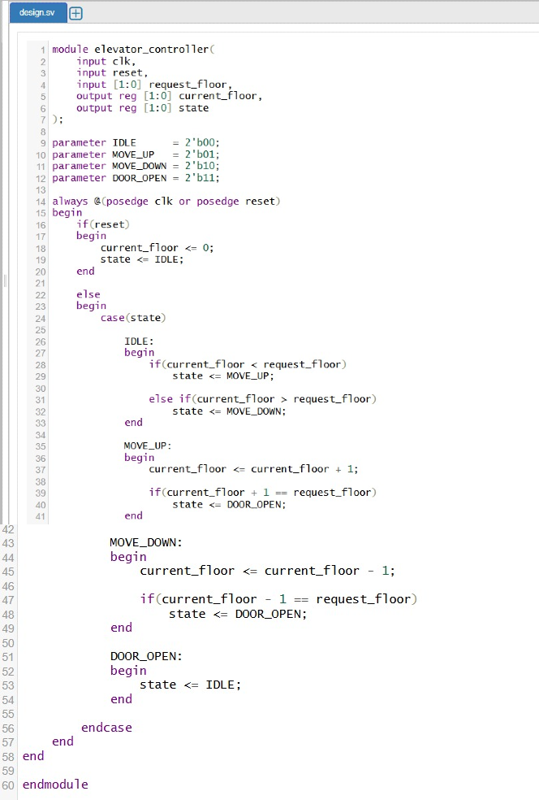
Figure 1: Verilog HDL implementation of the elevator controller.
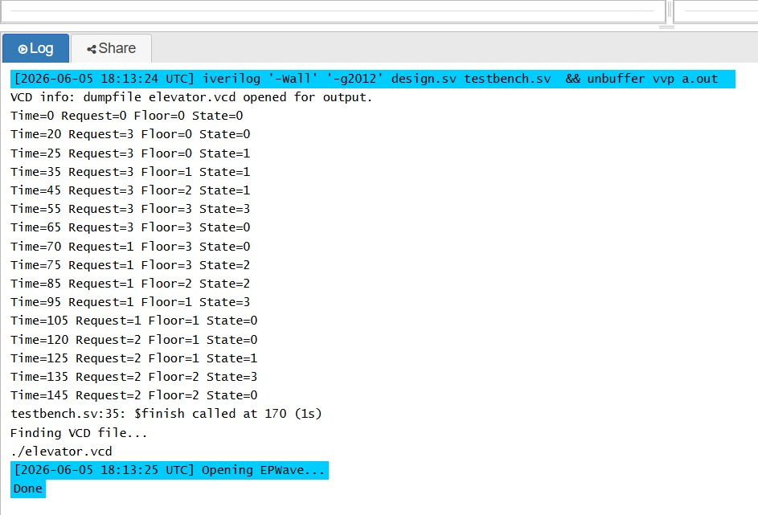
Figure 2: Simulation output showing floor transitions and FSM behavior.
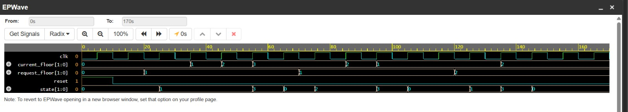
Figure 3: EPWave waveform showing signal activity and state transitions.

Simulation Results
Simulation confirms that the elevator responds correctly to floor requests. When a higher floor is requested, the controller transitions into the MOVE_UP state and increments the floor count. Similarly, requests for lower floors result in MOVE_DOWN transitions. Upon reaching the destination floor, the controller enters the DOOR_OPEN state and then returns to IDLE.

Waveform Analysis
Waveform verification provides a graphical view of signal behavior over time. The clock signal drives state transitions, while the request_floor signal determines the target floor. The current_floor output changes as the elevator moves. The state signal clearly indicates FSM transitions between IDLE, MOVE_UP, MOVE_DOWN, and DOOR_OPEN.

Advantages
• Simple and modular design
• Easy FPGA implementation
• Reliable FSM-based control
• Easy verification through simulation
• Scalable for additional floors

Applications
Elevator controllers are used in residential buildings, commercial complexes, hospitals, hotels, and industrial facilities. The same FSM design principles can also be applied to automated transport systems and industrial automation controllers.

Conclusion
The FPGA-Based Elevator Controller was successfully designed and verified using Verilog HDL. Simulation and waveform analysis confirmed the correct operation of the FSM and floor control logic. The project demonstrates fundamental FPGA design concepts and provides a strong foundation for more advanced digital systems.

Future Scope
Future enhancements may include support for multiple simultaneous requests, larger numbers of floors, emergency handling mechanisms, priority scheduling algorithms, and direct deployment on FPGA development boards.

