Industrial SCADA Interface using ESP32
A Real-Time Industrial Monitoring and Control System

Abstract
This project presents an Industrial SCADA Interface using ESP32 for real-time monitoring of water level, temperature, and humidity. The system uses an HC-SR04 ultrasonic sensor for tank level measurement and a DHT22 sensor for environmental monitoring. Based on sensor readings, LEDs, a relay module, and a buzzer provide visual and audible indications of system conditions.

Introduction
Supervisory Control and Data Acquisition (SCADA) systems are widely used in industries to monitor and control processes. This project demonstrates a simplified SCADA interface capable of collecting sensor data, processing information, and generating alerts.

Objectives
• Monitor water level in a storage tank.
• Measure temperature and humidity.
• Generate alerts for abnormal conditions.
• Control relay-based outputs.
• Provide real-time status indication.

Hardware Components
ESP32 Development Board
DHT22 Temperature and Humidity Sensor
HC-SR04 Ultrasonic Sensor
Relay Module
Buzzer
LED Indicators
Breadboard and Jumper Wires

Software Requirements
Arduino IDE / Wokwi Simulator
ESP32 Board Package
DHT Sensor Library
Embedded C/C++ Programming

Working Principle
The ultrasonic sensor measures the distance between the sensor and water surface. The ESP32 calculates water level percentage from this distance. Temperature and humidity are obtained from the DHT22 sensor. Depending on threshold values, the controller activates LEDs, relay outputs, and buzzer alerts.

Algorithm
1. Read ultrasonic sensor data.
2. Calculate water level percentage.
3. Read DHT22 temperature and humidity.
4. Compare values with predefined thresholds.
5. Display status through serial monitor.
6. Activate LEDs, buzzer, and relay accordingly.
7. Repeat continuously.

Figure 1: Tank Low Condition
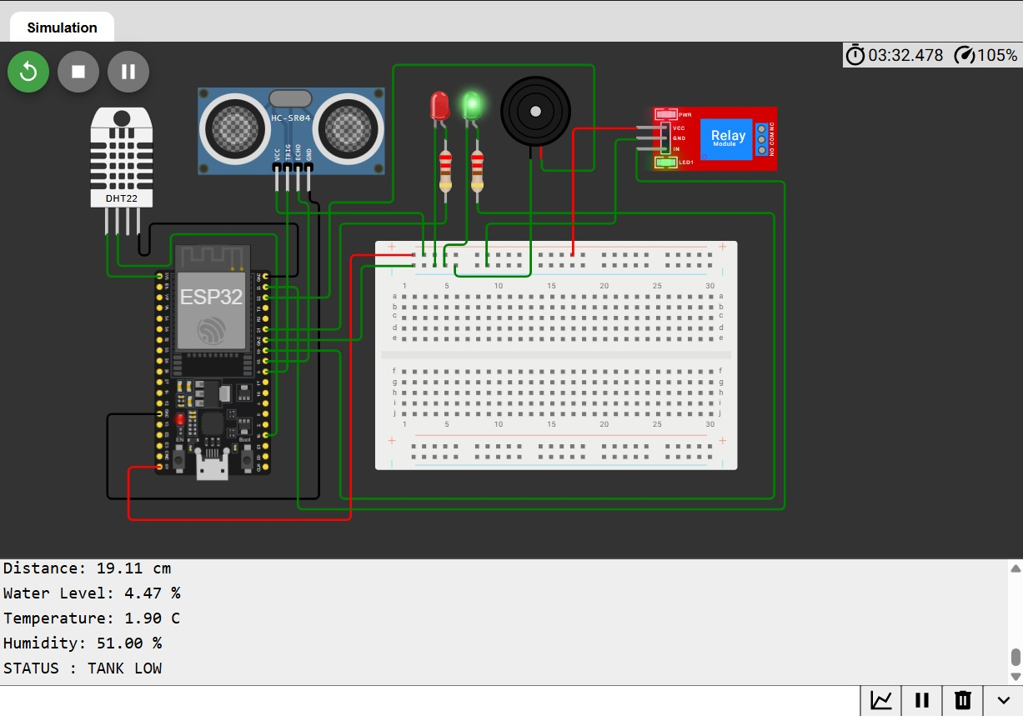
Figure 1: Tank Low Condition

Figure 2: Normal Operating Condition
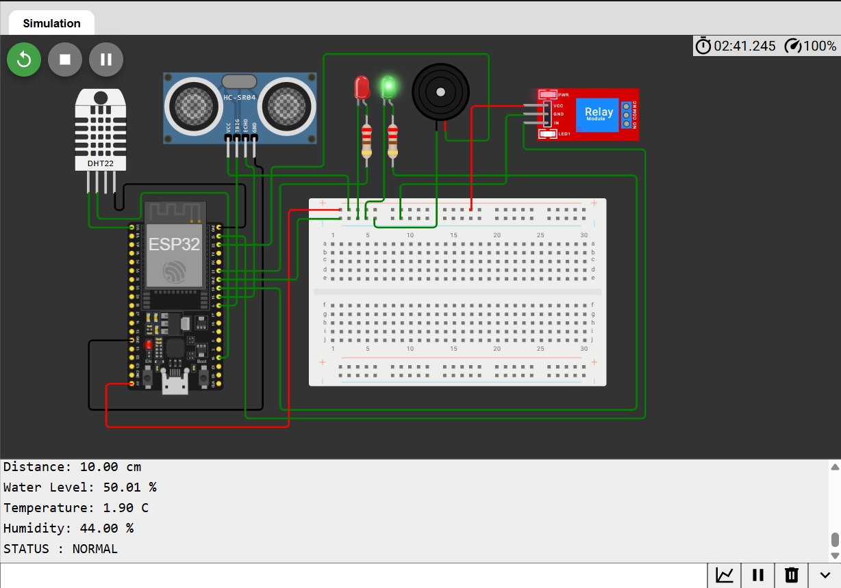
Figure 2: Normal Operating Condition

Figure 3: High Temperature Alert Condition
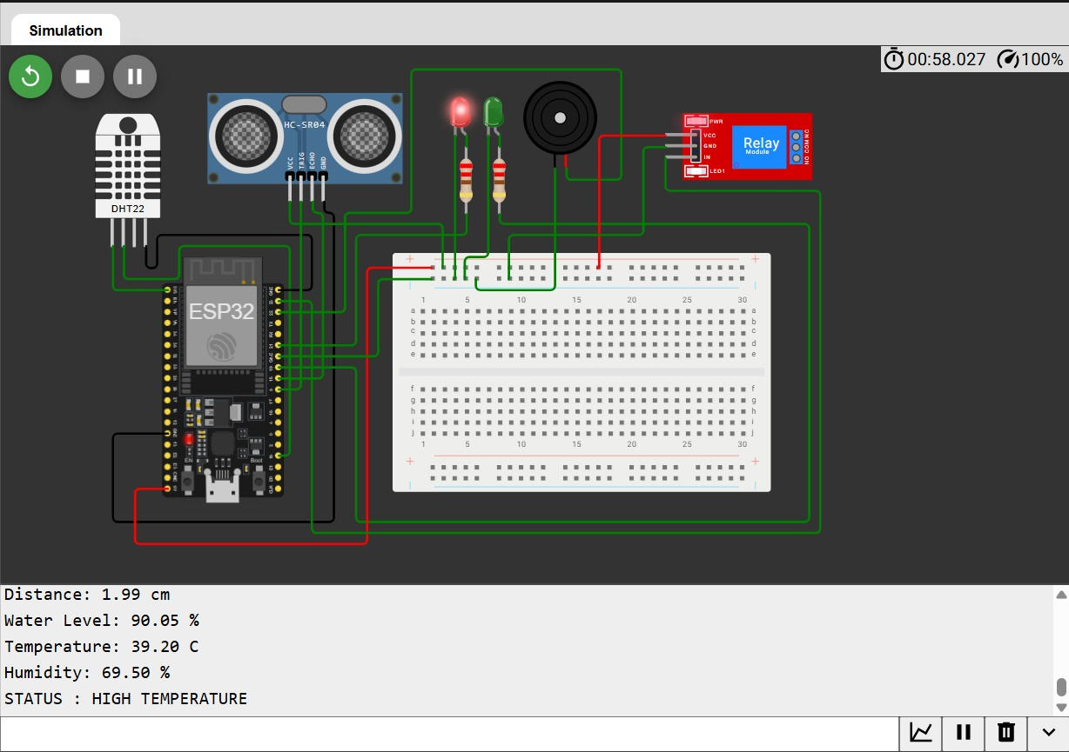
Figure 3: High Temperature Alert Condition

Results and Discussion
The developed system successfully monitored industrial parameters under different operating conditions. When the water level dropped below the threshold, the system displayed a Tank Low status. During normal operation, sensor readings remained within acceptable limits. When temperature exceeded the threshold value, the system generated a High Temperature warning and activated the alert mechanism.

Advantages
• Low-cost industrial monitoring solution
• Real-time sensor monitoring
• Easy scalability and expansion
• Suitable for IoT integration
• Supports industrial automation concepts

Applications
Water treatment plants, industrial tanks, manufacturing units, smart factories, process monitoring systems, and remote monitoring applications.

Future Scope
Future enhancements include cloud connectivity, dashboard visualization, mobile notifications, predictive maintenance using AI, and integration with industrial communication protocols.

Conclusion
The Industrial SCADA Interface using ESP32 successfully demonstrates monitoring, control, and alert generation in an industrial environment. The project combines sensing, processing, and automation to provide a practical and scalable monitoring solution.

