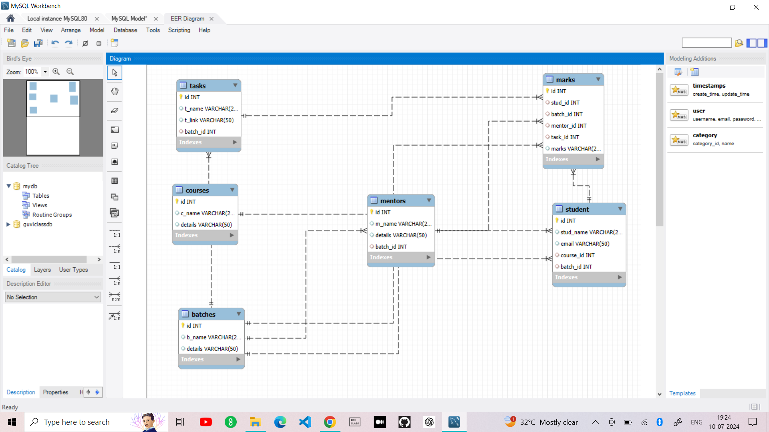

STEP 1: Creating the Database in Mysql with Name “Guviclassdb”..
STEP 2 : Use that Database
Query : use guviclassdb;
STEP 3 : creating the required Tables for all the fields :
- Student tble,
- Mentor tble,
- Batch tble,
- Courses tble,
- Marks tble,
- Tasks tble.
STEP 4 : Creating tables
- BATCHES TABLE :
create table batches(id int primary key , b_name varchar(25) , details varchar(50));
- COURSES TABLE :
create table courses(id int primary key , c_name varchar(25) , details varchar(50));
- STUDENT TABLE :
create table student(id int primary key ,
stud_name varchar(25) ,
email varchar(50),
course_id int,
foreign key (course_id) references courses (id),
batch_id int,
foreign key (batch_id) references batches(id));
STEP 5 : Creating the tables for : Mentors , Tasks , Marks
- MENTORS TABLE :
create table mentors(
id int primary key ,
m_name varchar(25) ,
details varchar(50),
batch_id int,
foreign key (batch_id) references batches(id));

- TASKS TABLE :
create table tasks(id int primary key ,
t_name varchar(25) ,
t_link varchar(50),
batch_id int,
foreign key (batch_id) references batches(id));

- MARKS TABLE :
create table marks(id int primary key ,
stud_id int,
foreign key (stud_id) references student (id),
batch_id int,
foreign key (batch_id) references batches(id),
mentor_id int,
foreign key (mentor_id) references mentors(id),
task_id int,
foreign key (task_id) references tasks(id),
marks varchar(20));

