After completing the assignment, please answer the questions in this text file and submit it to I-Learn.

1. Copy and paste the URL for your Heroku web application:

<https://git.heroku.com/infinite-anchorage-47368.git>

1. Copy and paste the URL for your GitHub source code repository:

<https://github.com/JeniferMLlerena/cs313-php.git>

1. Briefly list and describe the elements of the application that are functioning. Include any special instructions about how to login and/or use your application.

I was able to connect to Heroku, Github and create the web and helloworld.html

1. Briefly describe any pieces of the assignment that are not yet working correctly.

For some reason, it doesn’t matter what I tried I keep receiving this every time I want to push to Heroku master.

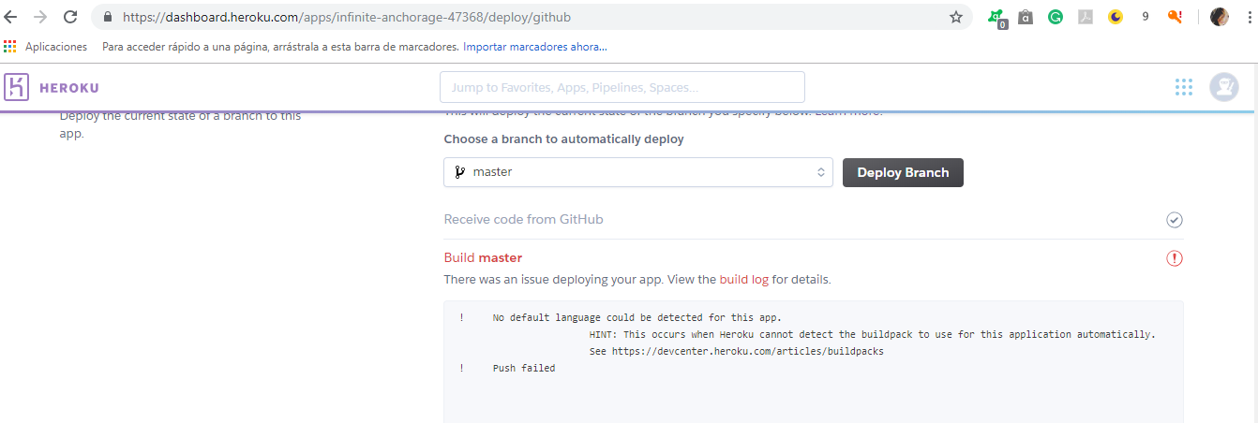

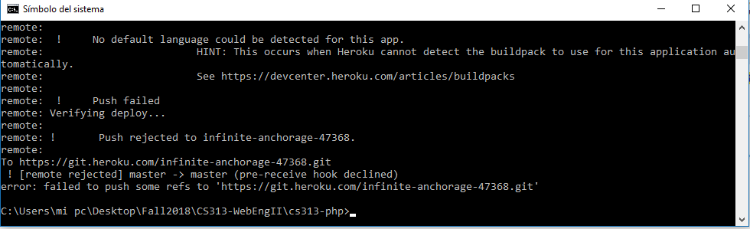

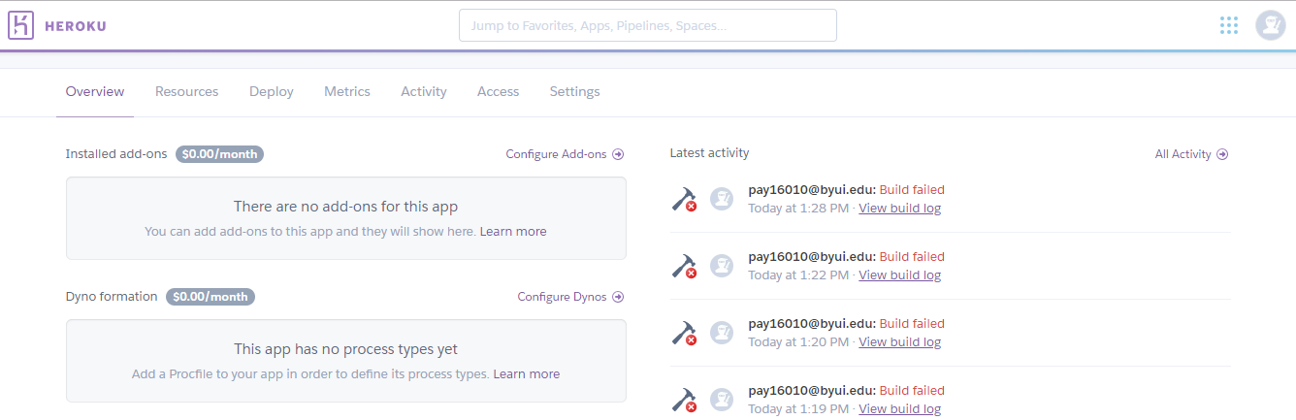

1. Briefly describe the "coolest" thing you learned while completing this assignment.

I didn’t know about Heroku and how we could build, run and operate the applications in the cloud.

1. Please select the category you feel best describes your assignment: [A-E]

A - Some attempt was made

B - Developing, but significantly deficient

C - Slightly deficient, but still mostly adequate

D - Meets requirements

E - Shows creativity and excels above and beyond requirements

1. Provide a brief justification (1-2 sentences) for selecting that category.

I’d loved to see this working, but I expended 2 hours already and I wouldn’t work. I hope after I fix this bug I can the opportunity to be more creative with the future assignments.