# PHP Project Proposal

## Description:

For this project I would do a website for people to buy affordable cars. The main audience in this project would be students or young people buying their first car for the best price.

## Design Overview:

This website would have many options would most of them would be focusing in the most commons and reliable car brands. Where the options would include a ranking of cars that meet qualities like mileage, fuel efficiency, and safety for the best price. For this a database would be created and the website would also have option for the users have access to their own account giving them the opportunity to see their favorite saved options and the option of buying them.

## Database:

The database for this website would have 5 tables: Customer, Order, Supplier, Product and OrderItem.

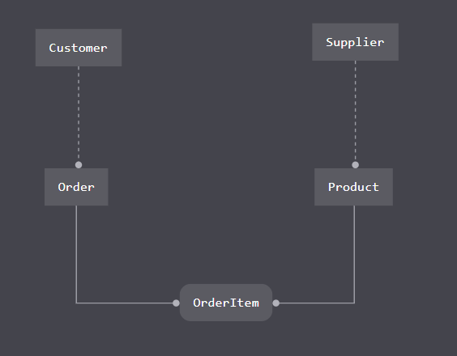

The tables would have primary keys, foreign keys and would have restrictions for no login users.

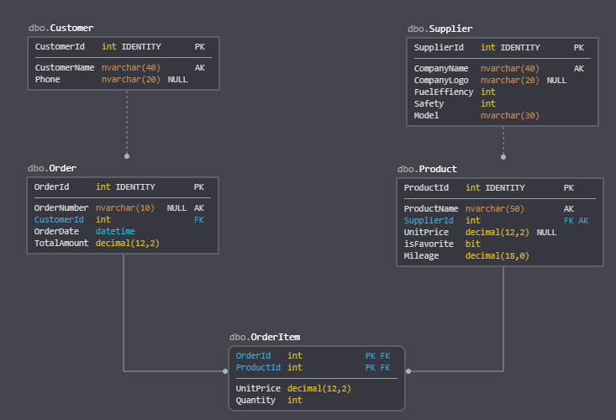

## Database Retrieval

The user would be able to display a list of the cars available in the database, the user would also be available to filter this list according to brand or model of the car, the mileage of the car, and the safety rating of a specific car. The cars would have an information card where the user would check the price and the other feature every model have.

## Database Update

The user would be able to login and select their favorite cars and marked then with a favorite heart icon so when he/she open her account again would see what was saved the last time he/she login. I have a column in my Product table that I would not user for the first or second week but I would use it for the update that is call isFavorite which would be check in a function to display those who have a T (true) in the favorite list.