Answer the following questions based on the given data set:

1. Are there any correlated features in the given dataset? If yes, state the correlation

Answer:

* Yes, this given dataset has correlation between some numerical features. The correlation matrix of influencer is shown in the below figure.

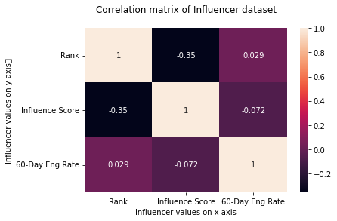

* Rank has positive linear correlation with the 60-Day Eng Rate with the co-efficient 0.029 and influence score is negatively correlated with co-efficient -0.35.

2. What is the frequency distribution of the following features?

○ Influence Score

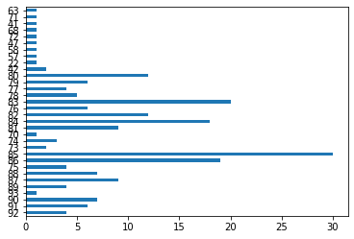

○ Followers

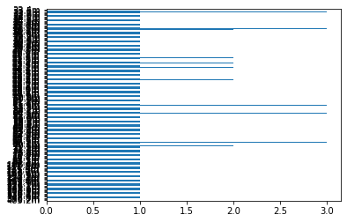

○ Posts

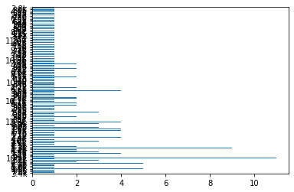

3. Which country houses the highest number of Instagram Influencers? Please show the

count of Instagram influencers in different countries using bar chart.

Answer: United States

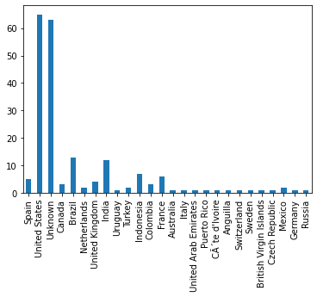

4. Who are the top 10 influencers in the given dataset based on the following features

● Followers

● Average likes

● Total Likes

Answer:

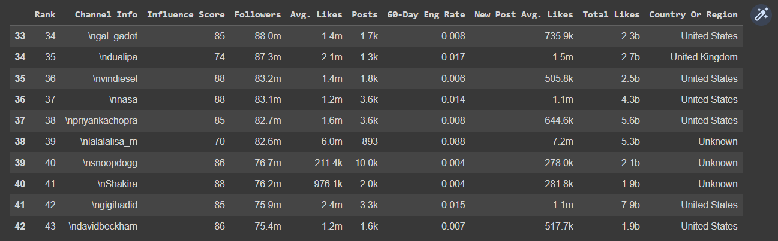

5. Describe the relationship between the following pairs of features using a suitable graph

● Followers and Total Likes

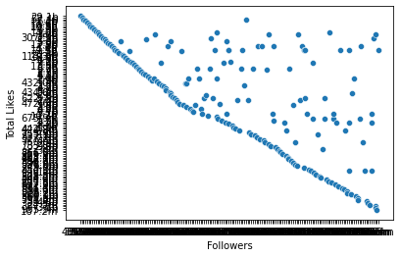

● Followers and Influence Score

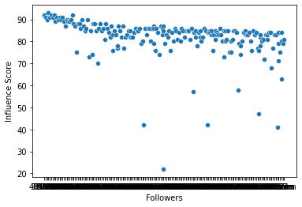

● Posts and Average likes

● Posts and Influence Score