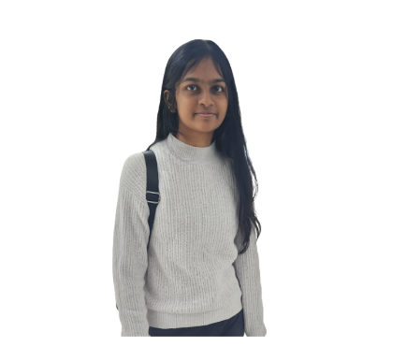Name: Albert Nelson Jeniffer Joyce

Email: 21025290@myrp.edu.sg

Mobile: +65 9636 3394

Linkedin: <https://www.linkedin.com/in/jeniffer-joyce-a-11ab43210/>

**Internship Objective**

A student studying at Republic Polytechnic aspiring to work in the IT Industry. Has great strengths in programming and communication and is responsible for completing any work that has been assigned efficiently.

**Summary of Key Skills**

|  |  |
| --- | --- |
| *Technical Skills*   * Programming using Java, Python, * Database Systems, MySQL, MongoDB * Styling Webpages with HTML, JavaScript, and CSS * Adobe XD, Photoshop, Adobe Illustrator * Data analysis in Excel, SAS Visual analytics   *Language Proficiency*   * English   (Proficient in spoken and written)   * Tamil (Proficient in spoken and written) | *Critical core skills*   * Problem solving * Creative thinking * Communication * Quick Thinking * Leadership |

**Education**

**Republic Polytechnic April 2024**

Diploma in Digital Design and Development

cGPA: 3.75

Final Year Project

Pet Transportation System

This project utilizes Fronte-End Development, Web Application Development, System Testing and UI/UX to propose, design, develop and host a web application. The users will be able to use this website to book pet transportation making it easier for the company to organize and operate the business.

My role in the project is the team coordinator whereas I work with my team and make sure that we are motivated to create an according website that fits all the requirements.

**Greendale Secondary School 2017 – 2020**

Attained 5 GCE ‘O’ Level Subject passes

**Edgefield Primary School 2011 – 2016**

Attained 5 PSLE passes

**Volunteer and Leadership Experience**

**Teaching juniors in CCA 2020**

**Senior teacher**

* Coordinated with batchmates to prepare slides and materials needed for teaching the juniors and made it easier to teach in an organized and effective manner.
* Coached fellow juniors who needed additional time to learn new concepts which increased the performance of juniors during the final assessment.
* Built a bond with juniors by interacting with them during the break and increased student engagement.

**Bright hill Evergreen Elderly Home** **2019**

**One of the leaders in charge of organizing events to be conducted**

* Worked alongside other leaders to create and execute 3 activities such as Coloring activity, Origami folding activity, and Bingo game.
* Solved practical problems on the spot when there were technical difficulties.
* Communicated with elderly despite the language barrier and was able to engage them during planning breaks.

**Blood donation drive 2019**

**One of the volunteers to help with executing activities**

* Worked with the other volunteers to collect recordings of blood donors and explain the process to them.
* Engaged with blood donors, making them feel more comfortable as they go through the lengthy processes.

**World Redcross day 2017**

**One of the volunteers in charge of educating people on donation drives and collecting donations**

* Conducted donation collections around local areas and was in charge of explaining the different donation drives that existed.
* Performed extensive research on donation drives, thus was able to increase engagement with people.
* Communicated with people about donation drives and encouraged more people to donate, thus increasing the amount of donations.

**First-aid duty for school softball competition 2019**

**One of the two first-aiders**

**Achievements & Awards**

* Diploma Prize **2022**
* Module Prize: Immersive Technologies **2022**
* Director’s Roll of Honor **Semester 2 2022**
* Max Lewis Scholarship **2022**
* Director’s Roll of Honor **Semester 1 2022**
* NCS Girls In Tech Hackathon Participation **2022**
* Director’s Roll of Honor **Semester 2 2021**
* Director’s Roll of Honor **Semester 1 2021**
* Red Cross Youth Unit Excellence Award **2020**
* Greendale Game Carnival **2019**
* Greendale Jogathon **2019**

**References**

Available upon request

– End –