IU2541230046 – CPP27 – PROJECT REPORT
Restaurant Billing System
Enrollment No.: IU2541230046
Student Name: Jenil Nagpara

1. Introduction
The Restaurant Billing System is a console-based application written in C++ that manages a restaurant's menu, customer records, orders, bills, payments and a business summary report. It was developed as the guided project for IU2541230046 (CPP27) by following the class blueprint provided by the faculty. The program stores its records in text data files so that all information survives when the application is closed and opened again.

2. Problem Statement
Small restaurants often manage menu prices, customer details and bills by hand. This makes calculation errors likely, slows down checkout, and makes it hard to see how much was sold and how it was paid. The problem addressed by this project is to provide one program in which a cashier can maintain menu items and customers, generate a bill with GST (5%), record the payment with change, and produce a summary of the day's business, while keeping all data safely on disk.

3. Objectives
• Model the restaurant domain with well-designed C++ classes (encapsulation, inheritance and polymorphism).
• Provide Add, Display, Search, Update and Delete operations for menu items and customers.
• Implement the main transaction: create an order, compute the bill with GST, process payment and return change.
• Use dynamic memory correctly, releasing every allocation with delete or delete[].
• Save and load all records so that the data is available after the program is reopened.
• Validate all user input and handle errors with exceptions, so that the program never crashes on bad input.

4. Functional Requirements
• FR1 - Add Record: add a menu item (name, price) or a customer (name, 10-digit phone). IDs are assigned automatically.
• FR2 - Display Records: show every stored menu item and customer using polymorphic display().
• FR3 - Search Record: search by ID or by a case-insensitive name keyword.
• FR4 - Update Record: change the name and price of a menu item, or the name and phone of a customer; blank input keeps the old value.
• FR5 - Delete Record: remove a record after confirmation.
• FR6 - Main Transaction: choose a customer (or walk-in), add menu items (a repeated ID means quantity), calculate subtotal + 5% GST, take payment (Cash, Card or UPI), print the bill and show the change.
• FR7 - Report: show number of menu items, customers, bills, total revenue, average bill and payments per mode.
• FR8 - Save / Load: save to and load from the Data folder. Data is also loaded automatically at start-up and saved automatically on exit.
• FR9 - Exit: save all data and close the program.

5. System / Project Flow
The flow of the system from user input to file storage is:
USER → MAIN MENU (RestaurantSystem::run) → RestaurantSystem (core API) → Entity classes (MenuItem, Customer, Order, Bill, Payment) → Main transaction (placeOrder) → FileManager → Data/records.dat and Data/transactions.dat
At start-up the system loads the data files into memory. The user then selects a menu option. The menu handler reads and validates input, calls the core API, and the entity objects enforce the business rules. Changes are kept in dynamic arrays and written back to the data files when the user saves or exits.

6. Class Descriptions
The eight classes of the system, with their data members, functions and responsibilities, are listed below. The class diagram is shown in Section 9.
Class | Data Members | Member Functions | Responsibility
Record (abstract) | id, name (protected) | getId(), getName(), setName(), display() {pure}, toFileLine() {pure}, typeLabel() {pure}, virtual ~Record() | Common base for all master records; enables polymorphic storage
MenuItem | price | MenuItem(), MenuItem(id, name, price), getPrice(), setPrice(), display(), toFileLine(), typeLabel(), ~MenuItem() | Represents a dish; validates price > 0
Customer | phone | Customer(), Customer(id, name, phone), getPhone(), setPhone(), display(), toFileLine(), typeLabel(), ~Customer() | Stores customer details; validates a 10-digit phone
Order | orderId, customerId, itemIds (int*), unitPrices (double*), count, capacity, total | Order(), Order(id, customer), copy constructor, operator=, addItem(), calculateTotal(), ~Order() | Collects ordered items in dynamic arrays and totals them
Bill | billId, orderId, customerId, subtotal, tax, total; TAX_RATE | Bill(), Bill(...), calculateTotal(), printBill(), toFileLine(), ~Bill() | Applies 5% GST and prints the bill
Payment | paymentId, billId, mode, amount, change, paid | Payment(), Payment(...), processPayment(), display(), toFileLine(), ~Payment() | Validates mode (Cash/Card/UPI), checks tendered amount, computes change
FileManager | dataDir | recordsPath(), transactionsPath(), writeLines(), readLines() | Only file input and output; no business logic
RestaurantSystem | records (Record**), bills (Bill**), payments (Payment**), counters, fileManager | run(), addMenuItem(), addCustomer(), findById(), searchByName(), updateMenuItem(), updateCustomer(), deleteRecord(), placeOrder(), buildReport(), saveData(), loadData(), ~RestaurantSystem() | Owns all data, runs the menu and coordinates the classes

7. OOP Concepts Used
• Encapsulation: all data members are private or protected; they are changed only through getters and setters that validate values (for example setPrice() rejects a price of zero or less).
• Constructors: default and parameterised constructors exist for Record, MenuItem, Customer, Order, Bill and Payment; parameterised constructors validate their arguments.
• Destructors: Record has a virtual destructor so that deleting through a base pointer is safe; Order releases its arrays with delete[]; RestaurantSystem releases every object and array.
• Inheritance: MenuItem and Customer inherit from the abstract base class Record, which provides the common id and name.
• Runtime polymorphism: display(), toFileLine() and typeLabel() are pure virtual in Record and are overridden in each derived class. displayAllRecords() calls them through Record* pointers, so the correct version is selected at run time.
• Dynamic memory: Record**, Bill** and Payment** arrays grow on demand; Order keeps its item IDs and prices in int* and double* arrays; FileManager::readLines allocates a string array.
• File handling: text files are read and written with ifstream and ofstream through FileManager.
• Exception handling: RestaurantException (derived from std::runtime_error) reports validation and business errors; the main loop catches them and shows a message instead of stopping. placeOrder() deletes the bill if payment fails, so nothing is stored.

8. File Handling and Data Persistence
All data is stored in two plain text files inside the Data folder. Each line is one record, with fields separated by the '|' character:
• Data/records.dat - one line per master record: M|id|name|price for a menu item and C|id|name|phone for a customer.
• Data/transactions.dat - one line per bill (B|billId|orderId|customerId|subtotal) and per payment (P|paymentId|billId|mode|amount).
The tax and total of each bill are recalculated when the file is loaded, so the stored values are always consistent. To verify persistence, the program was run, data was saved and the program was closed; when it was opened again it displayed the same 4 records and 1 bill (see Section 12, Screenshot 4).

9. UML Diagrams
The four required UML diagrams are included: one use case diagram (2 actors and 8 use cases), one class diagram, and two sequence diagrams. The .dot source files are kept in the UML folder of the submission.
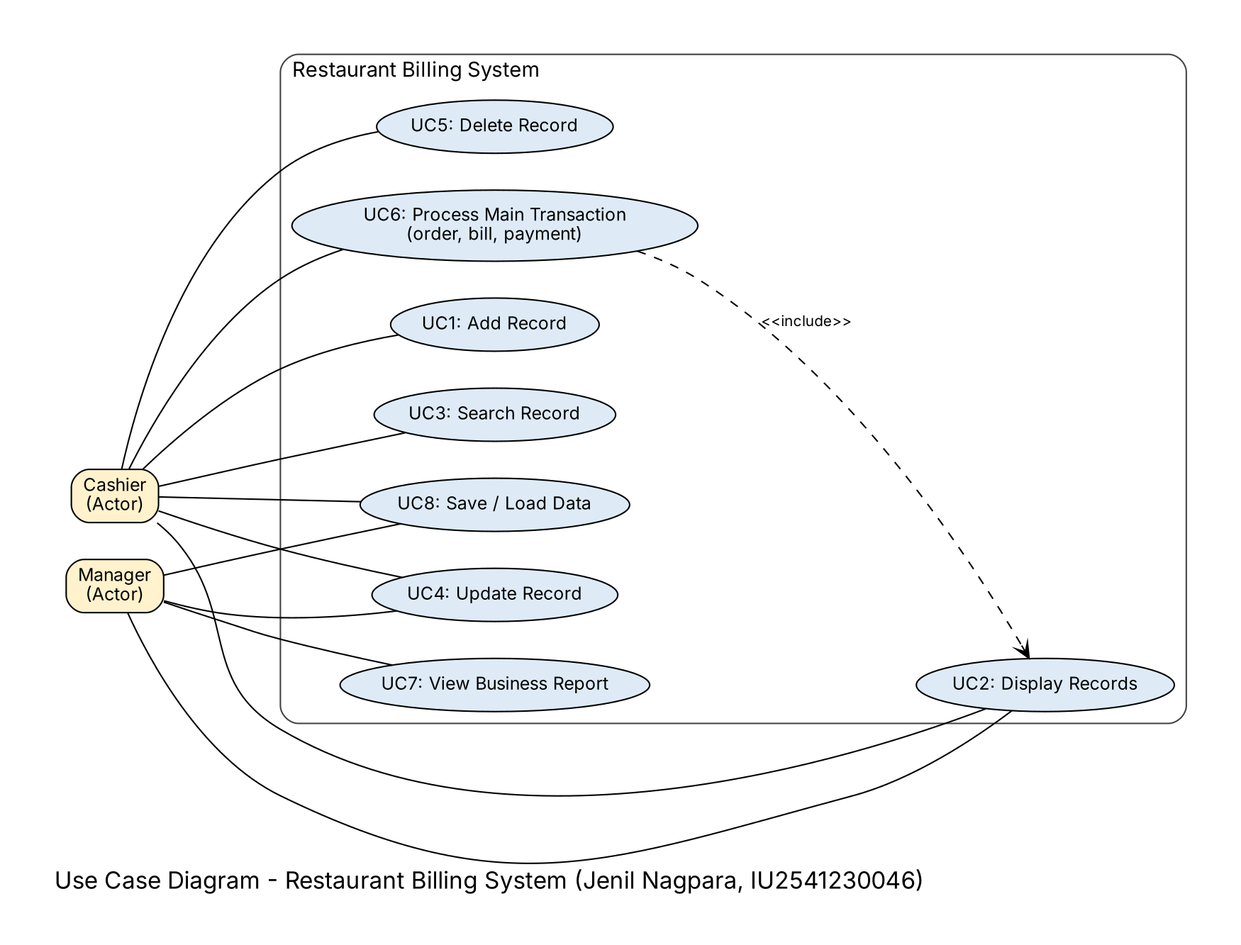
Figure 1: Use Case Diagram (actors: Cashier and Manager)
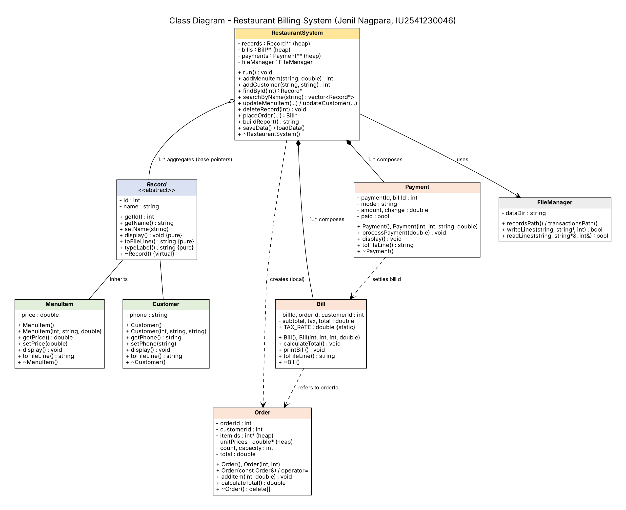
Figure 2: Class Diagram (inheritance, aggregation, composition and dependencies)
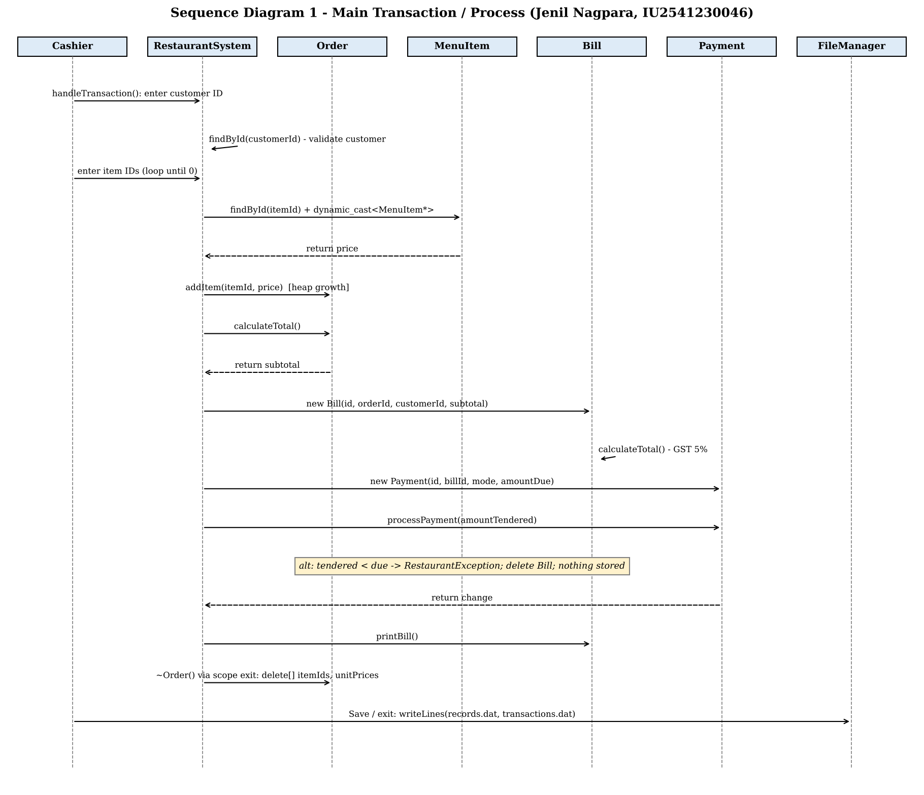
Figure 3: Sequence Diagram 1 - Main Transaction / Process
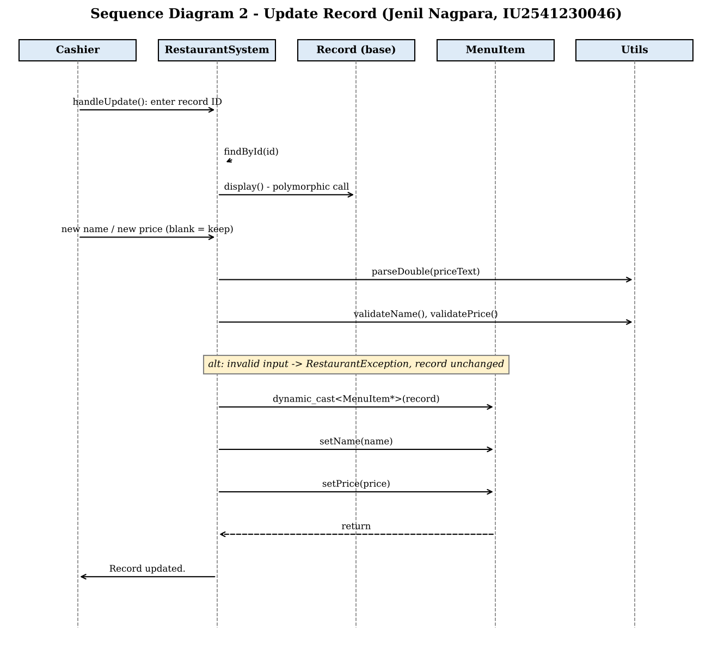
Figure 4: Sequence Diagram 2 - Update Record

10. Implementation Details
Source structure: src/ contains main.cpp, one .h/.cpp pair for each class (Record, MenuItem, Customer, Order, Bill, Payment, FileManager, RestaurantSystem), Utils.h/.cpp for input and validation helpers, and RestaurantException.h. tests/test_restaurant.cpp contains the 15 test cases. Data/ holds records.dat and transactions.dat.
main.cpp: creates one RestaurantSystem object and calls run(). All logic is in the RestaurantSystem class, as the blueprint requires.
Core API versus console: RestaurantSystem separates the core API (addMenuItem, placeOrder, updateMenuItem and so on, which contain no console input or output and throw exceptions) from the menu handlers. This allows the 15 test cases to call the core API directly.
Input handling: all input is read as a complete line and then parsed, so a letter typed where a number is expected produces a message rather than a failure. Input that reaches end-of-file ends the program cleanly after saving.
Build: build.sh (Linux/macOS) and build.bat (Windows, MinGW g++) compile the program with -std=c++11 -Wall -Wextra. The build produced no warnings.
Run: run the program from the project folder so that the Data folder is found.
GitHub repository: https://github.com/<your-github-username>/IU2541230046_PROJECT (replace this with the repository link before submission)

11. Testing and Results
All 15 test cases were run with the automated test suite (tests/test_restaurant.cpp). Result: 15 of 15 test cases passed. The actual output of each test was compared with the expected output.
Test ID | Input / Operation | Expected | Actual | Status
T01 | Add valid menu item: 'Paneer Tikka', 250 | ID assigned; name and price stored | ID 1, 'Paneer Tikka', Rs 250.00 | PASS
T02 | Add valid customer 'Asha Verma', 9876543210 | Stored with type Customer | Type 'Customer', ID 2 | PASS
T03 | Add menu item with price 0 | Error: price must be > 0 | Error: Price must be greater than 0 and at most 100000. | PASS
T04 | Add customer with phone 98765 | Error: phone must be 10 digits | Error: Phone number must be exactly 10 digits. | PASS
T05 | Add menu item named 'Bad|Name' | Error: '|' not allowed | Error: Name cannot contain the '|' character. | PASS
T06 | Search name 'DOSA' (case-insensitive) | 2 matches | 2 match(es) | PASS
T07 | Update menu item price 30 to 35 | Price becomes Rs 35.00 | Rs 35.00 | PASS
T08 | Delete a record | Record removed; count falls by 1 | Record removed; count 6 | PASS
T09 | Order total: Masala Dosa (120) + Coffee (40) | Subtotal 160, GST 8, total Rs 168.00 | Total Rs 168.00 | PASS
T10 | Pay Rs 100 for a Rs 126 bill | Rejected; no bill stored | Rejected (no bill stored) | PASS
T11 | 2 x Masala Dosa, UPI Rs 300 | Bill Rs 252.00; change Rs 48.00 | Bill Rs 252.00; change Rs 48.00 | PASS
T12 | Order using a customer ID as a menu item | Error: not a valid menu item | Error: ID 2 is not a valid menu item. | PASS
T13 | Save, close, reopen and load | Same records and bills restored | Restored 6 records, 1 bill | PASS
T14 | Typelabel through Record* base pointers | 'Menu Item' and 'Customer' | 'Menu Item' and 'Customer' | PASS
T15 | Report after one UPI transaction | 1 bill, revenue Rs 252.00, 1 UPI payment | Bills 1, revenue Rs 252.00, UPI 1 payment(s) | PASS

12. Sample Screens / Output
The following screens were captured from a real run of the program. Screenshot 1 shows adding records and displaying them; Screenshot 2 shows a rejected short payment followed by a successful transaction and bill; Screenshot 3 shows the report and saving; Screenshot 4 shows the data restored after the program was reopened.
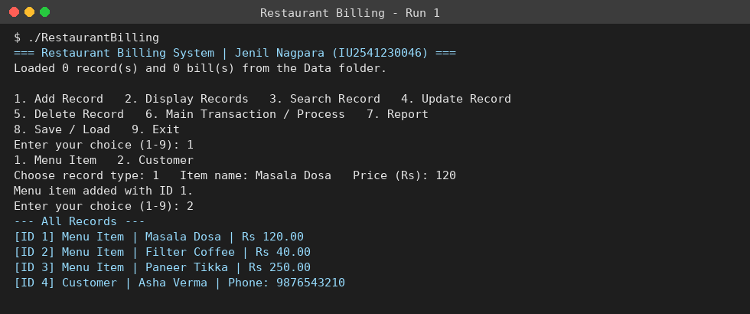
Screenshot 1: Adding menu items and a customer, then displaying all records
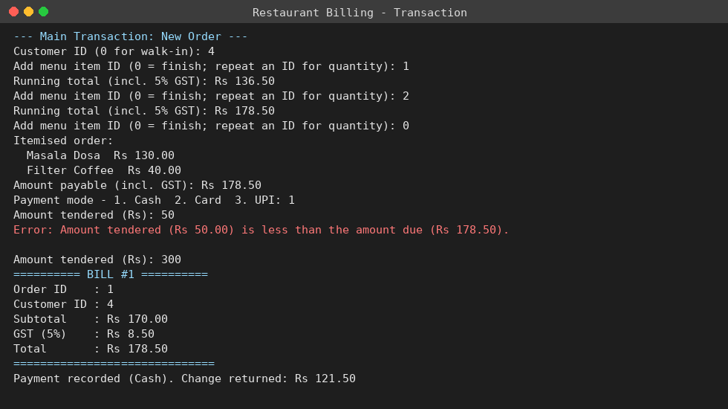
Screenshot 2: Main transaction - short payment rejected, then bill and change
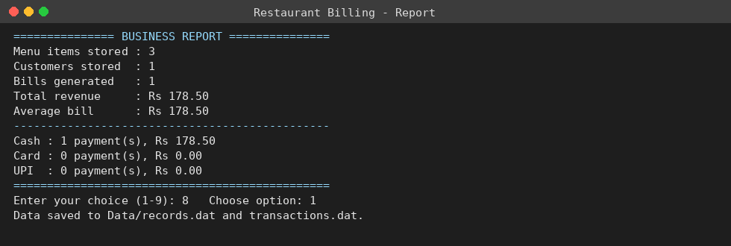
Screenshot 3: Business report and save
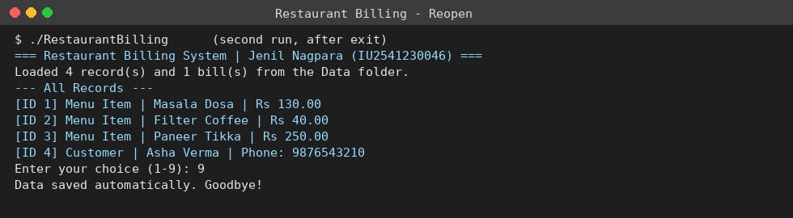
Screenshot 4: Program reopened - saved records are loaded

13. Limitations
• The bill file stores only the subtotal and totals, not the item lines, so a past bill cannot be reprinted with its items.
• Deleting a customer or menu item does not check whether old bills refer to it.
• GST is fixed at 5% and there are no discounts, service charges or split payments.
• Data is stored in plain text and is not encrypted; there is no login or user accounts.
• The program is single-user and uses a console interface.
• The report is a summary only; it cannot be filtered by date.

14. Future Scope
• Save the item lines of every bill and allow reprinting of past bills.
• Add date-wise reports, discounts, service charges and split payment.
• Replace the text files with a database, and add a graphical user interface.
• Add user login with different permissions for cashier and manager.

15. Conclusion
The Restaurant Billing System meets all the required features of the blueprint: five or more classes, constructors and destructors, inheritance with runtime polymorphism, dynamic memory, file persistence, the complete Add / Search / Update / Delete operations, the main transaction, four UML diagrams and fifteen passing test cases. The project shows how a real billing workflow can be modelled with object-oriented design, and how data can be kept safely between program runs.

