**First Things First: A Few Financial Basics**

**1. Create a Financial Calendar**

If you don’t trust yourself to remember to pay your quarterly taxes or periodically pull a credit report, think about setting appointment reminders for [these important money to-dos](https://www.themuse.com/advice/are-you-holding-yourself-back-from-financial-success) in the same way that you would an annual doctor’s visit or car tune-up. A good place to start? Our [ultimate financial calendar](http://www.learnvest.com/knowledge-center/ultimate-2014-financial-calendar/).

**2. Check Your Interest Rate**

Q: Which loan should you [pay off first](https://www.themuse.com/advice/4-types-of-loans-you-can-refinance)? A: The one with the highest interest rate. Q: Which savings account should you open? A: The one with the best interest rate. Q: Why does credit card debt give us such a headache? A: Blame it on the compound interest rate. Bottom line here: Paying attention to interest rates will help inform which debt or savings commitments you should focus on.

**3. Track Your Net Worth**

Your net worth—the difference between your assets and debt—is the big-picture number that can tell you [where you stand financially](https://www.themuse.com/advice/6-easy-ways-to-whip-your-finances-into-shape). Keep an eye on it, and it can help keep you apprised of the progress you’re making toward your financial goals—or warn you if you’re backsliding.

**How to Budget Like a Pro**

**4. Set a Budget, Period**

This is the [starting point](https://www.themuse.com/advice/how-to-deal-living-on-a-budget) for every other goal in your life. Here’s a checklist for building [a knockout personal budget](http://www.learnvest.com/knowledge-center/i-want-to-set-up-a-budget/).

**5. Consider an All-Cash Diet**

If you’re consistently overspending, this will break you out of that rut. Don’t believe us? The cash diet changed the lives of [these three people](http://www.learnvest.com/2014/01/all-cash-diet-changed-my-life/). And when [this woman](http://www.learnvest.com/2014/03/cash-only-diet/) went all cash, she realized that it wasn’t as scary as she thought. Really.

**6. Take a Daily Money Minute**

This one comes straight from LearnVest Founder and CEO Alexa von Tobel, who swears by setting aside one minute each day to check on her financial transactions. This 60-second act helps identify problems immediately, keep track of goal progress—and set your spending tone for the rest of the day!

**7. Allocate at Least 20% of Your Income Toward Financial Priorities**

By priorities, we mean building up emergency savings, paying off debt, and padding your retirement nest egg. Seem like a big percentage? Here’s why we [love this number](http://www.learnvest.com/knowledge-center/how-much-do-i-really-need-to-save/).

**8. Budget About 30% of Your Income for Lifestyle Spending**

This includes movies, restaurants, and happy hours—basically, anything that doesn’t cover basic necessities. By abiding by the 30% rule, you can [save and splurge](https://www.themuse.com/advice/outsource-your-choresand-still-save-money) at the same time.

**How to Get Money Motivated**

**9. Draft a Financial Vision Board**

You need motivation to start adopting better money habits, and if you craft a vision board, it can help remind you to stay on track with your financial goals.

**10. Set Specific Financial Goals**

Use numbers and dates, not just words, to describe what you [want to accomplish](https://www.themuse.com/advice/get-your-business-finances-in-order) with your money. How much debt do you want to pay off—and when? How much do you want saved, and by what date?

**11. Adopt a Spending Mantra**

Pick out a positive phrase that acts like a mini rule of thumb for how you spend. For example, ask yourself, “Is this [fill in purchase here] better than Bali next year?” or “I only charge items that are $30 or more.”

**12. Love Yourself**

Sure, it may sound corny, but it works. Just ask [this author](http://www.learnvest.com/2013/09/how-i-found-financial-freedom-after-paying-off-20000-in-debt/), who paid off $20,000 of debt after realizing that taking control of her finances was a way to value herself.

**13. Make Bite-Size Money Goals**

One study showed that the farther away a goal seems, and the less sure we are about when it will happen, the more likely we are to give up. So in addition to focusing on big goals (say, buying a home), aim to also [set smaller, short-term goals](https://www.themuse.com/advice/the-surprising-power-of-small-stupid-goals) along the way that will reap quicker results—like saving some money each week in order to take a trip in six months.

**14. Banish Toxic Money Thoughts**

Hello, self-fulfilling prophecy! If you psych yourself out before you even get started (“I’ll never pay off debt!”), then you’re setting yourself up to fail. So don’t be a fatalist, and switch to more positive mantras.

**15. Get Your Finances–and Body—in Shape**

One study showed that [more exercise leads to higher pay](http://www.learnvest.com/2012/10/new-study-shows-more-exercise-leads-to-higher-pay-123/) because you tend to be more productive after you’ve worked up a sweat. So taking up running may help amp up your financial game. Plus, all the habits and discipline associated with, say, running marathons are also associated with managing your money well.

**16. Learn How to Savor**

Savoring means appreciating what you have now, instead of trying to get happy by acquiring more things.

**17. Get a Money Buddy**

According to [one study](http://www.learnvest.com/2014/01/stop-contagious-bad-money-habits/?gallery=744#pid-8689_aint-0), friends with similar traits can pick up good habits from each other—and it applies to your money too! So try gathering several friends for regular money lunches, like this woman did, [paying off $35,000 of debt](http://www.learnvest.com/2013/01/how-i-paid-off-35000-of-debt-over-lunch/) in the process.

**How to Amp Up Your Earning Potential**

**18. When Negotiating a Salary, Get the Company to Name Figures First**

If you give away your current pay from the get-go, you have no way to know if you’re lowballing or highballing. Getting a potential employer to name the figure first means you can then push them higher.

**19. You Can Negotiate More Than Just Your Salary**

Your work hours, official title, maternity and paternity leave, vacation time, and which projects you’ll work on could all be things that a future employer may be willing to negotiate.

**20. Don’t Assume You Don’t Qualify for Unemployment**

At the height of the recent recession, only half of people eligible for unemployment applied for it. Learn the [rules of unemployment](https://www.themuse.com/advice/what-you-need-to-know-about-unemployment).

**21. Make Salary Discussions at Your Current Job About Your Company’s Needs**

Your employer doesn’t care whether you want more money for a bigger house—it cares about keeping a good employee. So when negotiating pay or asking for a raise, emphasize the [incredible value](https://www.themuse.com/advice/the-real-reason-your-job-isnt-the-right-fit) you bring to the company.

**How to Keep Debt at Bay**

**22. Start With Small Debts to Help You Conquer the Big Ones**

If you have a mountain of debt, [studies show](http://www.learnvest.com/knowledge-center/the-secret-to-conquering-big-debt-123/) paying off the [little debts](https://www.themuse.com/advice/are-you-stuck-in-the-buy-debt-work-lifestyle) can give you the confidence to tackle the larger ones. You know, like paying off a modest balance on a department store card before getting to the card with the bigger balance. Of course, we generally recommend chipping away at the card with the highest interest rate, but sometimes psyching yourself up is worth it.

**23. Don’t Ever Cosign a Loan**

If the borrower—your friend, family member, significant other, whoever—misses payments, your credit score will take a plunge, the lender can come after you for the money, and it will likely destroy your relationship. Plus, if the bank is requiring a cosigner, the bank doesn’t trust the person to make the payments. Bonus tip for parents: If you’re asked to cosign a private loan for [your college student](https://www.themuse.com/advice/student-loan-grace-period-ending-5-steps-to-take-now), first check to see if your kid has maxed out federal loan, grant, and scholarship options.

**24. Every Student Should Fill Out the FAFSA**

Even if you don’t think that you’ll get aid, it doesn’t hurt to fill out the form. That’s because 1.3 million students last year missed out on a Pell Grant—which doesn’t need to be paid back!—because they didn’t fill out the form.

**25. Always Choose Federal Student Loans Over Private Loans**

Federal loans have flexible terms of payment if your employment dreams don’t exactly go according to plan after college. Plus, federal loans typically have better interest rates. So be smart about [the loans you take out](https://www.themuse.com/advice/your-guide-to-student-loan-repayment)—and try to avoid [these other big student loan mistakes](http://www.learnvest.com/knowledge-center/top-student-loan-mistakes-to-avoid/).

**26. If You’re Struggling With Federal Student Loan Payments, Investigate Repayment Options**

Just call up your lender and ask whether they offer graduated, extended, or income-based plans. Read more about [these options here](http://www.learnvest.com/knowledge-center/what-to-do-if-youre-struggling-with-student-loan-payments/).

**27. Opt for Mortgage Payments Below 28% of Your Monthly Income**

That’s a general rule of thumb when you’re trying to figure out how much house you can afford. [Learn more about this number here](http://www.learnvest.com/knowledge-center/buying-a-house-how-much-can-you-afford/). And then indulge in some voyeurism and [see what other couples can afford](http://www.learnvest.com/2014/04/how-much-can-i-afford-for-a-home/).

**How to Shop Smart**

**28. Evaluate Purchases by Cost Per Use**

It may seem more financially responsible to buy a trendy $5 shirt than a basic $30 shirt—but only if you ignore the quality factor! When deciding if the latest tech toy, kitchen gadget, or apparel item is worth it, factor in how many times you’ll use it or wear it. For that matter, you can even consider cost per hour for experiences!

**29. Spend on Experiences, Not Things**

Putting your money [toward purchases](https://www.themuse.com/advice/to-market-to-market-6-nottomiss-shopping-destinations) like a concert or a picnic in the park—instead of spending it on pricey material objects—gives you more happiness for your buck. The research [says so](http://www.learnvest.com/2013/07/spend-smarter-how-to-use-money-to-buy-happiness/).

**30. Shop Solo**

Ever have a friend declare, “That’s so cute on you! You have to get it!” for everything you try on? Save your socializing for a walk in the park, instead of a stroll through the mall, and treat shopping with serious attention.

**31. Spend on the Real You—Not the Imaginary You**

It’s easy to fall into the trap of buying for [the person you want to be](https://www.themuse.com/advice/3-lessons-to-learn-from-your-childhood-fantasy): chef, professional stylist, triathlete.

**32. Ditch the Overdraft Protection**

It sounds nice, but it’s actually a way for banks to tempt you to overspend, and then charge a fee for the privilege. [Find out more about overdraft protection](http://www.learnvest.com/knowledge-center/avoid-overdraft-fees-by-opting-out-of-overdraft-protection/) and [other banking mistakes to avoid](http://www.learnvest.com/knowledge-center/top-banking-mistakes-to-avoid/).

**How to Save Right for Retirement**

**33. Start Saving ASAP**

Not next week. Not when you get a raise. Not next year. Today. Because money you put in your retirement fund now will have [more time to grow](https://www.themuse.com/advice/6-clever-ways-to-save-more-money) through the power of compound growth.

**34. Do Everything Possible Not to Cash Out Your Retirement Account Early**

Dipping into [your retirement funds](https://www.themuse.com/advice/11-lies-we-tell-ourselves-about-retirement) early will hurt you many times over. For starters, you’re negating all the hard work you’ve done so far saving—and you’re preventing that money from being invested. Second, you’ll be penalized for an early withdrawal, and those penalties are usually pretty hefty. Finally, you’ll get hit with a tax bill for the money you withdraw. All these factors make cashing out early a very last resort.

**35. Give Money to Get Money**

The [famous 401(k) match](https://www.themuse.com/advice/the-new-retirement-option-you-should-know-about) is when your employer contributes money to your retirement account. But you’ll only get that contribution if you contribute first. That’s why it’s called a match, see?

**36. When You Get a Raise, Raise Your Retirement Savings, Too**

You know how you’ve always told yourself you would save more when you have more? We’re calling you out on that. Every time you get a bump in pay, the first thing you should do is up your automatic transfer to savings, and increase your retirement contributions. It’s just one step in our checklist for starting to [save for retirement](https://www.themuse.com/advice/7-huge-retirement-mistakes-you-might-be-making).

**How to Best Build—and Track—Your Credit**

**37. Review Your Credit Report Regularly—and Keep an Eye on Your Credit Score**

This woman [learned the hard way](http://www.learnvest.com/2014/03/how-my-credit-score-almost-cost-me-my-dream-house/) that a less-than-stellar credit score has the potential to cost you thousands. She only checked her credit report, which seemed fine—but didn’t get her actual credit score, which told a different story.

**38. Keep Your Credit Use Below 30% of Your Total Available Credit**

Otherwise known as your credit utilization rate, you calculate it by dividing the total amount on all of your credit cards by your total available credit. And if you’re using more than 30% of your available credit, it can ding [your credit score](https://www.themuse.com/advice/credit-report-101-a-visual-guide-to-building-your-score).

**39. If You Have Bad Credit, Get a Secured Credit Card**

A secured card helps [build credit](https://www.themuse.com/advice/trying-to-build-credit-what-you-should-know-about-credit-cards) like a regular card—but it won’t let you overspend. And you don’t need good credit to get one! Here’s [everything you need to know](http://www.learnvest.com/knowledge-center/rough-credit-history-get-a-secured-credit-card/) about secured credit cards.

**How to Get Properly Insured**

**40. Get More Life Insurance on Top of Your Company’s Policy**

That’s because the basic policy from your employer is often far too little. Not convinced? Read how extra life insurance [saved one family](http://www.learnvest.com/2012/12/money-mic-how-my-dads-life-insurance-saved-our-family/).

**41. Get Renters Insurance**

It, of course, covers robberies, vandalism, and natural disasters, but it could also cover things like the medical bills of people who get hurt at your place, damages you cause at someone else’s home, rent if you have to stay somewhere else because of damage done to your apartment—and even stuff stolen from a storage unit. Not bad for about $30 a month!

**How to Prepare for Rainy (Financial) Days**

**42. Make Savings Part of Your Monthly Budget**

If you wait to put money aside for when you consistently have enough of a cash cushion available at the end of the month, you’ll never [have money to put aside](https://www.themuse.com/advice/9-ways-to-improve-your-finances-in-2013)! Instead, bake monthly savings into your budget now. Read more on this and [other big savings mistakes](http://www.learnvest.com/knowledge-center/top-saving-mistakes-to-avoid/)—and how to fix them.

**43. Keep Your Savings Out of Your Checking Account**

Here’s a universal truth: If you see you have money in your checking account, you will spend it. Period. The fast track to building up savings starts with opening [a separate savings account](https://www.themuse.com/advice/the-work-benefits-that-save-you-money), so it’s less possible to accidentally spend your vacation money on another late-night online shopping spree.

**44. Open a Savings Account at a Different Bank Than Where You Have Your Checking Account**

If you keep both your accounts at the same bank, it’s easy to transfer money from your savings to your checking. Way too easy. So avoid the problem—and [these other money pitfalls](http://www.learnvest.com/knowledge-center/top-saving-mistakes-to-avoid/).

**45. Direct Deposit is (Almost) Magic**

Why, you ask? Because it makes you feel like the money you shuttle to your savings every month appears out of thin air—even though you know full well it comes from your paycheck. If the money you allot toward savings never lands in your checking account, you probably won’t miss it—and may even be pleasantly surprised by how much your account grows over time. Find out [other ways to get your emergency fund started](http://www.learnvest.com/knowledge-center/5-ways-to-start-an-emergency-fund/).

**46. Consider Switching to a Credit Union**

[Credit unions](https://www.themuse.com/advice/credit-unions-the-best-kept-secret-in-banking) aren’t right for everyone, but they could be the place to go for better customer service, kinder loans, and better interest rates on your savings accounts.

**47. There Are 5 Types of Financial Emergencies**

Hint: A wedding isn’t one of them. Only dip into your [emergency savings account](https://www.themuse.com/advice/how-fomo-can-ruin-your-finances) if you’ve lost your job, you have a medical emergency, your car breaks down, you have emergency home expenses (like a leaky roof), or you need to travel to a funeral. Otherwise, if you can’t afford it, just say no. [We explain more here](http://www.learnvest.com/knowledge-center/so-what-really-counts-as-a-financial-emergency/).

**48. You Can Have Too Much Savings**

It’s rare, but possible. If you have more than six months’ savings in your emergency account (nine months if you’re self-employed), and you have enough socked away for your short-term financial goals, then start thinking about investing.

**How to Approach Investing**

**49. Pay Attention to Fees**

The fees you pay in your funds, also called expense ratios, can eat into your returns. Even something as seemingly low as a 1% fee will cost you in the long run. Our general recommendation is to stick with low-cost index funds.

**50. Rebalance Your Portfolio Once a Year**

We’re not advocates of playing the market, but you need to take a look at your brokerage account every once in a while to make sure that your investment allocations still match your greater investing goals. [Here’s how to rebalance](http://www.learnvest.com/knowledge-center/how-do-you-rebalance-an-investment-portfolio/).

## How to Manage Money Better

Let’s start with some personal finance basics. Here are a few essential money management tips for laying the foundations.

###### **1. Create a Budget**

This is arguably the most essential piece of money advice out there: Make a budget (and stick to it).

The author John C. Maxwell explains budgeting perfectly, “A budget is telling your money where to go instead of wondering where it went.”

### [→ Click Here to Launch Your Online Business with Shopify](https://accounts.shopify.com/store-create?utm_source=oberlo&utm_medium=ENcta&utm_campaign=how-to-make-money-online-text-link-survey&prev_msid=b15934a7-C33D-4F19-8E85-B00031E18749)

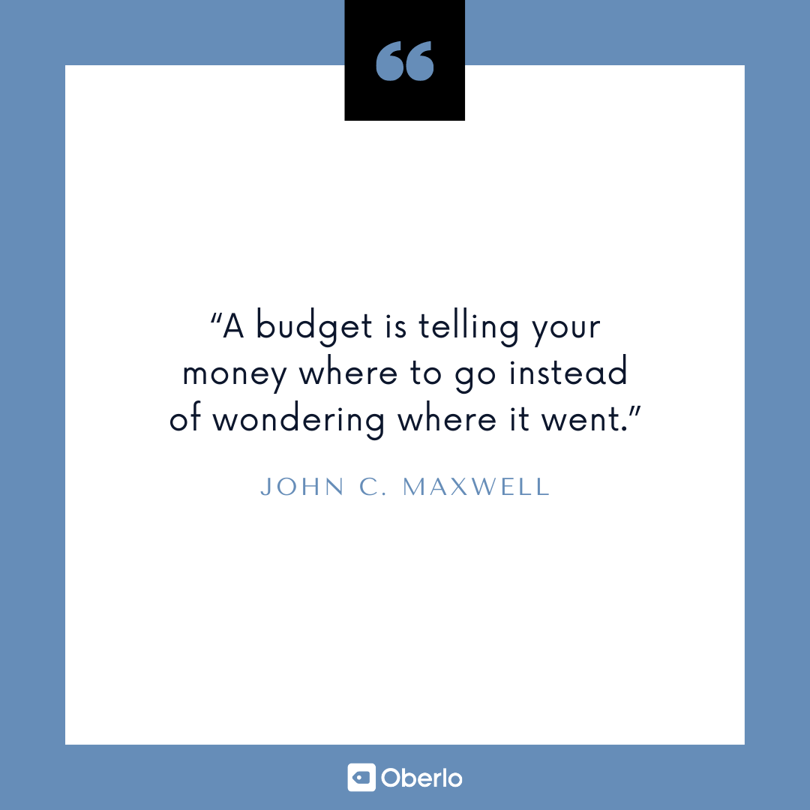

###### **2. Stay Organized with Budgeting Apps**

Learning how to budget your money is not an easy task, so why not make it easier for yourself?

Another top personal finance tip is to use [budgeting apps](https://letstalkaboutmoney.com/blog/best-budget-app/). These apps can help you bring all of your finances into one simple dashboard.

Check out top budgeting apps like [You Need a Budget](https://www.youneedabudget.com/), [Wally](http://wally.me/), and [EveryDollar](https://www.everydollar.com/).



###### **3. Create a Financial Calendar**

Okay, if you’re like many people, this list may already be making you anxious! If that’s you, it’s okay – you got this.

Plus, this personal finance tip isn’t as scary as it sounds.

To create a financial calendar, set reminders for important financial tasks, such as paying quarterly taxes and checking your credit report. This quick financial tip can help to save you a ton of hassle down the road.

###### **4. Track Your Net Worth**

Your net worth is the total sum of your assets minus the total sum of your debts.

For example, say you have $1,000 in the bank, a car worth $1,000, and $500 of credit card debt. Your assets are worth $2,000, and your debts are $500. So, your total net worth is $1,500.

Monitor your net worth and keep trying to improve it.

If you have a ton of student loans, it’s not uncommon to have a net worth of –$100,000. If this is you, don’t stress – just take it one step at a time.

(Oh, and remember that your net worth is not how much *you’re* worth as a person – you’re worth more than you can imagine!)



###### **5. Don’t Make Impulse Purchases**

Everyone makes impulse purchases from time to time, but they can quickly drain your bank account.

So, the next time you see something you just ‘have’ to buy, wait a week before you hand over your cash.

The time will give you room for some perspective. Then, if you still want to buy it, you’ll know it’s definitely worth your money. Chances are, you’ll decide to keep your money.

As the cartoonist and journalist Kin Hubbard said, “The safest way to double your money is to fold it over and put it in your pocket.”



## Personal Finance Tips to Manage Debt

Now, let’s check out some simple money management tips to help you deal with debt.

###### **6. Get Clear About Your Debt**

Gulp. Really? Yep.

Start by writing down the total amounts of everything you owe, as well as the interest rates, monthly minimum payments, and any loan payback lengths. Then, keep this document up to date.

Remember, knowledge is power.

###### **7. Understand Interest Rates**

Interest rates are significant.

They determine which debts to pay off first and which credit cards to avoid. They also help us understand how debt works – compound interest is a cruel master.

I mean, even Albert Einstein noted the importance of the concept: “Compound interest is the eighth wonder of the world. He who understands it, earns it; he who doesn’t, pays it.”

So, make sure you understand the interest rates that affect your finances.



###### **8. Pay Off Your Debt**

When tackling debt, there are two main personal finance strategies:

1. Avalanche: Keep up with minimum payments on all of your debt, but focus on paying off the debt with the highest interest rate first. This method aims to reduce the amount of money you pay back overall.
2. Snowball: Focus on paying off your smallest debt first, regardless of the interest rates. Although you may pay more overall, the sense of empowerment and achievement could help you pay off your debts faster.

## Credit Tips for Financial Success

Here’s some money advice to help you make credit work for you instead of against you.

###### **9. Avoid Debt and Learn About Credit**

Here’s a piece of essential personal finance advice: Avoid debt. As Thomas Jefferson, the third President of the United States, said, “Never spend your money before you have it.”

Still, in a few situations utilizing credit can make sense.

When used effectively, it can help you purchase a house, a car, or manage your medical bills. However, when used irresponsibly, it could spiral you into a mountain of debt that will rob you of the future you want.

No pressure.

So, whatever you do, make sure you understand how credit works, in detail.

###### **10. Track Your Credit Score and Report**

Your credit score can have a massive impact on your ability to rent somewhere to live, purchase a car, get a mortgage, or even sign up for basic utilities. So it’s vital to understand how credit works, and check your score and report regularly.

Ideally, you need to get your [credit score](https://www.experian.com/blogs/ask-experian/infographic-what-are-the-different-scoring-ranges/) into the blue zone, at more than 740 points:



###### **11. Keep Your Credit Utilization Rate Low**

Your credit utilization rate is a measure of how much of your available credit you’re using.

For example, if you’re able to borrow up to $1,000 dollars on a credit card and your balance is $250, your credit utilization rate would be 25%.

A high credit utilization rate will negatively impact your credit score. So, the general rule of thumb is never to let your credit utilization rate be more than 30%.

## Money Advice on Savings

No list of personal finance tips would be complete without tackling savings. So, here’s some money advice on how to build up a nest egg.

###### **12. Create a Savings Plan**

The French writer and pioneering aviator Antoine de Saint-Exupéry said, “A goal without a plan is just a wish.”

Turn your wishes into goals by creating a savings plan (and – you guessed it – sticking to it).

Work out what you’re saving for and how much you plan to save every month. Then, try to get into a rhythm of putting money aside each month.



###### **13. Use the 50/30/20 Rule**

If you’re struggling with budgeting and saving, consider following U.S. Senator [Elizabeth Warren’s 50/30/20 rule](http://fiftythirtytwenty.com/). The idea is to spend your income in the following way:

* 50% on needs, such as groceries, housing, utilities, and health insurance.
* 30% on wants, such as dining out, shopping, and hobbies.
* 20% on savings, such as emergency savings, a college fund, or a retirement plan.

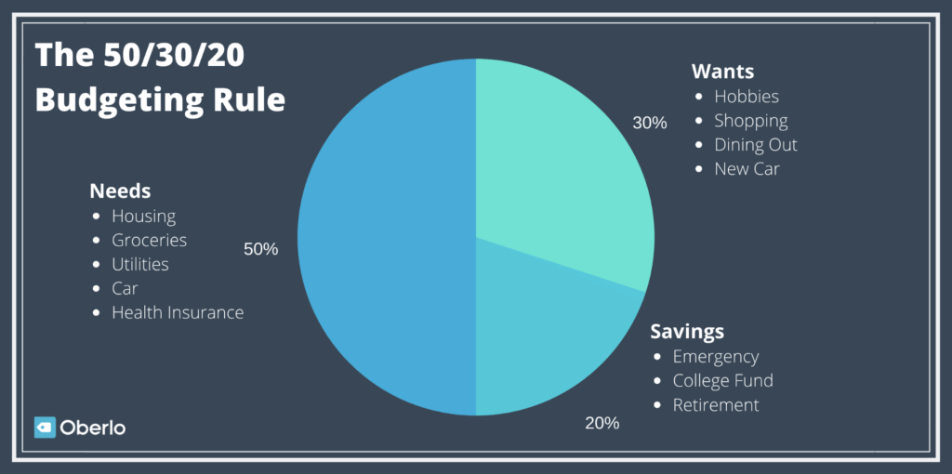

###### **14. Pay Yourself First**

Here’s the idea: Don’t spend your money and save what’s left – instead, save first and then spend what’s left.

Personal finance expert Dave Ramsey said it best: “Saving must become a priority, not just a thought. Pay yourself first.”

###### **15. Separate Your Savings**

If you keep your savings in your checking account, there’s a good chance you’ll dip into them from time to time.

Avoid this common error by creating a separate savings account. Plus, some bank accounts pay a little interest on money held in savings accounts.

###### **16. Cut Back on Expenses**

It doesn’t matter how much you earn if you spend it all. So, try to cut back on expenses to boost the amount of money you can save and invest each month.

You could [save money](https://letstalkaboutmoney.com/blog/how-to-save-money/) on big expenses such as housing by downsizing to a smaller property or moving to a cheaper area. Or you could cut back on the amount you spend on shopping and eating out.

Personal finance advisor Suze Orman said, “Look everywhere you can to cut a little bit from your expenses. It will all add up to a meaningful sum.”



## Personal Finance Advice on Income

To learn how to manage your money better, you need to have some money in the first place! So, let’s explore some of the best finance tips when it comes to income.

###### **17. Find Ways to Increase Your Income**

You can budget, save, and be mindful of your spending until the cows come home, but eventually, you’ll hit a wall. Then, you’ll need to find a way to make more money to improve your financial situation.

I know, easier said than done…

Still, try to find ways to increase your income. Perhaps you could take a [free online course](https://www.oberlo.com/blog/best-free-online-courses-start-today) to improve your skills. Or you could…

###### **18. Start a Side Hustle**

Starting a side hustle is a great way to boost your income if you [need money](https://www.oberlo.com/blog/need-money). Plus, there are countless [side hustle ideas](https://www.oberlo.com/blog/side-hustle) out there. For example, you could:

1. [Start a dropshipping business](https://www.oberlo.com/blog/shopify-dropshipping-guide)
2. [Become an affiliate marketer](https://www.oberlo.com/blog/what-is-affiliate-marketing)
3. [Start and monetize a niche blog](https://www.oberlo.com/blog/how-to-start-a-blog)

###### **19. Negotiate Your Salary**

Arguably one of the easiest ways to boost your income is to do a good job negotiating your salary when starting a new job.

The rule to live by? Never share your current pay rate – get the potential employer to name a figure first. Then you can focus on pushing it higher.

###### **20. Beware of Lifestyle Creep**

When you start earning more money, beware a common trap called “lifestyle creep.” This is when the amount of money you spend increases alongside your income.

For example, when you get a raise, you might decide to buy a new car. Don’t. Resist lifestyle creep at all costs and focus on your savings and investing goals.

## Money Advice on Investing

It’s the ultimate aim: earning [passive income](https://www.oberlo.com/blog/passive-income) from money that makes more money for you. Here are some top personal finance tips to help you learn how to manage money better.

###### **21. Take Responsibility for Your Financial Education**

Adulting is hard. And when it comes to money, you’re responsible for improving your situation.

So, grab your finances by the horns and dedicate some time each week to learn more about money. Thankfully, there are plenty of great [personal finance blogs](https://www.oberlo.com/blog/best-personal-finance-blogs) out there.

As the American founding father, Benjamin Franklin said, “An investment in knowledge pays the best interest.”



###### **22. Invest In Yourself**

Before you start investing in stocks, you may want to invest in yourself.

Have you ever heard the expression, “your 20s are for learning, your 30s are for earning”?

The idea is that if you haven’t yet established yourself in a business or career, your money may be best spent on developing the skills and education that will allow you to increase your earnings over time.

Check out online course platforms like [Khan Academy](https://www.khanacademy.org/?country=266) and [Coursera](https://www.coursera.org/), or free business courses like [Shopify Compass](https://www.shopifycompass.com/).

###### **23. Learn About Investing Options**

There are countless investing options out there, such as 401Ks, real estate investment trusts (REIT), peer-to-peer lending, and stock market staples like the S&P and Dow Jones.

Make sure you understand the options available and their pros and cons before you give your money away.

###### **24. Invest in Assets, Avoid Purchasing Liabilities**

This is one of the most essential money management tips out there.

In essence, an asset puts money into your pocket, and a liability takes money out of your pocket. Here’s a diagram to help explain this concept from the book, [Rich Dad, Poor Dad](https://www.oberlo.com/blog/rich-dad-poor-dad):

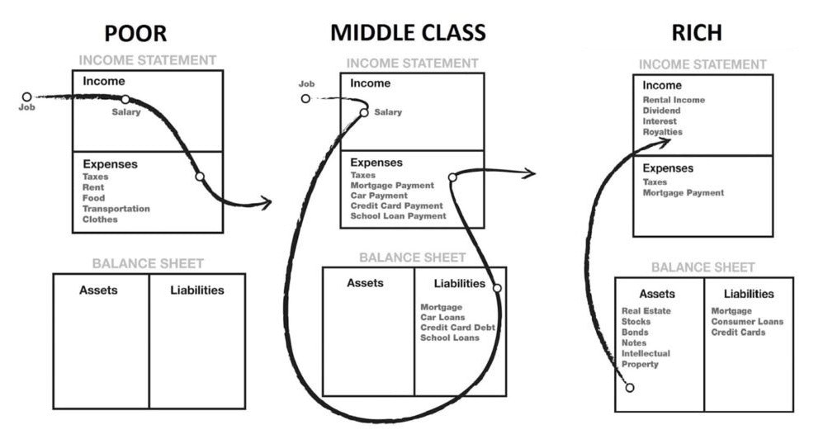

Here’s the thing: The rich own assets and the poor don’t. In short, if you want to be rich, you need to buy assets, not liabilities. This concept can help you achieve [financial freedom](https://www.oberlo.com/blog/financial-freedom).

###### **25. Start Investing Today**

When it comes to investing, time is key.

Compound interest can revolutionize your finances over time, so start investing now and you’ll reap the rewards later. So, put your money to work for you now.

## How to Be Smart with Money

Sometimes the most challenging part of personal finance is the “personal” part. So, here’s some money advice to help you learn how to get better with money.

###### **26. Focus on Your Situation**

Comparing yourself to others is a very effective way to make yourself miserable. There’s no point in “keeping up with the Joneses.”

Instead, focus on you and your financial situation – in this race, you’re only competing against yourself.

###### **27. Learn How to Be Frugal, Not Cheap**

The academic Elise Boulding said, “Frugality is one of the most beautiful and joyful words in the English language, and yet one that we are culturally cut off from understanding and enjoying.”

Here’s the thing: Frugality is empowering – the idea is to prioritize your spending. On the other hand, being cheap is the concept of trying to spend less on everything, all the time, no matter what.

In short, don’t be cheap, be frugal.



###### **28. Create Personal Finance Goals**

You can’t make your money work for you unless you have proper goals.

So, what do you want? An emergency fund? A house? How about a holiday? Whatever it is, write down your goals and then create a plan.

###### **29. Take Your Values Into Account When Making a Purchase**

The stage and film actor Will Rogers once said, “Too many people spend money they haven’t earned to buy things they don’t want to impress people they don’t like.”

Don’t be one of these people. Instead, carefully consider every purchase you make and ensure it fits with your values.

###### **30. Discuss Finances with Your Significant Other**

If you’re in a serious relationship, it’s a good idea to discuss your finances with your significant other.

Financial advisor Suze Orman said, “After you marry, every asset either of you acquires is jointly held. That’s why you both need to be in sync on your long-term financial goals, from paying off the mortgage to putting away for retirement. Ideally, you should talk about all this before you wed. If you don’t, you can end up deeply frustrated and financially spent.”



## How to Manage Money Better: A Summary

Looking for some money advice? In summary, here are 30 personal finance tips to help you learn how to manage money better.

1. Use budgeting apps like [You Need a Budget](https://www.youneedabudget.com/), [Mint](https://www.mint.com/), [Wally](http://wally.me/), and [EveryDollar](https://www.everydollar.com/)
2. Create a budget (and stick to it!)
3. Create a financial calendar
4. Track your net worth
5. Don’t make impulse purchases
6. Understand your debt
7. Understand interest rates
8. Pay off debt with the avalanche or snowball method
9. Avoid debt and learn about credit
10. Check your credit score and report regularly
11. Keep your credit utilization rate low
12. Create a savings plan
13. Use the 50/30/20 rule
14. Pay yourself first
15. Separate your savings
16. Cut back on expenses
17. Find ways to increase your income
18. Start a side hustle
19. Negotiate your salary
20. Beware of lifestyle creep
21. Take responsibility for your financial education
22. Invest in your skills and knowledge
23. Learn about investing options
24. Invest in assets and avoid purchasing liabilities
25. Start investing today to take advantage of compound interest
26. Don’t compare yourself to others, focus on your situation
27. Be frugal, don’t be cheap
28. Create personal finance goals (and then stick to them!)
29. Take your values into account when you buy things
30. Discuss your finances with your significant other

We’ve just covered a lot of personal finance tips, so if you’re [feeling overwhelmed](https://www.oberlo.com/blog/feeling-overwhelmed), take a breath! You don’t need to do it all at once. Go for small, consistent daily improvements over time.