TRAFFIC MANAGEMENT   
DEVELOPMENT PART-2

**ABSTRACT:**

With the fast increase of personal luxury and employment opportunities, people are more comfortable driving their own automobiles than using public transit to meet their mobility demands. This is due to the simplicity of access and the ability to utilize the cars at any time. This results in severe traffic congestion and lengthy wait times at traffic lights, which has become a significant hardship in all large cities. This will influence the environment due to the pollution generated by the large number of automobiles and will also disrupt the individual’s schedule. The purpose of this article is to demonstrate how data analytics, machine learning algorithms, and the Internet of things may be used to forecast traffic flow, create exact data regarding real-time traffic congestions, and reroute cars utilizing navigation to a less crowded course. The system’s design is based on image analysis of cars utilizing cameras at traffic signals, as well as the use of GPS in mobile devices to monitor traffic along a certain route. When these two factors are combined, meaningful statistics concerning traffic congestion may be generated. The next section calculates the most efficient route to the destination using the provided data in order to reduce traffic and arrive in a short amount of time.

The primary data source for this project is crowdsourced data. Nowadays, with the advancement of technology in the vehicle sector, a GPS sensor is being employed for automotive smart applications. GPS data collected from autos may be quite beneficial in developing the data model. The GPS sensor (global positioning system) determines the vehicle’s precise location. With the position of all autos, it is possible to anticipate whether or not there is traffic congestion. This data is especially valuable for determining the traffic rate or density of traffic at a certain place. The traffic density may be estimated by comparing the position of a given car to the number of cars present within a 100-meter radius of that place. The vehicle’s speed also has a significant impact in this. Another source of helpful data is the CCTV cameras installed on the route.

**GOAL OF TRAFFIC SYSTEM:**

The goal of this work is to use Kafka, one of the most popular Big Data techniques, to develop an extendable real-time traffic management system. As a result, it’s critical to investigate the similarities and differences between the present control system and Kafka stream analytics. The observation of the situation (data collection) and the execution of the determined control strategy are the two basic components of real-time traffic control systems (data processing and information dissemination). A local system examines real-time input data, which is then combined and processed to determine the scenario (e.g., incident detection). When a threshold is exceeded, the controller objective function is optimized using one of the established techniques. In certain instances, a central system sets the strategic goal, while local systems are flexible enough to behave adaptively in response to changing circumstances. The most prevalent traffic control techniques are the feedback loop and model predictive control (MPC). They are, however, mostly single-objective and need data that has been purposefully perceived (i.e., fundamental traffic flow parameters).

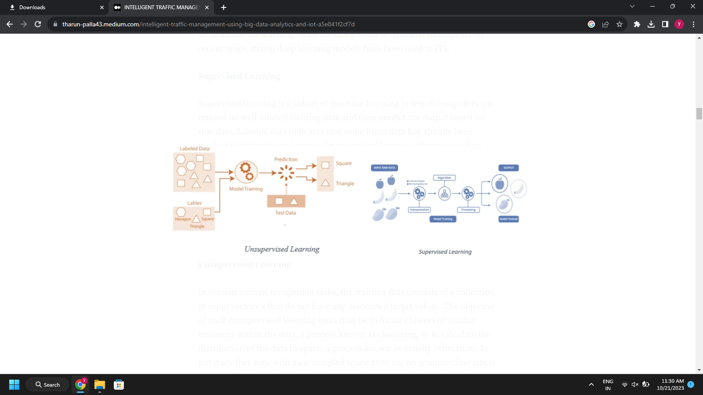

**Big Data from Sensors:**

Sensors deployed in ITS capture data such as vehicle speeds, vehicle density, traffic flows, and travel times. On-road sensors (e.g., infrared and microwave detectors) have evolved to collect, calculate, and transmit traffic data [8]. As described in [8], sensor data gathering may be classified into three categories: roadside data, floating automobile data, and broad area data [9]. The term “roadway data” refers mostly to data gathered by sensors situated along the roadside. For many years, conventional roadside sensors such as inductive magnetic loops, pneumatic road tubes, piezoelectric loop arrays, and microwave radars were employed. With recent advancements in technology, next generation roadside sensors including as ultrasonic and acoustic sensor systems, magnetic vehicle detectors, infrared systems, light detection and ranging (LIDAR), and video image processing and detection systems are progressively becoming available. Floating car data (FCD) primarily refers to vehicle mobility data collected at various places within an ITS system using specific detectors implanted in cars [10]. Certain onboard sensors give reliable and efficient data for route selection and estimate. Popular FCD sensor technologies include automated vehicle identification (AVI), licence plate recognition (LPR), and transponders such as probing cars and electronic toll tags. Wide area data refers to traffic flow data acquired over a large area using a variety of sensor monitoring methods, including photogrammetric processing, sound recording, video processing, and space-based radar.

Sensors are being introduced in the car sector at the moment to monitor each and every aspect of the vehicle. The route is evaluated, and things are detected using 3D Mapper. This is used to identify obstacles in self-driving automobiles. The technique is used with machine learning to enhance item recognition and classification based on their form and motion. This data from the car may be communicated through IoT, which may be quite beneficial in terms of supplying big data for the analytics of intelligent traffic management system.

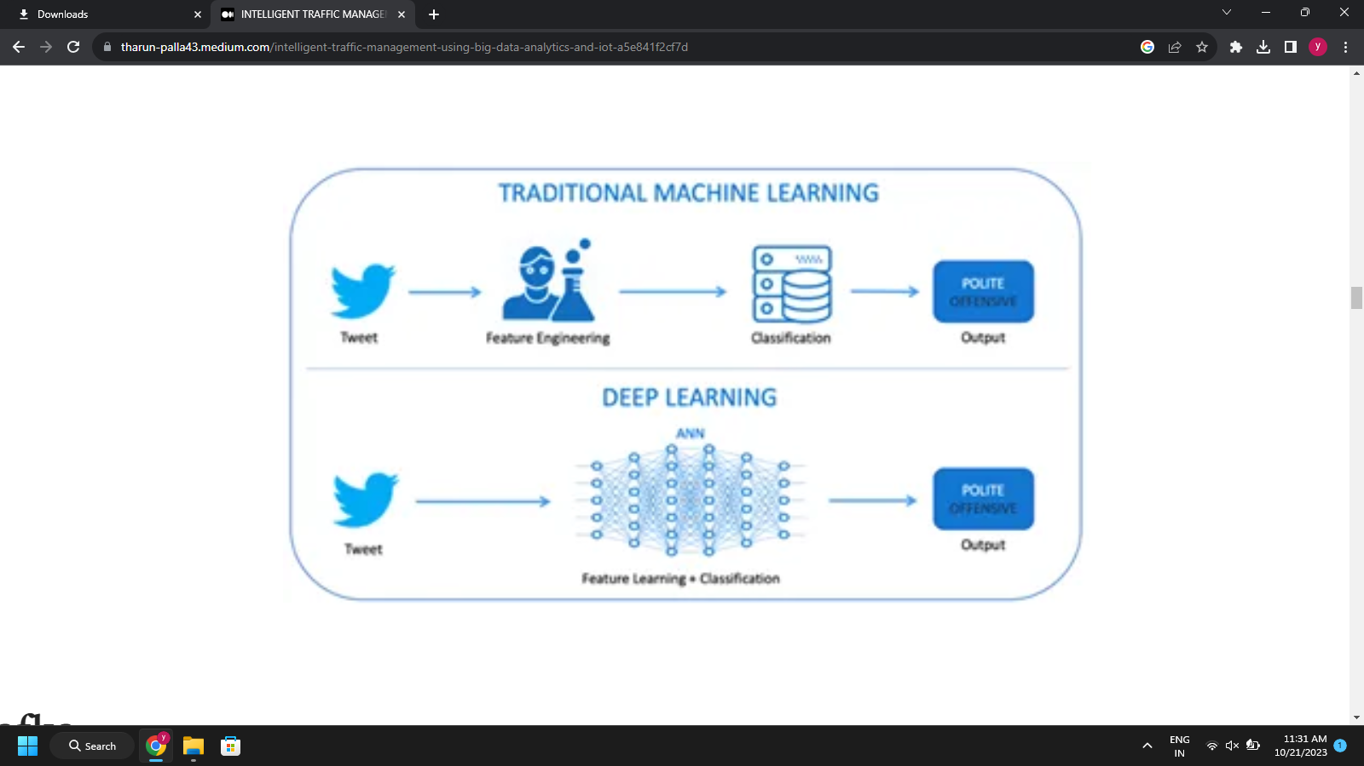

**DATA ANALYTIC:**  
The data analytics engine analyses and/or controls the logic established by each customer, which might range from a basic feedback loop to complex machine-learning algorithms. Additionally, customers may select the time intervals for getting the analytics engine’s output. As data is received, it is handled using user-defined reducer functions. These functions are topic specific. For instance, in the case of speed data, a suitable reducer function may calculate the incoming data’s moving average. A separate evaluator function is run at the conclusion of each time period. The evaluator has access to the outputs of all reducers; here is where judgments may be made based on the combined analysis of the various reducers. In the case of automated traffic control, the evaluator activates modifications to the traffic system on a conditional basis through the change provider.

**ALGORITHM:**

The algorithm consists of the following steps to evaluate:

Input: Gathered sequence of data of a particular area

Output: Predicted traffic flow of a particular road of the area

· Divide the real-world data obtained into 70:30 ratios for training and testing.

· Select a look back step size of b in the training data, and at time t, create lookback observations as x1,x2,x3,…

· xb as the input and xb+1 as the expected value yt

· Establish a random initialization procedure for model parameters, weight wt and bias c.

· Train the model using a forward greedy-layer wise approach and update the model parameters using bi-directional processing.

· The back propagation algorithm optimizer is used to update the model.

· Loss function minimization

· Utilize test data for model validation and another batch of training data for a subsequent retraining procedure.

· Rep until the training set is completed.

· Return the output sequence of the prediction Y.

**Evaluation Model:**

In practical approach it consists the three different

modules are adding.

4.1. Experimental Setup

For experimental setup three different modules are

there for overall application designing. Based on figure it shows deploying technologies on root phase.

4.2. Internet of things module

Approach is to completely IoT based vehicle

information gathering system. Intel IoT kit with all latest

features and vehicle detection sensors. Connected the

sensors based on our criteria deploy on road ½ km or 1 km

and more it depends best is to deploy very near distance for

getting better results.

At least 5 sensors are connected in each other and it

communicates to the single IoT kit. All kits are connected

to the network access sharing information among the

Internet. It continues monitoring for vehicles and updates

are sending to the big data storage and analytics.

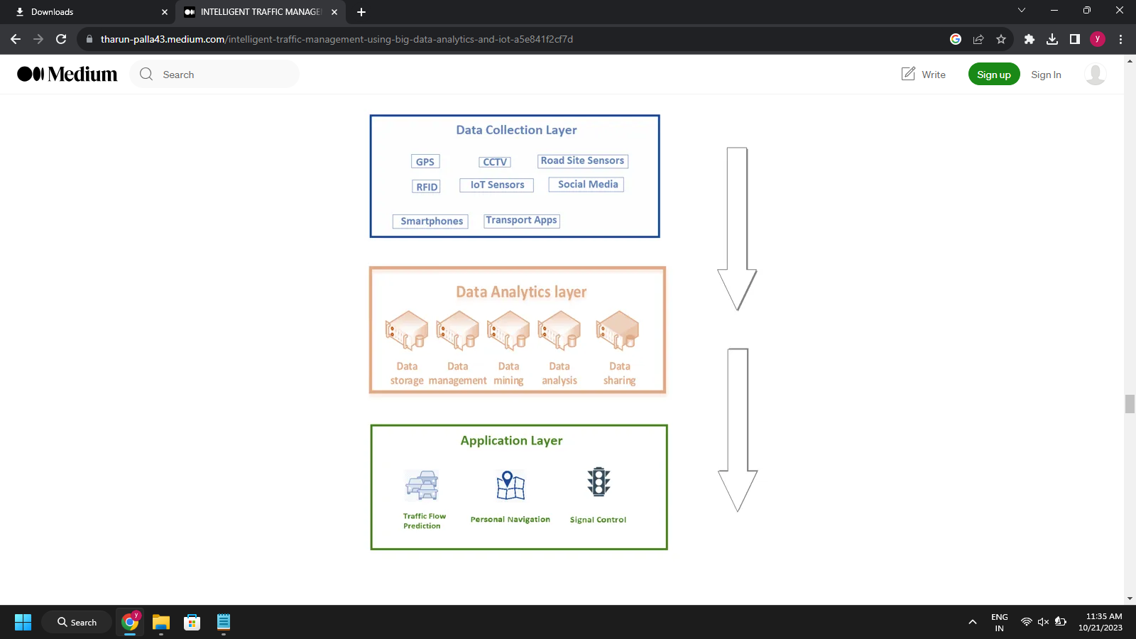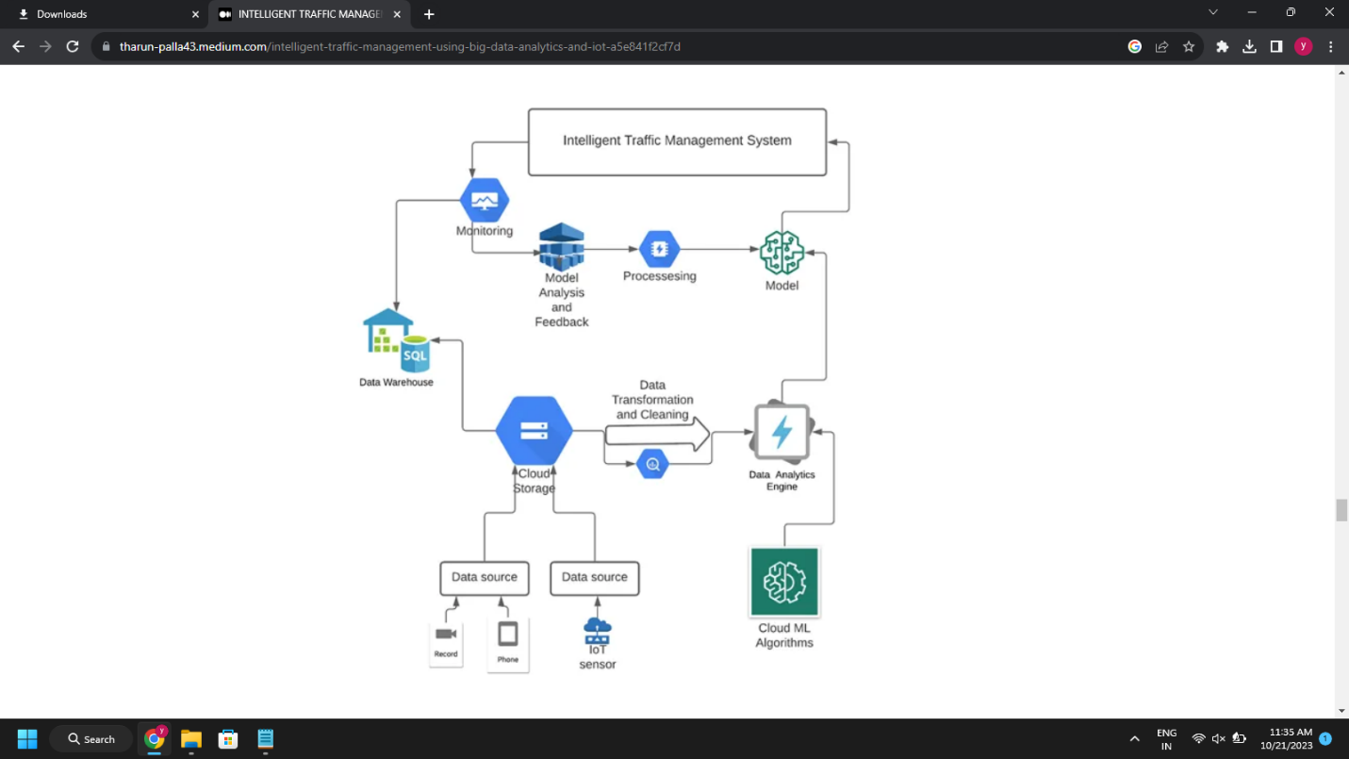

**STS Algorithm:**

Input:

x Red - maximum time of congestion.

x Green - maximum time for congestion free

network.

x Count - minimum frequency of vehicles passing

per second stored statically in controllers.

Algorithm:

Signal turns green.

While (Timer< green and Timer is not 0)

do

If (

Count> count)

Keep the signal green.

-- Count by 1.

Else

if (

Count<= count)

Goto 2.

End

Signal red.

Turn the adjacent signal green.

Go to 1.

Output:

Effective congestion management

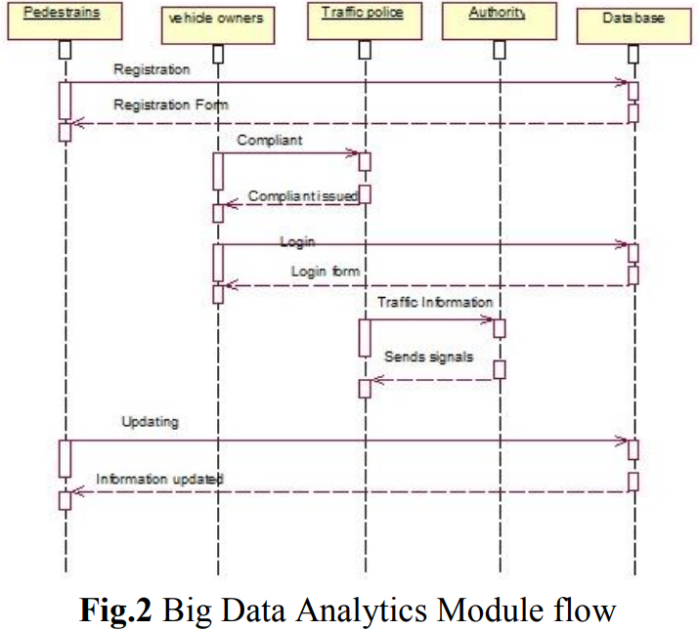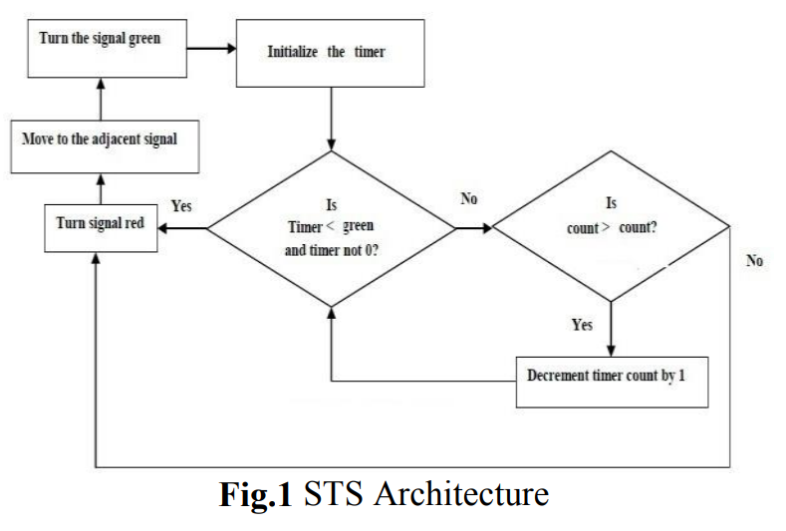

**Power usage:**

A continuous monitoring system must be created to always collect data. This can ensure that the forecast is correct and that the model is updated on any accidents or occurrences that may affect the model’s assessment. High power is used to keep the systems operational 24 hours a day, seven days a week.

**User Interaction Modules:**

In this module consists of the latest analytics and decision tools are providing for travelers. Capacity of road number of vehicles are there status everything shown accessing internet. Multiple way’s user wants to access the information example mobile APP, internet browser throw enabling GPS on Device, etc. In user point of view very faster interaction and fast data processing are to be done by using background as big data stream analytics.

**CONCLUSION:**

We presented a complete and adaptable architecture for real-time traffic management based on Big Data analytics with deep learning in this paper. The architecture is the result of a methodical examination of the domain’s needs. Real time deep learning algorithms simultaneously combined with kafka streaming or spark streaming services for the data flow can lead to development of highly optimized model for prediction of the traffic. The study’s primary weakness was a lack of access to real-world data. By training the model using real-world data, we can significantly increase the model’s efficiency. Data collection is a significant constraint. Maintaining such massive volumes of data requires a great deal of work and management mechanisms.

**Future work**

The proposed system discussed about a low cost STS to provide better service by deploying traffic indicators to update the traffic details instantly. Low cost vehicle detecting sensors are shown in the middle of road for every 500 meters. IoT are being used to acquire traffic data quickly and send it for processing. The streaming data is sent for Big Data analytics. There are several analytical scriptures to analyze the traffic density and provide solution through predictive analytics. Moreover, our approach is provided a better result while comparing to the existing systems. In future advanced sensors used for detecting nature of capacity of vehicle using big data analytics to create more flexible to travelers.