TRAFFIC MANAGEMENT  
DEVELOPMENT PART-1

Abstract-

A significant amount of research work carried out on traffic management systems, but intelligent traffic monitoring is still an active research topic due to the emerging technologies such as the Internet of Things (IoT) and Artificial Intelligence (AI). The integration of these technologies will facilitate the techniques for better decision making and achieve urban growth. However, the existing traffic prediction methods mostly dedicated to highway and urban traffic management, and limited studies focused on collector roads and closed campuses. Besides, reaching out to the public, and establishing active connections to assist them in decision-making is challenging when the users are not equipped with any smart devices. This research proposes an IoT based system model to collect, process, and store real-time traffic data for such a scenario. The objective is to provide real-time traffic updates on traffic congestion and unusual traffic incidents through roadside message units and thereby improve mobility. These early-warning messages will help citizens to save their time, especially during peak hours. Also, the system broadcasts the traffic updates from the administrative authorities. A prototype is implemented to evaluate the feasibility of the model, and the results of the experiments show good accuracy in vehicle detection and a low relative error in road occupancy estimation.

An Internet of Things (IoT)-enabled intelligent traffic management system can solve pertinent issues by leveraging technologies like wireless connectivity & intelligent sensors. Considered a cornerstone of a smart city, they help improve the comfort and safety of drivers, passengers & pedestrians.

Role of IoT in Smart City Traffic Management;

* Expand the capacity of city streets without having to build new roads.
* Optimize the traffic flow and keep the drivers safe. It would include cameras, sensors, and cellular technologies that automatically adjust traffic lights, expressway lanes, speed limits, and highway exit counters.
* Transmit accurate information about available parking spaces to citizens in real-time
* Collect data on congestion and improve traffic signaling to reduce blockages and optimize commute
* Locate incidents and report them to emergency rooms immediately with road sensors and video surveillance
* Employ real-time data feeds to ensure the streetlights turn dim or brighten up per the changing weather conditions and the onset of day and night.

It helps with the following:

* Reducing traffic jams and accidents on the streets.
* Ensuring immediate clearance for emergency vehicles.
* Facilitating safer and shorter commute times.
* Reducing congestion & energy consumption at intersections.
* Offering significant productivity benefits with real-time monitoring of crucial infrastructures.
* Reducing operating costs with efficient traffic management processes.
* Ensuring compliance with the regulations for reducing the carbon footprint.
* Saving billions of gallons of fuel wasted every year.
* Accurate tracking & quick recovery of lost and stolen vehicles.

Functioning of Traffic Monitoring System Using IoT Capabilities:

This intelligent system comprises several components, including wireless sensors, RFID tags, and BLE beacons installed at the traffic signals to monitor the movement of vehicles. A real-time data analytics tool connects the Geographic Information System (GIS-enabled) digital roadmap with control rooms for real-time traffic monitoring.

The smart traffic management system captures the images of vehicles at the signals using the digital image processing technique. This data is then transferred to the control room via wireless sensors. The system also leverages BLE beacons or RFID tags to track the movement of vehicles and keep traffic congestion in control, track down stolen vehicles and even clear the road for emergency vehicles that are installed with RFID readers.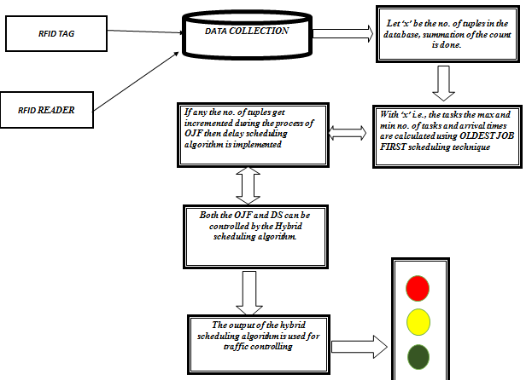

City governments can improve their operations & infrastructure by placing IoT sensors and tracking devices on roads and highways for recording, analyzing, and sharing data in real-time.

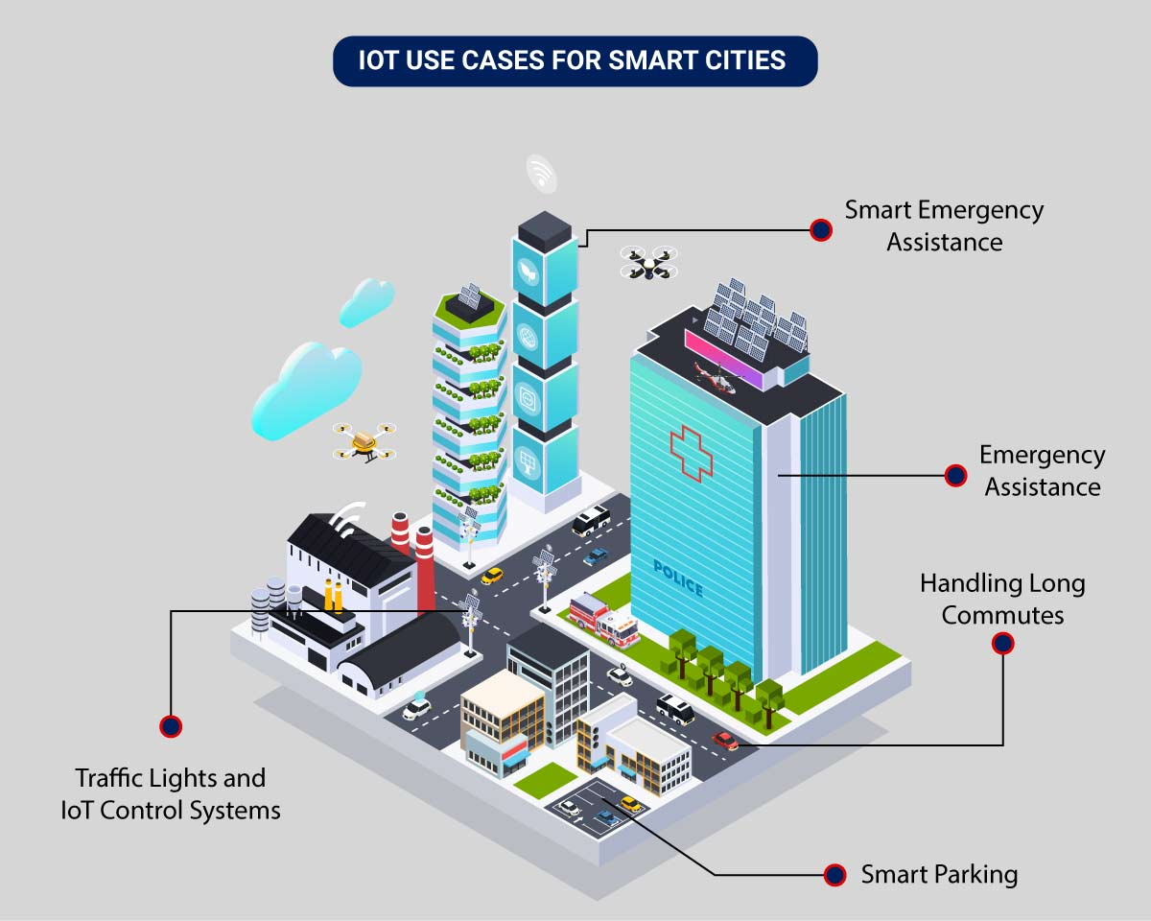

The four main system development activities are:

(i) populate geographical map details for a given location (ii) detect vehicle and estimate vehicle length, (iii) determine growing queue, and (iv) display traffic updates. The system components include (i) Geographical map, (ii) Sensors, (iii) Microcontroller, (iv) IoT platform, (v) Database, and (vi) Electronic display units.

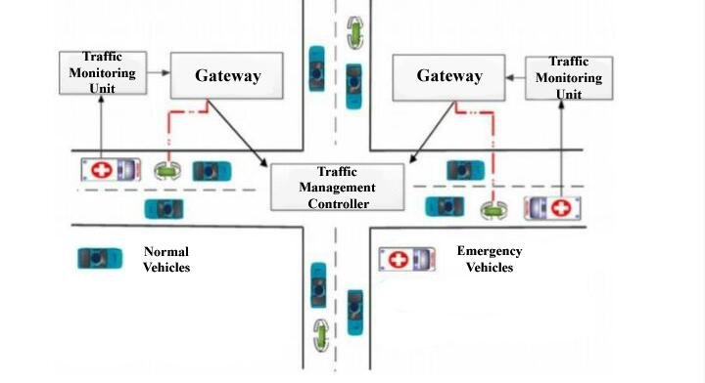

An intelligent traffic monitoring system using IoT capabilities has so many factors & use cases, including;

1. Traffic Lights and IoT Control Systems: Smart traffic signals may look like a typical stoplight, yet they utilize an array of sensors to monitor real-time traffic. Usually, the goal is to help cars reduce the amount of time spent idle. And IoT technology enables the various signals to communicate with each other. This is while adapting to changing traffic conditions in real time. The outcome is less time spent in traffic jams and even reduced carbon emissions.
2. Parking Enabled through IoT: Smart meters and mobile apps make on-street parking spaces easily accessible with instant notifications. Drivers receive alerts whenever a parking spot is available to reserve it instantly. The app gives easy directions to the parking spot with a convenient online payment option.
3. Emergency Assistance through IoT: A traffic monitoring system using IoT technology enables emergency responders to speed up the care mechanism in case of accidents late at night or in isolated locations. The sensors on the road detect any accident, and the problem is immediately reported to the traffic management system. This request is passed on to relevant authorities to take corrective action. Emergency response personnel would include medical technicians, police officers, and fire departments for enhanced responsiveness and timely intervention.
4. Commute Assistance: With every vehicle acting as an IoT sensor, a dedicated app can make suggestions, determine optimal routes & provide advance notice of accidents or traffic jams. Further, it can even suggest the best time to leave. It is all because of a robust algorithm that helps reduce driving time with intelligent traffic lights.

Sensors for collecting data and sending it to a centralized cloud platform:

* Actuators for physical devices to make necessary adjustments like – restricting the water supply in pipelines with leakages or dimming & brightening streetlights based on weather conditions.
* Field gateways to collect & compress data before moving it to a cloud platform.
* Cloud gateways enable secure data transfer between field gateways & the cloud storage of the traffic management system
* A data lake to store the raw, unstructured information before it is cleansed, processed, transformed & moved to a data warehouse for extracting actionable insights
* Data warehouse stores contextual information about connected objects and devices installed with sensors and actuators.
* Data analytics for analyzing the data from streetlight sensors on a centralized dashboard to adjust the intensity of lights
* ML algorithms to analyze traffic patterns & trends from historical data – stored in the data warehouse. The identified trends are then used to build predictive models for control apps. These apps modify the average vehicle speed to avoid congestion.
* Rules to enable actuators to automate the functioning & control of smart city objects and devices. These rules are manually defined to tell actuators what needs to be done to solve a specific problem.
* User applications that allow citizens to receive instant notifications in case of traffic jams and congested routes. Desktop user apps for control rooms send commands to actuators for altering traffic signals. It helps to relieve congestion and optimize routes.
* Cross-solution integrations with traffic lights or streetlight management systems. Control apps apply ML models or predefined rules to prompt appropriate output action if the air quality is poor.

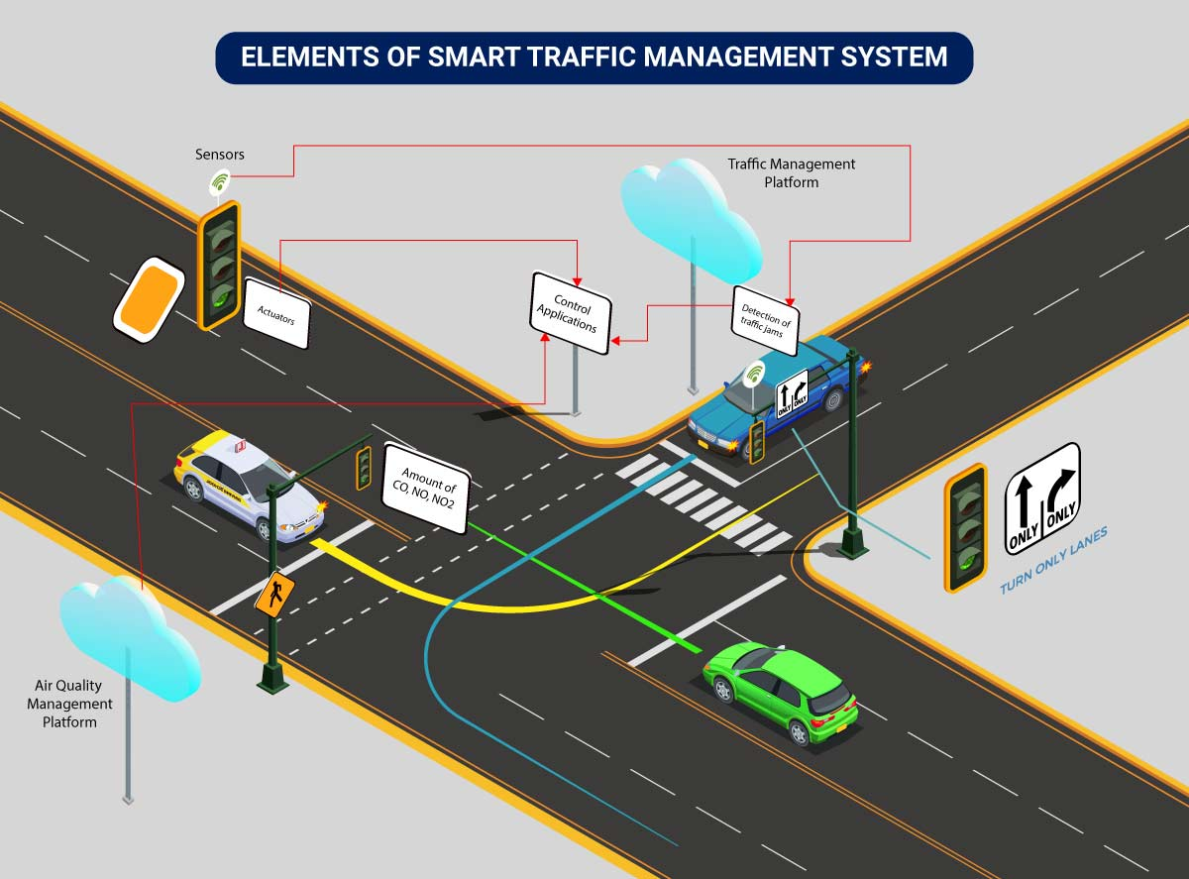

Lane control aims to enhance the efficiency of the highway

through ensuring best use of existing road space. There are

several types of lane control that can be implemented including:

• tidal flow operations for peak periods

• part time running lanes

• lane management for specific vehicle types e.g. bus priority

lanes

• lane management systems e.g. overhead lane control matrix

signs

• dynamic road markings

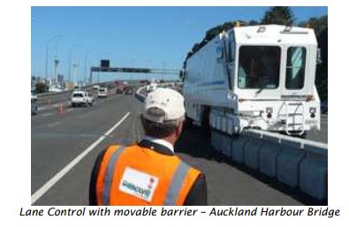

An IoT based system architecture mostly contains a sensing layer, network layer, service layer, and an application layer . The sensing layer acquires data from the things, the network layer transfers the collected data from devices to the service layer, the service layer controls the devices and analyzes the collected data, and finally, the application layer which indicates the user interface.

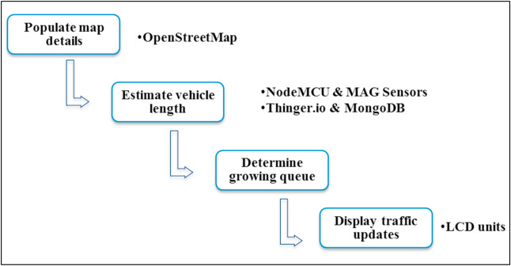

The geographical map provides the road segment information, intersections, and routes. The maps are processed to load the road information to the database as well as to extract the message board locations. The user-generated map can be used to find the message board location [24]. The road junctions that have more connected road segments are the best locations to display traffic-warning messages. The message board locations are selected based on its exposure to maximize message visibility. The message board selection is considered as a maximization problem because the objective is to maximize the visibility of the message. The idea of billboard advertising can be applied here to maximize the strength of message exposure (L [70]. Also, the major parking slots in a closed campus can be selected to reach the messages to the maximum. The number of connected roads is one parameter that decides the strength of message exposure. Besides, the earlier patterns of traffic density can also be selected while determining the message unit location.

The OSM map for a given location can be downloaded from the OpenStreetMap website. The OSM file follows XML format and there are three key elements: nodes, ways, and relations. There is a different tag to identify each type of road. The highway key can have different values such as a motorway, trunk, primary, residential, etc. Similarly, the link roads also can be identified. The junctions key can be used together with highways, and particular types of junctions are roundabouts, circular, filter, and jughandle. These keys help to extract the relevant information on a street. The flowchart to process the OSM file is presented.

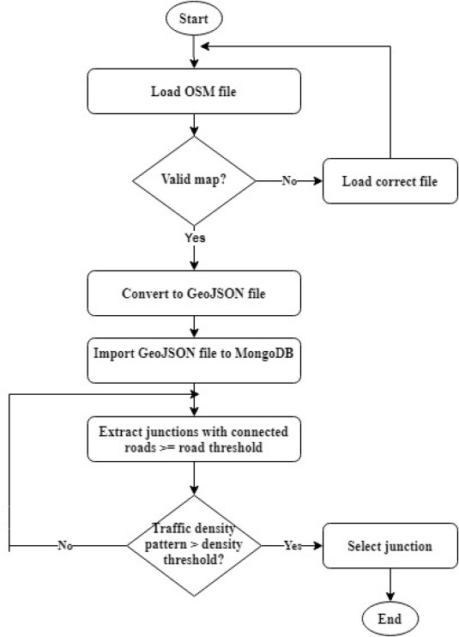

Conclusion:

This research proposed an IoT based system model to collect, process, and store real-time traffic data. This research provided real-time traffic monitoring for traffic updates through roadside message units. The traffic authorities can also broadcast messages on VIP visits, medical emergencies, accidents, etc. to corresponding message units, which will assist the public in decision making and save their time on roads. The proposed system uses magnetic sensor nodes to collect real-time vehicle information. The real-time data is processed by WiFi-enabled microcontrollers and sends to an IoT platform for further actions. Whereas, the proposed system does not expect any smart equipped devices with the driver of the car or within the car such as sensors, GPS, WiFi, etc. and which makes this model unique. The proposed system is expected to be considered in any smart city initiatives such as a smart university campus or any closed smart premises. As a prototype was implemented to demonstrate the feasibility of the proposed model, the results of the prototype demonstration showed good accuracy in vehicle detection and a low relative error in road occupancy estimation. Thus, the proposed model can help citizens to save their time based on the early-warning messages displayed in the message unit, especially during peak hours. The traffic administration can send priority messages to the citizens; hence, the traffic congestion due to accidents or any such unusual incidents can be avoided.