PHASE 1: 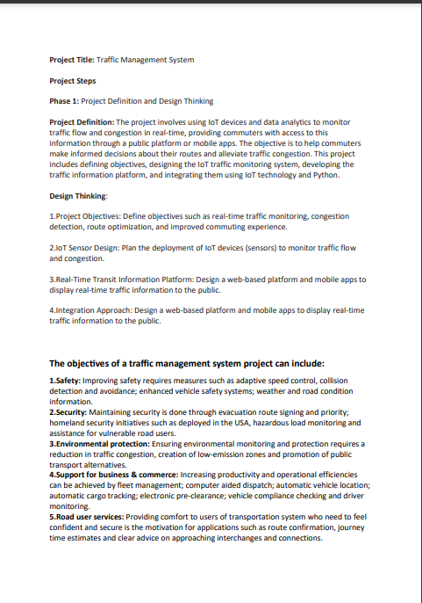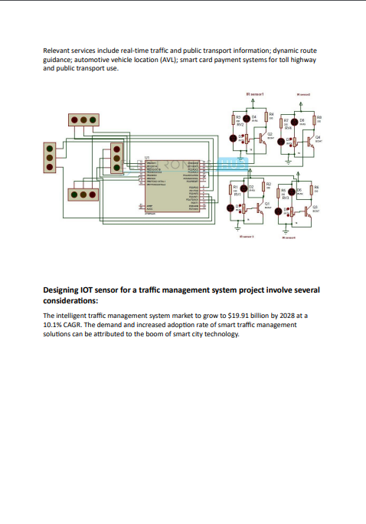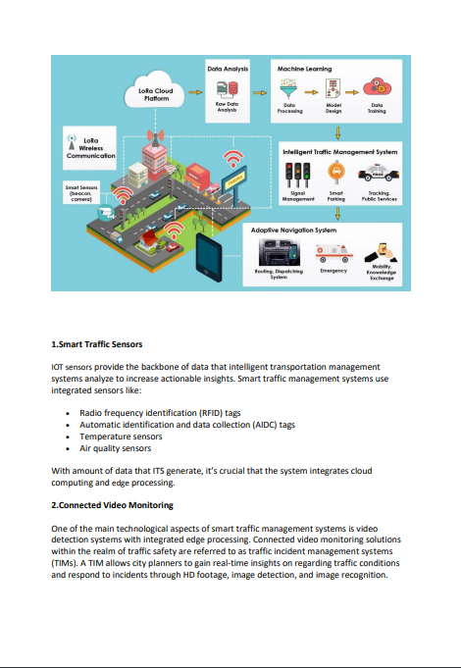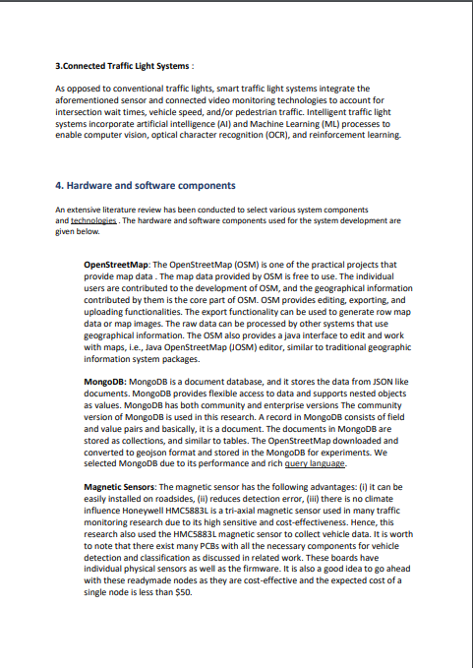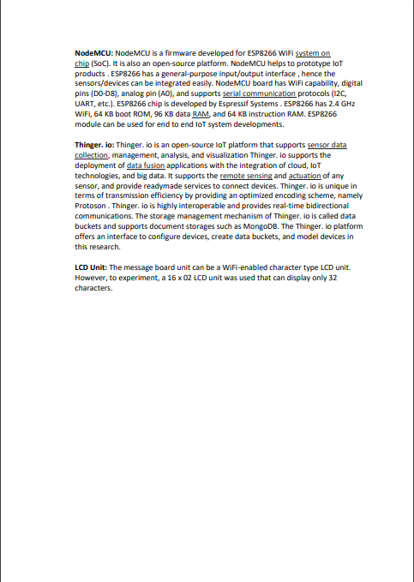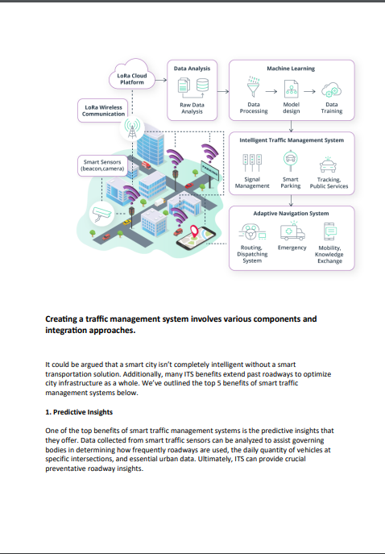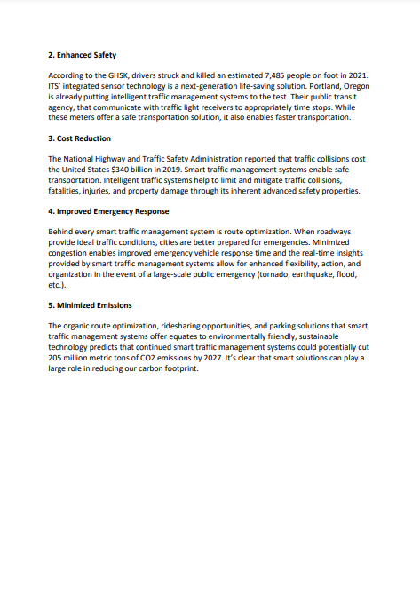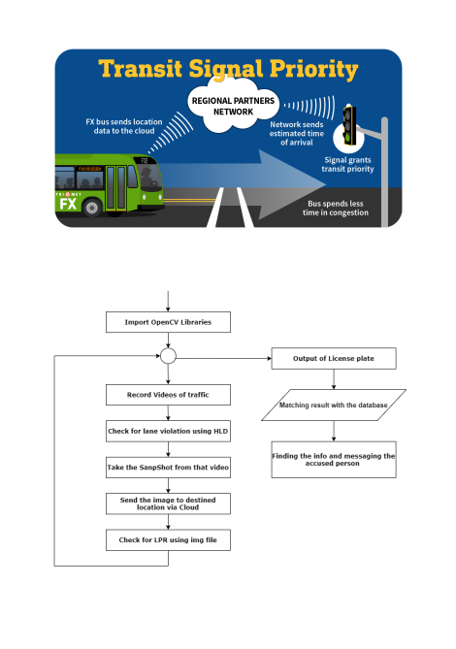

PHASE 3:

TRAFFIC MANAGEMENT  
DEVELOPMENT PART-1

Abstract-

A significant amount of research work carried out on traffic management systems, but intelligent traffic monitoring is still an active research topic due to the emerging technologies such as the Internet of Things (IoT) and Artificial Intelligence (AI). The integration of these technologies will facilitate the techniques for better decision making and achieve urban growth. However, the existing traffic prediction methods mostly dedicated to highway and urban traffic management, and limited studies focused on collector roads and closed campuses. Besides, reaching out to the public, and establishing active connections to assist them in decision-making is challenging when the users are not equipped with any smart devices. This research proposes an IoT based system model to collect, process, and store real-time traffic data for such a scenario. The objective is to provide real-time traffic updates on traffic congestion and unusual traffic incidents through roadside message units and thereby improve mobility. These early-warning messages will help citizens to save their time, especially during peak hours. Also, the system broadcasts the traffic updates from the administrative authorities. A prototype is implemented to evaluate the feasibility of the model, and the results of the experiments show good accuracy in vehicle detection and a low relative error in road occupancy estimation.

An Internet of Things (IoT)-enabled intelligent traffic management system can solve pertinent issues by leveraging technologies like wireless connectivity & intelligent sensors. Considered a cornerstone of a smart city, they help improve the comfort and safety of drivers, passengers & pedestrians.

Role of IoT in Smart City Traffic Management;

* Expand the capacity of city streets without having to build new roads.
* Optimize the traffic flow and keep the drivers safe. It would include cameras, sensors, and cellular technologies that automatically adjust traffic lights, expressway lanes, speed limits, and highway exit counters.
* Transmit accurate information about available parking spaces to citizens in real-time
* Collect data on congestion and improve traffic signaling to reduce blockages and optimize commute
* Locate incidents and report them to emergency rooms immediately with road sensors and video surveillance
* Employ real-time data feeds to ensure the streetlights turn dim or brighten up per the changing weather conditions and the onset of day and night.

It helps with the following:

* Reducing traffic jams and accidents on the streets.
* Ensuring immediate clearance for emergency vehicles.
* Facilitating safer and shorter commute times.
* Reducing congestion & energy consumption at intersections.
* Offering significant productivity benefits with real-time monitoring of crucial infrastructures.
* Reducing operating costs with efficient traffic management processes.
* Ensuring compliance with the regulations for reducing the carbon footprint.
* Saving billions of gallons of fuel wasted every year.
* Accurate tracking & quick recovery of lost and stolen vehicles.

Functioning of Traffic Monitoring System Using IoT Capabilities:

This intelligent system comprises several components, including wireless sensors, RFID tags, and BLE beacons installed at the traffic signals to monitor the movement of vehicles. A real-time data analytics tool connects the Geographic Information System (GIS-enabled) digital roadmap with control rooms for real-time traffic monitoring.

The smart traffic management system captures the images of vehicles at the signals using the digital image processing technique. This data is then transferred to the control room via wireless sensors. The system also leverages BLE beacons or RFID tags to track the movement of vehicles and keep traffic congestion in control, track down stolen vehicles and even clear the road for emergency vehicles that are installed with RFID readers.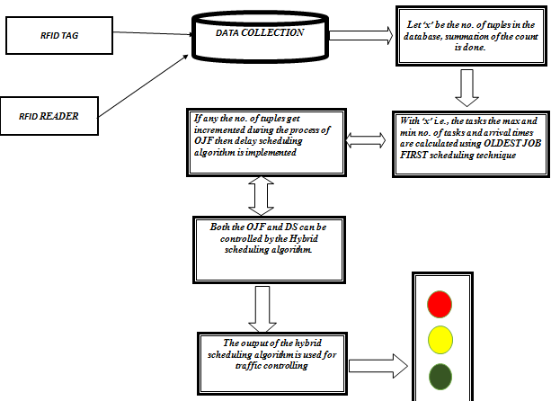

City governments can improve their operations & infrastructure by placing IoT sensors and tracking devices on roads and highways for recording, analyzing, and sharing data in real-time.

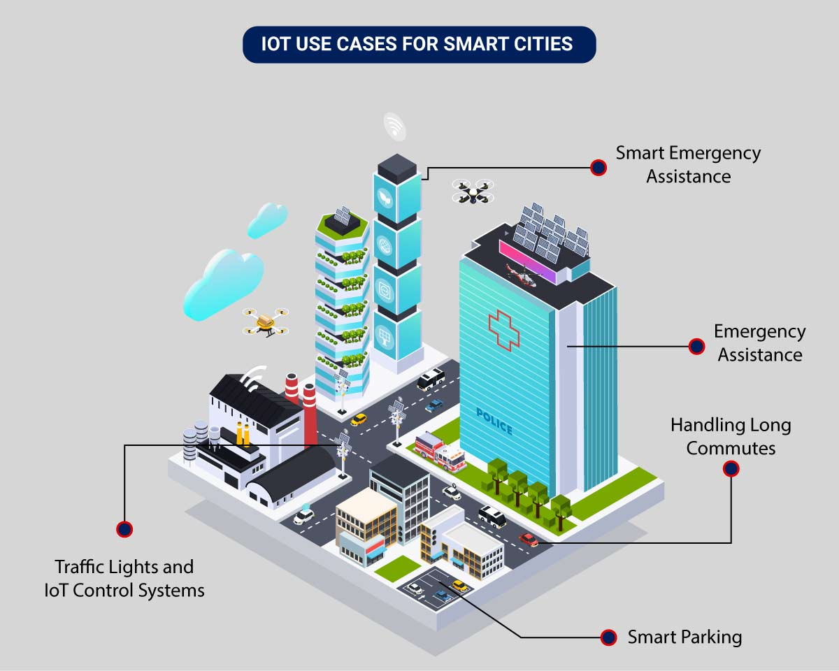

The four main system development activities are:

(i) populate geographical map details for a given location (ii) detect vehicle and estimate vehicle length, (iii) determine growing queue, and (iv) display traffic updates. The system components include (i) Geographical map, (ii) Sensors, (iii) Microcontroller, (iv) IoT platform, (v) Database, and (vi) Electronic display units.

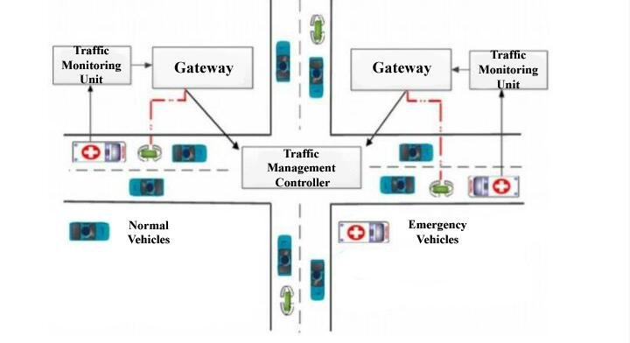

An intelligent traffic monitoring system using IoT capabilities has so many factors & use cases, including;

1. Traffic Lights and IoT Control Systems: Smart traffic signals may look like a typical stoplight, yet they utilize an array of sensors to monitor real-time traffic. Usually, the goal is to help cars reduce the amount of time spent idle. And IoT technology enables the various signals to communicate with each other. This is while adapting to changing traffic conditions in real time. The outcome is less time spent in traffic jams and even reduced carbon emissions.
2. Parking Enabled through IoT: Smart meters and mobile apps make on-street parking spaces easily accessible with instant notifications. Drivers receive alerts whenever a parking spot is available to reserve it instantly. The app gives easy directions to the parking spot with a convenient online payment option.
3. Emergency Assistance through IoT: A traffic monitoring system using IoT technology enables emergency responders to speed up the care mechanism in case of accidents late at night or in isolated locations. The sensors on the road detect any accident, and the problem is immediately reported to the traffic management system. This request is passed on to relevant authorities to take corrective action. Emergency response personnel would include medical technicians, police officers, and fire departments for enhanced responsiveness and timely intervention.
4. Commute Assistance: With every vehicle acting as an IoT sensor, a dedicated app can make suggestions, determine optimal routes & provide advance notice of accidents or traffic jams. Further, it can even suggest the best time to leave. It is all because of a robust algorithm that helps reduce driving time with intelligent traffic lights.

Sensors for collecting data and sending it to a centralized cloud platform:

* Actuators for physical devices to make necessary adjustments like – restricting the water supply in pipelines with leakages or dimming & brightening streetlights based on weather conditions.
* Field gateways to collect & compress data before moving it to a cloud platform.
* Cloud gateways enable secure data transfer between field gateways & the cloud storage of the traffic management system
* A data lake to store the raw, unstructured information before it is cleansed, processed, transformed & moved to a data warehouse for extracting actionable insights
* Data warehouse stores contextual information about connected objects and devices installed with sensors and actuators.
* Data analytics for analyzing the data from streetlight sensors on a centralized dashboard to adjust the intensity of lights
* ML algorithms to analyze traffic patterns & trends from historical data – stored in the data warehouse. The identified trends are then used to build predictive models for control apps. These apps modify the average vehicle speed to avoid congestion.
* Rules to enable actuators to automate the functioning & control of smart city objects and devices. These rules are manually defined to tell actuators what needs to be done to solve a specific problem.
* User applications that allow citizens to receive instant notifications in case of traffic jams and congested routes. Desktop user apps for control rooms send commands to actuators for altering traffic signals. It helps to relieve congestion and optimize routes.
* Cross-solution integrations with traffic lights or streetlight management systems. Control apps apply ML models or predefined rules to prompt appropriate output action if the air quality is poor.

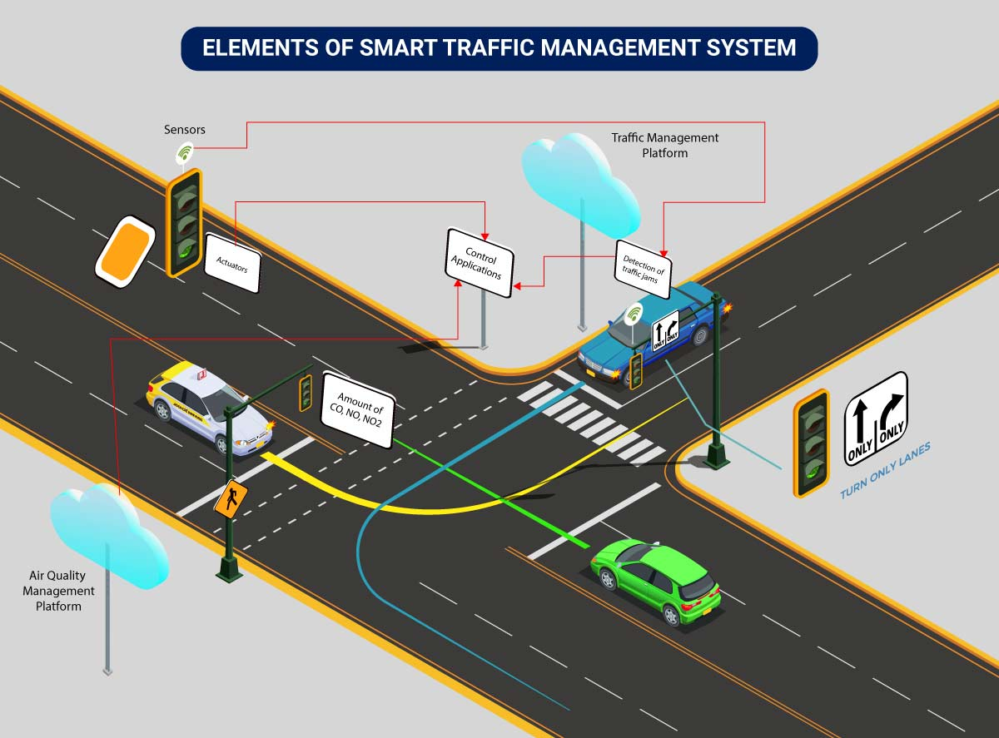

Lane control aims to enhance the efficiency of the highway

through ensuring best use of existing road space. There are

several types of lane control that can be implemented including:

• tidal flow operations for peak periods

• part time running lanes

• lane management for specific vehicle types e.g. bus priority

lanes

• lane management systems e.g. overhead lane control matrix

signs

• dynamic road markings

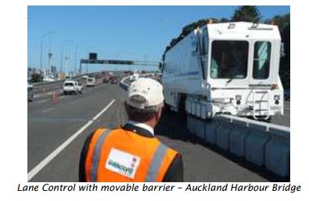

An IoT based system architecture mostly contains a sensing layer, network layer, service layer, and an application layer . The sensing layer acquires data from the things, the network layer transfers the collected data from devices to the service layer, the service layer controls the devices and analyzes the collected data, and finally, the application layer which indicates the user interface.

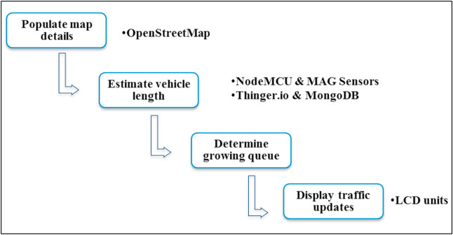

The geographical map provides the road segment information, intersections, and routes. The maps are processed to load the road information to the database as well as to extract the message board locations. The user-generated map can be used to find the message board location [24]. The road junctions that have more connected road segments are the best locations to display traffic-warning messages. The message board locations are selected based on its exposure to maximize message visibility. The message board selection is considered as a maximization problem because the objective is to maximize the visibility of the message. The idea of billboard advertising can be applied here to maximize the strength of message exposure (L [70]. Also, the major parking slots in a closed campus can be selected to reach the messages to the maximum. The number of connected roads is one parameter that decides the strength of message exposure. Besides, the earlier patterns of traffic density can also be selected while determining the message unit location.

The OSM map for a given location can be downloaded from the OpenStreetMap website. The OSM file follows XML format and there are three key elements: nodes, ways, and relations. There is a different tag to identify each type of road. The highway key can have different values such as a motorway, trunk, primary, residential, etc. Similarly, the link roads also can be identified. The junctions key can be used together with highways, and particular types of junctions are roundabouts, circular, filter, and jughandle. These keys help to extract the relevant information on a street. The flowchart to process the OSM file is presented.

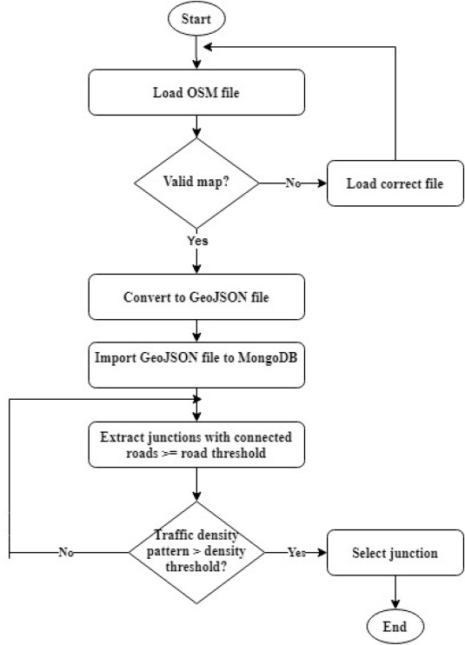

Conclusion:

This research proposed an IoT based system model to collect, process, and store real-time traffic data. This research provided real-time traffic monitoring for traffic updates through roadside message units. The traffic authorities can also broadcast messages on VIP visits, medical emergencies, accidents, etc. to corresponding message units, which will assist the public in decision making and save their time on roads. The proposed system uses magnetic sensor nodes to collect real-time vehicle information. The real-time data is processed by WiFi-enabled microcontrollers and sends to an IoT platform for further actions. Whereas, the proposed system does not expect any smart equipped devices with the driver of the car or within the car such as sensors, GPS, WiFi, etc. and which makes this model unique. The proposed system is expected to be considered in any smart city initiatives such as a smart university campus or any closed smart premises. As a prototype was implemented to demonstrate the feasibility of the proposed model, the results of the prototype demonstration showed good accuracy in vehicle detection and a low relative error in road occupancy estimation. Thus, the proposed model can help citizens to save their time based on the early-warning messages displayed in the message unit, especially during peak hours. The traffic administration can send priority messages to the citizens; hence, the traffic congestion due to accidents or any such unusual incidents can be avoided.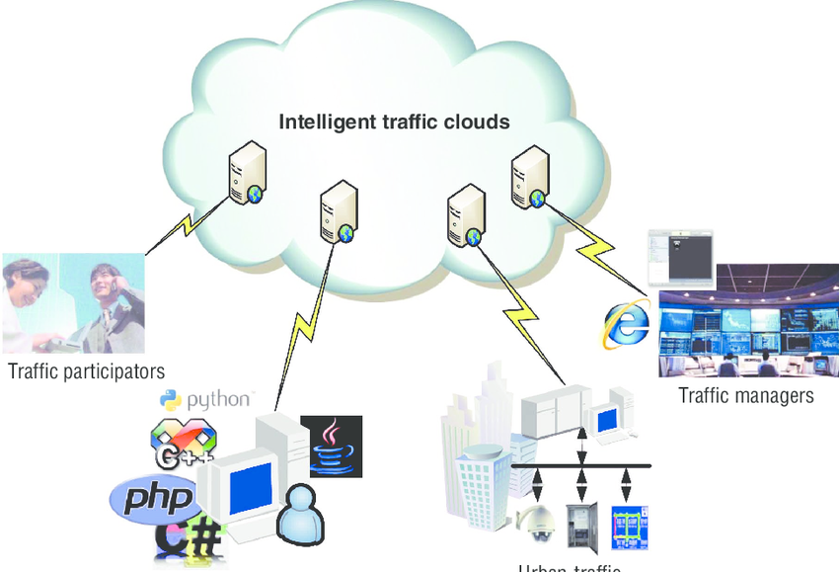

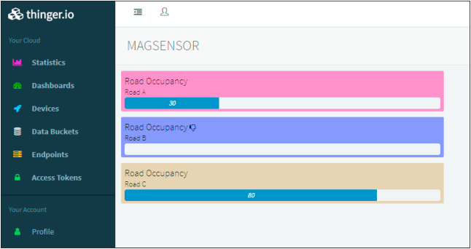

PHASE4:

TRAFFIC MANAGEMENT   
DEVELOPMENT PART-2

**ABSTRACT:**

With the fast increase of personal luxury and employment opportunities, people are more comfortable driving their own automobiles than using public transit to meet their mobility demands. This is due to the simplicity of access and the ability to utilize the cars at any time. This results in severe traffic congestion and lengthy wait times at traffic lights, which has become a significant hardship in all large cities. This will influence the environment due to the pollution generated by the large number of automobiles and will also disrupt the individual’s schedule. The purpose of this article is to demonstrate how data analytics, machine learning algorithms, and the Internet of things may be used to forecast traffic flow, create exact data regarding real-time traffic congestions, and reroute cars utilizing navigation to a less crowded course. The system’s design is based on image analysis of cars utilizing cameras at traffic signals, as well as the use of GPS in mobile devices to monitor traffic along a certain route. When these two factors are combined, meaningful statistics concerning traffic congestion may be generated. The next section calculates the most efficient route to the destination using the provided data in order to reduce traffic and arrive in a short amount of time.

The primary data source for this project is crowdsourced data. Nowadays, with the advancement of technology in the vehicle sector, a GPS sensor is being employed for automotive smart applications. GPS data collected from autos may be quite beneficial in developing the data model. The GPS sensor (global positioning system) determines the vehicle’s precise location. With the position of all autos, it is possible to anticipate whether or not there is traffic congestion. This data is especially valuable for determining the traffic rate or density of traffic at a certain place. The traffic density may be estimated by comparing the position of a given car to the number of cars present within a 100-meter radius of that place. The vehicle’s speed also has a significant impact in this. Another source of helpful data is the CCTV cameras installed on the route.

**GOAL OF TRAFFIC SYSTEM:**

The goal of this work is to use Kafka, one of the most popular Big Data techniques, to develop an extendable real-time traffic management system. As a result, it’s critical to investigate the similarities and differences between the present control system and Kafka stream analytics. The observation of the situation (data collection) and the execution of the determined control strategy are the two basic components of real-time traffic control systems (data processing and information dissemination). A local system examines real-time input data, which is then combined and processed to determine the scenario (e.g., incident detection). When a threshold is exceeded, the controller objective function is optimized using one of the established techniques. In certain instances, a central system sets the strategic goal, while local systems are flexible enough to behave adaptively in response to changing circumstances. The most prevalent traffic control techniques are the feedback loop and model predictive control (MPC). They are, however, mostly single-objective and need data that has been purposefully perceived (i.e., fundamental traffic flow parameters).

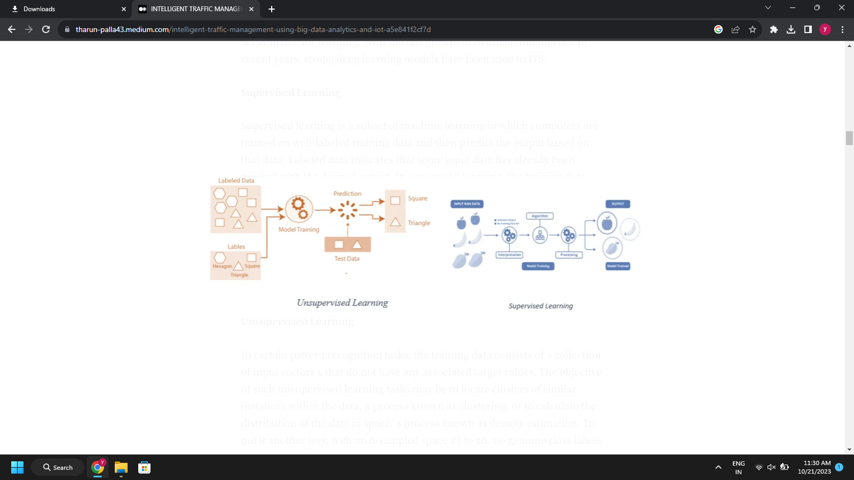

**Big Data from Sensors:**

Sensors deployed in ITS capture data such as vehicle speeds, vehicle density, traffic flows, and travel times. On-road sensors (e.g., infrared and microwave detectors) have evolved to collect, calculate, and transmit traffic data [8]. As described in [8], sensor data gathering may be classified into three categories: roadside data, floating automobile data, and broad area data [9]. The term “roadway data” refers mostly to data gathered by sensors situated along the roadside. For many years, conventional roadside sensors such as inductive magnetic loops, pneumatic road tubes, piezoelectric loop arrays, and microwave radars were employed. With recent advancements in technology, next generation roadside sensors including as ultrasonic and acoustic sensor systems, magnetic vehicle detectors, infrared systems, light detection and ranging (LIDAR), and video image processing and detection systems are progressively becoming available. Floating car data (FCD) primarily refers to vehicle mobility data collected at various places within an ITS system using specific detectors implanted in cars [10]. Certain onboard sensors give reliable and efficient data for route selection and estimate. Popular FCD sensor technologies include automated vehicle identification (AVI), licence plate recognition (LPR), and transponders such as probing cars and electronic toll tags. Wide area data refers to traffic flow data acquired over a large area using a variety of sensor monitoring methods, including photogrammetric processing, sound recording, video processing, and space-based radar.

Sensors are being introduced in the car sector at the moment to monitor each and every aspect of the vehicle. The route is evaluated, and things are detected using 3D Mapper. This is used to identify obstacles in self-driving automobiles. The technique is used with machine learning to enhance item recognition and classification based on their form and motion. This data from the car may be communicated through IoT, which may be quite beneficial in terms of supplying big data for the analytics of intelligent traffic management system.

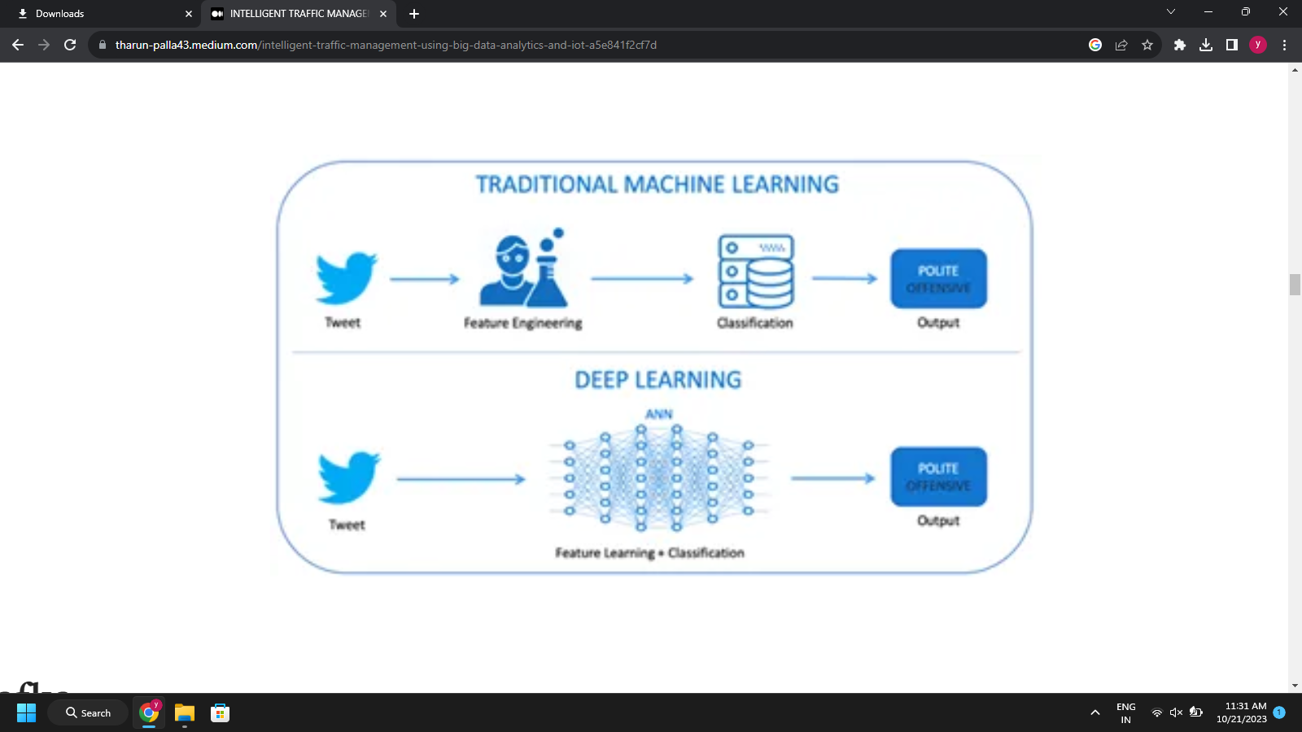

**DATA ANALYTIC:**  
The data analytics engine analyses and/or controls the logic established by each customer, which might range from a basic feedback loop to complex machine-learning algorithms. Additionally, customers may select the time intervals for getting the analytics engine’s output. As data is received, it is handled using user-defined reducer functions. These functions are topic specific. For instance, in the case of speed data, a suitable reducer function may calculate the incoming data’s moving average. A separate evaluator function is run at the conclusion of each time period. The evaluator has access to the outputs of all reducers; here is where judgments may be made based on the combined analysis of the various reducers. In the case of automated traffic control, the evaluator activates modifications to the traffic system on a conditional basis through the change provider.

**ALGORITHM:**

The algorithm consists of the following steps to evaluate:

Input: Gathered sequence of data of a particular area

Output: Predicted traffic flow of a particular road of the area

· Divide the real-world data obtained into 70:30 ratios for training and testing.

· Select a look back step size of b in the training data, and at time t, create lookback observations as x1,x2,x3,…

· xb as the input and xb+1 as the expected value yt

· Establish a random initialization procedure for model parameters, weight wt and bias c.

· Train the model using a forward greedy-layer wise approach and update the model parameters using bi-directional processing.

· The back propagation algorithm optimizer is used to update the model.

· Loss function minimization

· Utilize test data for model validation and another batch of training data for a subsequent retraining procedure.

· Rep until the training set is completed.

· Return the output sequence of the prediction Y.

**Evaluation Model:**

In practical approach it consists the three different

modules are adding.

4.1. Experimental Setup

For experimental setup three different modules are

there for overall application designing. Based on figure it shows deploying technologies on root phase.

4.2. Internet of things module

Approach is to completely IoT based vehicle

information gathering system. Intel IoT kit with all latest

features and vehicle detection sensors. Connected the

sensors based on our criteria deploy on road ½ km or 1 km

and more it depends best is to deploy very near distance for

getting better results.

At least 5 sensors are connected in each other and it

communicates to the single IoT kit. All kits are connected

to the network access sharing information among the

Internet. It continues monitoring for vehicles and updates

are sending to the big data storage and analytics.

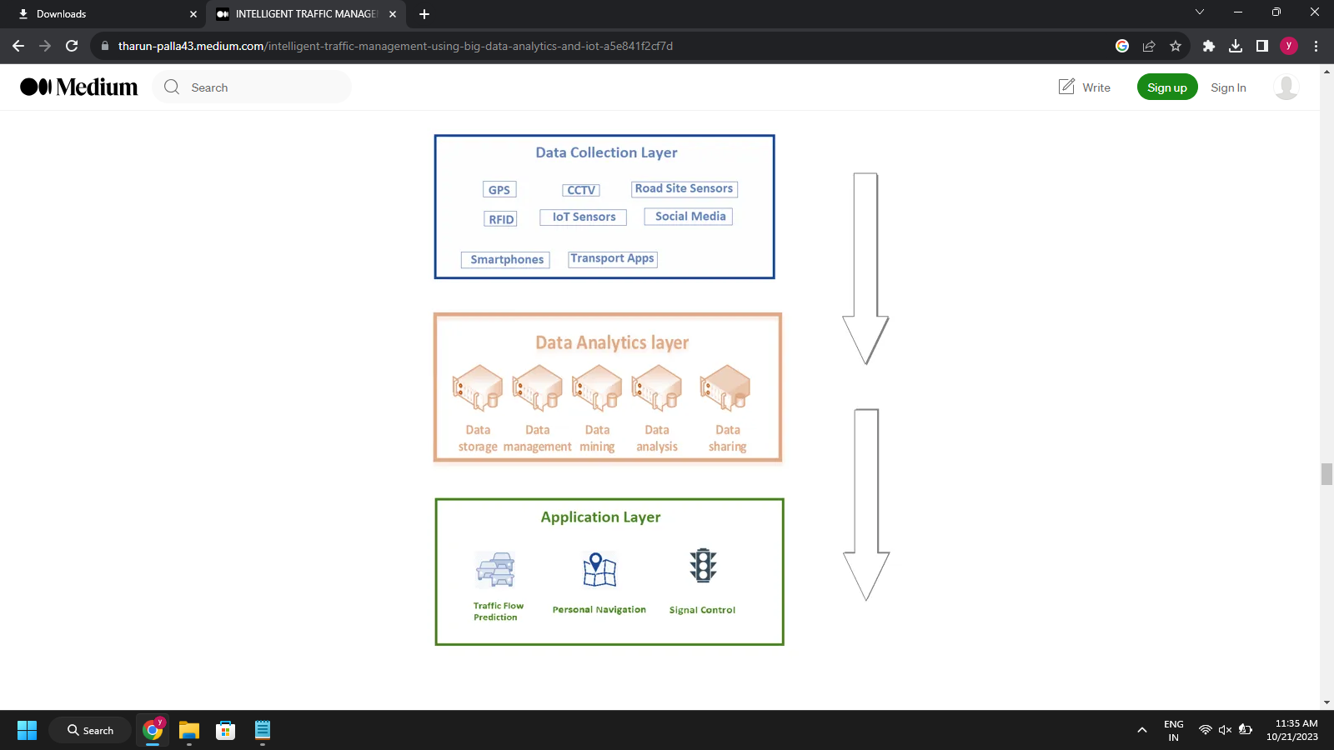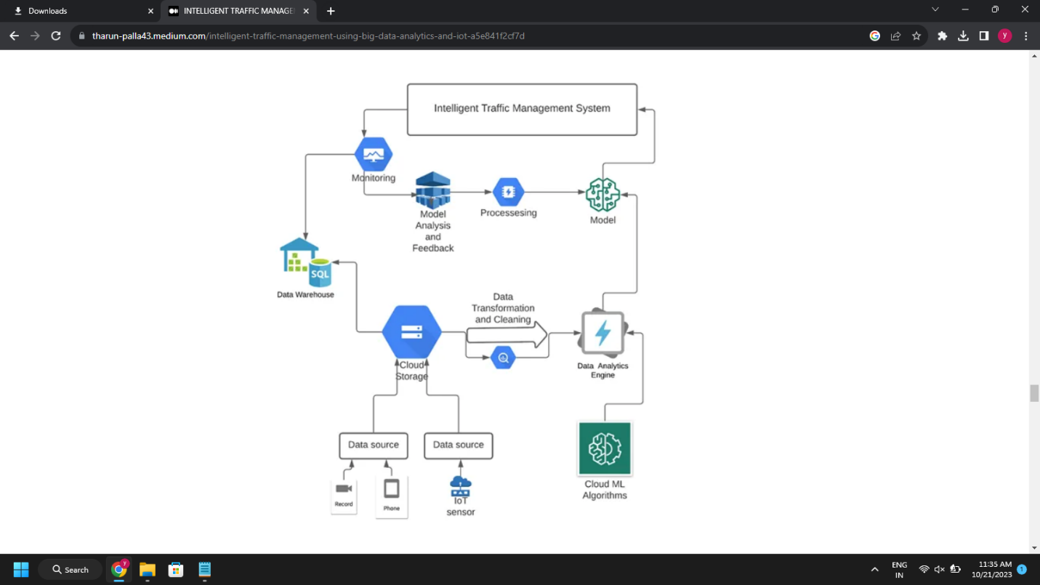

**STS Algorithm:**

Input:

x Red - maximum time of congestion.

x Green - maximum time for congestion free

network.

x Count - minimum frequency of vehicles passing

per second stored statically in controllers.

Algorithm:

Signal turns green.

While (Timer< green and Timer is not 0)

do

If (

Count> count)

Keep the signal green.

-- Count by 1.

Else

if (

Count<= count)

Goto 2.

End

Signal red.

Turn the adjacent signal green.

Go to 1.

Output:

Effective congestion management

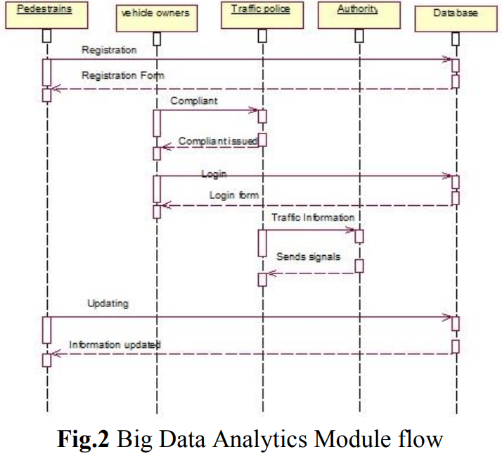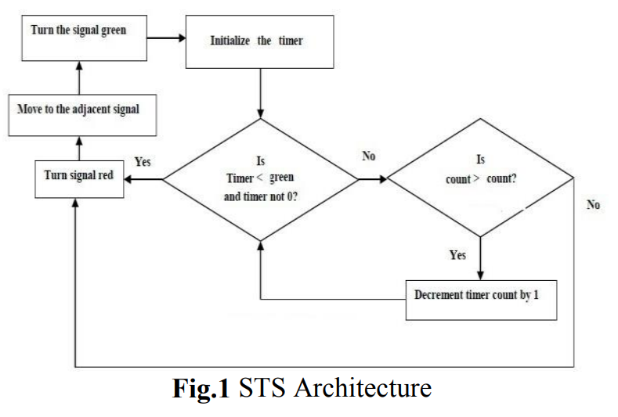

**Power usage:**

A continuous monitoring system must be created to always collect data. This can ensure that the forecast is correct and that the model is updated on any accidents or occurrences that may affect the model’s assessment. High power is used to keep the systems operational 24 hours a day, seven days a week.

**User Interaction Modules:**

In this module consists of the latest analytics and decision tools are providing for travelers. Capacity of road number of vehicles are there status everything shown accessing internet. Multiple way’s user wants to access the information example mobile APP, internet browser throw enabling GPS on Device, etc. In user point of view very faster interaction and fast data processing are to be done by using background as big data stream analytics.

**CONCLUSION:**

We presented a complete and adaptable architecture for real-time traffic management based on Big Data analytics with deep learning in this paper. The architecture is the result of a methodical examination of the domain’s needs. Real time deep learning algorithms simultaneously combined with kafka streaming or spark streaming services for the data flow can lead to development of highly optimized model for prediction of the traffic. The study’s primary weakness was a lack of access to real-world data. By training the model using real-world data, we can significantly increase the model’s efficiency. Data collection is a significant constraint. Maintaining such massive volumes of data requires a great deal of work and management mechanisms.

**Future work**

The proposed system discussed about a low cost STS to provide better service by deploying traffic indicators to update the traffic details instantly. Low cost vehicle detecting sensors are shown in the middle of road for every 500 meters. IoT are being used to acquire traffic data quickly and send it for processing. The streaming data is sent for Big Data analytics. There are several analytical scriptures to analyze the traffic density and provide solution through predictive analytics. Moreover, our approach is provided a better result while comparing to the existing systems. In future advanced sensors used for detecting nature of capacity of vehicle using big data analytics to create more flexible to travelers.