MINI PROJECT REPORT
On
“Part-of-Speech (POS) Tagger for Indian Languages using Natural Language Processing”

A Report Submitted for a mini project for: Laboratory Practice-VI in 8th Semester Computer Engineering.

Fourth Year (COMPUTER ENGINEERING)
Academic Year 2025-26

Submitted by- Jenil Girish Rathod
Roll No.: B22009 Div.: B



Zeal Education Society's
Zeal College of Engineering & Research Narhe, Pune – 411041
Department of Computer Engineering

Zeal Education Society’s
Zeal College of Engineering & Research Department of Computer Engineering



CERTIFICATE

Certified that the project entitled “Part-of-Speech (POS) Tagger for Indian Languages using Natural Language Processing” is a bona fide work carried out by Jenil Girish Rathod (B22009). It is certified that all corrections/suggestions indicated for Internal Assignment have been incorporated in the report. The project report has been approved as it satisfies the academic requirements in respect of Project work prescribed for the Bachelor of Engineering Degree.

Prof. Shruti Karad Prof. A. V. Mote
Project Guide H. O. D

ACKNOWLEDGEMENT

We take this opportunity to thank our project guide Prof. Shruti Karad mam and Head of the department Prof. A. V. Mote mam for their valuable guidance and for providing all the necessary facilities, which were indispensable in the completion of this project report. We are also thankful to all the staff members of Computer Engineering Department for their valuable time, support, comments, suggestions and persuasion. We would also like to thank the institute for providing the required facilities, Internet access and important books.

INDEX

Sr. No | CONTENT | Page No.
1. | Abstract | 5
2. | Software Requirement | 6
3. | Introduction | 7
4. | Problem Statement | 8
5. | Objective And Outcome | 8
6. | Implementation Code | 9
7. | Test Cases | 12
8. | Output | 13
9. | Conclusion | 14
10. | References | 14

ABSTRACT

This project presents the implementation of a Part-of-Speech (POS) tagging system for Indian languages using Natural Language Processing techniques. POS tagging is the process of assigning grammatical labels such as noun, verb, adjective, and others to each word in a sentence. Traditional methods require rule-based approaches that are complex and less scalable, especially for multilingual text processing. This project leverages pre-trained language models to automate the tagging process efficiently and accurately.

To achieve this, the system utilizes the Stanza NLP library, which provides language-specific pipelines for tokenization and POS tagging. The input text is processed through these pipelines to identify individual words and assign corresponding grammatical tags. The system supports multiple Indian languages such as Hindi, Marathi, and Tamil. A user-friendly interface is developed using Streamlit, allowing users to input text, select language, and visualize tagged outputs in both tabular and color-coded formats.

The proposed system demonstrates accurate and efficient text analysis with improved usability and multilingual support. It also includes features such as automatic model downloading and interactive visualization for better understanding. This project highlights the practical application of NLP in language processing and showcases how modern AI techniques can be used for linguistic analysis in real-world scenarios.

SOFTWARE AND HARDWARE REQUIREMENT
Software Requirements:
- Programming Language: Python 3.x
- Framework / UI: Streamlit (for web-based interface)
- NLP Library: Stanza (for POS tagging and language processing)
- Libraries Used: Pandas
- IDE / Editor: VS Code / PyCharm / Jupyter Notebook
- Operating System: Windows / Linux / macOS

Hardware Requirements
- Processor (CPU):
  - Minimum: Intel Core i3 (or equivalent) or higher
  - Recommended: Intel Core i5/i7 or equivalent AMD processor
- Memory (RAM):
  - Minimum: 4 GB of RAM
  - Recommended: 8 GB of RAM or more
- Storage:
  - Minimum: 2 GB of free disk space
  - Recommended: 5 GB of free disk space or more
- Display:
  - Minimum: 1024x768 screen resolution
  - Recommended: 1920x1080 screen resolution (Full HD)
- Graphics Processing Unit (GPU):
  - Minimum: NVIDIA GPU with CUDA support
  - Recommended: NVIDIA GTX/RTX Series

INTRODUCTION

In the modern era of artificial intelligence and natural language processing, understanding and analysing human language has become an essential task in many applications such as text analysis, machine translation, and information retrieval. One fundamental task in NLP is Part-of-Speech (POS) tagging, which involves assigning grammatical labels such as noun, verb, adjective, and others to each word in a sentence. This helps in understanding the structure and meaning of text data.

Traditional POS tagging methods relied on rule-based systems, which were difficult to design and maintain, especially for multiple languages. With advancements in machine learning and deep learning, modern NLP libraries can automatically learn linguistic patterns from large datasets and provide accurate tagging results. This project utilizes such techniques to perform POS tagging efficiently for multiple Indian languages.

The system is implemented using the Stanza library, which provides pre-trained language models for tasks like tokenization and POS tagging. The input text is processed through these models to generate structured outputs containing words and their corresponding tags. The project supports multiple languages such as Hindi, Marathi, and Tamil, making it useful for multilingual text analysis.

A user-friendly interface is developed using Streamlit, allowing users to input text, select language, and view results interactively. The output is displayed both in tabular format and as color-coded text for better visualization and understanding. The system also supports automatic model downloading during the first run, ensuring ease of use.

This project demonstrates the practical application of NLP in real-world scenarios and highlights how artificial intelligence can be used to analyse and understand human language effectively. It provides valuable insight into multilingual language processing, system design, and interactive application development.

PROBLEM STATEMENT

Understanding the grammatical structure of text is essential for many Natural Language Processing applications. However, manually identifying parts of speech in sentences is time-consuming and error-prone, especially for multiple Indian languages. Traditional rule-based systems are difficult to scale and maintain. Therefore, there is a need to develop an automated POS tagging system that can accurately and efficiently analyze text across different languages.

OBJECTIVE
- To develop an automated system for Part-of-Speech tagging
- To utilize NLP techniques using the Stanza library
- To support multiple Indian languages such as Hindi, Marathi, and Tamil
- To generate accurate grammatical tags for input text
- To design a user-friendly interface using Streamlit
- To provide visual representation of tagged words
- To ensure easy usage with automatic model downloading

OUTCOME

- Successful implementation of a multilingual POS tagging system
- Accurate identification of grammatical categories (noun, verb, etc.)
- Efficient text processing using pre-trained NLP models
- Interactive web-based interface for user input and output visualization
- Color-coded output for better understanding of tagged words
- Reliable system with support for multiple languages
- Demonstration of practical application of NLP in real-world scenarios

IMPLEMENTATION CODE

Technologies Used:
- Frontend: Streamlit
- Backend: Python, PyTorch, OpenCV, NumPy, Pandas, Pillow (PIL)

- Backend Logic

# Lightweight POS tagger wrapper using Stanza
import stanza
import pandas as pd
from typing import Tuple
_PIPELINES = {}
def _init_pipeline(lang: str = 'hi', use_gpu: bool = False):
try:
nlp = stanza.Pipeline(lang=lang, processors='tokenize,pos', use_gpu=use_gpu, verbose=False)
except Exception:
# download model and retry
stanza.download(lang)
nlp = stanza.Pipeline(lang=lang, processors='tokenize,pos', use_gpu=use_gpu, verbose=False)
return nlp
def get_pipeline(lang: str = 'hi', use_gpu: bool = False):
key = (lang, use_gpu)
if key not in _PIPELINES:
_PIPELINES[key] = _init_pipeline(lang, use_gpu)
return _PIPELINES[key]
def tag_text(text: str, lang: str = 'hi', use_gpu: bool = False) -> pd.DataFrame:
"""Return a pandas DataFrame with columns: word, upos, xpos"""
nlp = get_pipeline(lang, use_gpu)
doc = nlp(text)
rows = []
for sent in doc.sentences:
for w in sent.words:
rows.append({'word': w.text, 'upos': getattr(w, 'upos', None), 'xpos': getattr(w, 'xpos', None)})
return pd.DataFrame(rows)
if __name__ == '__main__':
# quick test (will download model if missing)
print(tag_text('यह एक परीक्षण वाक्य है।', lang='hi'))
- Frontend/UI

import streamlit as st
import pandas as pd
from pos_tagger import tag_text
st.set_page_config(page_title='POS Tagger (Indian Languages)', layout='centered')
st.title('POS Tagger — Indian Languages (Demo)')
lang_map = {'Hindi': 'hi', 'Marathi': 'mr', 'Tamil': 'ta'}
lang_choice = st.selectbox('Language', list(lang_map.keys()), index=0)
lang = lang_map[lang_choice]
text = st.text_area('Enter text to tag', value='भारत में भाषा विविधता है।', height=150)
# Improved color palette for UPOS tags
TAG_COLORS = {
'NOUN': '#FFD166',
'VERB': '#06D6A0',
'ADJ' : '#118AB2',
'ADV' : '#EF476F',
'PRON': '#8ECAE6',
'NUM' : '#F4D35E',
'DET' : '#FDE68A',
'ADP' : '#C7F9CC',
'CONJ': '#E9D5FF',
'PART': '#FEC89A',
'INTJ': '#F0EFEB',
'X' : '#E2E8F0',
'PUNCT': '#F8F9FA'
}
def _hex_to_rgb(hex_color: str):
h = hex_color.lstrip('#')
return tuple(int(h[i:i+2], 16) for i in (0, 2, 4))
def _text_color_for_bg(hex_color: str) -> str:
r, g, b = _hex_to_rgb(hex_color)
# perceived luminance
lum = 0.299 * r + 0.587 * g + 0.114 * b
return '#000000' if lum > 186 else '#ffffff'
def _escape_html(s: str) -> str:
return str(s).replace('&', '&amp;').replace('<', '&lt;').replace('>', '&gt;')
if st.button('Tag Text'):
with st.spinner('Tagging...'):
try:
df = tag_text(text, lang=lang)
except Exception as e:
st.error(f'Error: {e}')
df = pd.DataFrame()
if df.empty:
st.info('No tokens found or an error occurred.')
else:
st.dataframe(df)
# Legend (show known tags with colors)
st.markdown('### Tag legend')
legend_tags = list(TAG_COLORS.keys())
legend_html = ' '.join(
f"<span style='background:{TAG_COLORS[t]};color:{_text_color_for_bg(TAG_COLORS[t])};padding:6px 10px;border-radius:6px;margin:4px;display:inline-block'>{t}</span>"
for t in legend_tags
)
st.markdown(legend_html, unsafe_allow_html=True)
# Inline colorized tokens
def colorize(row):
upos = row.get('upos') if isinstance(row, dict) else row['upos']
if upos is None:
upos = 'X'
bg = TAG_COLORS.get(upos, TAG_COLORS['X'])
fg = _text_color_for_bg(bg)
word = _escape_html(row['word'])
return f"<span style='background:{bg};color:{fg};padding:4px 8px;border-radius:6px;margin:2px;display:inline-block'>{word} <small style='opacity:.9'>/{_escape_html(upos)}</small></span>"
html = ' '.join(colorize(r) for _, r in df.iterrows())
st.markdown(html, unsafe_allow_html=True)
st.info('Model download: first run may download language models via Stanza.')

Test Cases

The system is tested for functionality, accuracy, and usability across different modules including input processing, NLP tagging, and user interface.

Module Name | Test Scenario ID | Test Scenario Name | Test Cases | Test Case ID | Test Case Description
Input Module | TS_001 | Text Input Handling | 2 | TC_001 | Verify system accepts valid text input
 |  |  |  | TC_002 | Verify system handles empty input properly
Language Module | TS_002 | Language Selection | 2 | TC_003 | Verify correct language selection (Hindi, Marathi, Tamil)
 |  |  |  | TC_004 | Verify error handling for unsupported language
NLP Module | TS_003 | POS Tagging | 2 | TC_005 | Verify correct tagging of words using Stanza model
 |  |  |  | TC_006 | Verify tagging accuracy for different sentence structures
Output Module | TS_004 | Result Display | 2 | TC_007 | Verify tagged output is displayed in table format
 |  |  |  | TC_008 | Verify color-coded output visualization
System Module | TS_005 | Model Loading | 2 | TC_009 | Verify automatic model download on first run
 |  |  |  | TC_010 | Verify system handles model loading errors
UI Module | TS_006 | User Interface | 2 | TC_011 | Verify text input box and button functionality
 |  |  |  | TC_012 | Verify proper display of tag legend
System Module | TS_007 | Performance | 2 | TC_013 | Verify system handles large text efficiently
 |  |  |  | TC_014 | Verify response time is acceptable

OUTPUT

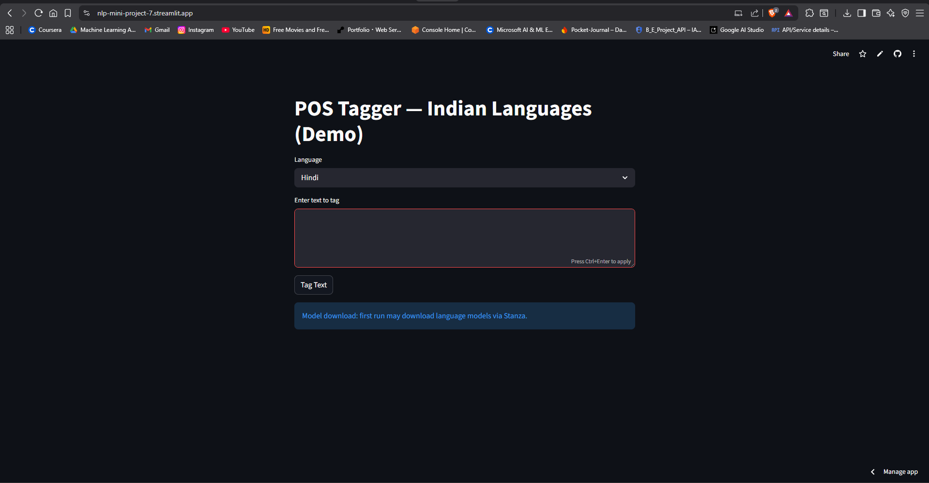

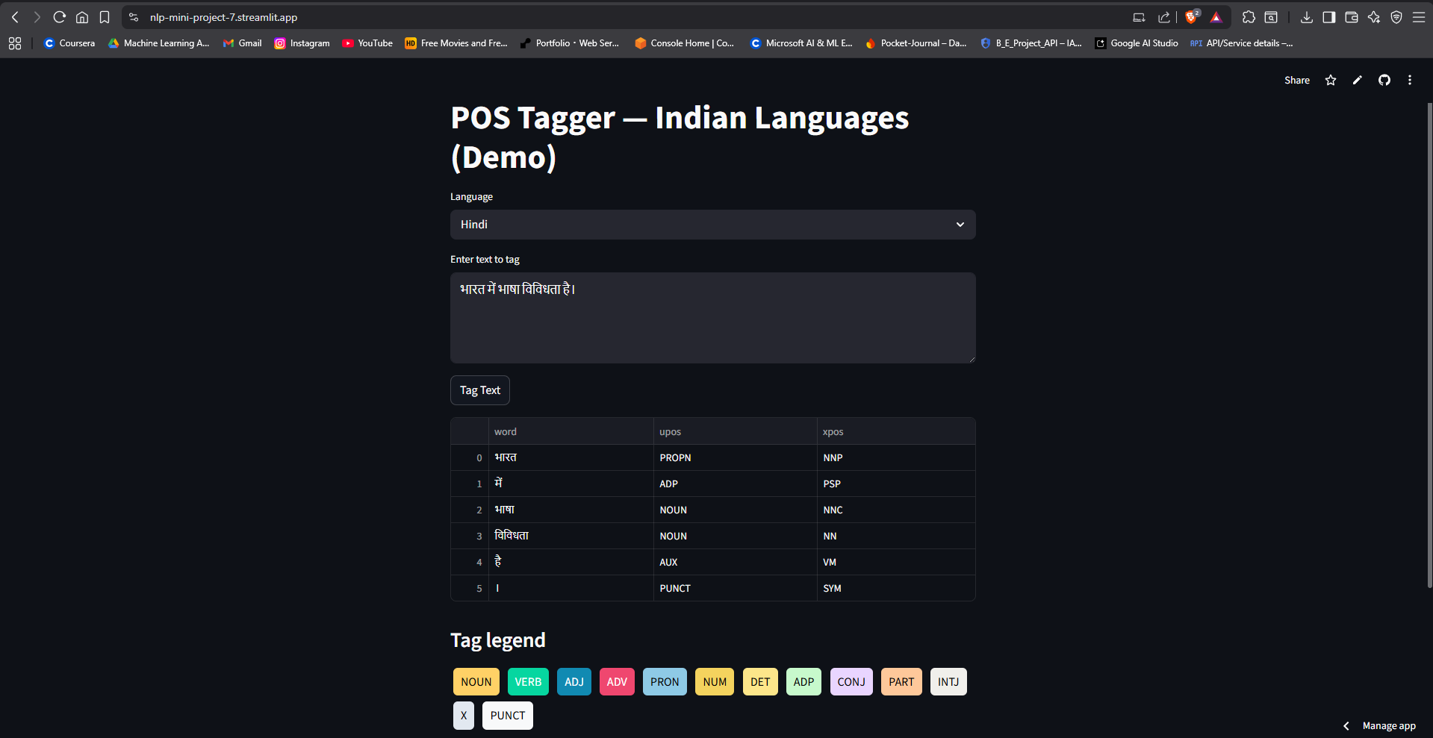

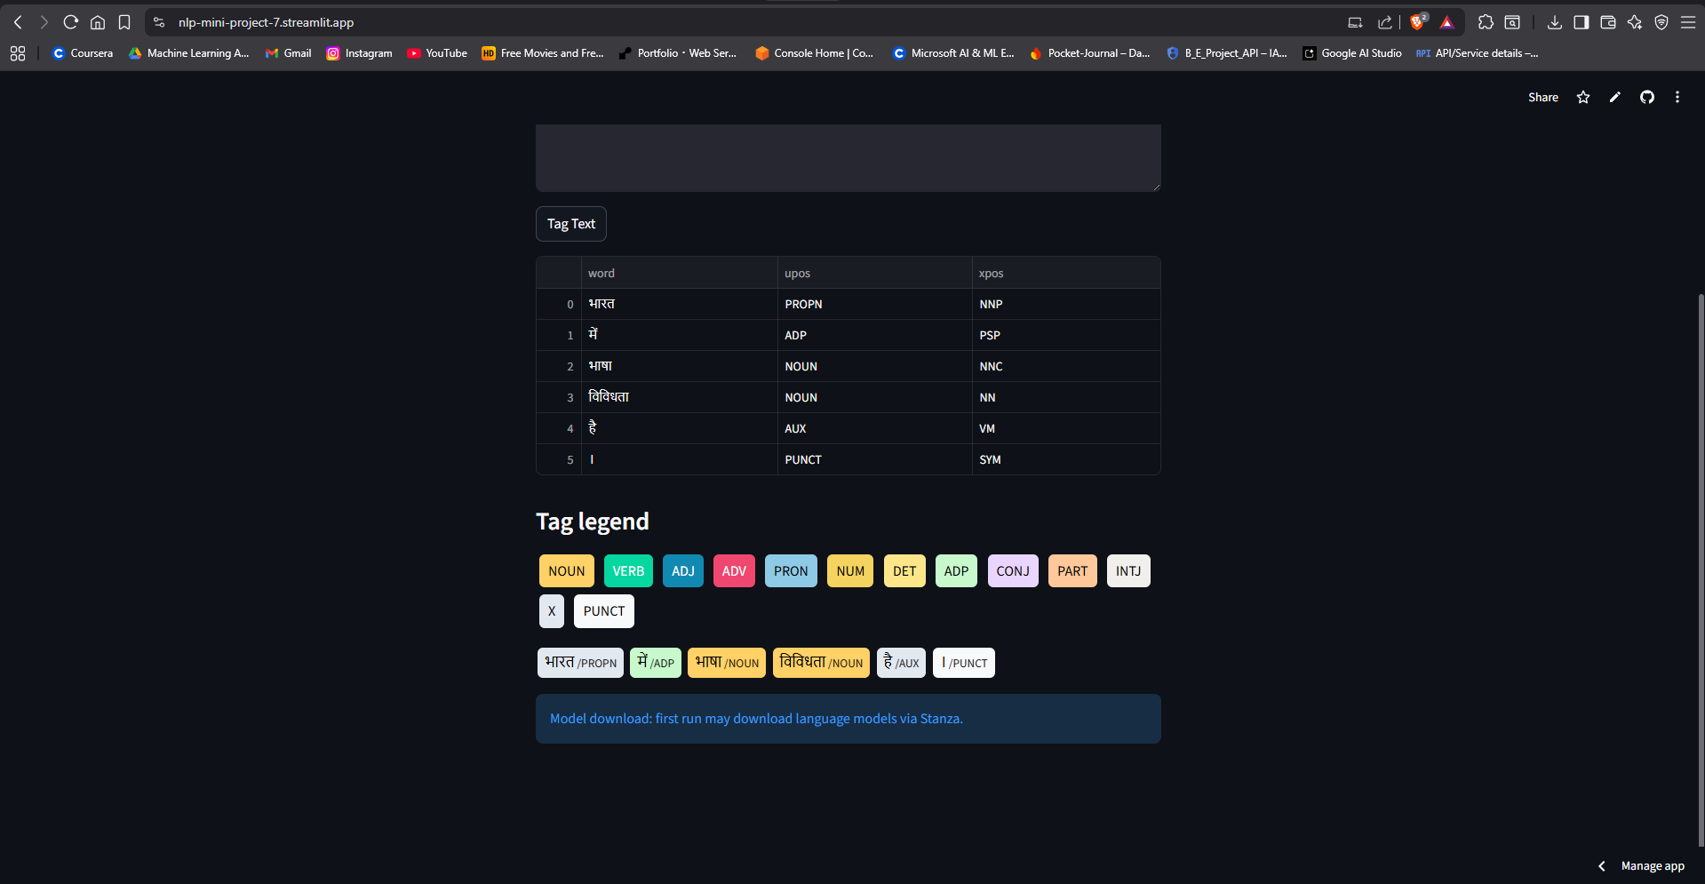

CONCLUSION

This project successfully demonstrates the implementation of a Part-of-Speech (POS) tagging system for Indian languages using Natural Language Processing techniques. By utilizing the Stanza library, the system efficiently analyses input text and assigns appropriate grammatical tags to each word. The support for multiple languages such as Hindi, Marathi, and Tamil makes the system versatile and useful for multilingual text processing applications.

The integration of a Streamlit-based user interface enhances usability by allowing users to input text, select language, and visualize results in both tabular and color-coded formats. The system also ensures reliability through automatic model downloading and smooth execution on standard hardware. Overall, the project highlights the practical application of NLP in language understanding and provides a foundation for further advancements in text analysis and AI-based language processing systems.

REFERENCES: -

Source Code: - https://nlp-mini-project-7.streamlit.app/
- Stanza NLP Library Documentation – https://stanfordnlp.github.io/stanza/
- Streamlit Documentation – https://docs.streamlit.io/
- Pandas Documentation – https://pandas.pydata.org/docs/
- Python Official Documentation – https://docs.python.org/3/
- Jurafsky, D., & Martin, J. H., Speech and Language Processing, 3rd Edition
- GeeksforGeeks – Part-of-Speech Tagging in NLP

