Zeal College of Engineering and Research Subject: LP-VI
Name: Jenil Girish Rathod Class: BE
Div: B Batch: B1
Roll No: B22009

Group B: Practical No:4

Program Statement: Import the data warehouse data in Microsoft Excel and create the Pivot table and Pivot Chart

STEP 1: Get the Data
- Download dataset
- Save it on your system

STEP 2: Open in Excel
- Open Microsoft Excel
- Go to: Data → Get Data → From Text/CSV
- Select your dataset
- Click Load
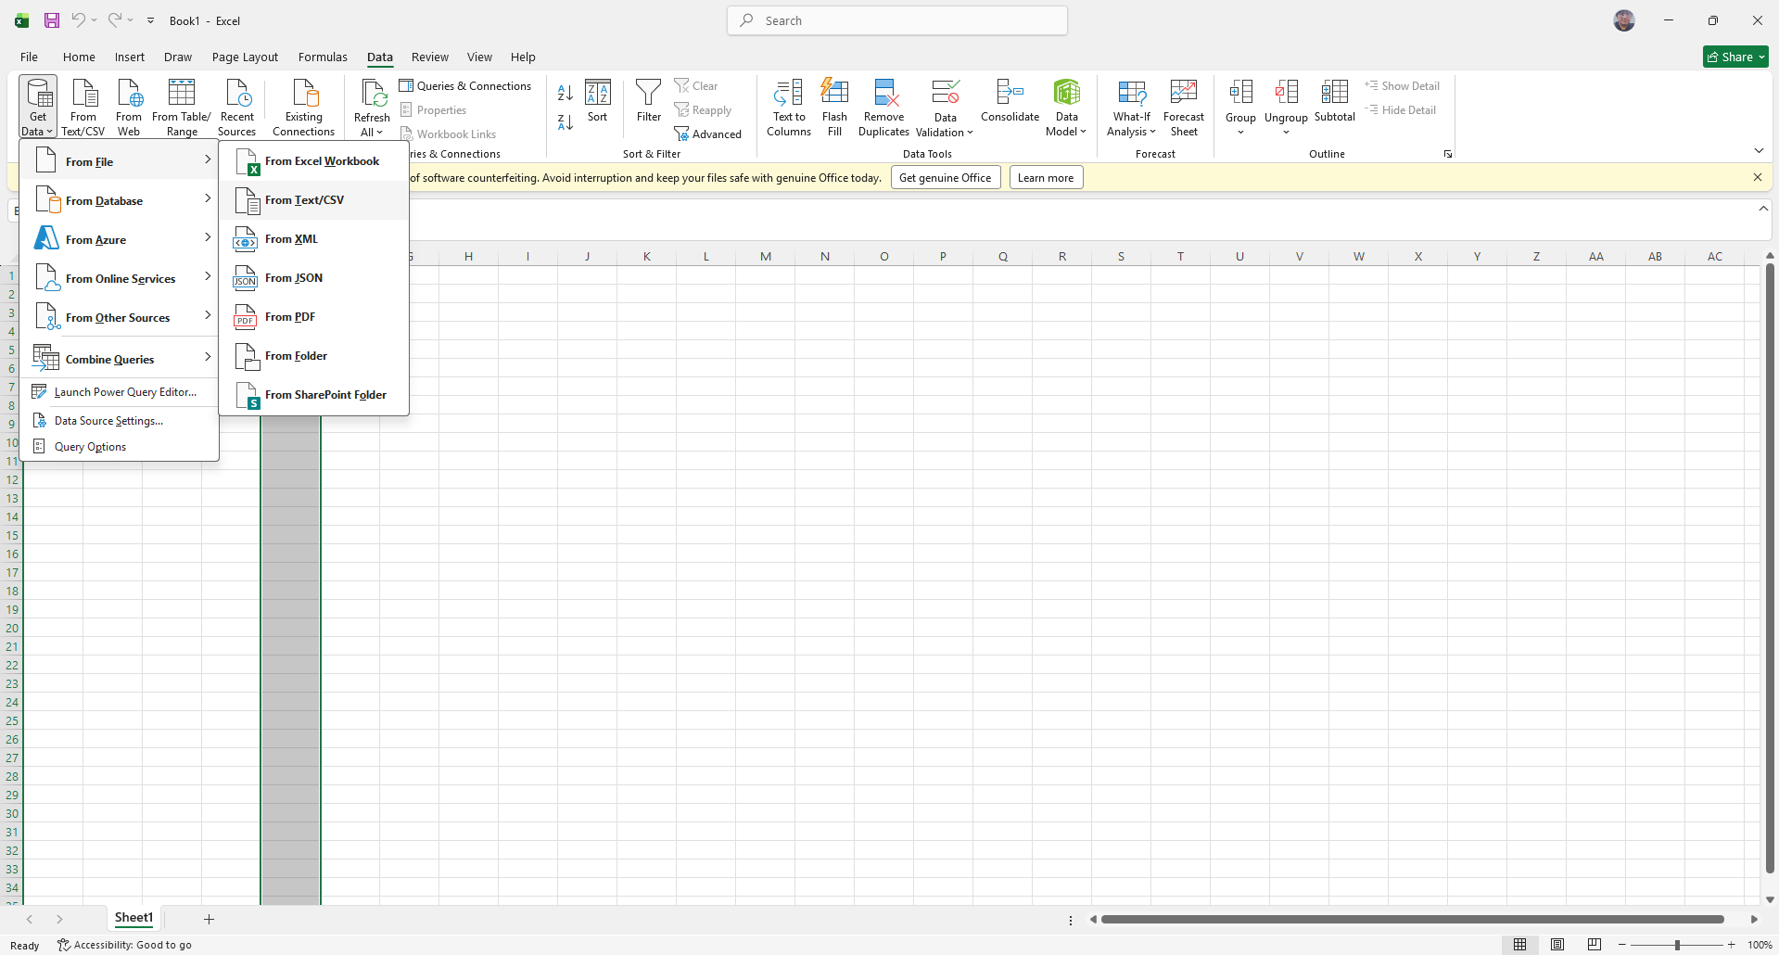
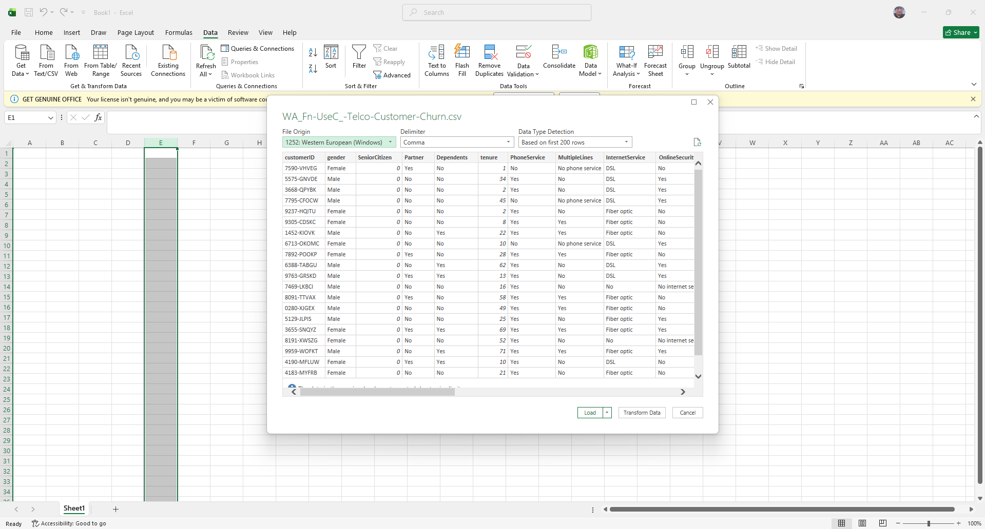
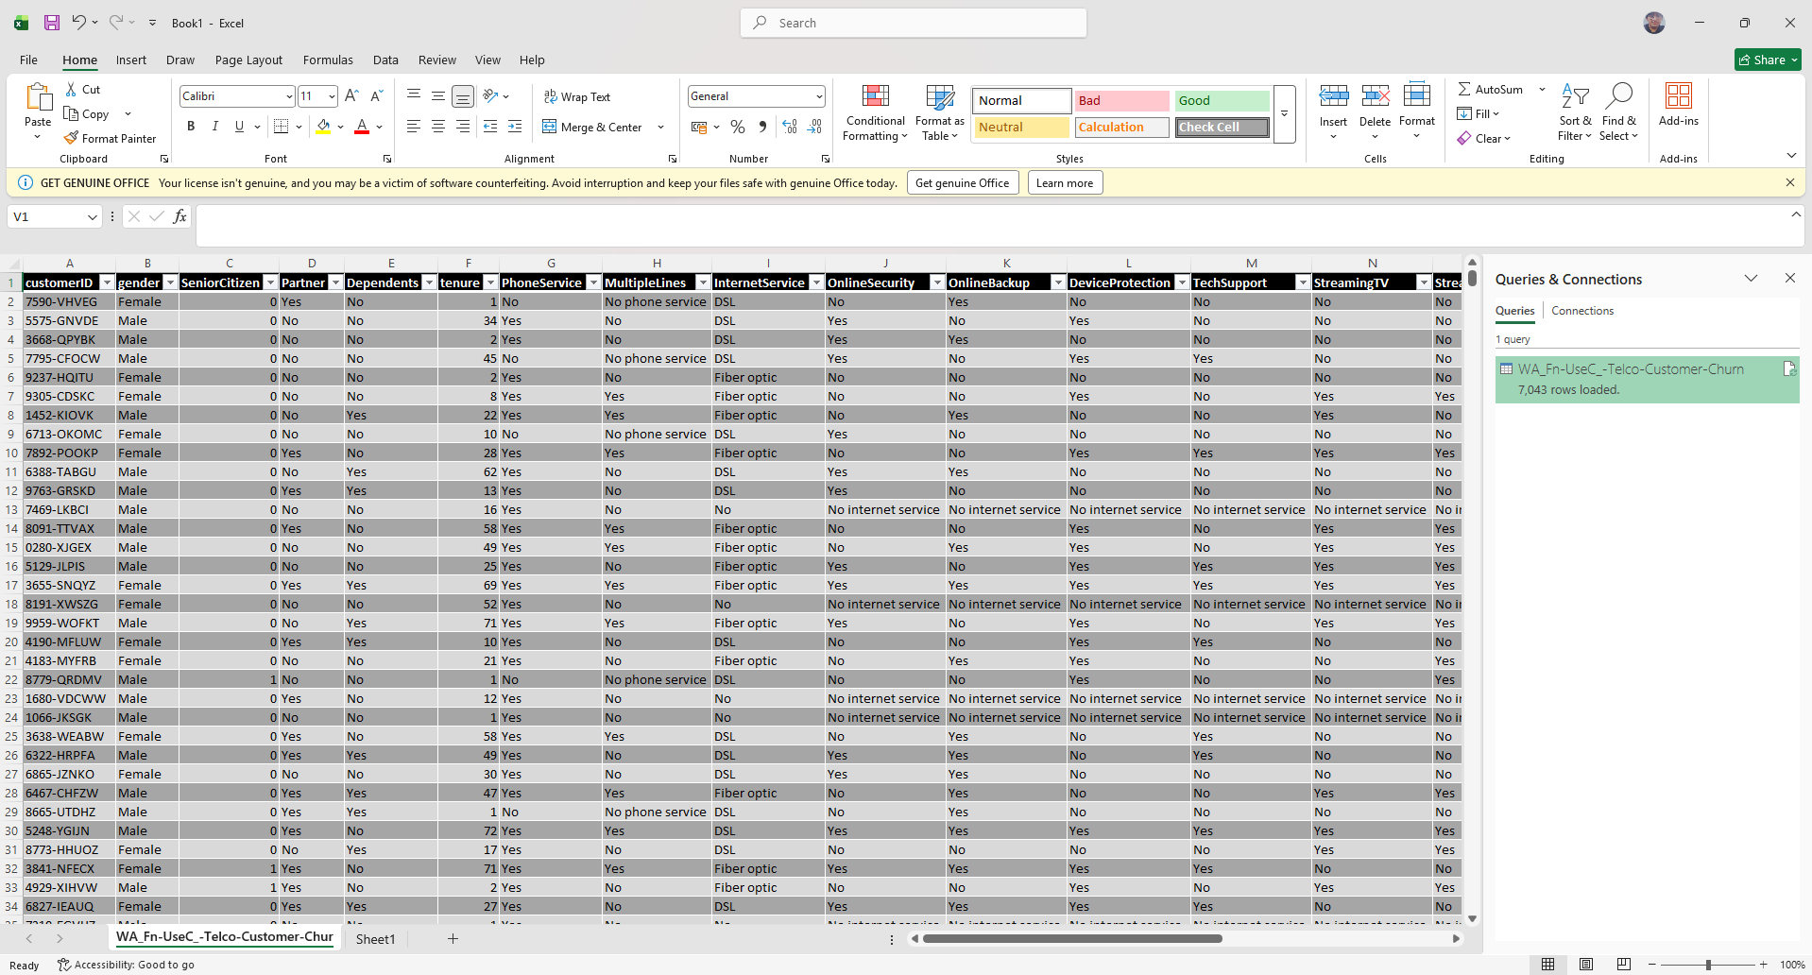

STEP 3: Check Data
- Ensure all columns are visible
- Check:
  - Churn (Yes/No)
  - Contract
  - Gender
- Remove blank rows if any
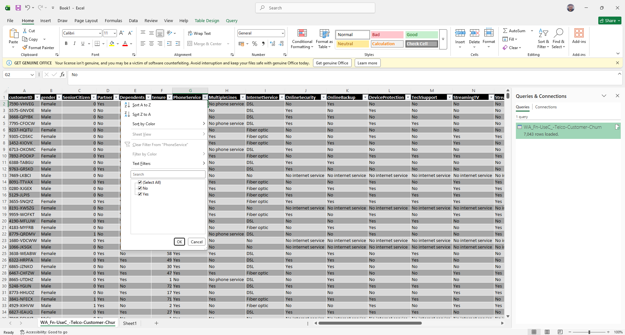
STEP 4: Select Data
STEP 5: Select Data
- Go to: Insert → PivotTable
- Select: PivotTable → Table/Range
- Select: New Worksheet → OK
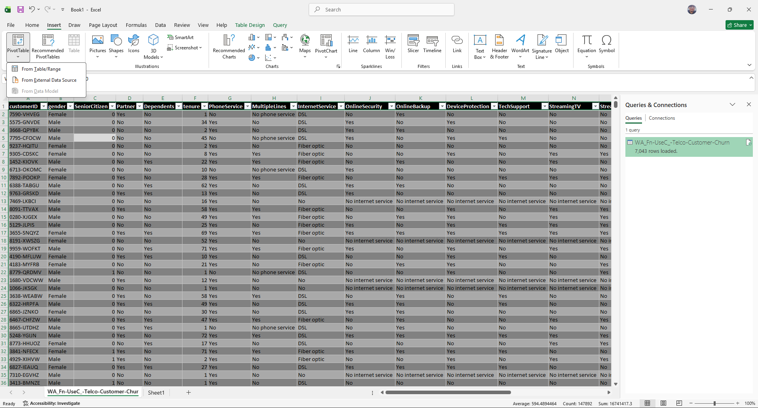
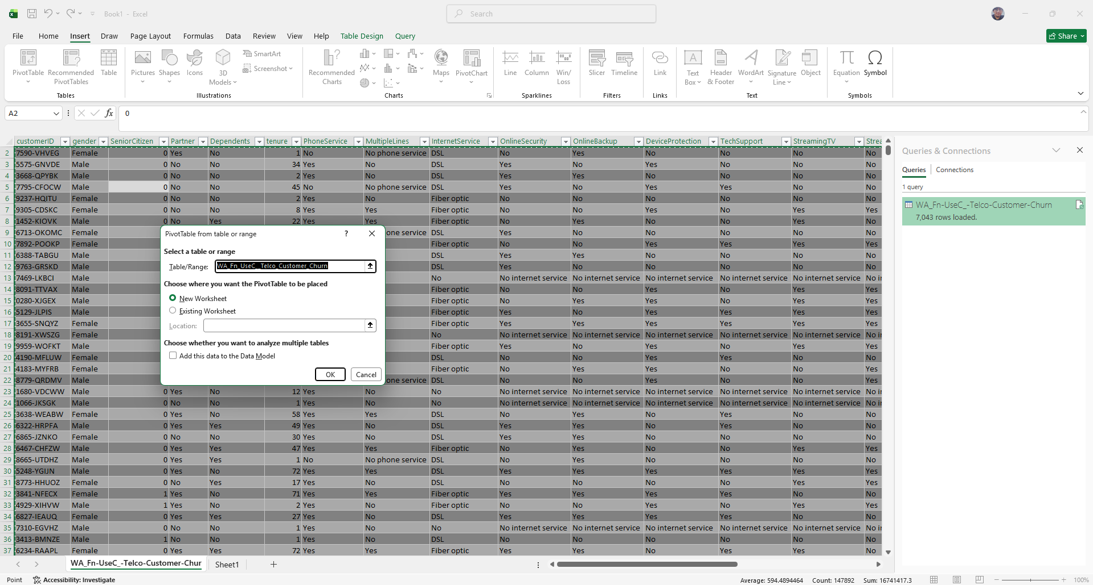
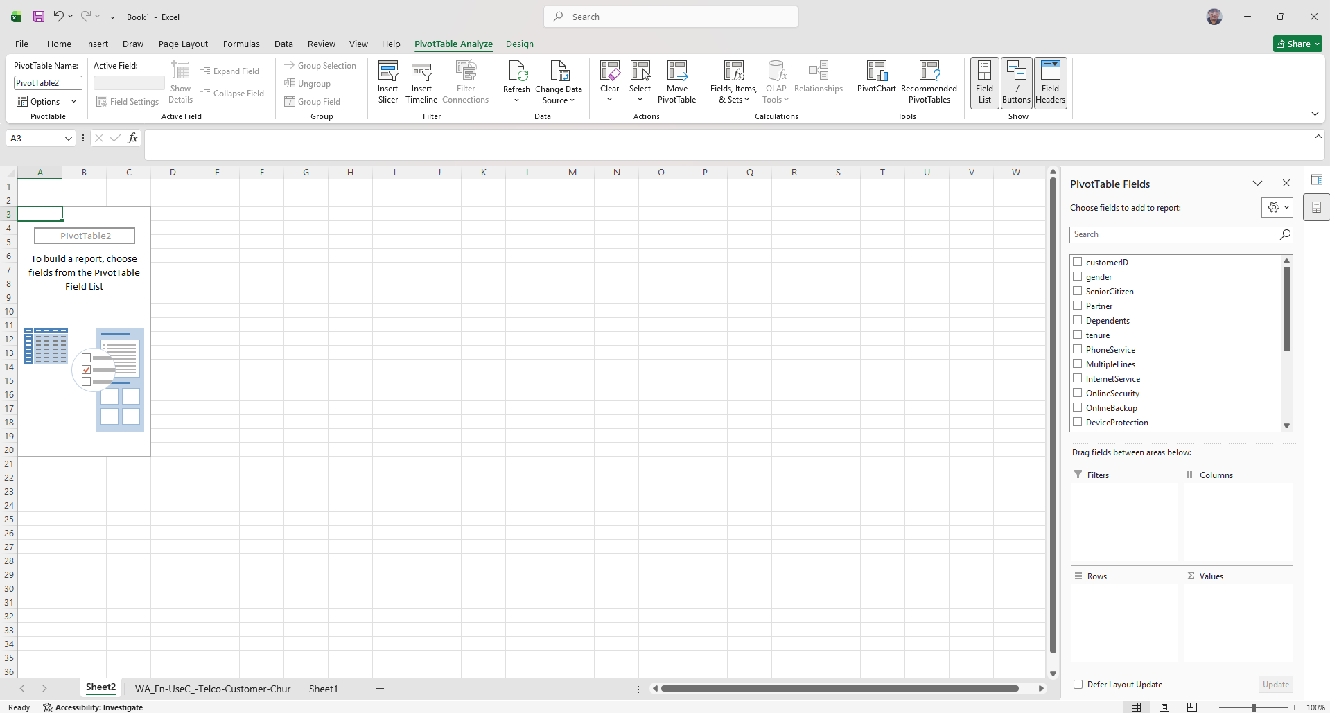
STEP 6: Create Pivot Table
- In the PivotTable Fields pane, drag Churn to the Rows area
- Drag Churn to the Values area
- Set the value field to Count
- The Pivot Table will display the number of customers who stayed and churned
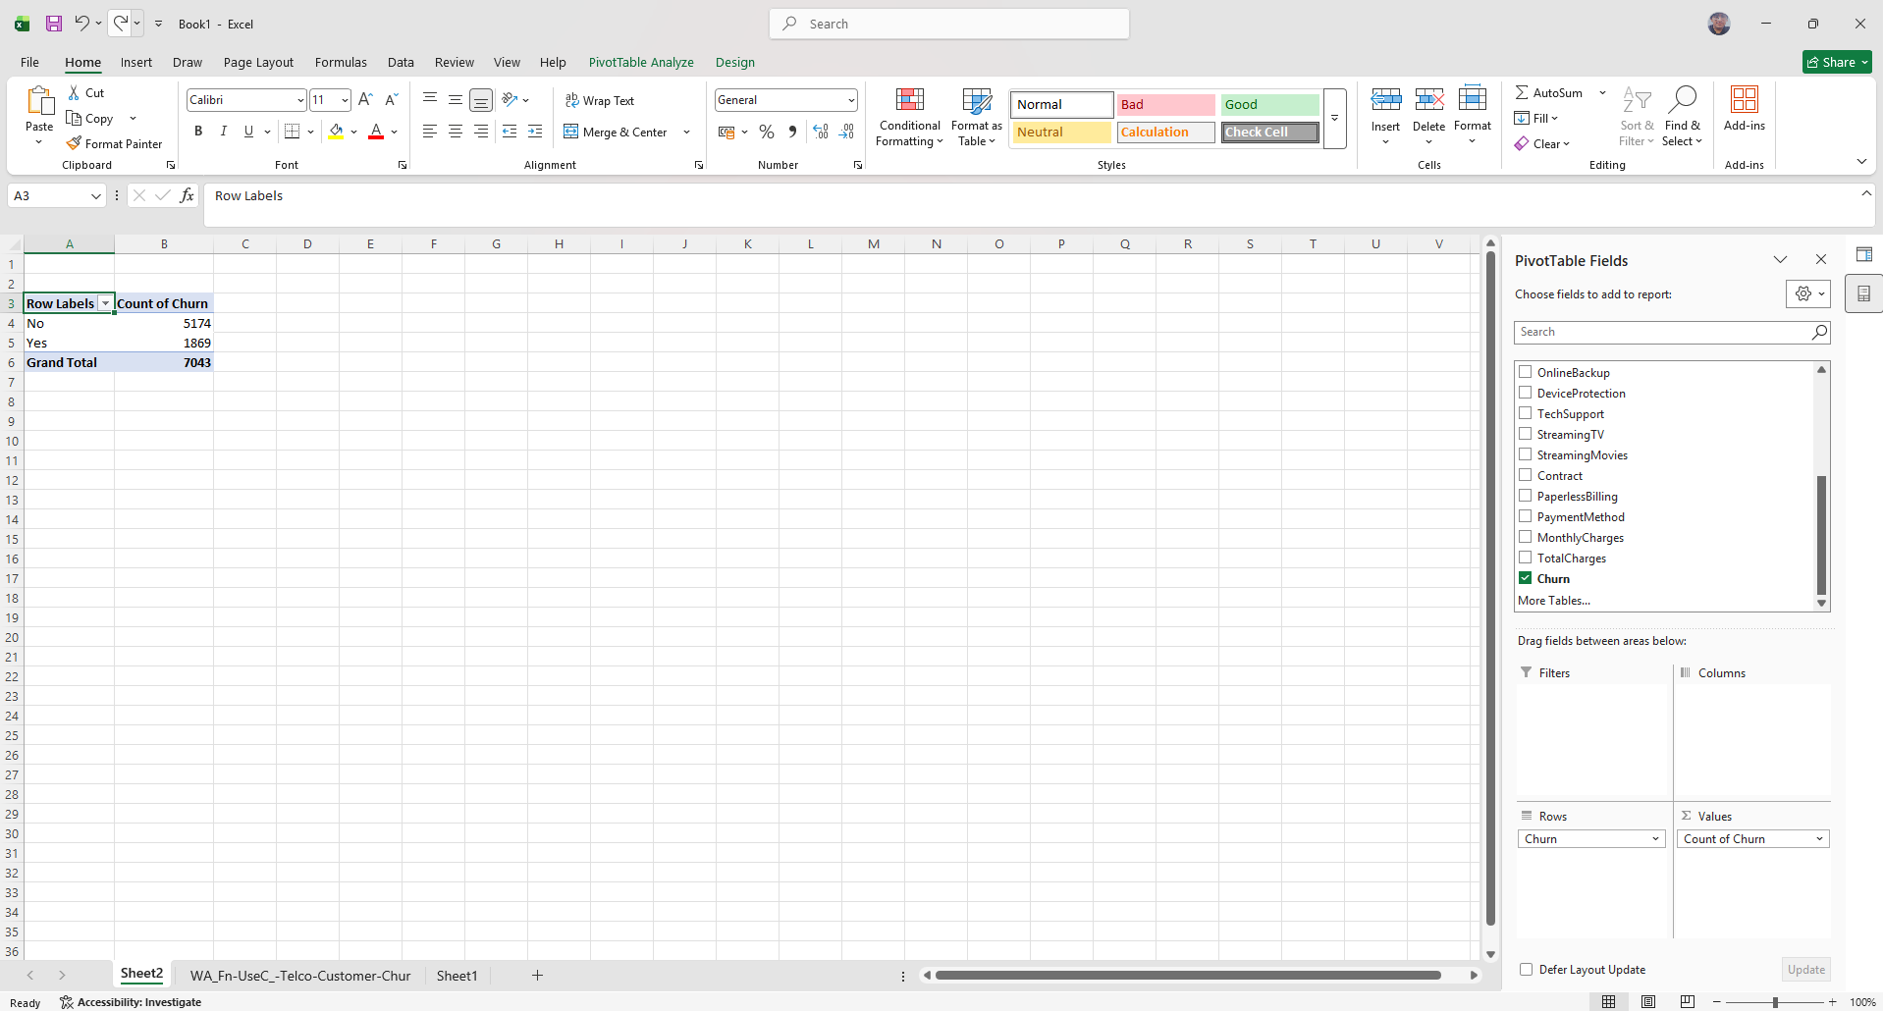
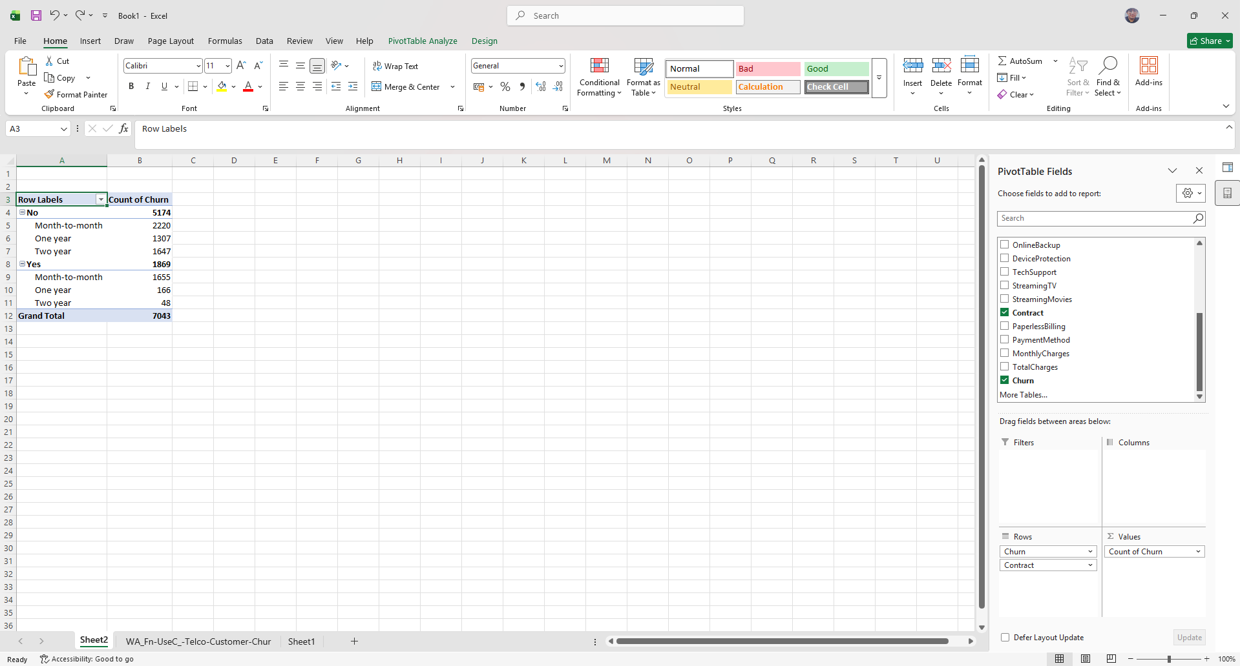
STEP 7: Create Additional Pivot Table
- Insert another Pivot Table
- Drag Contract to Rows
- Drag Churn to Columns
- Drag Churn to Values (Count)
- This shows churn distribution based on contract type

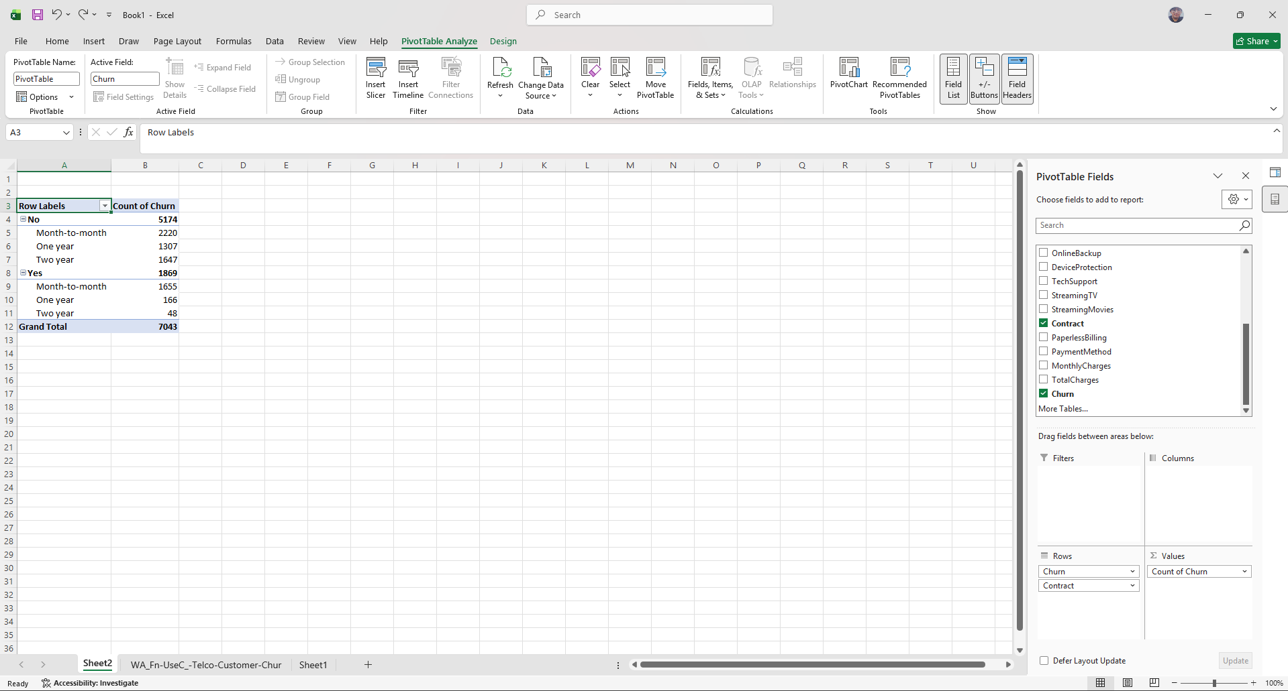
STEP 8: Create Pivot Table for Tenure
- Insert a new Pivot Table
- Drag tenure to Rows
- Drag Churn to Columns
- Drag Churn to Values (Count)
- Select any tenure value
- Go to PivotTable Analyze → Group Selection
- Group data into intervals (e.g., 0–10, 10–20, etc.)

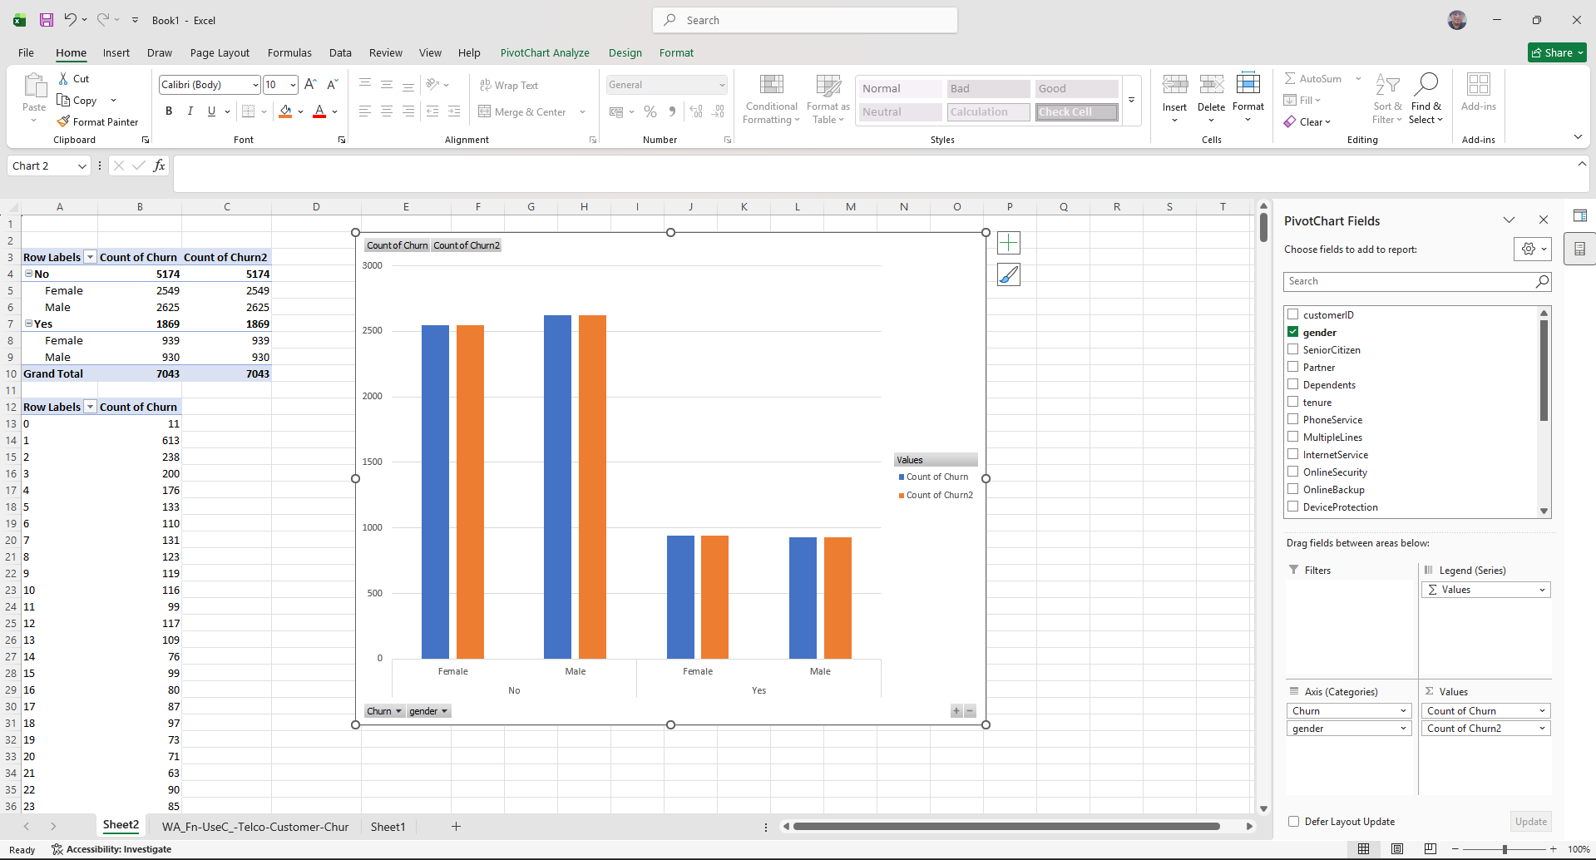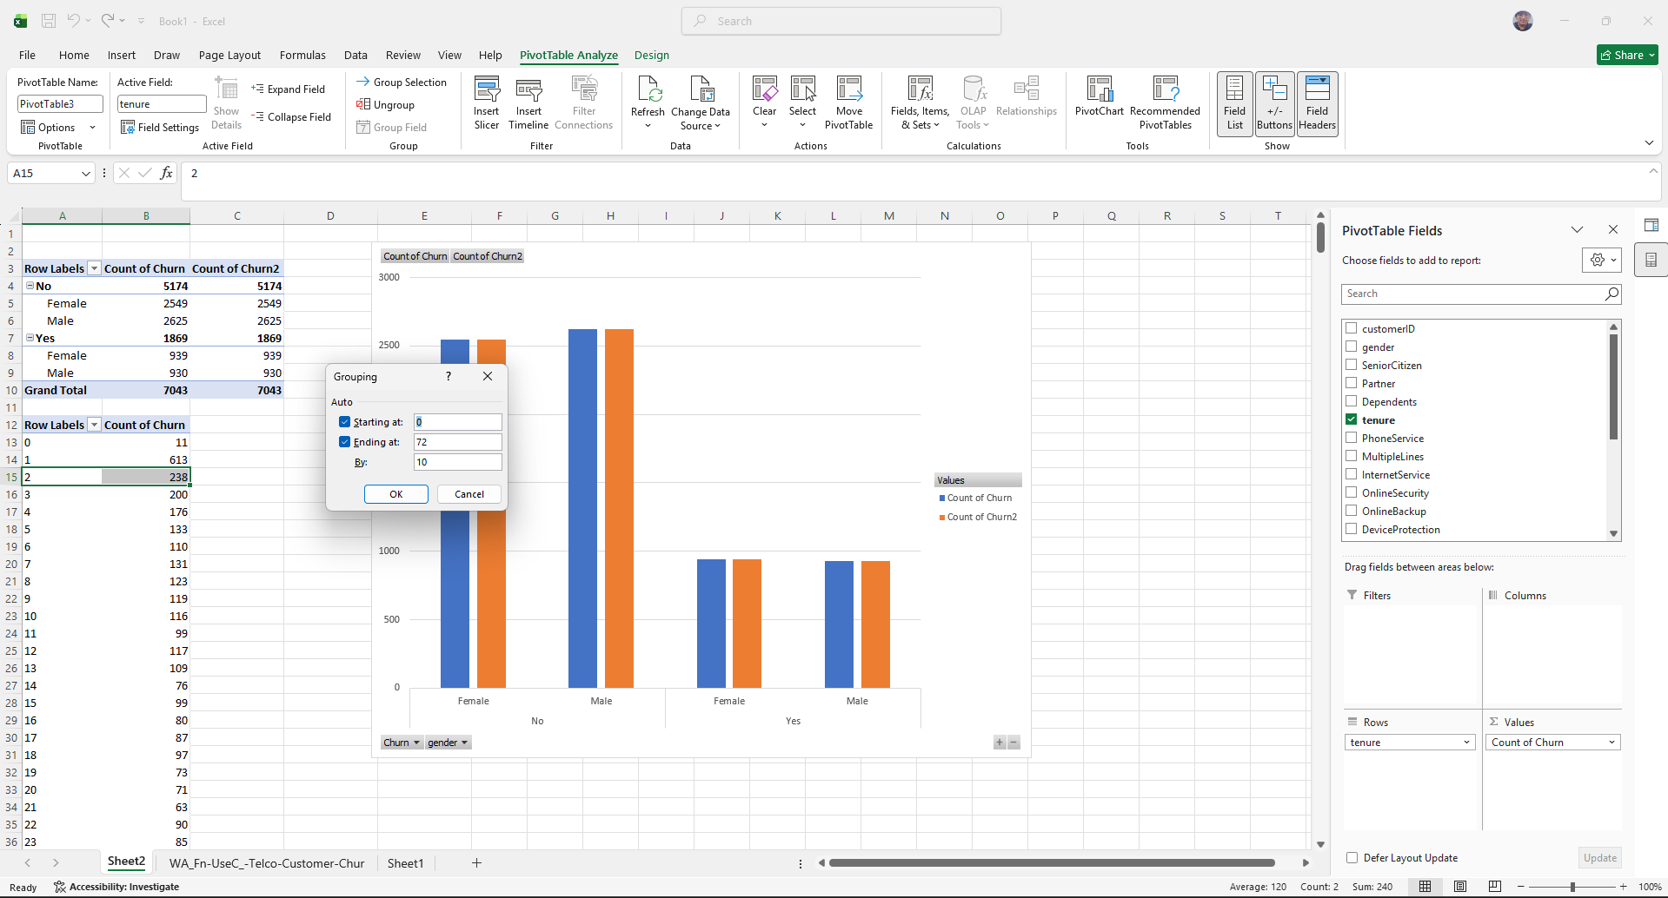
STEP 9: Create Pivot Chart
- Click inside any Pivot Table
- Go to Insert → PivotChart
- Select Column Chart
- Click OK
- Format the chart and add title: Customer Churn Analysis
