Zeal College of Engineering and Research Subject: LP-VI
Name: Jenil Girish Rathod Class: BE
Div: B Batch: B1
Roll No: B22009

Group B: Practical No:1

Program Statement: Import the legacy data from different sources such as (Excel, SQL Server, Oracle etc.) and load in the target system. (You can download sample database such as Adventure works, Northwind, foodmart etc.)

Step 1: Open Power BI Desktop:
- Launch Microsoft Power BI Desktop
- Click “Get Data” on the Home ribbon
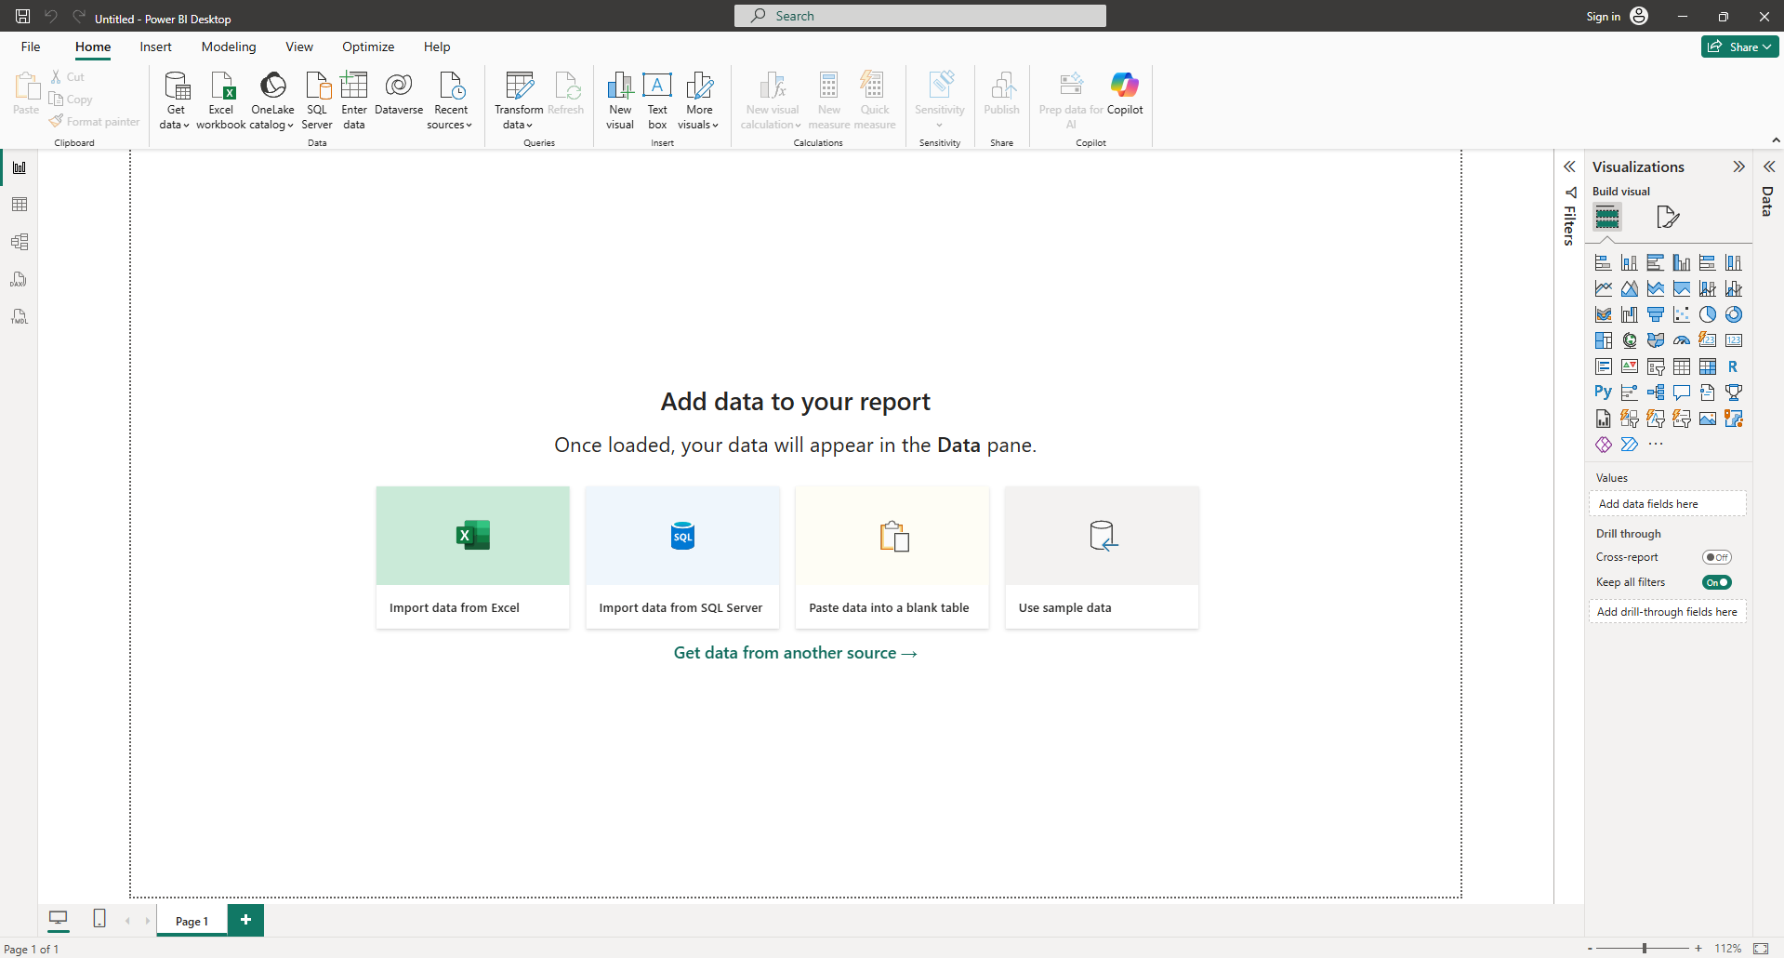

Step 2: Connect to Excel Data
- Click Get Data → Excel
- Browse and select your .xlsx file
- Navigator window opens:
  - Select sheets/tables
  - Click Load (or Transform Data for cleaning)
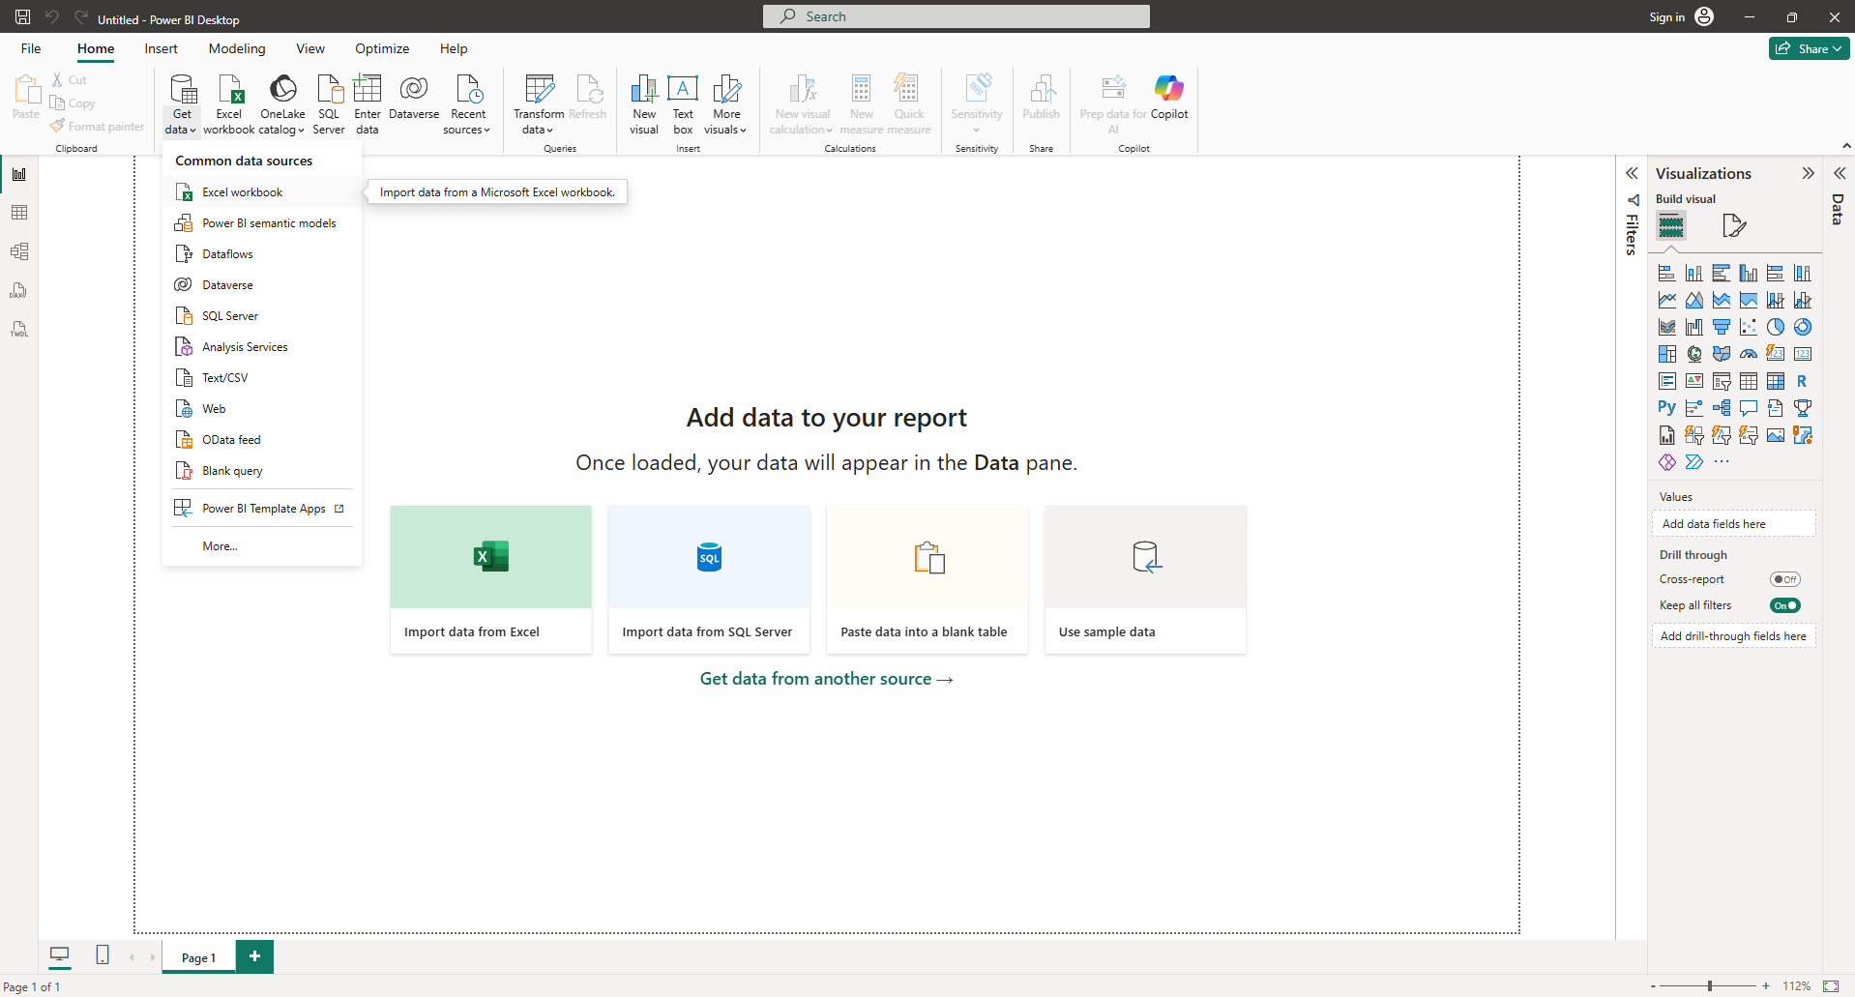
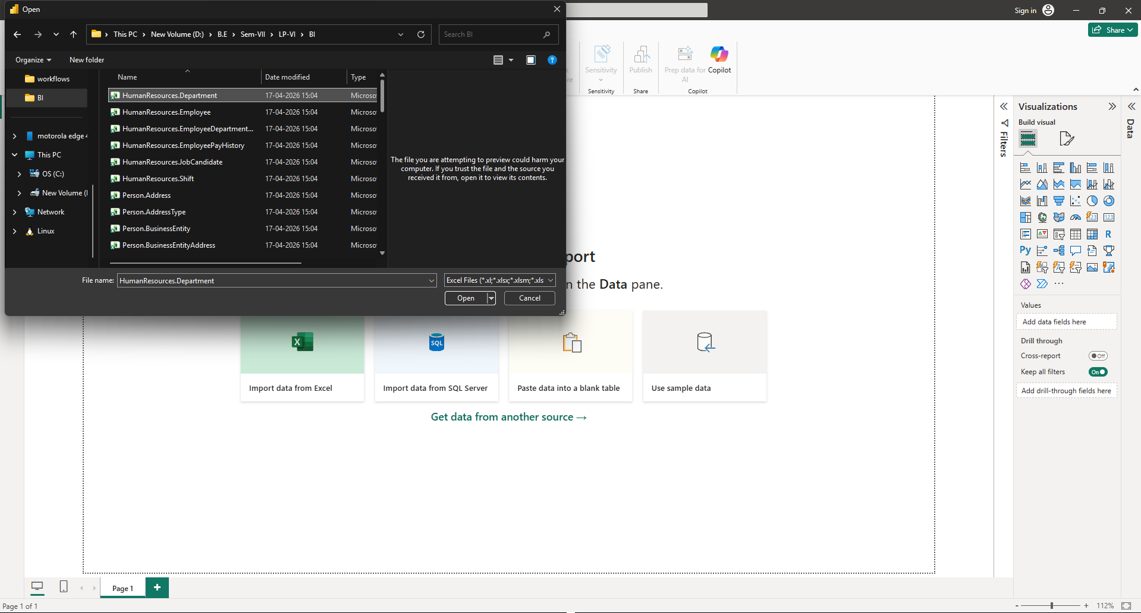

Step 3: Clean Excel Data in Power BI (Power Query)
- Open Power Query Editor
  - After selecting Excel file → click Transform Data (NOT Load)
  - This opens the Power Query Editor
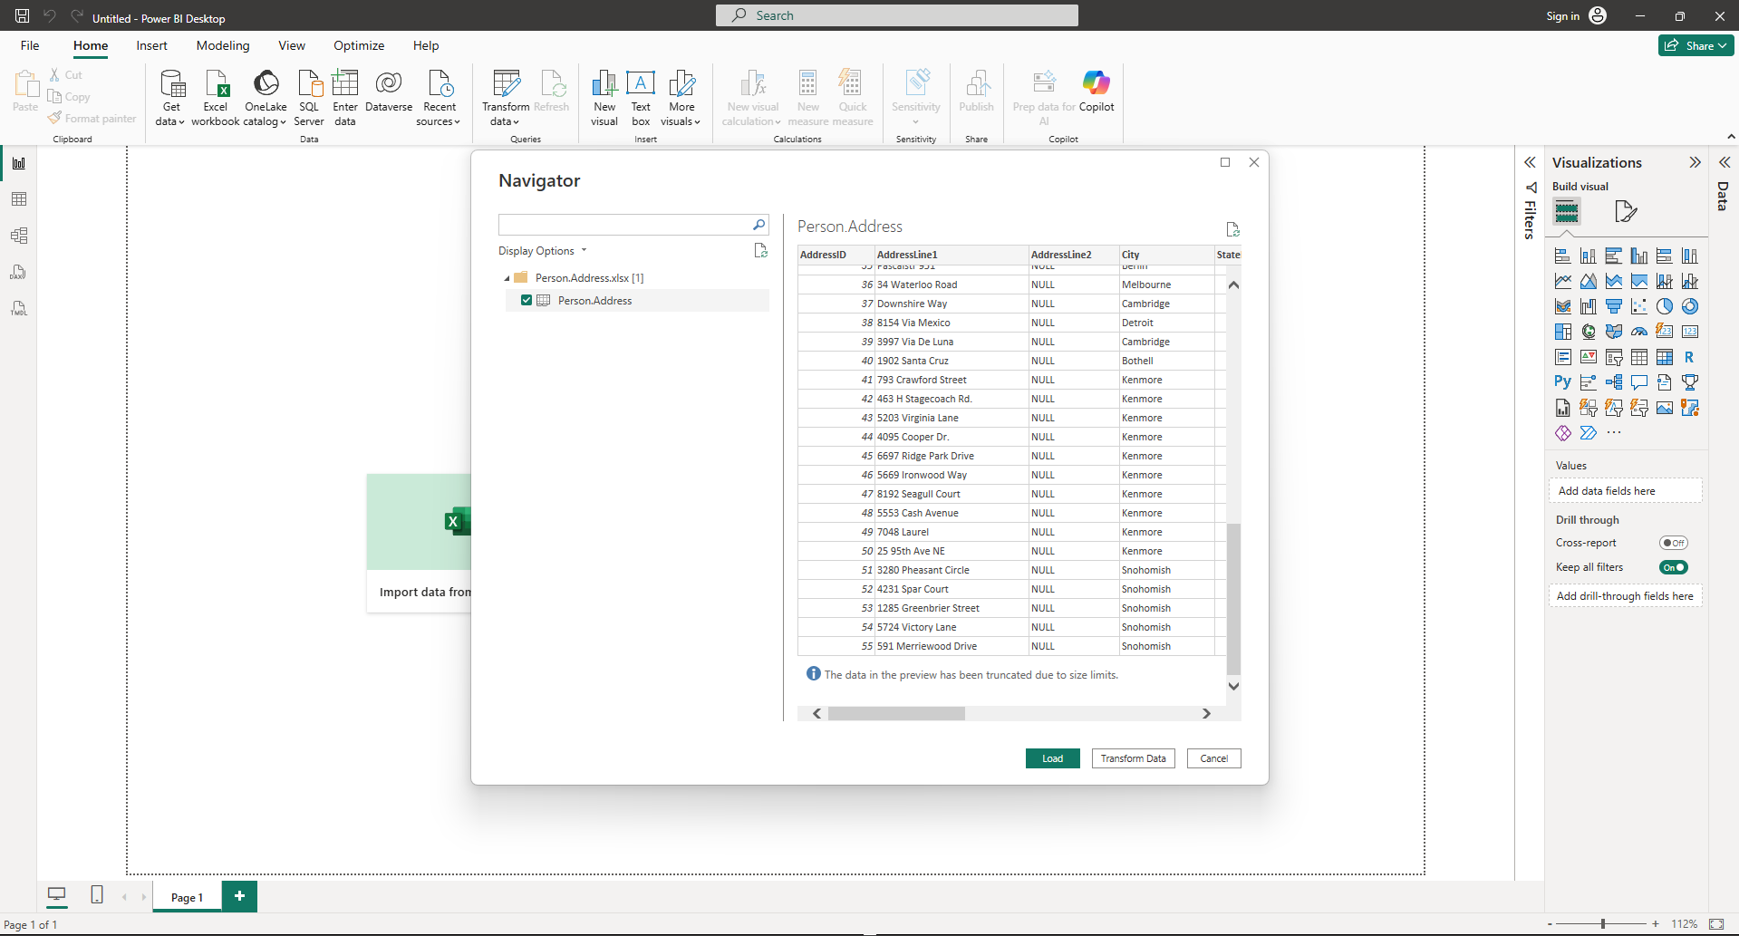
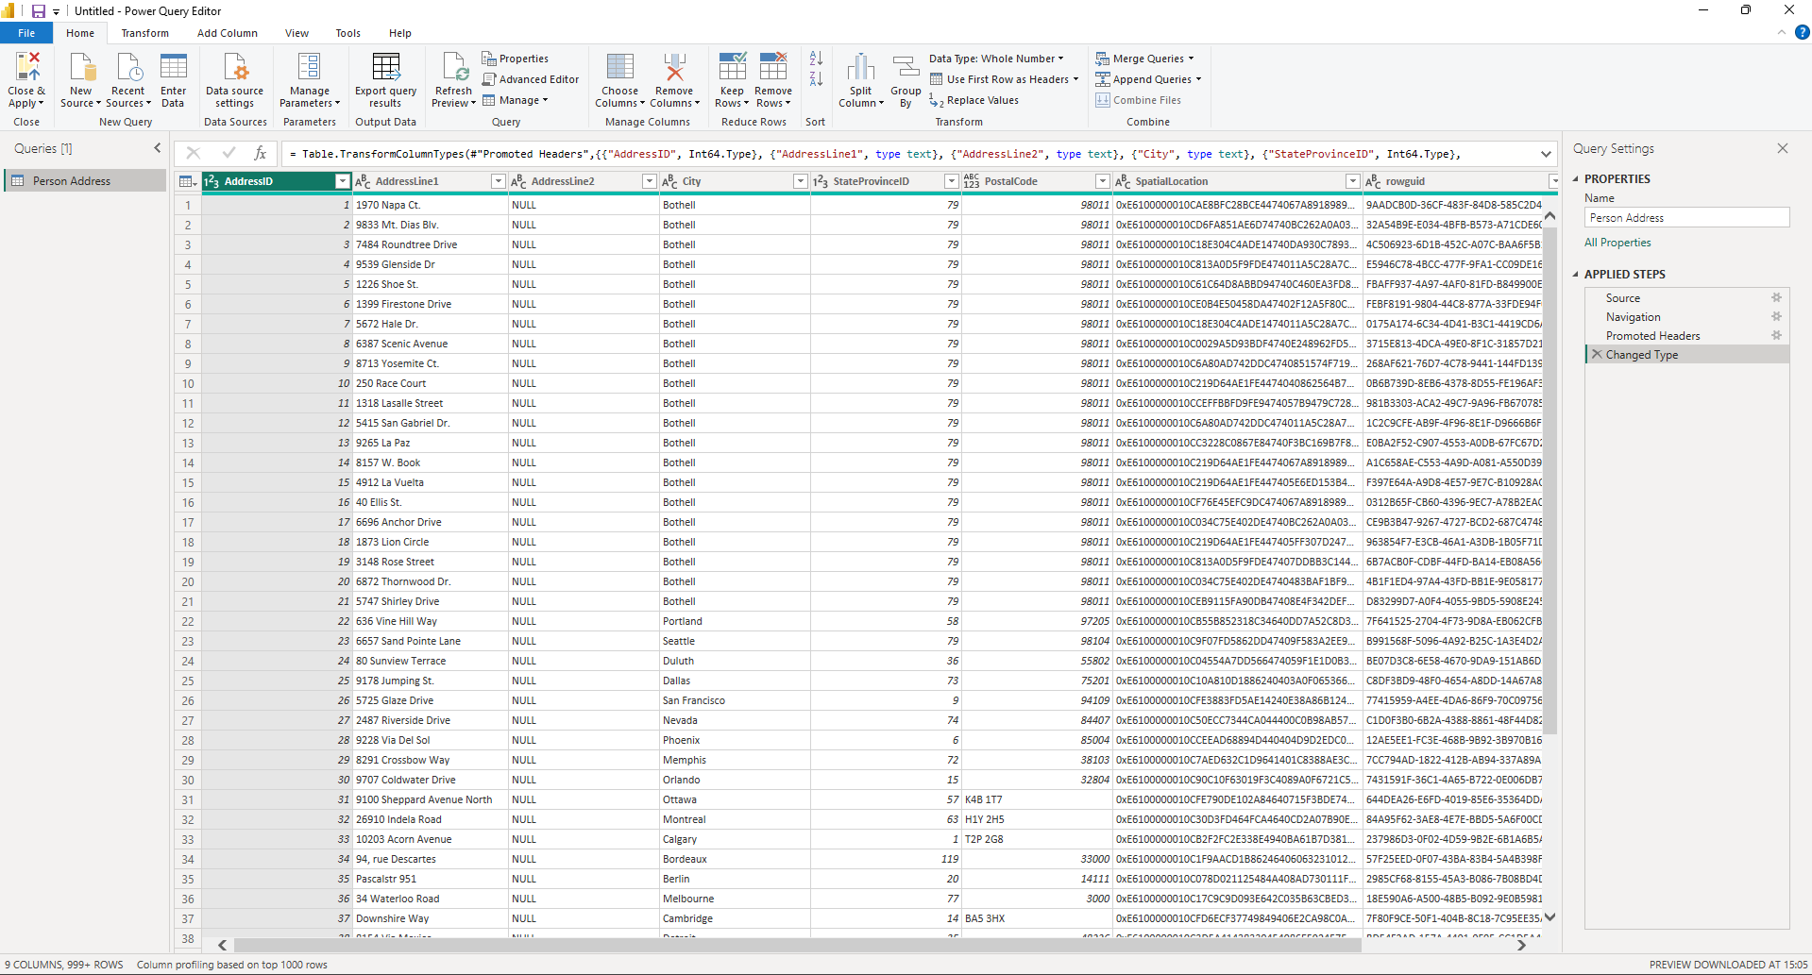

Step 4: Remove Unnecessary Columns
- Select unwanted columns
- Right-click → Remove Columns
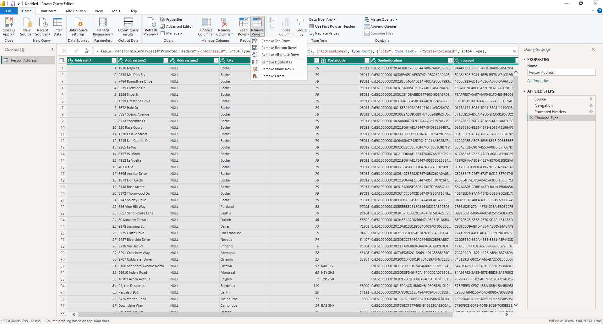
Step 5: Handle Missing Values (Nulls)
Remove rows → if critical fields are empty
Replace nulls:
- Numeric → 0
- Text → “Unknown”
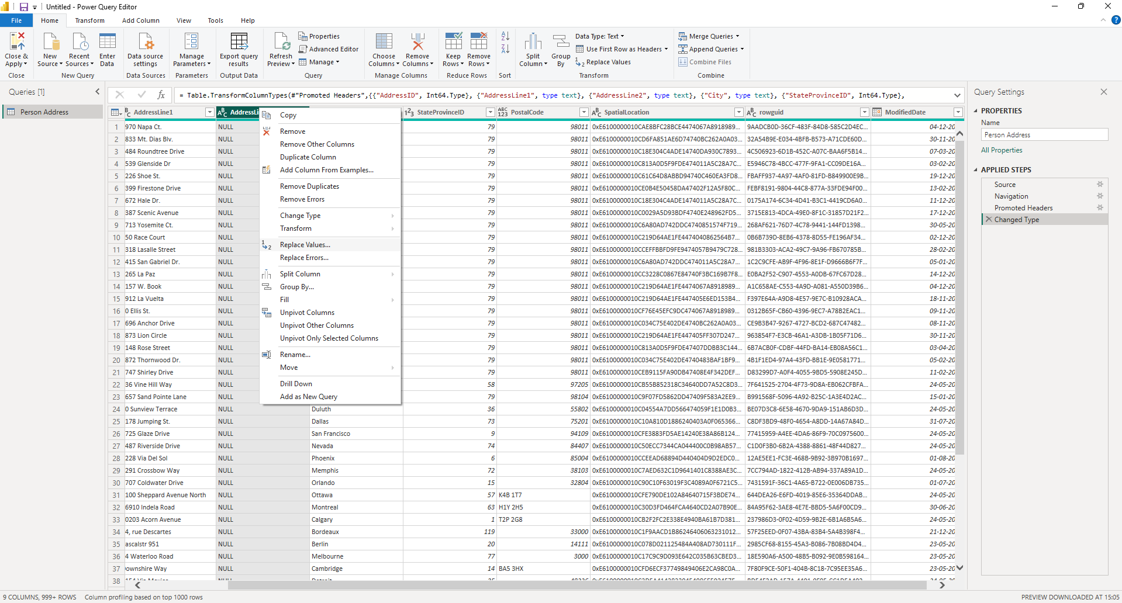
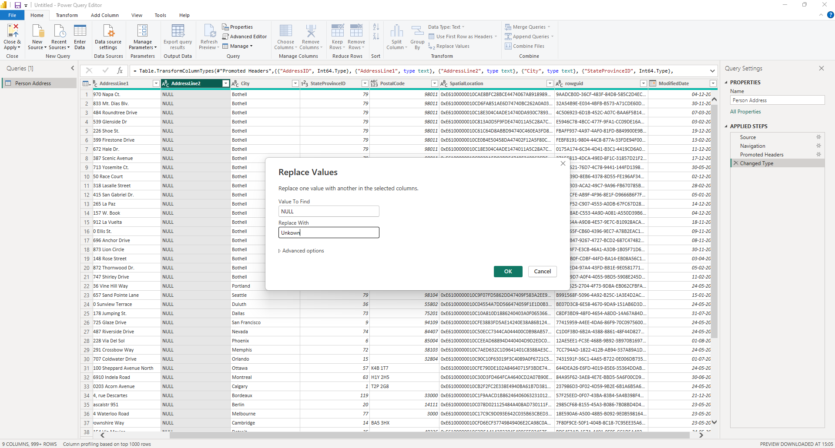
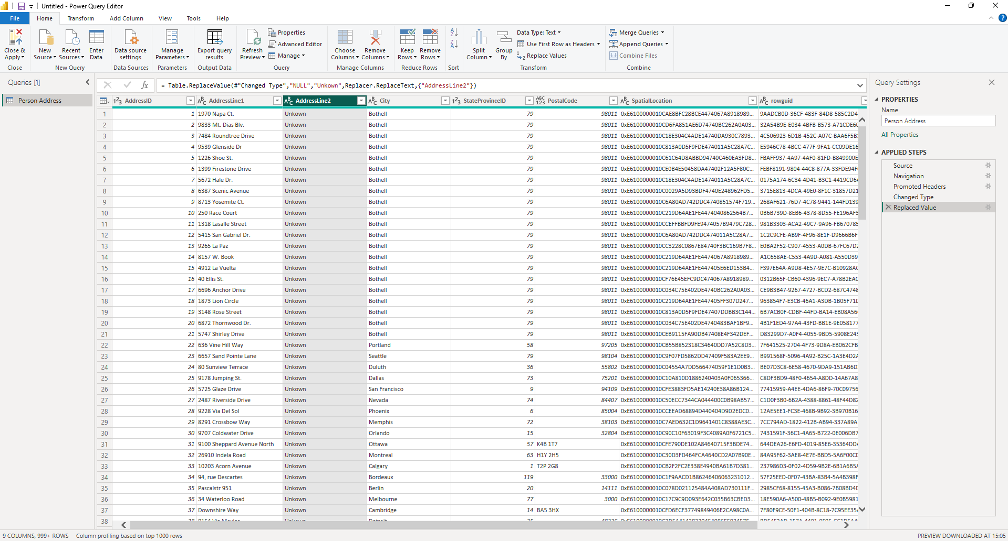

Step 6: Fix Data Types (CRITICAL)
- Click column icon (ABC / 123)
- Set correct type:
Date → Date
Amount → Decimal Number
IDs → Whole Number or Text
- Wrong types = broken calculations later

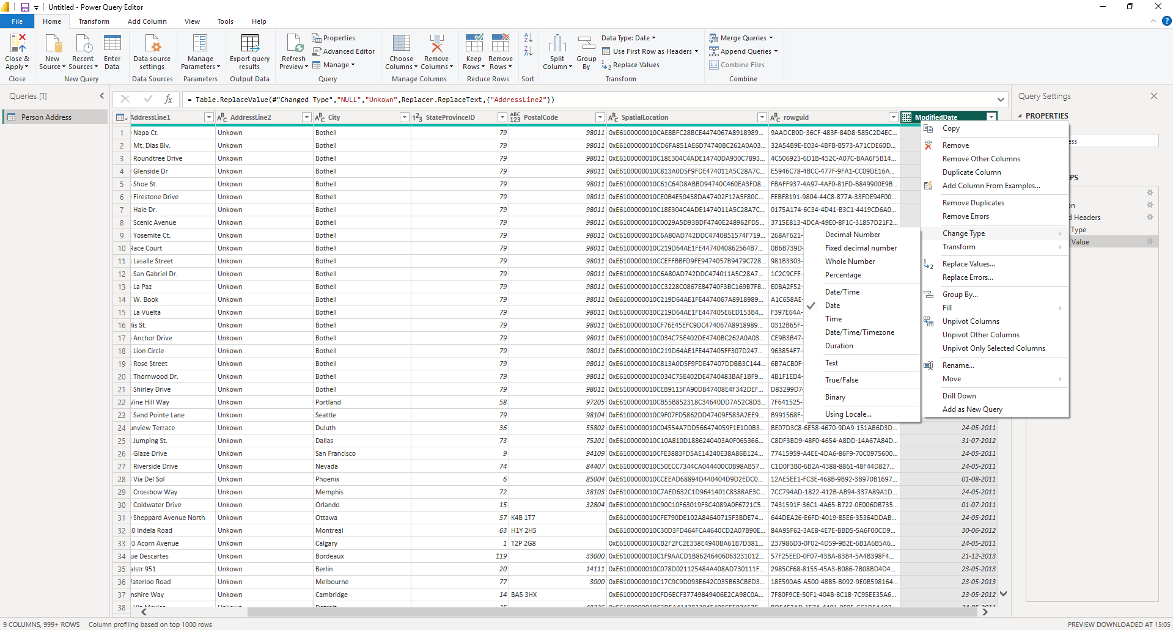

Step 7: Rename Columns Properly
- Double-click column name
- Use business-friendly naming:
cust_id → CustomerID
amt → SalesAmount
- This improves readability across your model
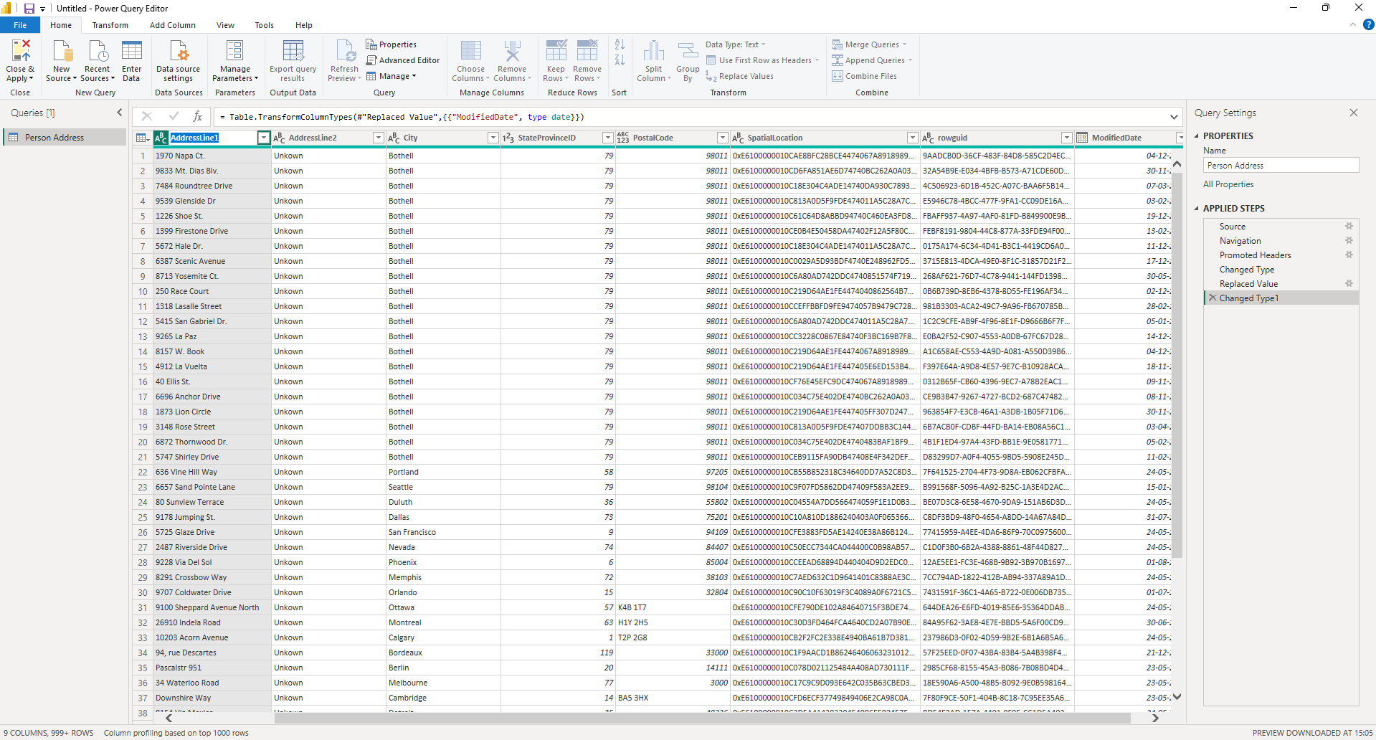
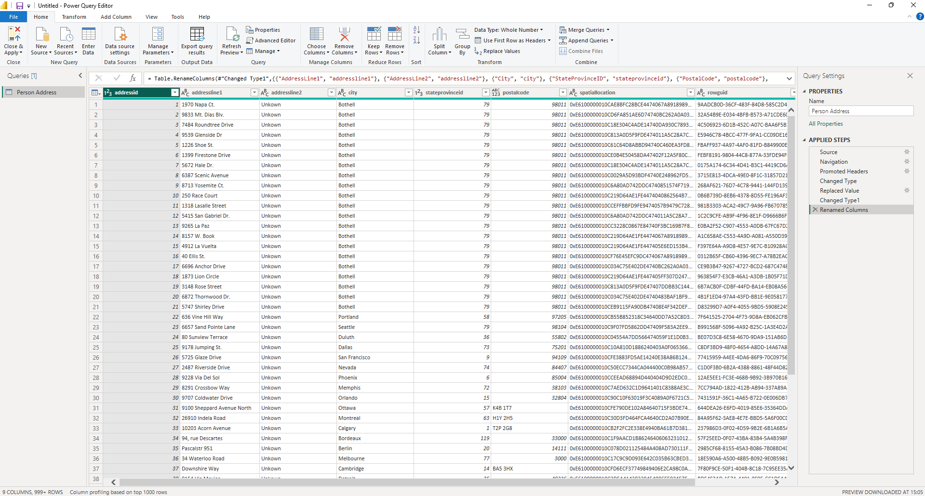

Step 8: Remove Duplicates
- Select key column
- Click Remove Duplicates
- Prevents inflated metrics
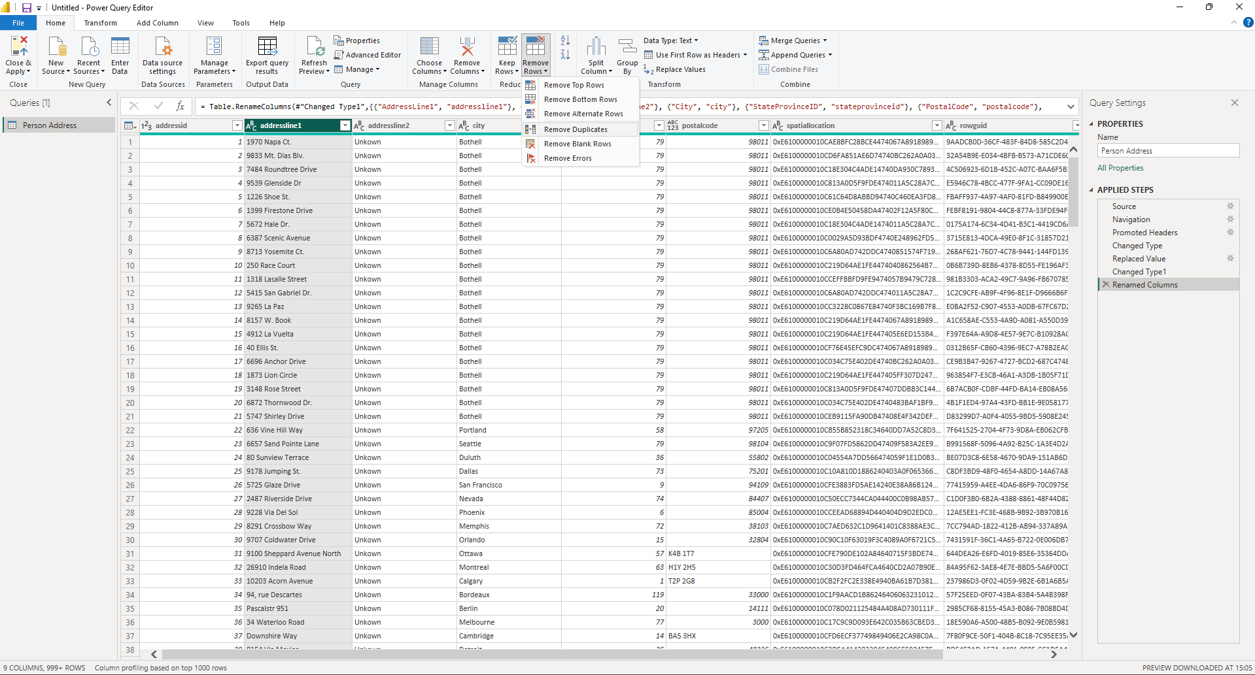
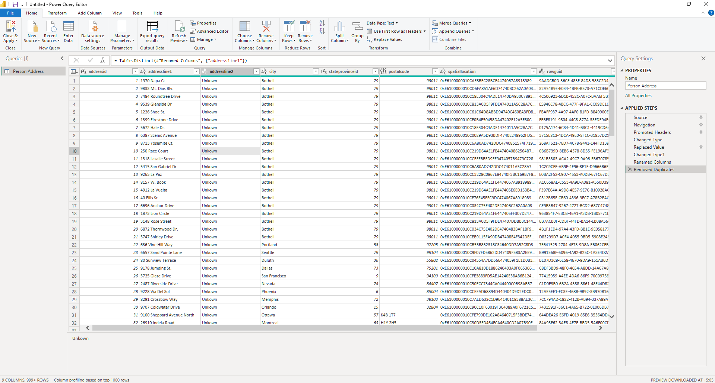

Step 9: Split or Merge Columns
- Split: Full Name → First + Last
- Merge: City + State → Location
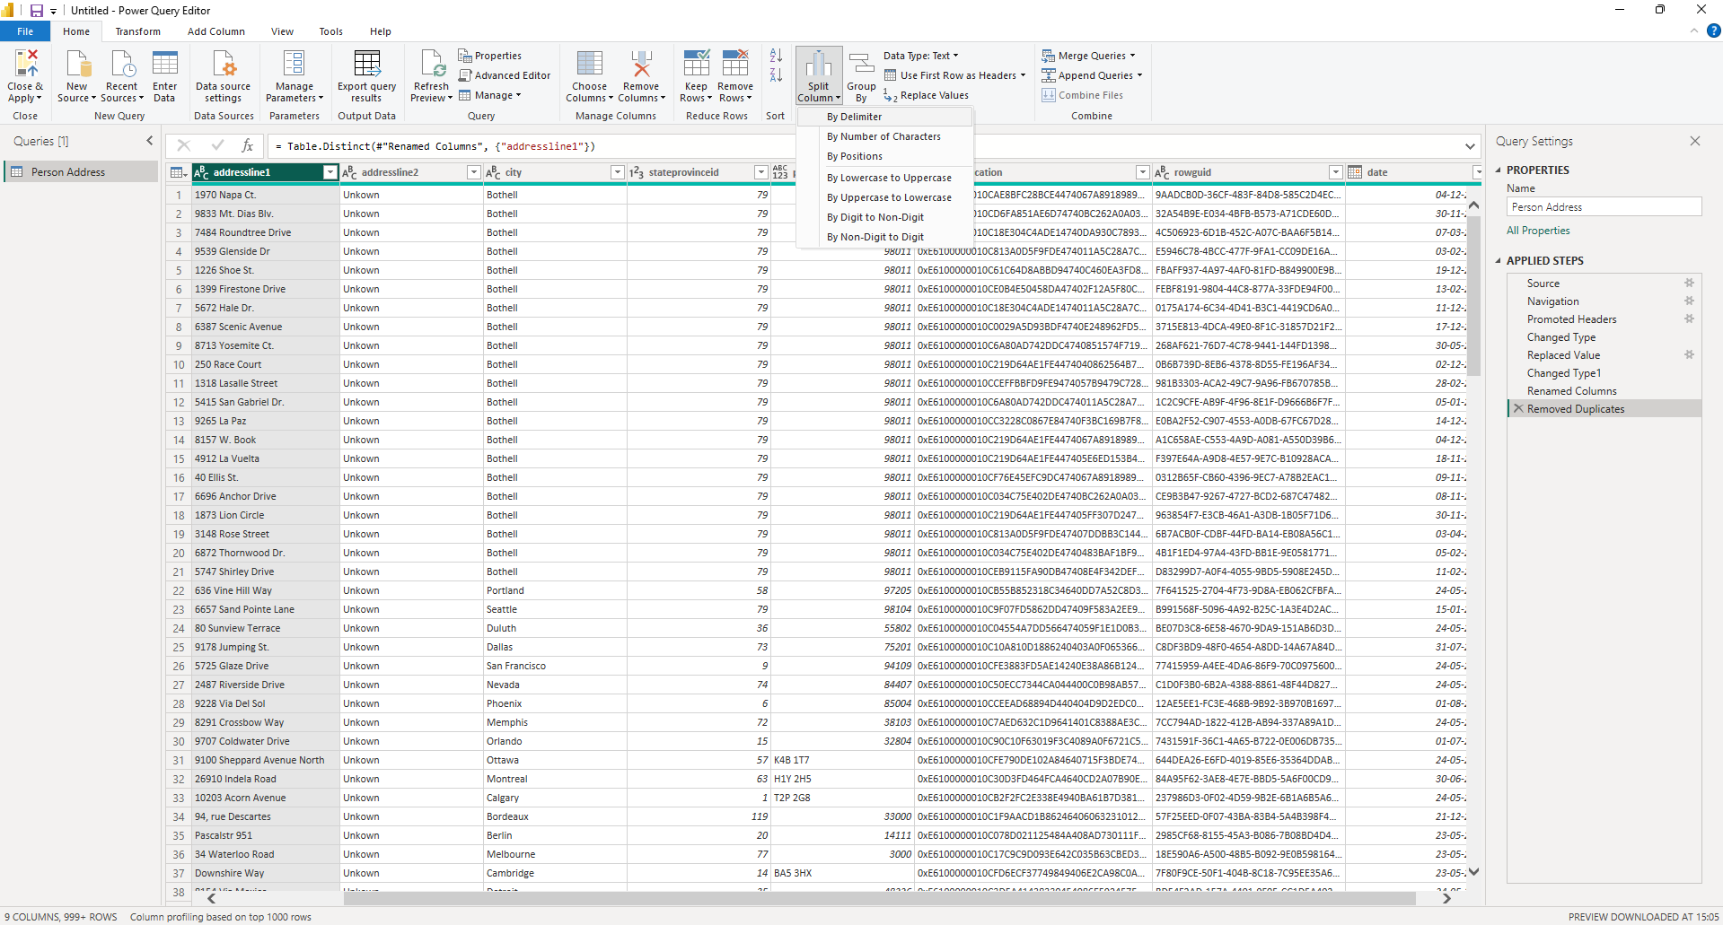
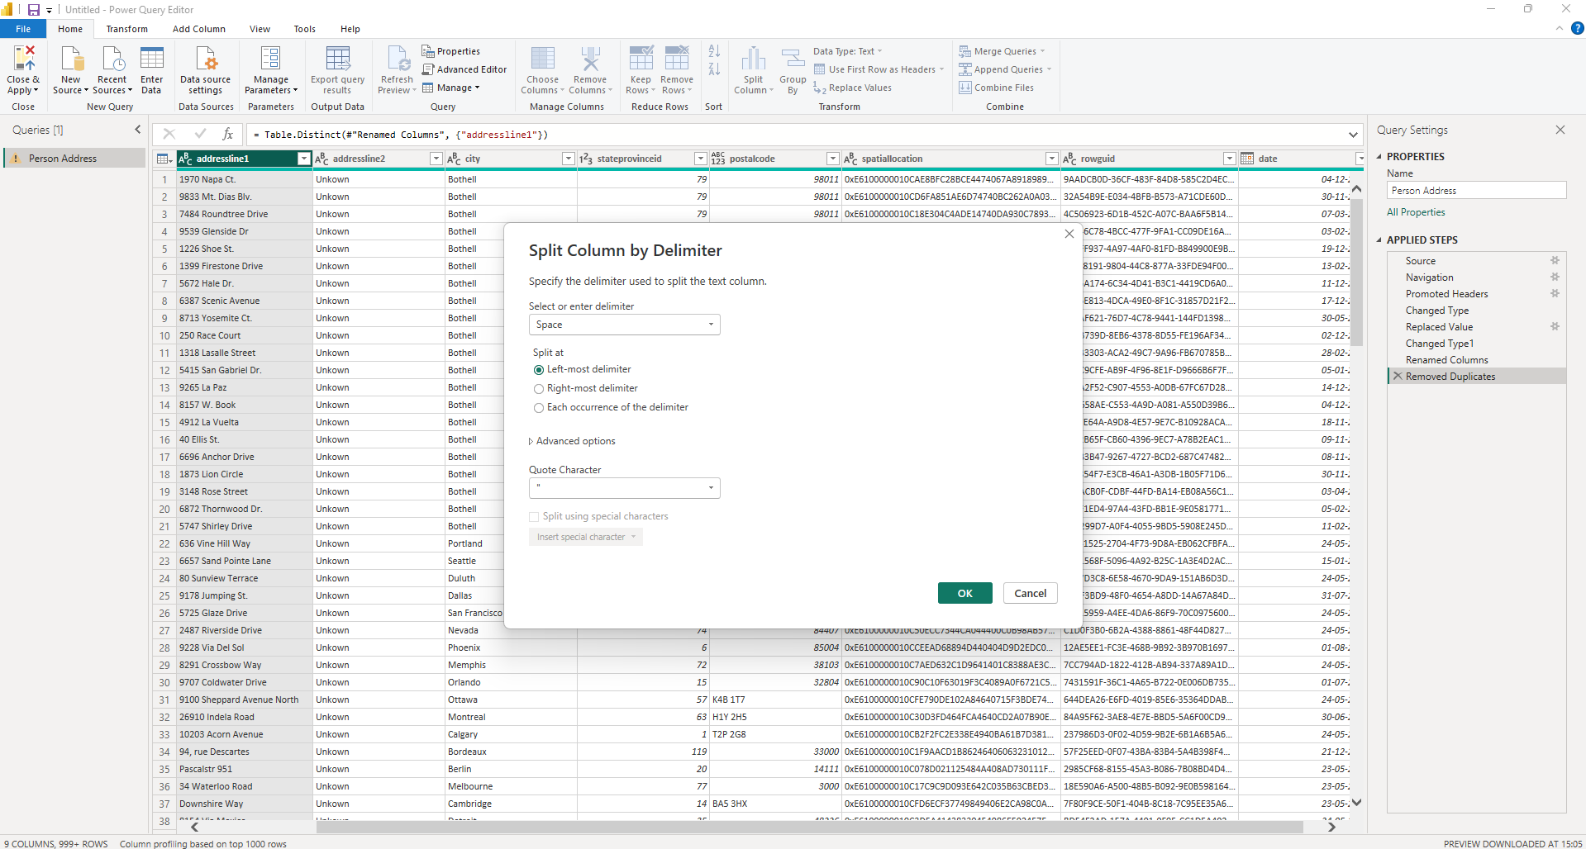
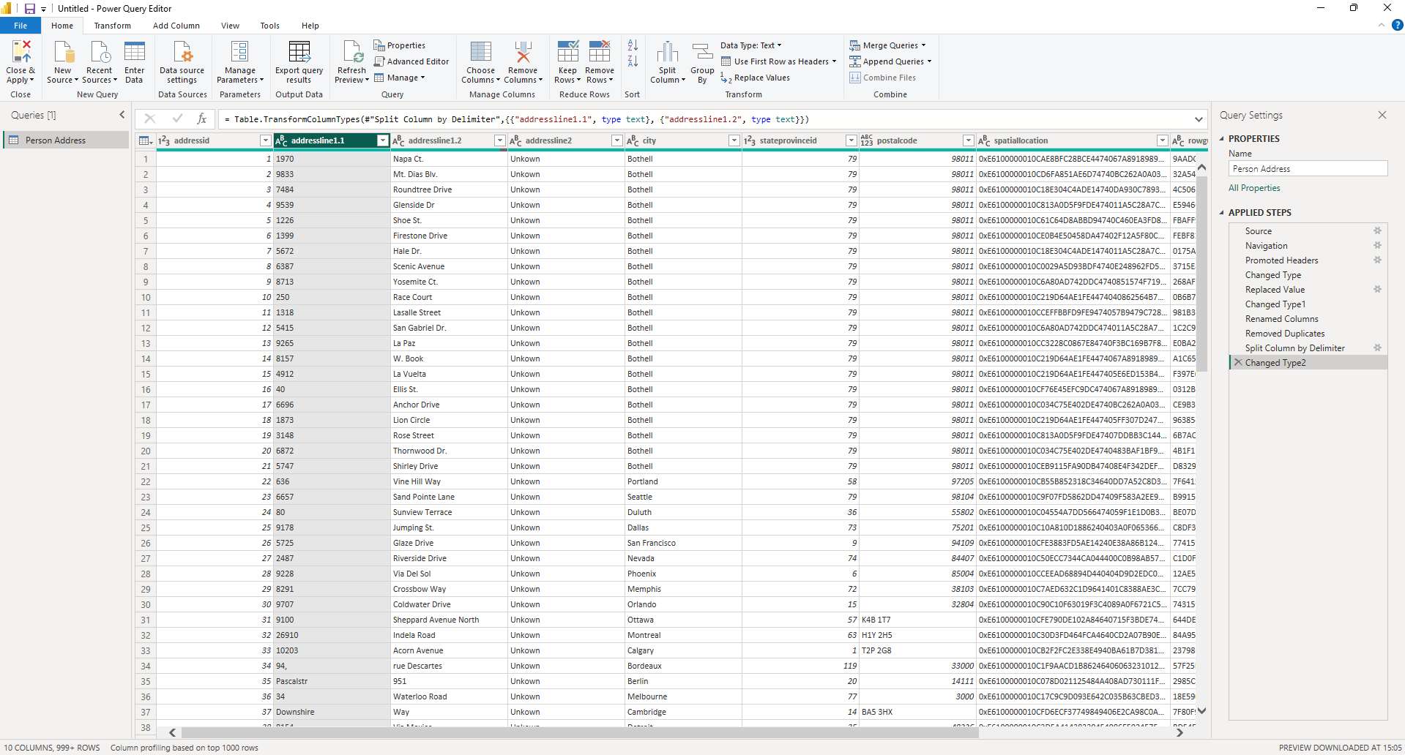
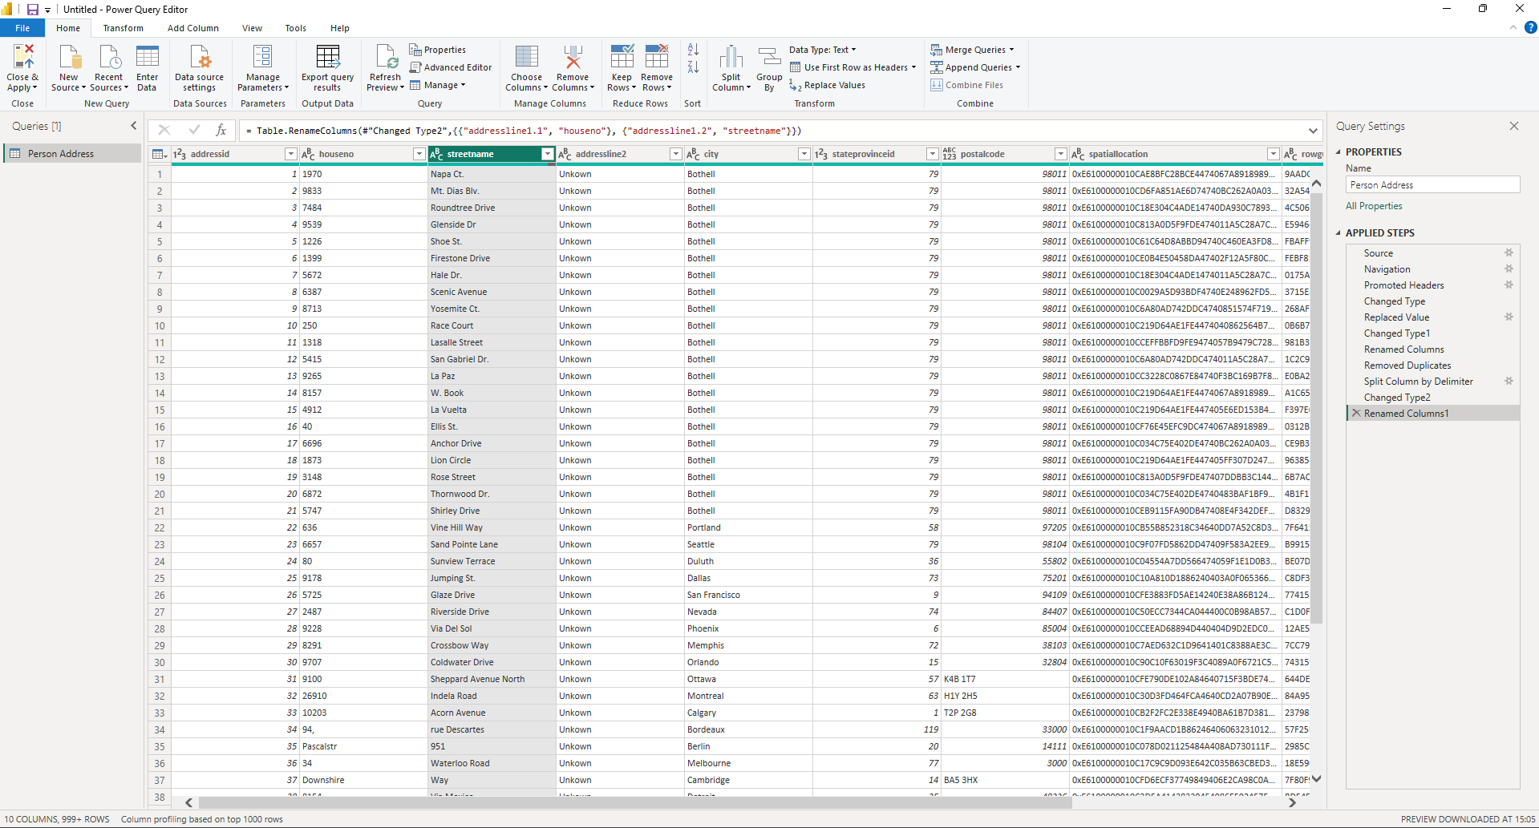

Step 10: Check “Applied Steps” (Audit Trail)
- Right side panel shows all transformations
You can:
- Edit steps
- Delete mistakes
- This is your data lineage
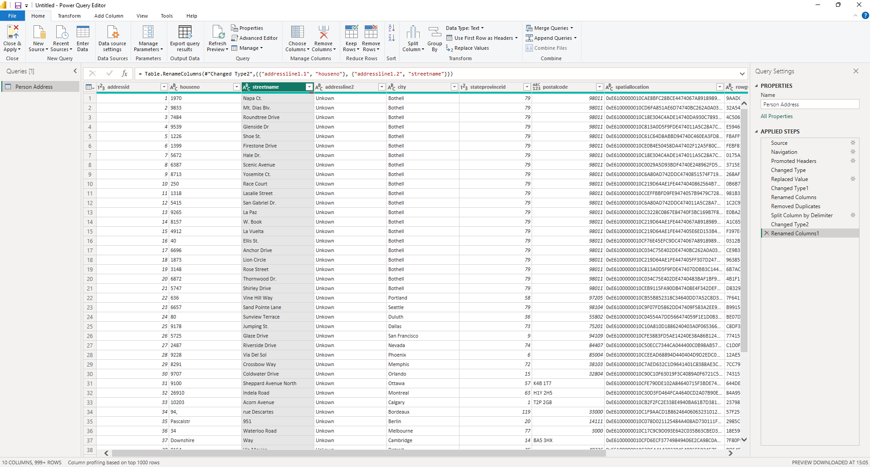

Step 11: Close & Apply
- Click Close & Apply
- Clean data is now loaded into Power BI model
