Zeal College of Engineering and Research Subject: LP-VI
Name: Jenil Girish Rathod Class: BE
Div: B Batch: B1
Roll No: B22009

Group B: Practical No:2

Program Statement: Perform the Extraction Transformation and Loading (ETL) process to construct the database in the Sql server.

STEP 1: Open Power BI
- Open Power BI Desktop
- Click Get Data → Excel
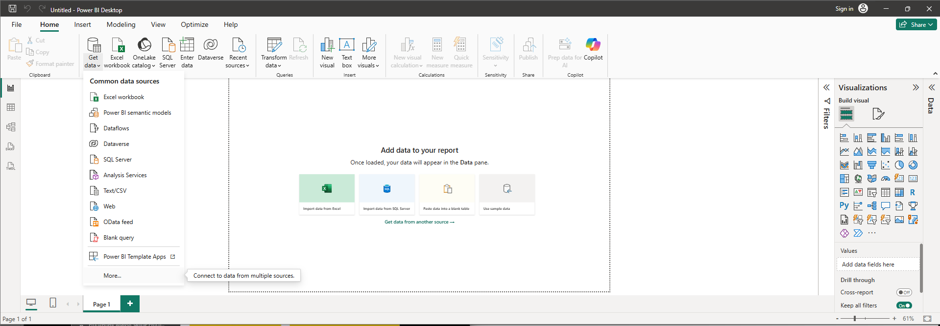
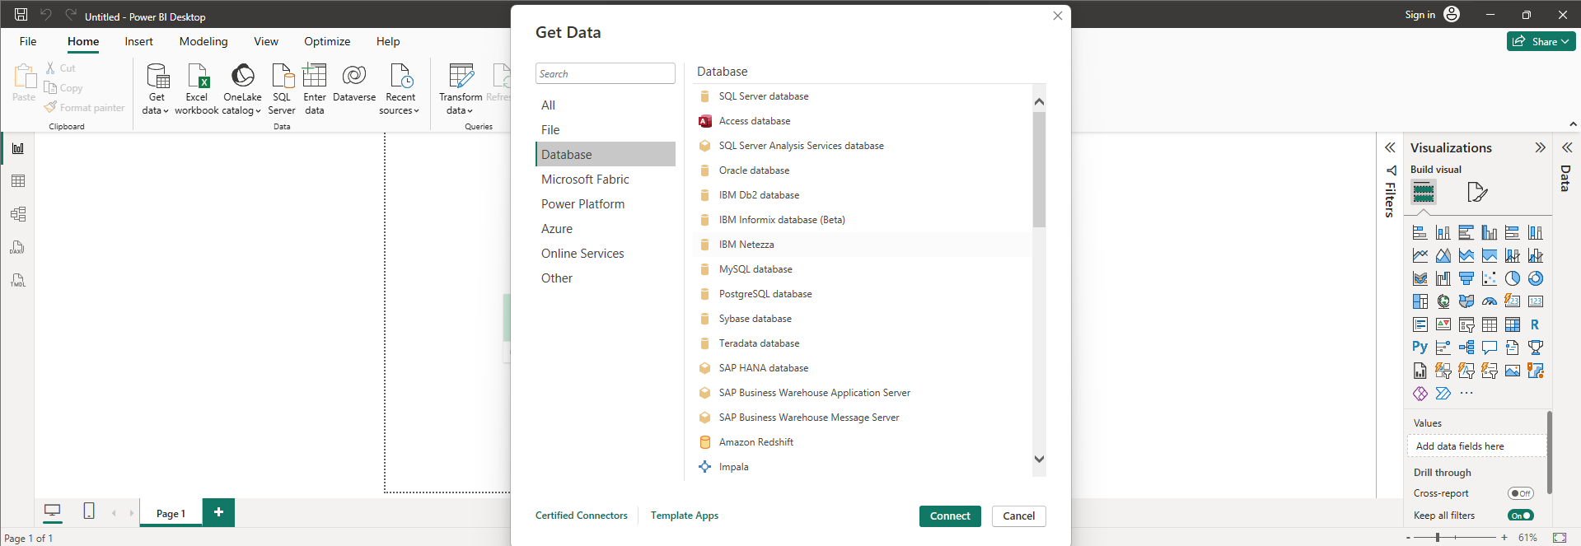
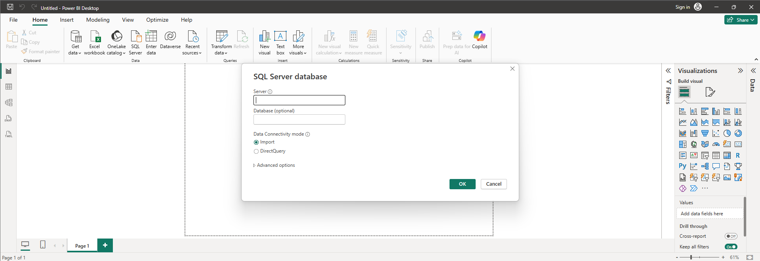
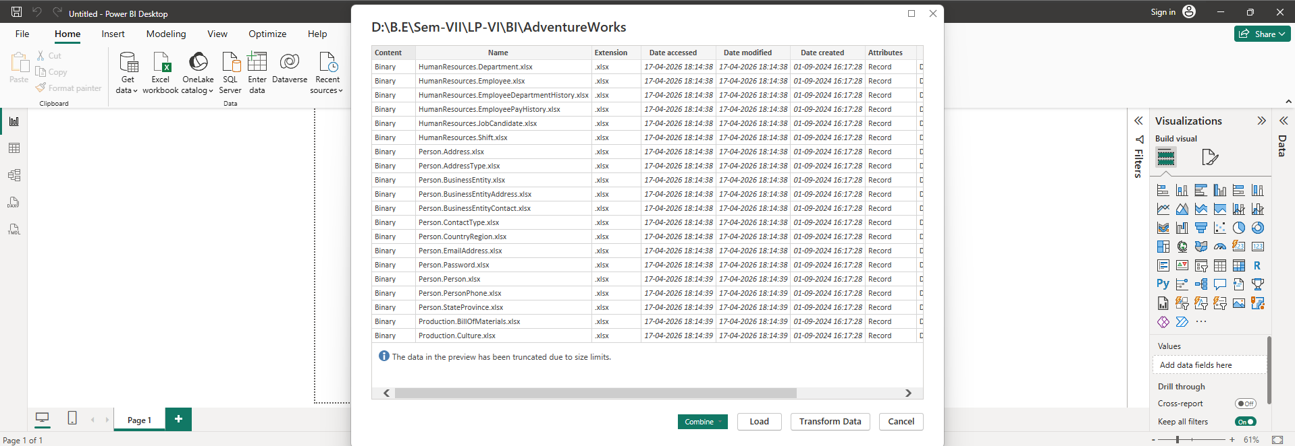
STEP 2: Extract Data (E in ETL)
- Select your Excel file
- Choose table/sheet
- Click Transform Data (IMPORTANT)
This loads data into Power Query (staging layer)
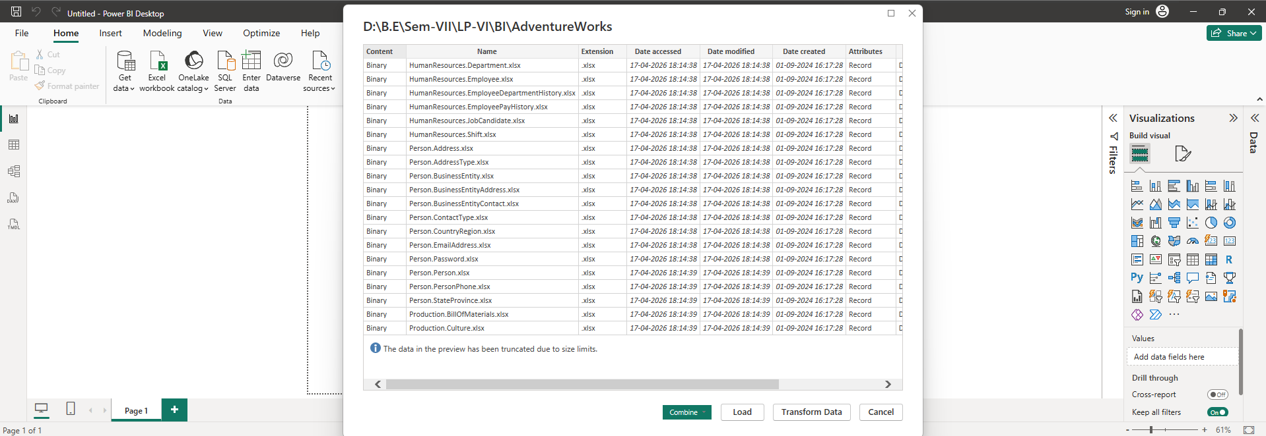
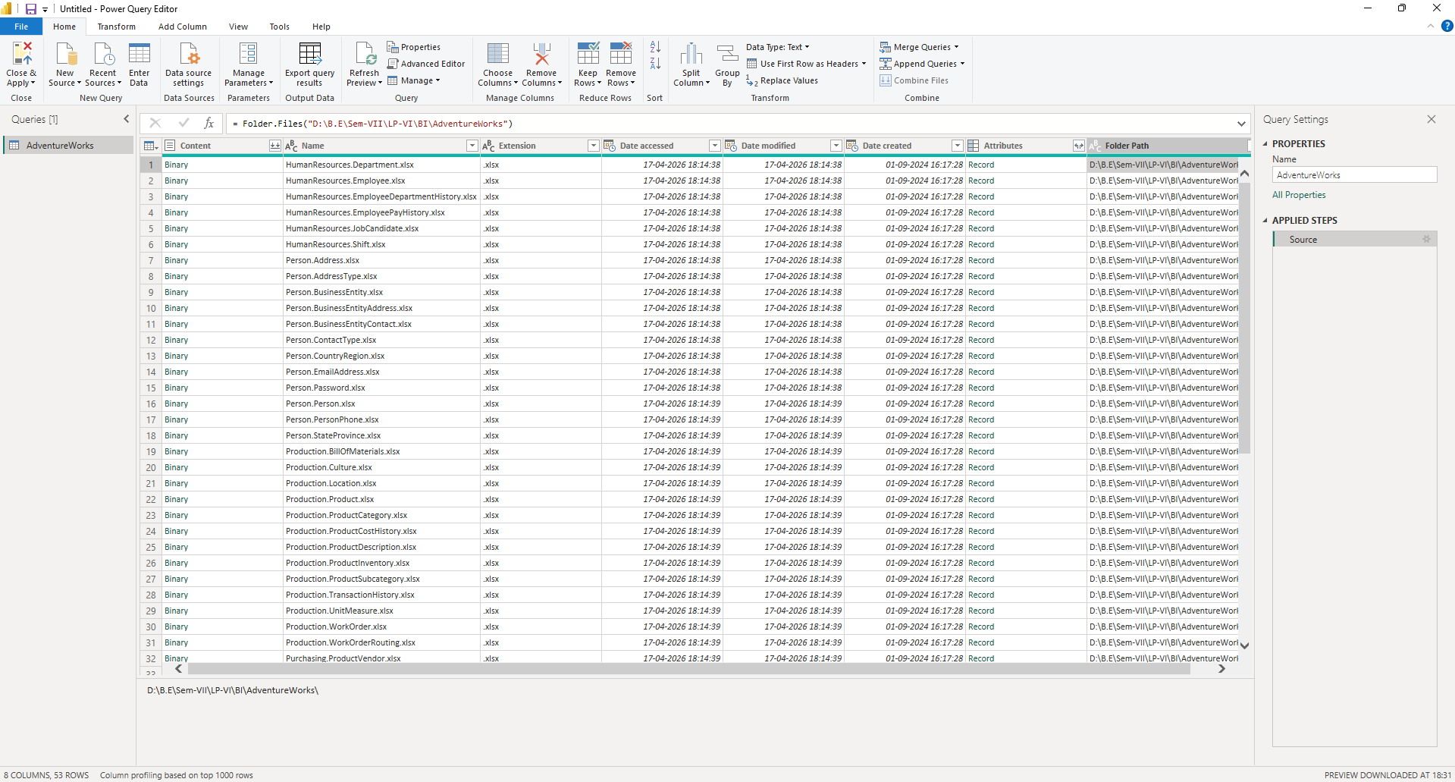
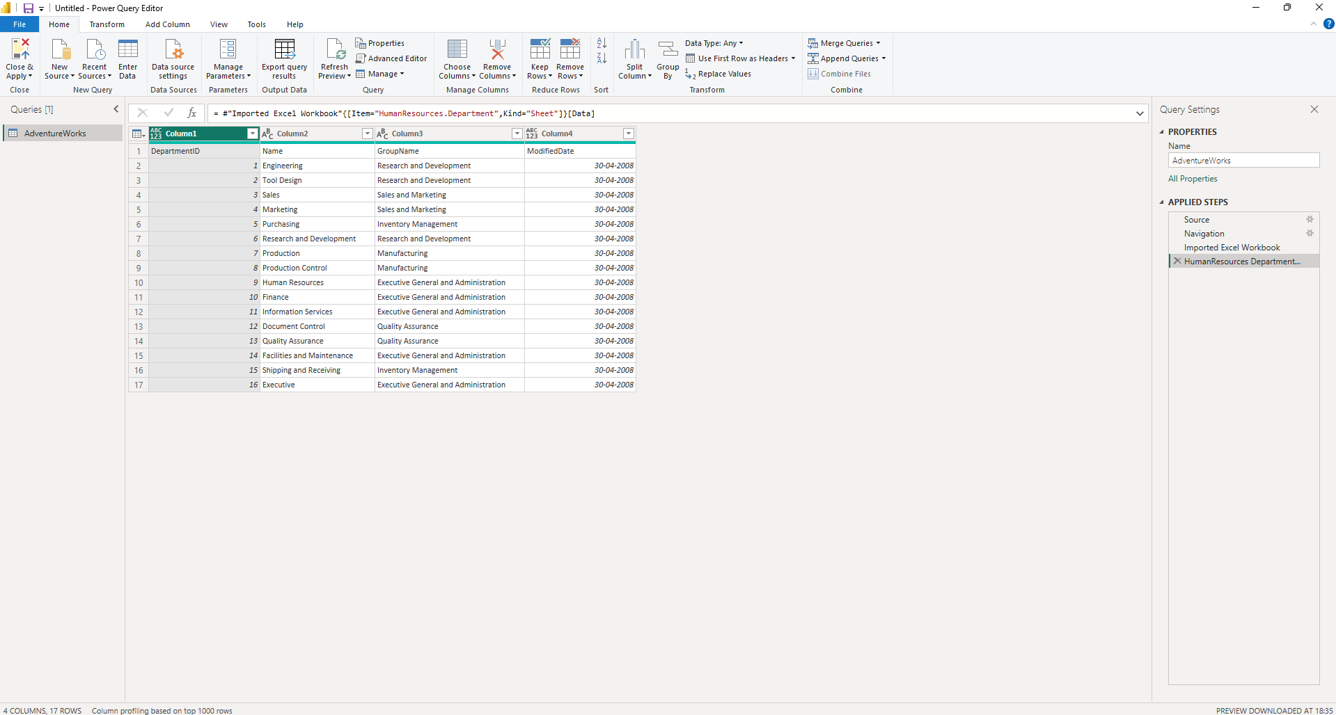
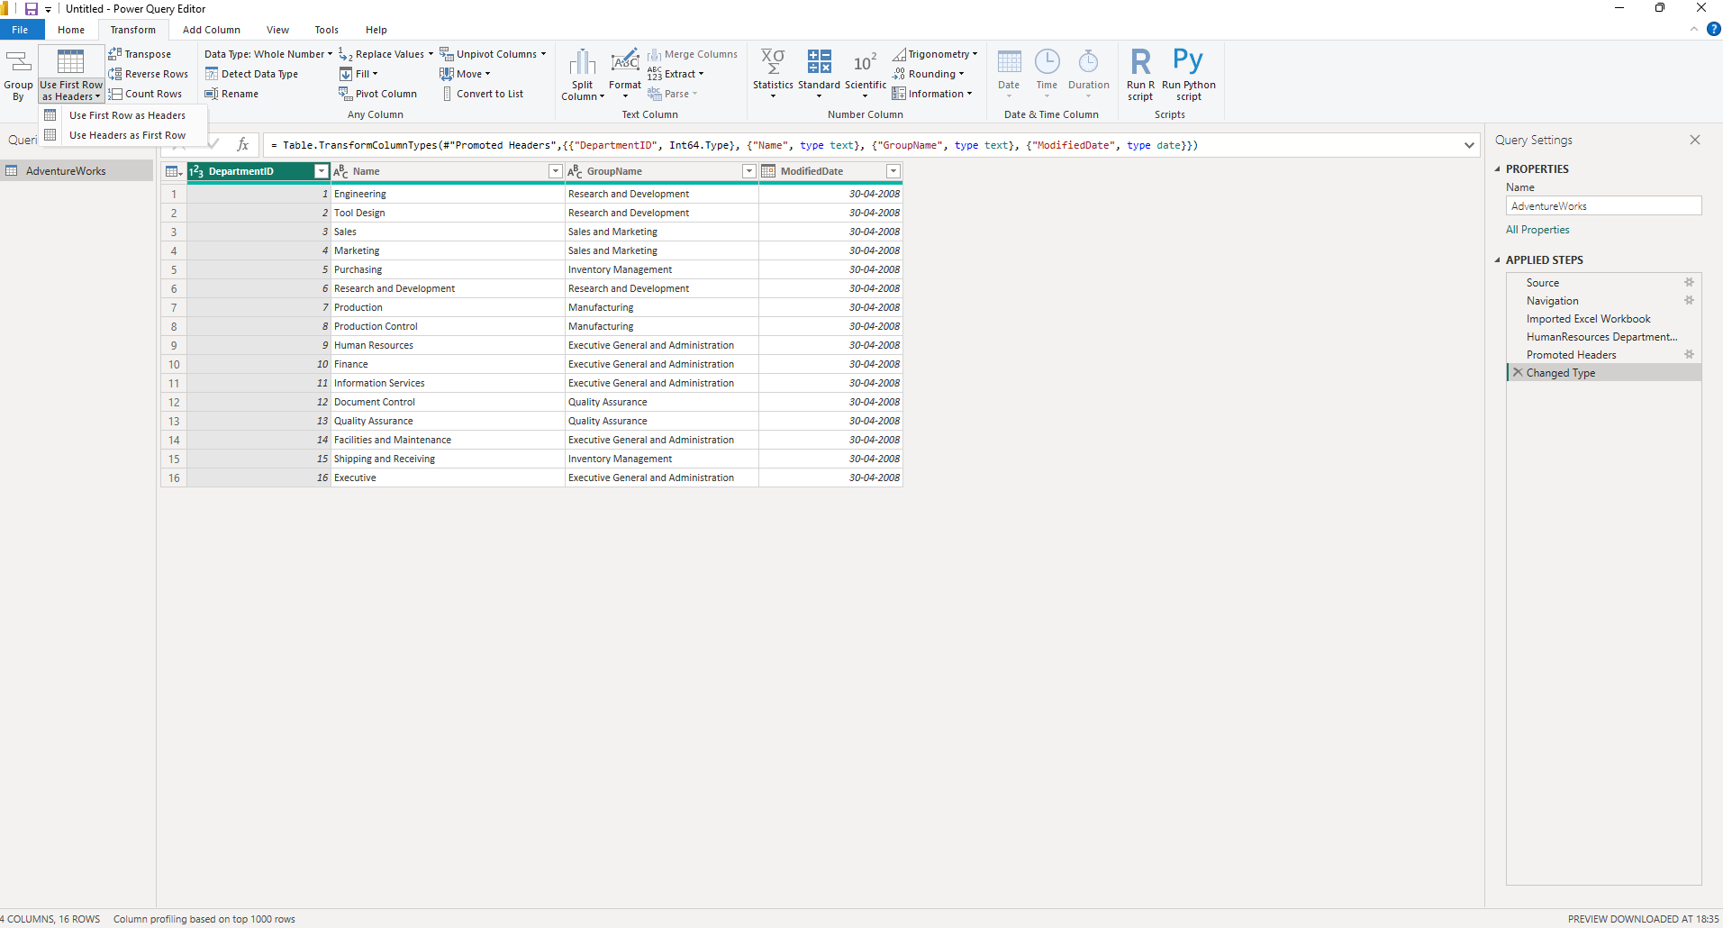
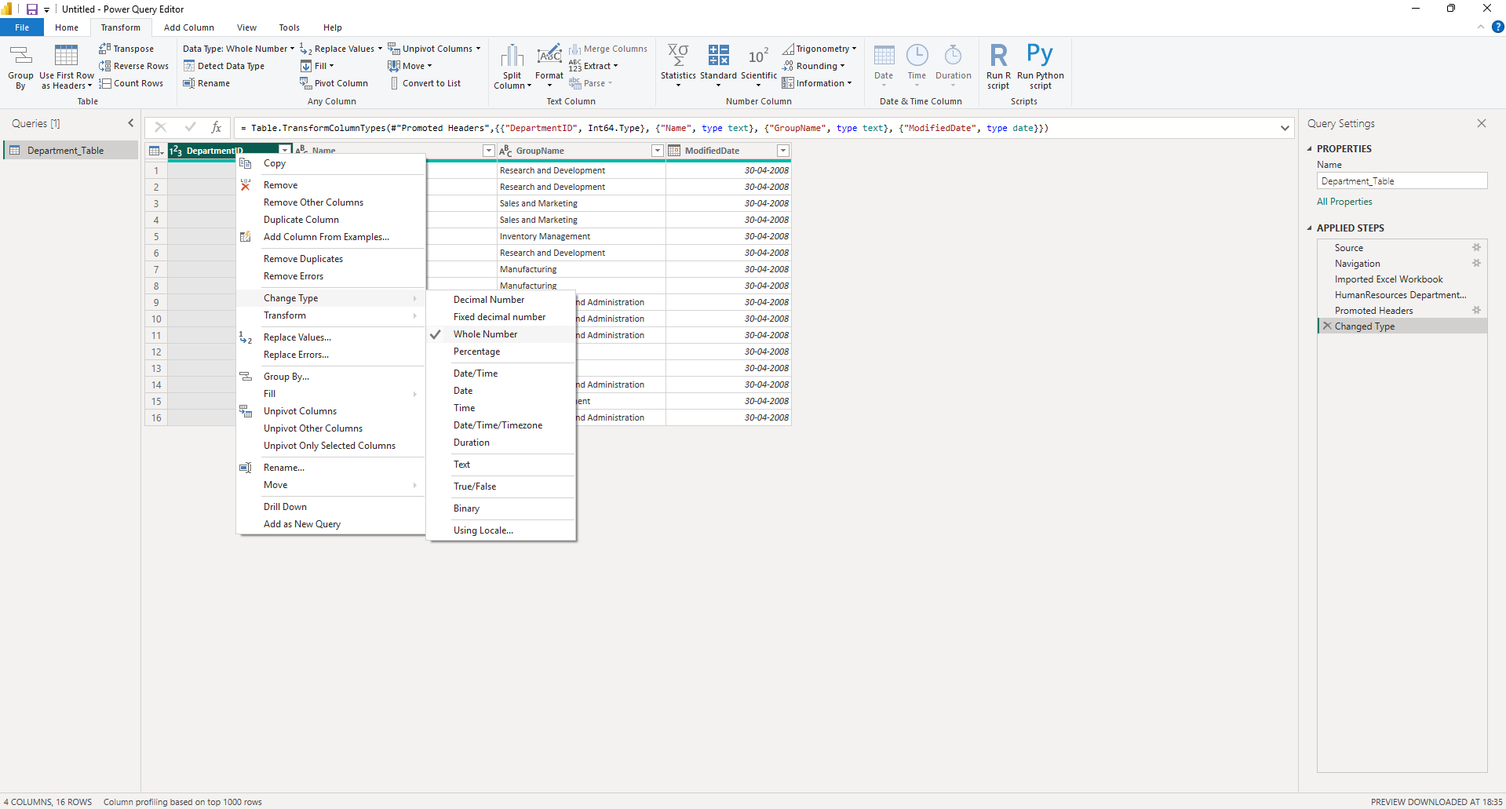
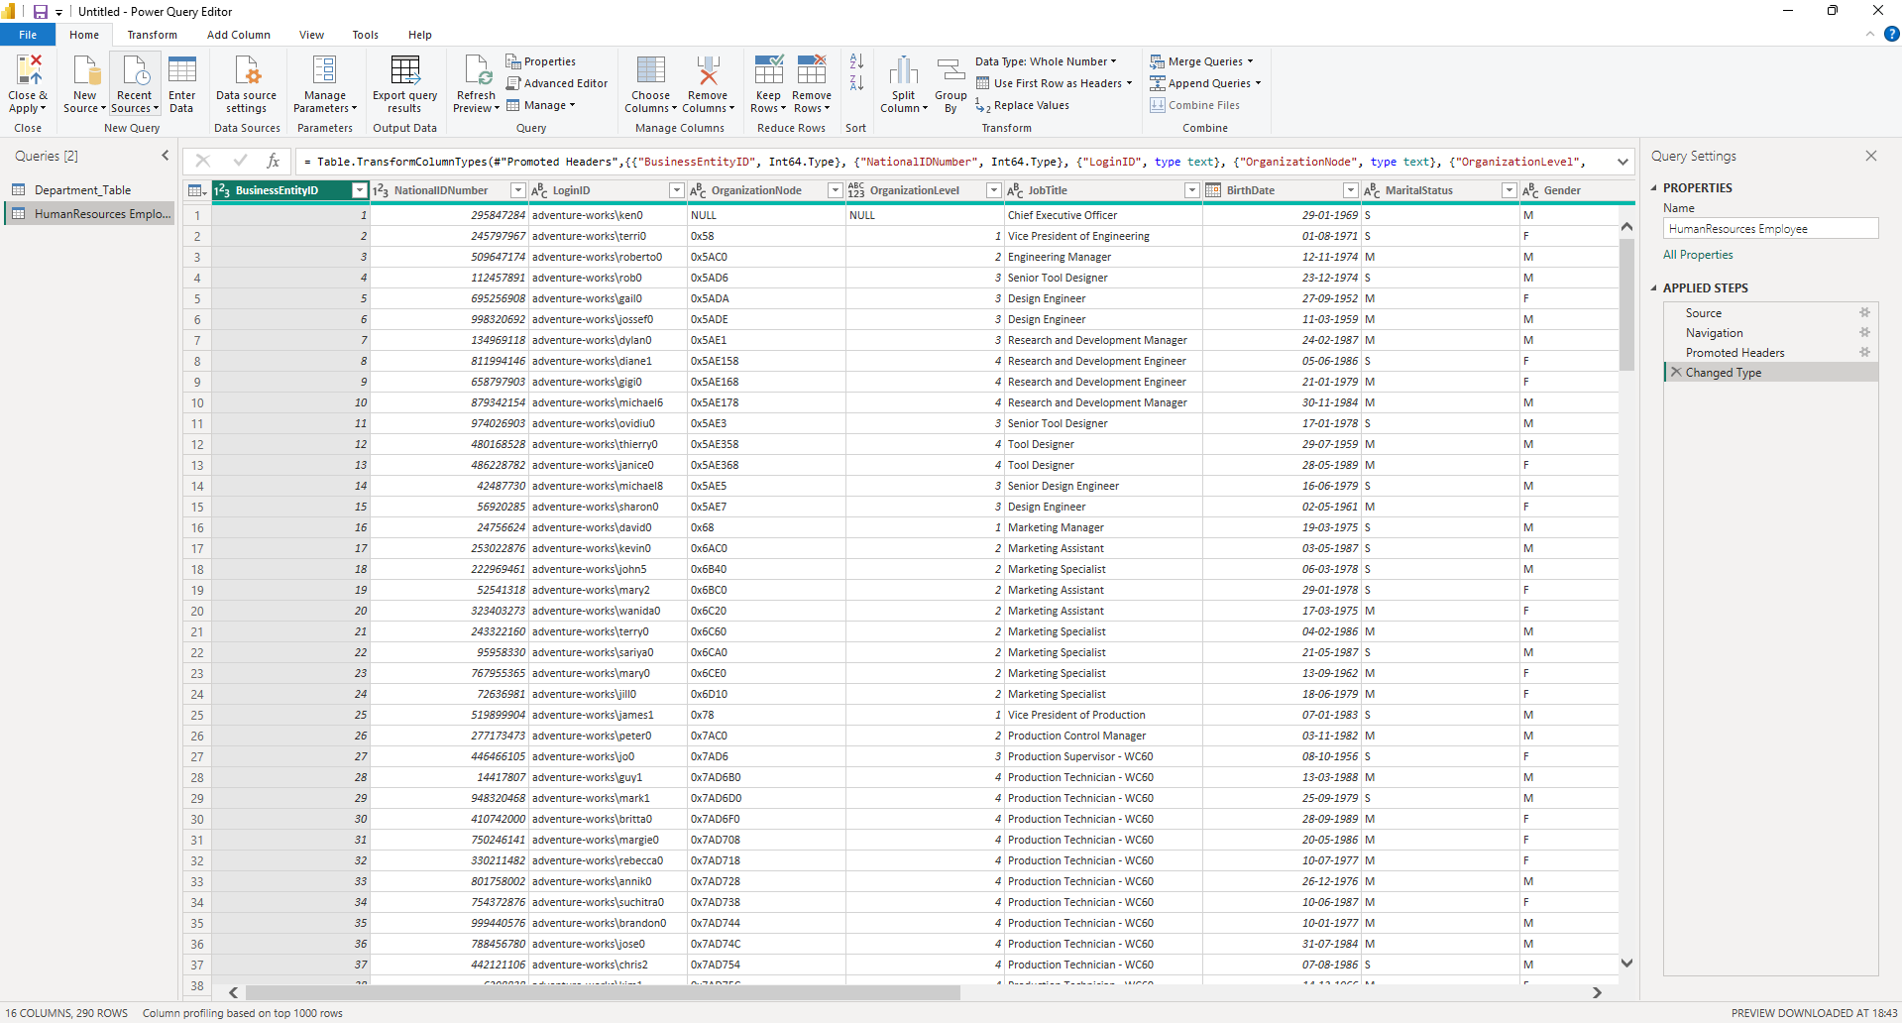

STEP 3: Clean Data (Transform Step 1)
In Power Query:
Remove unwanted columns:
- rowguid
- OrganizationNode
- LoginID
- NationalIDNumber
Right-click → Remove
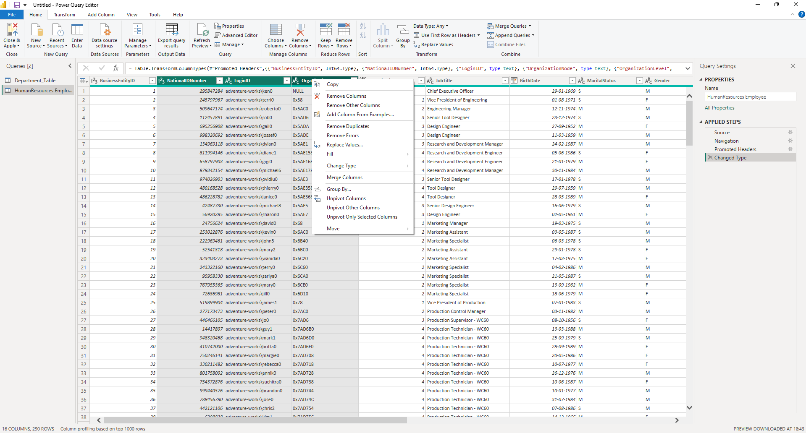
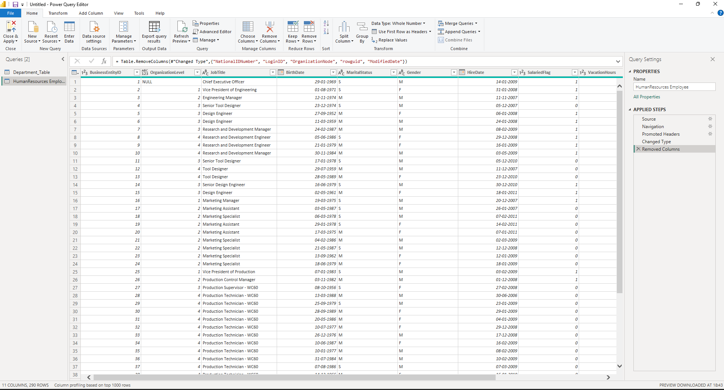
STEP 4: Handle Null Values
- Filter out null rows
OR
- Replace nulls with:
  - “Unknown” (text)
  - 0 (numbers)
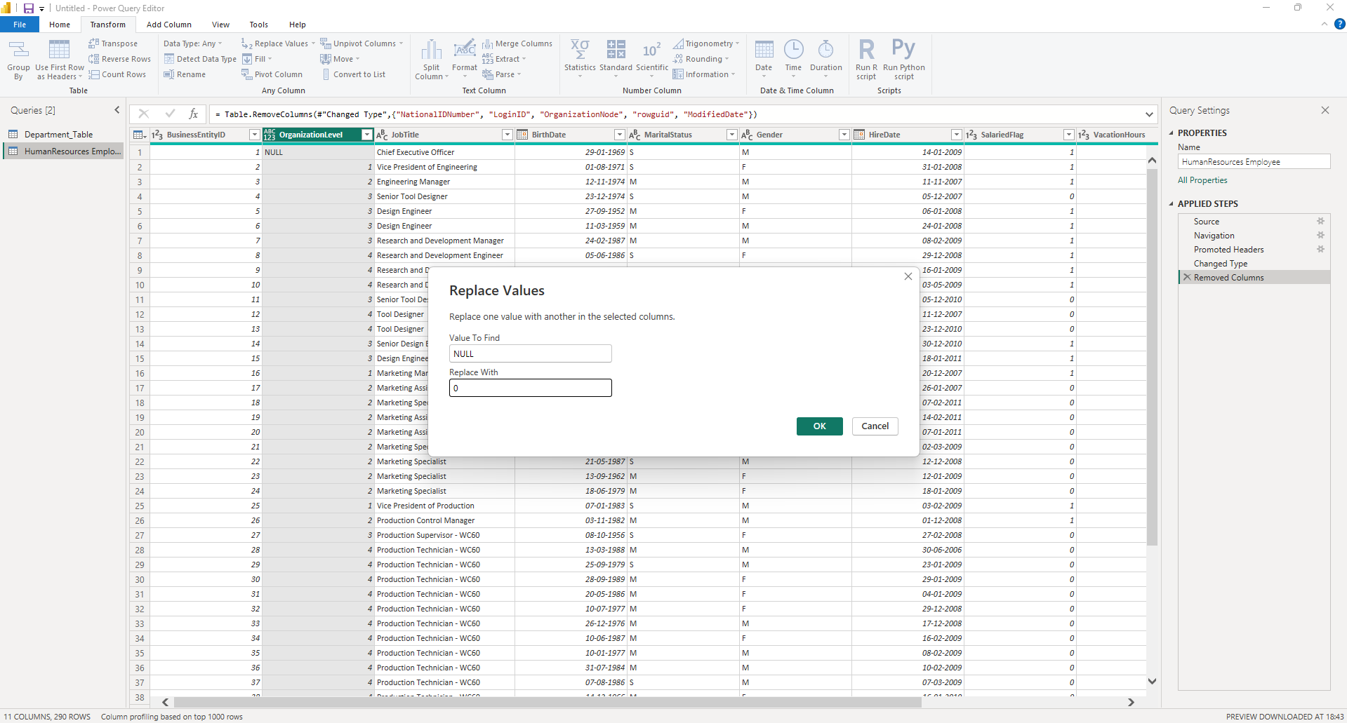
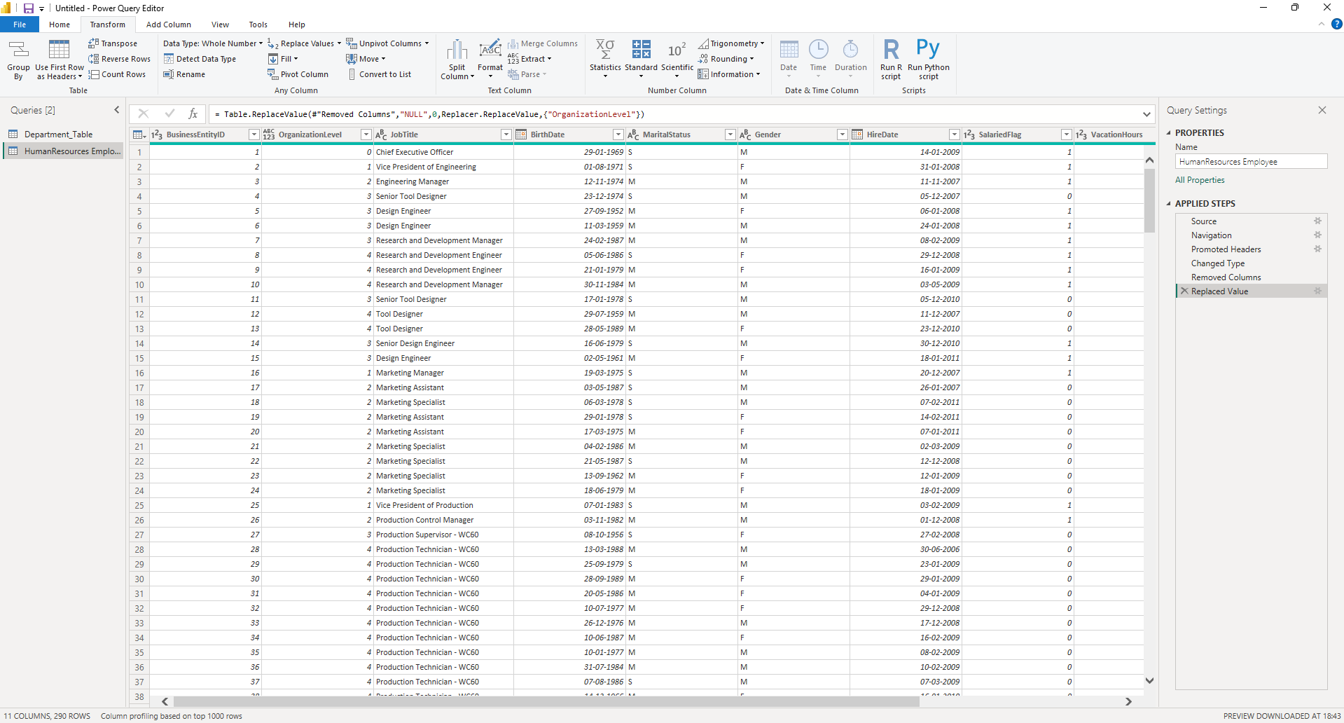
STEP 5: Split Address Column (Transform Step 2)
- Select JobTitle
- Click Split Column → By Delimiter
- Choose:
  - Delimiter = Space
  - Split at = Left-most
You get:
- Role
- Department
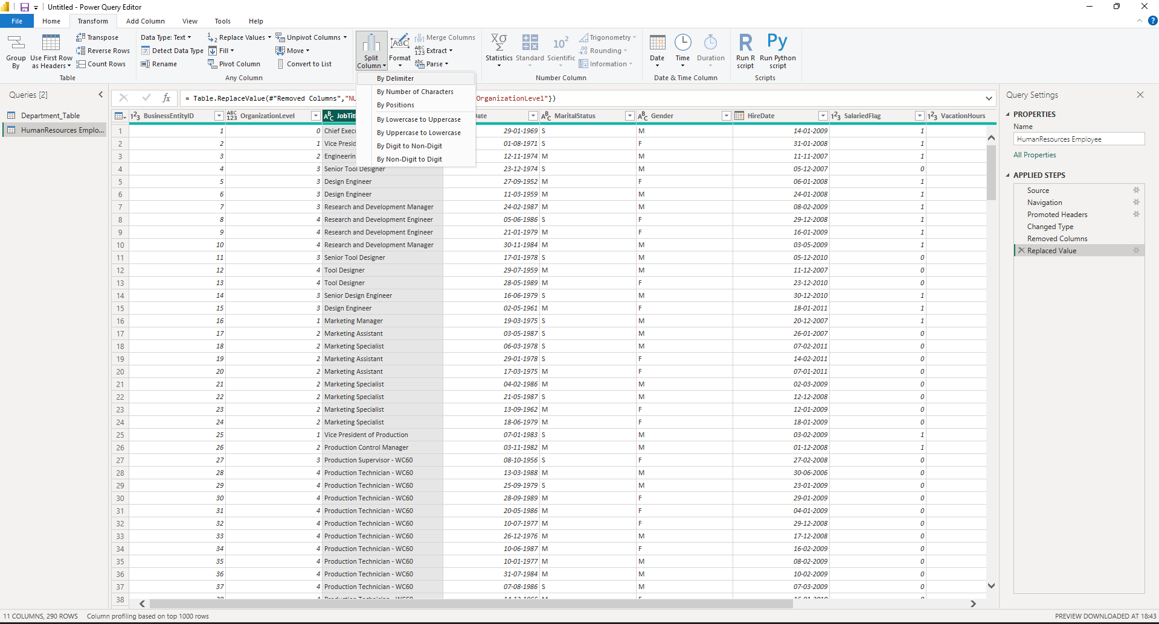
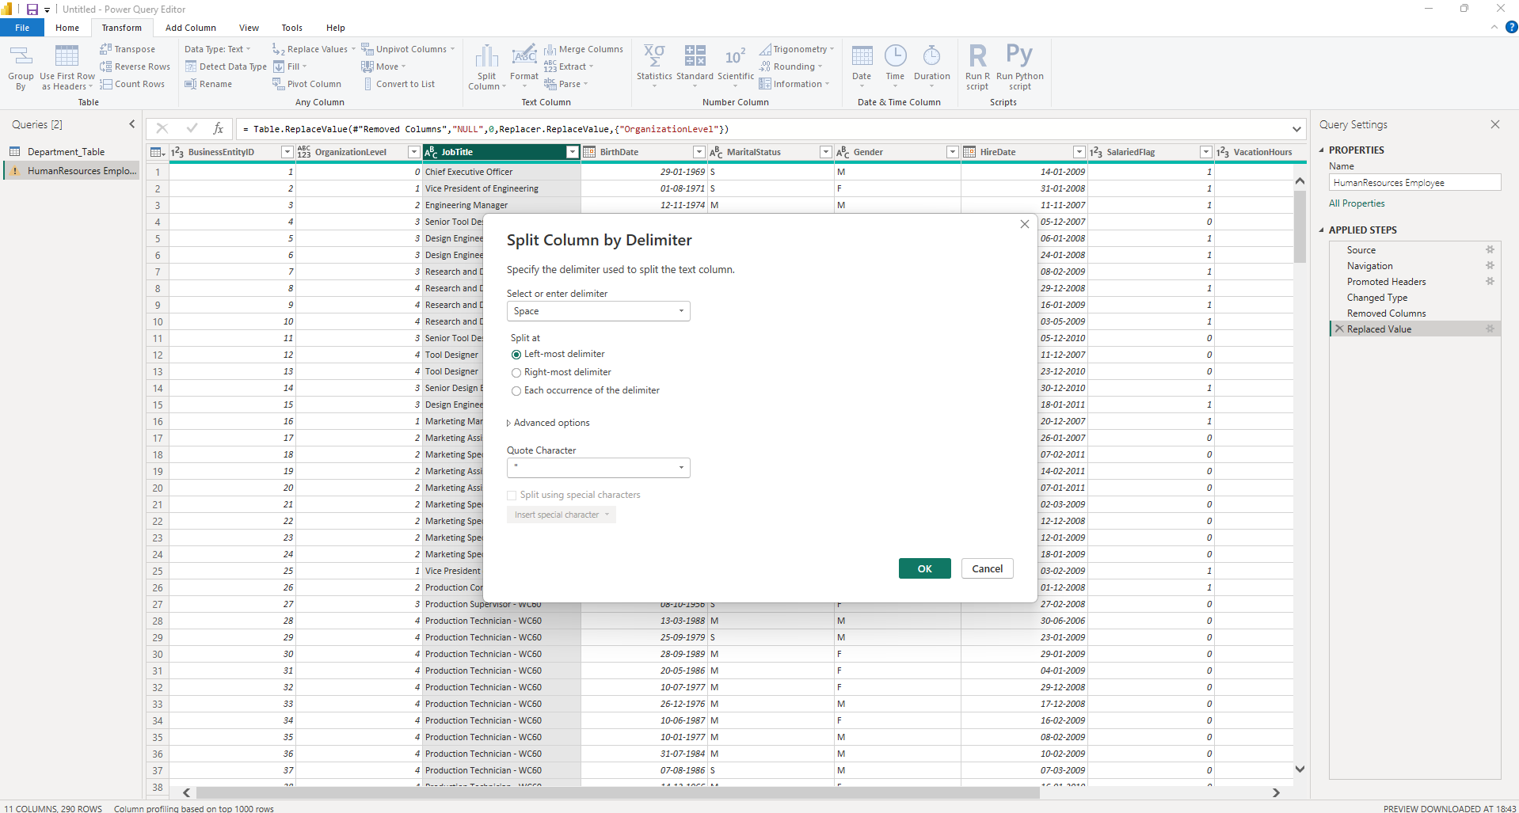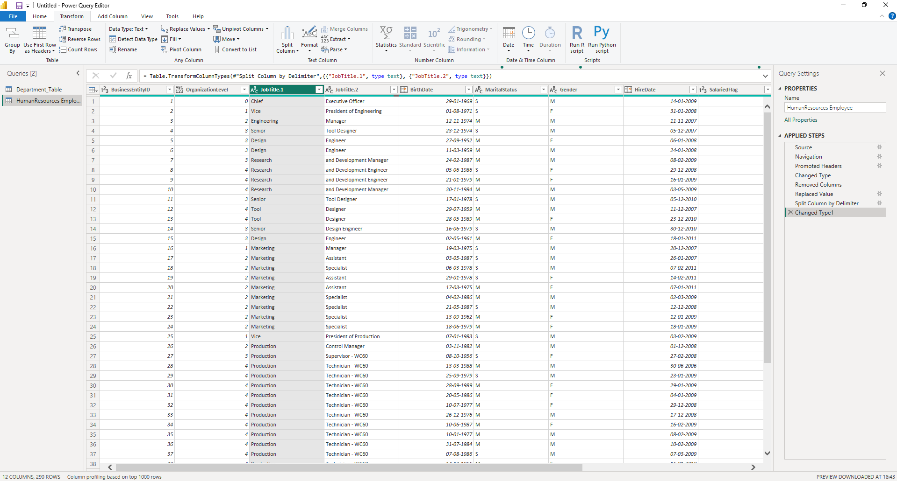
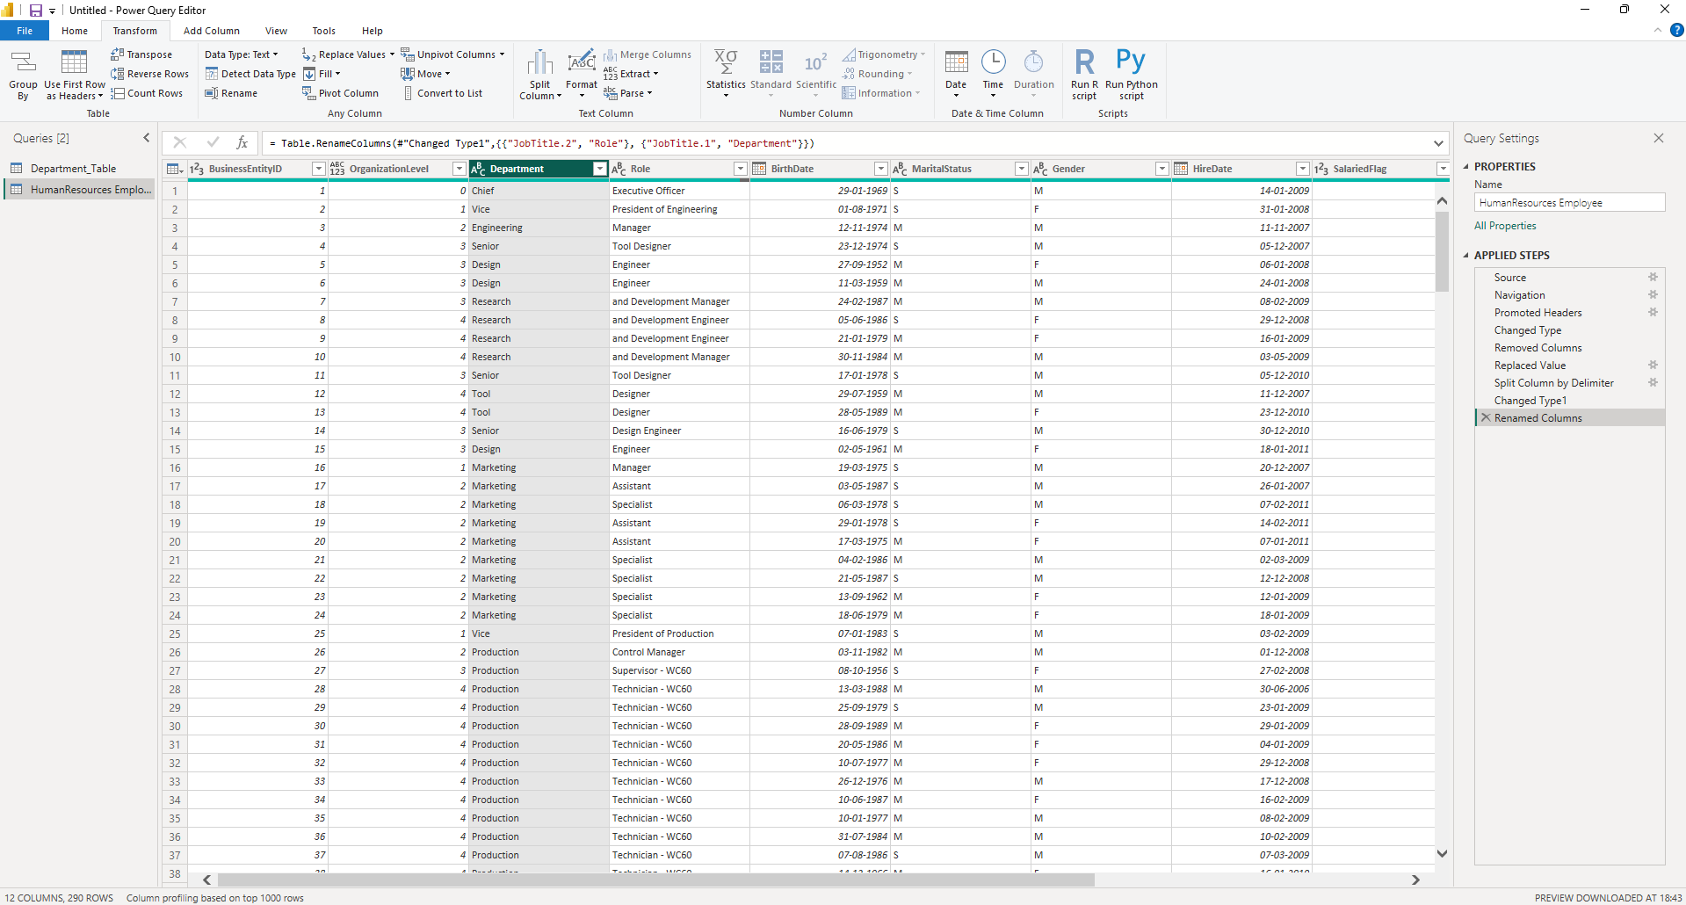

STEP 6: Create Age Column (Transform Step 3)
- Go to: Add Column → Custom Column
- Formula: Age = Date.Year(DateTime.LocalNow()) - Date.Year([BirthDate])
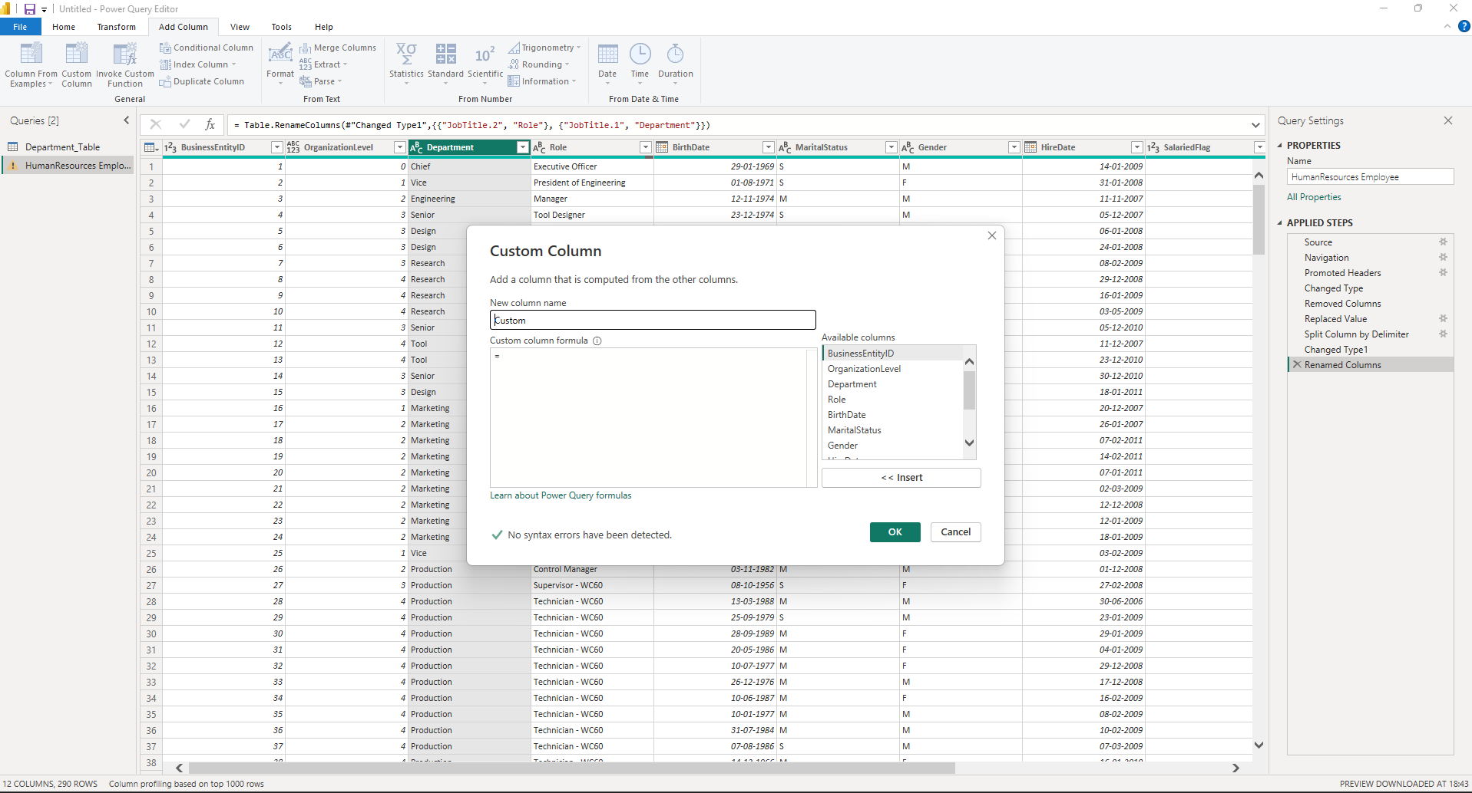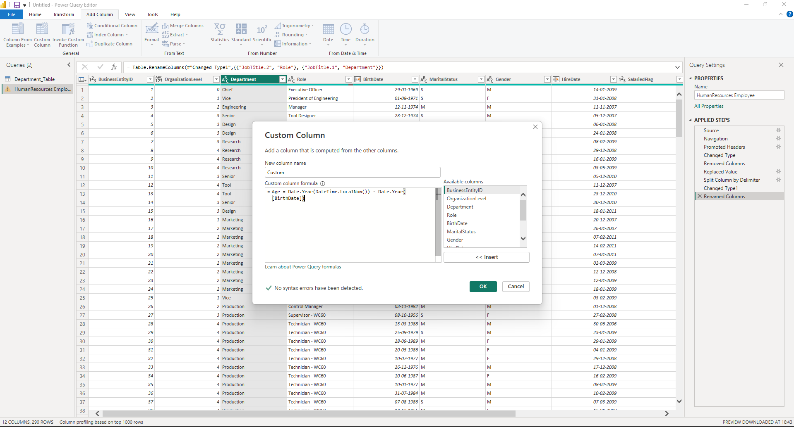
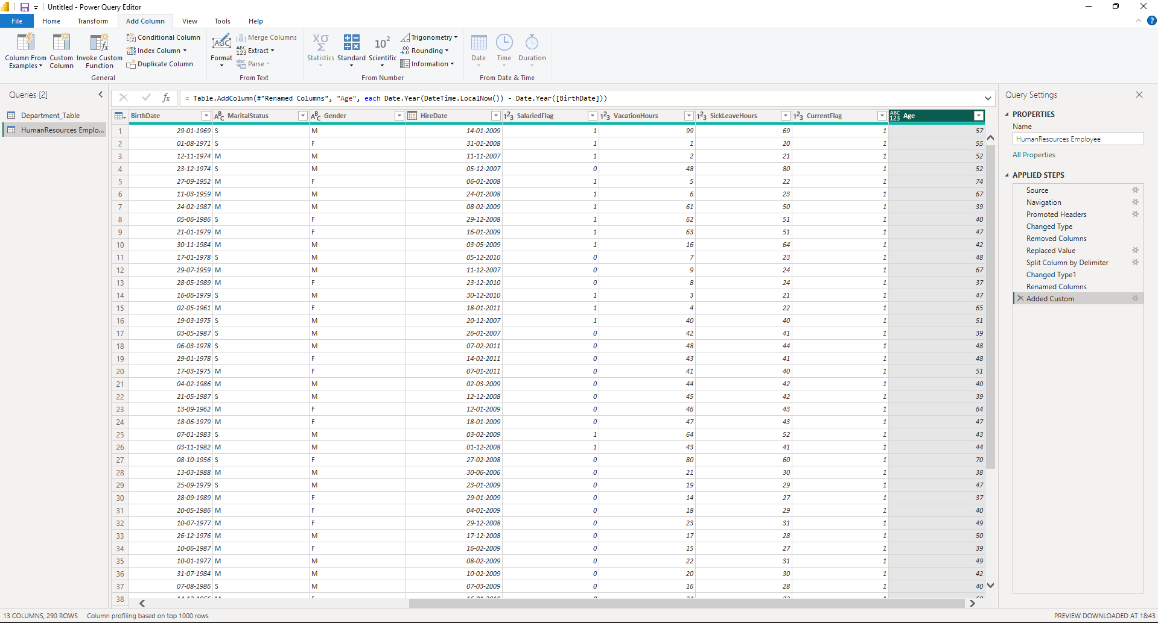
STEP 7: Fix Data Types (Transform Step 4)
- Set:
BusinessEntityID → Whole Number
BirthDate → Date
HireDate → Date
VacationHours → Whole Number
SickLeaveHours → Whole Number
Gender → Text
JobTitle → Text
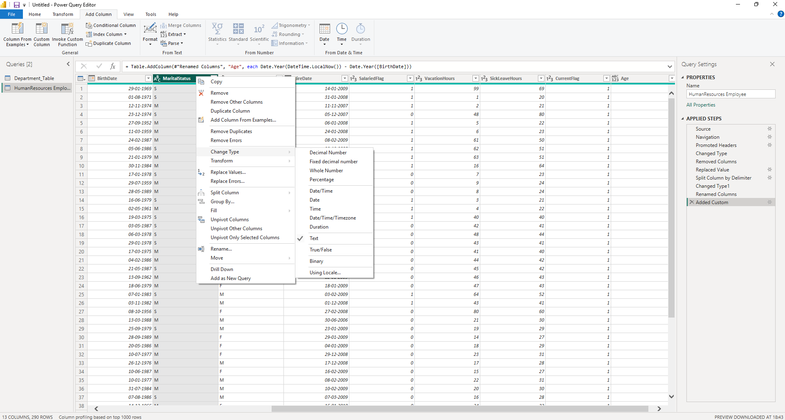

STEP 8: Load Data (L in ETL)
- Click: Close & Apply
- Data is now loaded into Power BI model
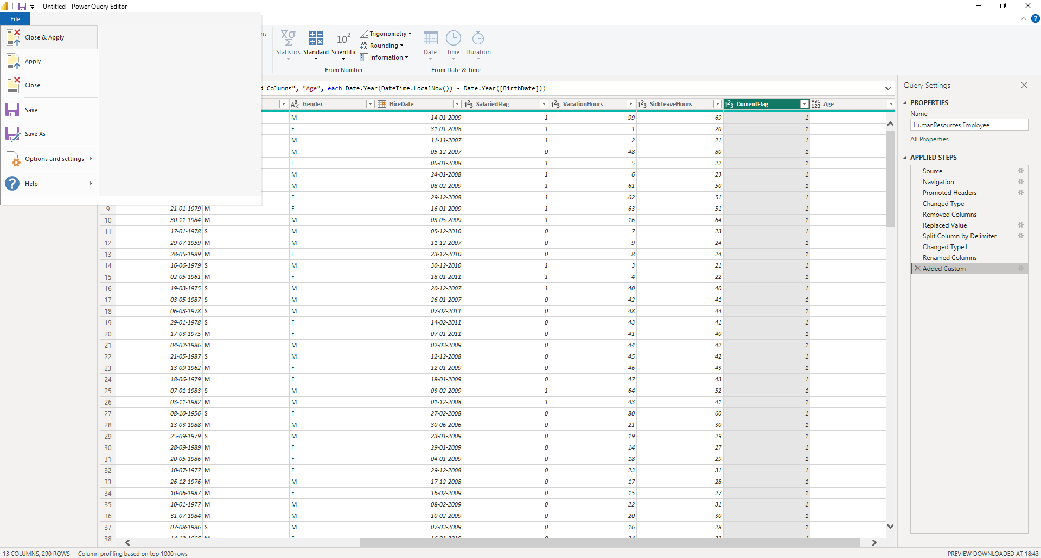
STEP 9: Create Simple Output (Proof)
- Add a Table Visual
- Show:
  - BusinessEntityID
  - JobTitle
  - Gender
  - HireDate
  - VacationHours
  - SickLeaveHours
This is final ETL output
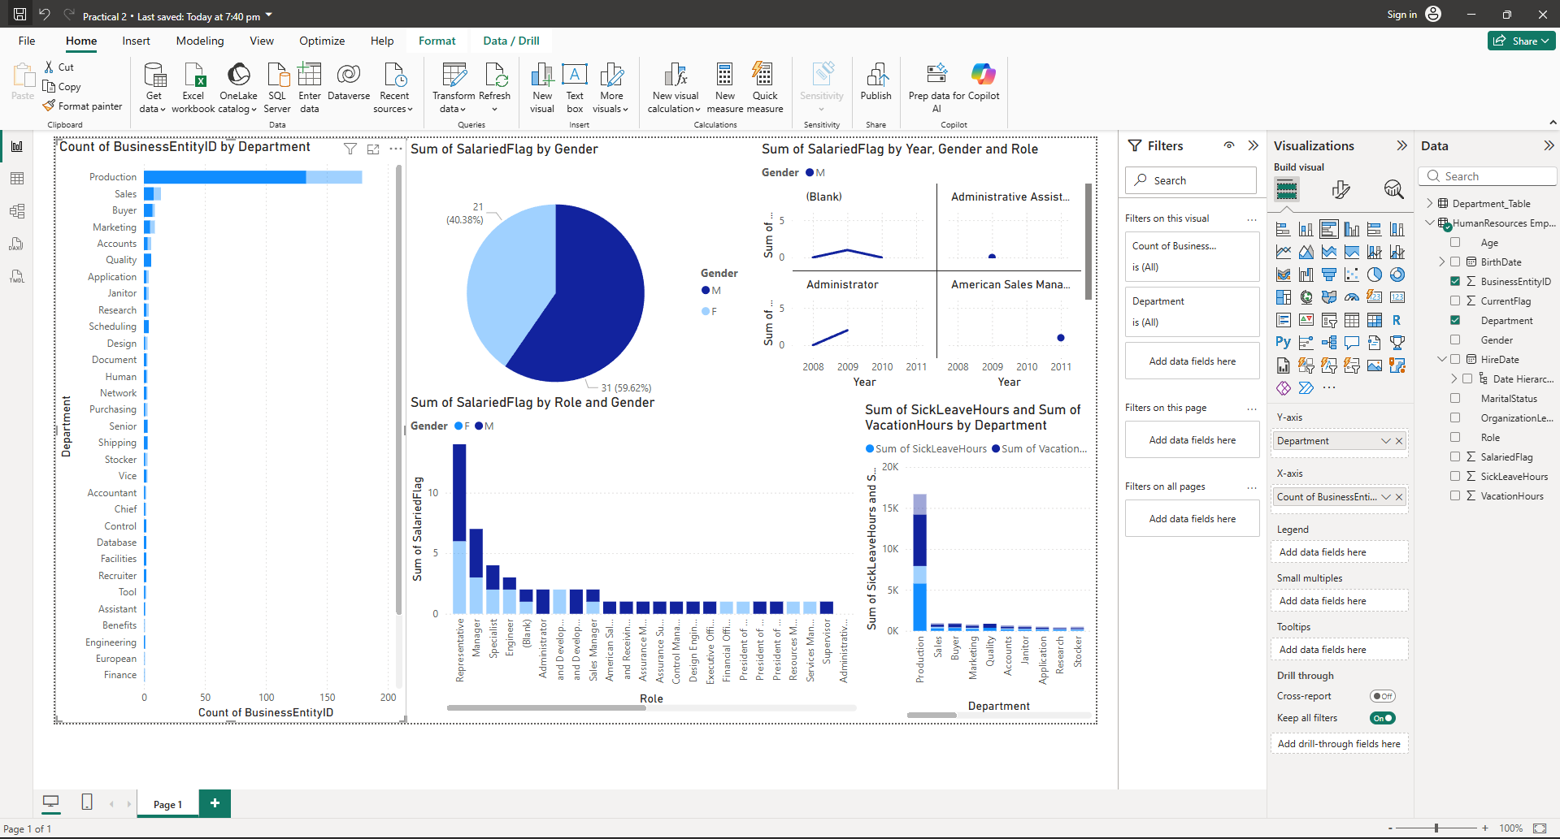
STEP 10: Save File
- File → Save
- Save as .pbix
