MINI PROJECT REPORT
On
“Business Intelligence Report on Customer Churn Analysis using Classification Techniques”

A Report Submitted for a mini project for: Laboratory Practice-VI in 8th Semester Computer Engineering.

Fourth Year (COMPUTER ENGINEERING)
Academic Year 2025-26

Submitted by- Jenil Girish Rathod
Roll No.: B22009 Div.: B



Zeal Education Society's
Zeal College of Engineering & Research Narhe, Pune – 411041
Department of Computer Engineering

Zeal Education Society’s
Zeal College of Engineering & Research Department of Computer Engineering



CERTIFICATE

Certified that the project entitled “Business Intelligence Report on Customer Churn Analysis using Classification Techniques” is a bona fide work carried out by Jenil Girish Rathod (B22009). It is certified that all corrections/suggestions indicated for Internal Assignment have been incorporated in the report. The project report has been approved as it satisfies the academic requirements in respect of Project work prescribed for the Bachelor of Engineering Degree.

Prof. Shruti Karad Prof. A. V. Mote
Project Guide H. O. D

ACKNOWLEDGEMENT

We take this opportunity to thank our project guide Prof. Shruti Karad mam and Head of the department Prof. A. V. Mote mam for their valuable guidance and for providing all the necessary facilities, which were indispensable in the completion of this project report. We are also thankful to all the staff members of Computer Engineering Department for their valuable time, support, comments, suggestions and persuasion. We would also like to thank the institute for providing the required facilities, Internet access and important books.

INDEX

Sr. No | CONTENT | Page No.
1. | Abstract | 5
2. | Software Requirement | 6
3. | Introduction | 7
4. | Problem Statement | 8
5. | Objective And Outcome | 8
6. | Implementation Code | 9
7. | Test Cases | 12
8. | Output | 13
9. | Conclusion | 14
10. | References | 14

ABSTRACT

This project presents a Business Intelligence (BI) approach to predict customer churn using data mining techniques. Customer churn refers to the loss of customers, which directly impacts business revenue and growth. Identifying customers who are likely to leave enables organizations to take proactive measures and improve retention strategies. The problem is formulated as a classification task, where the objective is to predict whether a customer will churn based on historical data.

The system utilizes a standard dataset containing customer demographics, service usage, and billing information. Data preprocessing techniques such as handling missing values, encoding categorical variables, and normalization are applied to prepare the dataset for analysis. Various classification algorithms such as Logistic Regression, Decision Tree, and Random Forest are used to build predictive models and evaluate performance using metrics like accuracy and precision.

The proposed solution provides valuable insights into customer behavior and helps businesses make data-driven decisions. By identifying key factors influencing churn, organizations can improve customer satisfaction and reduce attrition. This project demonstrates the practical application of data mining and BI techniques in solving real-world business problems.

SOFTWARE AND HARDWARE REQUIREMENT
Software Requirements:
- Microsoft Power BI / Tableau
- Microsoft Excel / CSV files
- Programming Language: Python
- Libraries Used: Pandas
- IDE / Editor: VS Code / PyCharm / Jupyter Notebook
- Operating System: Windows / Linux / macOS

Hardware Requirements
- Processor (CPU):
  - Minimum: Intel Core i3 (or equivalent) or higher
  - Recommended: Intel Core i5/i7 or equivalent AMD processor
- Memory (RAM):
  - Minimum: 4 GB of RAM
  - Recommended: 8 GB of RAM or more
- Storage:
  - Minimum: 2 GB of free disk space
  - Recommended: 5 GB of free disk space or more

INTRODUCTION

In the modern business environment, organizations generate large volumes of data from customer interactions, transactions, and services. Transforming this raw data into meaningful insights is essential for effective decision-making. Business Intelligence (BI) plays a crucial role in analyzing such data to identify patterns, trends, and opportunities that can improve business performance.
One of the key challenges faced by businesses is customer churn, where customers stop using a company’s services. High churn rates can lead to significant revenue loss and affect long-term growth. Therefore, understanding customer behavior and predicting churn has become an important task for organizations aiming to retain customers and maintain competitiveness.
This project focuses on applying data mining techniques to analyze customer data and predict churn. By using classification algorithms, the system identifies patterns that indicate whether a customer is likely to leave. The analysis is performed on a standard dataset containing customer demographics, service usage, and billing information.
The insights obtained from this analysis are visualized using Business Intelligence tools, enabling clear and interactive representation of results. These visualizations help stakeholders make informed decisions and develop strategies to improve customer retention.
Overall, this project demonstrates how BI and data mining techniques can be combined to solve real-world business problems and support data-driven decision-making.

PROBLEM STATEMENT

In a competitive business environment, organizations face significant challenges in retaining customers, as customer churn leads to revenue loss and increased acquisition costs. Many businesses lack the ability to effectively analyze customer data and identify customers who are likely to leave. This project aims to address this issue by using data mining techniques to predict customer churn based on historical data, enabling organizations to take proactive measures and improve customer retention strategies.

OBJECTIVE

- To analyze customer data using Business Intelligence techniques
- To identify factors influencing customer churn
- To apply classification algorithms for churn prediction
- To preprocess and prepare data for analysis
- To visualize insights using BI tools like Power BI or charts
- To support data-driven decision making for customer retention
- To improve business performance by reducing churn rate

OUTCOME

- Successful identification of customers likely to churn based on historical data
- Improved understanding of key factors influencing customer behavior and churn
- Accurate prediction of churn using classification techniques
- Clear visualization of insights through charts and BI dashboards
- Support for data-driven decision making in customer retention strategies
- Enhanced business performance by reducing customer attrition
- Practical demonstration of Business Intelligence and data mining in real-world scenarios

IMPLEMENTATION / METHODOLOGY

The project follows a structured data mining approach to predict customer churn:

Step 1: Data Collection
A standard dataset (Telco Customer Churn) is used for analysis.

Step 2: Data Preprocessing
Missing values are handled, categorical variables are encoded, and data is cleaned.

Step 3: Data Analysis
Exploratory analysis is performed to identify patterns and relationships.

Step 4: Model Building
Classification techniques such as Logistic Regression and Decision Tree are applied.

Step 5: Visualization
Results are visualized using charts and dashboards for better understanding.

Test Cases

The system is tested for functionality, accuracy, and usability across different modules including input processing, NLP tagging, and user interface.

Module Name | Test Scenario ID | Test Scenario Name | Test Cases | Test Case ID | Test Case Description
Input Module | TS_001 | Data Input Handling | 2 | TC_001 | Verify system accepts valid customer dataset
 |  |  |  | TC_002 | Verify system handles empty or invalid dataset
Preprocessing Module | TS_002 | Data Cleaning | 2 | TC_003 | Verify missing values are handled correctly
 |  |  |  | TC_004 | Verify categorical data is encoded properly
Model Module | TS_003 | Model Execution | 2 | TC_005 | Verify classification model runs successfully
 |  |  |  | TC_006 | Verify churn prediction output (Yes/No) is generated
Output Module | TS_004 | Result Display | 2 | TC_007 | Verify prediction results are displayed correctly
 |  |  |  | TC_008 | Verify insights are shown using charts/graphs
System Module | TS_005 | Dataset Handling | 2 | TC_009 | Verify system processes large datasets efficiently
 |  |  |  | TC_010 | Verify system handles inconsistent data formats
Visualization Module | TS_006 | BI Dashboard | 2 | TC_011 | Verify charts and dashboards are displayed properly
 |  |  |  | TC_012 | Verify correct representation of churn analysis
System Module | TS_007 | Performance | 2 | TC_013 | Verify system response time is acceptable
 |  |  |  | TC_014 | Verify system runs without errors during analysis

OUTPUT

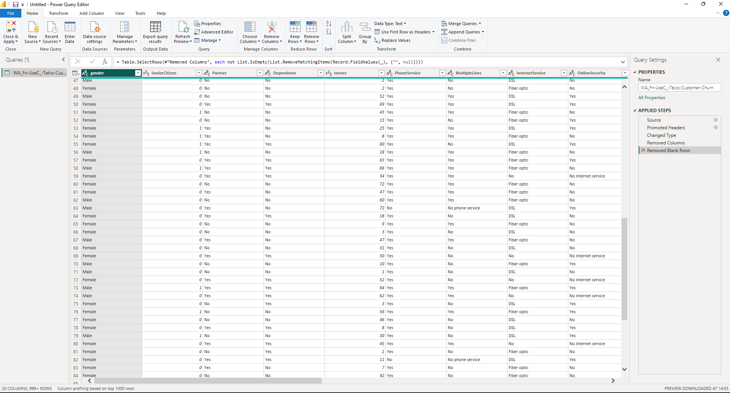

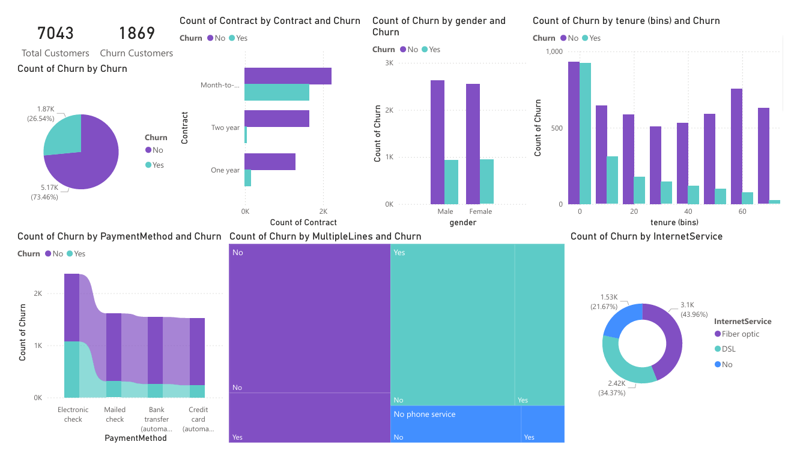

The BI dashboard presents customer churn analysis using multiple visualizations and key performance indicators. The total number of customers is 7043, out of which 1869 customers have churned. The churn distribution shows that a significant proportion of customers have discontinued the service.

The contract-based analysis indicates that customers with month-to-month contracts have the highest churn rate compared to one-year and two-year contracts. The tenure-based analysis shows that customers with shorter durations are more likely to churn, highlighting the importance of early customer engagement.

The payment method analysis using ribbon charts reveals that customers using electronic check methods have higher churn rates. The internet service analysis indicates that fiber optic users contribute more to churn compared to DSL users. Gender-based analysis shows that churn is relatively similar across male and female customers, indicating that gender is not a major influencing factor.

CONCLUSION

This project successfully demonstrates the application of Business Intelligence and data mining techniques to analyse customer data and predict churn. By utilizing classification methods, the system is able to identify patterns in customer behaviour and determine the likelihood of customers leaving a service. The analysis provides valuable insights that can help organizations take proactive steps to improve customer retention and reduce revenue loss.

The use of data visualization tools further enhances the understanding of results by presenting insights in a clear and interactive manner. Although the project is based on a standard dataset, it effectively illustrates how BI techniques can be applied to real-world business problems. Overall, the project highlights the importance of data-driven decision making and provides a foundation for further development and implementation in practical scenarios.

REFERENCES: -

Source Code: - https://github.com/Jenil7828/Sem-VII /LP-VI/BI/Mini-Project.pbix
- Kaggle – Telco Customer Churn Dataset https://www.kaggle.com/blastchar/telco-customer-churn
- Han, J., Kamber, M., & Pei, J., Data Mining: Concepts and Techniques, Elsevier
- Python Documentation https://docs.python.org/3/
- Pandas Documentation https://pandas.pydata.org/docs/
- Scikit-learn Documentation https://scikit-learn.org/stable/
- Microsoft Power BI Documentation https://learn.microsoft.com/en-us/power-bi/
- GeeksforGeeks – Customer Churn Prediction using Machine Learning
- IBM Sample Dataset Documentation – Telco Customer Churn

