A PRELIMENERY REPORT ON

POCKET JOURNAL – AN AI POWERED DIARY ANALYZER AND MEDIA RECOMMENDER

SUBMITTED TO THE SAVITRIBAI PHULE PUNE UNIVERSITY, PUNE IN THE PARTIAL FULFILLMENT OF THE REQUIREMENTS
FOR THE AWARD OF THE DEGREE OF

BACHELOR OF ENGINEERING (COMPUTER ENGINEERING)

SUBMITTED BY

JENIL GIRISH RATHOD B22009
MANAS BALLAL JOSHI B22011
SALONI MAHESH NAIK B22051
ADITYA SUNIL NALLA B22053


DEPARTMENT OF COMPUTER ENGINEERING

Zeal College of Engineering & Research

NARHE, PUNE - 411041

SAVITRIBAI PHULE PUNE UNIVERSITY 2025 -2026


CERTIFICATE
This is to certify that the project report entitles

“POCKET JOURNAL – AN AI POWERED DIARY ANALYZER AND MEDIA RECOMMENDER”

Submitted by

JENIL GIRISH RATHOD B22009
MANAS BALLAL JOSHI B22011
SALONI MAHESH NAIK B22051
ADITYA SUNIL NALLA B22053

This is a bonafide student of this institute and the work has been carried out by him/her under the supervision of Prof. A. V. Mote and it is approved for the partial fulfillment of the requirement of SavitribaiPhule Pune University, for the award of the degree of Bachelor of Engineering (Computer Engineering).

(Prof. A. V. Mote) (Prof. A. V. Mote)
Guide Head
Department of Computer Engineering Department of Computer Engineering

(Prof. ) (Dr. Ajit M. Kate)
External Examiner Principal,
SPPU Zeal College of Engineering & Research, Pune-41
Place: Pune Date:

ACKNOWLEDGEMENT

We would like to express our heartfelt gratitude to all those who guided and supported us throughout the development of this project. First and foremost, we would like to thank our guide, Prof. A. V. Mote, for her valuable suggestions, continuous encouragement, and expert guidance that helped us in successfully completing this project work. We are equally grateful to the Department of Computer Engineering, Zeal College of Engineering and Research, Pune, for providing us with the facilities, resources, and technical support necessary for the completion of this project.

We extend our sincere appreciation to our teachers and mentors for their constant motivation and for sharing their knowledge, which played a significant role in shaping this project. We would also like to acknowledge the support and cooperation of our classmates and friends, who contributed valuable feedback and ideas during the development phase. Finally, we are deeply thankful to our families for their encouragement, patience, and unwavering support, which has been the foundation of our success.

JENIL GIRISH RATHOD MANAS BALLAL JOSHI SALONI MAHESH NAIK ADITYA SUNIL NALLA

ABSTRACT

Pocket Journal is an intelligent mobile application designed to transform the conventional practice of diary-keeping into an interactive and insightful process for self-reflection. By integrating advanced Artificial Intelligence (AI) and Natural Language Processing (NLP), the system analyzes user-written entries to provide meaningful feedback and data-driven insights. The application's core capabilities include summarizing lengthy entries, detecting emotional states, and identifying personal goals to offer constructive recommendations.

To foster an engaging user experience, Pocket Journal provides personalized media recommendations, such as music from Spotify or movies from TMDB, that align with the user's detected mood. The system is architected with a cross-platform frontend developed in Flutter and a high-performance Python backend using Flask for AI processing, requiring an active internet connection for all analytical features. User data, including entries and analysis, is securely stored and synchronized using Google's Firebase. Throughout the development, user privacy and data security were held as top priorities, enforced through robust authentication and data encryption. Ultimately, Pocket Journal is crafted to serve as a digital companion for mental well-being, aiming to enhance self-awareness and support personal growth by making journaling an intelligent and responsive activity.

.

[P3]

TABLE OF CONTENTS
LIST OF ABBREVATIONS i LIST OF FIGURES ii
LIST OF TABLES iii

CHAPTER | TITLE | PAGE NO.
01 | Introduction | 1
1.1 | Motivation | 1
1.2 | Problem Definition | 2
02 | Literature Survey | 3
03 | Software Requirements Specification | 9
3.1 | Introduction | 9
 | 3.1.1 Project Scope | 9
 | 3.1.2 User Classes and Characteristics | 10
 | 3.1.3 Assumptions and Dependencies | 10
3.2 | Functional Requirements | 11
 | 3.2.1 User Authentication and Profile Management | 11
 | 3.2.2 Journal Entry Creation and Management | 11
 | 3.2.3 AI-Powered Mood Detection | 12
 | 3.2.4 Automated Text Summarization | 12
 | 3.2.5 Personalized Media Recommendations | 12
 | 3.2.6 Generative Behavioral Insights | 12
 | 3.2.7 Goal Tracking and Progress Visualization | 12
3.3 | External Interface Requirements (If Any) | 12
 | 3.3.1 User Interfaces | 12
 | 3.3.2 Hardware Interfaces | 13
 | 3.3.3 Software Interfaces | 13
 | 3.3.4 Communication Interfaces | 13
3.4 | Nonfunctional Requirements | 13
 | 3.4.1 Performance Requirements | 13
 | 3.4.2 Safety Requirements | 14
 | 3.4.3 Security Requirements | 14
 | 3.4.4 Software Quality Attributes | 14
3.5 | System Requirements | 14
 | 3.3.1 Database Requirements | 14
 | 3.3.2 Software Requirements (Platform Choice) | 14
 | 5.3.3 Hardware Requirements | 14
3.6 | Analysis Models: SDLC Model to be applied | 14
3.7 | System Implementation Plan | 15
04 | System Design | 16
4.1 | System Architecture | 16
4.2 | Data Flow Diagrams | 17

  - Entity Relationship Diagrams 19
  - UML Diagrams 21
- Other Specification 23
  - Advantages 23
  - Limitations 23
  - Applications 24
- Conclusions & Future Work 25
Appendix A: Problem statement feasibility assessment using, satisfiability 26
analysis and NP Hard,NP-Complete or P type using modern algebra and relevant mathematical models.
Appendix B: Details of the papers referred in IEEE format (given earlier) 27
Summary of the above paper in not more than 3-4 lines. Here you should write the seed idea of the papers you had referred for preparation of this project report in the following format.
Example:
Thomas Noltey, Hans Hanssony, Lucia Lo Belloz,”Communication Buses for Automotive Applications” In Proceedings of the 3rd Information Survivability Workshop (ISW-2007), Boston, Massachusetts, USA, October 2007. IEEE Computer Society.
Appendix C: Plagiarism Report 28

References:
Camilo, T., Carreto, C., Silva, J.S. and Boavida, F., 2006, September. An energy-efficient ant-based routing algorithm for wireless sensor networks. In International Workshop on Ant Colony Optimization and Swarm Intelligence (pp. 49-59). Springer, Berlin, Heidelberg.

LIST OF ABBREVATIONS

Abbreviation | Illustration
AI | Artificial Intelligence
NLP | Natural Language Processing
BART | Bidirectional and Auto-Regressive Transformers
RoBERTa | Robustly Optimized BERT Pretraining Approach
API | Application Programming Interface
SDK | Software Development Kit
UI | User Interface
GDPR | General Data Protection Regulation
LLM | Large Language Model
TMDB | The Movie Database
SRS | Software Requirements Specification
DFD | Data Flow Diagram
ERD | Entity Relationship Diagram
UML | Unified Modeling Language

 | LIST OF FIGURES
Figure | Illustration | Page No.
4.1 | System Architecture Overview | 17
4.2.a | Data Flow Diagram (DFD) - Level 0 | 18
4.2.b  4.3.a  4.4.a | Data Flow Diagram (DFD) - Level 1 Firestore Data Model Diagram  Use Case Diagram | 19  22
4.4.b  4.4.c | Sequence Diagram for Journal Entry Submission  Class Diagram | 22

 | LIST OF TABLES
Table | Illustration | Page No.
2.1 | Literature Review Table | 5

CHAPTER 1 INTRODUCTION
The practice of journaling, a time-honoured method for self-reflection and emotional processing, has long been valued for its contributions to mental clarity and personal growth. However, in its traditional form, the diary serves as a passive repository of thoughts, lacking the mechanisms to provide feedback or identify underlying patterns. While digital journaling applications have made the practice more accessible, many still function as little more than text editors, failing to harness technology's full potential. The "Pocket Journal" project was conceived to address these limitations by re-envisioning journaling as a dynamic, interactive, and intelligent process, aiming to empower users with a more profound understanding of their own emotional landscape.
At the heart of Pocket Journal is a sophisticated pipeline of Artificial Intelligence (AI) and Natural Language Processing (NLP) models. For nuanced emotional analysis, the system employs a fine-tuned RoBERTa transformer model, capable of classifying text into seven distinct emotional categories. For content distillation, a BART model generates concise, abstractive summaries of entries, allowing users to quickly grasp the essence of their reflections. Beyond this, the application integrates a powerful generative Large Language Model (Gemini) to produce deep, on-demand insights, helping users recognize progress, identify internal conflicts, and set meaningful personal goals based on their own writing.
To enhance user engagement and provide tangible support, Pocket Journal features a personalized media recommendation engine that interfaces with external APIs like Spotify and TMDB. The entire system is built on a modern technical stack, with a user-facing application developed in Flutter for the Android platform, a Python Flask backend to serve the complex AI models, and Google's Firebase for secure authentication and data management. By integrating state-of-the-art AI with a user-centric design, Pocket Journal aims to be more than just a diary it is a comprehensive tool designed to support mental wellness and foster personal development in the digital age.

Motivation

The primary motivation behind developing Pocket Journal stems from a desire to address the inherent limitations of traditional journaling and transform it into a more dynamic and supportive tool for modern users. Many people turn to diaries to articulate their thoughts, process emotions, and

track personal growth. However, a conventional journal is a passive recipient of this information; it can store what is written, but it cannot offer feedback, reveal underlying emotional patterns, or provide guidance during challenging times. This one-way interaction means that a significant opportunity for deeper self-awareness is often missed, as users are left to interpret their own entries without assistance.

At the same time, we recognized the profound impact that different forms of media, including music, movies, and articles, can have on an individual's mood and perspective. The right song can provide comfort, a relevant article can offer a new viewpoint, and an engaging movie can serve as a welcome escape. The core idea that sparked this project was to bridge the gap between the static nature of journaling and the dynamic, supportive potential of personalized media. We were motivated to build a smart diary that not only "listens" to what a user writes but also understands the emotional context and responds in a helpful way.

By leveraging technologies like Flutter for broad accessibility, Firebase for secure data management, and advanced AI models for intelligent analysis, Pocket Journal was conceived as a digital companion. It is designed especially for students and young adults who are navigating the complexities of daily life and are seeking intuitive tools for mental well-being. The project's driving force is not just to create another digital diary, but to build a proactive and empathetic tool that encourages consistent self-reflection, supports emotional health, and actively participates in a user's journey toward personal growth.

Problem Definition

To address the inherent limitations of traditional journaling, which functions as a passive record- keeping tool lacking analytical feedback, this project introduces an intelligent and interactive framework for personal reflection. The core problem is to transform the static nature of diary- keeping into a dynamic, two-way dialogue that provides users with actionable insights into their own emotional patterns and personal growth. This is achieved by leveraging advanced AI models, including RoBERTa for nuanced mood detection and BART for text summarization, all delivered through a secure and accessible platform built with Flutter and Firebase. By doing so, Pocket Journal directly confronts the passivity of conventional diaries by creating a responsive and supportive environment that actively assists users on their journey toward greater self-awareness.

CHAPTER 2 LITERATURE SURVEY

The development of a project like Pocket Journal, an AI-assisted diary analyzer and media recommender, requires a strong foundation in existing research and practical implementations related to e-commerce, mobile app design, and sustainability practices. A literature survey provides insights into the methodologies, tools, and concepts that have been successfully applied in similar domains. It also helps identify gaps in the current body of knowledge, allowing the project to position itself as a unique contribution. Several research works and case studies highlight the importance of specialized e-commerce platforms, user-centered design, and eco-friendly practices in academic and consumer environments.

Discussion of Literature

    - The paper by Barkha, Tushar Kanjwani, Shahzad Nasim, and Arslan Ahmed (2025), published on ResearchGate, compared the effectiveness of DistilBERT, XLNet, RoBERTa, and BigBird for emotion detection in conversational text. The study’s aim was to identify which transformer model works best in dialogue-based emotion classification. Using fine- tuned versions of these models on conversational datasets, the authors evaluated them with standard metrics. While the analysis provided valuable benchmarking, it did not explore computational efficiency, leaving room for future studies to consider model cost and scalability.
    - In 2023, Iqra Ameer, Necva, Grigori Sidorov, and Burcu Can published their work in IEEE on Emotion Classification in Texts Over Graph Neural Networks. The research examined whether semantic graph representations of text outperform syntactic structures for emotion classification tasks. They employed graph neural networks with both semantic and syntactic inputs and compared performance outcomes. Though the findings highlighted the strength of semantic graphs, the study was limited by evaluation on relatively small datasets, which restricts generalizability.
    - The IEEE paper by Fahim Anzum and Mariana L. G. (2023) introduced a novel approach for emotion detection in micro-blogs. Recognizing the challenges of short and noisy text, the objective was to improve accuracy in such environments. The methodology involved

designing a new input encoding strategy tailored for micro-blog text, which was then tested with traditional machine learning classifiers. Despite showing improvements, the system struggled with informal language, and the results could not be generalized across different platforms beyond micro-blogs.
    - In 2025, Buchepalli Praneeth, Mohana, Eshitha Chowdary Nattem, Kamala Jetti, and B. K. Kavyash published their IEEE paper on optimizing customer feedback summarization using large language models. Their focus was on creating an efficient summarization and query- answering system over large feedback datasets. The approach relied on hierarchical chunking, retrieval-augmented generation, and multi-hop refinement, tested using LLaMA- 3 and GPT-3.5 with DSPy frameworks. While the framework showed promise, it was limited by the reliance on synthetic data, high computational requirements, and risks of noise in query expansion.
    - The work by Bilal Khan, Muhammad Usman, Inayat Khan, Jawad Khan, Dildar Hussain, and Yeong Hyeon Gu (2025), published in IEEE Access, presented Next-Generation Text Summarization: A T5-LSTM FusionNet Hybrid Approach. The goal was to enhance abstractive summarization of complex psychological texts. Their method fused transformer- based T5 with LSTM to capture both contextual depth and sequential dependencies, benchmarked against models like BERT, DistilBERT, and LSTM alone. Although FusionNet showed superior precision and recall, limitations included high computational cost and weaker retention of longer sequences.
    - Alejandro de León Languré and Mahdi Zareei (2024) explored the impact of emotion models on text emotion detection systems in their IEEE paper. Their study investigated how the choice of emotion categories influences system generalizability across datasets. Using models such as Linear Regression, Neural Networks, and BERT, they tested eight datasets while applying label mapping techniques to standardize categories. While the findings showed that category choice plays a critical role, the work still suffered from poor cross- dataset generalization and limited exploration of advanced fine-tuning.
    - The study by Ms. Sarwath Unnisa and Akshaya N. S (2024), published in IJNRD, proposed a mood-centric book recommendation framework. The objective was to personalize reading suggestions by combining machine learning with content-based filtering. The authors used mood and preference data to match users with appropriate books, relying on metadata and

content similarity. However, the system was limited by a small dataset, a cold-start problem for new users, and reliance solely on available book metadata without deeper contextual understanding.
    - In 2024, Neeraja Krishnakumar, Musharaf K. K, and Sivadasan E. T presented their work in ICTer, titled Mood-Based Recommender: Music and Book Recommendations. Their system was designed to recommend both music and books depending on user mood. The approach used user-provided mood inputs in combination with recommendation algorithms to generate personalized suggestions. Although effective as a prototype, it faced challenges with limited personalization, reliance on a small dataset, and occasional inaccuracies in mood detection.
    - The paper by Nimasha Tennakoon, Oshada Senaweera, and H. A. S. G. Dharmarathne (2024), also in ICTer, focused on developing an emotion-based movie recommender. The goal was to align film suggestions with a user’s emotional state. The authors collected emotional input through text-emotion mapping and applied recommendation algorithms for personalized filtering. While the system showed potential, it was restricted by small-scale implementation, dependence on specific datasets, and difficulty handling complex or mixed emotional states.

  - Literature Review Table

Publisher | Author | Year | Name of the paper | Objective | Methodology | Limitation
IEEE | Iqra Ameer, Necva, Grigori Sidorov, Burcu Can | 2023 | Emotion Classification in Texts Over Graph Neural Networks: Semantic Representation is Better Than Syntactic | Test if semantic graphs outperfor m syntactic ones for emotion classificati on. | Used GNNs with both semantic and syntactic text structures and compared results. | Evaluated on limited datasets.

Research Gate | Barkha, Tushar Kanjwani, Shahzad Nasim, Arslan Ahmed | 2025 | Comparative Analysis of DistilBERT, XLNet, RoBERTa, and BigBird for Emotion Detection in Conversational Text | To compare transforme r models for emotion detection in dialogues | Fine-tuned DistilBERT, XLNet, RoBERTa, and BigBird on conversational datasets and evaluated with standard metrics. | While the study benchmarks multiple transformer models, it does not consider computational efficiency
IEEE | Fahim Anzum, Mariana L.G, | 2023 | Emotion Detection From Micro- Blogs Using Novel Input Representation | To improve emotion detection in short, noisy micro- blogs. | Proposed a new input encoding for micro-blogs and tested with ML classifiers. | Informal text reduces accuracy; results not generalized to other platforms.
IEEE | BUCHEPAL LI PRANEE TH  , MOHANA  , ESHITHA CHOWDAR Y NATTEM  ,KAMALA J ETTI , B. K. KAVYAS | 2025 | Optimization o f Customer Fee dback Summar ization Using L arge Language Models (LLM) and Advanced Retrieval | To create a n LLM-  based syst em that ca n summari ze and ans wer querie s from larg e sets of cu stomer fee dback. | Used hierarchic al chunking, retr ieval- augmented gene ration and multi  -  hop refinement with DSPy; test ed on LLaMA- 3, GPT-3.5 | Relies on synth etic customer d ata (not real- world); needs h igh computatio n; query expan sion may add n oise.
IEEE | Bilal Khan, Muhammad Usman, Inayat Khan, Jawad Khan, Dildar Hussain, Yeong Hyeon Gu | 2025 | Next- Generation Text Summarization  : A T5-LSTM  FusionNet Hybrid Approach | To improve abstractive text summariza tion, especially for complex psychologi cal texts. | Hybrid T5- LSTM model tested against T5, BERT,  DistilBERT, and LSTM using ROUGE and accuracy metrics.. | Needs better sequence retention; high computational cost; focused only on psychology.

IEEE | Bilal Khan, Muhamma d Usman, Inayat Khan, Jawad Khan, Dildar Hussain, Yeong Hyeon Gu | 2025 | Next- Generation Text Summarizatio n: A T5- LSTM  FusionNet Hybrid Approach | To improve abstractive text summarization, especially for complex psychological texts. | Hybrid T5- LSTM model tested against T5, BERT,  DistilBERT, and LSTM using ROUGE and accuracy metrics.. | Needs better sequence retention; high computational cost; focused only on psychology.
IEEE | Bilal Khan, Muhamma d Usman, Inayat Khan, Jawad Khan, Dildar Hussain, Yeong Hyeon Gu | 2025 | Next- Generation Text Summarizatio n: A T5- LSTM  FusionNet Hybrid Approach | To improve abstractive text summarization, especially for complex psychological texts. | Hybrid T5- LSTM model tested against T5, BERT,  DistilBERT, and LSTM using ROUGE and accuracy metrics.. | Needs better sequence retention; high computational cost; focused only on psychology.
IEEE | Alejandro de León Languré & Mahdi Zareei | 2024 | Evaluating the Effect of Emo tion Models o n the Generali zability of Tex t Emotion Det ection Systems | To study how t he choice of e motion categor ies (emotion m odels) affects h ow well text- emotion detecti on systems wor k across differe nt datasets | Tested 3 mod els (Linear Re gression, Neu ral Network, BERT) on 8 d atasets; used l abel mapping to unify differ ent emotion c ategories. | Still poor gene ralization acro ss datasets; did n’t test very ad vanced tuning or broader mo dels.
IJNRD (Inter national Jour nal of Novel Research and Developmen t) | Ms. Sarwa th Unnisa, Akshaya  N. S | 2024 | Personalized Mood- Centric Book Recommendat ion Integrating Machine Lear  ning with Cont ent-  Based Filterin g | To recommend books based o n a user’s moo d, combining ML with conte nt-  based filtering. | Used machine learning to an alyze user mo ods/preferenc es and applied content- based filtering to match boo ks accordingl y. | Limited datase t; may not ada pt well to new users (cold- start problem); only works wi th available bo ok metadata.

International Journal on A dvances in IC T for Emergi ng Regions (I CTer) | Neeraja Kr ishnakuma r, Mushara f K. K, Siv adasan E. T | 2024 | MOOD- BASED REC OMMENDER  : Music and B ook Recomme ndations | To recommend both music an d books based on user mood. | Designed a m ood-  based recomm ender system using user mo od inputs + re commendatio  n algorithms t  o suggest med ia. | Mood detectio n may not alw ays be accurat e; recommend ations depend on limited data set; personaliz ation scope is basic.
International Journal on A dvances in IC T for Emergi ng Regions (I CTer) | Nimasha T ennakoon, Oshada Se naweera,  H. A. S. G  . Dharmar athne | 2024 | Emotion- Based Movie Recommendat ion System | To recommend movies accord ing to a user’s emotions. | Collected user emotional inp ut (via text/e motion mappi ng) and applie d filtering + re commendatio n algorithms f or personalize d movie sugg estions. | Small-  scale system; l imited to speci fic datasets; m ay struggle wit h complex or mixed emotion s.

CHAPTER 3
SOFTWARE REQUIREMENTS SPECIFICATION

The Software Requirements Specification (SRS) serves as the foundational document for the Pocket Journal project. It meticulously outlines the system's objectives, functionalities, constraints, and quality attributes. The purpose of this SRS is to create a shared and unambiguous understanding of the project among all stakeholders, establishing a clear basis for the subsequent phases of system design, development, and testing. It ensures that the final product aligns with the initial vision and meets all specified requirements.

Introduction
The Pocket Journal application is a mobile platform designed to elevate the traditional practice of journaling into an intelligent and interactive experience. The system assists users in reflecting on their daily entries, understanding their emotional states, and receiving actionable feedback. A core feature is the delivery of personalized, mood-based media recommendations, including music, movies, and articles, transforming the diary into a supportive digital companion that actively promotes self-awareness and personal growth.
The primary target audience for the application includes students and young adults who are interested in tracking their moods, goals, and emotional progress over time. The platform integrates several key features, such as mood detection, text summarization, and goal tracking, into a single, cohesive interface to enhance user engagement. The system is built with a Flutter-based frontend for cross-platform usability, a Python backend using the F framework for AI-driven processing, and Firebase for secure authentication and data management.
The analytical power of the application is driven by advanced deep learning models, specifically RoBERTa for mood detection and BART for summarization. The system also leverages external APIs, such as Spotify and TMDB, to provide relevant and timely media suggestions. By combining AI, cloud infrastructure, and intelligent personalization, Pocket Journal delivers a secure, scalable, and user-centric journaling experience.

Project Scope
The scope of the Pocket Journal project is intentionally focused on delivering a high-quality, mobile-first journaling application that offers significant value beyond simple note-taking. The core

scope includes the analysis of user entries to provide personalized feedback through mood detection, text summarization, and goal tracking. It also encompasses the generation of media recommendations based on this analysis. Key priorities throughout the project are usability, security, and reliability to ensure a positive and trustworthy user experience.
While the initial implementation is centred on text-based journaling and AI-driven recommendations, the system's architecture has been designed with future scalability in mind. Potential future enhancements could include features like voice-based journaling or integration with wearable devices for real-time emotional tracking. However, the current scope deliberately excludes highly complex functionalities, such as clinical therapy modules, to maintain focus on delivering a polished and effective product for everyday users seeking self-improvement.
This approach ensures that Pocket Journal is a practical and helpful tool from its initial release, while establishing a solid foundation for future expansion and the addition of more advanced features over time.

User Classes and Characteristics
The Pocket Journal application is designed for a single primary user class: the individual journaler.

Individual User: (Buyers/Sellers):

      - This user represents the entire user base of the application. They are typically students, young adults, or any individual interested in self-reflection and personal growth.
      - The user registers and authenticates securely within the app to create a private and personal journaling space.
      - They are the sole creator and manager of their journal entries, goals, and personal data.
      - The user interacts with the AI-driven features to gain insights into their own writing, track their emotional trends, and receive personalized media recommendations.
      - It is assumed that the user is familiar with standard mobile application interfaces, so the UI is designed to be clean, simple, and intuitive.

Assumptions and Dependencies
The design and functionality of the Pocket Journal application are based on several key assumptions and technical dependencies. It is assumed that users will have access to a modern smartphone with a stable and consistent internet connection, as all AI processing and data synchronization features are reliant on connectivity. It is also assumed that users will engage with

the application on a reasonably regular basis, as the accuracy and value of the AI-driven insights are directly correlated with the consistency of the journal entries.
The project has several critical technical dependencies. The system relies heavily on Google's Firebase platform for core backend services, including user authentication and the Firestore database. The successful implementation of the AI features is dependent on the PyTorch framework for building and executing the transformer models (RoBERTa and BART). The cross-platform mobile application is entirely dependent on the Flutter SDK.
Furthermore, the media recommendation feature is dependent on the continued availability and stable operation of external, third-party APIs, specifically Spotify and TMDB. Any changes to the policies, rate limits, or uptime of these services could directly impact the functionality of this feature. The overall success of the application also depends on user trust in our data security and privacy measures.

Functional Requirements
Functional requirements define what the system must do to achieve its goals. For Pocket journal-AI Journal & Media Recommender, these include user authentication, product listing, browsing, communication, and notifications. Each requirement is essential to ensure a seamless and reliable user experience.

System Feature 1: Mood Detection
      - The system analyzes user journal entries using NLP models to detect and classify the user’s
emotional states such as happiness, sadness, stress, anxiety, or calmness.
      - The detected moods and a corresponding confidence score shall be securely stored in Firebase with a timestamp.
      - The application shall display the detected mood and confidence score to the user.

System Feature 2: Summarization
      - The system generates concise and meaningful summaries of journal entries, highlighting main ideas and emotional tone.
      - Summaries are stored alongside the original entries and are viewable within the app.
      - Summaries shall automatically update if an existing entry is edited.

System Feature 3: Personalized Recommendations
      - The system provides personalized media recommendations (e.g., music, movies) based on the user's detected mood.
      - Integration with external services such as Spotify, TMDB, and Google Books API is supported.
      - Users shall have the ability to interact with recommendations to help refine future suggestions.

System Feature 4: User Authentication and Data Security
      - The system requires users to authenticate via Firebase Authentication using an email and password.
      - All user journal data shall be encrypted during transmission and while at rest in the database.
      - Users shall only be able to access and manage their own journal entries.
      - Password reset and secure session management are supported to ensure privacy and prevent unauthorized access.

System Feature 5: Goal Tracking and Feedback
      - The system shall allow users to create, edit, and delete personal goals within the application.
      - The application shall provide visualizations, such as charts or progress indicators, to display goal progress.
Each functional requirement directly supports the project’s objective of enabling smooth, secure,
and efficient exchanges within the campus.

External Interface Requirements
This section defines how the Pocket Journal system interacts with external components.

User Interfaces
      - The Pocket Journal app provides a clean, intuitive interface.
      - Flutter ensures cross-platform consistency across Android and iOS devices.
      - The design prioritizes simplicity, accessibility, and clarity for all users.
      - The UI will ensure a consistent and responsive experience on the Android platform
      - Journal Entry Screens: Create, edit, and view entries with text formatting options.

      - Mood Visualization Dashboards: Graphs and charts showing detected moods over time.
      - Goal Tracking Dashboards: Display progress, completion percentages, and AI-generated suggestions.
      - Notifications and Reminders: Daily reminders for journaling and alerts for goal deadlines or achievements.

Hardware Interfaces
      - Users need smartphones or tablets (Android/iOS) with touchscreen capability.
      - A stable internet connection is required for full functionality, including AI processing cloud storage, API access and data synchronization.

Software Interfaces
      - Backend: Firebase for user authentication, database management, cloud storage, and automatic backups.
      - Frontend: Flutter SDK and Dart language for cross-platform app development.
      - AI Models: The system utilizes PyTorch for the implementation and execution of the RoBERTa and BART models
      - Generative AI: The Gemini API is used for generating deep behavioral insights.
      - External Media APIs: The system interfaces with APIs from Spotify and TMDB to fetch media recommendations.
      - Notification Services: Firebase Cloud Messaging or equivalent for push notifications.

Communication Interfaces
      - All communication between the client application and the backend services will use the secure HTTPS protocol.
      - The system will gracefully handle API rate limits from external services to prevent service disruptions.

Nonfunctional Requirements
Nonfunctional requirements define how the system performs rather than what it does.

Performance Requirements

      - The application must support real-time AI analysis and data synchronization with minimal delay.
      - Must handle multiple concurrent user sessions without a degradation in performance.

Safety Requirements
      - All journaling and goal tracking are private to each authenticated user.
      - Admin oversight prevents misuse.

Security Requirements
      - Strong authentication through email verification.
      - All user data encrypted in Firebase during storage and transmission.

Software Quality Attributes
      - Usability: Simple and intuitive design.
      - Reliability: Stable functioning with minimal downtime.
      - Scalability: Extendable to multiple campuses.

System Requirements

Database Requirements
      - Firebase Firestore stores users, journal entries, moods, summaries, goals, and preferences.
      - Detected moods, confidence scores, and AI-generated feedback are stored in Firestore.
      - Firebase Cloud Storage handles media files, if any (e.g., images, audio).

Software Requirements (Platform Choice)
      - Development IDE: Android Studio / VS Code
      - Frontend Framework: Flutter SDK
      - Backend Framework: Python with Flask
      - AI Framework: PyTorch
      - External APIs: Gemini, Spotify, TMDB, Google Books

Hardware Requirements
      - User Device: Smartphones with internet access.
      - Developer Machine: Computers with 8GB RAM, 500GB storage minimum, 4GB VRAM.

Analysis Models: SDLC Model to be Applied

The Agile model is chosen for the Pocket Journal app. Agile supports iterative development, testing, and continuous feedback, which is ideal for an app focused on personal journaling and mood tracking, where user needs may evolve. Short development sprints ensure steady progress while maintaining flexibility. Stakeholders, including users and project supervisors, provide feedback after each iteration, improving usability, feature relevance, and personalization.

System Implementation Plan
Implementation is divided into phases:
- Requirements Gathering & Analysis – Understanding user needs and defining functional and non-functional requirements.
- Design Phase – Creating architecture diagrams, ERDs, and UML models to blueprint the system.
- Model Building & Data Preparation – Collecting and preprocessing relevant journaling data to train and fine-tune advance NLP models Bidirectional and Auto-Regressive Transformers (BART), and RoBERTa that will handle summarization and mood detection.
- Frontend Development – Building the Flutter-based user interface for seamless journaling and interaction.
- Backend Integration – Linking Firebase with frontend application for secure authentication, storage, and data handling, and integrating the trained NLP models to provide intelligent analysis and personalized recommendations.
- Testing – Conducting unit, integration, and user acceptance tests to ensure functionality, security, and usability.
- Deployment – Rolling out the app for campus-wide use, with monitoring for performance and scalability.
- Maintenance & Updates – Providing ongoing support post-launch, which includes fixing bugs, introducing new features, and updating the AI models as needed.
This phased approach ensures controlled, measurable progress while maintaining quality.

CHAPTER 4 SYSTEM DESIGN

System Architecture
The system architecture of Pocket Journal-AI Journal & Media Recommender is built upon a modern, decoupled client-server model designed for scalability and maintainability. This architecture consists of three primary components: a mobile client, a backend for data and authentication, and a dedicated AI processing service.
- Mobile Client (Frontend): The frontend is a mobile application developed using Flutter, which allows for a single, unified codebase to run on the Android platform. This approach ensures a consistent and responsive user experience. The client is responsible for all user interactions, including text input for journal entries, rendering data visualizations for mood and insights, and displaying personalized media recommendations.
- Backend Services (Firebase): Google's Firebase platform serves as the primary backend for data management and user authentication.
  - Firebase Authentication provides a secure and reliable system for managing user registration and login, ensuring that all user data remains private.
  - Firestore is used as the NoSQL database. It stores all persistent data in a collection- document model, including user profiles, journal entries, and the results from the AI analysis (moods, summaries, and generated insights). Its real-time capabilities ensure that data is seamlessly synchronized between the client and the server.
- AI Processing Service (Backend API): The intensive AI and NLP tasks are handled by a separate, custom-built backend service. This service is developed in Python using the Flask framework, which is optimized for high performance. It hosts the fine-tuned transformer models (RoBERTa and BART) and integrates with the Gemini API. When the client application requires an analysis, it sends the journal entry text to this API endpoint. The service processes the text and returns the structured results (mood scores, summary, etc.) back to the client, which then stores them in Firestore.
This modular, three-tiered architecture ensures a clear separation of concerns: the Flutter app handles the user experience, Firebase manages data and security, and the Python server manages all complex computational logic. This design enhances scalability, as each component can be updated and scaled independently.

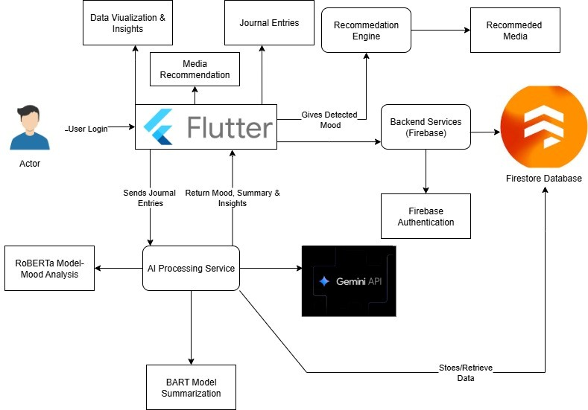
4.1.a. System Architecture Overview

Data Flow Diagrams (DFD)
The Data Flow Diagrams for Pocket Journal illustrate how information moves through the system between the user and the various backend components.
DFD Level 0 (Context Diagram): At the highest level, the entire Pocket Journal System is treated as a single process. It interacts with several external entities: the User, the Firebase backend, the AI Processing Service, and external Media APIs (Spotify, TMDB). The primary data flows are as follows: the user submits a journal entry to the system and receives a dashboard and recommendations in return. The system sends the entry text to the AI Processing Service for analysis and stores the final data in Firebase. It also queries the Media APIs to fetch recommendations based on the analysis.

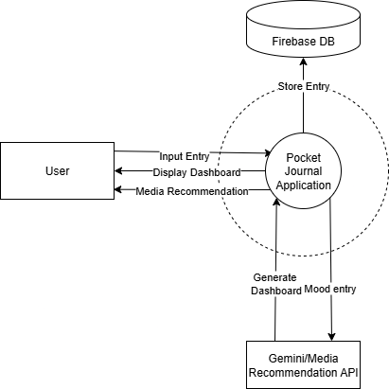

Data Flow Diagram (DFD) - Level 0

DFD Level 1: This level provides a more detailed view of the internal processes. When a User submits an entry, it is handled by the "Process Journal Entry" function. This function sends the text to the "Analyze Entry" process (our Python API), which returns a mood and summary. The original entry and the analysis results are then sent to be stored in the Firestore Database. Concurrently, the "Fetch Recommendations" process uses the detected mood to query the Media APIs. All this information is compiled by the "Display Dashboard" process and presented back to the user. This flow demonstrates the clear separation between data storage, AI analysis, and external data fetching.

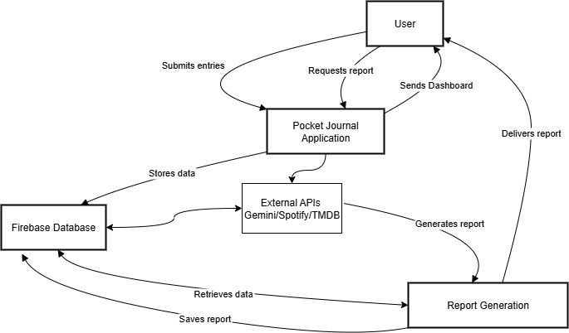

    - Data Flow Diagram (DFD) - Level 1

Entity Relationship Diagrams (ERD) / Data Model
As Pocket Journal utilizes Firestore, a NoSQL database, the data structure is represented as a Data Model composed of distinct collections designed for efficient, decoupled data management. The primary collections are:
- users collection: Each document represents a single user, keyed by their Firebase Authentication UID. It stores basic profile information like email and createdAt.
- journal_entries collection: This collection stores the raw, immutable user input. Each document contains the userId, the full entryText, and a timestamp. Separating the raw text ensures the original entry is always preserved.
- entry_analysis collection: This collection stores the output from the AI models. Each document corresponds to a single journal entry and contains the entryId, the generated summary, and a mood map with the confidence scores for each emotion. This creates a clear one-to-one relationship with a document in journal_entries and allows for re-analysis without altering the original entry.

- insights collection: This collection stores the long-term analytical reports generated by the Gemini API. Each document contains the userId, the startDate and endDate of the analysis period, and the detailed textual insights (goals, progress, conflicts, etc.).
- insights_mapping collection: This collection serves as a crucial link between the long-term insights and the source entries. Each document is a simple map containing an insightId and an entryId. This creates a many-to-many relationship, allowing the system to trace exactly which journal entries contributed to a specific insight report.
This decoupled structure is highly efficient. To display an entry, the application fetches a document from journal_entries and its corresponding document from entry_analysis. This design improves query performance and makes the system more maintainable.
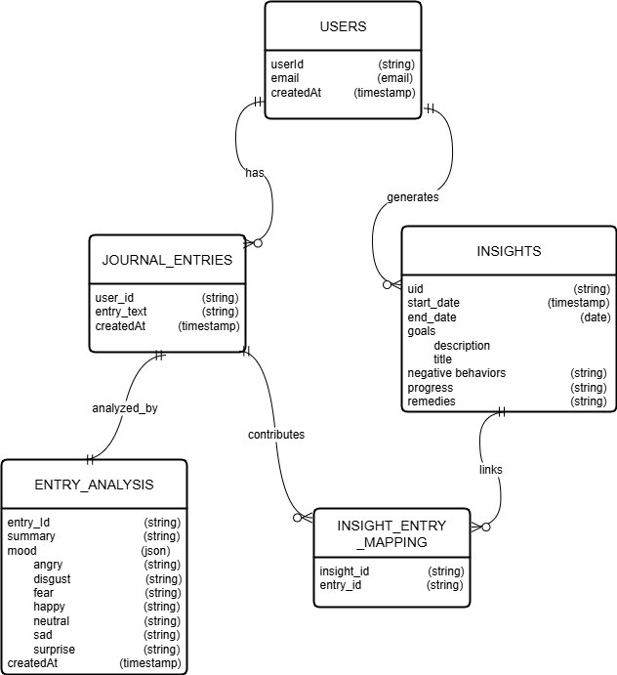

    - Firestore Data Model Diagram

UML Diagrams
UML diagrams visualize the structural and behavioural aspects of the Pocket Journal system.
- Use Case Diagram: This diagram illustrates the interactions between the User and the system. Key use cases include: Register/Login, Create Journal Entry, View Mood Analysis, Receive Media Recommendation, and Generate Behavioural Insight. These visually represent the core functional requirements.
- Sequence Diagram: A sequence diagram for "Submitting a Journal Entry" would detail the following flow:
  - The User saves an entry in the Flutter App.
  - The Flutter App sends an API request to the Python API Server.
  - The Python API Server returns a JSON object with the mood and summary.
  - The Flutter App then performs two separate write operations to Firestore: one to save the original text in the journal_entries collection and another to save the analysis in the entry_analysis collection.
- Class Diagram: The class diagram would now clearly define separate Journal Entry and Entry Analysis classes, reflecting the decoupled data model. The Journal Entry class would contain attributes like text and timestamp, while the Entry Analysis class would hold summary and mood scores. This clarifies the logical structure within the application's codebase.

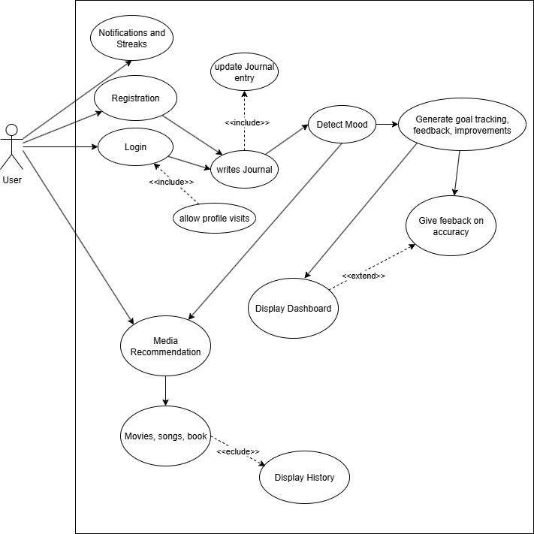
4.4.a: Use Case Diagram
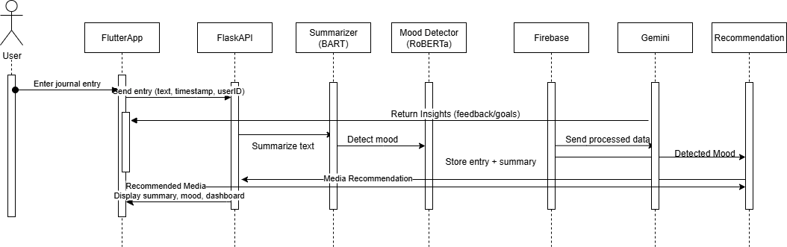
4.4.b. Sequence Diagram for Journal Entry Submission

CHAPTER 5 OTHER SPECIFICATION

Advantages
A key strength of the Pocket Journal project is its ability to transform a traditionally passive activity into an interactive tool for personal development. The system provides significant benefits in several areas:

    - Enhanced Self-Awareness: The application's core AI features, particularly the mood detection and automated summaries, provide users with objective feedback on their own writing. This encourages consistent self-reflection and helps users gain a much deeper understanding of their emotional patterns over time.
    - Proactive and Supportive Experience: Unlike a static diary, Pocket Journal actively engages with the user. Through personalized media recommendations and goal-tracking functionalities, the system serves as a supportive companion that can help manage stress and maintain motivation on a personal growth journey.
    - Secure and Accessible Design: The project was built with a user-centric approach. The clean Flutter interface ensures the application is intuitive and easy to use, while the secure Firebase backend provides a private and reliable space for users' sensitive thoughts and data.
    - Scalable and Modern Architecture: The system’s modular design is a significant advantage. It allows for future expansion with new features, such as voice-based journaling, ensuring the project has long-term viability and can evolve as a modern tool for digital well- being.

Limitations

It is important to acknowledge the project's current limitations and dependencies, which define the boundaries of its functionality.

- Technical Dependencies: The application’s core analytical features are dependent on a constant internet connection. Furthermore, the media recommendation functionality relies on the stability and policies of third-party APIs, which are outside of our direct control.

- Data and AI Constraints: The accuracy of the AI-driven insights is directly correlated with the quality and detail of the user's journal entries. It is also important to recognize that while the system is secure, it requires users to place trust in the platform with their sensitive personal data.
- Scope and Functionality: The initial version of the application is limited to the English language. We must also clearly state that Pocket Journal is designed as a self-help and awareness tool; it is not a substitute for professional medical or psychological advice.
- Operational Considerations: The long-term maintenance of the application will involve ongoing operational costs for cloud services and API usage. As the user base grows, the system's performance will need to be carefully monitored to ensure continued reliability.

Applications

Beyond its primary function as a personal diary, the Pocket Journal platform has potential applications in a variety of contexts where emotional well-being and self-reflection are valued.

- Personal Well-being: The main application is for individuals seeking an intelligent and private tool to track their moods, practice mindfulness, and work consistently towards their personal development goals.
- Educational Environments: For students at universities and colleges, the app can serve as a valuable resource for managing academic stress and tracking emotional health throughout the demanding semester cycles.
- Corporate and Professional Settings: The platform could be offered as part of corporate wellness programs, especially in remote work environments, to help employees manage stress and maintain a healthy work-life balance.
- Supportive and Clinical Contexts: While not a clinical tool itself, Pocket Journal could be used in a supplementary capacity. Therapists or counsellors might recommend it to patients for logging moods and experiences between sessions, providing valuable talking points for discussion.

CHAPTER 6 CONCLUSIONS & FUTURE WORK

Conclusion
The Pocket-Journal AI Journal & Media Recommender project has successfully demonstrated the effective integration of artificial intelligence with tools for mental health awareness and personal growth. This work shows how modern technologies, specifically Natural Language Processing, mood detection, and recommendation systems, can be leveraged to transform the traditional, static practice of journaling into an interactive, insightful, and engaging experience. The current version of the application delivers a reliable set of core features, including mood tracking, automated summarization, and personalized media recommendations. While the project has achieved its initial objectives, its scalable architecture establishes a strong foundation for future enhancements, ensuring that the application can evolve into an even more comprehensive and impactful self-improvement tool.

Future Work
To build upon the current success of the project, several key areas for future development have been identified. These enhancements are designed to broaden the application's functionality, improve its intelligence, and increase user engagement

    - Expansion of Input Modalities: Future versions will aim to incorporate support for voice and multimedia journaling, allowing users to record audio notes or add images and videos to make their entries more expressive.
    - Multi-Language Support: To increase accessibility and reach a global audience, future work will involve extending the application's NLP capabilities to support various regional and international languages.
    - Advanced AI-Driven Feedback: The plan is to integrate more advanced large language models to provide users with deeper, more personalized feedback and actionable guidance for their emotional well-being.
    - Integration with Professional Support: To provide a more holistic support system, future versions could include an optional feature that allows users to connect with certified mental health professionals or other credible wellness resources.

Appendix A

Problem Statement Feasibility Assessment

- Feasibility Using Mathematical Models: The project's feasibility is grounded in its use of established NLP models. A fine-tuned RoBERTa model is used for emotion classification, and a BART model is used for text summarization. These mathematical engines are proven to be effective at extracting structured meaning from unstructured text, making the core problem solvable.
- Computational Complexity (P-Type): The system's computational tasks are feasible. The intensive fine-tuning of the AI models is performed offline and does not impact the user. The real-time analysis (inference) of a journal entry is a fast, fixed calculation handled by the backend server. This makes the live analysis a computationally tractable P-type problem, ensuring the application remains responsive.
- Data Dependency and Quality: The mood detection feature's feasibility was validated by fine-tuning the RoBERTa model on approximately 14,000 labeled entries, out of which 5,000 were custom entries created by the team in the form of scripts and journal-style text. These additional samples enhanced the dataset’s diversity and contextual depth, enabling the model to perform emotion classification more accurately and effectively in real-world scenarios.
- Hardware and Resource Constraints: The primary hardware constraints are on the backend, not the user's device. The user only needs a smartphone with a stable internet connection. The feasibility at scale depends on provisioning a backend server with sufficient computational resources (CPU/GPU and RAM) to handle concurrent API requests for AI inference.
- Probabilistic Nature of Output: The emotion classification model provides a probabilistic output across seven emotional categories. The system's design feasibly handles this by identifying the emotion with the highest probability score as the "dominant mood." This method of interpreting the probabilistic data is a core and practical component of the application's logic.

APPENDIX B REFERENCES
- I. Ameer, N. Bölücü, G. Sidorov, and B. Can, “Emotion Classification in Texts Over Graph Neural Networks: Semantic Representation is Better Than Syntactic,” IEEE Access, vol. 11, pp. 56921–56934, May 2023, doi: 10.1109/ACCESS.2023.3281544.

- H. Gunjal, T. Kharde, A. Nair, T. Sase, and Y. Sisodia, “Emotion Based Music and Movie
Recommendation System Using Python,” Int. J. Current Science (IJCSPUB), vol. 13, no. 2, pp. 415– 422, Apr. 2023.

- S. Challa, N. P., G. Manohari V., D. D. Clemency C. A., and R. M. S., “Content Recommendation Based on Recognised Emotion,” in Proc. 2023 Int. Conf. Recent Adv. Electr., Electron., Ubiquitous Commun., Comput. Intell. (RAEEUCCI), 2023, pp. 1–6, doi: 10.1109/RAEEUCCI57140.2023.10134505.

- J. K. Leung, I. Griva, and W. G. Kennedy, “Text-Based Emotion Aware Recommender,” in Proc. CS & IT - CSCP, 2020, pp. 101–114, doi: 10.5121/csit.2020.101009.

- J. Mizgajski and M. Morzy, “Affective Recommender Systems in Online News Industry: How
Emotions Influence Reading Choices,” User Modeling and User-Adapted Interaction, vol. 29, pp. 345– 379, 2019, doi: 10.1007/s11257-018-9213-x.

- S. Unnisa and A. N. S., “Personalized Mood-Centric Book Recommendation Integrating Machine Learning with Content Based Filtering,” Int. J. Inf. Technol., Res. Appl. (IJITRA), vol. 3, no. 3, pp. 15– 22, Sep. 2024, doi: 10.59461/ijitra.v3i3.100.

- T.-Y. Kim, H. Ko, S.-H. Kim, and H.-D. Kim, “Modeling of Recommendation System Based on Emotional Information and Collaborative Filtering,” Sensors, vol. 21, no. 6, p. 1997, Mar. 2021, doi: 10.3390/s21061997.

- N. Krishnakumar, M. K. K., N. A. R., M. N. S., and S. E. T., “Mood-Based Recommender: Music and Book Recommendations,” Int. J. Novel Res. Dev. (IJNRD), vol. 9, no. 5, pp. a737–a743, May 2024.

- N. Tennakoon, O. Senaweera, and H. A. S. G. Dharmarathne, “Emotion-Based Movie
Recommendation System,” Int. J. Adv. ICT Emerg. Regions, vol. 17, no. 1, pp. 35–39, 2024, doi: 10.4038/icter.v17i1.7275.

- A. Karve, B. Shivbhakta, A. Humnabadkar, and S. Naik, “Machine Learning Based Mood
Prediction and Recommendation System,” Int. J. Sci. Res. Eng. Manage. (IJSREM), vol. 8, no. 9, pp. 1–9, Sep. 2024, doi: 10.55041/IJSREM37402.

- A. Nanopoulos, D. Rafailidis, P. Symeonidis, and Y. Manolopoulos, “MusicBox: Personalized Music Recommendation Based on Cubic Analysis of Social Tags,” IEEE Trans. Audio, Speech, Lang. Process., vol. 18, no. 2, pp. 407–412, Feb. 2010, doi: 10.1109/TASL.2009.2033973.

- A. Wenish J., S. K., A. Julian, and K. R., “Applying Artificial Intelligence for Emotion Detection from Text Messages,” in Proc. 2024 Int. Conf. Trends Quantum Comput. Emerg. Bus. Technol. (TQCEBT), Mar. 2024, pp. 1–4, doi: 10.1109/TQCEBT59414.2024.10545136.

- S. Kusal, S. Patil, K. Kotecha, R. Aluvalu, and V. Varadarajan, “AI Based Emotion Detection for Textual Big Data: Techniques and Contribution,” Big Data and Cognitive Computing, vol. 5, no. 3, p. 43, Sep. 2021, doi: 10.3390/bdcc5030043.

- R. Padate, A. Gupta, P. Chakrabarti, and A. Sharma, “Emotion Recognition from WhatsApp Text Messages Using Unsupervised Machine Learning,” in Proc. 2024 8th Int. Conf. I-SMAC (IoT Social, Mobile, Anal. Cloud) (I-SMAC), 2024, pp. 1871–1876, doi: 10.1109/I-SMAC61858.2024.10714817.

- S. Yang, “Emotion Detection and Analysis Techniques Based on NLP,” in Proc. 3rd Int. Conf. Mechatron. Smart Syst., 2025, pp. 147–153, doi: 10.54254/2755-2721/135/2025.21215.

- P. Nandwani and R. Verma, “A Review on Sentiment Analysis and Emotion Detection from Text,” Social Network Analysis and Mining, vol. 11, no. 81, Aug. 2021, doi: 10.1007/s13278-021- 00776-6.

- K. Machová, M. Szabóová, J. Paralič, and J. Mičko, “Detection of Emotion by Text Analysis Using Machine Learning,” Frontiers in Psychology, vol. 14, p. 1190326, Sep. 2023, doi: 10.3389/fpsyg.2023.1190326.

- R. Goyal, N. Chaudhry, and M. Singh, “Personalized Emotion Detection from Text Using Machine Learning,” in Proc. 2022 3rd Int. Conf. Comput., Anal. Netw. (ICAN), 2022, pp. 1–6, doi: 10.1109/ICAN56228.2022.10007248.

- A. Ahmed, Barkha, T. Kanjwani, and S. Nasim, “Comparative Analysis of DistilBERT, XLNet, RoBERTa & BigBird for Emotion Detection in Conversational Text,” ILMA J. Technol. Softw. Manage. (IJTSM), vol. 6, no. 1, pp. 1–13, Sep. 2025, doi: 10.13140/RG.2.2.34790.69440.

- F. Anzum and M. L. Gavrilova, “Emotion Detection From Micro-Blogs Using Novel Input Representation,” IEEE Access, vol. 11, pp. 19512–19522, Feb. 2023, doi: 10.1109/ACCESS.2023.3248506.

- B. Khan, M. Usman, I. Khan, J. Khan, D. Hussain, and Y. H. Gu, “Next-Generation Text Summarization: A T5-LSTM FusionNet Hybrid Approach for Psychological Data,” IEEE Access, vol. 13, pp. 37557–37571, Feb. 2025, doi: 10.1109/ACCESS.2025.3540590.

- S. L. Jemina and P. P. R. V., “Decoding Feelings: A Novel Approach to Emotion Recognition from Textual Data,” IOSR J. Comput. Eng. (IOSR-JCE), vol. 27, no. 2, pp. 58–64, Mar. 2025, doi: 10.9790/0661-2702025864.

- A. A. Maruf, Z. M. Ziyad, M. M. Haque, and F. Khanam, “Emotion Detection from Text and Sentiment Analysis of Ukraine Russia War Using Machine Learning Technique,” Int. J. Adv. Comput. Sci. Appl. (IJACSA), vol. 13, no. 12, pp. 868–882, 2022.

