SYNOPSIS
Group 16

Title: Pocket Journal

1. Introduction
In today's fast-paced world, everyone is looking for better ways to manage their mental well-being. That’s where Pocket Journal comes in. It’s not just another diary app where you can write down your thoughts. We envision it as a true wellness companion, a friend in your pocket that helps you understand yourself better and also finds the right content to support your mood.

The vision is two-fold: first, to use smart AI to look at your journal entries and find patterns in your emotions going beyond simple "happy" or "sad" to understand a whole range of feelings. Second, to use this emotional insight to recommend helpful media, like books, podcasts, or articles, that can either lift your spirits or help you lean into a moment of reflection. It transforms the simple act of journaling into a complete, interactive wellness cycle: from expression to understanding, and finally to supportive action.

2. Objectives
- To build a solid, secure mobile app using Flutter, where your personal thoughts are kept completely private.
- To create a smart two-part AI system: one part for quick, instant sentiment feedback and media recommender and a more powerful part for a deep-dive emotional summary over time.
- To develop an advanced emotion classifier that can pick up on a variety of feelings like joy, sadness, anger, fear, love, surprise, and even hints of sarcasm.
- To build a dynamic media recommendation engine that suggests books, podcasts, articles, and other content based on the user's mood, which can be taken from their diary entries or entered directly.
- To design a simple and beautiful user interface with two core features: a "Wellness Dashboard" for insights and a "Media Hub" for personalized content.

3. Literature Survey
To make sure we are building something truly useful, we have based our project on solid research. The initial planning was guided by a wide-ranging study from Kusal et al. (2021), which gives a fantastic overview of how AI can detect emotions from text. This paper confirmed our idea that we need to go beyond basic sentiment and pointed out how tricky it is for AI to detect things like sarcasm, a challenge we want to take on.
For the actual tech part of emotion analysis, we are taking inspiration from the work of Machová et al. (2023). They built and tested a system using a combination of CNN and LSTM models and got over 90% accuracy in identifying six different emotions. Their success gives us a proven technical path for building Pocket Journal’s core analysis engine.

The recommendation feature is strongly supported by existing literature. The study by Karve et al. (2024) clearly shows that building recommendation systems based on a user's mood is a viable and effective approach. While their system used direct user inputs, we plan to take it a step further. The "MusicBox" paper by Nanopoulos et al. (2010) gives a glimpse of this advanced future, showing how personalized music suggestions can be made using the rich, contextual data from social tags. Pocket Journal will adapt this very principle; instead of public tags, it will use the deep, private, and nuanced emotional context from your own journal entries to give truly personal and supportive media recommendations.

4. Proposed System

The proposed system, Pocket Journal, is designed around two core, interconnected features: an AI-powered analysis engine and a personalized media recommender.

The AI Insight Engine: This is the primary analysis component. When a user writes in their journal, a powerful Large Language Model (Gemini 2.0 Flash) on the backend analyses the text from a user-selected date range. It performs a multi-class emotion analysis to identify a spectrum of feelings (joy, sadness, anger, etc.). The resulting insights—including identified goals, emotional patterns, and positive moments—are then organized and presented to the user in a structured "Wellness Dashboard."

The Personalized Media Recommender: This feature provides supportive content based on the user's emotional state. The system can be triggered in two ways: either by the emotions automatically detected by the Insight Engine from journal entries, or by a mood the user selects directly. Based on this emotional context, the engine recommends relevant media such as books, podcasts, and articles, which are presented in a dedicated "Media Hub" within the application.

5. Methodology

The system's implementation uses a client-server architecture. The client is a cross-platform mobile application developed in Flutter. It is responsible for the user interface, secure user authentication, and making REST API calls to the backend.

The backend is a Python Flask server that handles all business logic. It interfaces with a Google Firestore database for the secure storage and retrieval of encrypted user journal entries.

The methodology consists of two primary operational flows:

Insight Generation: The Flutter client sends a request with a specified date range to the Flask backend. The backend retrieves the corresponding journal entries from Firestore, concatenates the text, and sends it to the Google Gemini API using a structured prompt. The API returns a JSON object containing the multi-class emotion analysis and thematic insights. This JSON is then parsed by the backend and relayed to the client for display on the "Wellness Dashboard."

Media Recommendation: The backend uses the emotional state (either from the insight engine or direct user input) as a primary keyword. It then queries relevant third-party media APIs (e.g., Google Books, Spotify for podcasts) to fetch a curated list of content. This list is returned to the client for display in the "Media Hub."

6. Block Diagram

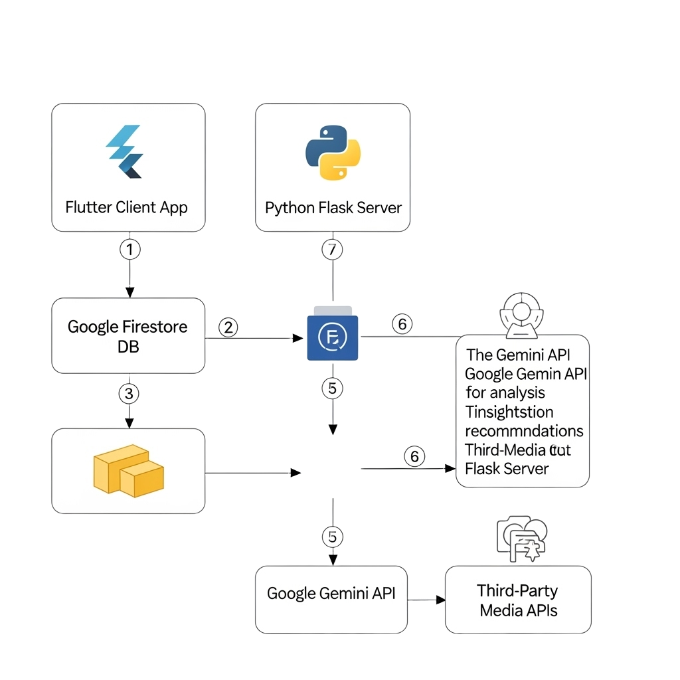

7. Hardware & Software Requirements

Hardware: •

Client: A modern smartphone (iOS or Android) with an active internet connection.

Server: A standard cloud computing instance (e.g., Google Cloud Run, AWS EC2) capable of running a Python web application and making external API calls.

Software:

Client Application:

Operating System: Android or iOS.

Framework: Flutter SDK with Dart.

Backend Server:

Language/Framework: Python 3.8+, Flask.

API structure for handling RESTful requests.

Database:

Service: Google Firestore.

AI Services & Libraries:

Google Gemini API (for summarization and multi-class emotion analysis).

Hugging Face Transformers library (for immediate sentiment classification).

Third-Party Services:

APIs for media recommendations (e.g., Google Books, Spotify, News APIs).

8. Expected Outcome
At the end of this project, we will have a fully working, polished mobile app.
This app will offer two core features:
- A "Wellness Dashboard" that gives users a nuanced breakdown of their emotions over time.
- A "Media Hub" that provides a constantly updated, personalized feed of supportive content.
- The app will successfully help users not only understand their feelings but also find healthy and constructive ways to manage them.

9. Applications

Personal Wellness: A great daily tool for anyone who wants to understand their emotions better and improve their mental well-being.

Mood Regulation: Actively helps users find content that can positively influence their mood.

Mindful Content Discovery: Provides a healthier alternative to endless scrolling by suggesting content that is genuinely relevant to the user's current emotional state.

Support for Therapy: A fantastic aid for therapy, allowing users to track emotional patterns and discover resources that supplement their sessions.

10. Conclusion

Pocket Journal is set to completely change what people expect from a digital diary. By combining a powerful, multi-class emotion detection engine with a smart, mood-based recommendation system, it goes far beyond what current apps offer. It turns the simple act of writing into an interactive and supportive experience. By providing feedback that is insightful, actionable, and genuinely helpful, Pocket Journal will become an essential companion for anyone on a journey of personal growth.

11. References

Books & Research Papers:

Kusal, S., Patil, S., Kotecha, K., Aluvalu, R., & Varadarajan, V. (2021). AI Based Emotion Detection for Textual Big Data: Techniques and Contribution. Big Data and Cognitive Computing, 5(43).

Machová, K., Szabóová, M., Paralič, J., & Mičko, J. (2023). Detection of emotion by text analysis using machine learning. Frontiers in Psychology, 14.

Karve, A., Humnabadkar, A., Shivbhakta, B., & Naik, S. (2024). Machine Learning based Mood Prediction and Recommendation System. International Journal of Scientific Research in Engineering and Management (IJSREM), 08(09).

Cardona, J. A., & Paredes, C. M. (2025). Artificial Intelligence for Dairy Production Prediction: A Machine Learning Approach. Conference Paper.

Lopez-Barreiro, J., Garcia-Soidan, J. L., Alvarez-Sabucedo, L., & Santos-Gago, J. M. (2024). Artificial Intelligence-Powered Recommender Systems for Promoting Healthy Habits and Active Aging: A Systematic Review. Applied Sciences, 14(10220).

Nanopoulos, A., Rafailidis, D., Symeonidis, P., & Manolopoulos, Y. (2010). MusicBox: Personalized Music Recommendation Based on Cubic Analysis of Social Tags. IEEE Transactions on Audio, Speech, and Language Processing, 18(2), 407-412.

Web References & Technical Articles:

Google Gemini API Documentation. (https://ai.google.dev/docs)

Hugging Face Transformers. (https://huggingface.co/docs/transformers)

Flutter Official Documentation. (https://flutter.dev/)

Flask Web Framework. (https://flask.palletsprojects.com/)

Google Firestore Documentation. (https://firebase.google.com/docs/firestore)

