Marwadi University
Faculty of Engineering & Technology
Department of Information and Communication Technology
  Subject: Digital Signal and  Image Processing (01CT1513) | Aim: Simulate discrete time sequences.
Experiment No: 1 | Date:17-07-2026 | Enrollment No:92400133024

Aim: Simulate discrete time sequences.

Program:-
import numpy as np
import matplotlib.pyplot as plt
n = np.arange(-10, 11)
impulse = np.where(n == 0, 1, 0)
step = np.where(n >= 0, 1, 0)
ramp = np.where(n >= 0, n, 0)

a = 0.8
exponential = np.where(n >= 0, a**n, 0)
f = 0.1 # Frequency
sinusoidal = np.sin(2 * np.pi * f * n)
plt.figure(figsize=(10, 12))

# Unit Impulse
plt.subplot(5, 1, 1)
plt.stem(n, impulse)
plt.title("Unit Impulse Sequence")
plt.xlabel("n")
plt.ylabel("δ(n)")
plt.grid(True)

# Unit Step
plt.subplot(5, 1, 2)
plt.stem(n, step)
plt.title("Unit Step Sequence")
plt.xlabel("n")
plt.ylabel("u(n)")
plt.grid(True)

# Ramp
plt.subplot(5, 1, 3)
plt.stem(n, ramp)
plt.title("Ramp Sequence")
plt.xlabel("n")
plt.ylabel("r(n)")
plt.grid(True)

# Exponential
plt.subplot(5, 1, 4)
plt.stem(n, exponential)
plt.title("Exponential Sequence (a = 0.8)")
plt.xlabel("n")
plt.ylabel("x(n)")
plt.grid(True)

# Sinusoidal
plt.subplot(5, 1, 5)
plt.stem(n, sinusoidal)
plt.title("Discrete-Time Sinusoidal Sequence")
plt.xlabel("n")
plt.ylabel("x(n)")
plt.grid(True)

plt.tight_layout()
plt.show()

Result:- 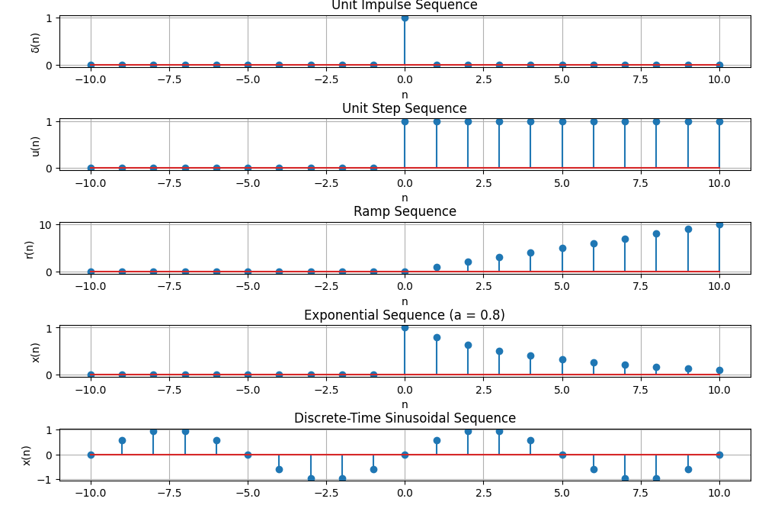
Conclusion:-
The simulation of discrete-time sequences was successfully carried out using Python. The generated plots of the unit impulse, unit step, ramp, exponential, and sinusoidal sequences matched their theoretical definitions. This experiment demonstrates how discrete-time signals can be represented, generated, and visualized using Python libraries such as NumPy and Matplotlib. It also provides a better understanding of the fundamental sequences used in Digital Signal Processing (DSP), which serve as the basis for analyzing and designing digital systems.

