GitHub link:-
Code for CROSS CORRELATION on Discrete signal time signal :
import numpy as np
import matplotlib.pyplot as plt

# Discrete-time signals
x = np.array([1, 2, 3, 2, 1])
y = np.array([1, 1, 2, 1, 0])

# Cross-correlation
rxy = np.correlate(x, y, mode='full') lags = np.arange(-(len(y)-1), len(x))

# Display output print("Cross-Correlation:") print(rxy)

# Plot only the cross-correlation plt.figure(figsize=(8,4)) plt.stem(lags, rxy)
plt.title("Cross-Correlation of Discrete-Time Signals") plt.xlabel("Lag")
plt.ylabel("Correlation") plt.grid(True)
plt.show()

OUTPUT :
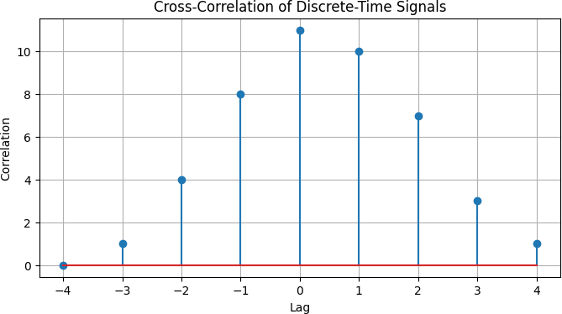

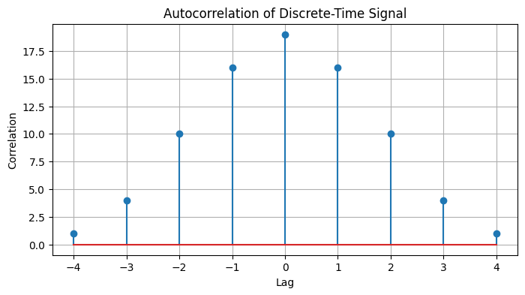
Code for AUTOCORRELATION on discrete signal time Signal.
import numpy as np
import matplotlib.pyplot as plt

# Discrete-time signal
x = np.array([1, 2, 3, 2, 1])

# Autocorrelation
auto_corr = np.correlate(x, x, mode='full') lags = np.arange(-(len(x)-1), len(x))

# Display output print("Autocorrelation:") print(auto_corr)

# Plot only the autocorrelation plt.figure(figsize=(8,4)) plt.stem(lags, auto_corr)
plt.title("Autocorrelation of Discrete-Time Signal") plt.xlabel("Lag")
plt.ylabel("Correlation") plt.grid(True)
plt.show()

OUTPUT :

