Punit Label Application Flow and Label Format Guide
Google Docs-ready guide generated from the Flutter source on 22 June 2026.

1. Application Flow
- Splash and login: the app starts at SplashView, then routes to LoginView when credentials are required. Login collects Company Code, email, and password, then stores authenticated user and token data.
- Dashboard: DashBoardView loads user permissions, dashboard totals, top products, low-stock products, company details, device reconnection, and printer status polling. Role flags control whether Inward and Dispatch cards are accessible.
- Global drawer configuration: the drawer controls default non-batch label format, white-label mode, serial number printing, timestamp printing, label copy count, tare behavior, printer/receipt mode, tower light status, scale connection, and printer connection.
- Inward entry: operators select Batch Inward or Non Batch Wise Inward. Both flows capture gross, tare, and net weights, create barcodes from serial numbers, print labels, maintain logs, and submit pause/stop payloads to the API.
- Dispatch: operators select a customer, scan or manually enter a barcode, verify and add dispatch items, then save the dispatch transaction and export reports.

2. Configuration That Changes Labels
Setting | Effect
White Label | Removes company header/footer from generic and special previews when enabled.
Serial Number | Prepends Sr No to labelFields where the selected label format supports it.
Time Stamp | Adds date/time to static previews and print payloads.
Label Copies | Repeats the platform print call from 1 to 10 times.
Tare State: OFF | Tare is forced to 0 and labels usually print Net Weight only.
Tare State: ON | Gross Weight, Tare Weight, and Net Weight can be printed.
Tare State: Barcode | Tare products can be selected/scanned and included in weighing logic.
Label vs Receipt | Label mode calls Android label-printer methods; Receipt mode sends item lines to the Bluetooth receipt printer.

3. Inward Workflow

Batch Wise
- Select a batch, then a product inside that batch.
- Select an existing label format. Batch flow currently previews existing/static formats.
- The controller syncs product tare unless global tare is OFF.
- Auto-weight mode monitors the scale every second. When the configured weight condition is met for the configured number of seconds, addToList creates a barcode, inserts a log entry, and prints the selected label.
- Pause/Stop groups barcodes by batch product and submits gross/tare/net/serial payloads, then generates an inward PDF report.

Non Batch Wise
- Enter a transaction name, select product, select label format, and choose product attributes.
- When custom label templates are supported, the UI adds Custom, label size, and custom option selectors.
- The app groups repeated entries by same product and same selected attributes; serial numbers continue inside that group.
- Existing/static labels build labelFields from selected attributes plus weight fields. Custom templates resolve field positions and values from the runtime template payload.
- Pause/Stop submits the transaction payload and generates a transaction PDF report.

4. Dispatch Workflow
- Open Dispatch from the dashboard when dispatch permission is enabled.
- Select a customer, then scan a barcode or type it into the Barcode field.
- verifyAndAddBarcode validates the barcode against dispatch data and appends it to dispatch logs.
- Save submits scanned barcodes. Export helpers can generate grouped PDF/Excel dispatch reports.

5. Label Format Catalog
Format | Preview/print size | Selectable field limit | Behavior
Majedar Tea | 600 x 410 | 1 | First non-weight attribute becomes the description; net weight prints as Weight; Code128 barcode.
Small | 600 x 410 | 3 | Generic label. Non-white mode allows up to 3 selectable fields; preview switches to grid when more than 1 field is present.
Medium | 600 x 600 | 4 or 6 | Generic square label. Grid mode starts after 5 fields; white-label mode raises selectable fields to 6.
Large | 700 x 600 | 5 or 8 | Generic larger label. Default non-batch fallback is Large. Grid mode starts after 5 fields.
Extra Large | 700 x 700 | 7 or 9 | Generic large square label. Grid mode starts after 5 fields.
Wholesale Pack | 700 x 1200 | 10 | Tall generic label with Wholesale Pack title, business-hours line, product name, selected attributes, Gross Weight, and barcode.
Small Seven | 600 x 410 | 5 | Special two-column label. Excludes Weight and Sr No from attributes; unit conversion can insert Units.
DryFruit | 600 x 410 | 3 | Special dry-fruit layout. Excludes gross/tare/weight/sr from attribute list; weight fields are formatted to 3 decimals with Kg.
Custom Runtime | 50x75, 75x75, 75x100, 100x100 | Template driven | Fields come from API template coordinates: company, product, gross/tare/net, barcode, sr_no, datetime, footer, and attr_* fields.

6. Label Field Rules
- Small labels use Weight/Net Weight depending on the controller path; Medium, Large, and Extra Large usually include selected attributes plus Net Weight or Gross/Tare/Net depending on tare setting.
- Wholesale Pack keeps selected attributes and Gross Weight; Sr No is preserved when enabled.
- Majedar Tea ignores Sr No and weight keys when choosing its visible attribute description.
- DryFruit and SmallSeven remove weight-like keys from their attribute lists, then add their own weight/unit presentation.
- Runtime custom templates resolve field values by field_key. Supported built-in keys include company_name, company_email, company_contact_no, company_gst_no, company_website, company_address, product_name, gross_weight, tare_weight, net_weight, barcode, barcode_text, sr_no, datetime, footer, and attr_*.

7. Label Preview Examples
The previews below use sample product data and recreate the app preview logic: label dimensions, visible fields, special filtering, grid thresholds, timestamp placement, and barcode placement.
Majedar Tea Label Format
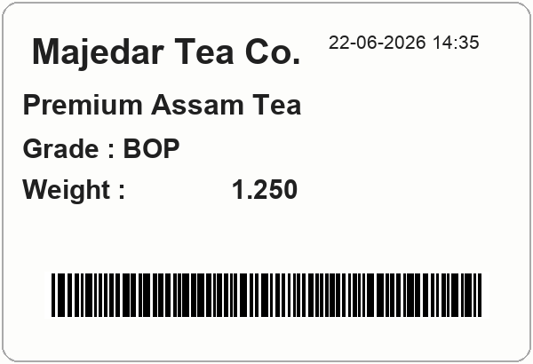
Small Label Select Max (3)
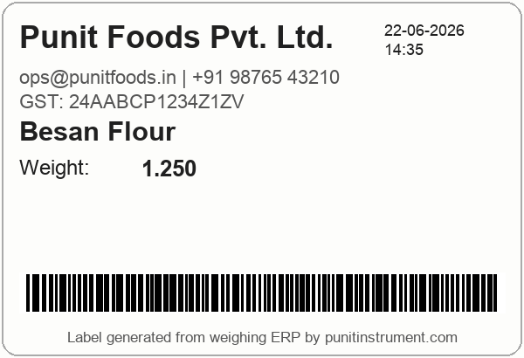
Medium Label Select Max (4/6)
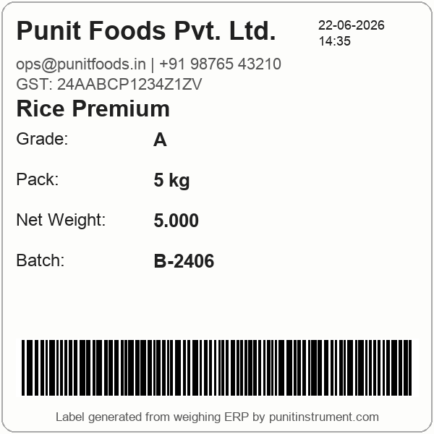
Large Label Select Max (5/8)
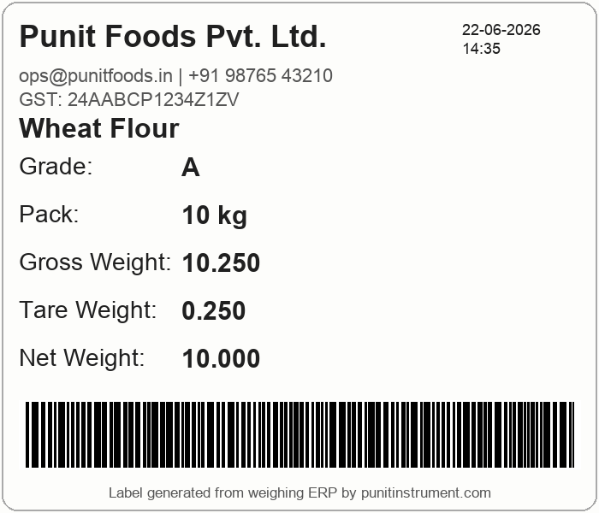
Extra Large Label Select Max (7/9)
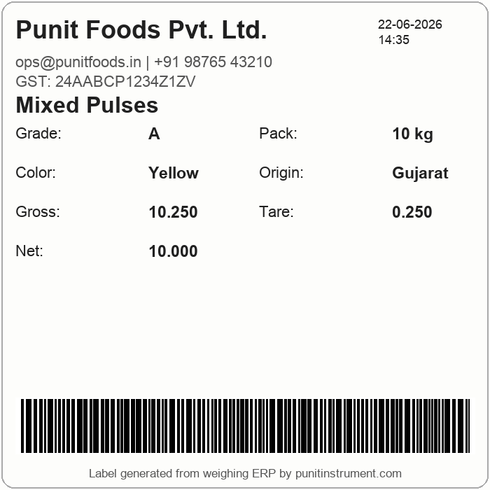
Wholesale Pack
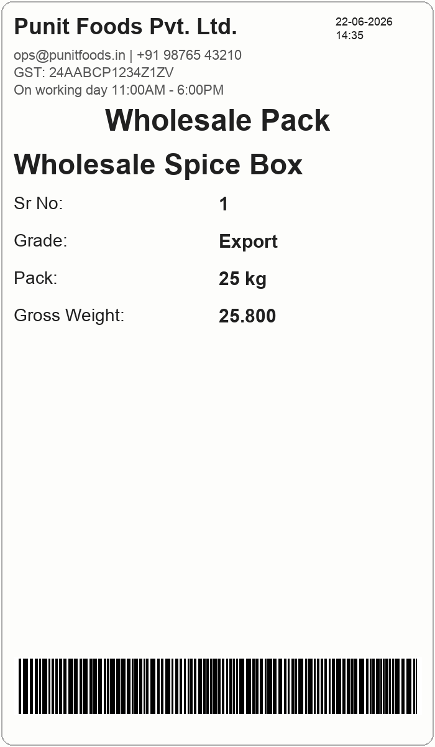
Small Seven (5)
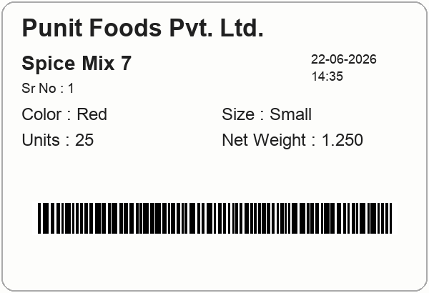
DryFruit Label Format
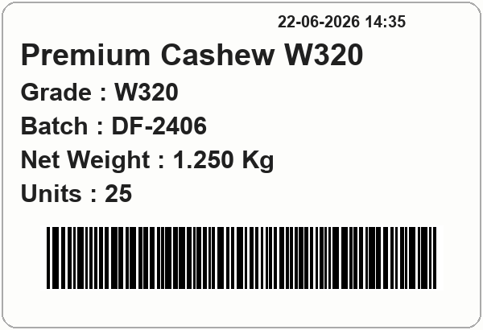
Custom Runtime Template Example
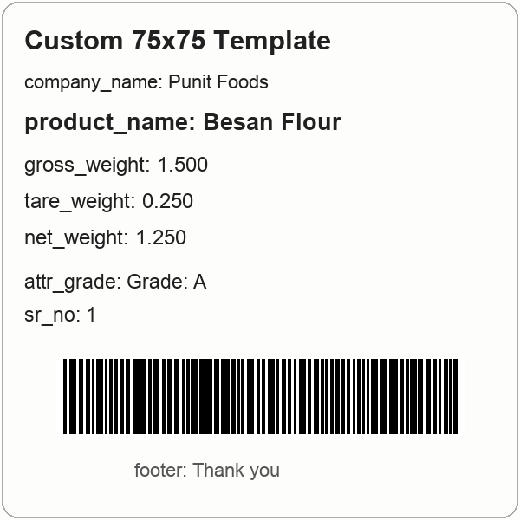

8. Example Print Payload
Field | Example
Product | Besan Flour
Barcode | A7K91
Attributes | Grade: A, Pack: 1 kg, Color: Yellow
Gross Weight | 1.500
Tare Weight | 0.250
Net Weight | 1.250
Units | 25, when unitConversion is enabled and unitValue x net weight equals 25
Serial Number | 1, when Serial Number toggle is enabled

