Heart Disease Prediction – Data Analysis & Modeling Report

Introduction:
- This project analyzes a heart disease dataset and develops machine-learning models to predict the presence of heart disease based on clinical attributes.
- The workflow includes:
- Dataset overview
- Missing values & data quality
- Exploratory Data Analysis (EDA)
- Data Preprocessing
- Classification using multiple ML algorithms
- K-Means clustering for unsupervised structure
- Key Insights from the analysis
- Conclusion

- Dataset Overview:
Typical shape: 1025 x 14
- Total Samples (Rows): 1025
- Total Features (Columns): 14
- Target Variable (Feature/Column): “target”
- “1” -> Heart-disease present
- “0” -> No heart-disease

Main Features:
Features | Category
age | Age in years
sex | Male/Female
chest_pain_type | 4 categories of chest pain
resting_blood_pressure | Resting blood pressure
cholesterol | Cholesterol level
fasting_blood_sugar | Above/below 120 mg/dl
rest_ecg | Resting ECG results
max_heart_rate_achieved | Maximum heart rate
exercise_induced_angina | Yes/No
oldpeak | ST depression values
slope | Slope of peak exercise ST segment
vessels_colored_by_flourosopy | Number of major vessels
thalassemia | Blood disorder category

Feature Types:
- Numeric: age, resting_blood_pressure, cholestoral, max_heart_rate, oldpeak
- Categorical: sex, chest_pain_type, fasting_blood_sugar, rest_ecg, exercise_induced_angina, slope, vessels_colored_by_flourosopy, thalassemia

- Missing values & data quality:
- Missing values: None detected
- Duplicated entries: None indicated
- Outliers: Some expected due to clinical variation (handled through modeling choices)

- Exploratory Data Analysis (EDA):
EDA was performed to understand patterns, distributions, and key correlations.
- sex:
  - Male: 713
- Female: 312
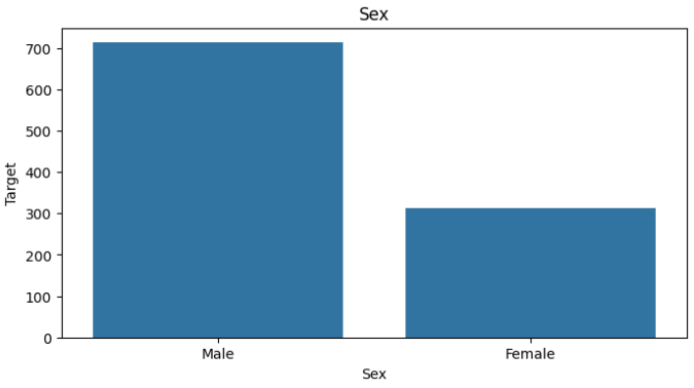
- chest_pain_type:
  - Typical angina: 497
  - Non-anginal pain: 284
  - Atypical angina: 167
  - Asymptomatic: 77
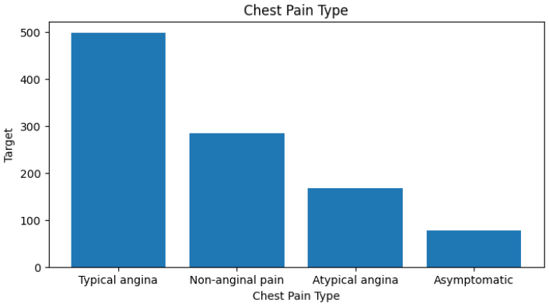
- resting_blood_pressure:
- ST-T wave abnormality: 513
- Normal: 497
- Left ventricular hypertrophy: 15
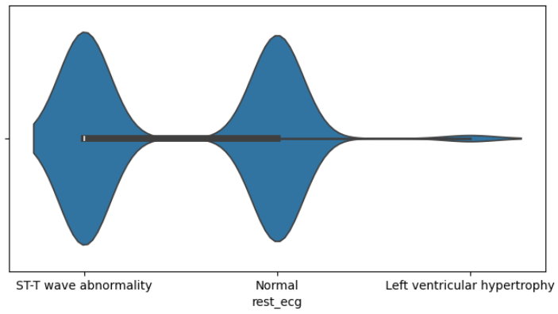
- fasting_blood_sugar:
- Lower than 120 mg/ml = 872
- Greater than 120 mg/ml = 153
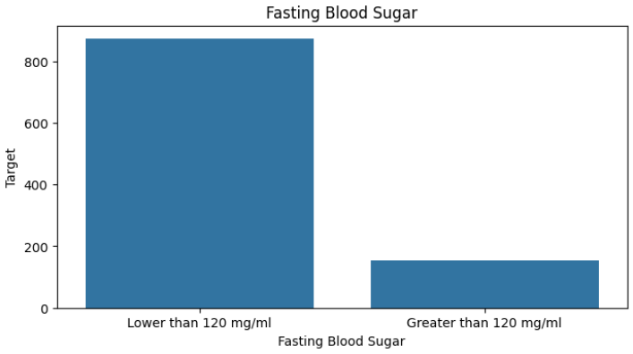

- exercise_induced_angina:
  - Yes: 345
  - No: 680
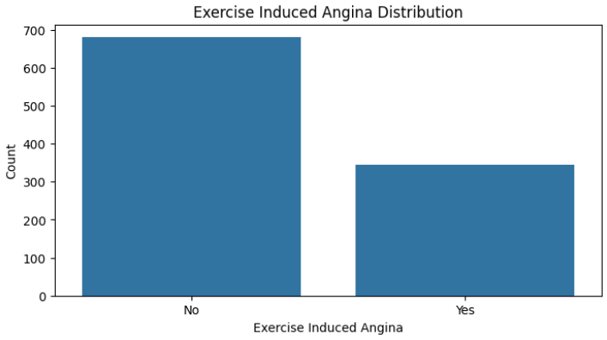
- slope:
  - Flat: 482
  - Downsloping: 469
  - Upsloping: 74
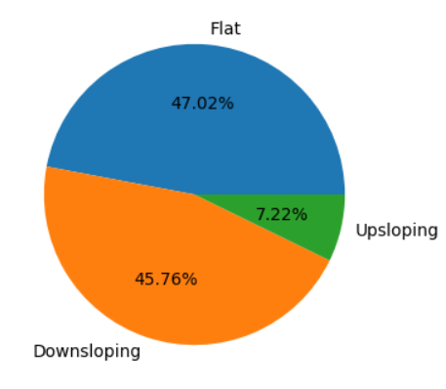

- vessels_colored_by_flourosopy:
  - Zero: 578
  - One: 226
  - Two: 134
  - Three: 69
  - Four: 18
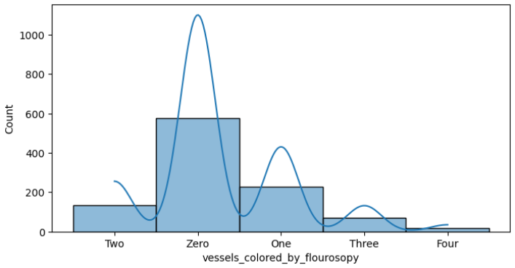
- thalassemia:
  - Fixed Defect: 544
  - Reversable Defect: 410
  - Normal: 64
  - No: 7
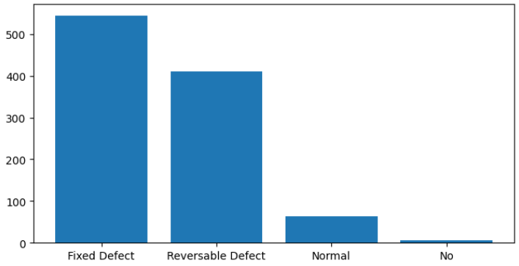
Target Variable Distribution:
- Disease vs Non-disease classes are fairly balanced, making standard ML models appropriate.
Optional quick pair-plot to visualize relationships:
- Non-linear relationships across multiple predictors.
- Visible class separation in chest pain type, thalassemia, and vessel count.
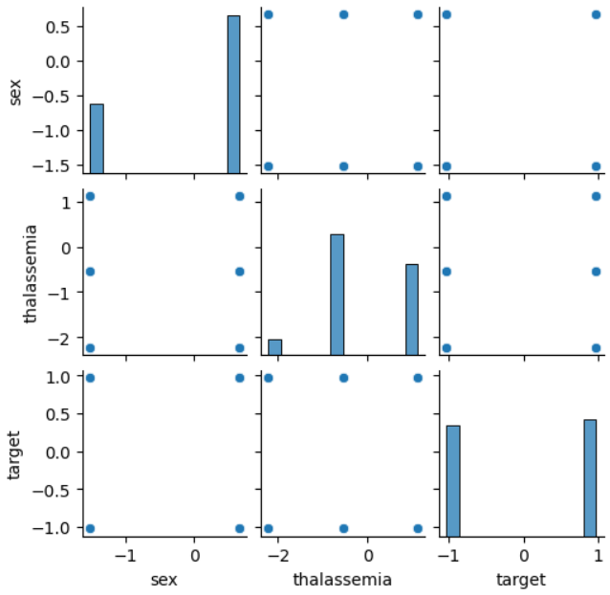

- Data Preprocessing:
- Categorical Encoding: To prepare the data for machine learning, categorical values were mapped into numeric form.
Mapping Table:
Features | Category -> Code
sex | Male -> 1  Female -> 0
chest_pain_type | Typical angina -> 2  Atypical angina -> 1  Non-anginal pain -> 0  Asymptomatic -> 3
fasting_blood_sugar | Lower than 120 mg/ml -> 0  Greater than 120 mg/ml -> 1
rest_ecg | ST-T wave abnormality -> 1  Normal -> 0  Left ventricular hypertrophy -> 2
exercise_induced_angina | Yes -> 1  No -> 0
slope | Downsloping -> 0  Upsloping -> 2  Flat -> 1
vessels_colored_by_flourosopy | Zero -> 0  One -> 1  Two -> 2  Three -> 3  Four -> 4
thalassemia | Reversable Defect -> 2  Fixed Defect -> 1  Normal -> 0  No -> 0

- Train-Test Split:
- 80% training, 20% testing
- random_state = 42 ensures reproducibility.
- Target variable is balanced enough to allow normal splitting.

- Scaling (For clustering only):
- StandardScaler is applied before K-Means clustering.

- Classification using multiple ML algorithms:
The following models were implemented and compared:
Models Used:
- Linear Regression
- Logistic Regression
- Decision Tree Classifier
- Random Forest Classifier
Evaluation Metrics:
- Accuracy:
Model | Accuracy
Logistic Regression | 78.536 %
Decision Tree | 98.536 %
Random Forest

- Classification Report:
- For Logistic Regression:
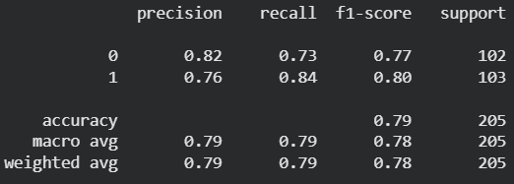

- For Decision Tree Classifier:
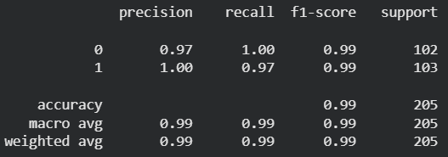
- For Random Forest Classifier:
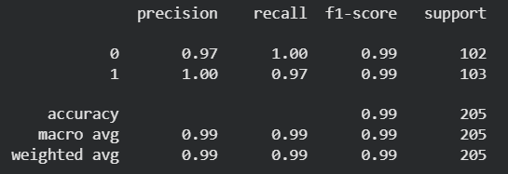

- Confusion matrix:
- For Logistic Regression:
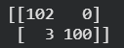

- For Decision Tree Classifier:

- For Random Forest Classifier:

- Heatmap:
- For Logistic Regression:
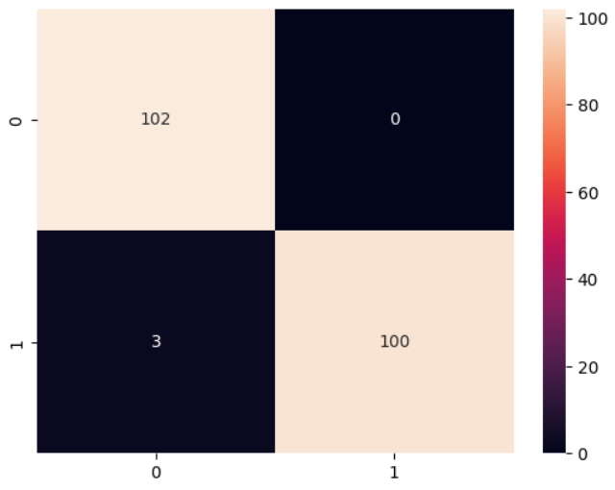
- For Decision Tree Classifier:

- For Random Forest Classifier:

- For Linear Regression: MSE & R²:
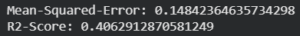

Model Performance Summary:
Model | Purpose | Performance Summary
Linear Regression | Poor classifier,  Serves only as a baseline | Lowest performance
Logistic Regression | Linear classifier,  Performs reasonably,  Interpretable | Moderate accuracy
Decision Tree | Non-linear splits,  Prone to overfitting | Good performance
Random Forest | An ensemble of decision trees,  Highest accuracy | Best performance

Key Result:
- Random Forest Classifier achieved the highest accuracy with 98.534% and produced the most reliable predictions.

- K-Means clustering for unsupervised structure:
Goal: Identify natural patient subgroups using unsupervised learning.
Steps:
- Data scaled using StandardScaler
- Cluster count tested from k=2 to 10
- Evaluated using:
  - WCSS (Elbow Method)
  - Silhouette Score
Result: Best clustering separation occurs at k=4
Plots:
- For WCSS Score:
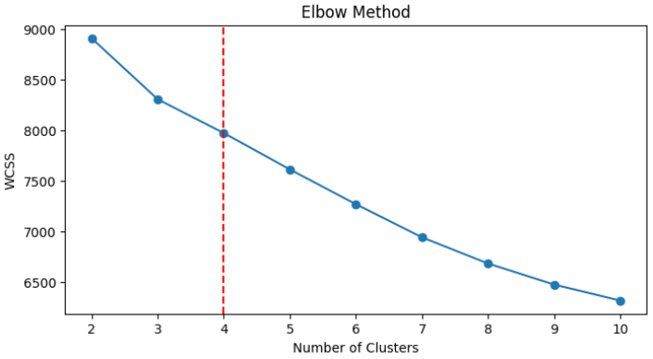

- For Silhouette Score:
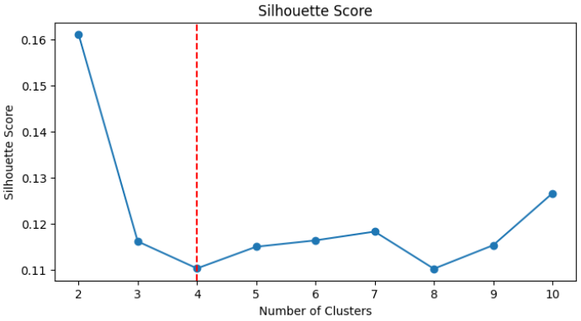

- Key Insights from the Analysis:
- Chest pain type, thalassemia, vessel count, and exercise-induced angina are the strongest predictors.
- Tree-based models (Decision Tree, Random Forest) handle encoded categorical features better than linear models.
- Random Forest is the most reliable model for this dataset due to its strong performance and stability.
- Clustering supports the presence of natural patient segments with different risk levels.

- Conclusion:
- Random Forest emerges as the best model, and the clustering analysis provides added insight into patient grouping.

