**Assignment-1**

**Q-1. What is software? What is software engineering?**

* **What is software?**
* Software is a set of instructions and programs.
* Which instructs the computer to complete a task.
* Software is a set of programs, rules, and functions that controls a computer system and coordinates between the various hardware of the computer.
* The group of programs that controls the functioning of the computer is called software.
* Software is an important part of the computer, without it we cannot do any work on the computer.
* **What is software engineering?**
* Software engineering is a technique through which we can developed or created software for computer systems and any other electronic devices.
* In other words, software engineering is a process in which user needs are analyzed and software is designed based on there needs.
* In software engineering the development of software using well define scientific principle, method and procedures.
* Software engineers build these software and applications by using designing and programming languages.

**Q-2. Explain types of software.**

1. System Software

* System software is the most important part of any computer system.
* System software is software that works to manage and control hardware.
* System software is the software that works to control and organize the computer system.
* System software provides a platform to run other software.

Operating Software

Windows

Linux

Ubuntu

Android

Language Translator

1. Compiler
2. Interpreter
3. Assembler

2)Application Software

* Application software is used to perform a specific task.
* Application software is designed to meet the needs of the users.
* Application software are programs that are created for users.
* We use different application software to perform different tasks.

1. Word Processing Software
2. Spreadsheet
3. Database Software
4. Graphics Software

3)Utility Software

* Utility software is the software which repairs the computer and enhances the performance of the computer and helps in making it functional.
* The work of utility software is to configure, maintain and optimize the computer system.
* Utility software is also known as service program.
* Utility software is used to perform specific tasks in a compute.

1. Disk Defragmenter
2. Anti Virus
3. Disk Cleaner
4. File Manager

**Q-3. What is SDLC? Explain each phase of SDLC.**

* **What is SDLC?**
* **Software development life cycle (SDLC) is a structured process that is used to design, develop, and test good-quality software.**
* SDLC, or software development life cycle, is a methodology that defines the entire procedure of software development step-by-step.
* The goal of the SDLC life cycle model is to deliver high-quality, maintainable software that meets the user’s requirements.
* SDLC in software engineering models outlines the plan for each stage so that each stage of the software development model can perform its task efficiently to deliver the software at a low cost within a given time frame that meets users’ requirements
* **SDLC is a process followed for software building within a software organization.**
* SDLC consists of a precise plan that describes how to develop, maintain, replace, and enhance specific software.
* The life cycle defines a method for improving the quality of software and the all-around development process.
* **Explain each phase of SDLC.**

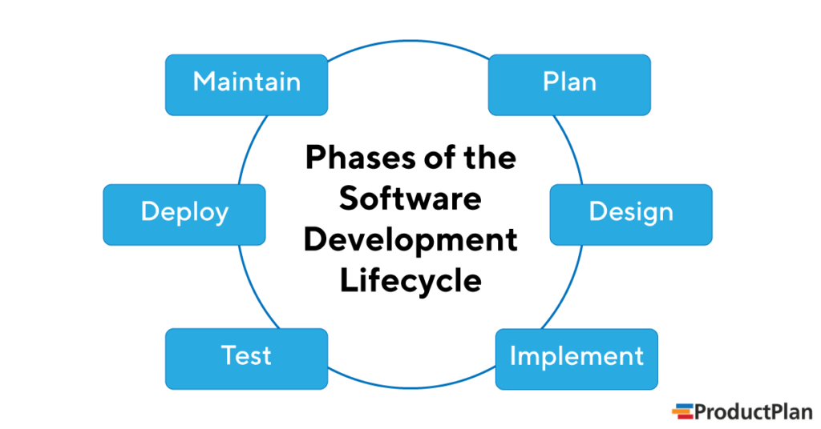

**1. Analysis**

* During this software development lifecycle phase, the specialists meticulously collect precise requirements from the customer to present a solution fine-tuned to their needs. Any unclarities must be elucidated in this stage only.
* The analysis phase also gathers business requirements and identifies any potential risks. This step in SDLC also includes a feasibility study, which defines all fortes and weak points of the project to assess the overall project viability.
* The goals you achieve at this stage are identified as the system of functions your business needs or wants to develop and implement. For that, software developers complete three primary activities:
* Listing Business Needs Or Requirements
* Developing Process Diagrams Or A Development Pipeline
* Performing The Analysis

The analysis stage includes:

* Clarifying Specific Details Required For Software Development
* Determining Initial Prototype Ideas:
  + What Functions Could Be The Most Suitable For The New Product
  + What USPs (Unique Selling Points) Your Future Software Should Have To Compete Well On The Market.
* This way, you can define the main requirements, what tools and approaches to use, and how to reach your business goals most efficiently.
* Thus, the analysis phase helps you understand your core business needs and what you should do to fulfill them.

**2. Planning**

* The purpose of the second stage is to outline the scope of the problem and identify solutions. Resources, costs, time, and other aspects should be considered here. The planning phase of the SDLC is also when the project plan is developed that identifies, prioritizes, and assigns the tasks and resources required to build the structure for a project.
* With that said, this step culminates in a detailed project plan.

**3. Architecture & Design**

* The third phase entails two further steps – High-Level Design (HLD) and Low-Level Design (LLD). The result of the former is the future architecture of a software product, whereas the LLD step describes how each and every feature in the product should work. It’s also in this phase when the database specification is developed to decide on data management and storage for future processing, retrieval, or evaluation.
* Among other things, the development team will mull over the core components, structure, processing, and procedures for the system to reach the stated goal.
* This design phase lays a foundation for the next step of the life cycle, which is development.

**4. Development**

* [Software development](https://devoxsoftware.com/expertise/outsource-web-development/) turns your project’s requirements and prototypes into a tangible solution.
* Thus, engineers start creating the entire system by crafting code using the required technology.
* During this software development lifecycle phase, clients will be able to have a first look at your future product. And by the end of the building process, clients will have an operating feature to share with the customers.

**5. Testing**

* In the fifth stage, all the pieces of code are tested to verify and validate a software product. Testers then [perform Software Testing Life Cycle activities](https://devoxsoftware.com/expertise/qa-outsourcing/) to monitor the system for bugs, and defects.
* This is done to check the correspondence between the real and expected behavior of a program.
* The testing stage and the initial SDLC phases can be performed with both internal software development and outsourcing, as they require end-user interaction.

**6. Maintenance**

* Once the system is deployed, any necessary upgrades, enhancements, and changes can be made, implementing new features into the operating software.
* It is crucial to maintain and modernize the system regularly so it can adapt to future needs.

**Q-4. What is DFD? Create a DFD diagram on Flipkart.**

* **Data Flow Diagrams (DFD)**
  + The DTFD takes an input-process-output view of a system i.e. data objects flow into the software, are transformed by processing elements, and resultant data objects flow out of the software.
  + Data objects represented by labeled arrows and transformation are represented by circles also called as bubbles. DFD is presented in a hierarchical fashion i.e. the first data flow model represents the system as a whole. Subsequent DFD refine the context diagram (level 0 DFD), providing increasing details with each subsequent level.
  + The DFD enables the software engineer to develop models of the information domain & functional domain at the same time. As the DFD is refined into greater levels of details, the analyst performs an implicit functional decomposition of the system. At the same time, the DFD refinement results in a corresponding refinement of the data as it moves through the processes that embody the applications.
* A context-level DFD for the system the primary external entities produce information for use by the system and consume information generated by the system. The labeled arrow represents data objects or object hierarchy.
* **0 LEVEL (DFD)**

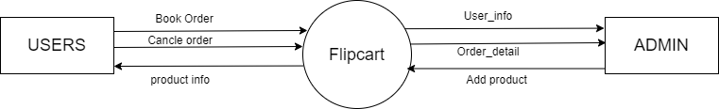

* **1 LEVEL (DFD)**

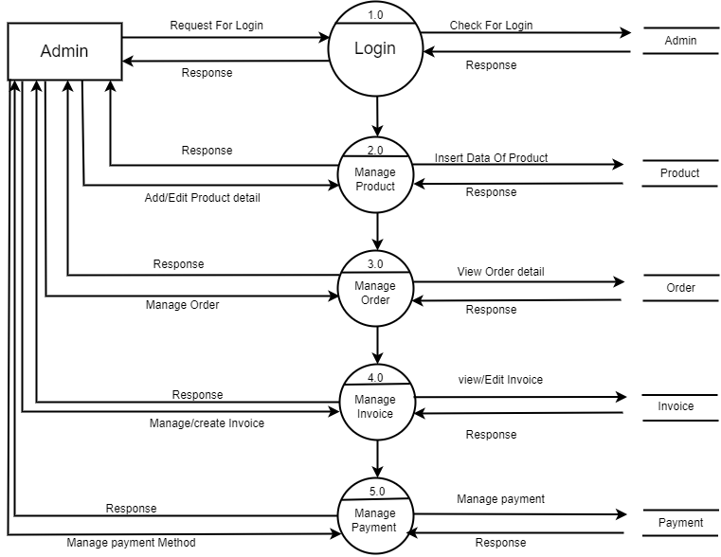

* **2(1) LEVEL (DFD)**

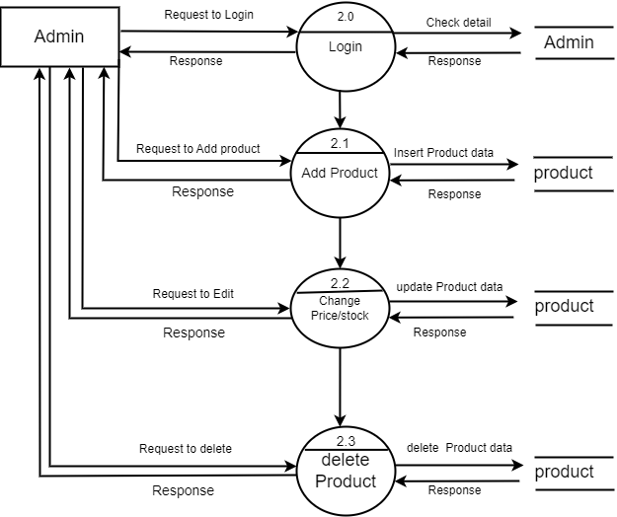

* **2(2) LEVEL (DFD)**

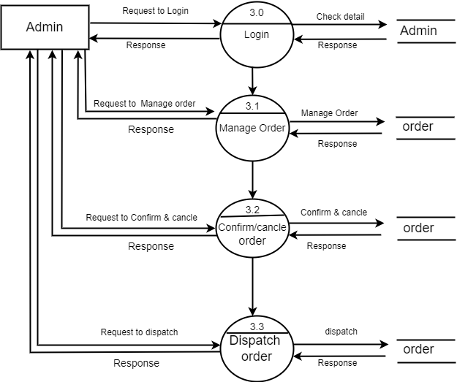

**Q-5. What is Flow chart? Create a flowchart to make addition of two numbers.**

Flowchart: A flowchart is a type of diagram that represents a workflow or process. A flowchart can also be defined as a diagrammatic representation of an algorithm.

Algorithm: a set of finite rules or instructions to be followed in calculations or other problem-solving operations.

#include<stdio.h>

Int main()

{

Int n1,n2,ans;

Printf(“enter 2 values”);

Scanf(“%d %d,&n1,&n2”);

Ans=n1+n2;

Printf(“%d”,ans);

Return 0;

}

**Algorithm:**

1)start

2)declare variables n1, n2, answer;

3)display enter 2 values

4)read values of n1, n2 from user

5)answer -> n1+n2;

6)display answer

7)stop

**FLOW CHART**

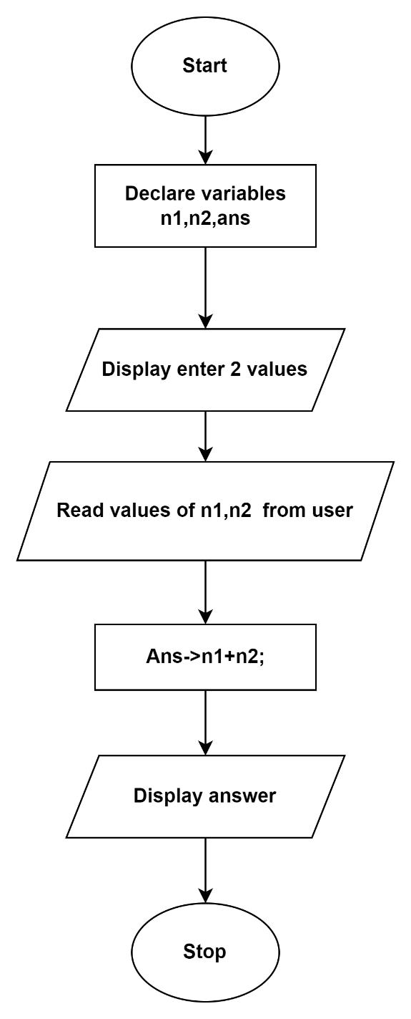

**Q-6. What is Use case Diagram? Create a use-case on bill payment on paytm.**

