Introduction:
-Retail store microservices application
-Multi-Container Application – 5 microservices, 3 DBs, 1 cache server, 1 messaging server
-Self-hosted persistent dataplane on aws eks cluster
-Multi-stage docker builds
-AWS vpc with public and private subnets
-Precedence of terraform variables
-Terraform remote state datasource
-EKS Pod Identity Agent (PIA), Kubernetes storage, aws ebs volumes for eks workloads
-AWS secrets manager for eks workloads + rds mysql db
-AWS load balancer controller install on aws eks
-Helm – k8s package manager
-Load balancers & dns
-Spot nodepool + interruption handlind + pod disruption budget
-Horizontal Pod Autoscaler (HPA)
-EKS cluster + metrics server using terraform
-ADOT - AWS Distro for Open Telemetry
-AWS DevOps CI CD: GitOps pipeline
-What is ArgoCd?
Section:1- Retail store project introduction
-5 microservices, 3 DBs, 1 cache server, 1 messaging server – total 10 containers
Section:2-docker commands
Docker on Amazon Linux 2023
-sudo dnf update -y
-sudo dnf install docker -y
-sudo systemctl enable docker
-sudo systemctl start docker
-sudo usermod -aG docker ec2-user
Local:
-sudo apt update
-sudo apt install docker.io
-docker –version
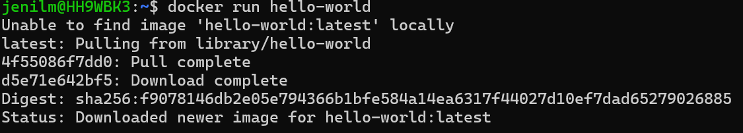
-sudo usermod -aG docker $USER
-newgrp docker
-sudo service docker start
-docker images
-docker ps – shows running container
-docker ps -a
-docker ps -aq
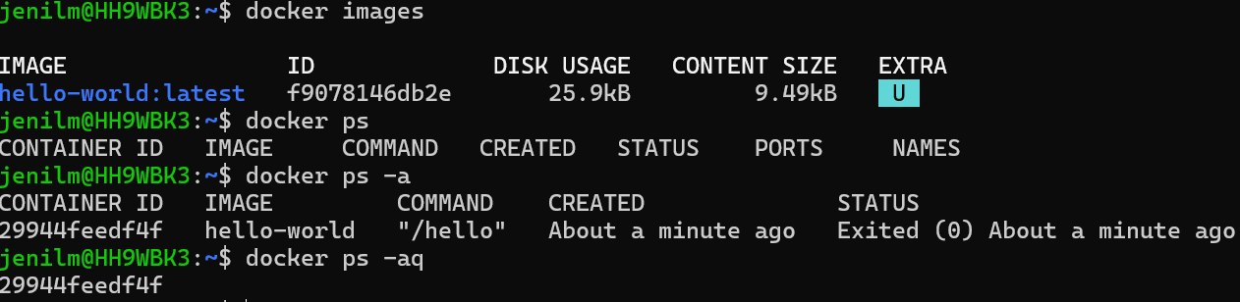
-docker rm $(docker ps -aq)
-docker images -q
-docker rmi $(docker images -q)
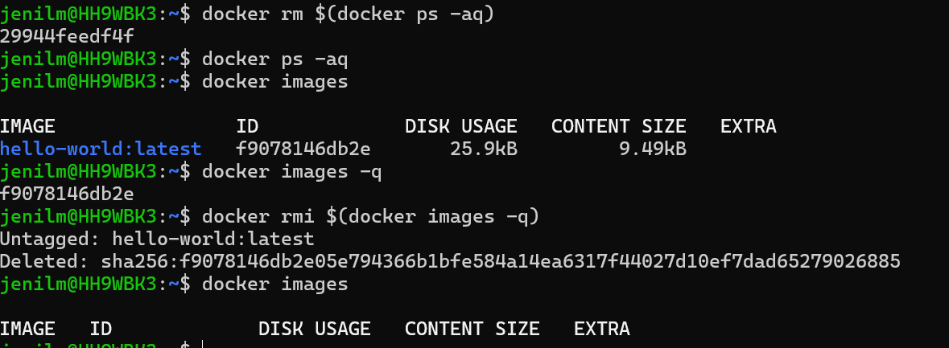
-docker version – both client and server version will show
How to pull docker image and run a docker container?
-docker pull stacksimplify/retail-store-sample-ui:1.0.0
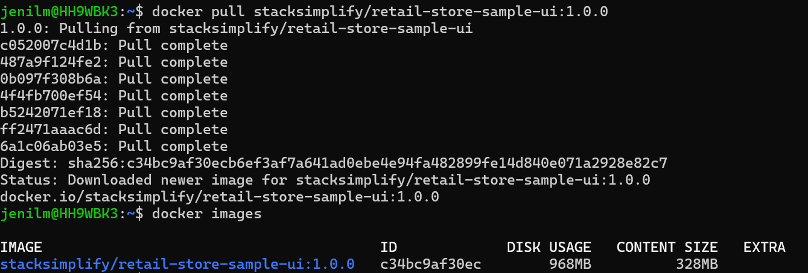
# Alternatively, pull from GitHub Packages (no download limits)
-docker pull ghcr.io/stacksimplify/retail-store-sample-ui:1.0.0
-docker run --name app1 -p 8888:8080 -d stacksimplify/retail-store-sample-ui:1.0.0
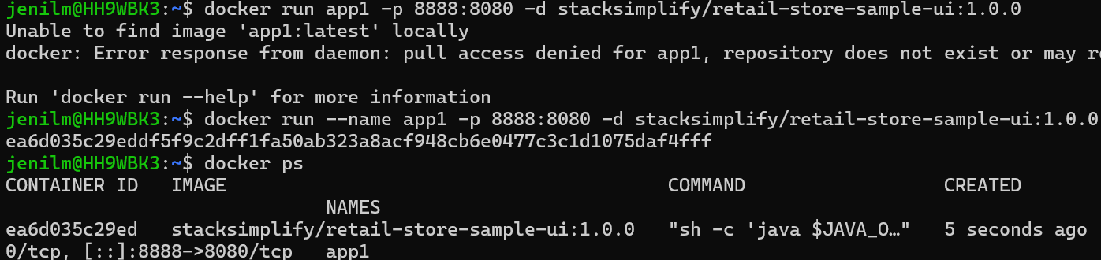
d-detach
8080-container port
8888-host port
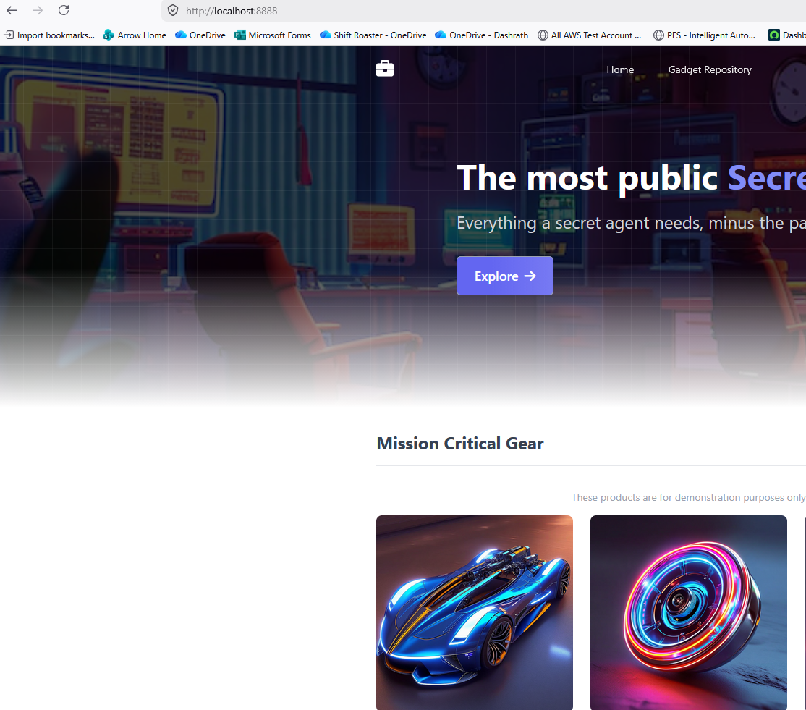

-docker exec -it app1 /bin/sh – inside the container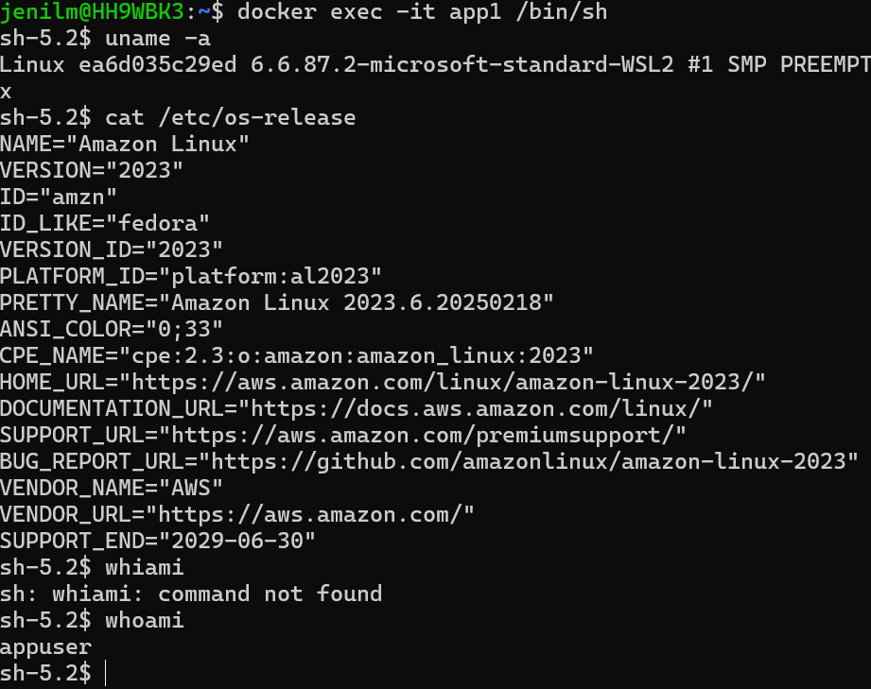
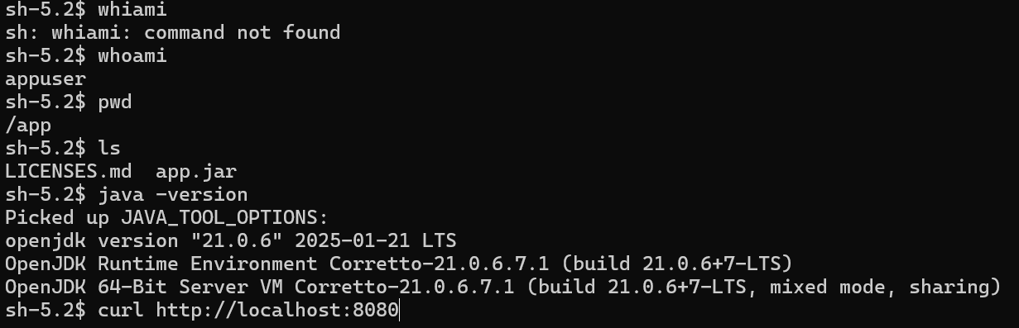

-docker exec -it app1 ls
-docker exec -it app1 env
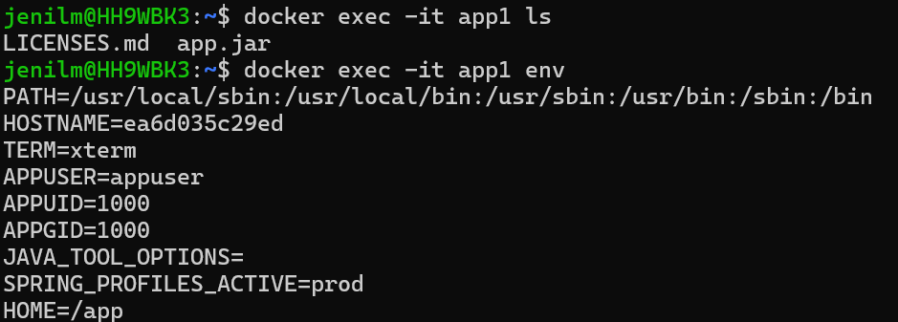
-docker stop app1
-docker start app1
-docker rm app1
-docker rmi <id>
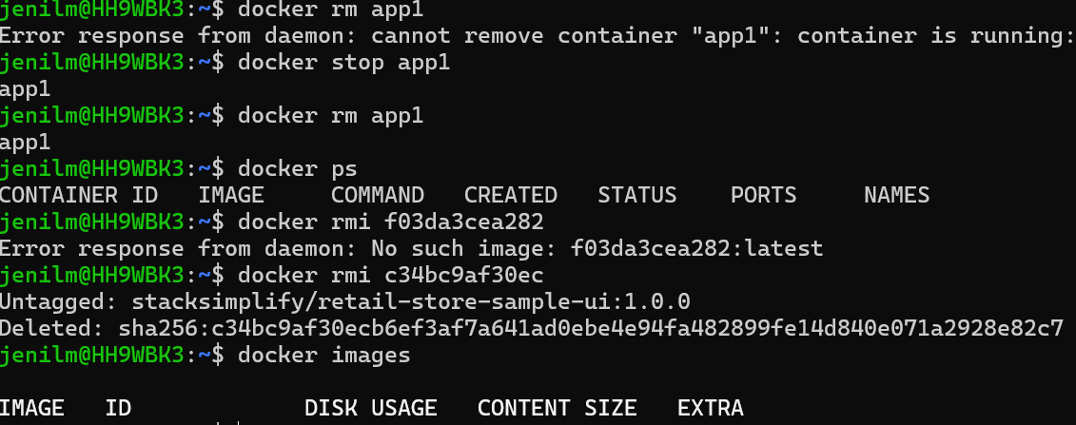
How to build docker image and push to docker hub?
-docker file instructions, docker build
Build docker image
- docker login
- mkdir demo-docker-build
-cd demo-docker-build
-wget https://github.com/aws-containers/retail-store-sample-app/archive/refs/tags/v1.4.2.zip
-unzip v1.4.2.zip
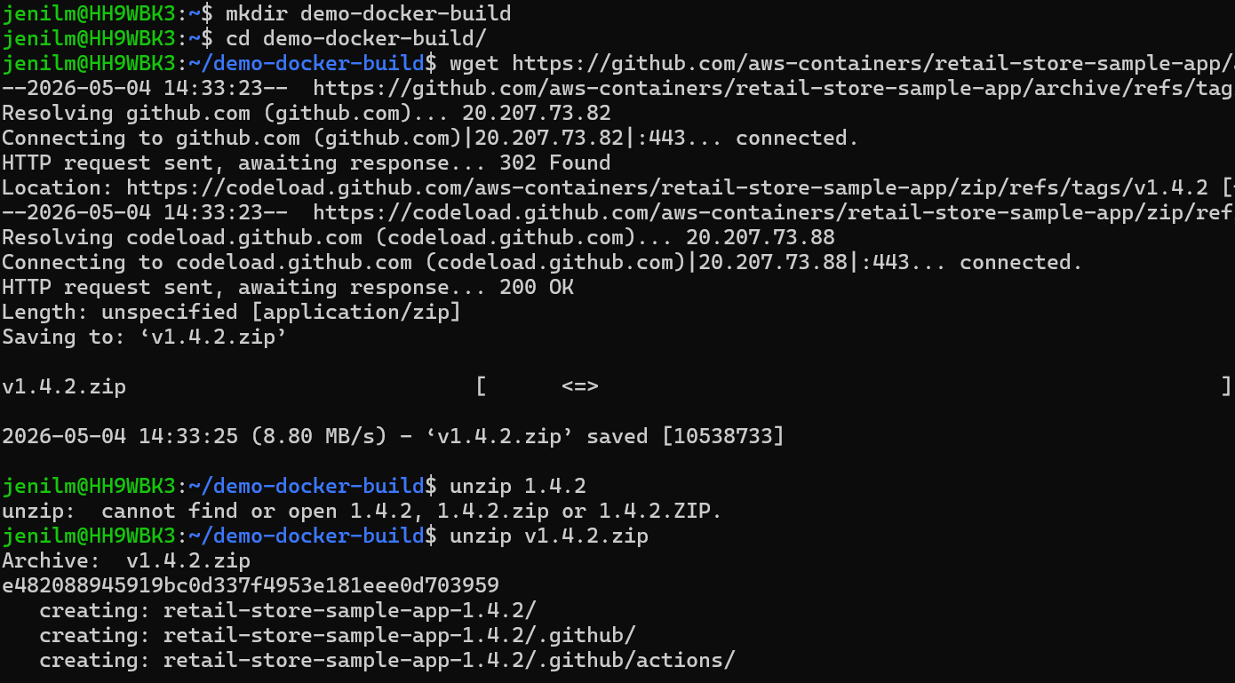
-download the code for which Docker Image to be built
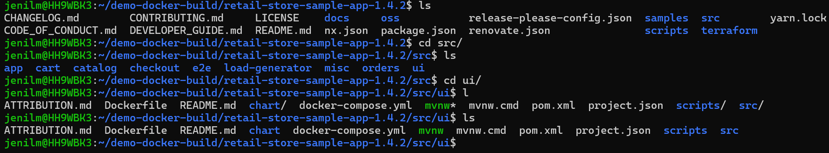
-sed -i 's/Secret Shop<\/span>/No more Secret Shop<\/span>/' home.html
- grep 'Secret Shop' home.html
-docker build -t retail-store-sample-ui:2.0.0 .
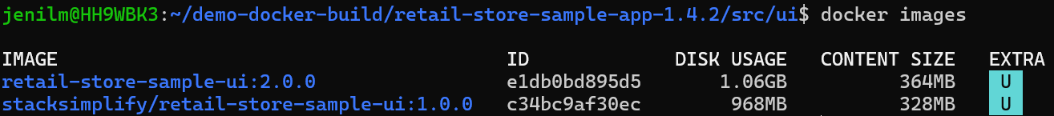
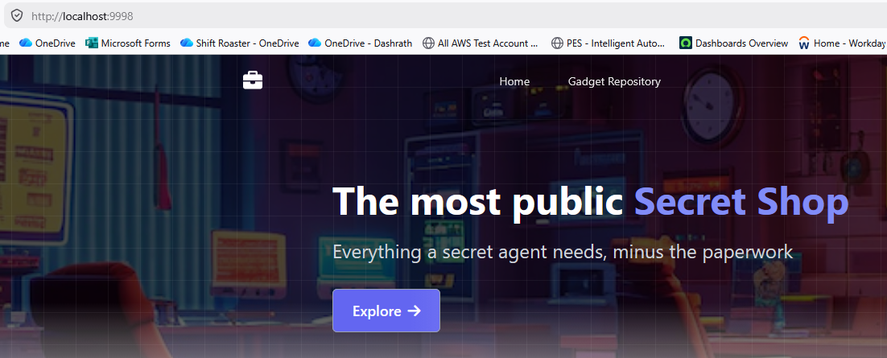
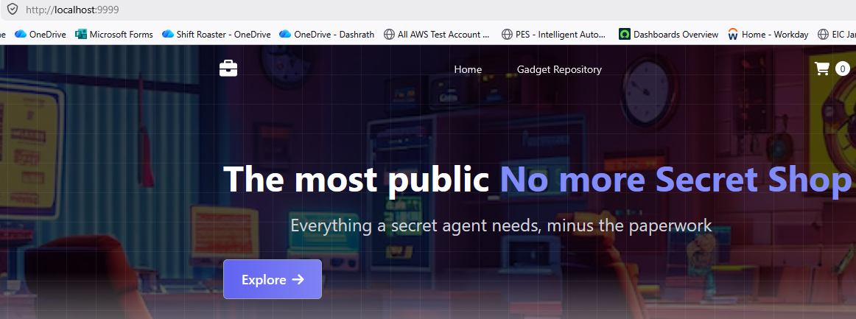
-docker tag retail-store-sample-ui:2.0.0 jenil83/devops-project-bootcamp:2.0.0
-docker push jenil83/devops-project-bootcamp:2.0.0
