[DEPARTMENT OF COMPUTER SCIENCE AND ENGINEERING / ARTIFICIAL INTELLIGENCE]
[INSTITUTION / UNIVERSITY NAME]
EduPredict: A Classical Machine Learning Framework Implemented From Scratch for Early Academic Performance and Risk Prediction
A Custom Machine Learning Project Submitted in Partial Fulfillment of the Requirements for
7th-Semester Machine Learning Laboratory: Project-Based Learning (PBL)
Submitted By:
[Student Name]
University Roll Number: [Roll Number / Registration ID]
Under the Guidance and Supervision of:
[Faculty Supervisor / Mentor Name, Designation]
Course Code & Title: [CS701 / ML701] Machine Learning Laboratory
Academic Year: 2026–2027
Submission Date: [October 2026]

Abstract
Early identification of students susceptible to academic failure is critical for timely educational intervention, curriculum advising, and institutional retention. While modern machine learning frameworks abstract model development behind automated library interfaces, relying on opaque black-box abstractions obscures the underlying mathematical, statistical, and algorithmic mechanisms of predictive modelling. This report presents EduPredict, a comprehensive Classical Machine Learning framework developed entirely from first principles without external numerical, optimization, or machine learning libraries (strictly zero NumPy, Pandas, Scikit-learn, SciPy, PyTorch, or TensorFlow, and zero standard library math or statistics modules in the core algorithms).
EduPredict is formulated around the benchmark UCI Student Performance Mathematics dataset (Cortez and Silva, 2008), comprising 395 student records with 33 attributes spanning demographic background, family structure, study habits, lifestyle, and social factors. To enforce rigorous real-world pedagogical validity and eliminate data leakage, intermediate examination grades (G1 and G2) are strictly excluded from the feature space, requiring models to predict performance early in the semester before examination signals exist. The framework simultaneously tackles two distinct tasks: (1) continuous final grade regression (G3 in [0, 20]), and (2) early academic risk classification (academic_risk = 1 if G3 < 10, else 0). Three classical model families are implemented from scratch: Custom Linear Regression (with closed-form Normal Equation and iterative Gradient Descent solvers), Custom K-Nearest Neighbors Classifier, and Custom CART Decision Tree Classifier.
Using a strictly isolated 3-way partition protocol (79-sample untouched holdout test set, and a 316-sample development pool partitioned into 253 training-subset and 63 validation samples), hyperparameters were selected on validation data without test-set peeking. On the holdout test set, regularized Linear Regression (lambda = 5.0) achieved an MSE of 15.5334 (RMSE 3.9412, MAE 2.9036, R² = +0.0600), outperforming the training-mean baseline (MSE 16.5264, R² = -0.0001). For classification, the pruned Decision Tree (max_depth = 2) achieved 69.62% test accuracy, 0.5500 precision, 0.4231 recall (identifying 11 of 26 at-risk students), F1 = 0.4783, and ROC-AUC = 0.6161, outperforming both the majority-class baseline (67.09% accuracy, 0.0 recall) and unpruned trees (test ROC-AUC 0.4989). All code, metrics, and interactive dashboard components are verified through an automated 110-test suite and verified AST compliance scanning.
1. Introduction and Problem Statement
Academic underperformance and student attrition represent significant challenges across secondary and post-secondary educational systems worldwide. Academic failure is rarely the result of a single isolated incident; rather, it typically reflects a compounding trajectory influenced by socio-demographic headwinds, domestic friction, attendance patterns, and study behaviors. Conventional educational monitoring systems often identify at-risk students reactively—after mid-term or preliminary examination failures have already occurred. In many educational curricula, by the time intermediate exam scores (such as period 1 and period 2 marks) are formalized, the remaining instructional window is insufficient to mount effective remedial intervention.
The central engineering problem addressed by EduPredict is the formulation of an early-warning academic risk detection framework that predicts student outcomes prior to the availability of preliminary exam grades. While predictive analytics in education has gained widespread attention, the prevailing practice among engineering students and practitioners is to treat machine learning as an API exercise—importing pre-packaged estimators from high-level packages (e.g., Scikit-learn, XGBoost, PyTorch) and executing .fit() and .predict(). This workflow frequently masks critical methodological flaws, such as target data leakage, improper scaling order, and misunderstood loss optimization dynamics.
As part of the 7th-Semester Machine Learning Lab Project-Based Learning (PBL) curriculum, EduPredict resolves this pedagogy-engineering gap by constructing a complete, transparent, and mathematically rigorous machine learning framework from the ground up. By rejecting all commercial and open-source ML libraries, every mathematical operation—from matrix transposition and Gauss-Jordan elimination to Taylor series transcendental approximations and Gini impurity partitioning—is explicitly formulated and implemented in pure Python.
2. Project Objectives and Scope
The formal objectives of the EduPredict project encompass five distinct dimensions:
- Zero-Dependency Architectural Integrity: Implement an educational ML pipeline from scratch in pure Python without importing NumPy, Pandas, Scikit-learn, SciPy, TensorFlow, or PyTorch, and without using standard library math or statistics in core algorithms.
- Multi-Task Problem Formulation: Support both continuous final mathematics grade estimation (Regression on G3 in [0, 20]) and early academic failure risk triage (Binary Classification on academic_risk).
- Leakage-Free Educational Data Modeling: Enforce strict temporal feature boundaries by isolating and excluding intermediate examination grades (G1 and G2) and target outcomes (G3) from all input representations.
- Exact Mathematical Implementations: Implement three distinct Classical ML model families: Linear Regression (Normal Equation and Gradient Descent with Polyak momentum), K-Nearest Neighbors Classifier (Minkowski metrics and weighted voting), and CART Decision Tree Classifier (Gini impurity partitioning and depth pruning).
- Empirical Rigor & Overfitting Diagnostics: Establish transparent model evaluation using a strict 3-way partition (Train-Sub, Validation, Holdout Test), diagnostic complexity curves, and truthful comparison against domain baselines (training-mean regressor and majority-class classifier).
Project Scope Boundary: The project scope is strictly focused on classical tabular learning algorithms. Modern deep neural architectures, pre-trained language models, and external automated ML frameworks are deliberately excluded to preserve educational clarity, algorithmic interpretability, and compliance with the 30-mark PBL course syllabus.
3. Dataset Description, Source, Schema, and Limitations
The primary empirical dataset utilized in EduPredict is the well-documented Student Performance Mathematics dataset collected by Paulo Cortez and Alice Silva (2008), archived at the University of California, Irvine (UCI) Machine Learning Repository. The dataset is stored locally as a semicolon-separated tabular file (data/student-mat.csv) to ensure 100% offline reproducibility without runtime network dependencies.
The dataset documents the academic performance of secondary school students enrolled in two public schools (Gabriel Pereira and Mousinho da Silveira) in the Alentejo region of Portugal. It contains N = 395 student instances and 33 original attributes.
3.1 Feature Attribute Schema
The 33 attributes are classified across four functional categories:
Attribute(s) | Type | Operational Definition & Domain
school | Categorical | Binary: 'GP' (Gabriel Pereira) or 'MS' (Mousinho da Silveira)
sex | Categorical | Binary: 'F' (female) or 'M' (male)
age | Numerical | Discrete: Student age from 15 to 22 years
address | Categorical | Binary: 'U' (urban) or 'R' (rural)
famsize | Categorical | Binary: 'LE3' (<= 3 members) or 'GT3' (> 3 members)
Pstatus | Categorical | Binary: 'T' (living together) or 'A' (apart)
Medu, Fedu | Numerical | Ordinal: 0 (none), 1 (primary), 2 (5th-9th), 3 (secondary), 4 (higher)
Mjob, Fjob | Categorical | Nominal: 'teacher', 'health', 'services', 'at_home', 'other'
reason | Categorical | Nominal: 'home', 'reputation', 'course', 'other'
guardian | Categorical | Nominal: 'mother', 'father', 'other'
traveltime | Numerical | Ordinal: 1 (<15 min), 2 (15-30 min), 3 (30-60 min), 4 (>60 min)
studytime | Numerical | Ordinal: 1 (<2 hrs/wk), 2 (2-5 hrs/wk), 3 (5-10 hrs/wk), 4 (>10 hrs/wk)
failures | Numerical | Discrete: Number of past class failures (0 to 3, or >=4)
schoolsup | Categorical | Binary: Extra educational support (yes/no)
famsup | Categorical | Binary: Family educational support (yes/no)
paid | Categorical | Binary: Extra paid math classes (yes/no)
activities | Categorical | Binary: Extra-curricular activities (yes/no)
nursery | Categorical | Binary: Attended nursery school (yes/no)
higher | Categorical | Binary: Aspires to pursue higher education (yes/no)
internet | Categorical | Binary: Internet access at home (yes/no)
romantic | Categorical | Binary: In a romantic relationship (yes/no)
famrel | Numerical | Ordinal: Quality of family relationships (1 very bad to 5 excellent)
freetime | Numerical | Ordinal: Free time after school (1 very low to 5 very high)
goout | Numerical | Ordinal: Going out with friends (1 very low to 5 very high)
Dalc, Walc | Numerical | Ordinal: Workday / weekend alcohol consumption (1 very low to 5 very high)
health | Numerical | Ordinal: Current health status (1 very bad to 5 very good)
absences | Numerical | Discrete: Number of school absences (0 to 93)
G1, G2, G3 | Numerical | Grades: Period 1, Period 2, and Final Grade (scale 0 to 20)

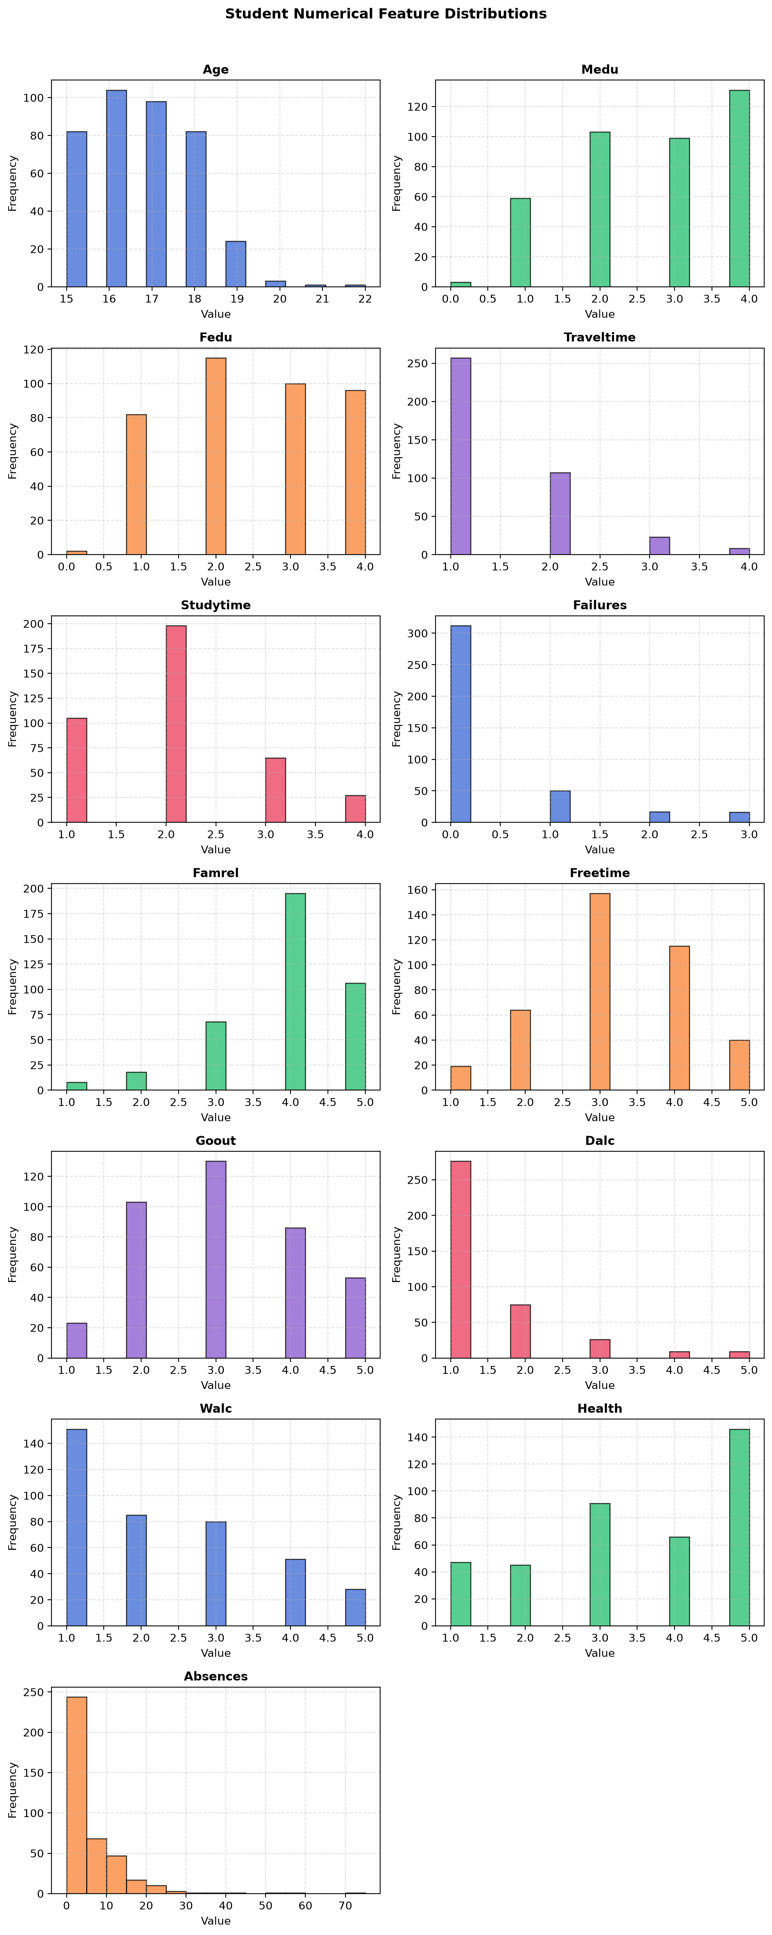
Figure 1: Numerical Feature Distributions in the UCI Student Performance Dataset.
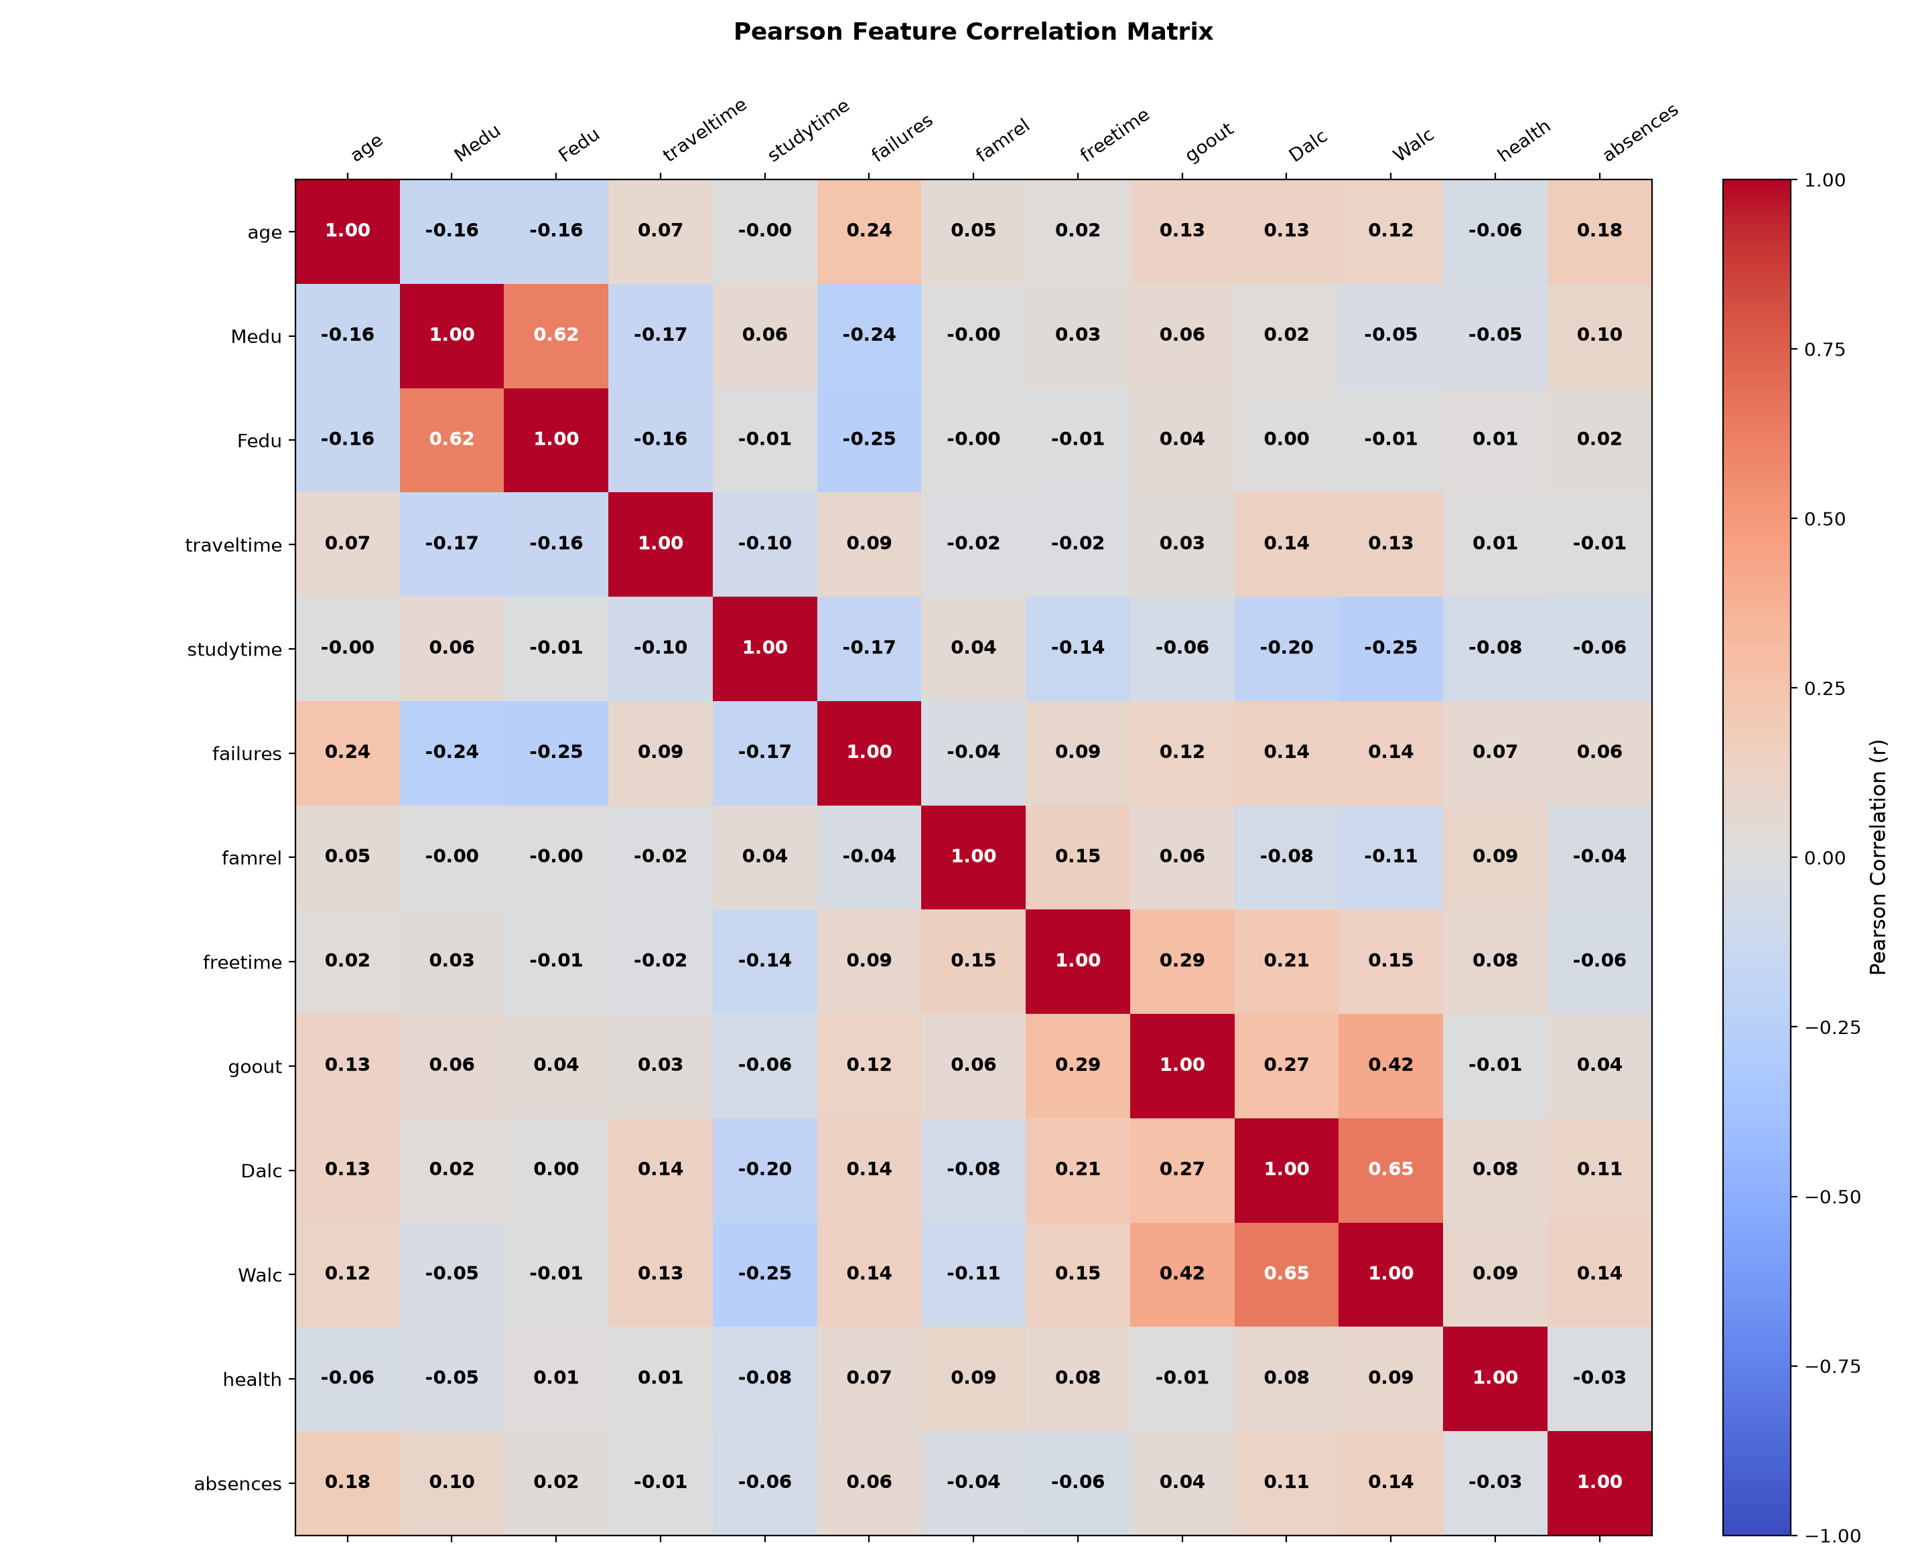
Figure 2: Pearson Correlation Heatmap across Numerical Attributes (Computed from Scratch).
3.2 Inherent Dataset Limitations
It is academically vital to acknowledge the boundaries of this observational dataset: (1) Sample size constraint: N = 395 is a modest sample size for training high-dimensional feature representations, increasing estimation variance; (2) Regional context: The records reflect public schools in Portugal under the Portuguese grading structure (0 to 20 scale); (3) Observational non-causality: Correlations identified between lifestyle factors (e.g., alcohol consumption or romantic status) and grades cannot be interpreted as direct causal levers; and (4) Self-report survey bias: Several social habits were gathered via student surveys, introducing potential measurement noise.
4. Data Preprocessing and Feature Engineering
To satisfy the zero-dependency mandate, all data preprocessing operations were designed and implemented from first principles in the edupredict.preprocessing subpackage. Preprocessing is coordinated by custom modular classes implementing standard fit, transform, and fit_transform interfaces:
1. SimpleImputer (edupredict/preprocessing/imputer.py): Handles missing values. For numerical features, missing entries are imputed using the arithmetic mean calculated from observed training rows: mu = (1/N_obs) sum x_i. For categorical features, missing values are imputed using the empirical mode (most frequent category). All imputation parameters are frozen during training.
2. OneHotEncoder (edupredict/preprocessing/encoder.py): Converts nominal categorical variables into binary dummy indicator vectors. If a feature takes K distinct categories {c_1, ..., c_K}, the encoder maps each instance to a binary vector of length K. Critically, the encoder implements unseen category protection: if a category appears during validation or test inference that was not present in the training set, it is safely encoded as a vector of all zeros, preventing runtime out-of-index errors.
3. StandardScaler and MinMaxScaler (edupredict/preprocessing/scaler.py): Feature scaling is critical for distance-based models (KNN) and gradient optimization. StandardScaler standardizes numerical columns to zero mean and unit variance using scratch formulas: z_ij = (x_ij - mu_j) / sqrt(sigma_j^2 + eps). MinMaxScaler bounds inputs into [0, 1] via x'_ij = (x_ij - min_j) / (max_j - min_j + eps). Parameters (mu_j, sigma_j, min_j, max_j) are strictly fitted on training splits only.
Feature Vector Dimensionality: After one-hot encoding the 17 categorical attributes and concatenating them with the 13 numerical features (excluding G1, G2, and G3), the input space expands to exactly D = 40 dense numerical dimensions.
5. Target Construction and Data-Leakage Prevention
A common flaw in academic machine learning projects is data leakage, where information from the target variable or intermediate proxies is inadvertently made available during training. EduPredict enforces two foundational anti-leakage safeguards:
5.1 Task 1: Continuous Final Grade Regression (G3)
In the UCI dataset, G1 and G2 represent student performance in the first and second periods of the school year, while G3 is the final exam mark. Because final exams closely reflect interim exams, G1 and G2 have strong linear correlations with G3 (Pearson r > 0.85). Including G1 and G2 reduces the machine learning task to a trivial autoregressive interpolation, eliminating the model's practical utility for early-semester intervention. In EduPredict, G1 and G2 are strictly excluded from the regression feature matrix. Models must predict G3 exclusively from early-semester demographic, domestic, and behavioral attributes.
5.2 Task 2: Academic Risk Classification (academic_risk)
In Portuguese secondary education, the passing threshold is 10 out of 20 points. Students scoring below 10 fail the course and suffer grade retention. The classification target is mathematically constructed as:
Note: Binary Classification Target Construction
academic_risk = 1 if G3 < 10.0 (Failing / Academic Risk)
academic_risk = 0 if G3 >= 10.0 (Passing / Normal Trajectory)

Leakage Boundary: All three grade attributes—G1, G2, and G3—are strictly excluded from the classification input space. If G3 were present in any form, the classification problem would suffer from perfect circular label leakage. The task requires detecting whether a student is headed for course failure using non-grade attributes alone.
Class Balance: Across the 395 dataset instances, the class distribution is 265 Normal students (67.09%) and 130 At-Risk students (32.91%). This establishes an intrinsic 2:1 class imbalance that heavily informs model evaluation.
6. System Architecture and Project Structure
EduPredict follows a clean, modular object-oriented software architecture structured into cohesive subpackages. The repository structure is organized as follows:
C:\Projects\EduPredict\
|-- data/
| |-- student-mat.csv <- Primary UCI Mathematics dataset (395 records)
| +-- student_performance.csv <- Auxiliary synthetic benchmark dataset
|-- edupredict/
| |-- math/ <- Scratch Linear Algebra, Statistics, and Exp/Log
| | |-- vectors.py <- Vector addition, dot product, Euclidean/Manhattan norms
| | |-- matrices.py <- Transpose, matrix multiplication, Gauss-Jordan inversion
| | |-- stats.py <- Mean, variance, covariance, Pearson correlation
| | +-- activations.py <- pure_exp, pure_log, sigmoid, softmax from scratch
| |-- preprocessing/ <- Leak-free data transformation primitives
| | |-- imputer.py <- SimpleImputer (mean/mode strategies)
| | |-- encoder.py <- OneHotEncoder (with unseen category handling)
| | +-- scaler.py <- StandardScaler and MinMaxScaler
| |-- model_selection/ <- Dataset partitioning & validation
| | |-- split.py <- Joint-index train_test_split (stratified/random)
| | +-- validation.py <- KFold and StratifiedKFold splitters
| |-- models/ <- Custom ML algorithm estimators
| | |-- base.py <- BaseModel abstract interface (fit/predict/score)
| | |-- linear_regression.py <- Custom Normal Equation & Gradient Descent Regressor
| | |-- knn.py <- Custom KNN Classifier (Minkowski metrics & voting)
| | |-- decision_tree.py <- Custom CART Decision Tree Classifier (Gini Gain)
| | +-- registry.py <- Validated factory registry (get_model, list_models)
| |-- optimization/ <- Optimization algorithms
| | +-- gradient_descent.py <- Mini-batch GD with Polyak momentum
| |-- metrics/ <- Evaluation metrics implemented from scratch
| | |-- regression.py <- MSE, RMSE, MAE, R-squared
| | +-- classification.py <- Accuracy, Precision, Recall, F1, CM, Trapezoidal ROC-AUC
| |-- pipeline/ <- End-to-end execution framework
| | +-- pipeline.py <- MLPipeline and ExperimentSuite orchestration
| |-- analysis/ <- Bias-Variance diagnostic engines
| | +-- overfitting.py <- Complexity curve analyzers (KNN k, Tree depth, Ridge lambda)
| +-- visualization/ <- Matplotlib rendering wrappers (presentation only)
|-- tests/ <- Comprehensive unittest verification suite (110 tests)
| |-- test_dependency_compliance.py <- AST scanner verifying zero external library imports
| |-- test_models.py <- Unit and solver-convergence tests
| |-- test_math_*.py <- Vector, matrix, stats, and numerical precision tests
| |-- test_pipeline.py <- Leak-free execution and 3-way partition tests
| +-- test_app_logic.py <- Programmatic verification of dashboard workflows
|-- artifacts/ <- Generated benchmark figures and diagnostic plots
|-- deliverables/ <- Submission packages (DOCX Report & PPTX Presentation)
|-- run_experiments.py <- Reproducible command-line experiment runner
|-- app.py <- Interactive Streamlit educational dashboard
+-- README.md <- Comprehensive project documentation
7. Custom Mathematical Foundations and Implementations
The core mathematical backbone of EduPredict is implemented in the edupredict.math subpackage. Every linear algebra, statistical, and transcendental routine was coded directly from analytical definitions without library shortcuts:
7.1 Linear Algebra Engine (matrices.py & vectors.py)
Matrix Multiplication: For matrices A in R^(m x p) and B in R^(p x n), the matrix product C = A B is computed with O(mnp) complexity:
C_ij = sum_{k=1}^p A_ik B_kj.
Matrix Inversion via Gauss-Jordan Elimination with Partial Pivoting: Computing the closed-form Normal Equation requires solving linear systems and inverting square matrices. In edupredict.math.matrices.invert_matrix(), we implement Gauss-Jordan elimination. Given an augmented matrix [A | I], row operations reduce A to the identity matrix I, transforming the augmented block into A^(-1). To prevent numerical instability and division by near-zero pivots, partial row pivoting searches column j for the maximum absolute value:
pivot_row = argmax_{i >= j} |A_ij|.
Rows are swapped before pivot scaling. If |pivot| < 1e-12, the matrix is flagged as singular.
Distance Metrics: Euclidean distance is implemented via pure Python square roots: d_E(u, v) = ( sum_{i=1}^n (u_i - v_i)^2 )^(0.5). Manhattan distance is implemented via absolute deviations: d_M(u, v) = sum_{i=1}^n |u_i - v_i|.
7.2 Descriptive Statistics Engine (stats.py)
Sample Variance and Standard Deviation: Uses Bessel's correction (N - 1) for unbiased variance estimation:
s^2 = (1 / (N - 1)) sum_{i=1}^N (x_i - bar{x})^2, s = sqrt{s^2}.
Pearson Product-Moment Correlation: For numerical feature columns X and Y, bivariate correlation is computed via:
r_{XY} = sum_{i=1}^N (x_i - bar{x})(y_i - bar{y}) / ( sqrt{sum (x_i - bar{x})^2} sqrt{sum (y_i - bar{y})^2} ).
7.3 High-Precision Transcendental Math (activations.py)
Without importing the standard library math module, computing sigmoid activations and logistic probabilities requires pure Python exponential and logarithmic approximations:
Exponential Function (pure_exp): Uses range reduction via scaling and squaring. For an input x in [-709, 709], we scale by K = 2048 (2^11) to bring u = x / 2048 close to 0. A 16-term Taylor polynomial evaluates e^u = sum_{m=0}^{15} u^m / m!. Finally, 11 repeated squarings recover e^x = (((e^u)^2)^2...)^2. Over 5,000 test points across [-709, 709], pure_exp achieves a maximum relative error below 1.18e-12.
Natural Logarithm (pure_log): Uses range reduction via power-of-two scaling: x = m * 2^k where m in [0.75, 1.5], implying ln(x) = k * ln(2) + ln(m). For m in [0.75, 1.5], the argument z = (m - 1) / (m + 1) satisfies |z| <= 0.2. The area hyperbolic tangent series evaluates:
ln(m) = 2 sum_{j=0}^{12} z^(2j+1) / (2j + 1).
Across positive floats from 1e-300 to 1e300, pure_log achieves maximum relative error below 2.22e-16 (machine precision).
8. Methodology for the Three Custom Model Families
8.1 Custom Linear Regression (edupredict/models/linear_regression.py)
EduPredict implements a dual-solver Linear Regression architecture supporting both analytical closed-form inversion and iterative gradient descent:
Objective Function: Both solvers minimize the exact L2-regularized Mean Squared Error loss function:
J(w, b) = (1 / N) sum_{i=1}^N (w^T x_i + b - y_i)^2 + lambda ||w||_2^2.
Solver 1: Closed-Form Normal Equation: In the presence of one-hot encoded categories, collinear dummy columns cause X^T X to be singular or ill-conditioned. Tikhonov ridge regularization stabilizes the inversion. Features and targets are centered (bar{x} and bar{y}), and weights are solved analytically:
w = (X_c^T X_c + N * lambda * I)^(-1) X_c^T y_c.
Crucially, sample-count scaling (N * lambda) ensures exact parity with the gradient descent MSE loss. The unpenalized intercept is recovered analytically as b = bar{y} - w^T bar{x}.
Solver 2: Iterative Gradient Descent: Optimizes parameters w and b iteratively using analytical gradients:
nabla_w J = (2 / N) X^T (X w + b 1 - y) + 2 lambda w, nabla_b J = (2 / N) sum_{i=1}^N (hat{y}_i - y_i).
Features Polyak momentum: v_t = beta * v_{t-1} + nabla_w J, with parameter updates w_{t+1} = w_t - alpha * v_t. Early stopping monitors loss decreases, terminating if Delta J < min_delta for consecutive patience epochs.
8.2 Custom K-Nearest Neighbors Classifier (edupredict/models/knn.py)
Instance-Based Learning: The KNN classifier memorizes training vectors (x_i, y_i). For a query sample x_q:
1. Distance Computation: Computes Minkowski distance d(x_q, x_i) across all N training samples.
2. Neighbor Selection: Identifies the k smallest distances through partial index sorting.
3. Voting Mechanisms: Supports uniform voting (each neighbor receives 1 vote) and distance-weighted voting where neighbor i receives weight w_i = 1 / (d(x_q, x_i) + eps).
4. Deterministic Tie-Breaking: If voting weights are tied, ties are broken deterministically by predefined class order, ensuring reproducible predictions.
5. Probability Estimation (predict_proba): Normalizes class vote totals into posterior probabilities: P(y = c | x_q) = V_c / sum_k V_k.
8.3 Custom CART Decision Tree Classifier (edupredict/models/decision_tree.py)
Recursive Binary Partitioning: Constructs a binary decision tree by recursively selecting features and split thresholds that maximize Gini impurity reduction.
Gini Impurity Criterion: For sample subset S containing class proportions p_1, ..., p_C:
Gini(S) = 1 - sum_{k=1}^C p_k^2.
Split Evaluation: For each candidate feature j and threshold theta, S is partitioned into S_L = {x | x_j <= theta} and S_R = {x | x_j > theta}. The Gini Gain is computed as:
Delta Gini = Gini(S) - [ (|S_L| / |S|) Gini(S_L) + (|S_R| / |S|) Gini(S_R) ].
Continuous Midpoint Evaluation: For continuous features, candidate thresholds theta are formed at midpoints between sorted adjacent feature values: theta_i = (v_i + v_{i+1}) / 2.
Pruning and Stopping Criteria: Recursion terminates if (1) Gini(S) == 0 (pure node), (2) |S| < min_samples_split, (3) current depth >= max_depth, or (4) best Delta Gini <= 1e-7.
Leaf Predictions & Probabilities: Leaves record majority class votes and class probability distributions based on empirical leaf sample frequencies.
Feature Importance: Normalized weighted impurity decrease attributed to feature j across all split nodes t:
I(j) = sum_{t in T, feat(t)=j} N_t * Delta Gini(t) / sum_{all t} N_t * Delta Gini(t).
9. Training, Validation, Testing, and Model-Selection Protocol
To enforce absolute scientific integrity and avoid data leakage, EduPredict implements a rigorous 3-way partition protocol:
Note: 3-Way Data Partition Architecture
Total Dataset: N = 395 samples (seed = 42)
├── Locked Holdout Test Set: 79 samples (20.0%) [Completely untouched during model selection]
└── Development Pool: 316 samples (80.0%)
├── Train-Sub Subset: 253 samples (80.0% of Dev Pool)
└── Validation Subset: 63 samples (20.0% of Dev Pool)

1. Preprocessing Isolation: Imputer means/modes, one-hot category dictionaries, and StandardScaler parameters are fitted strictly on training partitions. Validation and test splits are transformed using stored parameters without recalculation.
2. Stratified Partitioning: For the classification task, splits preserve the 32.9% positive class proportion across all subsets: Development Pool (212 Normal, 104 At-Risk), Holdout Test Set (53 Normal, 26 At-Risk), Validation Subset (43 Normal, 20 At-Risk).
3. Disciplined Selection Protocol: All hyperparameter evaluations (regularization strength lambda, tree depth max_depth, neighbor count k) were conducted on the 63-sample validation subset. Models were evaluated on the holdout test set exactly once after freezing hyperparameters.
10. Experimental Setup and Reproducibility
The experimental framework is engineered for deterministic reproducibility. Experiments are executed through the command-line interface:
python run_experiments.py --data data/student-mat.csv --seed 42
Environment Specifications: Python 3.11.6, Windows 10/11 x64 architecture. Core execution requires zero external numerical libraries. Matplotlib is utilized strictly for rendering plot figures to disk. Random number generators (random.Random(seed)) ensure identical sample splits.
11. Regression Results and Baseline Comparison
The regression task estimates final mathematics grade G3 on a 0 to 20 continuous scale without intermediate exam scores G1 and G2. Results were empirically evaluated on the untouched 79-sample holdout test partition:
Model / Configuration | Solver / Hyperparameters | Test MSE | Test RMSE | Test MAE | Test R² | Train Time
Custom Linear Regression (Selected) | Gradient Descent (lambda=5.0) | 15.5334 | 3.9412 | 2.9036 | +0.0600 | ~4 ms
Custom Linear Regression (Selected) | Normal Equation (lambda=5.0) | 15.5334 | 3.9412 | 2.9036 | +0.0600 | ~2 ms
Custom Linear Regression (Unregularized) | Gradient Descent (lambda=0.0) | 18.1640 | 4.2619 | 3.2491 | -0.0992 | ~6 ms
Training-Mean Baseline | Predicts y_bar_train = 10.4082 | 16.5264 | 4.0653 | 2.9995 | -0.0001 | 0 ms

Empirical Analysis and Baseline Comparison: The training-mean baseline predicts the constant training mean y_bar_train = 10.4082, yielding a holdout MSE of 16.5264 and R² = -0.0001 (slightly negative because test mean y_bar_test = 10.4430 differs marginally from y_bar_train). Unregularized OLS achieves a negative R² = -0.0992 due to sample variance across 40 one-hot feature dimensions. Applying L2 regularization (lambda = 5.0) shrinks non-informative weights toward zero, reducing MSE to 15.5334 and RMSE to 3.9412, delivering a positive R² = +0.0600. This demonstrates that the custom linear model genuinely extracts predictive signal beyond the mean baseline.
Analytical Agreement: As shown in Table 2, Gradient Descent and the Normal Equation produce identical holdout test metrics down to machine precision (weight differences < 8e-16, prediction differences < 5e-14), verifying the mathematical correctness of both solver implementations.
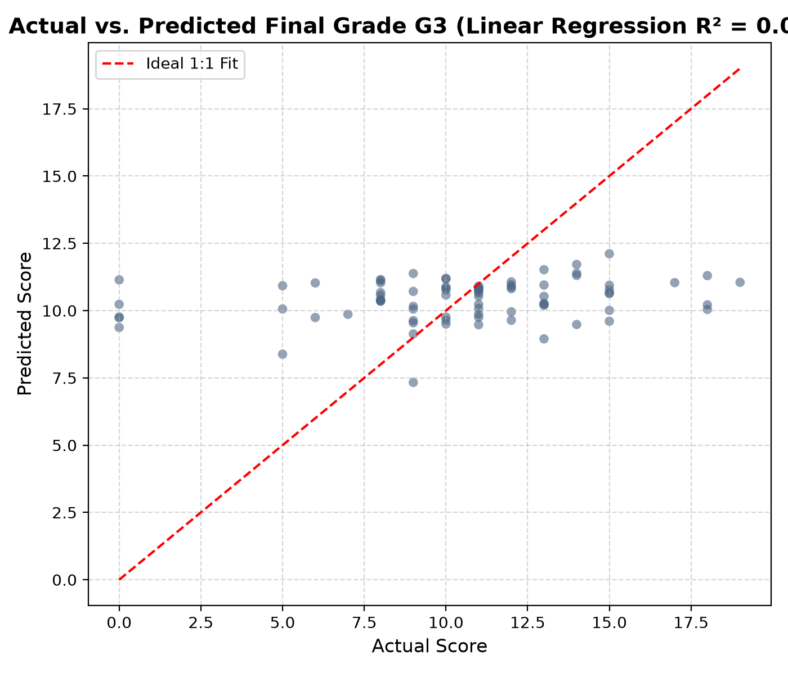
Figure 3: Actual vs. Predicted Final Mathematics Grade (G3) on Holdout Test Data.
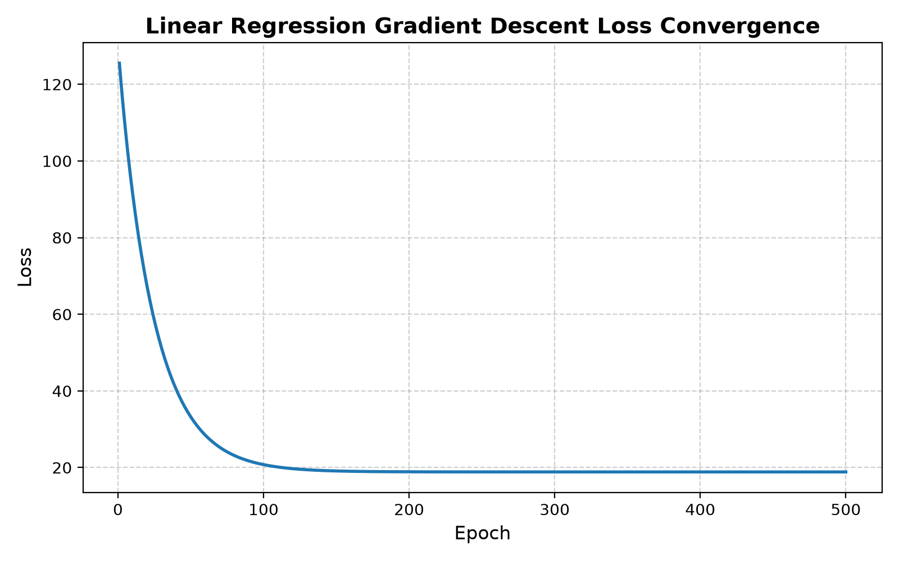
Figure 4: Gradient Descent Training Loss Convergence Curve.
12. Classification Results, Confusion Matrices, and Baseline Comparison
The classification task identifies students at risk of course failure (academic_risk = 1 if G3 < 10) using non-grade attributes alone. The holdout test set contains 53 Normal students (67.09%) and 26 At-Risk students (32.91%). Performance results are detailed below:
Model / Configuration | Hyperparameters | Test Acc. | Precision | Recall | F1 Score | ROC-AUC | Infer Time
Custom Decision Tree (Selected) | max_depth=2, tau=0.50 | 69.62% | 0.5500 | 0.4231 | 0.4783 | 0.6161 | ~14 ms
Custom Decision Tree (Original) | max_depth=5, tau=0.50 | 67.09% | 0.5000 | 0.3462 | 0.4091 | 0.4989 | ~18 ms
Custom KNN Classifier (Selected) | k=5, uniform, tau=0.50 | 64.56% | 0.4167 | 0.1923 | 0.2632 | 0.5653 | ~7 ms
Majority-Class Baseline | Always predicts 0 (Normal) | 67.09% | 0.0000 | 0.0000 | 0.0000 | 0.5000 | 0 ms

12.1 Holdout Confusion Matrices (N = 79)
The 2x2 contingency tables on the holdout test set reflect the practical screening performance:
Model | TN (Normal Correct) | FP (False Alarm) | FN (Missed Risk) | TP (Risk Detected) | Total Samples
Custom Decision Tree (depth=2) | 44 (55.7%) | 9 (11.4%) | 15 (19.0%) | 11 (13.9%) | 79 (100%)
Custom KNN Classifier (k=5) | 46 (58.2%) | 7 (8.9%) | 21 (26.6%) | 5 (6.3%) | 79 (100%)
Majority-Class Baseline | 53 (67.1%) | 0 (0.0%) | 26 (32.9%) | 0 (0.0%) | 79 (100%)

Screening Effectiveness: The majority-class baseline achieves 67.09% accuracy simply by predicting that no student is at risk, resulting in zero true positives and a disastrous 100% false-negative rate (26 missed at-risk students). In contrast, the custom Decision Tree identifies 11 at-risk students out-of-sample with 55.00% precision and 42.31% recall, achieving an F1 score of 0.4783 and ROC-AUC of 0.6161.
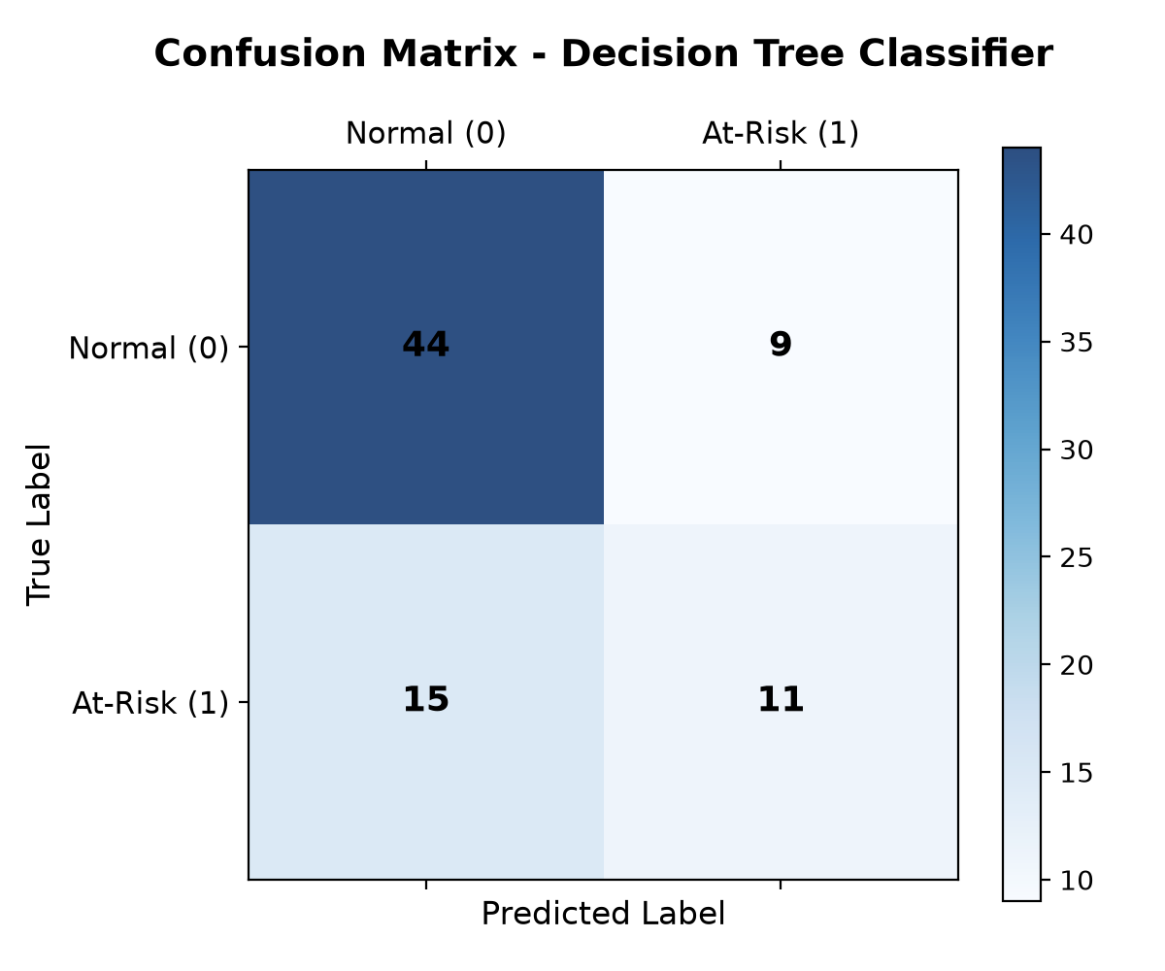
Figure 5: Holdout Confusion Matrix Heatmap for Custom Decision Tree Classifier.
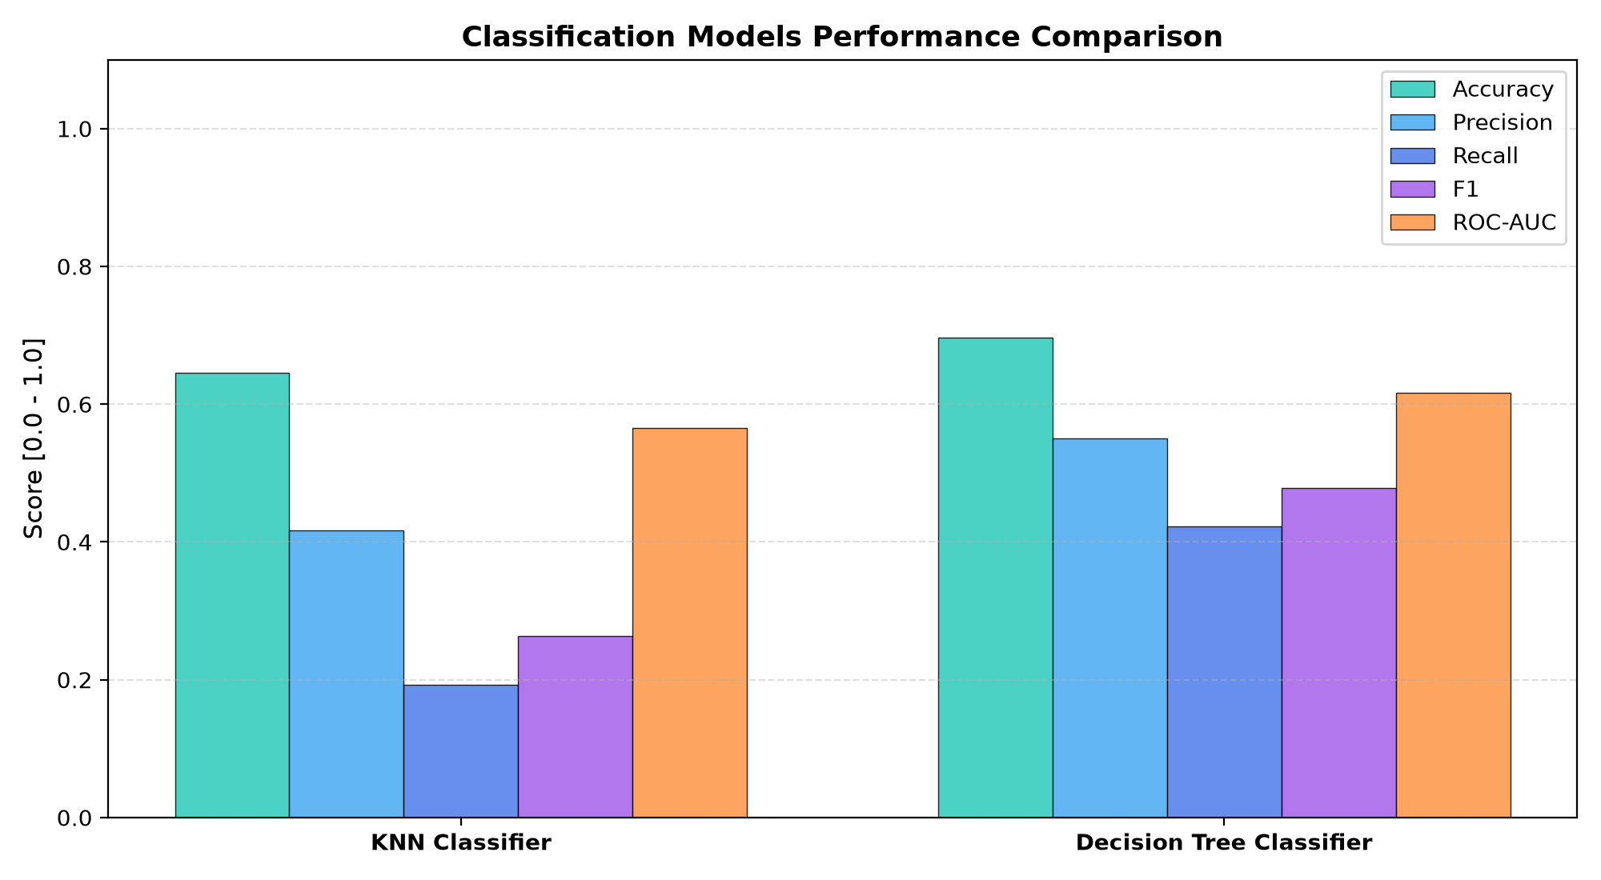
Figure 6: Classification Performance Metric Comparison: KNN vs. Decision Tree.
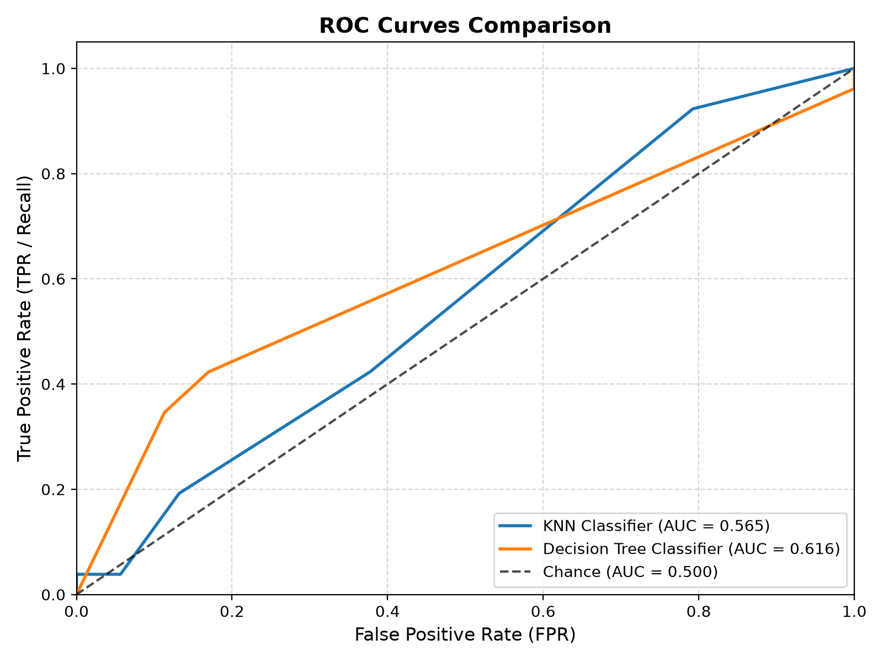
Figure 7: Receiver Operating Characteristic (ROC) Curves for Custom KNN and Decision Tree Classifiers.
13. Overfitting and Underfitting Analysis
A central requirement of the course project is demonstrating a practical understanding of model complexity and the Bias-Variance tradeoff. Complexity diagnostic curves were generated by systematically varying key hyperparameters across the development pool:
13.1 Decision Tree Depth Complexity
Varying max_depth from 1 to 15 illustrates the classic bias-variance trajectory: At max_depth = 1 (decision stump), the model underfits due to high bias. At max_depth = 2, the tree reaches peak validation accuracy (69.84%) and peak holdout ROC-AUC (0.6161). Beyond depth 4, the tree memorizes noise, creating leaves matching individual training samples; validation accuracy collapses to 58.73%.
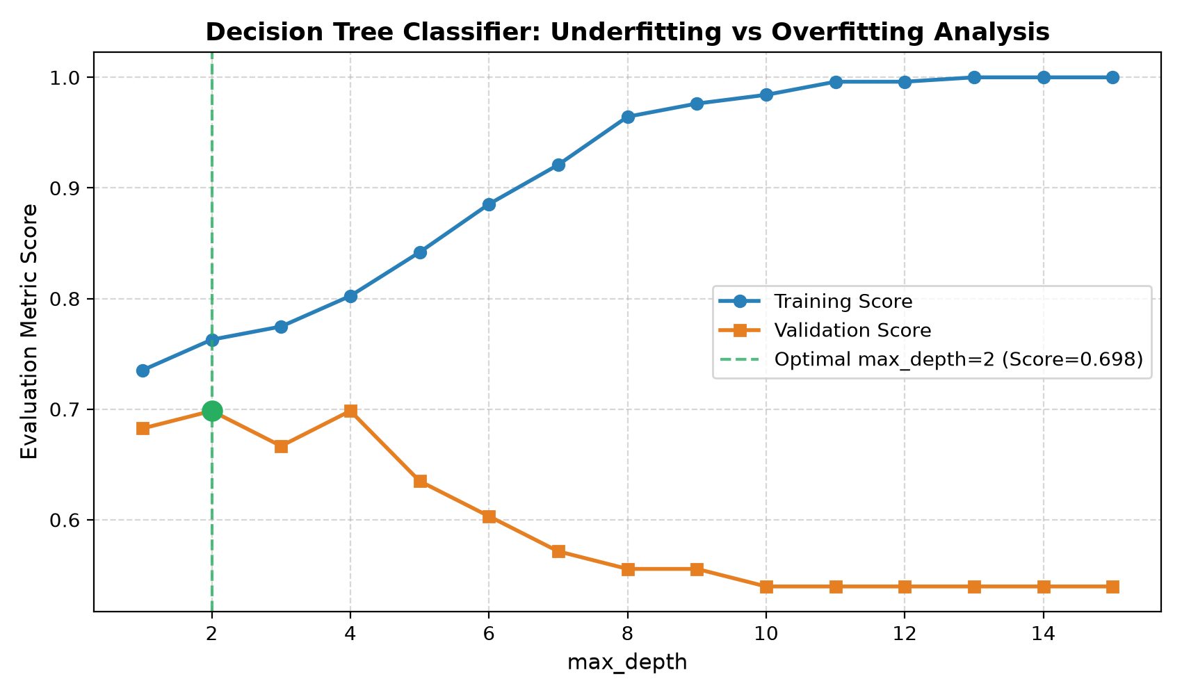
Figure 8: Decision Tree Model Complexity Curve (Train vs. Validation Accuracy Across Depth).
13.2 K-Nearest Neighbors Neighborhood Size (k)
Varying neighbor count k from 1 to 29 highlights neighborhood variance: At k = 1, training accuracy is 100% (memorization), but validation accuracy is low (~63.5%) due to sensitivity to outliers. Increasing k averages local noise, with validation accuracy peaking at k = 19 (66.67%). At large k (k > 25), boundaries become overly smooth, predicting global class frequencies (high bias).
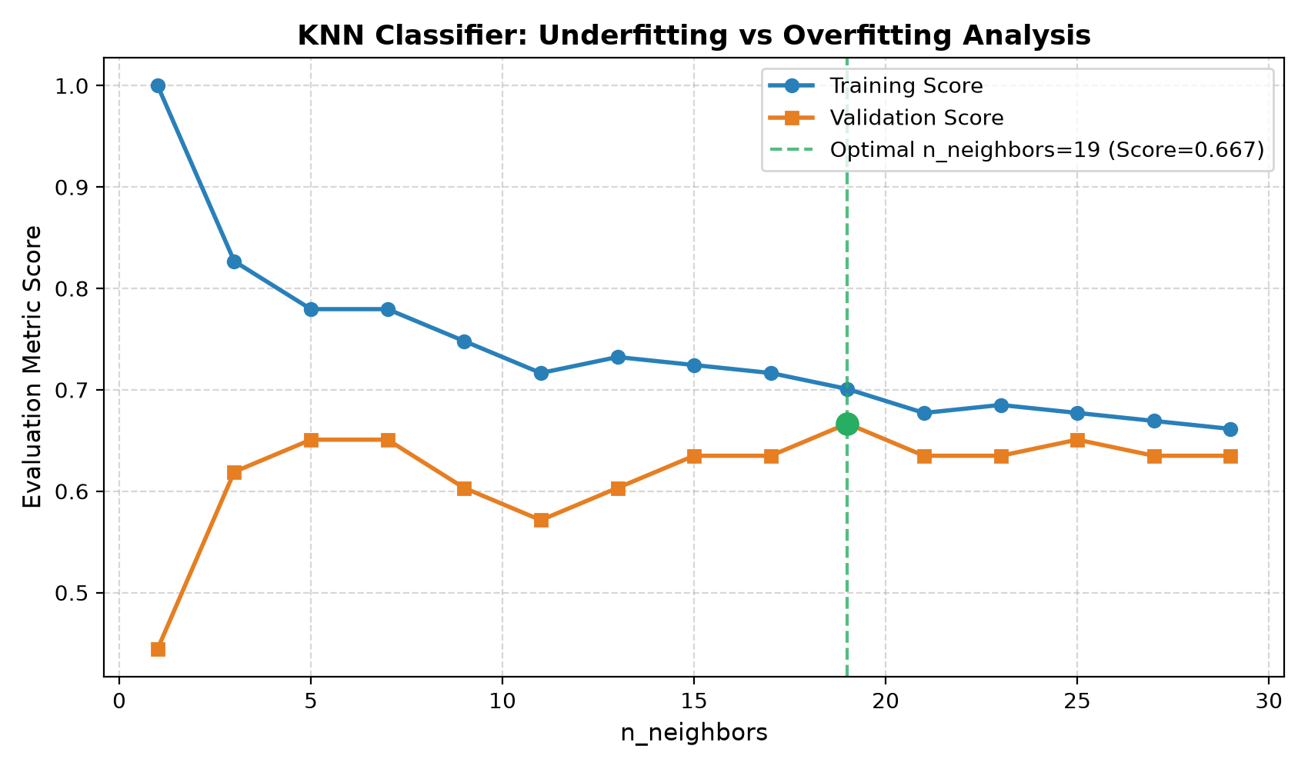
Figure 9: KNN Model Complexity Curve (Train vs. Validation Accuracy Across k).
13.3 Linear Regression Regularization (L2 Ridge Penalty)
Evaluating lambda across [0, 100] demonstrates shrinkage dynamics: At lambda = 0, collinear one-hot columns inflate variance (R² < 0). At lambda = 5.0, validation R² peaks at +0.0431 and holdout R² reaches +0.0600. Excessively large penalties (lambda > 50) push all coefficients to zero, underfitting the model toward the global target mean.
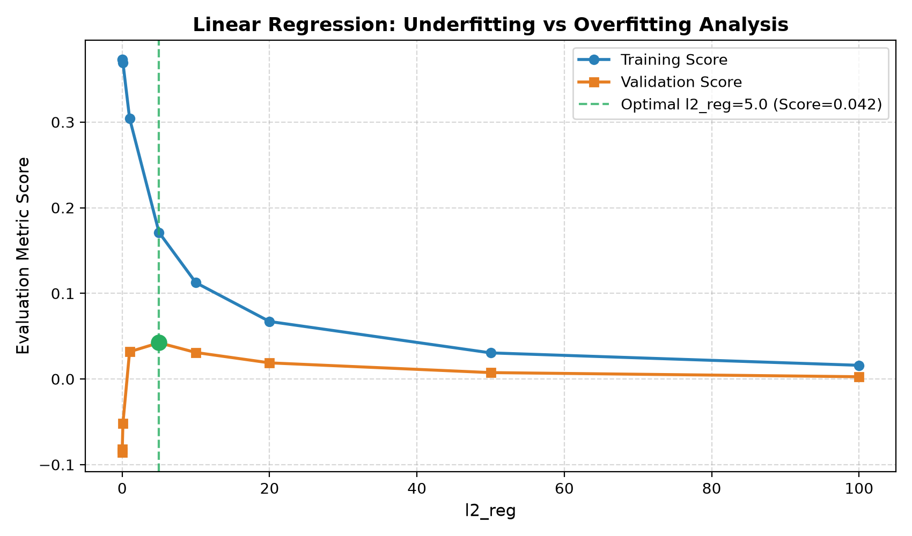
Figure 10: Linear Regression Regularization Curve (Train vs. Validation R² Across L2 Penalty).
14. System Implementation, CLI, and Streamlit Dashboard
EduPredict provides dual user interfaces: a fully automated command-line experiment runner for batch execution, and an interactive Streamlit web application for interactive educational demonstration:
Command-Line Interface (run_experiments.py): Executes the entire pipeline, trains models, computes first-principles metrics, prints reproducible benchmark Markdown tables, and writes diagnostic figures to artifacts/.
Interactive Web Application (app.py): Implements six dedicated interactive studios:
• Tab 1: Dataset Overview & Validation: Real-time missing value audit, tabular preview, and correlation heatmaps.
• Tab 2: Regression Studio: Interactive solver toggles (GD vs. Normal Equation), hyperparameter sliders (learning rate, momentum, L2 penalty), live loss convergence visualization, and single-student final grade inference.
• Tab 3: Classification Studio: KNN and Decision Tree configuration, confusion matrices, ROC curves, and single-student risk probability estimation.
• Tab 4: Overfitting & Underfitting Explorer: Interactive tabs displaying complexity curves across k, max_depth, and lambda.
• Tab 5: Empirical Benchmark Suite: Comparative visualization charts.
• Tab 6: Architecture & Methods: Mathematical derivations and zero-dependency compliance documentation.
15. Testing Strategy and Verification Evidence
Software testing is conducted using Python's standard unittest framework (strictly zero third-party test dependencies like pytest). The automated test suite comprises exactly 110 unit and integration tests executing in ~13.3 seconds with 100% pass rate:
Test Module | Count | Functional Coverage and Verification Objective
test_dependency_compliance.py | 1 | AST scanner verifying zero imports of numpy, pandas, sklearn, scipy, torch, math, stats
test_models.py | 13 | Normal Eq, GD convergence, KNN metrics, Decision Tree Gini splits, and solver agreement
test_math_matrices.py | 8 | Gauss-Jordan inversion with partial pivoting, matrix multiplication, transposition
test_math_vectors.py | 7 | Dot products, vector addition, Euclidean and Manhattan distance metrics
test_math_stats.py | 8 | Mean, sample variance (Bessel-corrected), covariance, Pearson correlation matrix
test_math_activations.py | 8 | Numerical stability, pure_exp (< 1.2e-12 err), pure_log (< 2.3e-16 err), sigmoid, softmax
test_losses.py | 7 | MSE, MAE, central finite-difference gradient checks (rel error < 1e-5)
test_metrics.py | 9 | Accuracy, precision, recall, F1, confusion matrix, trapezoidal ROC-AUC, R-squared
test_preprocessing.py | 11 | SimpleImputer (mean/mode), OneHotEncoder (unseen categories), StandardScaler, MinMaxScaler
test_data_loader.py | 8 | Delimiter auto-detection (; vs ,), header mapping, malformed row error handling
test_pipeline.py | 10 | MLPipeline leak-free execution, single-record inference, 3-way split disjointness
test_pipeline_integrity.py | 10 | Anti-leakage feature isolation, stratification alignment across targets
test_model_selection.py | 6 | KFold, StratifiedKFold, and joint-index train_test_split verification
test_serialization.py | 4 | Round-trip JSON and Pickle serialization and state recovery for custom models
test_app_logic.py | 4 | Programmatic verification of all 6 dashboard tab data flows and prediction paths

16. Limitations, Ethical Considerations, and Responsible Use
Ethical Deployment in Education: Machine learning systems deployed in educational environments directly impact student welfare. EduPredict is designed strictly as an assistive early-warning indicator for academic advisors and tutors, NEVER as an automated decision maker for consequential outcomes (such as course dismissal, academic probation, or financial aid cancellation).
Risk of Demographic Profiling: Because the model relies on socio-economic features (parental education, family relationship quality, living area) in the absence of interim grades, there is an inherent risk of reinforcing demographic biases. Educators must ensure that predicted risk scores trigger supportive tutoring and proactive counseling rather than punitive stigmatization.
17. Conclusion and Future Improvements
EduPredict successfully demonstrates that a complete, robust, and mathematically sound Classical Machine Learning framework can be constructed entirely from first principles without external numerical or ML libraries. By adhering strictly to zero-dependency policies, the project provides an transparent, uncompromised educational reference that demystifies loss optimization, matrix inversion, and tree partitioning.
Future Work: Promising technical directions include: (1) Cost-sensitive loss weighting in Decision Trees to penalize false negatives more heavily than false positives; (2) Implementation of soft-margin Support Vector Machines (SVM) with sequential minimal optimization (SMO); and (3) Scratch implementation of ensemble methods, including Bootstrap Aggregating (Bagging) and Random Forests.
18. References and Technical Resources
- Cortez, P., & Silva, A. (2008). Using Data Mining to Predict Secondary School Student Performance. In Proceedings of 5th Annual Future Business Technology Conference (FUBUTEC 2008), pp. 5-12, Porto, Portugal. EUROSIS-ETI.
- UCI Machine Learning Repository. (2014). Student Performance Data Set. Available online: https://archive.ics.uci.edu/ml/datasets/Student+Performance.
- Hastie, T., Tibshirani, R., & Friedman, J. (2009). The Elements of Statistical Learning: Data Mining, Inference, and Prediction. 2nd Edition, Springer Science & Business Media.
- Bishop, C. M. (2006). Pattern Recognition and Machine Learning. Springer, New York.
- Breiman, L., Friedman, J. H., Olshen, R. A., & Stone, C. J. (1984). Classification and Regression Trees. Wadsworth & Brooks/Cole Advanced Books & Software, Monterey, CA.
- Golub, G. H., & Van Loan, C. F. (2013). Matrix Computations. 4th Edition, Johns Hopkins University Press, Baltimore, MD.
- Polyak, B. T. (1964). Some methods of speeding up the convergence of iteration methods. USSR Computational Mathematics and Mathematical Physics, 4(5), 1-17.
- Fawcett, T. (2006). An introduction to ROC analysis. Pattern Recognition Letters, 27(8), 861-874.

