Traffic Sign Recognition System Using Deep Learning
A PROJECT REPORT

Major Project - I (01CE0716)
Submitted by

Aarav Patel

92301703098

Jenisha Bodar

92301703122

BACHELOR OF TECHNOLOGY
in

Computer Engineering


Faculty of Engineering & Technology

Marwadi University, Rajkot
August, 2026



Major Project-I (01CE0716)
Department of Computer Engineering
Faculty of Engineering & Technology
Marwadi University
A.Y. 2026-27
CERTIFICATE
This is to certify that the project report submitted along with the project entitled Traffic Sign Recognition System Using Deep Learning has been carried out by Aarav Patel (92301703098), Jenisha Bodar (92301703122) under my guidance in partial fulfillment for the degree of Bachelor of Technology in Computer Engineering, 7th Semester of Marwadi University, Rajkot during the academic year 2026-27.

Prof. Charmy Vora | Prof. (Dr.) Krunal Vaghela
Assistant Professor | Associate Dean & Head
Department of Computer Engineering | Department of Computer Engineering


Major Project-I (01CE0716)
Department of Computer Engineering
Faculty of Engineering & Technology
Marwadi University
A.Y. 2026-27
CERTIFICATE
This is to certify that the project report submitted along with the project entitled Traffic Sign Recognition System Using Deep Learning has been carried out by Aarav Patel (92301703098) under my guidance in partial fulfilment for the degree of Bachelor of Technology in Computer Engineering, 7th Semester of Marwadi University, Rajkot during the academic year 2026-27.

Prof. Charmy Vora | Prof. (Dr.) Krunal Vaghela
Assistant Professor | Associate Dean & Head
Department of Computer Engineering | Department of Computer Engineering



Major Project-I (01CE0716)
Department of Computer Engineering
Faculty of Engineering & Technology
Marwadi University
A.Y. 2026-27
CERTIFICATE
This is to certify that the project report submitted along with the project entitled Traffic Sign Recognition System Using Deep Learning has been carried out by Jenisha Bodar (92301703122) under my guidance in partial fulfilment for the degree of Bachelor of Technology in Computer Engineering, 7th Semester of Marwadi University, Rajkot during the academic year 2026-27.

Prof. Charmy Vora | Prof. (Dr.) Krunal Vaghela
Assistant Professor | Associate Dean & Head
Department of Computer Engineering | Department of Computer Engineering



Major Project-I (01CE0716)
Department of Computer Engineering
Faculty of Engineering & Technology
Marwadi University
A.Y. 2026-27

DECLARATION

We hereby declare that the Major Project (01CE0716) report submitted along with the Project entitled Traffic Sign Recognition System Using Deep Learning submitted in partial fulfilment for the degree of Bachelor of Technology in Computer Engineering to Marwadi University, Rajkot, is a bonafide record of original project work carried out by us at Marwadi University under the supervision of Prof. Charmy Vora and that no part of this report has been directly copied from any students’ reports or taken from any other source, without providing due reference.

Name of the Student Sign of Student
- ______________________ _______________
- ______________________ _______________

Acknowledgement
We would like to thank all of those who have helped us in this project. This work could not have been completed without their assistance and support.
To begin with, we want to make it clear that we would like to give a great deepening of our gratitude to our in-house guide, the Assistant Professor, Computer Engineering, Marwadi University, Prof. Charmy Vora. We never returned to her without some tips or a helping hand to guide us at all times, as she answered our questions calmly and would offer a practical advice that would keep us moving on in each stage. Her leadership style, to challenge us to think and solve problems by ourselves, had a great influence on our educational experience.
We would also like to acknowledge that Prof. (Dr.) Krunal Vaghela, Professor and Associate Dean, Department of Computer Engineering has supported this project by providing a good academic environment and the infrastructure required. Resources such as the computing facilities and access to the libraries that were part of the department were very helpful throughout the semester.
We are grateful to all the teachers within the Department of Computer Engineering who provided us with guidance at various levels, gave us some useful tips and inspired us to enhance the quality of our work by giving us feedback during the reviews.
Lastly, both of us would like to tell our life-long thanks to our family and friends that supported, encouraged, and motivated us during the completion of this project.

Abstract
Traffic sign recognition (TSR) is one of the practical implementations of intelligent transportation systems (ITS), advanced driver assistance systems (ADAS), and autonomous driving technology. Precise recognition of traffic signs allows vehicles to be aware of the rules that apply on the road and improve the safety on roads. In this paper, a deep learning-based traffic sign detection approach with the implementation of YOLOv11n is proposed, along with the comparison of this model's performance with YOLOv8n and YOLOv10n.
These models were trained and tested using the Self-Driving Cars dataset provided by Roboflow with 4,969 annotated images of street-scenes representing 15 classes of traffic signs. According to the results of experiments, the most efficient model is YOLOv11n, with the following parameters: 95.91% Precision, 91.98% Recall, 96.76% mAP@50, and 83.35% mAP@50-95.
These results confirm that YOLOv11n demonstrates a high level of accuracy and reliability in traffic sign detection, at the same time being suitable for real-time applications.

Table of Contents

Acknowledgement................................................................................................................... I
Abstract ................................................................................................................................. II
Table of Contents ................................................................................................................. III
List of Figures ........................................................................................................................V
List of Tables ........................................................................................................................VI
List of Abbreviations ...........................................................................................................VII

Chapter 1 Introduction….……………………................................................................... 1
1.1 Introduction………….......................................................................................................1
1.2 Motivation…………........................................................................................................ 1
1.3 Analysis of traffic sign image.............................................................................………..2
1.4 Feature extraction..............................................................................................................2
1.4.1 Spatial features......................................................................................................3
1.4.2 Shape features.......................................................................................................3
1.4.3 Color features........................................................................................................3
1.4.4 Edge features.........................................................................................................3
1.4.5 Symbol features.....................................................................................................4
1.4.6 Multi-scale features...............................................................................................4
1.5 Statements of problem.......................................................................................................4

Chapter 2 Literature review ……………………................................................................5
2.1 Review paper.....................................................................................................................5
2.2 Literature review table.......................................................................................................7

Chapter 3 Methodology…………………………...............................................................10
3.1 Flow of proposed model..................................................................................................10
3.2 Pre trained models...........................................................................................................11
3.2.1 EfficientNet-B0 ..................................................................................................11
3.2.2 YOLOv8n….…...................................................................................................12
3.2.3 YOLOv10n……..................................................................................................12
3.2.4 YOLOv11n……..................................................................................................13
3.3 Evaluation Measures of Proposed Method .....................................................................13
3.4YOLOv11n Detection and Classification.........................................................................14

Chapter 4 implementation...……………………...............................................................15
4.1 Software and tool setup...................................................................................................15
4.2 Dataset………….............................................................................................................15
4.3 Flow of implementation...................................................................................................16

Chapter 5 Experimentation and result…………..............................................................20
5.1 Result…………………………………………………………………………………...25
5.1.1 Confusion Matrix………………………………………………………………25
5.1.2 Testing Model………………………………………………………………….27

Conclusion…………………………………………………………………………………30
Future work………………………………………………………………………………..31
Appendices…………………………………………………………………………………32
References………………………………………………………………………………….34

List of Figures

Fig 3.1 Flow Chart ………………………………………………………………………….11
Fig 5.1 Confusion Matrix ……...…………………………………………………………...26
Fig 5.2 Result Graph…….……...…………………………………………………………...26
Fig 5.3 Stop …………………..…………………………………………………………….27
Fig 5.4 Speed Limit 80……….……………………………………………………………..27
Fig 5.5 Speed Limit 40……………………………………………………………………...27
Fig 5.6 Speed Limit 30……………...……………………………………………………….27
Fig 5.7 Traffic Light Green..…………..…………………………………………………….28

List of Tables

Table 2.1 Literature Review ……………………………………………………………..7
Table 5.1 Performance Comparison of YOLO Models …………………………………20
Table 5.2Detection Confidence Comparison under different image conditions ………..21
Table 5.3YOLOv11n Class-wise performance e.……………………………………......22
Table 5.4 Robustness Analysis of YOLOv11n under Different Image Conditions……..24

Abbreviations

AI – Artificial Intelligence
DL – Deep Learning
ML – Machine Learning
CNN – Convolutional Neural Network
CV – Computer Vision
TSR – Traffic Sign Recognition
TSD – Traffic Sign Detection
YOLO – You Only Look Once
YOLOv8n – You Only Look Once Version 8 Nano
YOLOv10n – You Only Look Once Version 10 Nano
YOLOv11n – You Only Look Once Version 11 Nano
TP – True Positive
FP – False Positive
TN – True Negative
FN – False Negative
IoU – Intersection over Union
P – Precision
R – Recall
AP – Average Precision
mAP – Mean Average Precision
mAP@50 – Mean Average Precision at IoU 0.50
mAP@50–95 – Mean Average Precision at IoU 0.50 to 0.95
NMS – Non-Maximum Suppression
GPU – Graphics Processing Unit
VRAM – Video Random Access Memory
CUDA – Compute Unified Device Architecture
CPU – Central Processing Unit
OpenCV – Open Source Computer Vision Library
VS Code – Visual Studio Code
ITS – Intelligent Transportation Systems
ADAS – Advanced Driver Assistance Systems
FPS – Frames Per Second
RGB – Red Green Blue
BGR – Blue Green Red
RGBA – Red Green Blue Alpha
COCO – Common Objects in Context
API – Application Programming Interface
CNN – Convolutional Neural Network
ReLU – Rectified Linear Unit
Roboflow – Roboflow Computer Vision Platform
N – Number of Classes

CHAPTER 1
INTRODUCTION
  - INTRODUCTION
Traffic signs are one of the most vital sources of information on the road. Traffic signs give the necessary information to the drivers about speed limits, warning signs, actions that must be performed, and prohibitions, thus ensuring safe driving and proper traffic management. In many cases, traffic signs help to avoid road accidents. However, fatigue, distraction, bad visibility, and adverse weather conditions affect the understanding of traffic signs and may cause road accidents.
The traffic sign recognition problem is still hard because of the variety of different traffic sign appearances depending on size, orientation, lighting, and the complexity of the background. Motion blur, shadows, occlusion, faded traffic signs, and different weather conditions complicate the recognition problem even more. Traditional approaches to traffic sign recognition use hand-crafted features like color, shape, edge, etc., which do not always show good performance in real-world environments.
In order to solve the problems mentioned above, this work proposes deep learning-based traffic sign detection system with YOLOv11n as the proposed model. The performance of YOLOv11n was compared with YOLOv8n and YOLOv10n using Self-Driving Cars dataset for evaluating the traffic sign detection accuracy and robustness in different image conditions.
Experimental results showed that YOLOv11n gives the best performance among the considered models. Proposed traffic sign detection system demonstrates high accuracy and robustness of traffic signs detection under different environmental conditions and can be used for ITS, ADAS, and autonomous driving tasks.
1.2 MOTIVATION
The Current traffic sign recognition systems mainly focus on improving detection accuracy. They pay little attention to performance in real-world driving conditions. Factors like poor lighting, rain, fog, motion blur, changing viewing angles, and partial obstructions can greatly reduce detection reliability.
This The aim of this work is to create a strong and accurate traffic sign detection system for real-world use. YOLOv11n is chosen as the proposed model and is compared with YOLOv8n and YOLOv10n to assess their detection performance and reliability under various image conditions. This comparison helps find the best model for real-time applications in Intelligent Transportation Systems (ITS), Advanced Driver Assistance Systems (ADAS), and autonomous driving.
1.3 ANALYSIS OF TRAFFIC SIGN IMAGE
Look at pictures of traffic signs, and you'll realize that they're all unique. Some are stop signs, some are speed limit signs, some are traffic lights and others are warning sign or mandatory signs. Not only do these traffic signs look different, they also have different shapes, colors, symbols and sizes. For example, the stop sign is red and octagonal, and the speed limit signs are circular, with varying numbers. Likewise, the traffic lights have various colors including red, yellow, green. The visual differences will enable the separation of one traffic sign from another.
In the real world, images of traffic signs may have issues like variations in lighting conditions, rain, fog, shadows, motion-blurring, and different vantage points. Also, some traffic signs can be hard to find because of their size, being partially visible, or having complex backgrounds. So, the object detection model needs to be trained to be robust enough to recognize objects in such a difficult context. The model can automatically extract the key performance values, such as shape, color, symbols and spatial patterns, which are important for it to recognize and classify traffic signs in real-road environments.
1.4 FEATURE EXTRACTION
In this work, the YOLOv11n architecture is used for feature extraction, which automatically extracts discriminative visual features from the input traffic sign images. Its model is able to capture key features like shape, colour, edges and symbols to accurately detect and classify various traffic sign categories. The extracted features are then used to perform real-time efficient localization and classification of traffic signs in road environments.
F(i,j)=m∑​n∑​I(i+m,j+n)⋅K(m,n) (1.4.1)
1.4.1 Spatial Features
The spatial features include the structural details of the edges, shapes and boundaries of the images of traffic signs. These features are learned automatically in YOLOv11n using convolutional layers to recognize pattern shapes like circles, triangles, rectangles and octagons, which allows the model to detect traffic signs at various positions, sizes, and angles.
1.4.2 Shape Features
Shape is one of the most critical attributes used for traffic sign recognition since traffic signs have standardized geometric shapes; for example, stop signs are octagonal, speed limit signs are circles, warning signs are triangles, and informational signs are rectangular. These unique shapes enable the differentiation of the traffic sign categories from each other.
1.4.3 Color Features
Color features capture the color patterns and distribution present in traffic sign images. YOLOv11n learns patterns such as red stop signs, red-bordered speed-limit signs, and red, yellow, and green traffic lights, helping it distinguish different traffic sign classes under varying lighting and road conditions.
1.4.4 Edge Features
Edge attributes include the boundaries and contours of the traffic sign. Clear edge detection assists in separating the traffic sign from the background, especially when detecting traffic signs in complex road scene.
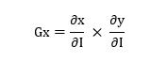 (1.4.4.1)

1.4.5 Symbol Features
Symbol features are the visual elements inside traffic signs, such as numbers, arrows, people, and traffic light symbols. These symbols help the YOLOv11n model understand the meaning of the sign and distinguish between signs with similar shapes or colors.
1.4.6 Multi-scale Features
Different sizes of traffic signs are caused by the varying distances from the traffic sign to the camera. Traffic signs closer to the vehicle will be larger, while more distant signs will be significantly smaller. Thus, the recognition algorithm should be scale invariant.
1.5 Statement Problem
Traffic sign images often contain challenges such as poor lighting, different viewing angles, weather effects, motion blur, and partial occlusions. Different sign sizes, distances, and complex road environments make accurate detection and classification difficult.
Traditional image processing methods mainly depend on handcrafted features and may not perform well under real-world conditions. Therefore, an automated and reliable system is needed to accurately detect traffic signs.
YOLOv11n provides an effective deep learning solution by detecting and classifying traffic signs quickly and accurately. Its fast detection capability makes it suitable for real-time traffic sign recognition under different road conditions.

CHAPTER 2
LITERATURE REVIEW

2.1 REVIEW PAPER
A study by W. E. Elside and A. J. Abougarair [1] proposed a Convolutional Neural Network (CNN)-based traffic sign recognition system for classifying traffic signs from road images. The study demonstrated that CNNs can automatically learn visual features and achieve high classification accuracy compared to traditional image processing methods. However, the work mainly focuses on traffic sign classification and does not evaluate modern object detection architectures such as YOLO for real-time traffic sign detection.
Y. Zhu and W. Q. Yan [2] developed a deep learning approach to traffic sign recognition which leverages the power of convolutional neural networks in traffic sign classification. In the paper, they addressed image processing, feature extraction, and classification methods with benchmark traffic sign datasets. It is evident from the experiment conducted that deep learning provides much better recognition rates than traditional methods. However, the work primarily emphasizes the issue of classification efficiency without comparing lightweight object detection approaches.
An Incremental Improvement, J. Redmon and A. Farhadi [3] propose an improved version of the YOLO architecture, which is capable of real-time object detection with high accuracy and object detection at different scales. The authors demonstrate that the new model achieves great speed and improved localization performance compared to the previous versions of YOLO. Nevertheless, the paper represents the general object detection framework, and there is no research on the applicability of the proposed framework for traffic sign recognition.
Deep learning approach to traffic sign recognition based on Convolutional Neural Networks was introduced by Z. Qin and W. Q. Yan [4]. It was shown how deep learning approach is efficient for automatic feature extraction and classification from traffic signs images. The study illustrates the efficiency of using CNNs for traffic sign recognition in contrast to handcrafted feature extraction methods. The study does not consider object detection approaches like YOLO.
R. K. Megalingam et al. [5] designed an Indian Traffic Sign Detection and Recognition System based on deep learning algorithms. This system attempted to overcome the problems involved in recognizing Indian traffic signs under diverse road conditions and exhibited potential detection accuracy. In this study, the role of deep learning was highlighted in relation to the intelligent transportation systems. Yet, the work is limited to Indian traffic signs and lacks a comparative study of recently designed lightweight YOLO architectures.
G. K. Samdariya and D. K. Meda [6] designed a deep learning approach to detect and recognize Indian traffic signs to enhance road safety and aid intelligent transportation systems. The authors successfully proved that deep learning techniques can help in detecting traffic signs in complex road environments. Nevertheless, a comparative study of existing state-of-the-art object detection architectures is not adequately covered in this paper.
A. A. Alshammari [7] proposes traffic sign recognition technique utilizing the YOLOv8 framework. The authors prove that YOLOv8 allows for much faster detection with higher accuracy than previous models which makes it more appropriate for self-driving cars applications. Nevertheless, the paper focuses only on evaluating the performance of YOLOv8 and does not present any comparative analysis with new generations of YOLO models, i.e., YOLOv10 and YOLOv11.
B. Xie and W. X. Xiong [8] introduce a real-time embedded traffic sign recognition system implemented via efficient convolutional neural network. The authors state that their system allows for high recognition rate with lower computational costs which makes it more appropriate for embedded systems. Nevertheless, no recent object detection frameworks are evaluated in the context of real-time traffic sign recognition task.
P. S. Zaki et al. [9] designed an innovative deep learning-based traffic sign detection and recognition framework that can detect and recognize traffic signs in road environment. The proposed method obtained high detection accuracy results and proved that deep learning can be used in intelligent transport systems. But the research does not include comparing several lightweight object detection frameworks and does not provide analysis of their efficiency depending on traffic conditions.
C. Kim et al. [10] suggested a deep learning-based real-time traffic sign recognition framework for urban areas. The suggested framework was mainly concerned about improving recognition results under realistic driving conditions. Thus, reliable real-time detection of traffic signs was proven. However, the research is mainly devoted to a single deep learning framework and does not include comprehensive comparative study of recent YOLO-based approaches.
2.2 Literature Review Table

Table 2.1 : Literature Review
Ref No. | Authors | Dataset Used | Method / Model Used | Accuracy (%) | Key Contribution | Limitation / Research Gap
[1] | W. E. Elside & A. J. Abougarair | GTSRB | CNN (VGG19, Sequential) | 94 | Developed a CNN-based traffic sign recognition system for multiple traffic sign classes | Focuses mainly on classification and does not emphasize real-time object detection
[2] | Y. Zhu & W. Q. Yan | GTSRB | YOLOv5, SSD | 97.70 | Applied deep learning-based object detection for traffic sign recognition | Limited number of traffic sign classes and dataset images compared with large-scale real-world datasets
[3] | J. Redmon & A. Farhadi | GTSRB, BTSC | Efficient Hierarchical CNN | 98 | Proposed an efficient deep learning approach for traffic sign recognition using hierarchical features | Older architecture and does not evaluate recent YOLO models
[4] | Z. Qin & W. Q. Yan | NZ-Traffic-Sign | Faster R-CNN | 97.9 mAP@50 | Applied deep learning-based object detection for traffic signs in New Zealand road scenes | Faster R-CNN is computationally heavier and may be less suitable for real-time applications
[5] | R. K. Megalingam et al. | Indian Traffic Sign Dataset (ITSD) | CNN | 97 | Developed a deep learning-based system for Indian traffic sign detection and recognition | Focuses on Indian traffic signs and does not compare lightweight YOLO architectures
[6] | G. K. Samdariya & D. K. Meda | Indian Traffic Sign Dataset (Custom) | Object Detection + CNN | 97 | Developed a system for detecting and recognizing mandatory, cautionary, and informatory traffic signs | Uses a custom dataset and limited comparison with modern object detection models
[7] | A. A. Alshammari | GTSRB, GTSDB, TT100K | Enhanced YOLOv8 | 91.5 | Improved YOLOv8 for traffic sign recognition using multiple traffic sign datasets | Performance is lower than some existing approaches and focuses mainly on YOLOv8
[8] | B. Xie & W. X. Xiong | GTSRB | Efficient CNN | 98.6 | Proposed an efficient CNN suitable for real-time embedded traffic sign recognition | Focuses on an older CNN architecture and does not compare modern YOLO versions
[9] | P. S. Zaki et al. | GTSDB | Faster R-CNN + Tiny YOLOv2 | 96 | Combined detection approaches to develop a traffic sign detection and recognition system | Uses older object detection architectures and does not evaluate recent lightweight YOLO models
[10] | C. Kim et al. | Large-scale highway image dataset (Custom) | YOLOv5 + Strong SORT | 99.5 mAP@50 | Developed a real-time traffic sign recognition system for urban environments using detection and tracking | Uses a custom dataset and older YOLOv5 architecture

CHAPTER 3
METHODOLOGY

3.1 FLOW OF PROPOSED MODEL
The goal of the proposed method is to identify and categorize road signs from road photos with the YOLOv11n deep learning network. As mentioned in Fig 3.1, the proposed traffic sign detection system comes with a workflow involving data collection and pre-processing, such as resizing images and removing incorrect annotations, and splitting the dataset into training, validation, and testing sets. Also, data augmentation is used to diversify the training images and enhance the model's generalization capabilities.
The preprocessed dataset is then fed into the pre-trained YOLOv11n model to train it. The model learns salient visual characteristics of whether the traffic sign is a highway sign, school crossing guard, or pedestrian crossing guard as well as its spatial location during the training process. The trained model can be used to predict the bounding box, class label and confidence score for every detected traffic sign in an input image.
Once trained, the model YOLOv11n is tested to see the different types of traffic signs. Moreover, robustness analysis is conducted by the use of simulated environmental factors, including Night Vision, Fog, Rain and Gaussian Blur, to the test images. It is helpful for assessing the model's ability to accurately predict performance in varying, demanding, road conditions.
Lastly, the performance of the proposed model is evaluated using standard object detection metrics such as Precision, Recall, mAP@50 and mAP@50-95. These metrics are employed to evaluate the accuracy, reliability and localization capabilities of the model, as well as its potential for implementing real-time traffic sign detection applications.

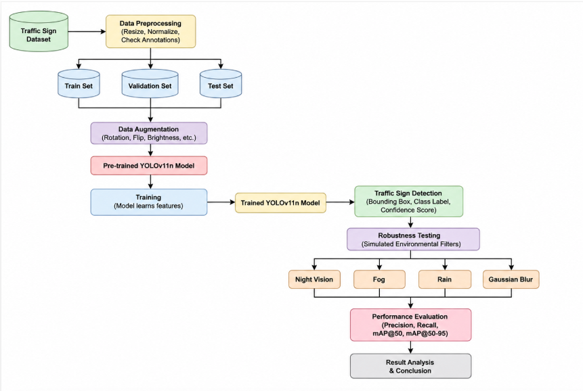
Fig 3.1: Flow Chart

3.2 PRE-TRAINED MODELS
Pre trained models are deep learning models that have been already trained on huge datasets and can be adjusted for a specific job via transfer learning, kind of like reusing knowledge. When you start from pre-trained weights the network can pick up more generalized visual patterns faster so the fitting phase is shorter and the detection results tend to be better even if you only have a smaller number of training samples. In this work, the pre-trained YOLO versions were finetuned using the Self-Driving Cars dataset, for the purpose of traffic sign detection. With transfer learning the models are able to learn the distinctive traits of traffic signs, like their traffic sign characteristics, including shape, color, and surface texture and this leads to more reliable object localization and category recognition.
3.2.1 EfficientNet-B0
The EfficientNet-B0 model is employed as a lightweight CNN network due to its good performance-weight ratio. It employs compound scaling to optimally trade off between network depth, width and image resolution of the input image to extract useful features from the image while maintaining a reasonable model size.
We train and test EfficientNet-B0 on the Traffic Sign Recognition problem in this study. The model's accuracy is 84.18%, the validation accuracy is 82.60%, and the F1 is 0.82. The results demonstrate that the EfficientNet-B0 network is capable of learning the features of the traffic signs and it can be applied as an efficient deep learning network for traffic sign classification.
3.2.2 YOLOv8n
YOLOv8n is a lightweight object detection model with a well-balanced accuracy and speed. It can detect objects and their classes at the same time, making it suitable for real-time applications. YOLOv8n is pre-trained on the Self-Driving Cars dataset to serve as a baseline for comparison with YOLOv10n and YOLOv11n in this work.
Despite its fast inference speed and low computational complexity, YOLOv8n may experience reduced detection accuracy for small or partially occluded traffic signs and under challenging environmental conditions, making it less robust than more advanced YOLO architectures.
3.2.3 YOLOv10n
YOLOv10n is an enhanced single-stage object detection algorithm which aims at improving detection accuracy without compromising on real-time detection. YOLOv10n includes architectural improvements and detection head that are optimized for efficient feature learning and low computational cost. YOLOv10n is able to detect multiple scales of features which facilitates detection of traffic signs of different shapes and sizes. In the current research, YOLOv10n has been fine-tuned with pre-trained weights on the Self-Driving Cars dataset and tested for comparison with YOLOv8n and proposed YOLOv11n models.
Even though YOLOv10n can provide enhanced feature extraction and reduced computational complexity, it may suffer poor detection results in case of heavy occlusion and drastic changes in illumination as well as complicated roads scenes.
3.2.4 YOLOv11n
YOLOv11n is the most recent lightweight object detection network from the family of YOLO networks, which is developed for the detection of objects with high accuracy while retaining real-time speed. The network uses enhanced backbone, neck, and detection head that help learn richer multi-scale features so as to accurately localize and classify traffic signs of different sizes with complex backgrounds. YOLOv11n was fine-tuned using the weights pretrained on the Self-Driving Cars dataset using the approach of transfer learning in this study. The network makes predictions regarding the coordinates of the bounding box, the object's confidence, and the class label at once, thereby making it suitable for the real-time detection of traffic signs. Due to its efficient architecture and rich feature learning capabilities, YOLOv11n has been chosen as the proposed network for this research.
Even though YOLOv11n has performed well in this study, it is possible that its detection performance can be affected in extremely difficult circumstances.
3.3 EVALUATION MEASURES OF PROPOSED METHOD.
The performance of the proposed YOLOv11n model was evaluated using standard object detection metrics, namely Precision, Recall, mAP@50, and mAP@50–95. These metrics assess the model's ability to accurately detect and localize traffic signs under different driving conditions.
Metrics
Precision:
$Precision=\frac{TP}{TP+FP}*100$(3.3.1)
Recall:
$Recall=\frac{TP}{TP+FN}*100$(3.3.2)
mAP@50:
$mAP@50=\frac{1}{N}\sum_{i=1}^{N}{{AP}_{i}}$(3.3.3)

mAP@50-95:
$mAP@50-95=\frac{1}{10}\sum_{i=0}^{9}{{AP}_{0.50+0.05i}}$(3.3.4)
3.4 YOLOv11n Detection and Classification
The YOLOv11n model is designed for traffic sign detection and classification in a single forward pass. Following preprocessing and data argumentation, the input image is fed to the YOLOv11n network and then a deep convolutional feature extractor that extracts a feature pyramid comprising hierarchically layered features encoding shape, color, and structure of the traffic signs, through multiple levels. The extracted features at different scales are integrated by the neck which is able to aggregate information from various receptive fields, helping the detection of traffic signs with varying scales.
The detection head predicts the target object location (box coordinates), object scores, and traffic sign classes of detected objects simultaneously. During inference time, Non-Maximum Suppression (NMS) is used to remove duplicated bounding box proposals by only selecting candidates with higher confidence. Then the predicted results include a traffic sign, its position, the object confidence value, and the traffic sign class. This end-to-end framework achieves robust and accurate traffic sign detection in real-time scenarios.

CHAPTER 4
IMPLEMENTATION
In this section, the practical implementation of the proposed traffic sign recognition system based on the YOLOv11n model is explained. It includes the software configuration, dataset information, preprocessing steps, model training, evaluation metrics, and the overall implementation process. The performance of YOLOv11n is also analyzed under different environmental conditions to evaluate its effectiveness and robustness for real-time traffic sign detection.
4.1 SOFTWARE TOOL AND SETUP
The proposed traffic sign detection system is implemented using Python programming language in Visual Studio Code (VS Code). The system uses the Ultralytics YOLO framework and PyTorch for training and evaluating the YOLOv8n, YOLOv10n, and YOLOv11n models.
The libraries and tools used are as follows:
- Ultralytics YOLO – to implement and train YOLO models.
- PyTorch – for deep learning model training and inference.
- OpenCV – for image preprocessing and augmentation.
- NumPy – for numerical computations.
- Pandas – for data handling and analysis.
The experiments are performed on Windows 11 (64-bit) with an NVIDIA GeForce RTX 3050 Laptop GPU (6 GB VRAM) and CUDA 12.6. The GPU helps accelerate model training and inference. The Self-Driving Cars dataset containing 15 traffic sign classes is used for training, validation, and evaluation.
4.2 DATASET
The dataset used in this research is the publicly available Self-Driving Cars dataset obtained from Roboflow.
The dataset contains 4,969 traffic sign images belonging to 15 traffic sign classes. Some of the classes include:
- Red Light – 585 images
- Green Light – 542 images
- Stop – 285 images
- Speed Limit 100 – 267 images
- Speed Limit 110 – 101 images
- Speed Limit 120 – 252 images
- Other traffic sign categories
The dataset is divided into training (71.04%), validation (16.12%), and testing (12.84%) sets. The images are annotated in YOLO format, where each label contains the class ID and normalized bounding-box coordinates: x-center, y-center, width, and height.
Before training, the images are resized to 640 × 640 pixels. YOLOv11n applies the required preprocessing and normalization during training. Data augmentation techniques such as scaling, translation, horizontal flipping, and mosaic augmentation are used to increase image diversity and improve model generalization.
Dataset Source: Self-Driving Cars Dataset – Roboflow
Dataset Link: https://universe.roboflow.com/selfdriving-car-qtywx/self-driving-cars-lfjou
4.3 FLOW OF IMPLEMENTATION
The implementation of the proposed traffic sign detection system follows a systematic process, starting from dataset preparation and continuing through model training, evaluation, and prediction. The overall workflow of the implementation is illustrated in Fig. 3.1.
Step 1: Dataset Acquisition
The Self-Driving Cars dataset is collected from Roboflow. It contains 4,969 traffic sign images belonging to 15 classes. Each image contains traffic signs in street-scene environments and is provided with corresponding annotations.
Step 2: Data Preparation
The dataset is divided into three subsets:
- Training – 71.04%
- Validation – 16.12%
- Testing – 12.84%
The training set is used for learning, the validation set is used to monitor model performance during training, and the testing set is used for final evaluation.
Step 3: Data Annotation
The traffic sign images are annotated in YOLO format. Each annotation contains the class ID and normalized bounding-box coordinates:
- x-centre
- y-centre
- Width
- Height
These annotations provide the location and class of each traffic sign in the image.
Step 4: Image Preprocessing
Before training, the input images are resized to 640 × 640 pixels. YOLOv11n performs the required preprocessing and normalization so that the images can be efficiently provided to the model.
Step 5: Data Augumentation
Data augmentation is applied during training to improve the model's ability to generalize to different road conditions. The augmentation techniques include:
- Random scaling
- Translation
- Horizontal flipping
- Mosaic augmentation
These techniques increase the variation in the training images and help the model learn more robust traffic sign features.
Step 6: Model Selection
YOLOv11n is selected as the proposed object detection model. A pretrained YOLOv11n model is used as the starting point, and transfer learning is applied to adapt the model to the traffic sign detection task.
Step 7: Model Architecture
The YOLOv11n architecture consists of different components for extracting and processing visual information. The model learns features from the input images and predicts the bounding boxes, confidence scores, and traffic sign classes for the detected objects.
Step 8: Model Training
The YOLOv11n model is trained for 50 epochs using transfer learning. The pretrained weights are fine-tuned using the Self-Driving Cars dataset. The model learns to detect and classify the 15 traffic sign classes from the annotated training images. The best-performing model is saved based on validation performance.
Step 9: Model Evaluation
After training, the YOLOv11n model is evaluated using the testing dataset. The performance is measured using standard object detection metrics:
- Precision
- Recall
- mAP@50
- mAP@50–95
These metrics measure the accuracy of traffic sign detection and the quality of bounding-box localization.
Step 10: Prediction System
The trained YOLOv11n model is used to detect traffic signs from new input images.For each detected traffic sign, the model generates:
- Bounding box
- Predicted class label
- Confidence score
This allows the system to identify the location and category of traffic signs automatically.
Step 11: Robustness Testing
The trained model is additionally tested under different challenging image conditions to evaluate its robustness. The testing conditions include:
- Night Vision
- Fog
- Rain
- Gaussian Blur
This analysis helps determine whether the YOLOv11n model can maintain reliable traffic sign detection when image quality or environmental conditions change.
Step 12: Result Analysis
Finally, the results are analyzed based on the detection metrics and model predictions. The performance of YOLOv11n is studied in terms of Precision, Recall, mAP@50, and mAP@50–95, along with its detection behavior under different environmental conditions. This analysis helps determine the effectiveness and reliability of YOLOv11n for real-time traffic sign detection.

CHAPTER 5
EXPLANATION AND RESULT

5. EXPLANATION AND RESULT
Table 5.1: Performance Comparison of YOLO Models
Model | Precision | Recall | mAP@50 | mAP@50-95
YOLOv8n | 89.36 | 87.26 | 92.06 | 78.90
YOLOv10n | 93.60 | 89.90 | 95.10 | 82.70
YOLOv11n | 95.91 | 91.98 | 96.76 | 83.35

A comparison of the three YOLO models is given in Table 5.1. The table shows that YOLOv8n obtained the worst performance of all the models, with a Precision of 89.36%, a Recall of 87.26% an mAP@50 of 92.06%, and an mAP@50–95 of 78.90%. Even though its detection accuracy is acceptable, its localization performance is comparatively lower than that of the other models.
YOLOv10n showed improved detection performance which reported a Precision of 93.60%, Recall of 89.90%, mAP@50 of 95.10% and mAP@50–95 of 82.70%. We saw that YOLOv10n does better in terms of object localization and overall detection performance when compared to YOLOv8n also it preserved efficiency in inference.
In terms of all the models evaluated YOLOv11n did the best which reported a Precision of 95.91%, Recall of 91.98%, mAP@50 of 96.76% and mAP@50–95 of 83.35%. The results which we got are that YOLOv11n does better in terms of traffic sign detection accuracy and also has better localization performance than the rest of the models. Thus, YOLOv11n was put forth as the traffic sign detection model of choice due to its improved accuracy, robustness and overall performance.

Table 5.2: Detection Confidence Comparison under Different Image Conditions
Image Condition | YOLOv8n | YOLOv10n | YOLOv11n
Original | 86.50 | 89.74 | 91.20
Night Vision | 91.72 | 88.67 | 95.27
Fog | 80.53 | 94.91 | 94.32
Rain | 54.93 | 92.32 | 49.84
Gaussian Blur | 81.16 | 93.63 | 91.05

Table 5.2 shows the robustness analysis of the three YOLO models subjected to various image transformations, including the Original, Night Vision, Fog, Rain, and Gaussian Blur. The evaluation criteria used to analyze the performance of the models include the detection confidence (%) of the Speed Limit 80 traffic sign.
From Table 2, it is noted that the three models performed well in detecting the original image with a high level of confidence. In particular, the proposed YOLOv11n model had the highest confidence level (91.20%) compared to YOLOv10n (89.74%) and YOLOv8n (86.50%). This means that the proposed model has learned more discriminative features for effective detection of traffic signs under normal lighting conditions.
In terms of Night Vision filter, the performance of the proposed YOLOv11n model improved further by detecting the speed limit traffic sign with 95.27% confidence level. Additionally, the YOLOv8n confidence improved to 91.72%. However, there was a reduction in the confidence of YOLOv10n (88.67%) under the same lighting condition. It means that the model proposed has better performance than other models in low-lighting conditions.
Concerning the Fog filter, YOLOv10n and YOLOv11n were more robust to reduced visibility due to foggy environments since they had high confidence levels (94.91% and 94.32%, respectively). On the contrary, there was a reduction in confidence levels of YOLOv8n (80.53%).
Among all filters applied, Rain filter made the most significant impact on the detection results. YOLOv8n identified the traffic sign as Speed Limit 60 with a confidence rate of 54.93%, whereas YOLOv11n correctly identified the traffic sign with a decreased confidence rate of 49.84%. In contrast to that, YOLOv10n demonstrated the greatest confidence rate of 92.32% despite the presence of a simulated rain filter in this experiment.
In case of Gaussian Blur (21 × 21), all models were capable of detecting the traffic sign, and the confidence rates of YOLOv10n and YOLOv11n remained high. Thus, YOLOv10n reached the highest confidence level of 93.63%, followed by YOLOv11n with the confidence rate of 91.05% and YOLOv8n with 81.16% confidence rate. It can be seen that the influence of moderate blur on detection capability of YOLOv10n and YOLOv11n models is lower compared to that of YOLOv8n.
In general, YOLOv11n had the most stable detection performance on most images and had the highest comprehensive evaluation score. Therefore, YOLOv11n was chosen as the proposed model with higher accuracy and good generalization ability.
Table 5.3: YOLOv11n Class-wise Performance
Class | Images | Instances | Precision (P) | Recall (R) | mAP@50 | mAP@50–95
All | 801 | 944 | 0.959 | 0.920 | 0.968 | 0.834
Green Light | 87 | 122 | 0.868 | 0.757 | 0.880 | 0.515
Red Light | 74 | 108 | 0.870 | 0.747 | 0.834 | 0.521
Speed Limit 100 | 52 | 52 | 0.969 | 0.942 | 0.993 | 0.897
Speed Limit 110 | 17 | 17 | 0.910 | 1.000 | 0.992 | 0.917
Speed Limit 120 | 60 | 60 | 0.991 | 0.983 | 0.994 | 0.912
Speed Limit 20 | 56 | 56 | 0.983 | 0.964 | 0.993 | 0.872
Speed Limit 30 | 71 | 74 | 0.955 | 0.959 | 0.983 | 0.922
Speed Limit 40 | 53 | 55 | 0.969 | 0.927 | 0.992 | 0.872
Speed Limit 50 | 68 | 71 | 1.000 | 0.895 | 0.977 | 0.883
Speed Limit 60 | 76 | 76 | 0.986 | 0.934 | 0.974 | 0.891
Speed Limit 70 | 78 | 78 | 0.978 | 0.987 | 0.994 | 0.909
Speed Limit 80 | 56 | 56 | 0.982 | 0.963 | 0.991 | 0.873
Speed Limit 90 | 38 | 38 | 0.982 | 0.842 | 0.975 | 0.778
Stop | 81 | 81 | 0.982 | 0.975 | 0.975 | 0.907

The Table 5.3 shows the class-wise performance of the proposed YOLOv11n model. The model achieved an overall Precision of 95.91%, Recall of 91.98%, mAP@50 of 96.76%, and mAP@50–95 of 83.35%. The results show that the model can accurately detect and classify traffic signs while achieving good localization results.
The speed limit classes proved to be a good test for the model. For example, Speed Limit 120 achieved a Precision of 99.1%, Recall of 98.3%, and mAP@50 of 99.4%. Additionally, Speed Limit 70 performed well on all metrics: Precision (97.8%), Recall (98.7%), and mAP@50 (99.4%). Likewise, Speed Limit 100 and Speed Limit 110 had mAP@50 scores of 99.3% and 99.2% respectively. In these results, the model is seen to be able to make the distinction and identify the location of different speed-limit signs.
The Stop sign also achieved good results, achieving 98.2% Precision, 97.5% Recall and 97.5% mAP@50. The class Speed Limit 30 had Precision, Recall and mAP@50 score of 95.5%, 95.9% and 98.3% respectively, which has a good balance of both correct detection and missed detection. The high values achieved by these classes demonstrate that YOLOv11n can learn the visual attributes of these classes well.
But the Green Light and Red Light classes showed relatively poor performance. Green Light achieved 86.8% Precision, 75.7% Recall, and 88.0% mAP@50, while Red Light achieved 87.0% Precision, 74.7% Recall, and 83.4% mAP@50. This suggests that traffic lights are harder to find consistently, which may be due to the small size and the diversity of how they appear in road scenes. For the speed-limit signs, Speed Limit 90 had relatively low Recall of 84.2% and mAP@50-95 of 77.8%.
The reported class-wise results indicate that YOLOv11n yield good and stable performance for detecting traffic signs across most of the classes. The high mAP@50 values especially in the categories of speed-limit and Stop sign are a proof of the accurate localization and classification of the objects. Although classes like traffic light have comparatively lower performances, the proposed model is effective with its overall performance of 95.91% Precision, 91.98% Recall, 96.76% mAP@50 and 83.35% mAP@50–95 for accurate and real-time traffic sign detection.
Table 5.4: Robustness Analysis of YOLOv11n under Different Image Conditions
Image Condition | Speed Limit 30 | Stop | Speed Limit 40 | Green Light | Speed Limit 80
Original | 0.94 | 0.97 | 0.862 | 0.91 | 0.912
Night Vision | 0.91 | 0.92 | 0.78 | 0.80 | 0.953
Fog | 0.84 | 0.97 | 0.66 | 0.83 | 0.943
Rain | 0.71 | 0.98 | 0.81 | 0.86 | 0.498
Gaussian Blur | 0.82 | 0.94 | 0.81 | 0.81 | 0.910
The robustness analysis of the proposed YOLOv11n model is shown in Table 5.4 for various image conditions such as Original, Night Vision, Fog, Rain and Gaussian Blur. The performance is assessed based on the detection confidence of the selected traffic sign classes: Speed Limit 30, Stop, Speed Limit 40, Green Light and Speed Limit 80.
YOLOv11n attains a high detection confidence for all the selected traffic sign classes in the original images. The confidence values are 0.94 for Speed Limit 30, 0.97 for Stop, 0.862 for Speed Limit 40, 0.91 for Green Light, and 0.912 for Speed Limit 80. This means that the model is able to recognize the traffic signs under normal image conditions.
The model has relatively high detection confidence under the condition of night vision. The Stop sign has a confidence of 0.92 and the Speed Limit 80 has a confidence value of 0.953. Some classes exhibit a drop-off from the original images, but the model still performs well and is able to detect images under low-light conditions.
Fog and Speed Limit 80 have a high confidence of 0.97, 0.943 respectively. However, fog can impact detection of some traffic sign classes, as shown by the reduction in Speed Limit 40 to 0.66. Overall, the model still has a good level of detection confidence for most of the selected classes.
For some classes, the detection confidence is significantly lowered under the Rain condition. However, Speed Limit 30 is reduced to 0.71, and Speed Limit 80 has the greatest reduction, at 0.498. The other is the Stop sign, which has a very high confidence of 0.98 as compared to the other signs. This means that during rain, there can be a dramatic impact on the visibility and detection of some traffic signage, especially Speed Limit 80.
When applied to the Gaussian Blur model, the confidence level for most of the classes remains relatively high. The Stop sign is 0.94 and Speed limit 40 and 80 are 0.81 and 0.910 respectively. The model is still robust to blurring of the images, though there is a small amount of reduction in the case of some traffic signs, when compared to the original images.
In general, the results indicate that YOLOv11n exhibits good generalization and a stable performance in detecting traffic signs under varying environmental conditions. Stop sign always has a high detection confidence across all tested conditions, so the detection is stable. The Rain condition, however, results in the most significant decrease in confidence for both cases, especially for Speed Limit 80, indicating that weather conditions can have a negative impact on detection performance. The results show that YOLOv11n is somewhat robust to NV, Fog, Rain, and Gaussian Blur while Gaussian Blur is still a difficult condition for some classes of traffic signs and heavy rain is still a challenge to YOLOv11n.
5.1 RESULT
5.1.1 Confusion Matrix
The confusion matrix shows the accuracy of the proposed YOLOv11n model at detecting various traffic signs. The x-axis shows the actual (true) classes and the y-axis shows the classes predicted by the model. The numbers on the diagonal are the number of traffic sign correctly detected and classified, while the off-diagonal numbers represent the number of traffic sign misclassified.
For multiple types of traffic signs, there is a good detection performance. For instance 104 Green Light, 90 Red Light, 78 Stop, 77 Speed Limit 70, 71 Speed Limit 30, and 71 Speed Limit 60 instances are correctly classified. The majority of the predictions are clustered around the diagonal, showing that the model can correctly classify most of the traffic sign classes.
Certain misclassifications can be seen in the speed limit classes, for example, Speed Limit 20, 30, 40, 50, 60, 70, 80 and 90. This is a normal confusion as these signs have similar shapes and differ mostly only in their numerical value. The background class also covers false detections and failure to detect traffic signs. In conclusion, the confusion matrix illustrates that the proposed YOLOv11n model is able to detect and recognize traffic signs effectively, and there is a relatively small false classification rate between classes.
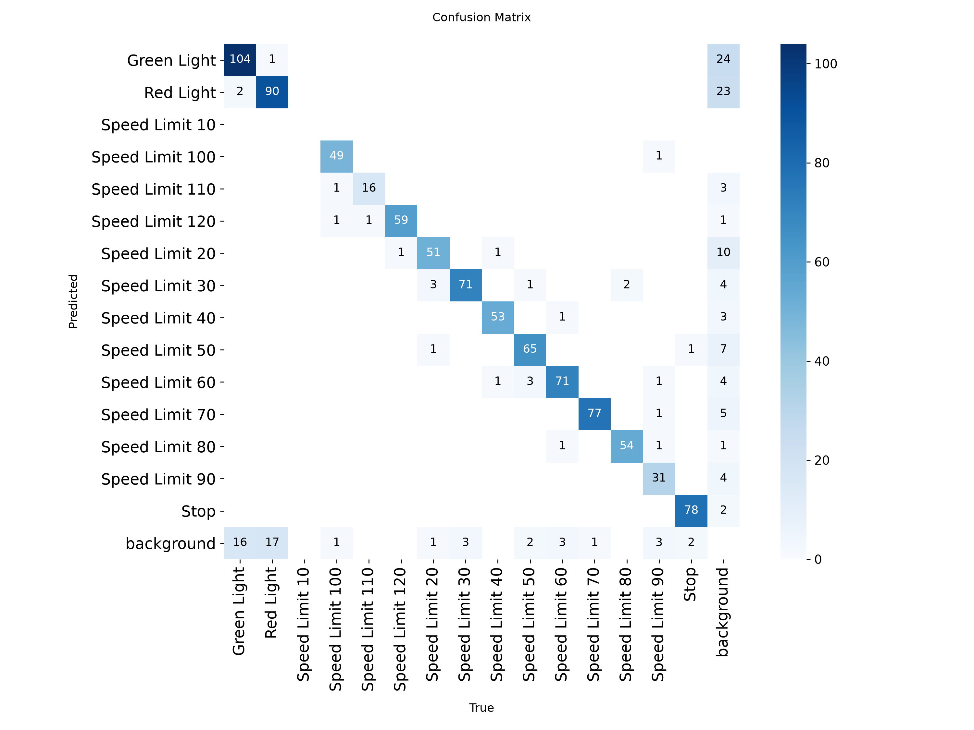
Fig 5.1 : Confusion Matrix
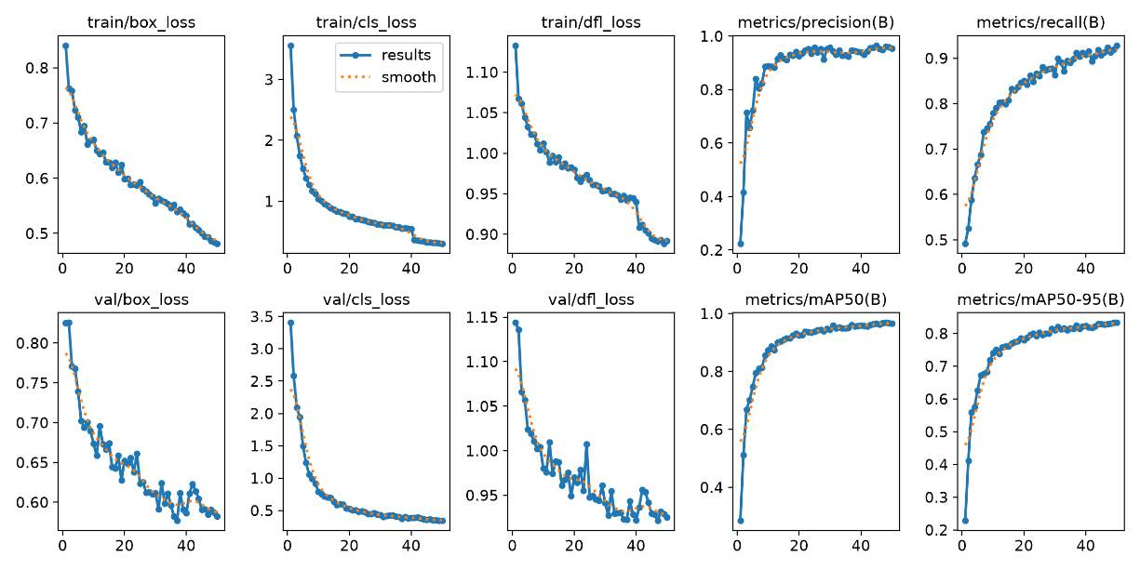
Fig 5.2 : Result Graphs
5.1.2 Testing Model

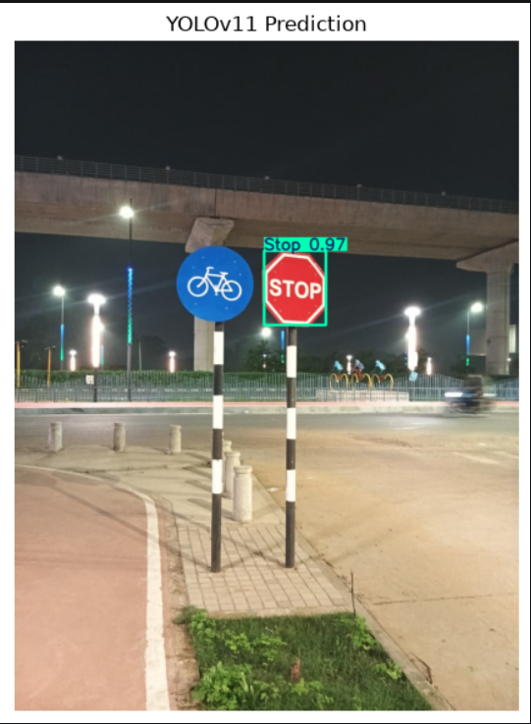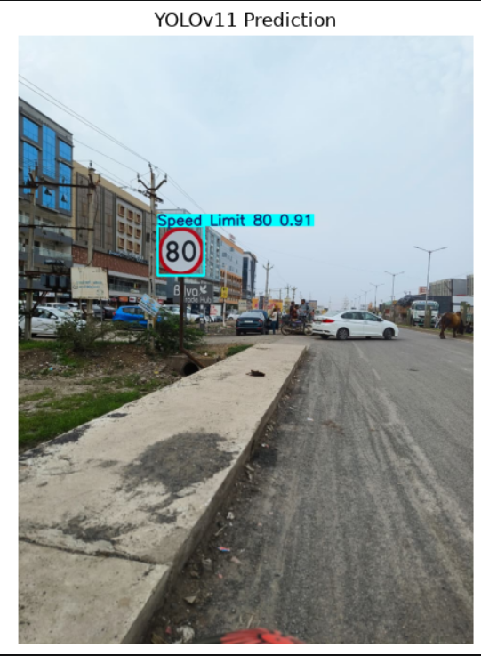
Fig 5.3: Stop Fig 5.4 : Speed Limit 80

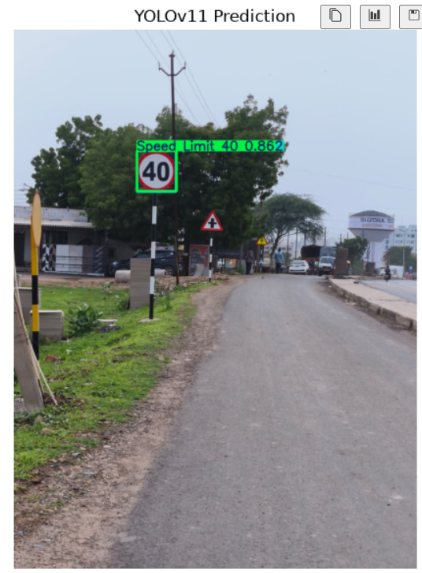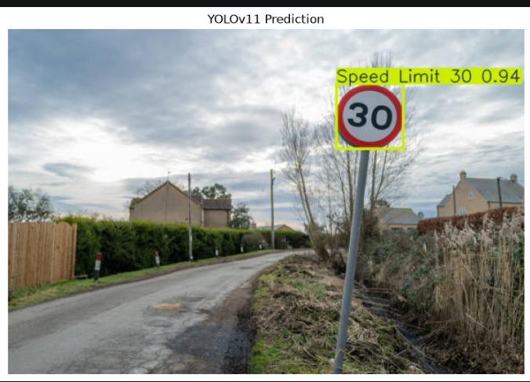
Fig 5.5 : Speed Limit 40 Fig 5.6 : Speed Limit 30
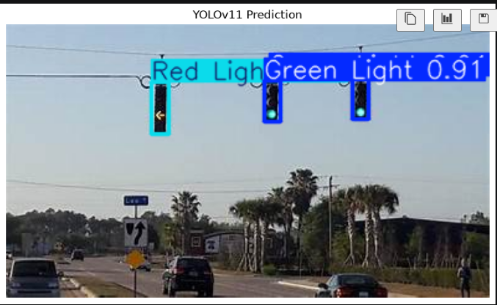
Fig 5.7: Traffic Light Green
For assessing the performance of the proposed model YOLOv11n, various test images with different traffic sign classes were fed into the model trained. The model predicted a class of traffic sign detected and the confidence of the prediction. The tests were conducted on a variety of signs such as Stop, Speed Limit 80, Speed Limit 40, Speed Limit 30, and Green Light. The results show that the model is able to recognize the road sign image through road images.
YOLOv11n is able to accurately identify a Stop sign in the Stop sign image (Fig. 5.2), with a reasonable confidence score of around 97%. The high confidence indicates that the model has learned the important visual characteristics of the Stop sign, such as its octagonal shape and red color. This is a good example of detecting the Stop sign in the test image.
The model is accurate in predicting the traffic sign of Speed Limit 80 (Fig. 5.3) with around 91.2% confidence. The model can recognize the circular sign and the numerical number in the sign that represents the speed limit. As shown, YOLOv11n can successfully recognize speed limit signs even in cases where sign details such as numerical values are included.
With the Speed Limit 40 image (Fig. 5.4), the model is predicting the right traffic sign with a confidence of around 86.2%. The confidence of the model is a little low compared to other signs, but it is able to identify the category of the sign. This means that YOLOv11n is able to recognize various speed limit signs according to their visual and symbolic characteristics.
The model successfully identifies the image of Speed Limit 30 (Fig. 5.5) with a very high confidence level (around 94%). The result demonstrates the model's capability to recognize the sign for circular speed-limit and distinguish the number '30' from the other speed-limit classes. Good recognition performance for this class, shown by the high confidence.
In the Green Light image (Fig. 5.6), the YOLOv11n model accurately detects the Green Light with a confidence score of about 91%. The model achieves good classification result based on the color and the visual properties of the traffic light. This proves that the model can identify objects that are related to traffic lights besides the conventional road signs.
Overall, the results of the tests reveal that YOLOv11n can accurately identify traffic signs of various categories with high confidence. The model had a very high level of confidence on the Stop and Speed Limit 30 signs, whereas fewer signs had a comparatively low level of confidence on the Speed Limit 40 signs. However, all tested examples were correctly detected, showing the effectiveness of the proposed model to be used for real-time traffic sign detection. The above results also demonstrate the applicability of the model for Intelligent Transportation Systems (ITS), Advanced Driver Assistance Systems (ADAS) and autonomous driving.

CONCLUSION
In this study, the success in developing a deep learning-based Traffic Sign Detection System based on YOLOv11n model is achieved. The proposed system was trained and tested on Self-Driving Cars dataset, which consists of 4,969 labelled images from 15 traffic sign classes. The system was built to recognize different traffic signs and give their class label, bounding box, and confidence score based on input road images without any human interference.
To compare the three lightweight object detection models, YOLOv8n, YOLOv10n, and YOLOv11n were used. YOLOv11n obtained the highest overall performance of 95.91% Precision, 91.98% Recall, 96.76% mAP@50, and 83.35% mAP@50–95 based on the experimental results. Such results suggest the proposed model has the ability to detect the traffic sign and is capable of good localization performance.
The performance of YOLOv11n was also tested under various image conditions such as Night Vision, Fog, Rain and Gaussian Blur. With these variations the model was able to reliably detect most classes of traffic signs. The analysis revealed, however, that there are traffic sign categories for which detection confidence is lowered with challenging conditions like Rain. This shows the need to test traffic sign detection models in scenarios that are closer to the real world.
The test results also showed that YOLOv11n was able to accurately recognize various traffic sign types, such as Stop, Speed Limit 80, Speed Limit 40, Speed Limit 30, and Green Light, with high accuracy. The model can detect signs of various shapes, colors, symbols and numbers, which is suitable for traffic sign detection in practice.
In general, the experimental results show that YOLOv11n can be used to accurately, reliably and efficiently detect traffic signs in real time. It is well suited for applications in Intelligent Transportation Systems (ITS), Advanced Driver Assistance Systems (ADAS) and autonomous driving, due to its high detection performance and independence of image circumstances. For future research, the authors suggest improving the model performance in extreme weather conditions, expanding the range of traffic signs in the dataset and tuning the model to deploy it on resource-constrained real-time devices.
FUTURE WORK
Future research will involve investigating various fine-tuning techniques for the YOLOv11n model, such as unfreezing additional layers and tuning training parameters like learning rates, batch sizes, etc. These enhancements can further boost its accuracy and generalization ability, and enable the model to learn more traffic sign-specific features.
The advanced object detection and classification architectures can be explored and compared in the future to enhance the accuracy, efficiency and inference time of the traffic sign recognition system. Other data augmentation methods and hyperparameter optimisation can also be used to minimise the misclassification of traffic signs, especially similar traffic signs in the same category, such as various speed limits.
The training set can also be enriched with images of other traffic signs taken from various angles, distances, weather conditions, backgrounds, and different illumination conditions, as well as under various occlusion scenarios. Incorporating more difficult real-world images can enhance the performance of the model and make it more resilient to various real-world scenarios, like rain or fog, or in low light conditions and with motion blur.
Lastly, the enhanced model can be optimized and deployed in real-time and resource-constrained devices for real-world applications in Intelligent Transportation System (ITS), Advanced Driver Assistance Systems (ADAS), and autonomous vehicles. This is useful for assessing the model in a real driving situation and for data mining and enhancing the model's reliability, detection speed and practicability.

Appendices
1. All Applicable Documents/Data/Details
- Project: Traffic Sign Recognition System Using Deep Learning
- Proposed Model: YOLOv11n
- Compared Models: YOLOv8n, YOLOv10n
- Dataset: Self-Driving Cars Dataset (Roboflow), 4,969 images, 15 classes
- Dataset Split: Training 71.04%, Validation 16.12%, Testing 12.84%
- Input Size: 640 × 640 pixels
- Training: 50 epochs, batch size 16
- Tools: Python, Ultralytics YOLO, PyTorch, OpenCV, NumPy, Pandas, VS Code
- Hardware: NVIDIA RTX 3050 Laptop GPU, 6 GB VRAM, CUDA 12.6
- Evaluation: Precision, Recall, mAP@50, mAP@50–95
- Robustness Tests: Original, Night Vision, Fog, Rain, Gaussian Blur
- Best YOLOv11n Results: Precision 95.91%, Recall 91.98%, mAP@50 96.76%, mAP@50–95 83.35%
- Dataset: Roboflow Self-Driving Cars Dataset
- GitHub Repository: Insert your updated GitHub repository link here.
This is enough. I would not add long explanations for every item in the appendix unless your university specifically requires detailed documentation.

2. SDG Mapping with Project (with Justification)
SDG 3 – Good Health and Well-Being: The proposed Traffic Sign Recognition System contributes to road safety by automatically detecting and recognizing traffic signs. Accurate detection of speed limits, stop signs, and traffic lights can provide timely information to drivers and intelligent transportation systems, helping reduce the risk of road accidents.
SDG 9 – Industry, Innovation and Infrastructure: The project applies deep learning and computer vision through the YOLOv11n model to develop an intelligent traffic sign detection system. The system supports technological innovation in Intelligent Transportation Systems (ITS), Advanced Driver Assistance Systems (ADAS), and autonomous driving applications. The proposed YOLOv11n model achieved 95.91% Precision, 91.98% Recall, 96.76% mAP@50, and 83.35% mAP@50–95.
SDG 11 – Sustainable Cities and Communities: The project supports safer and smarter transportation infrastructure by enabling automated traffic sign detection in road environments. Its potential application in ITS and ADAS can contribute to safer and more efficient urban mobility.

REFERENCES

[1] W. E. Elside and A. J. Abougarair, "Traffic Sign Recognition Using CNN," Journal of Advances in Artificial Intelligence, vol. 3, no. 1, pp. 19–39, Jan. 2025, doi: 10.18178/JAAI.2025.3.1.19-39.
[2] Y. Zhu and W. Q. Yan, "Traffic sign recognition based on deep learning," Multimedia Tools and Applications, vol. 81, no. 13, pp. 17779–17791, 2022, doi: 10.1007/s11042-022-12163-0.
[3] J. Redmon and A. Farhadi, "YOLOv3: An Incremental Improvement," arXiv preprint arXiv:1808.10524, 2018, doi: 10.48550/arXiv.1808.10524.
[4] Z. Qin and W. Q. Yan, "Traffic-Sign Recognition Using Deep Learning," in Geometry and Vision: First International Symposium, ISGV 2021, Auckland, New Zealand, January 28–29, 2021, Revised Selected Papers, M. Nguyen, W. Q. Yan, and H. Ho, Eds., Communications in Computer and Information Science, vol. 1386. Cham, Switzerland: Springer, 2021, pp. 13–25, doi: 10.1007/978-3-030-72073-5_2.
[5] R. K. Megalingam, K. Thanigundala, S. R. Musani, H. Nidamanuru, and L. Gadde, "Indian traffic sign detection and recognition using deep learning," International Journal of Transportation Science and Technology, vol. 12, no. 3, pp. 683–699, 2023, doi: 10.1016/j.ijtst.2022.06.002.
[6] G. K. Samdariya and D. K. Meda, "Deep Learning Based Indian Traffic Sign Detection And Recognition System," International Journal of Engineering Science & Humanities, vol. 16, no. 2, pp. 497–511, 2026. [Online]. Available: https://www.ijesh.com/j/article/view/847
[7] A. A. Alshammari, "Enhancing Traffic Sign Recognition on the Performance Based on YOLOv8," arXiv preprint arXiv:2504.02884, 2025, doi: 10.48550/arXiv.2504.02884.
[8] B. Xie and W. X. Xiong, "Real-Time Embedded Traffic Sign Recognition Using Efficient Convolutional Neural Network," IEEE Access, vol. 7, pp. 53330–53346, 2019, doi: 10.1109/ACCESS.2019.2912311.
[9] P. S. Zaki, M. M. William, B. K. Soliman, K. G. Alexsan, K. Khalil, and M. El-Moursy, "Traffic Signs Detection and Recognition System using Deep Learning," arXiv preprint arXiv:2003.03256, 2020, doi: 10.48550/arXiv.2003.03256.
[10] C. Kim, J. Park, Y. Park, W. Jung, and Y. S. Lim, "Deep Learning-Based Real-Time Traffic Sign Recognition System for Urban Environments," Infrastructures, vol. 8, no. 2, Art. no. 20, 2023, doi: 10.3390/infrastructures8020020.

