Jenish Patel

Prof. Henry

CS450

02/13/2021

Title: HW4

Step 1

Input: An empty line is a bug

|  |  |
| --- | --- |
| **Token Name** | **Token Values = Lexemes** |
| article | an |
| adjective | Empty |
| noun | line |
| verb | is |
| article | a |
| noun | Bug |

Input: This line is a longer sentence

|  |  |
| --- | --- |
| **Token Name** | **Token Values = Lexemes** |
| article | This |
| noun | Line |
| verb | Is |
| article | a |
| adjective | Longer |
| noun | sentence |

Step 2

Input:

|  |  |
| --- | --- |
| **Token Name** | **Token Values = Lexemes** |
| article | an |
| adjective | Empty |
| noun | line |
| verb | is |
| article | a |
| noun | Bug |

**Derivation:**

**Article adjective noun verb article noun**

Input:

|  |  |
| --- | --- |
| **Token Name** | **Token Values = Lexemes** |
| article | This |
| noun | Line |
| verb | Is |
| article | a |
| adjective | Longer |
| noun | sentence |

**Derivation:**

**Article noun verb article adjective noun**



Parser Tree:

An empty line is a bug.

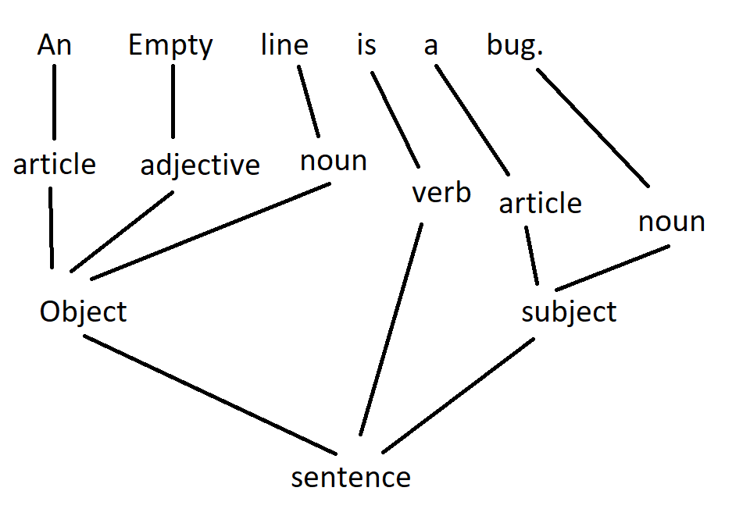

This is a longer sentence.

