Using retrofit and rxjava, rxandroid for multithreaded REST requests:

* Libraries required for this project:

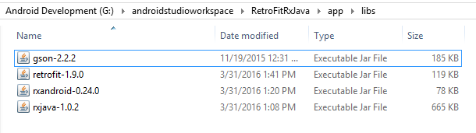

* Build.gradle

dependencies {  
 compile fileTree(dir: **'libs'**, include: [**'*.jar'**])  
 testCompile **'junit:junit:4.12'** compile **'com.android.support:appcompat-v7:23.1.1'** compile **'com.android.support:design:23.1.1'** compile **'com.android.support:cardview-v7:23.1.1'**

**}**

* Make sure internet permission is enabled in manifest.