**HandsOn 9-ReactJS HOL:**

**Code:**

**ListofPlayers.js:**

import React from 'react'

const ListofPlayers = () => {

    const players = [

    { name: "Rohit Sharma", score: 95 },

    { name: "Virat Kohli", score: 120 },

    { name: "Shubman Gill", score: 65 },

    { name: "Dhoni", score: 45 },

    { name: "Dravid", score: 85 },

    { name: "Smith", score: 72 },

    { name: "Warner", score: 40 },

    { name: "Bravo", score: 68 },

    { name: "Mohammed Shami", score: 15 },

    { name: "Jasprit Bumrah", score: 30 },

    { name: "Malinga", score: 55 },

  ];

  const lowScorers = players.filter((player) => player.score < 70);

  return (

    <div>

      <h2>List of Players</h2>

      <ul>

        {players.map((player, index) => (

          <li key={index}>

            {player.name} - {player.score}

          </li>

        ))}

      </ul>

      <hr />

      <h2>Players with score below 70</h2>

      <ul>

        {lowScorers.map((player, index) => (

          <li key={index}>

            {player.name} - {player.score}

          </li>

        ))}

      </ul>

    </div>

  );

}

=

export default ListofPlayers;

**IndianPlayers.js:**

import React from 'react'

const IndianPlayers = () => {

    const players=["Rohit Sharma", "Virat Kohli", "Shubman Gill", "Suryakumar Yadav", "KL Rahul", "Hardik Pandya", "Ravindra Jadeja"];

    const evenPlayers = players.filter((player, index) => index % 2 === 0);

    const oddPlayers = players.filter((player, index) => index % 2 !== 0);

    const T20Players = ["Pant", "Iyer", "Bhuvi"];

    const RanjiPlayers = ["Pujara", "Rahane", "Shami"];

    const allPlayers = [...players, ...T20Players, ...RanjiPlayers];

  return (

    <div>

      <h2>Even Players</h2>

      <ul>

        {evenPlayers.map((player, index) => (

          <li key={index}>{player}</li>

        ))}

      </ul>

       <hr />

      <h2>Odd Players</h2>

      <ul>

        {oddPlayers.map((player, index) => (

          <li key={index}>{player}</li>

        ))}

      </ul>

       <hr />

      <h2>All Players</h2>

      <ul>

        {allPlayers.map((player, index) => (

          <li key={index}>{player}</li>

        ))}

      </ul>

    </div>

  )

}

export default IndianPlayers

**App.js:**

import './App.css';

import ListofPlayers from './ListofPlayers';

import IndianPlayers from './IndianPlayers';

function App() {

  const flag= true;

  return (

    <>

   {flag ? <ListofPlayers /> : <IndianPlayers />}

    </>

  );

}

export default App;

**Output:**

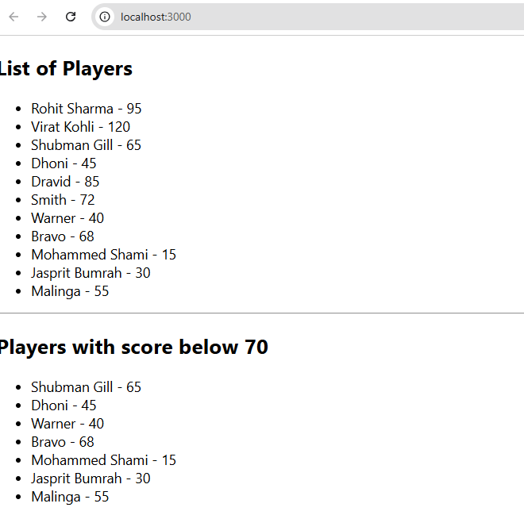

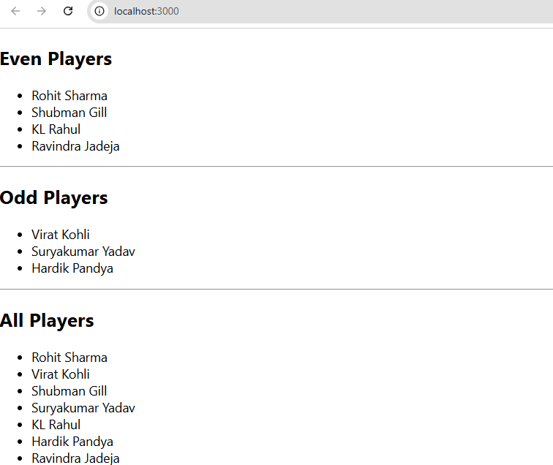

**HandsOn 10-ReactJS HOL: (OfficespaceRentalApp)**

**Code:**

**OfficespaceRental.js:**

import React from "react";

function OfficeSpaceRental() {

  const offices = [

    {

      id: 1,

      name: "Skyline Workspace",

      rent: 55000,

      address: "123 MG Road, Bangalore",

      image: "https://plus.unsplash.com/premium_photo-1681487178876-a1156952ec60?fm=jpg&q=60&w=3000&ixlib=rb-4.1.0&ixid=M3wxMjA3fDB8MHxzZWFyY2h8MXx8b2ZmaWNlc3xlbnwwfHwwfHx8MA%3D%3D"

    },

    {

      id: 2,

      name: "Tech Park Tower",

      rent: 65000,

      address: "456 Whitefield, Bangalore",

      image: "https://thumbs.dreamstime.com/b/office-work-place-5879959.jpg"

    },

    {

      id: 3,

      name: "Urban Hub",

      rent: 45000,

      address: "789 Koramangala, Bangalore",

      image: "https://cdn.sanity.io/images/uqxwe2qj/production/62db3c671745e98cb27690dff96f8033d2bb7f35-2048x1010.jpg"

    }

  ];

  return (

    <div className="App">

      {/* Heading */}

      <h1>Office Space Rental App</h1>

      {/* Loop through office list */}

      <div className="office-list">

        {offices.map((office) => (

          <div key={office.id} className="office-card">

            {/* Attribute for image */}

            <img src={office.image} alt={office.name} style={{ width: "250px", height: "auto" }} />

            {/* Office Details */}

            <h2>Name: {office.name}</h2>

            <p>Location: {office.address}</p>

            <p

              className="rent"

              style={{

                color: office.rent < 60000 ? "red" : "green"

              }}

            >

              Rent: ₹{office.rent}

            </p>

          </div>

        ))}

      </div>

    </div>

  );

}

export default OfficeSpaceRental;

**Output:**

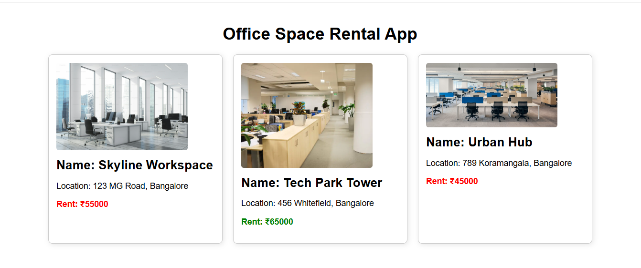

**HandsOn 11-ReactJS HOL: (EventExample)**

**Code:**

**EventexamplesApp.js:**

import React, { useState } from "react";

function EventexamplesApp() {

  const [count, setCount] = useState(1);

  const [amount, setAmount] = useState("");

  const [currency, setCurrency] = useState("Euro");

  const handleIncrement = () => setCount(count + 1);

  const handleDecrement = () => setCount(count - 1);

  const handleWelcome = () => alert("Welcome to React App!");

  const handleClickMe = () => alert("You clicked on me!");

  const handleSubmit = (e) => {

    e.preventDefault();

    let convertedAmount = 0;

    if (currency === "Euro") {

      convertedAmount = amount * 80;

    } else if (currency === "Dollar") {

      convertedAmount = amount * 70;

    } else if (currency === "Yen") {

      convertedAmount = amount * 0.65;

    }

    alert(`Converting to ${currency} Amount is ${convertedAmount}`);

  };

  return (

    <div style={{ padding: "20px" }}>

      <h3>{count}</h3>

      <button onClick={handleIncrement}>Increment</button>

      <button onClick={handleDecrement}>Decrement</button>

      <button onClick={handleWelcome}>Say welcome</button>

      <button onClick={handleClickMe}>Click on me</button>

      <h1 style={{ color: "green" }}>Currency Convertor!!!</h1>

      <form onSubmit={handleSubmit}>

        <div>

          <label>

            Amount:{" "}

            <input

              type="number"

              value={amount}

              onChange={(e) => setAmount(e.target.value)}

            />

          </label>

        </div>

        <div>

          <label>

            Currency:{" "}

            <select

              value={currency}

              onChange={(e) => setCurrency(e.target.value)}

            >

              <option value="Euro">Euro</option>

              <option value="Dollar">Dollar</option>

              <option value="Yen">Yen</option>

            </select>

          </label>

        </div>

        <button type="submit">Submit</button>

      </form>

    </div>

  );

}

export default EventexamplesApp;

**Output:**

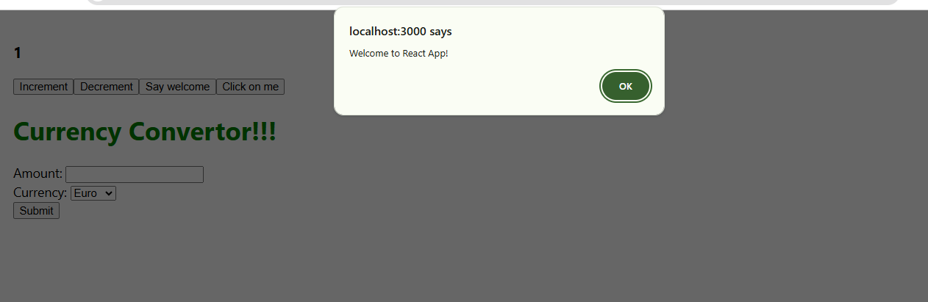 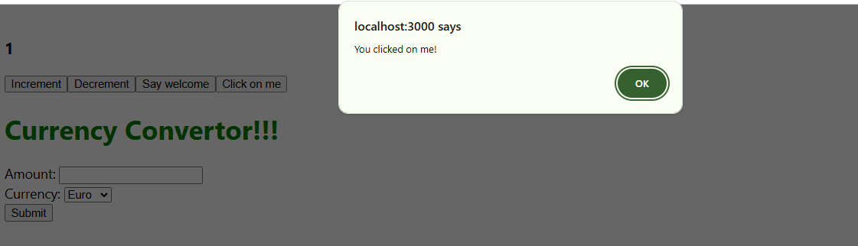

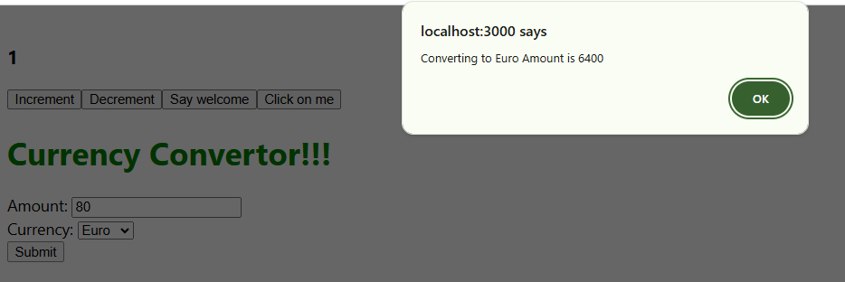

**HandsOn 12-ReactJS HOL:**

**Code:**

**FlightList.js:**

import React from "react";

const flights = [

  { id: 1, from: "New York", to: "London", price: 500 },

  { id: 2, from: "Paris", to: "Tokyo", price: 700 },

  { id: 3, from: "Berlin", to: "Dubai", price: 450 },

];

function FlightList({ showBooking }) {

  return (

    <div>

      <h2>Available Flights</h2>

      <ul>

        {flights.map((flight) => (

          <li key={flight.id} style={{ marginBottom: "10px" }}>

            {flight.from} → {flight.to} (${flight.price})

            {showBooking && <button style={{ marginLeft: "10px" }}>Book</button>}

          </li>

        ))}

      </ul>

    </div>

  );

}

export default FlightList;

**GuestPage.js:**

import React from "react";

import FlightList from "./FlightList";

function GuestPage() {

  return (

    <div>

      <h2>Welcome Guest!</h2>

      <p>You can browse flights but must log in to book tickets.</p>

      <FlightList showBooking={false} />

    </div>

  );

}

export default GuestPage;

**UserPage.js:**

import React from "react";

import FlightList from "./FlightList";

function UserPage() {

  return (

    <div>

      <h2>Welcome User!</h2>

      <p>You can browse and book flights below:</p>

      <FlightList showBooking={true} />

    </div>

  );

}

export default UserPage;

**App.js:**

import React, { useState } from "react";

import GuestPage from "./components/GuestPage";

import UserPage from "./components/UserPage";

function App() {

  const [isLoggedIn, setIsLoggedIn] = useState(false);

  const handleLogin = () => setIsLoggedIn(true);

  const handleLogout = () => setIsLoggedIn(false);

  return (

    <div>

      <header style={{ padding: "10px", background: "#282c34", color: "white", display: "flex", justifyContent: "space-between", alignItems: "center" }}>

        <h1>Ticket Booking App</h1>

        {isLoggedIn ? (

          <button onClick={handleLogout} style={{ padding: "8px", backgroundColor: "red", color: "white", borderRadius: "4px" }}>Logout</button>

        ) : (

          <button onClick={handleLogin} style={{ padding: "8px", backgroundColor: "green", color: "white", borderRadius: "4px" }}>Login</button>

        )}

      </header>

      <main style={{ padding: "20px" }}>

        {isLoggedIn ? <UserPage /> : <GuestPage />}

      </main>

    </div>

  );

}

export default App;

**Output:**

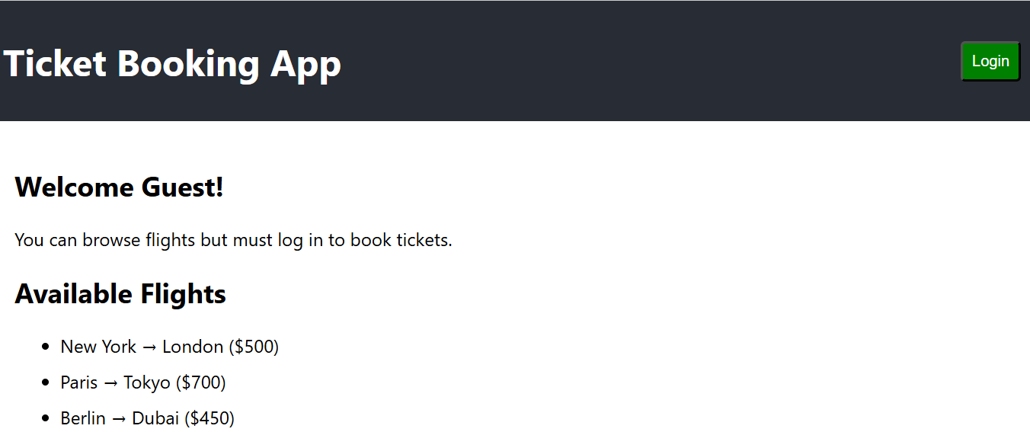

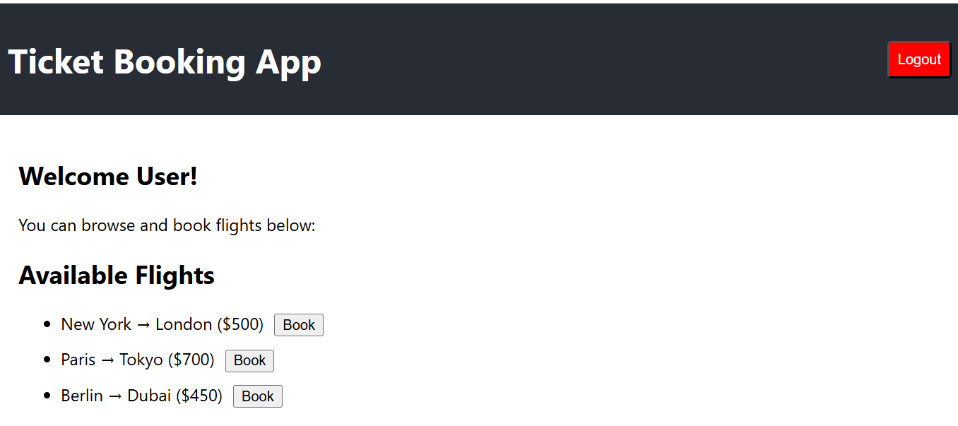

**HandsOn 12-ReactJS HOL:**

**Code:**

**Data.js:**

export const books = [

  { id: 101, bname: 'Master React', price: 670 },

  { id: 102, bname: 'Deep Dive into Angular 11', price: 800 },

  { id: 103, bname: 'Mongo Essentials', price: 450 },

];

export const blogs = [

  { id: 1, title: 'React Learning', author: 'Stephen Biz', content: 'Welcome to learning React!' },

  { id: 2, title: 'Installation', author: 'Schwezdneir', content: 'You can install React from npm.' }

];

export const courses = [

  { id: 1, cname: 'Angular', date: '4/5/2021' },

  { id: 2, cname: 'React', date: '6/3/2021' }

];

**Books.js:**

import React from "react";

function Books({ books }) {

  return (

    <div className="st2">

      <h1>Book Details</h1>

      <ul>

        {books.length > 0 ? (

          books.map((book) => (

            <li key={book.id}>

              <h3>{book.bname}</h3>

              <h4>{book.price}</h4>

            </li>

          ))

        ) : (

          <p>No Books Available</p>

        )}

      </ul>

    </div>

  );

}

export default Books;

**course.js:**

import React from "react";

function Courses({ courses }) {

  return (

    <div className="mystyle1">

      <h1>Course Details</h1>

      {courses.length === 0 && <p>No Courses Available</p>}

      {courses.length > 0 && (

        <ul>

          {courses.map((course) => (

            <li key={course.id}>

              <h2>{course.cname}</h2>

              <p>{course.date}</p>

            </li>

          ))}

        </ul>

      )}

    </div>

  );

}

export default Courses;

**Blogs.js:**

import React from "react";

function Blogs({ blogs }) {

  return (

    <div className="v1">

      <h1>Blog Details</h1>

      {blogs && blogs.length ? (

        blogs.map((blog) => (

          <div key={blog.id}>

            <h2>{blog.title}</h2>

            <h4>{blog.author}</h4>

            <p>{blog.content}</p>

          </div>

        ))

      ) : (

        <p>No Blogs Found</p>

      )}

    </div>

  );

}

export default Blogs;

**App.js:**

import React, { useState } from "react";

import { books, blogs, courses } from "./Data";

import Books from "./components/Books";

import Blogs from "./components/Blogs";

import Courses from "./components/Courses";

function App() {

  const [showBooks, setShowBooks] = useState(true);

  const [showBlogs, setShowBlogs] = useState(true);

  const [showCourses, setShowCourses] = useState(true);

  return (

    <div style={{ display: "flex", justifyContent: "space-around" }}>

      {/* 1. Using Ternary Operator */}

      {showBooks ? <Books books={books} /> : <p>Books Hidden</p>}

      {/* 2. Using Logical && */}

      {showBlogs && <Blogs blogs={blogs} />}

      {/* 3. Using Variable to Hold JSX */}

      {(() => {

        if (showCourses) return <Courses courses={courses} />;

        return <p>Courses Hidden</p>;

      })()}

    </div>

  );

}

export default App;

**Output:**

