**Exercise 1: Mocking and Stubbing**

**Code:**

**MyService.java**

package org.example;  
  
public class MyService {  
 private final ExternalApi externalApi;  
 public MyService(ExternalApi externalApi) {  
 this.externalApi = externalApi;  
 }  
 public String fetchData() {  
 return externalApi.getData(); // Will throw NullPointerException if externalApi is null  
 }  
}

**ExternalApi.java**

package org.example;  
  
public interface ExternalApi {  
 String getData();  
}

**MyserviceTest.java**

package org.example;  
  
import org.junit.jupiter.api.Test;  
import static org.junit.jupiter.api.Assertions.*assertEquals*;  
import static org.mockito.Mockito.*;  
  
public class MyServiceTest {  
 @Test  
 public void testExternalApi() {  
 ExternalApi mockApi = *mock*(ExternalApi.class);  
 *when*(mockApi.getData()).thenReturn("Mock Data");  
   
 MyService service = new MyService(mockApi);  
 String result = service.fetchData();  
   
 *assertEquals*("Mock Data", result);  
 }  
}

**Output:**

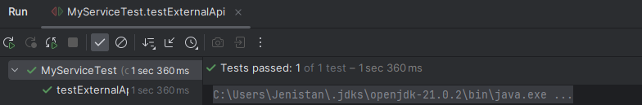

**Exercise 2: Verifying Interactions**

**Code:**

**MyService.java**

package org.example;  
  
public class MyService {  
 private final ExternalApi externalApi;  
 public MyService(ExternalApi externalApi) {  
 this.externalApi = externalApi;  
 }  
 public String fetchData(String id) {  
 return externalApi.getData(id); // Will throw NullPointerException if externalApi is null  
 }  
}

**ExternalApi.java**

package org.example;  
  
public interface ExternalApi {  
 String getData(String id);  
}

**MyserviceTest.java**

package org.example;  
  
import org.junit.jupiter.api.Test;  
import static org.mockito.Mockito.*;  
import static org.junit.jupiter.api.Assertions.*;  
  
class MyServiceTest {  
  
 @Test  
 void testVerifyInteraction() {  
 // Arrange  
 ExternalApi mockApi = *mock*(ExternalApi.class);  
 *when*(mockApi.getData("ABC123")).thenReturn("Mock Data");  
  
 MyService service = new MyService(mockApi);  
 // Act  
 String result = service.fetchData("ABC123");  
 // Assert  
 *assertEquals*("Mock Data", result);  
 // Assert  
 *verify*(mockApi, *times*(1)).getData("ABC123");  
 *verifyNoMoreInteractions*(mockApi);  
 }  
}

**Output:**