**HandsOn 1-ReactJS HOL: (**Basic environment setup**)**

**Code:**

**App.js:**

function App() {

  return (

    <>

      <h1>

        Welcome to the first session of React!....

      </h1>

      <h4>React is Javascript library which is used to build Single Page Application..</h4>

    </>

  );

}

export default App;

**Output:**

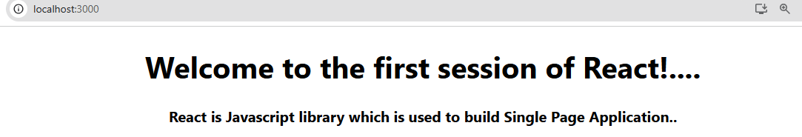

**HandsOn 2-ReactJS HOL: (**React Component**)**

**Code:**

**Home.js:**

import React,{Component} from "react";

import '../App.css';

class Home extends Component {

    render() {

        return (

            <div>

                <h3>Welcome to the Home Page of the Student Management Portal</h3>

            </div>

        )

    }

}

export default Home;

**About.js:**

import React,{Component} from "react";

import '../App.css';

class About extends Component {

    render() {

        return (

            <div>

                <h3>Welcome to the About Page of the Student Management Portal</h3>

            </div>

        )

    }

}

export default About;

**Contact.js:**

import React,{Component} from "react";

import '../App.css';

class Contact extends Component {

    render() {

        return (

            <div>

                <h3>Welcome to the Contact Page of the Student Management Portal</h3>

            </div>

        )

    }

}

export default Contact;

**App.js:**

import Home  from './Components/Home'

import About from './Components/About'

import Contact from './Components/Contact'

function App() {

  return (

    <div>

      <Home/>

      <About/>

      <Contact/>

    </div>

  );

}

export default App;

**Output:**

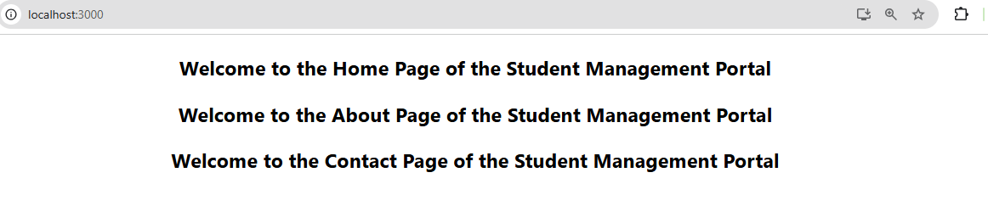

**HandsOn 3-ReactJS HOL:** (React Component)

**Code:**

**CalculateScore.js:** (Components)

import '../Stylesheets/mystyle.css'

const CalculateScore = (props) => {

  const calcScore = (total, goal) => {

    return (total / goal).toFixed(2) + '%';

  };

  return (

    <div className="formatstyle">

      <h1>Student Details</h1>

      <p className="Name">Name: {props.Name}</p>

      <p className="School">School: {props.School}</p>

      <p className="Total">Total Marks: {props.total}</p>

      <p className="Score">Score: {calcScore(props.total, props.goal)}</p>

    </div>

  );

};

export default CalculateScore;

**mystyle.js:** (Stylesheets)

.Name {

  color: blue;

  font-weight: 300;

}

.School {

  color: crimson;

}

.Total {

  color: darkmagenta;

}

.Score {

  color: forestgreen;

}

.formatstyle {

  text-align: center;

  font-size: 20px;

}

**App.js:**

import CalculateScore from './Components/CalculateScore';

function App() {

  return (

    <div>

      <CalculateScore Name={"Jenistan"}

      School={"National Public School"}

      total={283}

      goal={3}

      />

    </div>

  );

}

export default App;

**Output:**

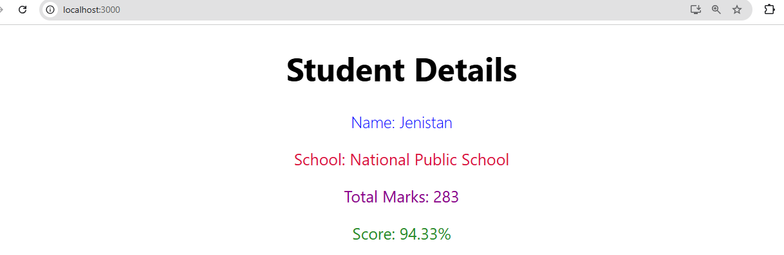

**HandsOn 4-ReactJS HOL:** (React Lifecycle Method)

**Code:**

**Post.js:**

class Post {

  constructor(userId, id, title, body) {

    this.userId = userId;

    this.id = id;

    this.title = title;

    this.body = body;

  }

}

export default Post;

**Posts.js:**

import React, { Component } from 'react';

import Post from './Post';

class Posts extends Component {

  constructor(props) {

    super(props);

    this.state = {

      posts: [],

      error: null,

    };

  }

  loadPosts = () => {

    fetch('https://jsonplaceholder.typicode.com/posts')

      .then((response) => {

        if (!response.ok) throw new Error('Network response was not ok');

        return response.json();

      })

      .then((data) => {

        const postObjects = data.map(

          (p) => new Post(p.userId, p.id, p.title, p.body)

        );

        this.setState({ posts: postObjects });

      })

      .catch((error) => {

        this.setState({ error });

      });

  };

  componentDidMount() {

    this.loadPosts();

  }

  componentDidCatch(error, info) {

    alert(`Error caught: ${error.message}`);

  }

  render() {

    const { posts, error } = this.state;

    if (error) return <p>Error: {error.message}</p>;

    return (

      <div>

        <h1>Blog Posts</h1>

        {posts.map((post) => (

          <div key={post.id} style={{ marginBottom: '20px' }}>

            <h3>{post.title}</h3>

            <p>{post.body}</p>

          </div>

        ))}

      </div>

    );

  }

}

export default Posts;

**App.js:**

import './App.css';

import Posts from './Posts';

function App() {

  return (

    <div className="App">

      <Posts />

    </div>

  );

}

export default App;

**Output:**

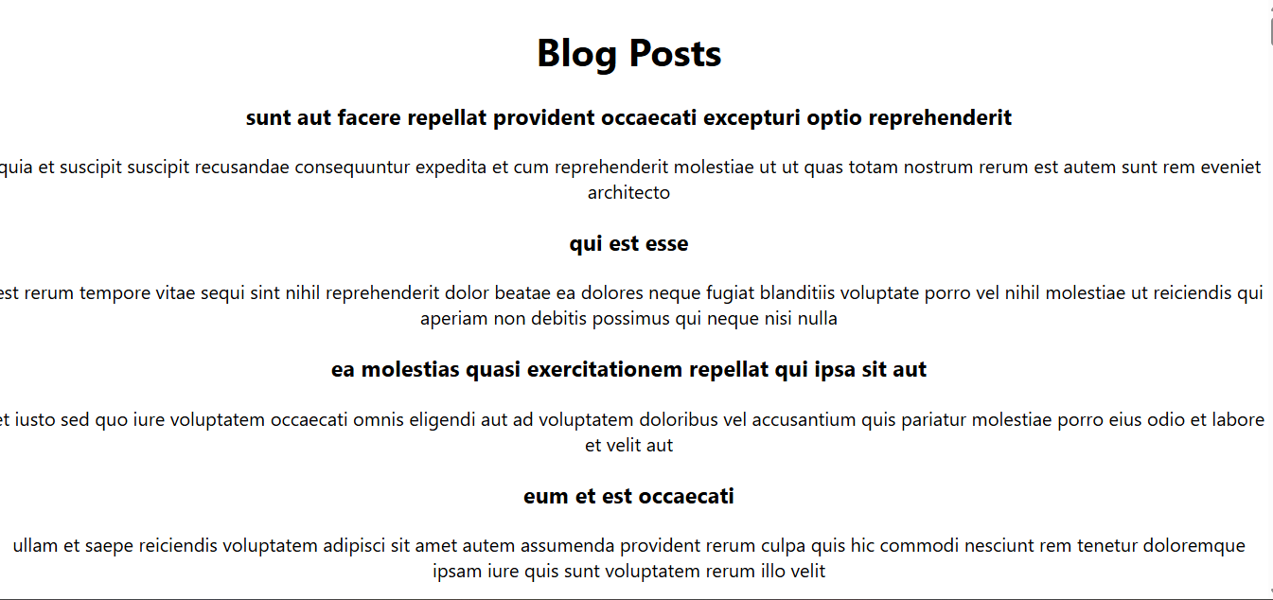

**HandsOn 5-ReactJS HOL:** (Styling Component)

**Code:**

**CohortDetails.js:**

import style from'./CohortDetails.module.css'

function CohortDetails(props) {

    return (

        <div className={style.box}>

            <h3 className={props.cohort.currentStatus==='Ongoing'?style.green:style.blue}>

                {props.cohort.cohortCode} -

                <span>{props.cohort.technology}</span>

            </h3>

            <dl>

                <dt>Started On</dt>

                <dd >{props.cohort.startDate}</dd>

                <dt>Current Status</dt>

                <dd>{props.cohort.currentStatus}</dd>

                <dt>Coach</dt>

                <dd>{props.cohort.coachName}</dd>

                <dt>Trainer</dt>

                <dd>{props.cohort.trainerName}</dd>

            </dl>

        </div>

    );

}

export default CohortDetails;

**CohortDetails.module.css:**

div{

    text-align: center;

}

.box{

    width: 250px;

    display: inline-block;

    margin: 10px;

    padding: 10px 20px 10px 20px;

    border: 1px solid black;

    border-radius: 10px;

}

dt{

    font-weight: 500;

}

.green{

    color: green;

}

.blue{

    color: blue;

}

**App.js:**

import './App.css';

import { CohortsData} from './Cohort'

import CohortDetails from './CohortDetails';

function App()

  return (

  <div>

    <h1>Cohorts Details</h1>

    {CohortsData.map(cohort => <CohortDetails cohort={cohort}/>)}

  </div>

  );

}

export default App;

**Output:**

