**Git – Exercise 1 – Configuration and Basic Commands**

1. **Setting up Git.**

* Adding git to the environment variables  
  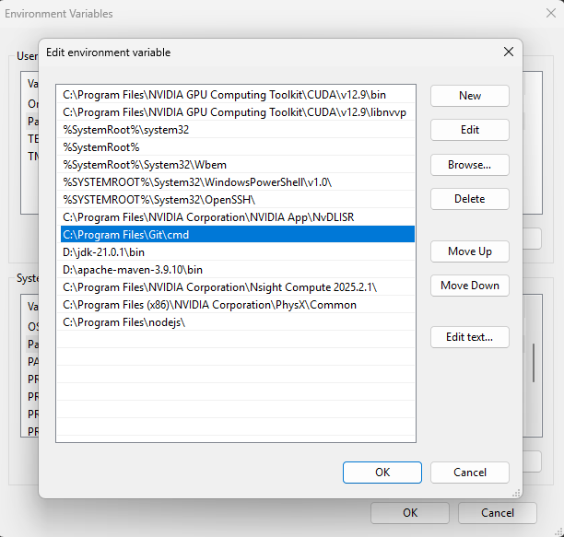
* Configuring Git User Info

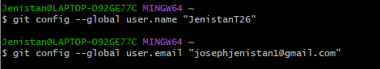

* Checking configuration



**Since Notepad++ isn’t mainstream anymore, I’ll be using VS Code since it is considered an all-around mainstream code editor.**

**Creating a basic Repository.**

We can use `git init` to initialize an empty repository.



We can create and add files to this repo by using the `git add` command.



Checking status before and after adding files.

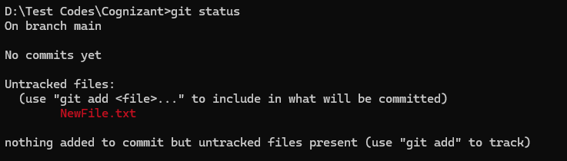

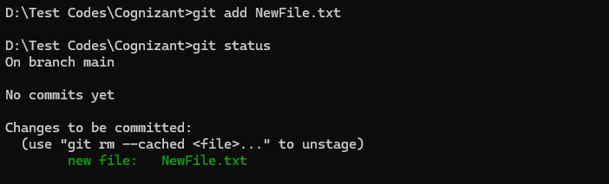

**Committing a repository using `git commit`**

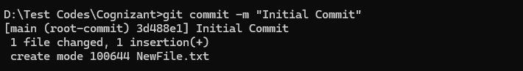

The -m flag is used for including a Commit message. Each commit needs to have a message.

**Checking status after commit**



**Pushing to GitHub**

